WEEK-2
A.KUVIRA
Roll No: 2520030192

Step 1 — Create Database & Books Table
Created the librarybook database and the Books table with column-level constraints (PRIMARY KEY, NOT NULL, UNIQUE, CHECK on published_year). Inserted 3 sample records and verified with SELECT * FROM Books.
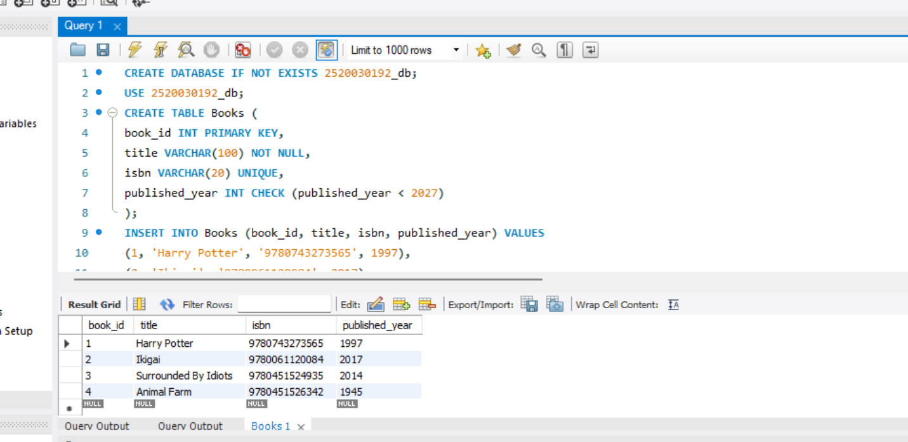

Step 2 — Create Members Table
Created the Members table (member_id, full_name, email) and inserted 3 sample members, then verified with SELECT * FROM Members.
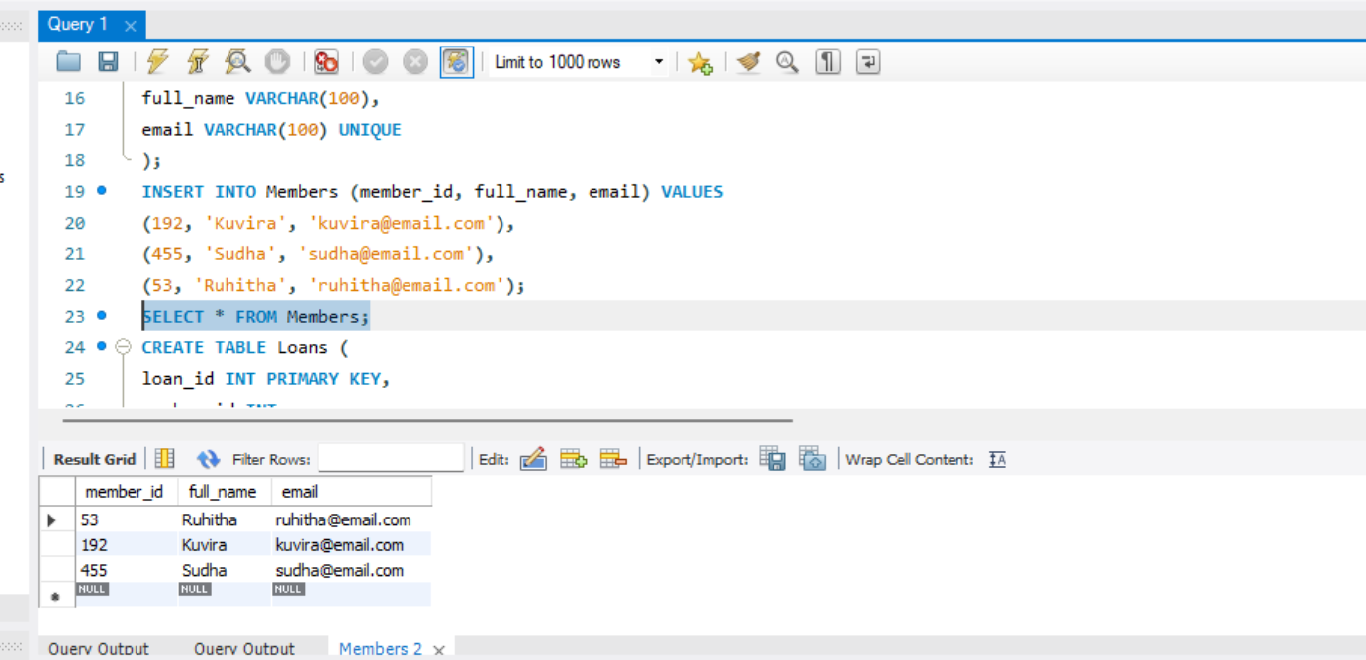

Step 3 — Create Loans Table
Created the Loans table linking Members and Books, then inserted 10 loan records and verified with SELECT * FROM Loans.
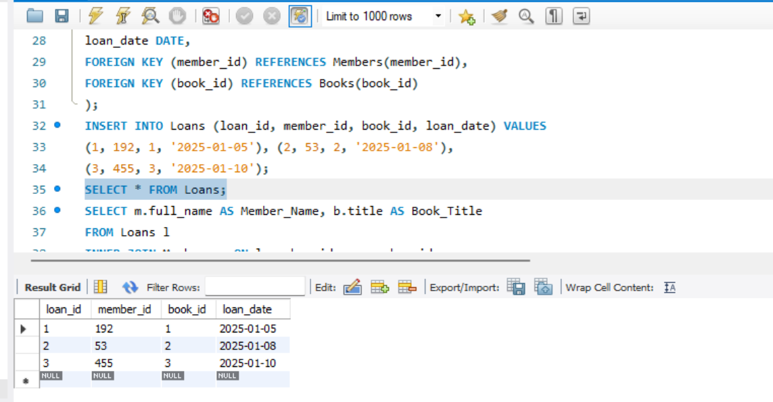

Step 4 — Join Query (Members & Books via Loans)
Used an INNER JOIN across Loans, Members, and Books to list which member borrowed which book.
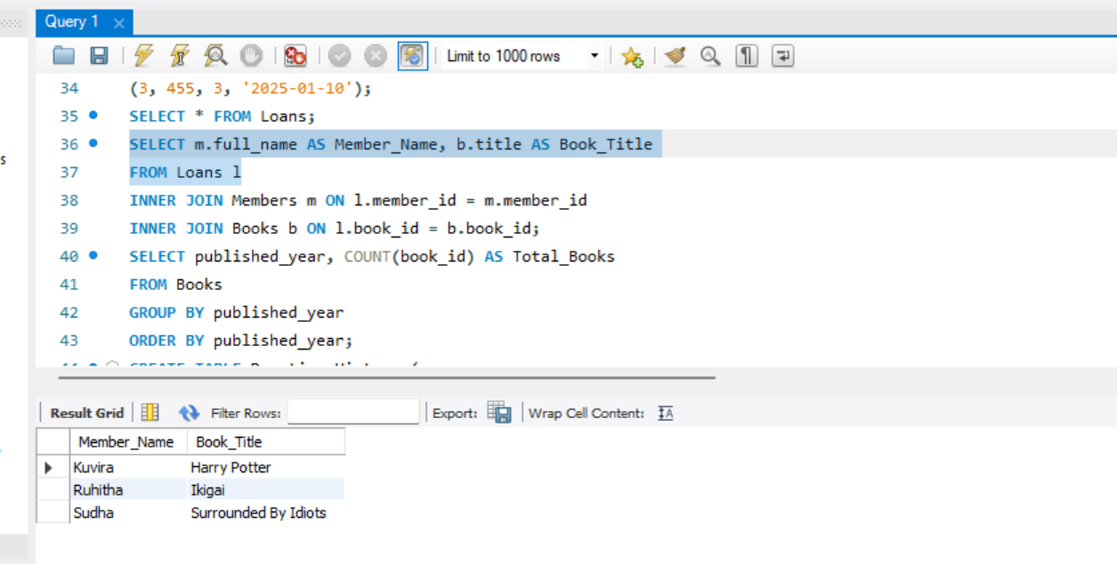

Step 5 — Aggregate Query (Books per Published Year)
Used GROUP BY with COUNT() to find the total number of books published in each year.
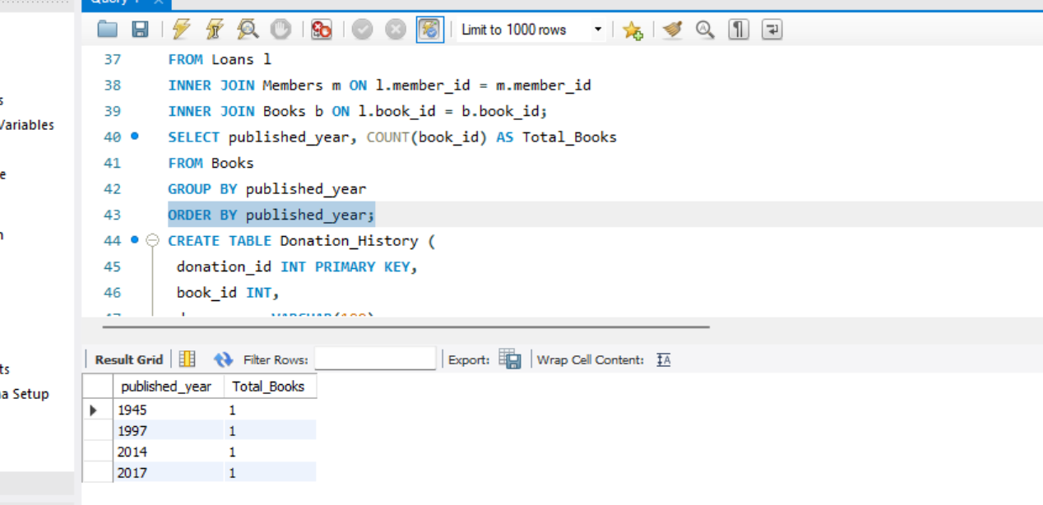

Step 6 — Donation_History Table & Transaction
Created the Donation_History table, then used START TRANSACTION / COMMIT to atomically insert a new book and log its donation record.
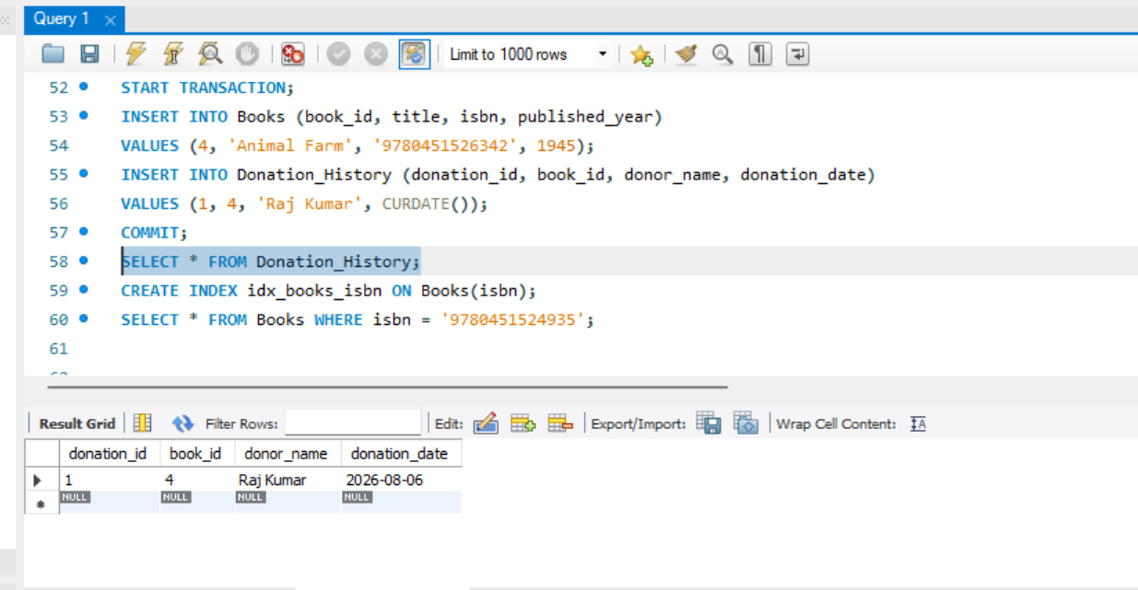

Step 7 — Index Creation & Indexed Search
Created an index on the isbn column of Books to speed up lookups, then queried a book by its ISBN.
