STUDENT CASE STUDY EXECUTION REPORT
Department | FED
Subject | DSA-2
Academic Year | I-III Semester (2025-26)
Faculty Name | P. Swetha Nagasri
Student Name | A.Kuvira
Roll Number | 2520030192
Branch | CSE
Course Outcome | 5
Case Study Topic: Snapdeal product-catalog sorting — Timsort on partially-sorted data.

Work Done Summary
In this case study, we analyzed Snapdeal's product catalog sorting problem and explored the use of Timsort for efficiently sorting partially sorted data.
We identified natural sorted runs within the dataset, reversed descending runs, and then merged all runs while maintaining stability.
We implemented a simplified version of Timsort in Java and observed how existing order in the data reduces sorting effort compared to traditional sorting algorithms.

Implementation Details
- Stored product listing dates in an integer array.
- Identified natural ascending and descending runs.
- Reversed descending runs to convert them into ascending runs.
- Applied insertion sort on small runs when required.
- Merged all runs while preserving stability.
- Generated the final sorted catalog.

Result: Screenshots / Output
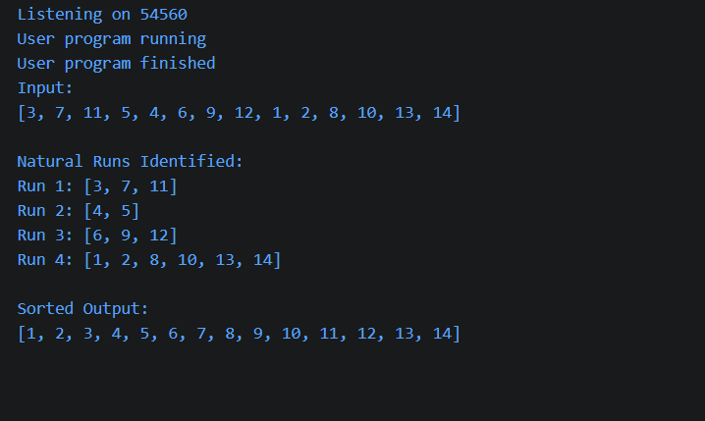
Time Complexity:
- Best Case: O(n)
- Average/Worst Case: O(n log n)
Timsort efficiently utilized the existing sorted runs within the dataset and required fewer operations than traditional sorting algorithms. Its ability to exploit partially sorted data makes it highly suitable for large-scale catalog management systems such as Snapdeal.
GitHub Link: __________________________
Student Signature | Faculty Signature
________________ | ________________

