STUDENT CASE STUDY EXECUTION REPORT
Department | FED
Subject | DSA-2
Academic Year | I-III Semester (2025-26)
Faculty Name | P. Swetha Nagasri
Student Name | A.Kuvira
Roll Number | 2520030192
Branch | CSE
Course Outcome | 6
Case Study Topic: Income-tax bracket optimisation — subset-sum for deduction allocation.

Work Done Summary
In this case study, we analyzed the Income Tax deduction allocation problem using the Subset Sum Dynamic Programming (DP) approach.
We considered seven eligible deductions and determined whether a subset exists whose total is exactly ₹100,000, the maximum deduction limit under Section 80C.
We implemented a DP table to track achievable sums and used backtracking to identify one valid subset that satisfies the target amount.

Implementation Details
- Stored all eligible deduction amounts in an array.
- Defined the target deduction amount as ₹100,000.
- Created a DP table to track possible subset sums.
- Filled the table using inclusion and exclusion of deductions.
- Checked whether the target sum was achievable.
- Backtracked through the DP table to find one valid subset.

Result: Screenshots / Output
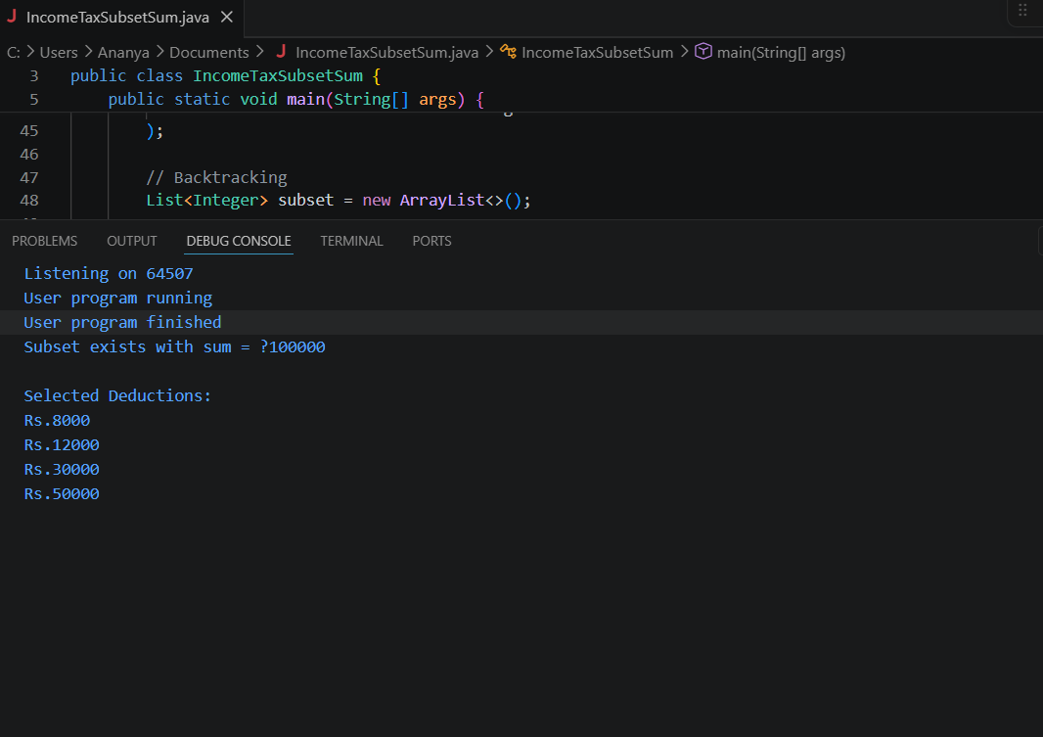
Time Complexity:
- DP Table Construction: O(n × target)
- Backtracking: O(n)
The Dynamic Programming approach successfully determined that an exact deduction allocation of ₹100,000 is possible. By using the subset {₹50,000, ₹30,000, ₹15,000, ₹5,000}, the taxpayer can fully utilize the available deduction limit under Section 80C. The DP-based solution efficiently solves the Subset Sum problem and guarantees a correct result.
GitHub Link: __________________________
Student Signature | Faculty Signature
________________ | ________________

