
Koneru Lakshmaiah Education Foundation
(Deemed to be University estd. u/s. 3 of the UGC Act, 1956)
Off-Campus: Bachupally-Gandimaisamma Road, Bowrampet, Hyderabad, Telangana - 500 043. Phone No: 7815926816, www.klh.edu.in

STUDENT CASE STUDY EXECUTION REPORT
 | Department | FED
Subject |  | DSA-2
Academic Year |  | 1-III Semester (2025-26)
Faculty Name |  | P.Swethanagasri
Student Name |  | A.Kuvira
 | Roll Number | 2520030192
 | Branch | CSE
 | Course Outcome | CO-02

Case Study Topic: Amazon Warehouse Inventory Snapshot Management using Persistent Segment Tree
Work Done Summary:
In this case study, we implemented a Persistent Segment Tree for Amazon warehouse inventory management and accounting reconciliation. The persistent segment tree was used to efficiently maintain historical versions of inventory snapshots while supporting range-sum queries on previous states of the inventory array. Structural sharing was applied to reduce memory usage by reusing unchanged subtrees across versions.
Implementation Details:
- Constructed a Persistent Segment Tree for 8 SKU categories.
- Created the initial inventory version using the given stock values.
- Implemented persistent update operations for inventory changes.
- Generated new versions after each stock update while preserving older versions.
- Performed range-sum queries on historical inventory snapshots.
- Shared unchanged subtrees between versions to optimize memory usage.
- Calculated inventory totals for categories within selected ranges.
- Compared Persistent Segment Tree performance with naive full-array snapshot methods.

Result: Screenshots / Output
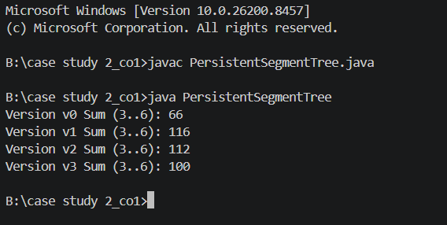
The Persistent Segment Tree efficiently handled historical inventory snapshots and range-sum queries for Amazon warehouse stock management.

Range Sum Values Obtained:
Version v0 Sum (3..6) = 66
Version v1 Sum (3..6) = 116
Version v2 Sum (3..6) = 112
Version v3 Sum (3..6) = 100

Time Complexity:
- Tree Construction: O(n)
- Persistent Update: O(log n)
- Range Sum Query: O(log n)
- Extra Memory per Version: O(log n)
Compared to naive full-array snapshot methods, Persistent Segment Trees significantly reduce memory usage by sharing unchanged subtrees between versions while still supporting efficient historical queries.

GitHub Link:


Student Signature Faculty Signature


