
Koneru Lakshmaiah Education Foundation
(Deemed to be University estd. u/s. 3 of the UGC Act, 1956)
Off-Campus: Bachupally-Gandimaisamma Road, Bowrampet, Hyderabad, Telangana - 500 043. Phone No: 7815926816, www.klh.edu.in

STUDENT CASE STUDY EXECUTION REPORT
 | Department | FED
Subject |  | DSA-2
Academic Year |  | 1-III Semester (2025-26)
Faculty Name |  | P.Swethanagasri
Student Name |  | A.Kuvira
 | Roll Number | 2520030192
 | Branch | CSE
 | Course Outcome

Case Study Topic: Bangalore Metro Phase-3 expansion — minimum-cost connection plan with redundancy
Work Done Summary:
In this case study, we implemented Kruskal’s Algorithm for the Bangalore Metro Phase-3 expansion planning system.The objective was to connect the new candidate metro stations:K (Kadugodi), W (Whitefield), S (Sarjapur), E (Electronic City Ext), Y (Yeshwanthpur West), and H (Hebbal North)to the central hub M (Majestic) while minimising total construction cost.We analysed a weighted graph where each edge represented metro construction cost in ₹-crore based on terrain difficulty, land acquisition, and tunnelling requirements.Using Kruskal’s Algorithm and Union-Find data structure, we:

Sorted all candidate edges in ascending order of cost.

Repeatedly selected the minimum-cost edge that did not form a cycle.

Constructed the Minimum Spanning Tree (MST) connecting all stations with minimum total cost.

We also examined the naïve Union-Find implementation without:

Path Compression

Union-by-Rank

and analysed how this increases find() pointer traversals and worst-case time complexity.Finally, we verified the regulatory redundancy mandate requiring at least two edge-disjoint paths between:
Majestic (M) and Whitefield (W).

We concluded that:

A normal MST alone does not guarantee redundancy because an MST always contains exactly one unique path between any two vertices.

Therefore, one additional minimum-cost edge must be added to satisfy the fault-tolerance requirement.

Implementation Details:
- Represented metro stations and candidate rail connections as a weighted graph.
- Applied Kruskal’s Algorithm to generate the Minimum Spanning Tree.
- Used Union-Find structure to detect cycles during edge selection.
- Analysed parent-pointer evolution during union operations.

- Calculated total MST construction cost in ₹-crore.
- Compared naïve Union-Find with optimised Union-Find using path compression and union-by-rank.
- Computed worst-case pointer hops in find() operations.
- Verified whether the MST satisfies the two edge-disjoint path mandate.
- Added minimum-cost augmentation edge to satisfy metro redundancy regulations.
- Concluded that optimised Union-Find significantly improves large-scale metro network planning performance.

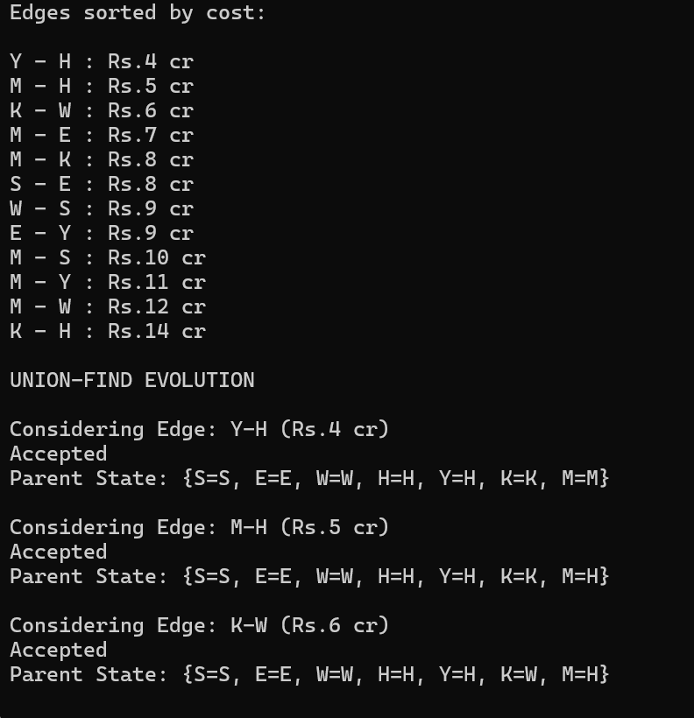
Result: Screenshots / Output:

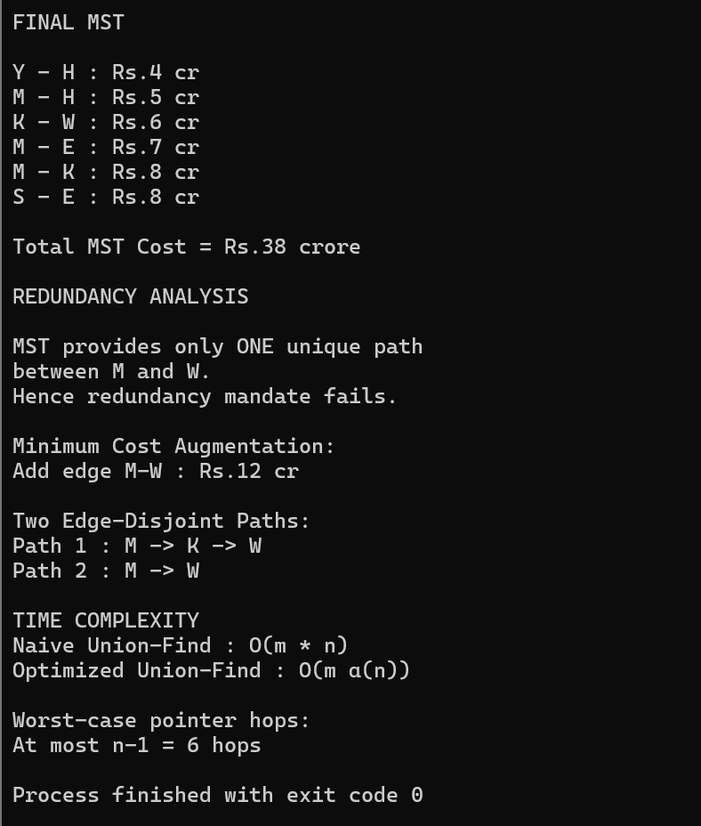

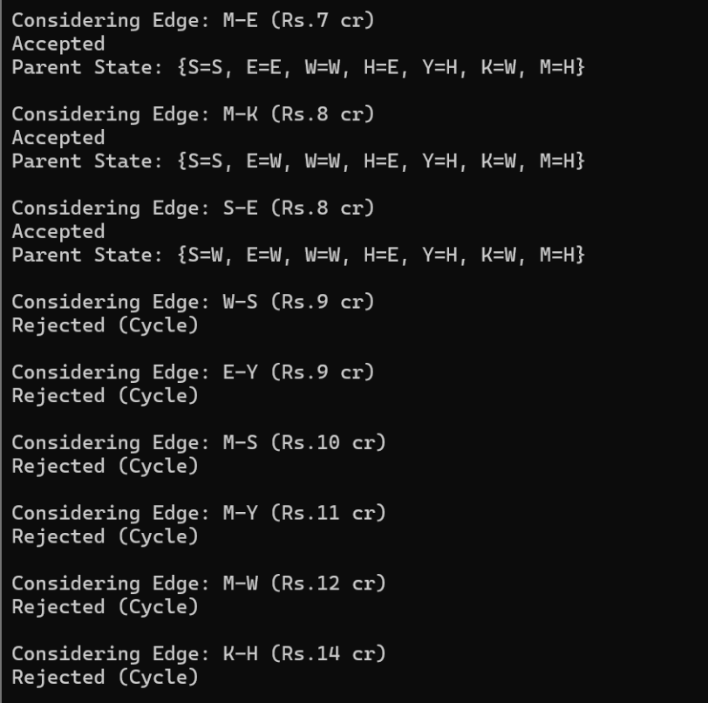

url:
