

Telecom Customer Churn and Retention Analysis
Who is leaving, what it costs, and who to call first
Client Report
Prepared by Kuwala Analytics
13 October 2026
About this report. This is a demonstration report. It uses the public IBM Telco Customer Churn sample dataset to show how Kuwala Analytics approaches a churn problem. It is not a real client's data, and the figures are not results achieved for any client. Amounts are in US dollars, as in the dataset.

1. Executive Summary
This report answers four questions a telecom or subscription business needs answered: how many customers are leaving and what it costs, which kinds of customers leave most, which individual customers to contact first, and what it is worth to keep some of them.
Measure | Result
Customers analysed | 7,043
Churn rate (left in the last month) | 26.5% (1,869 customers)
Retention rate | 73.5%
Monthly revenue lost to churn | $139,131 (30.5% of monthly billing)
Average monthly charge | $64.76
Average tenure | 32.4 months
Customer lifetime value to date (avg monthly charge x avg tenure) | $2,096

What we found
- Contract type is the strongest signal. Month-to-month customers churn at 42.7%, against 2.8% on two year contracts.
- The first six months are the danger zone. 52.9% of customers in their first 6 months leave.
- Leavers are the higher-paying customers. They paid $74 a month on average, against $61 for those who stayed.
- Support add-ons go with much lower churn. Internet customers with online security churn at 14.6%, against 41.8% without it.
- A prediction model can focus the retention effort. The riskiest 20% of customers contained 51% of all leavers.

What we recommend
Look after new customers in their first six months, move month-to-month customers onto contracts, bundle online security and tech support, shift electronic check payers to automatic payment, review the fibre optic offer, and call the highest-risk customers every week. Details are in section 7.
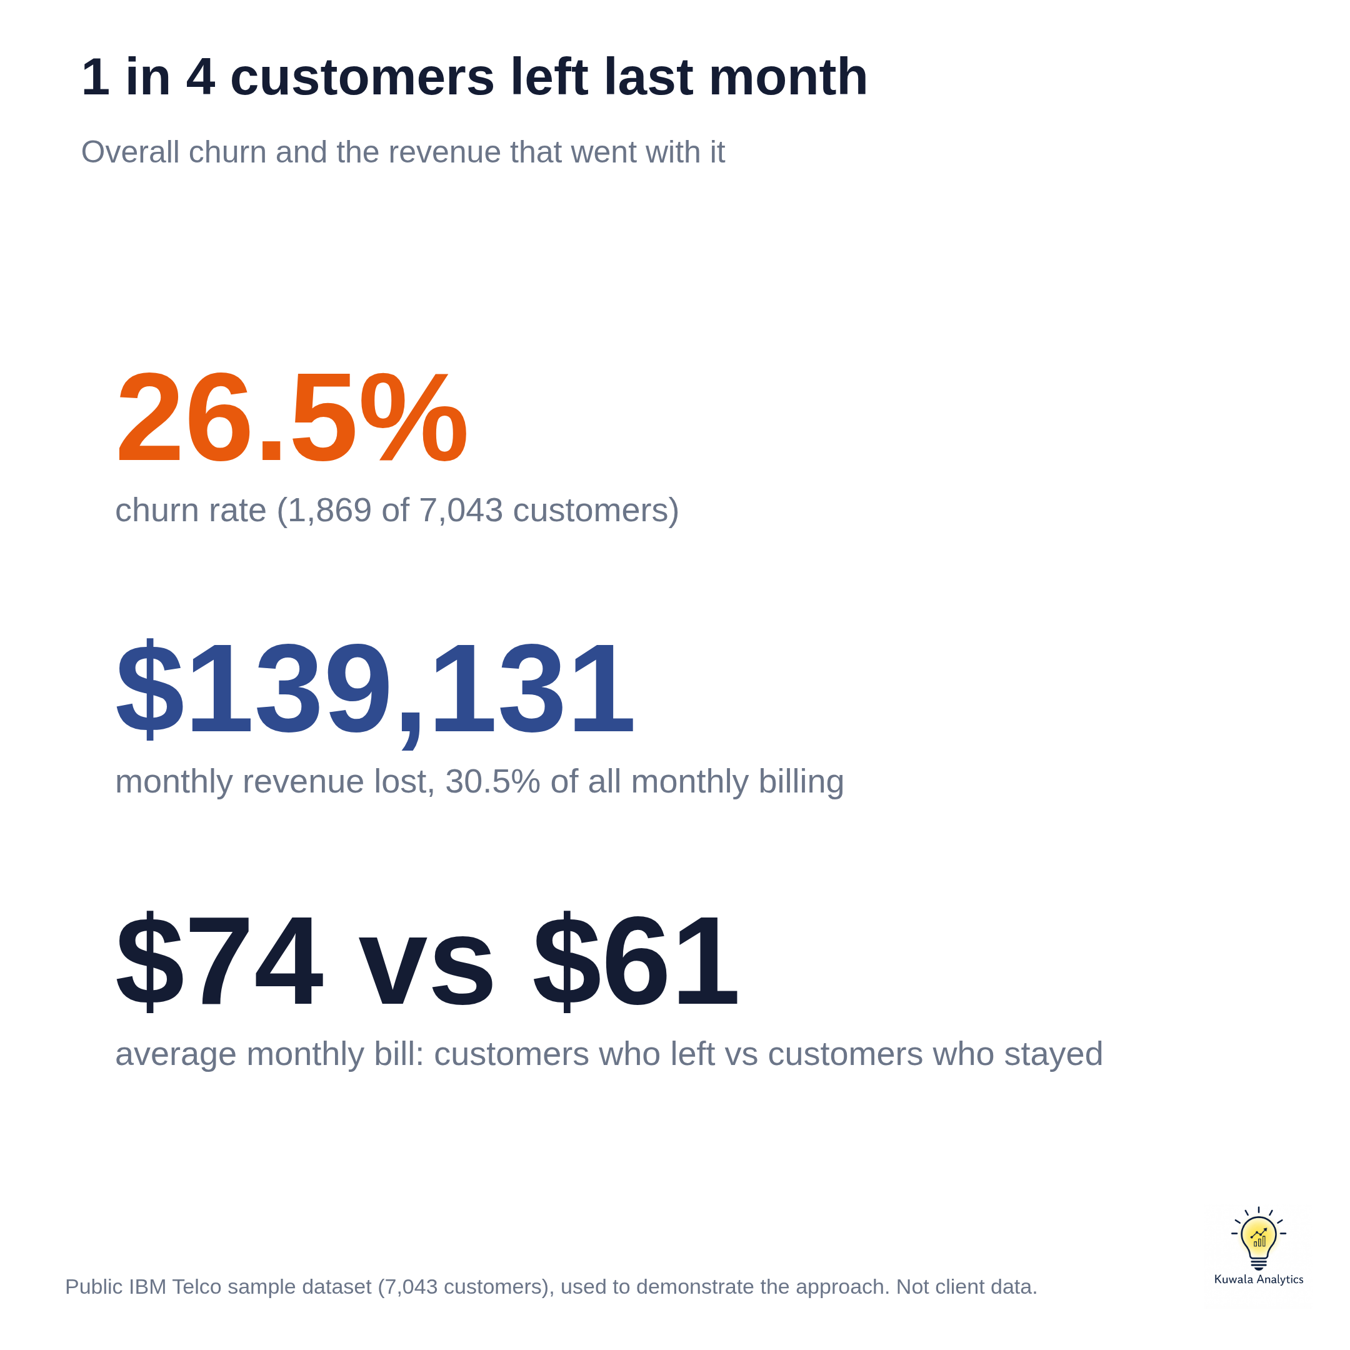
Figure 1. Overall churn and the revenue that went with it

2. The Data
The dataset holds 7,043 customers, one row each, with 21 columns. A churn flag marks customers who left in the last month.
Group | Columns
Services | Phone, multiple lines, internet type, online security, online backup, device protection, tech support, streaming TV, streaming movies
Account | Tenure (months), contract type, payment method, paperless billing, monthly charges, total charges
Demographics | Gender, senior citizen, partner, dependents
Outcome | Churn (Yes or No)

Data quality
Check | Result
Rows and columns | 7,043 rows, 21 columns
Duplicate rows | 0
Duplicate customer IDs | 0
Missing values | 11 blank values in total charges; none elsewhere

Cleaning decisions
- Total charges. The column arrived as text. Its 11 blank values all belong to customers with 0 months of tenure, meaning new customers not yet billed. They were set to 0 and kept, not dropped.
- Senior citizen. Recoded from 0 and 1 to No and Yes, to match the other columns.
- Duplicates. None found, so no rows were removed.

Features added
- Tenure band: 0-6, 7-12, 13-24, 25-48 and 49-72 months.
- Monthly charge band: under $30, $30-49, $50-69, $70-89 and $90 or more.
- Number of services: a count of phone, multiple lines, internet and the six add-ons.
- No add-ons flag: customers with none of the six add-ons. Add-on comparisons use internet customers only, because customers without internet cannot buy them.

3. Key Findings

3.1 Contract type
Customers on month-to-month plans leave at 42.7%. On one year contracts the rate is 11.3%, and on two year contracts 2.8%.
Group | Customers | Churn rate | Monthly revenue lost
Month-to-month | 3,875 | 42.7% | $120,847
One year | 1,473 | 11.3% | $14,118
Two year | 1,695 | 2.8% | $4,165

3.2 Tenure
Churn falls steadily the longer a customer stays. Half of all leavers had been customers for 10 months or less.
Group | Customers | Churn rate | Monthly revenue lost
0-6 months | 1,481 | 52.9% | $49,896
7-12 months | 705 | 35.9% | $19,058
13-24 months | 1,024 | 28.7% | $23,082
25-48 months | 1,594 | 20.4% | $27,462
49-72 months | 2,239 | 9.5% | $19,632

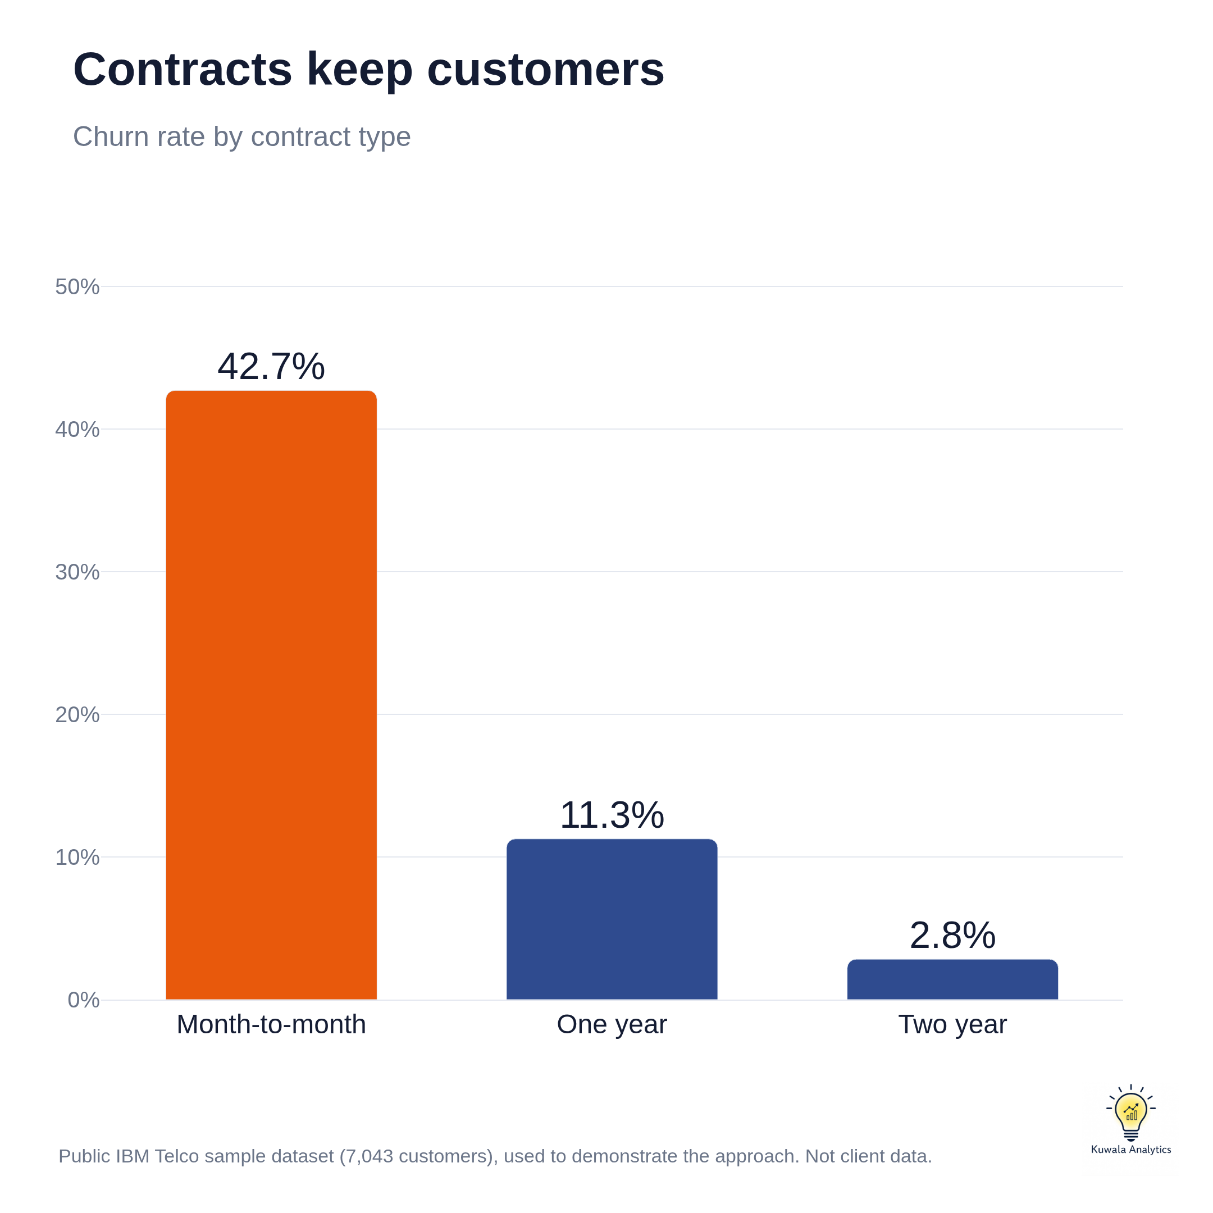 | 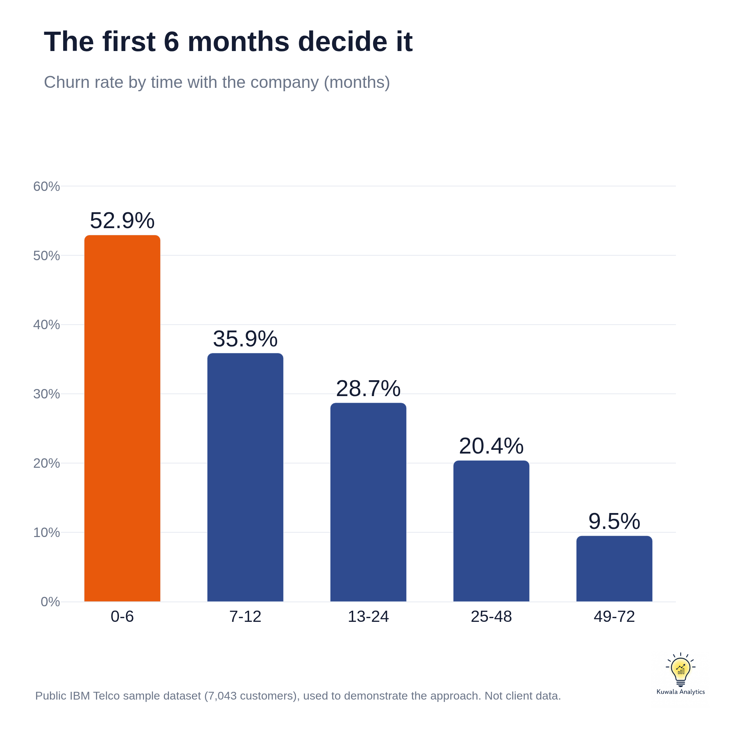
Figures 2 and 3. Churn rate by contract type and by time with the company

3.3 Payment method
Customers paying by electronic check leave far more often than customers on any other payment method.
Group | Customers | Churn rate | Monthly revenue lost
Electronic check | 2,365 | 45.3% | $84,289
Mailed check | 1,612 | 19.1% | $16,804
Bank transfer (automatic) | 1,544 | 16.7% | $20,092
Credit card (automatic) | 1,522 | 15.2% | $17,947

3.4 Internet service and billing
Fibre optic customers churn at more than twice the rate of DSL customers and account for most of the lost revenue. Customers on paperless billing also leave more often.
Group | Customers | Churn rate | Monthly revenue lost
Fibre optic internet | 3,096 | 41.9% | $114,300
DSL internet | 2,421 | 19.0% | $22,529
No internet | 1,526 | 7.4% | $2,302
Paperless billing: yes | 4,171 | 33.6% | $109,510
Paperless billing: no | 2,872 | 16.3% | $29,621

3.5 Demographics
Senior citizens, and customers without a partner or dependents, leave more often. Gender makes no difference.
Group | Customers | Churn rate | Monthly revenue lost
Senior citizen: yes | 1,142 | 41.7% | $38,420
Senior citizen: no | 5,901 | 23.6% | $100,711
Partner: yes | 3,402 | 19.7% | $53,390
Partner: no | 3,641 | 33.0% | $85,741
Dependents: yes | 2,110 | 15.4% | $23,754
Dependents: no | 4,933 | 31.3% | $115,376
Gender: Female | 3,488 | 26.9% | $70,249
Gender: Male | 3,555 | 26.2% | $68,882

3.6 Services linked to lower churn
Among internet customers, online security and tech support go with much lower churn. Streaming services make little difference. Customers with no add-ons at all churn at 52.2%, against 28.9% for those with at least one.
Service | Customers who have it | Churn with it | Churn without it
Online security | 37% | 14.6% | 41.8%
Tech support | 37% | 15.2% | 41.6%
Online backup | 44% | 21.5% | 39.9%
Device protection | 44% | 22.5% | 39.1%
Streaming movies | 50% | 29.9% | 33.7%
Streaming TV | 49% | 30.1% | 33.5%

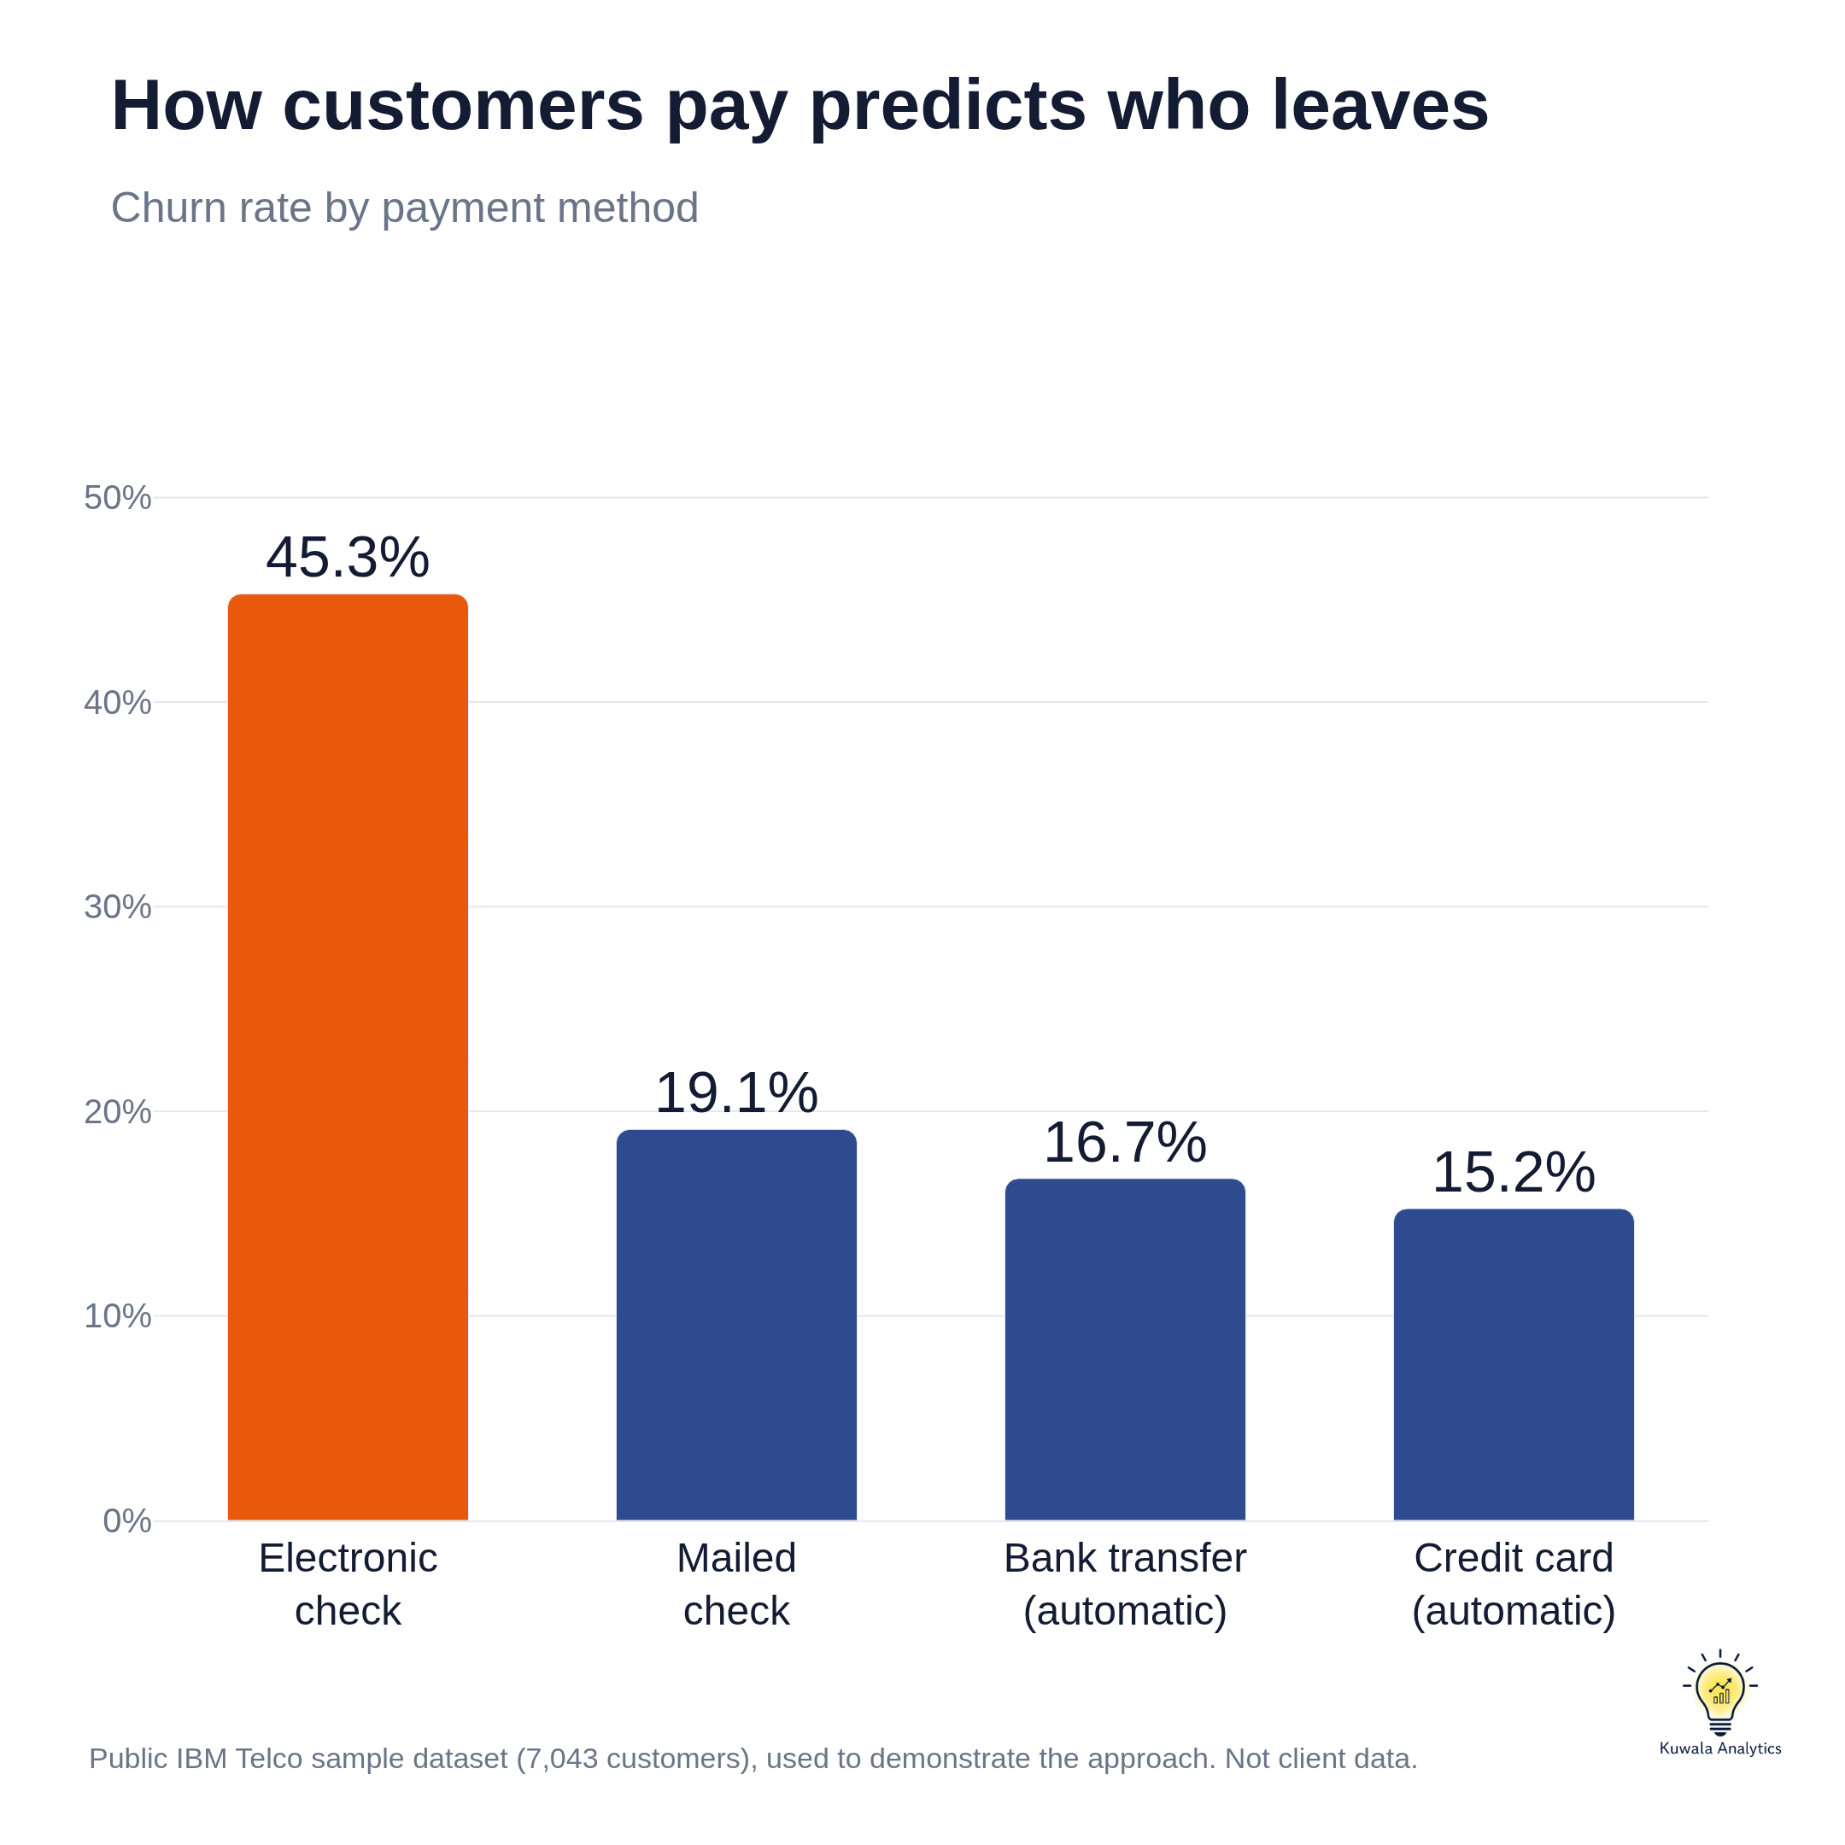 | 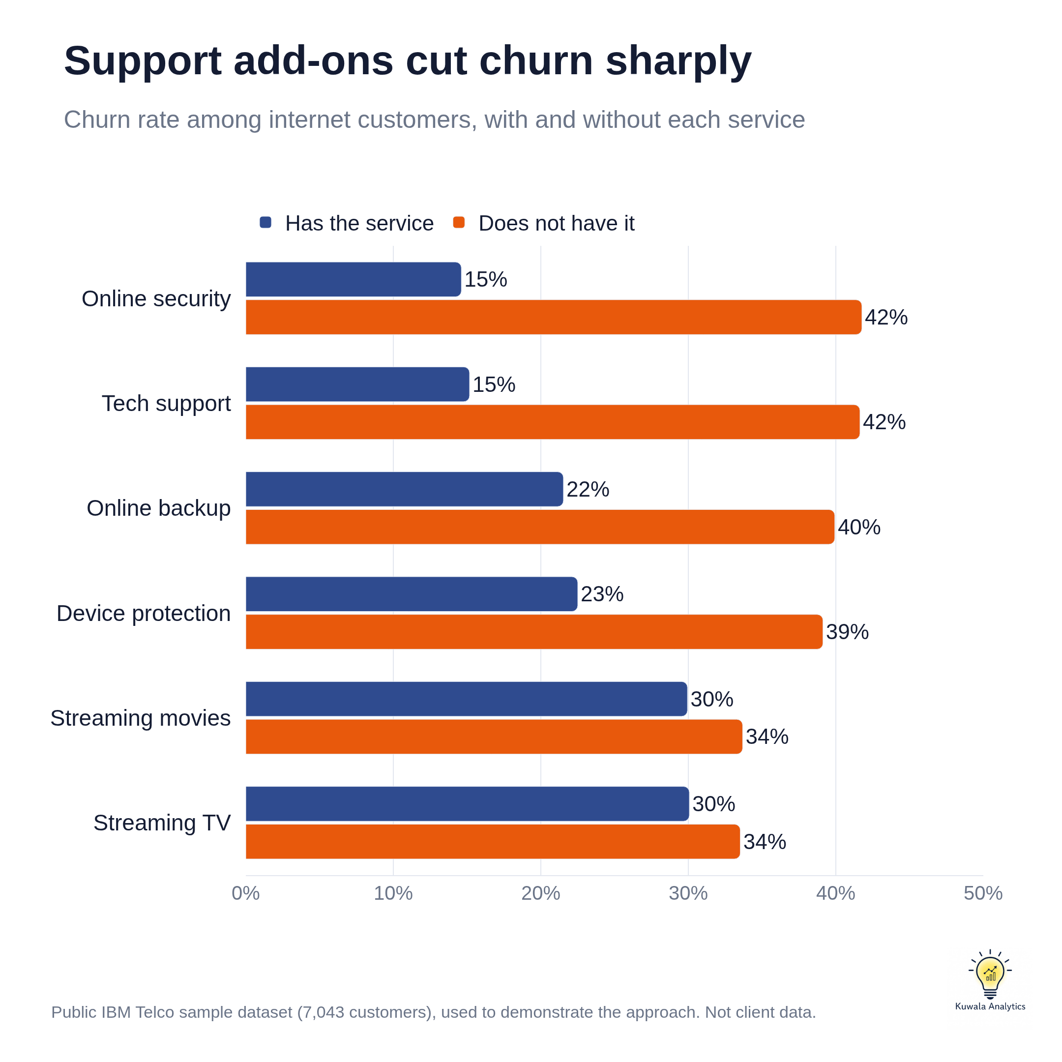
Figures 4 and 5. Churn rate by payment method, and with and without each service (internet customers only)

4. Customer Segments
Customers were grouped into five named segments using simple rules a sales or service team can apply without a data scientist. The segments do not overlap, and every customer belongs to exactly one.
Segment | Rule | Customers | Churn | Avg monthly | Share of leavers
New and Uncommitted | Month-to-month contract, 12 months or less with the company | 1,994 | 51.3% | $58 | 54.8%
Fibre Flight Risks | Month-to-month contract, over 12 months tenure, fibre optic internet | 1,212 | 42.8% | $91 | 27.8%
Settled Month-to-Month | Month-to-month contract, over 12 months tenure, DSL or no internet | 669 | 16.7% | $47 | 6.0%
Loyal High-Value | One or two year contract, paying $70 or more per month | 1,487 | 11.0% | $94 | 8.7%
Committed Essentials | One or two year contract, paying under $70 per month | 1,681 | 3.0% | $35 | 2.7%

How to read the segments
- Highest risk: New and Uncommitted. More than half leave (51.3%), and they make up 55% of all leavers.
- Costliest to lose: Fibre Flight Risks. Established customers paying $91 a month, churning at 42.8%.
- Most valuable to protect: Loyal High-Value. They pay $94 a month and have paid $5,439 each to date. Churn is low at 11.0%, so the aim is to keep it there.
- Where to focus: the first two segments are 46% of customers but 83% of leavers.
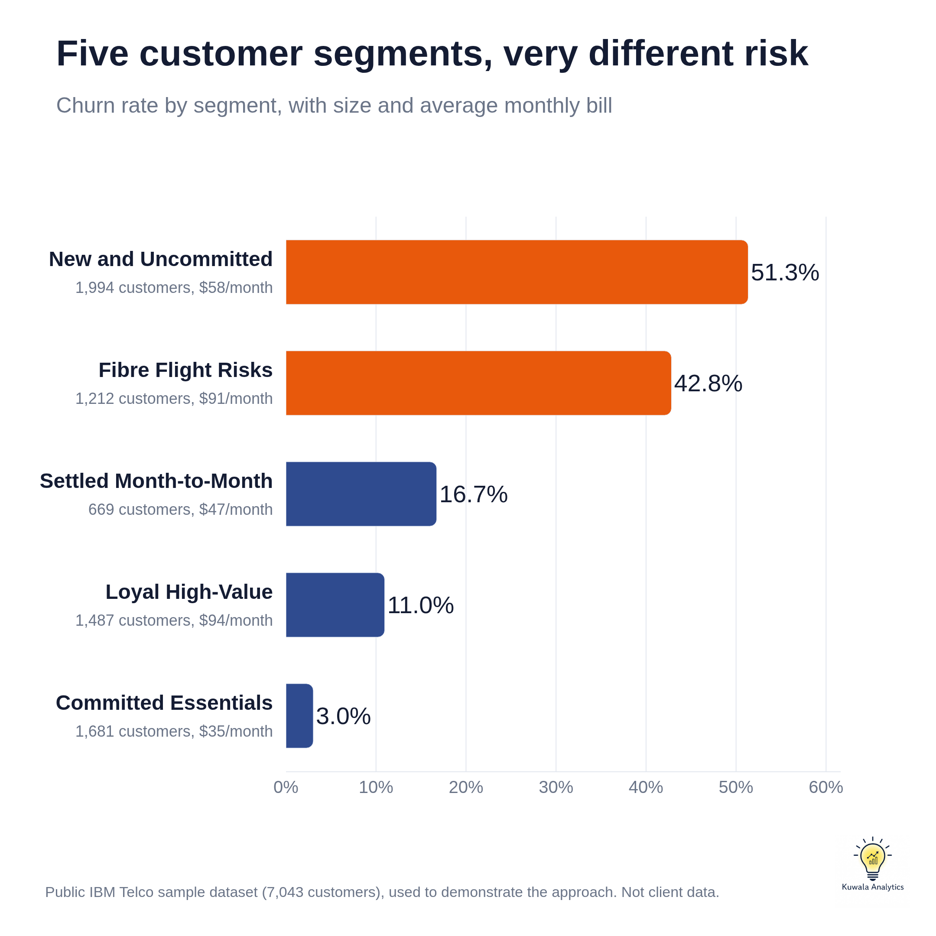
Figure 6. Churn rate by customer segment

5. Churn Prediction Model
Three models were trained to score each customer's risk of leaving, then tested on 1,409 customers the models had never seen (374 of whom left). Leavers are the smaller group, so the classes were balanced during training to stop the models ignoring them.
Model | Precision | Recall | F1 | ROC-AUC
Logistic Regression | 0.50 | 0.78 | 0.61 | 0.842
Random Forest | 0.55 | 0.77 | 0.64 | 0.843
Gradient Boosting (used for risk scores) | 0.52 | 0.78 | 0.62 | 0.844

What the measures mean
- Recall of 78%: of every 100 customers who really left, the model flagged 78 beforehand.
- Precision of 52%: of every 100 customers it flagged, 52 really left. The rest received attention they may not have needed, a small cost compared with losing a customer.
- F1 of 0.62: a single score that balances precision and recall.
- ROC-AUC of 0.84: pick one leaver and one stayer at random, and the model ranks the leaver as riskier 84 times out of 100.
All three models performed almost identically, so the result does not depend on one technique. Gradient Boosting was used for risk scores because it had the highest cross-validated ROC-AUC (0.847), by a small margin. Without balancing the classes, recall fell from 78% to 56%, which would mean missing nearly half the leavers.

Risk bands
Each customer receives a risk score from 0 to 100. The bands below show how well the score matched what actually happened.
Risk band | Score range | Customers | Actual churn rate
High | 60 to 100 | 2,276 | 57.1%
Medium | 30 to 59 | 1,546 | 25.6%
Low | 0 to 29 | 3,221 | 5.4%

Top churn drivers
The factors the model relies on most are contract type, tenure, total charges to date, internet service type, online security, tech support and payment method.
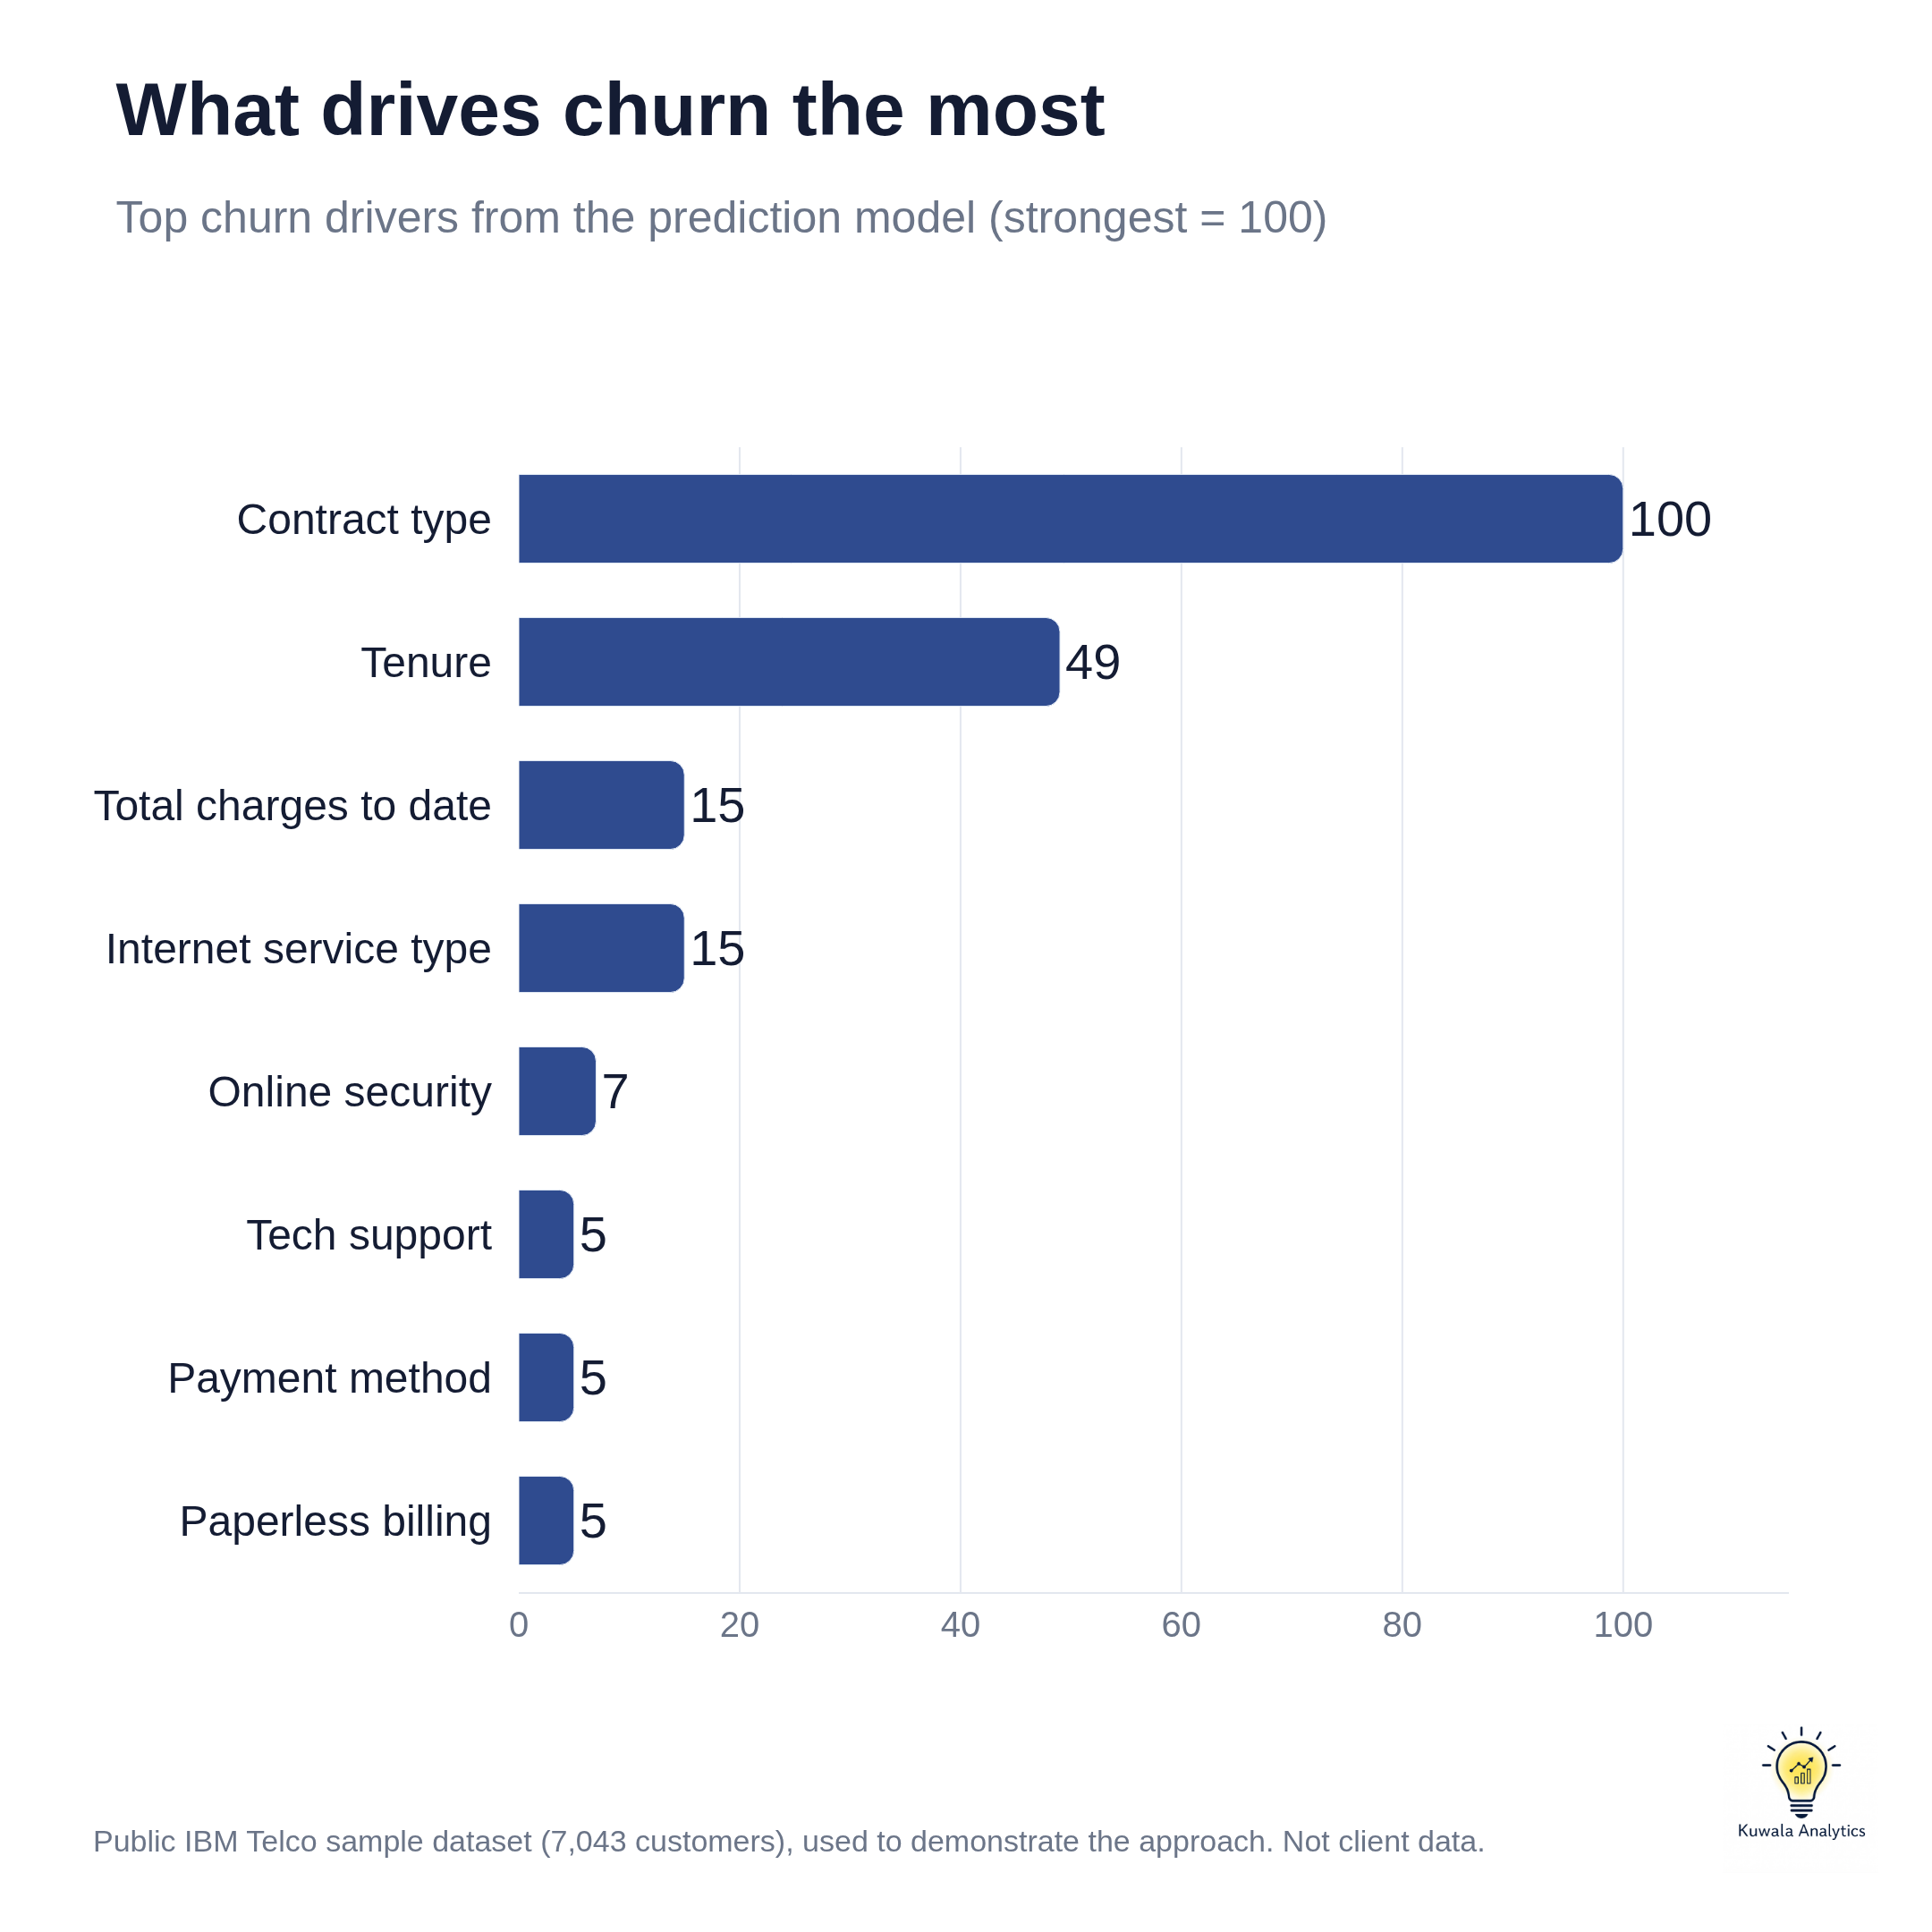
Figure 7. Top churn drivers (strongest = 100)

6. Value of Acting on the Top At-Risk Customers
Ranking customers by risk score and contacting only the top of the list concentrates effort where it counts.
Customers contacted | How many | Actual leavers among them | Share of all leavers reached | Better than random
Top 10% by risk | 704 | 76% | 29% | 2.9x
Top 15% by risk | 1,056 | 71% | 40% | 2.7x
Top 20% by risk | 1,409 | 67% | 51% | 2.5x

Calling customers at random would reach a leaver 27% of the time. The risk list reaches one 67% to 76% of the time.

Revenue protected
The leavers in the top 20% were paying $74,907 a month between them. What that is worth depends on how many a retention offer keeps.
If the offer keeps | Monthly revenue protected | Over 12 months
20% of them | $14,981 | $179,776
30% of them | $22,472 | $269,664
40% of them | $29,963 | $359,551

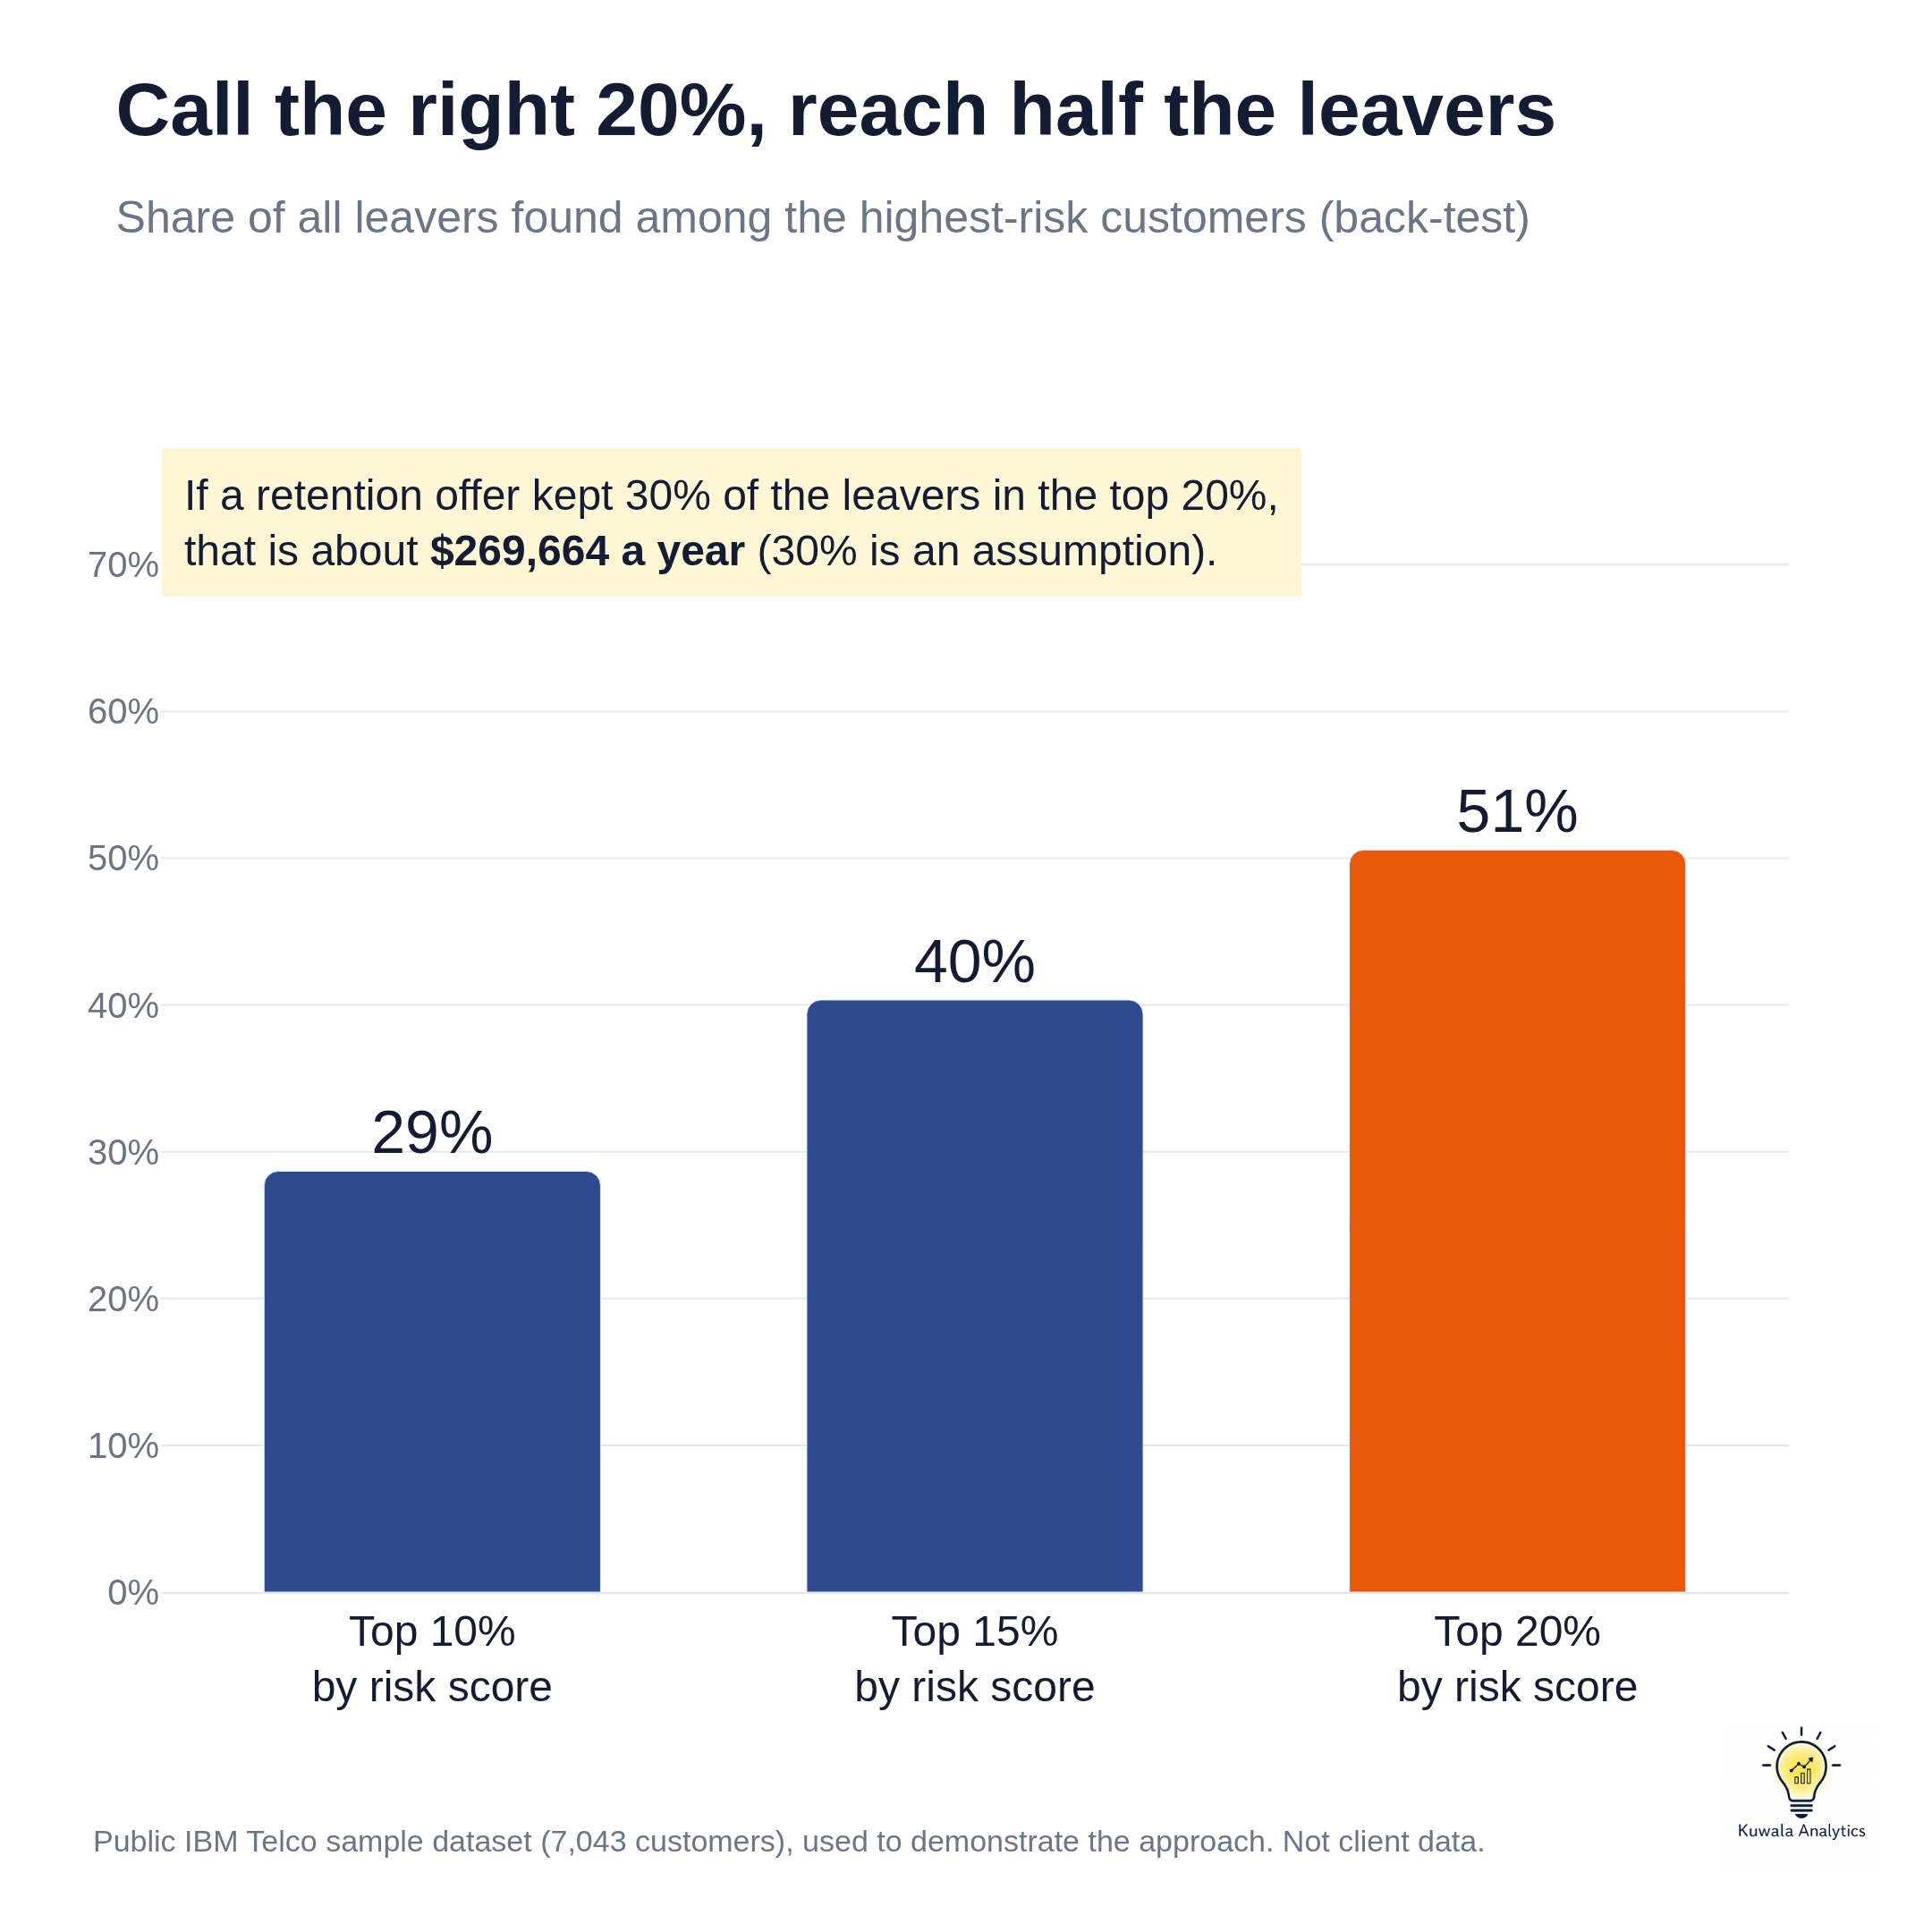
Figure 8. Share of all leavers found among the highest-risk customers

How to read these figures
These are scenarios, not measured outcomes. They come from a back-test on customers who had already left. The save rates are assumptions, the 12 month figure assumes saved customers stay for the year, and the cost of the retention offer is not included. A real engagement would test the offer on a small group first and measure the true save rate.

7. Recommendations
# | Action | Evidence | First step
1 | Win the first six months | 52.9% of customers in their first 6 months leave. | Add a welcome call, a 30 day check-in and a 90 day review for every new customer.
2 | Move month-to-month customers onto contracts | Month-to-month churn is 42.7%, against 11.3% on one year contracts. | Offer a discount or a free add-on for committing to 12 months.
3 | Bundle online security and tech support | Internet customers with no add-ons churn at 52.2%; those with online security churn at 14.6%. | Trial these services free for 3 months with customers who have no add-ons.
4 | Shift electronic check payers to automatic payment | Electronic check payers churn at 45.3%, about three times the rate of customers on automatic payments. | Give a small bill credit for switching.
5 | Review the fibre optic experience and price | Fibre customers churn at 41.9% and account for $114,300 of the $139,131 lost each month. | Survey leavers and compare price and service quality with competitors.
6 | Call the highest-risk customers every week | The riskiest 20% of customers contained 51% of all leavers. | Work the at-risk list in the dashboard from the top, starting with high-value customers.

A caution
These patterns show what goes together with churn. They are not proof of cause. For example, customers who choose a two year contract may already be more loyal. Each recommendation should be run as a small test first and measured before it is rolled out.

8. The Interactive Dashboard
All of the analysis is available in one interactive dashboard. It has filters for contract, internet service, payment method, tenure band and senior citizen, seven key figures, six charts, a sortable and searchable list of at-risk customers, the model results and the recommended actions. It works on a laptop or phone, and offline.
Open it here: https://kuwalaanalytics.github.io/telecom-churn-retention-analysis/
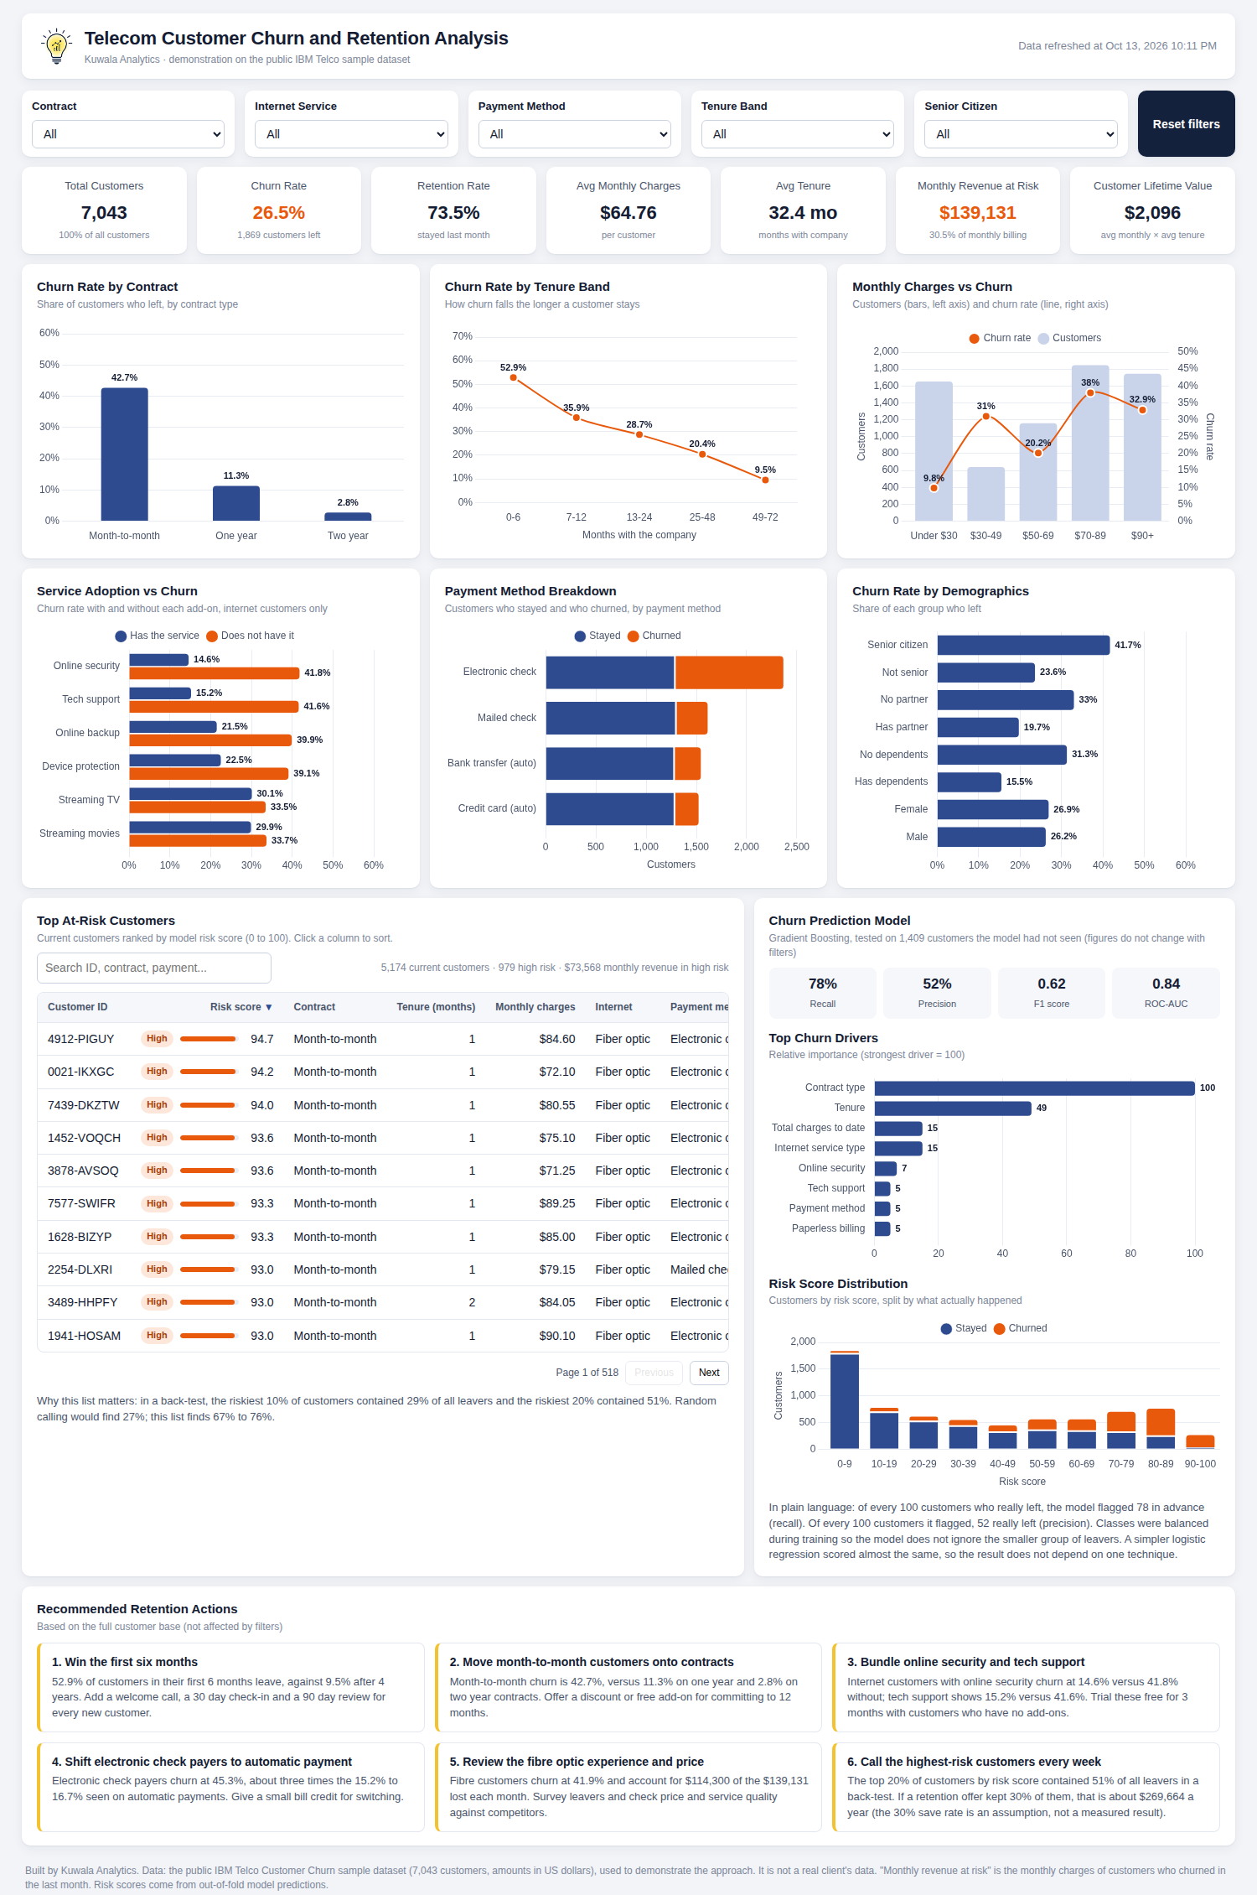
Figure 9. The dashboard with no filters applied

9. Method and Limitations

Method
- Clean and prepare. Fixed data types, handled missing values and added the features described in section 2.
- Explore. Measured churn rate and lost revenue across every customer attribute.
- Segment. Grouped customers with simple, non-overlapping rules.
- Predict. Compared logistic regression, random forest and gradient boosting on a 20% holdout, with balanced class weights.
- Score. Risk scores are out-of-fold predictions from 5-fold cross-validation, so no customer is scored by a model trained on their own record.
- Value. Ranked customers by risk and measured how many real leavers sat at the top of the list.

Limitations
- Sample data. This is the public IBM sample dataset, not a real client's data.
- One snapshot. The data covers a single month of churn, so seasonal patterns and trends cannot be seen.
- Association, not cause. The findings show which groups leave more often, not why.
- No cost data. The cost of serving customers and of retention offers is not in the data, so figures are revenue, not profit.
- No reasons for leaving. Complaints, service quality and competitor offers are not recorded.

Tools
Python (pandas, scikit-learn, Plotly), Chart.js, HTML, CSS and JavaScript.

