Development of a Document Tracking System for the
Local Government Unit of Tuao

_____________________

A Thesis Presented to
the Faculty of the Graduate School
Cagayan State University - Carig Campus
Tuguegarao City

_____________________

In Partial Fulfillment of the
Academic Requirements for the degree
Master of Science in Information Technology

_____________________

By:
Kevin D. Apil

APPROVAL SHEET
In partial fulfillment of the academic requirements for the degree, Master of Science in Information Technology, this manuscript, capstone project entitled "Development of a Document Tracking System for the Local Government Unit of Tuao" has been prepared and submitted by Maverick M. Ballesteros hereby recommended for oral defense.
DR. EDISON D. BRAVO
Adviser

Approved by the board of panel with a grade of ______ on ______________, 2026.

ENGR. ARTHUR G. IBAÑEZ, PhD, ASEAN Engr.
Chairman

ENGR. ROGER P. RUMPON
Member

DENNIS M. BACUYAG, DPA
Member

CHARMIE S. CALVO, DIT
Member

GENERINO P. SIDDAYAO, DIT
Member

MANNY R. CAPILI
Reader/Critic

Accepted and approved in partial fulfillment of the requirements for the degree, Master of Science in Information Technology.

DENNIS M. BACUYAG, DPA
Dean, Graduate School

ACKNOWLEDGEMENT
First and foremost, I would like to express my deepest gratitude to the Almighty God for giving me the strength, wisdom, and perseverance throughout the completion of this academic work.
I would like to extend my sincere appreciation to the Graduate School of Cagayan State University – Carig Campus for providing the academic environment and opportunity that made this study possible. I am especially grateful to my adviser, Dr. Edison D. Bravo, for his valuable guidance and support, and to the proposal-defense panel for their constructive comments and recommendations that helped improve this study.
I would also like to express my appreciation to the public health personnel whose work in animal bite treatment, patient follow-up, and reporting provided the practical foundation for this project. Their dedication inspired the emphasis of this system on complete records, consistent schedules, and accessible information.
My sincere gratitude also goes to my family, friends, colleagues, and everyone who provided encouragement and support throughout the preparation of this system and manuscript. Their understanding and assistance contributed greatly to the completion of this academic requirement.
Lastly, I acknowledge everyone who, in one way or another, contributed to the completion of this study. Above all, I remain grateful for the opportunity to learn and develop through this work and take full responsibility for its implementation, interpretations, and remaining limitations.
The Researcher

DEDICATION
This work is dedicated to my family, teachers, and colleagues whose encouragement and support continue to inspire me in the pursuit of learning and public service. It is also dedicated to the health personnel who tirelessly care for individuals affected by animal bite incidents. May this work and the responsible use of information technology support their daily efforts and contribute to more organized and responsive public health services.
The Researcher

TABLE OF CONTENTS
(Update this table in Word.)

LIST OF TABLES
Table 1. Abbreviations used in the manuscript 12
Table 2. Literature-to-design synthesis 12
Table 3. Agile increment plan and acceptance focus 14
Table 4. Actors and principal responsibilities 18
Table 5. Software requirements and identified dependencies 20
Table 6. Suggested hardware baseline for pilot planning 21
Table 7. Respondent groups and evaluation contribution 23
Table 8. Proposed interpretation of questionnaire means 26
Table 9. Existing-process concerns and implemented response 27
Table 10. Objective-to-implementation traceability 28
Table 11. Logical data domains 48
Table 12. Table relationship and flow matrix 49
Table 13. aclients column definitions 51
Table 14. abiteinfo column definitions 52
Table 15. aexposure column definitions 53
Table 16. asched column definitions 54
Table 17. avaccines column definitions 55
Table 18. zofficeinfo column definitions 56
Table 19. userx column definitions 56
Table 20. ahumanrabies column definitions 57
Table 21. bauditlogs column definitions 59
Table 22. zsignatories column definitions 59
Table 23. yprovinces column definitions 59
Table 24. ymunicipalities column definitions 60
Table 25. ybarangays column definitions 60
Table 26. vautoemailnotif column definitions 60
Table 27. Quality evidence and remaining evaluation 61
Table 28. Functional acceptance scenarios for pilot execution 62
Table 29. Disposition of proposal-panel comments 66
Table 30. Pilot execution and acceptance record template 72
Table 31. Users manual document control 73
Table 32. Troubleshooting guide 80
Table 33. Functional suitability evaluation items 81
Table 34. Performance efficiency evaluation items 81
Table 35. Compatibility evaluation items 82
Table 36. Usability evaluation items 82
Table 37. Reliability evaluation items 82
Table 38. Security evaluation items 83
Table 39. Maintainability evaluation items 83
Table 40. Portability evaluation items 84
Table 41. Blank quality-results worksheet 85
Table 42. Matched task-time recording sheet 85
Table 43. Source-code organization 86
Table 44. Documentation and evidence register 88

LIST OF FIGURES
Figure 1.1. Original conceptual framework from the proposal 2
Figure 1.2. Conceptual framework of the study 3
Figure 1.3. Research paradigm 4
Figure 3.1. Sashimi SDLC model in the original proposal 13
Figure 3.2. Agile development and review cycle 14
Figure 3.3. Original proposed system architecture 15
Figure 3.4. Architecture of the implemented application 16
Figure 3.5. Original use-case diagram from the proposal 17
Figure 3.6. Use-case overview by actor 18
Figure 3.7. Original context-level data flow diagram 19
Figure 3.8. Context-level data flow diagram 20
Figure 3.9. Respondent distribution proposed in the original manuscript 23
Figure 4.1. Original HIPO diagram from the proposal 29
Figure 4.2. Functional decomposition using HIPO 30
Figure 4.3. Original detailed IPO diagram from the proposal 31
Figure 4.4. Operational IPO diagram 32
Figure 4.5. Core data relationships 33
Figure 4.6. Sign-in view: actual running application 34
Figure 4.7. Dashboard view: actual running application 35
Figure 4.8. Case assessment view: actual running application 36
Figure 4.9. Rabies immunization view: actual running application 37
Figure 4.10. Vaccination schedule view: actual running application 37
Figure 4.11. Client records view: actual running application 38
Figure 4.12. Human rabies surveillance view: actual running application 39
Figure 4.13. Public online services view: actual running application 40
Figure 4.14. Accomplishment report view: actual running application 41
Figure 4.15. Bite cases report view: actual running application 42
Figure 4.16. Cohort report view: actual running application 43
Figure 4.17. Vaccine setup view: actual running application 44
Figure 4.18. Treatment-center administration view: actual running application 45
Figure 4.19. Account administration view: actual running application 46
Figure 4.20. Report signatories view: actual running application 47
Figure 4.21. Personal settings view: actual running application 47
Figure 4.22. Table design connection and record flow 49

LIST OF ABBREVIATIONS
Table 1. Abbreviations used in the manuscript
Abbreviation | Meaning
API | Application Programming Interface
CSS | Cascading Style Sheets
CRUD | Create, Read, Update, and Delete
DBMS | Database Management System
ERD | Entity-Relationship Diagram
HTTP | Hypertext Transfer Protocol
ISO/IEC | International Organization for Standardization / International Electrotechnical Commission
LAN | Local Area Network
MySQL | My Structured Query Language
PHP | PHP: Hypertext Preprocessor
QR Code | Quick Response Code
RBAC | Role-Based Access Control
SDLC | Software Development Life Cycle
UI | User Interface
URL | Uniform Resource Locator
UX | User Experience
Vue.js | Vue JavaScript Framework
Vite | Next Generation Frontend Build Tool

ABSTRACT
Title : Development of Document Tracking System for the Local Government Unit of Tuao
Name : Kevin D. Apil

Course : Master of Science in Information Technology

Adviser : Dr. Edison D. Bravo

______________________________________________________________________________
This study aimed to develop the Document Tracking System for the Local Government of Tuao. The system was designed to improve the registration, monitoring, routing, receiving, processing, and retrieval of office documents. It addresses common challenges in manual document handling, including delayed routing, difficulty in determining the current location of documents, incomplete processing records, and limited access to document history.
The study employed a developmental research approach using Agile development principles in the design and development of the system. The application was developed using Vue for the user interface, Laravel for the application programming interface, and MySQL for data management. The system applies role-based access control and office-based restrictions to help ensure that authorized users can access and process only the documents within their assigned responsibilities and offices.
The developed system allows authorized users to register documents, generate and use Quick Response (QR) codes for tracking, forward documents to concerned offices, receive routed documents, record current actions and processing notes, attach supporting files, and view routing and processing history. It also supports the management of users, roles, offices, document types, and other master data. Through document-routing records and activity history, the system provides improved visibility of document custody and movement among offices.
The developed system provides a more organized, transparent, and accountable approach to document management for the Municipality of Tuao. Further implementation and evaluation should include continued testing of role and office restrictions, QR tracking, document routing accuracy, attachment handling, audit logging, reporting functions, and overall system usability.
Keywords: document tracking system, document management, QR code, web-based system, Laravel, Vue, role-based access control, Municipality of Tuao

CHAPTER I
THE PROBLEM AND ITS BACKGROUND

1.1 Introduction

Philippine LGUs process a high volume of administrative documents daily, including memoranda, official correspondence, reports, citizen requests, permits and compliance-related filings. These documents often require sequential routing across multiple offices, levels of approval and eventual archiving. However, a significant number of LGUs continue to depend on manual or semi-manual systems such as physical logbooks, paper-based filing, and handwritten notations for tracking (Santos, 2021). This reliance results in extended processing times, as documents must be physically transported between offices or barangays, frequently causing delays during high-volume periods, staff absences, or logistical disruptions.

These inefficiencies have broader governance implications. Prolonged document handling impedes timely service delivery to citizens, for instance, in issuing business permits, resolving complaints, or implementing local programs leading to diminished public trust and satisfaction (Department of the Interior and Local Government [DILG], 2025a). The lack of real-time status visibility reduces accountability, complicating supervisors' efforts to monitor progress, identify irregularities, or enforce standards. Paper-based records are susceptible to loss, environmental damage (e.g., flooding prevalent in regions like Cagayan Valley), tampering, or human error in logging, raising serious concerns for data integrity, security, and adherence to laws such as Republic Act No. 10173 (Data Privacy Act of 2012) and Republic Act No. 11032 (Ease of Doing Business and Efficient Government Service Delivery Act of 2018). High staff turnover in LGUs further exacerbates knowledge loss and perpetuates inconsistent practices, while limited budgets and technical capacity slow digital transitions (Ademola et al., 2012; International Journal of Frontiers in Multidisciplinary Research [IJFMR], 2025a).

Tuao, Cagayan, a rural municipality in the Cagayan Valley region divided by the Chico River (creating logistical challenges between "Tuao-East" and "Tuao-West") experiences intensified versions of these national LGU issues due to its agricultural economy, limited resources and geographical constraints. As a smaller, lower-class municipality, Tuao heavily depends on manual document processes because of inadequate infrastructure, funding shortages for technology and limited trained personnel. Routing documents across offices or barangays often encounters delays from physical transport difficulties especially during inclement weather or river-related barriers—resulting in misplaced files, inconsistent tracking logs, and extended resolution times for citizen requests (similar patterns noted in rural LGU studies; ISRG Publishers, 2025).

Additionally, the lack of a centralized automated system restricts administrative oversight in Tuao hindering municipal leaders' ability to pinpoint workflow bottlenecks, assess performance or produce reliable reports for compliance with oversight bodies like the DILG. Manual methods increase error risks, institutional knowledge loss during personnel changes, and opacity in processes, potentially undermining public confidence in local governance. While national programs such as the DILG's eLGU initiative (with over 900 LGUs adopting it for online services as of 2025) and the planned rollout of the Document Management System for LGUs (DMS4LGUs) in 2026 aim to promote digitization for efficiency and transparency under RA 11032 (DILG, 2025b; DILG, 2025c), adoption in rural settings like Tuao faces barriers including unreliable internet, insufficient IT support, and the need for context-specific, cost-effective solutions (IJFMR, 2025b).

Although challenges in LGU records management are increasingly recognized, notable gaps remain in both research and implementation. National initiatives including the DILG's eLGU system (now adopted by over 900 LGUs for streamlined permits and services) and the forthcoming DMS4LGUs under the Local Government Unit Support System (LGUSS), emphasize digitization to reduce delays, enhance transparency, and comply with RA 11032 (DILG, 2025b; DILG, 2025c; Philippine Information Agency, n.d.). However, these efforts are unevenly implemented, with rural or lower-class municipalities lagging due to infrastructure and capacity limitations. Much existing literature and case studies concentrate on urban or larger LGUs, offering limited insights into tailored adaptations for geographically challenged, resource-constrained areas like Tuao (ResearchGate publications on digital governance, 2025).

Furthermore, while web-based document tracking systems have proven effective in improving efficiency, real-time monitoring, centralized storage, and cost reductions in public sector contexts (International Business Machines Limited [IBML], n.d.; GovOS, 2024), few Philippine studies or implementations integrate QR code technology specifically for bridging physical and digital documents in routine municipal workflows. QR codes enable rapid scanning for status verification, metadata access or authentication demonstrated in government uses like project monitoring in Bacolod City or verification processes (Philippine News Agency, 2025; examples in educational and civil registry contexts) yet their application to everyday document routing, tracking, and management at the LGU level remains underexplored, particularly in scalable, low-infrastructure solutions suitable for rural settings (Journal of Information Systems Engineering and Management, 2024; IJFMR, 2023).

In response to these persistent challenges and identified gaps, this study aims to develop and propose a Web-Based Document Tracking System integrated with QR Code Technology for monitoring, routing and managing documents in the Local Government Unit of Tuao, Cagayan. The system is intended to enhance document traceability, streamline processing workflows, reduce delays and errors, promote accountability and transparency and ultimately foster more efficient, responsive and citizen-oriented local governance.

1.2 Conceptual Framework
This section discusses the main concept and research paradigm of the study.
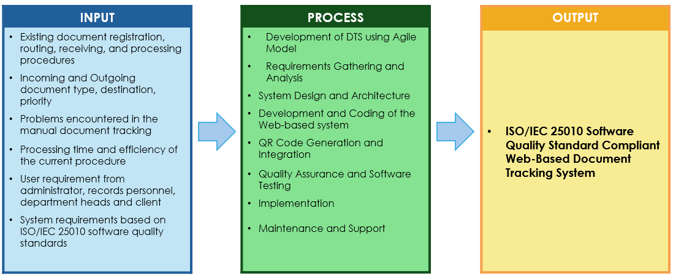
Figure 1.1. Conceptual Framework
The conceptual framework of this study is grounded in the Input-Process-Output (IPO) model, a widely adopted systems analysis and software engineering approach that systematically depicts how inputs are transformed through structured processes into desired outputs. This model provides a clear, logical structure for understanding system dynamics, identifying inefficiencies, and guiding development efforts in information systems research.
The inputs of the study include the existing document handling procedures of the Local Government Unit of Tuao as well as details of incoming and outgoing documents such as document type, source, destination and priority. The paradigm also considers the problems encountered in manual document tracking including delays, misplacement of documents and lack of real-time monitoring. In addition, the processing time and efficiency of current procedures are assessed. User requirements gathered from administrators, records personnel, and department heads form part of the inputs, together with system requirements guided by the ISO/IEC 25010 software quality standards.
The process stage involves the design and development of the Document Tracking System with QR Code Technology for Monitoring, Routing, and Managing Documents using a structured system development approach. The development process includes requirements analysis, system design and architecture, system development and coding, QR code generation and integration, quality assurance and software testing, system implementation and maintenance. Data gathering techniques such as interviews, surveys, observation and document flow analysis are employed to evaluate the efficiency of the existing manual process and to validate system requirements.
Data analysis methods such as descriptive statistics, frequency counts, and comparative analysis are applied to assess system performance, usability, and workflow efficiency. The system development activities follow an iterative Software Development Life Cycle (SDLC) approach, allowing overlapping phases to ensure timely identification and resolution of issues encountered during system development.
The outputs of the study consist of an ISO/IEC 25010–compliant Web-Based Document Tracking System that supports centralized and organized document records. The system provides real-time document monitoring and routing, QR code–based document identification and retrieval, automated tracking logs and audit trails and consolidated monitoring and management reports to support effective decision-making.
The feedback mechanism enables system users to provide evaluations and recommendations for continuous system improvement.

1.3 Research Paradigm

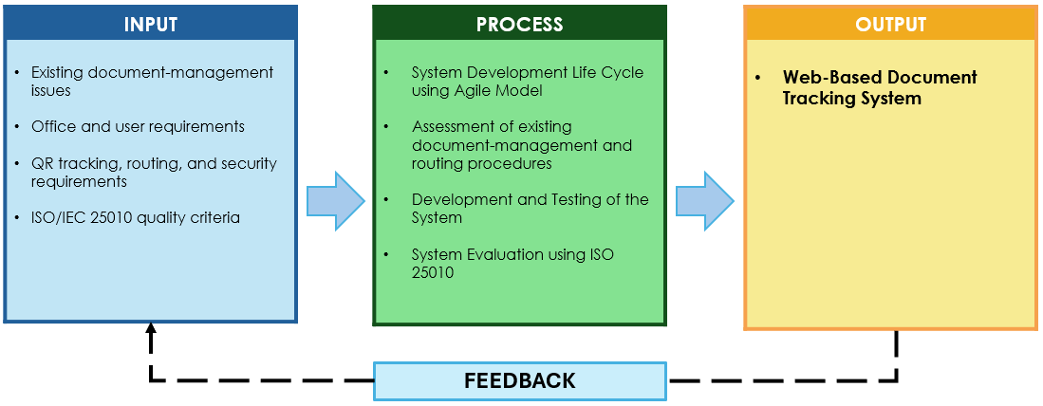
Figure 1.2. Research paradigm
As shown in Figure 1.2, the inputs of the study include the issues and recommendations identified from the existing document registration, routing, receiving, and tracking procedures of the Municipality of Tuao. They also include the requirements of authorized users and offices, existing document-handling practices, QR code tracking requirements, role-based access restrictions, and ISO/IEC 25010 software quality criteria. These inputs served as the basis for identifying the functional, operational, and quality requirements of the Document Tracking System.
The development process follows Agile principles, which support iterative planning, design, development, testing, and improvement based on identified requirements and user feedback. The process includes the assessment of existing document-management procedures, development and testing of the system, and system evaluation using ISO/IEC 25010 software quality criteria.
Through these inputs and processes, the Document Tracking System was developed to support document registration, QR code tracking, document forwarding and receiving, processing records sand routing history. The feedback mechanism enables user observations, identified issues, and evaluation results to be considered for further refinement and improvement of the system.

1.4 Objectives of the Study

1.4.1 General Objective
The study aims to develop a Document Tracking System for the Local Government of Tuao.

1.4.2 Specific Objectives
1. Identify the challenges encountered in using the existing document tracking process of the Local Government Unit of Tuao.
2. Design and develop a Document Tracking System with QR Code Technology for the LGU of Tuao.
3. Evaluate the compliance of the developed system with ISO/IEC 25010 Software Quality Standards in terms of:
- Functional Suitability
- Performance Efficiency
- Compatibility
- Usability
- Reliability
- Security
- Maintainability
- Portability

1.5 Scope and Limitation of the Study
This study develops and evaluates a web-based document tracking system with QR code technology exclusively for the Local Government Unit of Tuao, Cagayan.
The research focuses on digitizing internal document management by recording key metadata (sender, recipient, date, type), tracking document movement across departments in real time, generating summary reports on status and history and enabling fast retrieval via QR code scanning. The goal is to replace slow, error-prone manual processes with a simple, centralized digital tool that improves efficiency, transparency and accountability in daily LGU operations.
The study addresses Tuao’s specific challenges that is a delay from physical routing (especially across the Chico River), misplaced files, lack of real-time visibility, logging errors and limited oversight by providing a low-cost, context-appropriate solution suitable for a rural, resource-constrained setting.
Target users are Tuao LGU employees who handle documents daily: administrative staff, clerical personnel, records officers, department heads and other office workers.
The scope is deliberately limited to Tuao LGU offices only. The system requires internet access (no offline mode), excludes physical document storage or archiving, provides no legal validation or approval functions, has no integration with national or external databases, and uses only necessary sample documents for testing and evaluation. These boundaries keep the project focused, practical and achievable within Tuao’s rural context and available resources.

1.6 Significance of the Study

LGU Administrators

The system will provide administrators with a clearer and more comprehensive view of document movement and processing within the LGU. The availability of consolidated and accurate reports will support monitoring, evaluation, and strategic decision-making related to office operations, service efficiency, and governance accountability.

LGU Personnel

The development of the proposed system will enhance how LGU personnel manage, track and monitor documents within their offices. The system will reduce reliance on manual record-keeping and eliminate difficulties in locating document records and routing status. With a centralized information system and QR code–based document retrieval, transaction time and document handling will be significantly reduced.

Clients and Stakeholders

The developed system will improve service delivery to clients and stakeholders by enabling faster document processing and more organized routing. Automated email notifications will inform responsible staff of document status or required actions, minimizing delays and improving workflow efficiency. These features contribute to increased accountability, transparency, and trust in LGU services.

The Researcher

This study will enhance the researcher’s skills in analyzing real-world administrative problems and developing an information system that complies with recognized software quality standards. It will also expand technical knowledge in web-based system development, database management, and system evaluation within a local government context.

Future Researchers

The study will serve as a reference for future researchers interested in developing public sector information systems, conducting comparative studies between manual and computerized processes, or exploring the application of QR code technology and automated notification systems in government services.

1.7 Definition of Terms
Administrator. A user with system-wide administrative access, including the management of users, roles, offices, and master data, subject to the system’s existing authorization rules.
Attachment. A supporting file uploaded and associated with a document record, such as a letter, memorandum, or related document.
Audit Log. A stored record of a system activity or change that identifies the responsible user, affected record, action performed, and date and time, where implemented.
Current Action. The present activity, status, or action being performed on a document by the office currently holding it.
Document. An official record registered in the system for tracking, routing, processing, and retrieval among authorized offices.
Document History. The recorded sequence of document registration, routing, receipt, processing, and other related activities.
Document Routing. The process of forwarding a document from one office to another and recording its movement, sender, recipient, and routing status.
Document Tracking System. A web-based system developed to register, monitor, route, receive, process, and retrieve documents within the Municipality of Tuao.
Forwarding. The authorized action of sending a document from the current office to another office for review, processing, or further action.
Office Scope. The restriction that allows a user to access or modify documents only when the user’s assigned office has the required custody or authority over the document.
Processing Note. An optional written remark that describes the action taken, status, or relevant details while processing a document.
QR Code. A machine-readable Quick Response code associated with a document and used to assist in document lookup and tracking.
Receiving. The authorized action of confirming that a routed document has been received by its destination office.
Role-Based Access Control. A security method that grants or restricts system functions according to the assigned role of a user.
User. An authorized person who accesses the Document Tracking System according to assigned account credentials, role, and office.

CHAPTER II
REVIEW OF RELATED LITERATURE AND STUDIES
This chapter presents a review of related literature and studies gathered from scholarly articles, technical reports, standards, and prior research related to document management systems, document tracking and routing, Quick Response (QR) code technology, web-based information systems, role-based access control, audit logging, and software quality evaluation. Foreign and local literature, together with selected foundational standards relevant to the study, are discussed to provide theoretical and empirical support for the development of the proposed Document Tracking system, a web-based document tracking system for the Municipality of Tuao.

2.1 Foreign Literature
Agile Development
The Agile Manifesto emphasizes working software, collaboration, and responsiveness to change as important principles in software development (Beck et al., 2001). These principles support a development process in which requirements may be reviewed, prioritized, implemented, and refined through incremental development.
Agile development is relevant to the present study because an integrated health information system involves several interconnected workflows, including client registration, case assessment, vaccination monitoring, reporting, and system administration. An iterative approach allows these functions to be developed and reviewed in manageable increments while incorporating changes that may arise during development.
Schwaber and Sutherland (2020) describe Scrum as an empirical framework based on transparency, inspection, and adaptation. These concepts further support regular review and improvement during software development. In the present study, Agile principles provide the basis for organizing development activities and adapting system functions according to identified operational requirements. Pasted markdown
Document Management and Tracking Systems
Document management systems (DMS) are designed to facilitate the systematic storage, retrieval, tracking, and control of documents in digital form. Traditionally, government institutions relied on paper-based filing systems, physical routing slips, and manual logbooks to manage official documents. While these systems are simple and low-cost, they are often inefficient, prone to human error, and susceptible to document loss or damage.
According to Rellon et al. (2021), manual document tracking processes typically suffer from delayed routing, incomplete records, inconsistent logging practices, and limited monitoring capabilities. These limitations negatively affect service delivery and organizational efficiency. In government offices where documents pass through multiple departments for approval, the absence of real-time monitoring increases processing time and reduces accountability.
The shift toward computerized document management systems has significantly improved administrative efficiency. Web-based DMS platforms enable centralized databases, automated transaction logs, multi-user access, and role-based permissions. Nugroho et al. (2024) found that digital document tracking systems enhance workflow transparency by allowing supervisors and authorized personnel to monitor document movement in real time. Similarly, Zadorozhnyi et al. (2025) emphasized that electronic document management reduces operational overhead and improves institutional transparency.
Despite these advantages, many existing systems are implemented in urban institutions, universities, and large enterprises where technological infrastructure is stable. Limited research focuses on rural local government units (LGUs), which often face resource constraints, limited ICT personnel, and inconsistent internet connectivity. This highlights the need for context-specific document tracking systems tailored to rural administrative environments.
QR Code Technology in Information Systems
Quick Response (QR) codes are two-dimensional matrix barcodes capable of storing alphanumeric information, URLs, identifiers, and encrypted data. Developed for rapid scanning and high data capacity, QR codes are widely adopted in various industries including education, banking, retail, healthcare, and logistics.
In information systems, QR codes function as unique identifiers that connect physical items to digital records. When integrated into document management systems, QR codes allow users to scan a printed document and instantly retrieve its digital record, routing history, or status. This reduces manual searching time and minimizes encoding errors.
Pati et al. (2023) demonstrated the effectiveness of QR code-based systems in attendance monitoring, reporting faster data capture and improved record accuracy. Fajar et al. (2025) similarly found that QR-integrated inventory systems significantly reduced retrieval time and improved tracking precision.
There are two types of QR codes commonly used in systems development:
Static QR Codes – Contain fixed information that cannot be modified once generated.
Dynamic QR Codes – Link to database entries and allow updates without regenerating the code.
For document tracking systems, dynamic QR codes are more suitable because document status and routing history change over time. Instead of storing sensitive information within the QR code itself, it is best practice to encode only a unique identifier that connects to a secure database.
Although QR technology has been widely studied in business and academic settings, structured implementation in local government internal document routing remains limited, particularly in rural municipalities. This represents an area where further applied research is needed.
Web-Based System Architecture and Development Approaches
Web-based systems are commonly developed using a layered architecture composed of front-end interfaces, back-end processing logic, database management systems and server infrastructure.
The front-end typically utilizes HTML, CSS, and JavaScript to provide user-friendly interfaces. The back-end employs server-side scripting languages such as PHP to process user requests, manage data transactions, and implement business logic. Database systems such as MySQL or PostgreSQL store structured records, including document metadata, routing logs, and user credentials.
Nugroho et al. (2024) emphasized the importance of structured development methodologies such as Agile for ensuring adaptability and user-centered design. Agile development promotes incremental releases, continuous feedback integration, and iterative refinement. This approach allows system developers to respond quickly to user concerns and operational challenges.
Compared to the traditional Waterfall model, Agile provides flexibility in modifying system requirements as the project evolves. For government-based systems where workflows may change during implementation, Agile development improves system usability and adoption rates.
However, the effectiveness of web-based architecture depends on infrastructure reliability. In rural settings, system performance must account for possible internet instability and limited hardware capacity. Therefore, system design must prioritize simplicity, efficiency, and resource optimization.
Security Considerations in QR Code-Enabled Systems
While QR codes enhance operational efficiency, they also introduce potential vulnerabilities. Mukhammedali et al. (2025) identified risks such as QR code phishing (QRishing), unauthorized access, and malicious redirection. Insecure implementation may expose systems to data breaches or manipulation.
To mitigate these risks, QR-enabled document tracking systems must incorporate:
- Role-based access control
- Secure login authentication
- Encrypted data transmission
- Audit trail logging
- Secure server-side validation
Al Dallal and Al Mukhtar (2023) recommended that QR codes should not store confidential data directly. Instead, they should contain only reference identifiers linked to secured databases.
For government institutions handling official documents, maintaining data integrity and confidentiality is essential. Thus, system security must be integrated at both application and database levels to ensure protection without sacrificing performance efficiency.
Software Quality
ISO/IEC 25010:2011 provides a software product quality model containing eight quality characteristics: functional suitability, performance efficiency, compatibility, usability, reliability, security, maintainability, and portability (International Organization for Standardization & International Electrotechnical Commission [ISO/IEC], 2011).
Functional suitability concerns the degree to which software provides functions that meet stated and implied needs. Performance efficiency refers to system performance in relation to the resources used. Compatibility addresses the ability of the software to operate and exchange information within its environment. Usability relates to the degree to which users can use the system effectively and satisfactorily. Reliability concerns consistent system performance under specified conditions. Security refers to the protection of information and access. Maintainability concerns the ease of modifying or improving the software, while portability refers to its ability to operate in different environments.
The 2023 revision of ISO/IEC 25010 introduces changes to the software product quality model. However, the present study adopts the 2011 edition because the evaluation instrument identified in the proposal is based on its eight quality characteristics. Pasted markdown
Technical Foundations of Web-Based Information Systems
Vue supports the development of component-based user interfaces in which visual elements and application functions can be organized into reusable components (Vue.js, n.d.). This structure is useful in web applications that contain multiple user interfaces and workflows.
Laravel provides facilities for application programming interfaces, authentication, and scheduled application tasks. Laravel Sanctum supports authentication mechanisms for API-oriented applications, while Laravel scheduling facilities support recurring automated processes (Laravel, n.d.-a; Laravel, n.d.-b).
MySQL InnoDB provides transactional mechanisms that help maintain consistency when related records must be created or updated together (Oracle, n.d.). Such mechanisms are relevant in systems where client, exposure, schedule, and vaccination records are stored across related tables.
Web Accessibility, Security, and Privacy
The Web Content Accessibility Guidelines provide testable criteria for improving accessibility in web applications, including keyboard access, labeling, visual contrast, and error identification (World Wide Web Consortium [W3C], 2024). These guidelines provide useful considerations in designing web interfaces that may be accessed by users with different needs and abilities.
Security is also an important consideration for applications that process identifying and health-related information. The OWASP Application Security Verification Standard provides structured guidance for evaluating security controls in web applications (OWASP Foundation, 2025). The NIST Privacy Framework provides guidance for identifying and managing privacy-related risks associated with information systems (National Institute of Standards and Technology [NIST], n.d.).
These frameworks provide useful references for considering access controls, privacy, information disclosure, and security practices in the developed system. Their use as reference materials does not, however, automatically establish complete certification or compliance.

2.2 Local Literature
Electronic records management is important for Philippine government offices, including local government units, because official records must be created, maintained, circulated, accessed, preserved, and properly disposed of throughout their life cycle. The National Archives of the Philippines emphasizes that electronic records management policies support the orderly handling of government records while promoting accountability, transparency, and the protection of public information. This provides a relevant foundation for the development of the Document Tracking System, which is intended to improve the registration, routing, monitoring, and retrieval of official documents within the Municipality of Tuao.
The Department of the Interior and Local Government has also recognized the need for digital document-management solutions in local government units. Its Document Management System for Local Government Units initiative aims to digitize and centralize government records, reduce delays caused by paper-based processes, and improve coordination, efficiency, and transparency among offices. This initiative demonstrates the relevance of document-tracking systems in supporting more responsive local government services.
Existing government document-tracking systems also demonstrate the practical use of tracking numbers, QR codes, routing history, and status monitoring. For example, the Online Document Tracking System of the Schools Division Office of Quezon Province allows stakeholders to monitor document status, use QR codes for verification, and view routing progress. Similarly, the City Government of Surigao’s Document Management Support System organizes office document records, documents currently being processed, and QR code stickers for tracking and identification.
These local initiatives support the development of the Document Tracking System by showing that centralized document records, QR-based tracking, office-based processing, and routing history can improve the visibility and accountability of document transactions. However, the Document Tracking System is designed specifically for the workflow and document-management requirements of the Municipality of Tuao, including document registration, forwarding, receiving, processing notes, attachments, and role- and office-based access restrictions.

2.3 Synthesis
The reviewed literature reveals several similarities across studies. Most researchers agree that web-based document tracking systems improve efficiency, reduce manual errors, and enhance transparency. QR code integration consistently demonstrates faster document retrieval, better traceability, and improved monitoring compared to traditional paper-based systems.
However, differences are observed in terms of implementation context. Many existing systems were developed for universities, private organizations, and urban institutions with reliable internet connectivity and adequate ICT infrastructure. These environments differ significantly from rural local government units that face geographical challenges, limited resources, and dependency on manual processes.
A major gap identified in the literature is the limited focus on rural Philippine LGUs, particularly lower-class municipalities, in implementing QR code-enabled document tracking systems for internal routing and monitoring. Most studies address general document management or QR applications in other sectors but do not tailor solutions to the operational realities of geographically constrained municipalities.
This study addresses the identified gap by developing a Web-Based QR Code-Enabled Document Tracking, Routing and Management System specifically designed for the Local Government Unit of Tuao, Cagayan. The system is will be customized to support internal document routing, real-time monitoring and QR-based retrieval within a rural government context. By integrating ISO/IEC 25010 evaluation standards and adopting an Agile development approach, the study contributes a context-appropriate, scalable, and practical solution that extends existing research into rural local governance applications.

CHAPTER III
RESEARCH METHODOLOGY

This chapter presents the methods and procedures used in the development and evaluation of the Document Tracking System for the Local Government of Tuao. It describes the research design, system architecture, use-case diagram, context-level data flow diagram, software and hardware requirements, respondents of the study, research instrument, locale of the study, data-gathering procedures, and methods of data analysis.
The methodology was structured to support both the development of the system and the evaluation of its software quality. The system development followed an Agile approach, while the evaluation was based on the ISO/IEC 25010:2011 software quality model. The procedures described in this chapter provide the basis for identifying document-management requirements, implementing the application, gathering evaluation data, and analyzing the results of the study.

3.1 Research Design
This study employed a developmental research design in the development and evaluation of the Document Tracking System for the Local Government of Tuao. The developmental approach was appropriate because the study focused on identifying existing document-management concerns, translating identified requirements into a working information system, and evaluating the quality of the developed application.
The development of the system followed an Agile development approach. The system was developed through iterative activities that included requirements gathering, planning, design, development and coding, testing, review, implementation, and refinement. This approach allowed system functions to be developed and improved in manageable increments based on identified operational requirements and feedback from intended users and stakeholders.
The study considered the existing processes related to document registration, routing, receiving, processing, tracking, attachment handling, and record retrieval. Information gathered from these processes served as the basis for defining the functional requirements of the system. The developed application supports document registration, QR code generation and tracking, document forwarding and receiving, recording of current actions and processing notes, attachment management, and viewing of document routing and processing history.
For software quality evaluation, the study adopted the ISO/IEC 25010:2011 software product quality model. The evaluation focused on the eight quality characteristics of functional suitability, performance efficiency, compatibility, usability, reliability, security, maintainability, and portability. The results of the evaluation were used to determine the extent to which the developed system satisfied the identified software quality criteria.
Through this research design, the study combined the development of the Document Tracking System for the Local Government of Tuao with a structured evaluation of its quality and suitability for the intended operational setting..
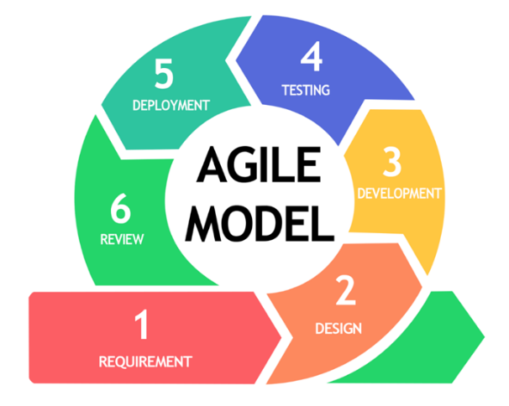
Figure 3.1. Agile SDLC model.

3.1.1 Requirements Gathering
The requirements of the system were gathered through consultation and interviews with personnel involved in document registration, routing, receiving, processing, records management, and administration within the Local Government Unit of Tuao. The existing procedures for document registration, routing, office receipt, processing, document retrieval, attachment handling, and history monitoring were examined to determine the operational problems and information requirements of the intended users.
The identified requirements served as the basis for the functions of the Document Tracking, Routing and Management System. These included document registration, QR code generation and tracking, document forwarding and receiving, Current Action and Processing Note recording, attachment management, document routing and processing history, user and role management, office management, and master-data management.

3.1.2 Design and Architecture
The gathered requirements were analyzed and translated into the system design. Diagrams such as the use-case diagram, context-level data flow diagram, document workflow diagram, and database structure were used to describe the interaction of users, processes, and data within the system.
The system was designed as a web-based application using a centralized architecture. The design allows authorized personnel of the Local Government Unit of Tuao to access appropriate system functions based on their assigned roles, permissions, and office assignments. The database structure was designed to maintain relationships among users, roles, offices, documents, document types, QR records, document routes, processing records, attachments, and audit logs.

3.1.3 Development and Coding
The Web-Based QR Code-Enabled Document Tracking, Routing and Management System was developed as a web-based application. Vue was used for the user interface, while Laravel was used for the application programming interface and server-side processing. A MySQL relational database was used to store and manage the system’s records.
The system was developed incrementally following Agile principles. Functional components were implemented and refined according to the identified requirements. These included document registration, QR code generation and tracking, document forwarding and receiving, Current Action and Processing Note recording, document routing history, attachment management, user and role management, office and document-type management, and document inquiry.
Version control and source-code management were used during development to track changes and support the continuous improvement of the application. System functions were reviewed and adjusted as operational requirements and issues were identified.

3.1.4 Quality Assurance and Software Testing
The developed system underwent functional testing to verify whether the implemented features operated according to the identified requirements. Testing covered major modules such as document registration, QR code generation and tracking, document forwarding, receiving, Current Action and Processing Note recording, attachment management, document-history viewing, user management, role management, office management, and document-type management.
The system was also tested for user-access restrictions, office-based authorization, data retrieval and updating, document routing and receiving, QR-based document lookup, attachment handling, and the recording of document routing and processing history. Errors and inconsistencies identified during testing were corrected and retested as part of the iterative development process.
The software quality of the system will be evaluated using the ISO/IEC 25010:2011 software product quality model, particularly the eight characteristics of functional suitability, performance efficiency, compatibility, usability, reliability, security, maintainability, and portability.

3.1.5 Implementation
The Document Tracking System for the Local Government of Tuao is intended for initial operational testing by authorized personnel. During this stage, intended users will review the system functions based on actual document-management workflows and operational requirements.
The initial implementation allows authorized users to test functions related to document registration, QR code tracking, document forwarding and receiving, Current Action and Processing Note recording, attachment management, document-history viewing, and administrative functions such as user, role, office, and document-type management.
Observations and recommendations from intended users will be considered as part of the continuing refinement of the system before wider or full-scale implementation.

3.1.6 Maintenance and Support
The system is currently undergoing continuous refinement based on issues identified during testing and recommendations provided by intended users of the Local Government Unit of Tuao. Maintenance activities include bug fixing, adjustment of existing functions, interface improvements, and enhancement of document registration, QR tracking, routing, receiving, processing, attachment handling, and document-history functions.

System modifications are reviewed and implemented as necessary to improve usability, reliability, security, and alignment with document-management requirements. Regular data backup procedures and server-level maintenance should also be performed to support data protection and the continued availability of the system.

3.2 System Architecture
A multi-tier web application architecture was adopted for the development of the Document Tracking System for the Local Government of Tuao. The architecture separates the presentation, application, and data layers to support security, maintainability, reliability, and future system expansion.
A. Presentation Layer. The presentation layer consists of the web-based user interface accessed through a standard web browser. It provides interfaces for authorized users, including Administrators, Records Officers, Office Users, and Viewers. The user interface supports document registration, document inquiry, QR code tracking, document forwarding and receiving, Current Action and Processing Note recording, attachment management, document-history viewing, and administrative functions. The available functions are displayed according to the role and office assignment of the logged-in user.
B. Application Layer. The application layer contains the core business logic and services of the system. It handles user authentication, role-based access control, office-based authorization, request validation, document registration, QR code generation and lookup, document routing, receiving, processing records, attachment management, and document-history retrieval. Laravel manages the application programming interface and server-side processing, while the Vue interface communicates with the application through authorized API requests.

The application layer enforces document workflow rules to preserve accountability. Authorized users may forward, receive, or process documents only according to their assigned role and office scope. A document cannot be processed by an office that does not currently hold it, and processing actions are restricted while a document has a pending route.
C. Data Layer. The data layer provides centralized storage through a MySQL relational database. It maintains relationships among user accounts, roles, offices, document types, documents, QR records, document routes, processing records, attachments, and audit logs. Centralized data storage allows authorized users to retrieve document information and routing history while maintaining records of document custody, processing activities, and related transactions.
The system also supports file storage for document attachments and QR code records for document identification and tracking. These supporting components are managed through the application layer and are accessible only to authorized users based on the established role and office restrictions.
Overall, the adopted architecture separates the user interface, application processing, centralized data storage, attachment handling, and QR code tracking functions. This structure supports a more organized, secure, transparent, and accountable document-management process for the Local Government Unit of Tuao.
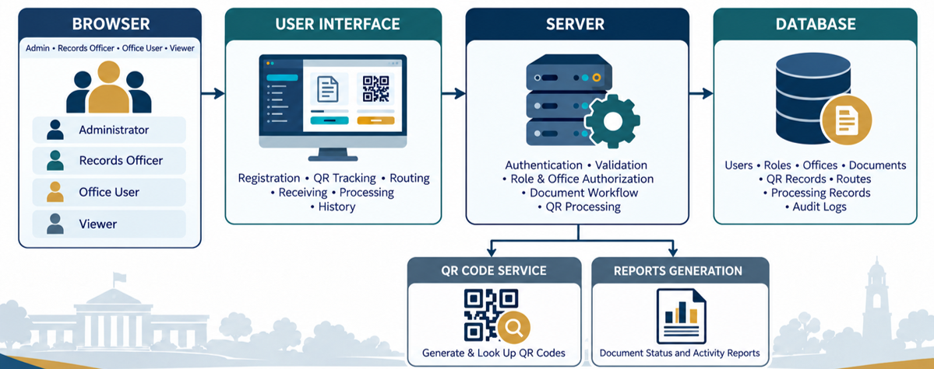
Figure 3.2. Architecture of the Integrated Management System.

3.3 Use-Case Diagram
The Use-Case Diagram illustrates the major functionalities of the Document Tracking System for the Local Government Unit of Tuao and identifies the key actors who interact with the system. These actors include the Administrator, Records Officer, Office User, and Viewer.
The diagram presents the system functions available to each actor according to the assigned role and office scope. The major functions include user authentication, document registration, QR code generation and tracking, document inquiry, document forwarding, document receiving, Current Action and Processing Note recording, document routing-history viewing, and report generation.
The Administrator has access to system-wide administrative functions, including user-account management, role management, office management, document-type management, and other master-data functions. The Administrator may also access document-management and monitoring functions according to the system’s authorization rules
Records Officers may register documents, access QR code functions, and view master data. Office Users perform operational document-workflow functions, such as forwarding, receiving, and processing documents, when their assigned office has the required custody of the document. Viewers are limited to authorized read-only functions, such as document inquiry and history viewing.
The diagram also reflects the system’s role-based and office-based access restrictions. A user’s role determines which functions may be accessed, while the user’s office assignment determines which currently held documents may be acted upon. Users cannot process a document when their office does not hold it or when the document has a pending route.

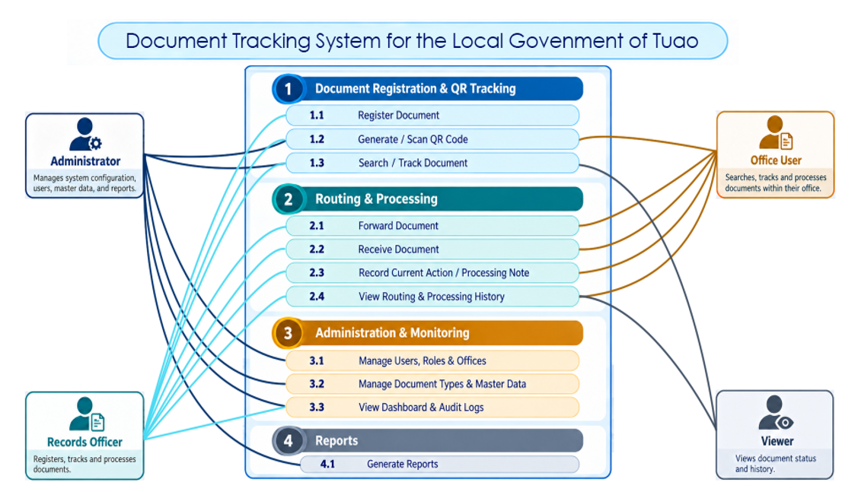Figure 3.3. Use Case Diagram

3.4 Context Level - Data Flow Diagram

The Context-Level Data Flow Diagram (DFD) presents the overall interaction between the external entities and the Document Tracking System for the Local Government of Tuao. The external entities include the Office User, Records Officer, Viewer, and Administrator.

The Office User submits document search requests, forwarding requests, receipt confirmations, and Current Action or Processing Note updates. In return, the system provides document status, assigned document details, and routing history.

The Records Officer submits document-registration data, QR code generation requests, and authorized routing and processing updates. The system provides QR codes, document details, and routing and processing history.

The Viewer submits document-inquiry requests. In return, the system provides authorized document information and routing and processing history based on the user’s access permissions.

The Administrator manages user-account data, role and office settings, master-data updates, and report requests. In return, the system provides dashboard data, audit information, and report output.

The diagram shows the major flow of information between the system and its external users and illustrates how the Document Tracking System supports document registration, QR code tracking, document routing, processing, monitoring, and reporting.
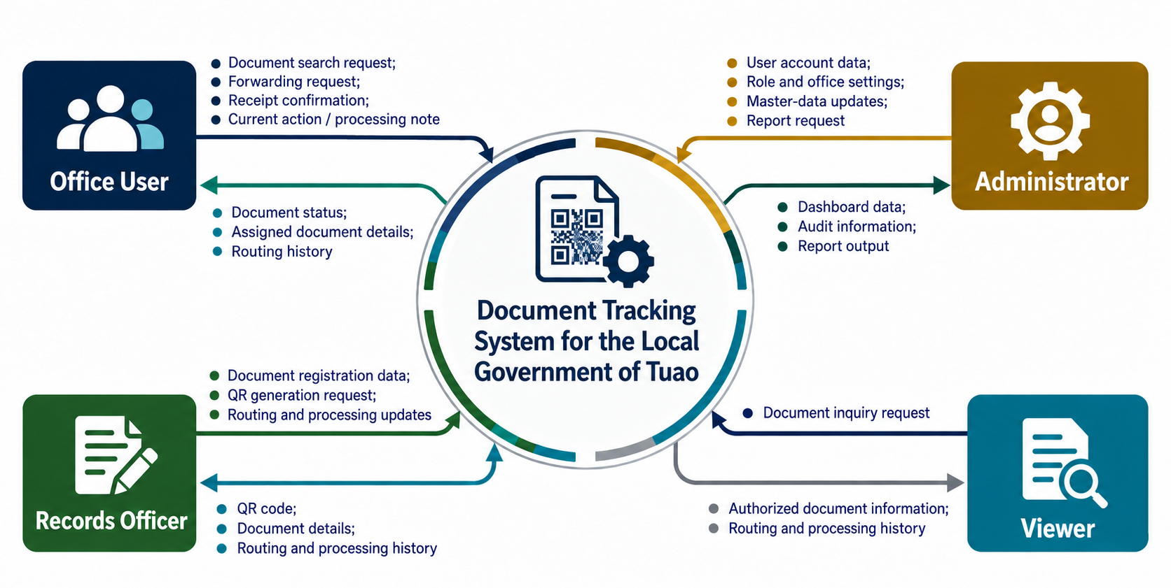
Figure 3.4. Context-level data flow diagram

3.5 Software and Hardware Requirements
Table 5. Software requirements and identified dependencies
Component | Implementation /requirement | Purpose
Frontend | Vue.js with Vite | Builds and serves the web-based user interface
Frontend Libraries | Vue Router, Axios, and the QR code libraries configured in the project | Supports page navigation, API requests, and QR code functions
Backend | Laravel with PHP | Provides the API, validation, authentication, authorization, and document-workflow processing
Database | MySQL relational database | Stores users, roles, offices, documents, QR records, routes, processing records, and other system data
Local Development Server | XAMPP, including Apache and MySQL | Hosts and runs the system during local development and testing
Authentication | Laravel token-based authentication and application middleware | Controls authenticated access to system functions
Authorization | Role-based and office-based access controls | Restricts functions and document actions according to user role and office custody
Package Management | Composer and Node Package Manager (npm) | Installs and manages backend and frontend project dependencies
QR Code Support | QR code generation and scanning components configured in the application | Supports document identification, lookup, and tracking

Table 6. Suggested hardware baseline for pilot planning
Environment | Suggested baseline | Qualification
Staff Workstation | Modern dual-core processor or higher, 8 GB RAM, and a display resolution of 1366 × 768 or higher | Supports web-based document registration, tracking, routing, and administration
QR Code Scanner or Camera | Camera-enabled smartphone, webcam, or QR-capable scanner, where QR scanning is required | Supports scanning and retrieval of document QR codes
Local Server or Host Computer | Quad-core processor, 8 GB RAM or higher, SSD storage, and sufficient capacity for database backups | Hosts the application and database during local or pilot deployment
Network | Stable local area network (LAN) or internet connection | Allows authorized users to access the system through a browser
Backup Storage | External drive, network storage, or secure backup location | Stores database backups and supports recovery procedures
These hardware specifications are planning recommendations rather than measured minimum or maximum limits. The project files establish the software dependencies required by the application but do not determine the maximum number of concurrent users the system can support. Before deployment, administrators should test response times, database performance, storage use, QR code functions, and network access under representative user activity. They should also verify compatibility of the installed application packages, web server, PHP version, database server, and supported web browsers..

3.6 Respondent of the Study

The respondents of the study were purposively selected personnel from the Local Government Unit of Tuao who were directly involved in document registration, records management, document routing, office processing, system administration, and technical evaluation. A total of [number] respondents participated in the evaluation, consisting of [number] IT experts, [number] administrative personnel, [number] records officers, and [number] office users or department representatives.

The respondents were selected based on their roles and relevance to the operation, supervision, administration, and technical evaluation of the Document Tracking System for the Local Government of Tuao. Records Officers and office personnel evaluated document-registration, QR tracking, routing, receiving, processing, and history functions. Administrative personnel evaluated user management, office management, document-type management, monitoring, and reporting functions. IT experts evaluated the technical and software quality characteristics of the developed system.
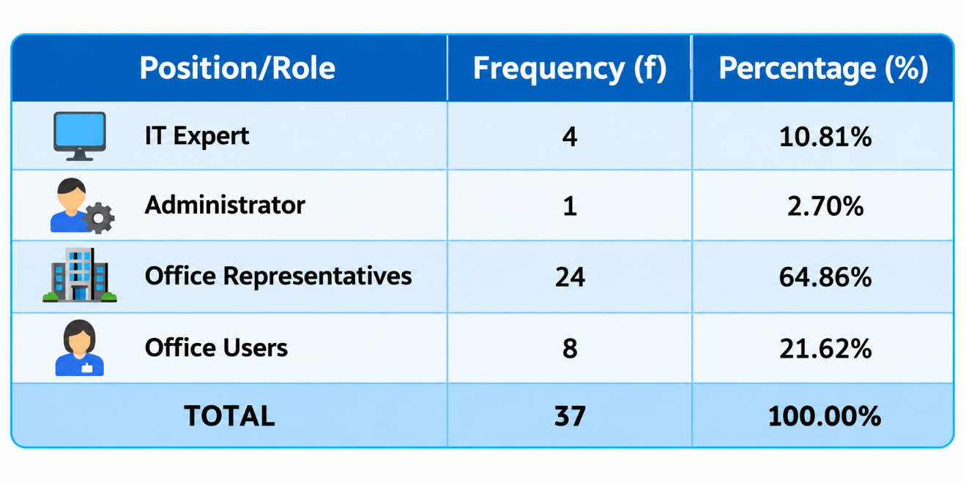
The respondents represented the intended users and stakeholders of the system within the Local Government Unit of Tuao. Their feedback was used to assess the system’s functional suitability, usability, security, reliability, and overall suitability for the intended document-management environment.
Figure 3.5. Position/Role of the Respondents
The respondents of the study were selected based on their actual participation in the evaluation and their relevance to the operation, administration, or technical assessment of the Document Tracking System for the Local Government of Tuao. The respondents included IT Experts, the system Administrator, designated Office Representatives, and Office Users from the Local Government Unit of Tuao who were formally included in the evaluation process.
User accounts, office records, documents, and other system data were not automatically considered study participants. Only personnel who were specifically selected, informed, and included in the evaluation were considered respondents of the study.

3.7 Research Instrument
The study used researcher-developed instruments to gather information regarding existing document-management processes and to evaluate the developed Document Tracking System for the Local Government of Tuao.
A semi-structured interview questionnaire was used to identify the problems and challenges encountered in document registration, routing, receiving, processing, tracking, and record retrieval. The interview questions also gathered information regarding the existing workflow and the requirements of records personnel, office users, administrators, and other intended users. The responses served as a basis for determining the operational requirements of the system.
For the evaluation of the developed system, an ISO/IEC 25010:2011-aligned questionnaire was used. The questionnaire was based on the eight software product quality characteristics of functional suitability, performance efficiency, compatibility, usability, reliability, security, maintainability, and portability. The instrument was researcher-developed and adapted to the functions and intended users of the Document Tracking System.
The questionnaire used a five-point rating scale to determine the respondents’ assessment of the software quality of the developed system. Respondents evaluated the characteristics and system functions relevant to their knowledge and experience. IT Experts primarily contributed to the technical evaluation, while the Administrator, Office Representatives, and Office Users evaluated the system based on its functionality, usability, performance, reliability, security, and relevance to document-management activities.
The research instruments were reviewed to ensure that the questions were understandable and aligned with the objectives of the study. No passwords, authentication tokens, confidential document contents, or unnecessary personal information were included in the evaluation questionnaire..

3.8 Locale of the Study
The study will be conducted at the Local Government Unit of Tuao, Cagayan, Philippines. The Local Government Unit of Tuao will serve as the primary locale for the development, testing, and evaluation of the Document Tracking System for the Local Government of Tuao.
The system is intended to support document registration, QR code tracking, routing, receiving, processing, monitoring, and retrieval among the offices of the Local Government Unit of Tuao. The study will include the 24 identified offices and departments of the municipality to ensure that the system requirements and evaluation consider the document-management workflow across different offices
The respondents of the study will include selected IT Experts, the system Administrator, Office Representatives, and Office Users from the Local Government Unit of Tuao.

3.9 Data Gathering
The researchers will follow the following procedures in gathering the data needed for the study:
- Securing permission. Permission will be obtained from the concerned Local Government Unit offices to conduct the study, gather information regarding existing document-management processes, and evaluate the developed system.
- Review of existing processes and documents. Existing document forms, routing procedures, document types, office records, and related practices will be reviewed to identify the current workflow and information requirements.
- Conduct of interviews. Selected personnel from the Local Government Unit of Tuao will be interviewed using a semi-structured interview guide. The interview will focus on problems encountered in document registration, routing, receiving, processing, tracking, and record retrieval.
- Identification of system requirements. Information gathered from interviews and document review will be organized and used as the basis for determining the functional and operational requirements of the Document Tracking System.
- Development and testing of the system. The identified requirements will be implemented through the Agile development approach. System functions will be developed, tested, reviewed, and refined throughout the development process.
- System orientation and initial operational testing. Selected respondents will be oriented on the major functions and workflows of the system and will be given the opportunity to use and review the application during testing.
- System evaluation. The selected respondents will evaluate the developed system using the ISO/IEC 25010:2011-aligned questionnaire. A total of 37 respondents will be included, consisting of four IT Experts, one Administrator, 24 Office Representatives, and eight Office Users.
- Collection of observations and recommendations. Comments, observations, and recommendations provided by respondents during testing and evaluation will be documented and considered for further refinement of the system.
- Data consolidation. Completed questionnaires and interview responses will be checked for completeness, organized, tabulated, and prepared for analysis.

3.10 Data Analysis
The data gathered through interviews, observations, and evaluation questionnaires will be tallied, organized, and analyzed for proper interpretation. Frequency count and weighted mean will be used to interpret the respondents’ assessment of the developed Document Tracking System for the Local Government of Tuao. Comments and recommendations will be grouped according to common themes and considered for system improvement.
The weighted mean will be used to determine the extent of software quality of the system based on the eight characteristics of ISO/IEC 25010:2011: functional suitability, performance efficiency, compatibility, usability, reliability, security, maintainability, and portability.
The weighted mean will be computed using the following formula:
$$\text{Efficiency of the DST}=\frac{\text{Manual Time}- \text{DTS Time}}{\text{DTS Time}}×100\%$$
The researcher will measure the processing time required to complete equivalent document-management tasks using both the existing manual procedure and the developed Document Tracking System for the Local Government of Tuao. The comparison will cover tasks such as document registration, document routing, document receiving, document searching, and status tracking. The results will be used to determine the difference in processing time between the two methods..
A five-point Likert scale will be utilized to obtain the numerical ratings and descriptive equivalents of the respondents’ responses. The scale will be used in the assessment of the developed system and in determining the extent of software quality based on ISO/IEC 25010:2011..
Table 8. Likert Scale for the Assessment of the Integrated Management System
Range | Interpretation | Scale point
4.21-5.00 | Strongly Agree | 5
3.41-4.20 | Agree | 4
2.61-3.40 | Neither Agree nor Disagree | 3
1.81-2.60 | Disagree | 2
1.00-1.80 | Strongly Disagree | 1

Table 9. Likert Scale for the Extent of Software Quality Based on ISO/IEC 25010:2011
Range | Interpretation | Scale point
4.21-5.00 | Very high extent | 5
3.41-4.20 | High extent | 4
2.61-3.40 | Moderate extent | 3
1.81-2.60 | Low extent | 2
1.00-1.80 | Very low extent | 1

CHAPTER IV
RESULTS AND DISCUSSIONS

This chapter presents the analysis and interpretation of data gathered during the development and evaluation of the Document Tracking System for the Local Government of Tuao.

4.1 Problems Encountered in the Existing System
This section presents the problems identified in the existing document-management process of the Local Government Unit of Tuao. The findings were based on interviews, observations, and review of the existing document-registration, routing, receiving, processing, and retrieval procedures conducted during the requirements-gathering stage of the study.
The identified problems included the following:
a. Difficulty in determining the current office or custody of a document
b. Delays in routing documents and confirming document receipt
c. Difficulty in retrieving document records and routing history
d. Incomplete or inconsistent recording of document actions and processing notes
e. Limited visibility of document status and movement among concerned offices
f. Difficulty in monitoring document transactions and preparing reports
g. Limited accountability when document activities are maintained through manual or separate records
These concerns are important because a document may pass through several offices before it is completed. When document movement and processing information are maintained manually, additional time and effort are required to locate the document, verify its current status, identify the responsible office, and review previous actions.
The existing process also has limitations in providing authorized users with quick document lookup, QR code-based tracking, routing history, and office-based access to document actions. These concerns served as the basis for defining the functional requirements of the Document Tracking System for the Local Government of Tuao.

4.2 The Developed System
The developed Document Tracking System for the Local Government of Tuao provides a centralized platform for registering, tracking, routing, receiving, processing, and retrieving official documents. It maintains related information such as user accounts, roles, offices, document types, document records, QR records, document routes, processing records, and document-history data.
Authorized users can register documents, generate and scan QR codes, search and track document records, forward documents to concerned offices, confirm document receipt, record Current Actions and Processing Notes, and view document routing and processing history. These functions help users identify the current status, location, and previous actions taken on a document.
The Administrator has access to administrative functions for managing user accounts, roles, offices, document types, and other master data. The Administrator may also access monitoring and report-related functions according to the system’s authorization rules.
Records Officers and Office Users may perform authorized document-workflow functions according to their assigned role and office. A document may only be forwarded, received, or processed when the user’s office has the required custody of the document. Viewers are limited to authorized read-only functions, such as document inquiry and history viewing.
The system applies role-based and office-based access restrictions to support document security, accountability, and proper management of document transactions.

4.2.1 Hierarchical Input Process Output (HIPO)
The Hierarchical Input-Process-Output (HIPO) diagram presents the major system modules and their relationship within the Document Tracking System for the Local Government of Tuao. It shows how the system is organized into functional areas for document registration, QR code tracking, document routing and processing, administration and monitoring, and reporting.
The HIPO structure illustrates the hierarchy of the system beginning with the main application and proceeding to its major functions and subfunctions. It provides a summarized representation of how the different modules work together to support document registration, tracking, forwarding, receiving, processing, history viewing, administrative functions, and report generation. The Hierarchical Input-Process-Output (HIPO) diagram presents the major system modules and their relationship within the Document Tracking System for the Local Government of Tuao. It shows how the system is organized into functional areas for document registration, QR code tracking, document routing and processing, administration and monitoring, and reporting.
The HIPO structure illustrates the hierarchy of the system beginning with the main application and proceeding to its major functions and subfunctions. It provides a summarized representation of how the different modules work together to support document registration, tracking, forwarding, receiving, processing, history viewing, administrative functions, and report generation.

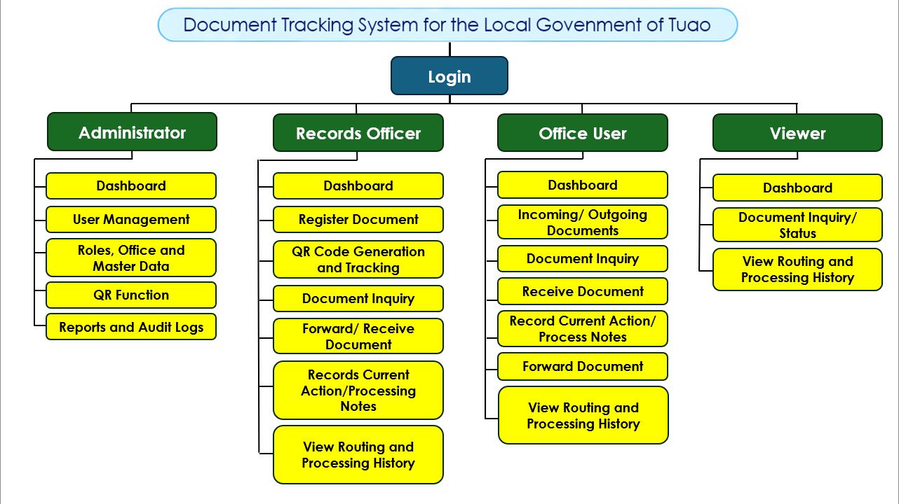Figure 4.1. HIPO diagram of DTS

4.2.2 Input Process Output (IPO) Diagram
The Input-Process-Output diagram presents the flow of information through the developed system. The inputs consist of client and guardian information, animal bite and exposure details, vaccination and treatment information, treatment-center data, human rabies information, user information, and reporting requirements.
The processes include client registration and retrieval, animal bite assessment, creation and updating of vaccination schedules, recording of administered doses, cross-center continuation of treatment, generation of QR-based vaccination records and vaccination slips, monitoring of vaccination schedules, management of vaccine availability, recording of human rabies cases, automated email reminder processing, and report generation.
The outputs include centralized client and exposure records, updated vaccination histories, monitored vaccination schedules, QR-based record retrieval, printable vaccination slips, automated vaccination reminders, treatment-center and vaccine availability information, dashboard and monitoring data, center-level accomplishment reports, and consolidated provincial and Department of Health reports.
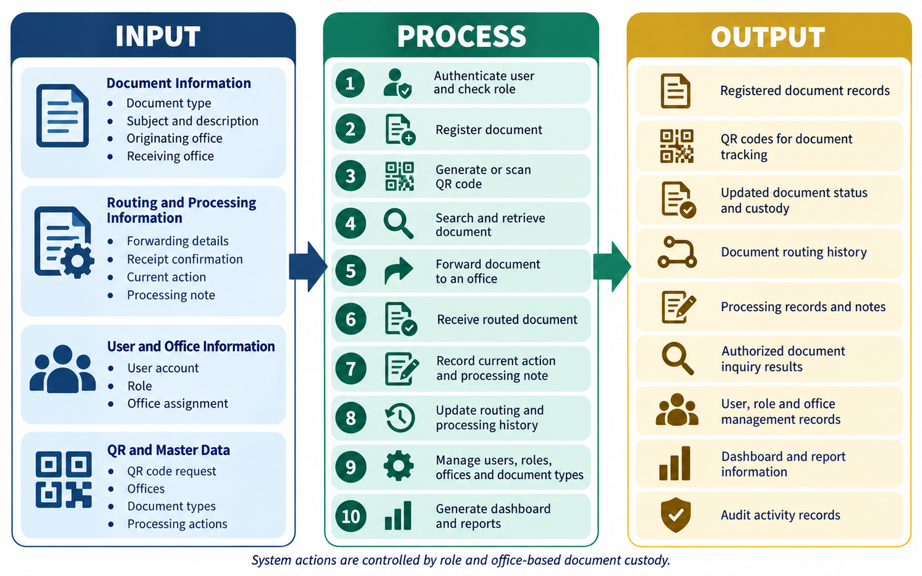
Figure 4.3. IPO diagram of the DTS

4.2.3 Entity Relationship Diagram (ERD)
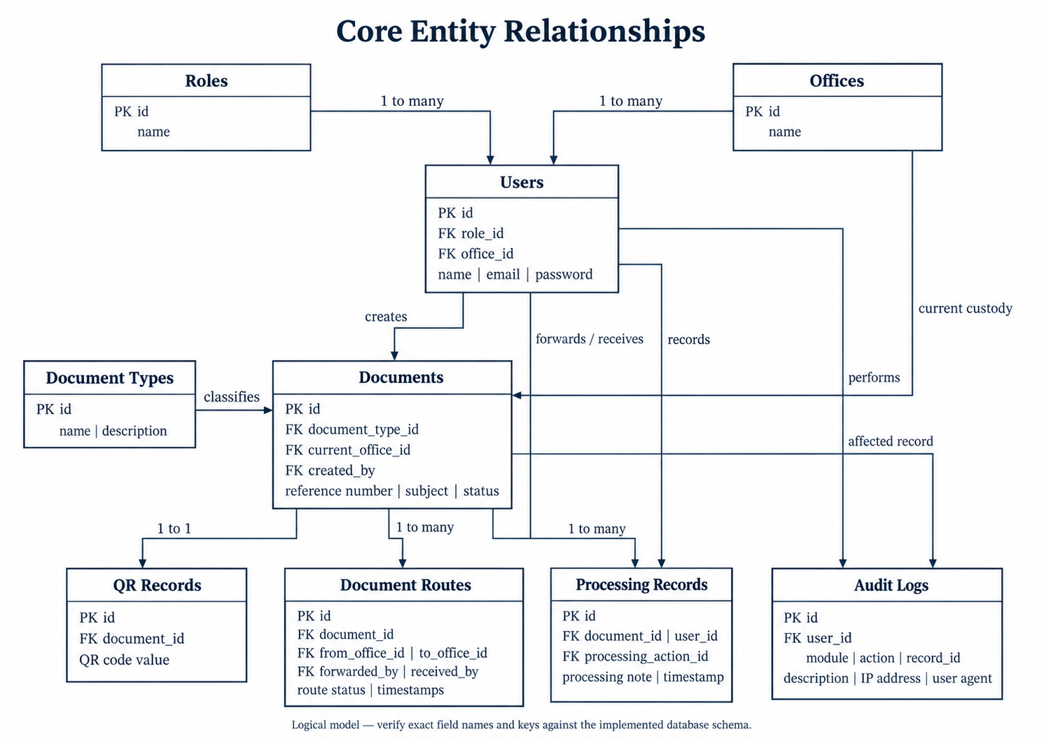
Figure 4.5. Core data relationships
The diagram summarizes the core logical relationships of the Document Tracking System for the Local Government of Tuao. It presents the relationship among roles, offices, users, document types, documents, QR records, document routes, processing records, and audit logs. The relationship labels describe the expected document-workflow flow and should not be mistaken for database-enforced uniqueness constraints.
Roles and offices are associated with user accounts to define the permissions and office assignment of each user. Document types classify document records, while each document is associated with its current office and the user who created it. A document may have a QR record for tracking and lookup, multiple document-route records for routing history, and multiple processing records for Current Actions and Processing Notes.
Document routes record the origin office, destination office, forwarding user, receiving user, route status, and related timestamps. Processing records identify the document, responsible user, selected processing action, note, and date of the activity. Audit logs record the responsible user, module, action, affected record reference, description, IP address, user agent, and timestamps where audit logging is implemented.
The diagram presents a logical model for documentation purposes. The exact table names, foreign keys, nullable fields, and database cardinalities must be verified from the implemented migrations and database schema before the diagram is treated as the final Entity-Relationship Diagram.

4.2.3.1 User's View
The following figures are screenshots of the running Document Tracking System, not recreated interface mockups. They show the local demonstration state, and displayed document counts, statuses, and other values must not be interpreted as official municipal records or verified operational statistics. Empty forms, sample records, and aggregate views were selected to explain the interface without disclosing confidential document contents or unnecessary personal information.
The screenshots establish the visible layout, navigation, and available controls of the system. They do not, by themselves, prove that every system function has passed functional, security, or end-to-end testing.
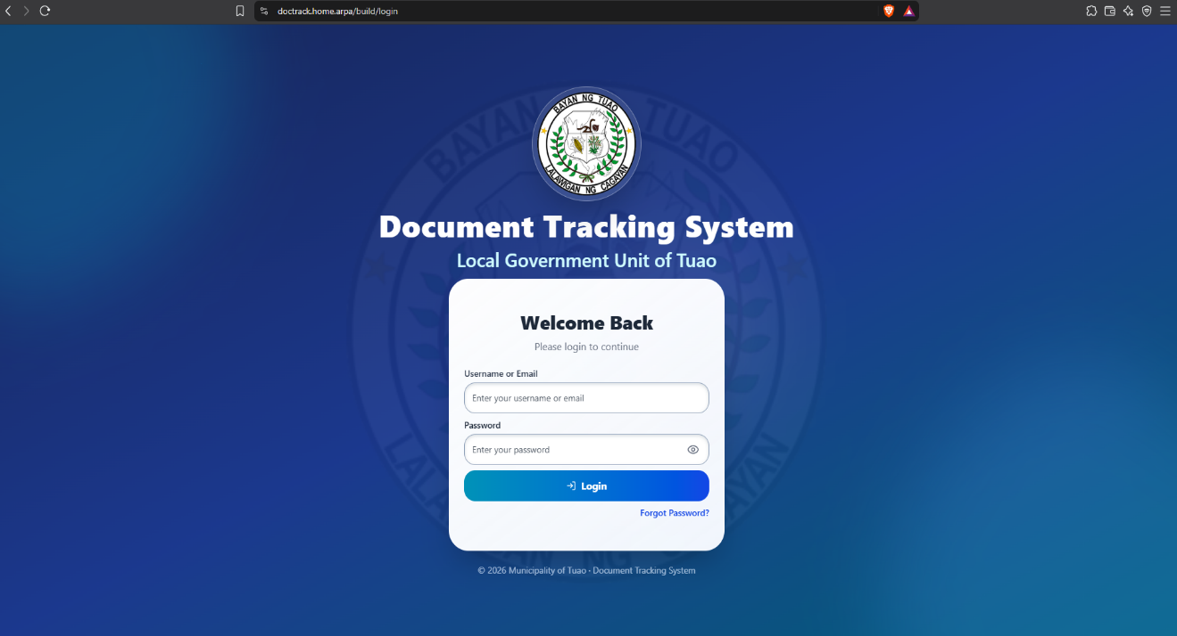
Sign-in view
Figure 4.6. Sign-in view: actual running application
Purpose: Accepts authorized user credentials and provides access to the authenticated workspace of the Document Tracking System.
The user enters an assigned email address and password. Successful authentication allows the system to retrieve the user profile, assigned role, and office context before granting access to authorized modules. Invalid, expired, or unauthorized credentials return the user to the sign-in workflow. Access to system functions is restricted according to the user’s role and office assignment
Dashboard view
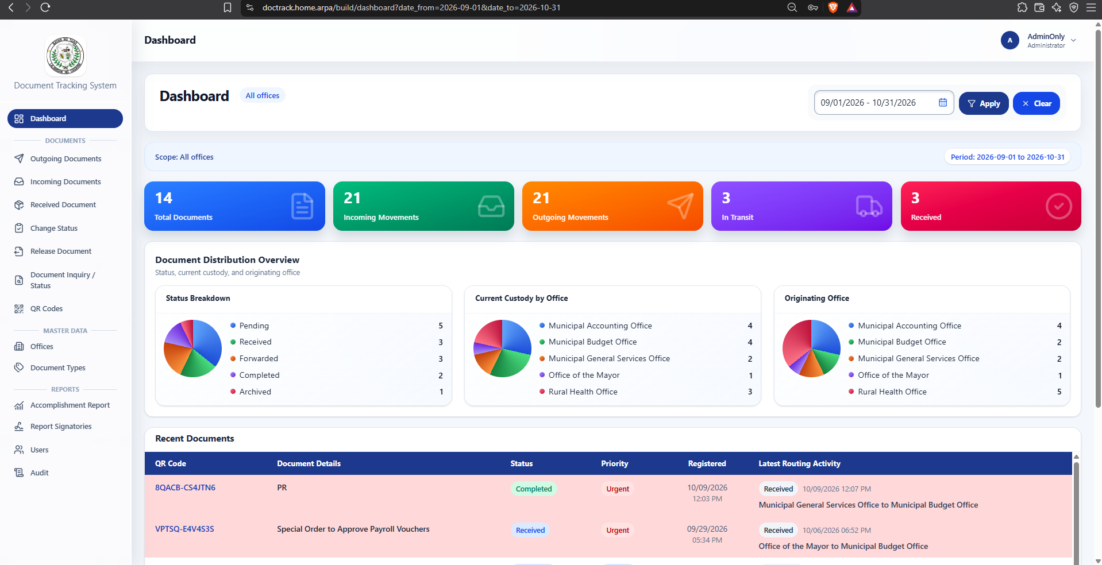
Figure 4.7. Dashboard view: actual running application
Purpose: Presents document-management summaries and status information in one location.
The user may select the available date range, office, document type, or status filters to review relevant document activity. Dashboard cards may display totals for registered documents, incoming documents, outgoing documents, documents in transit or pending receipt, received documents, and other available status categories. The selected period, office scope, and document population represented by each measure must be considered before comparing results.
Outgoing Documents View
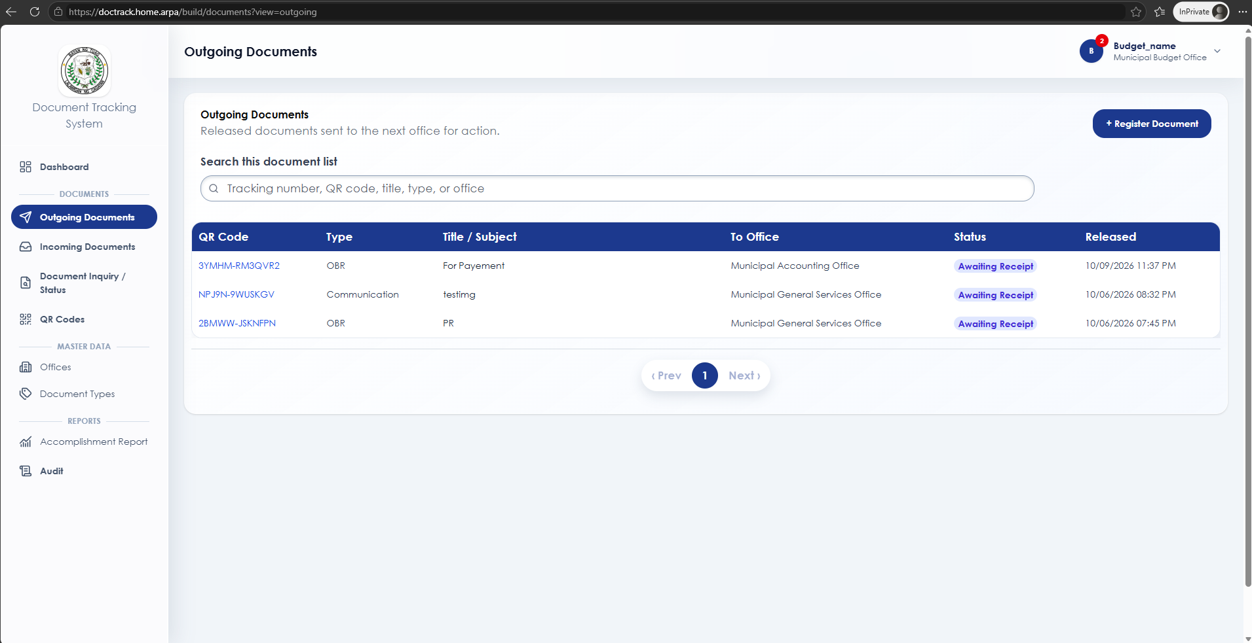
Figure 4.8. Outgoing Documents view: actual running application
Purpose: Displays documents forwarded or released by the user’s assigned office and supports monitoring of their routing status.
The page allows authorized users to review outgoing documents, including the document reference number, subject, destination office, date forwarded, and current routing status. Users may select a document to view its details and routing history. Before forwarding or releasing a document, the user must verify that the document is currently held by their assigned office and that the selected destination office is correct. The page supports accountability by showing the movement of documents between offices; however, it does not replace the official review, approval, or signatory requirements of the Local Government Unit.
Register New Document View
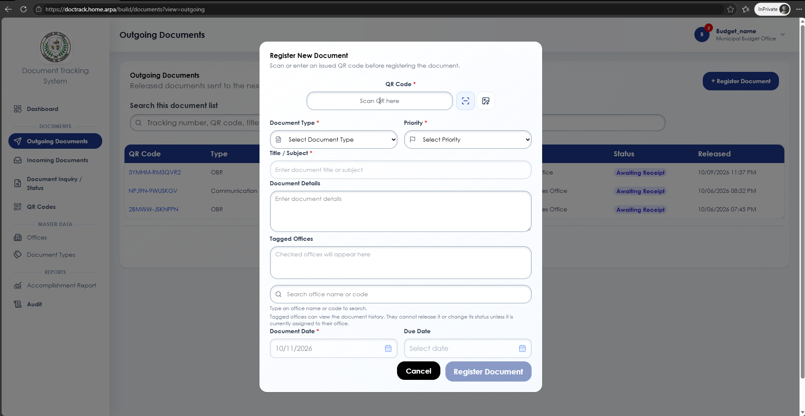
Figure 4.9. Register New Document view: actual running application
Purpose: records a new document and starts its tracking lifecycle.
Authorized personnel enter the document reference details, type, subject, origin, destination, and other required information. Upon saving, the system creates a document record that can be tracked, routed, received, and processed by authorized offices.
Incoming Documents view
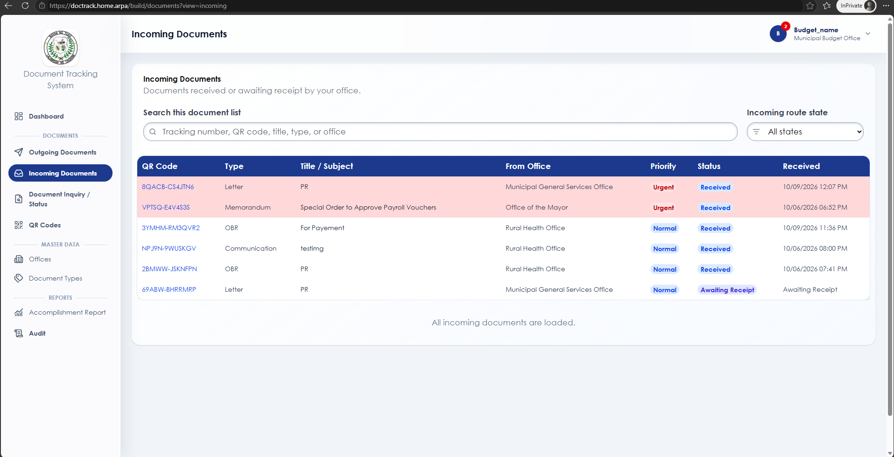
Figure 4.10. Incoming Documents view: actual running application
Purpose: displays documents currently routed to or received by the user’s assigned office.
The page helps office personnel identify documents awaiting receipt, action, or processing. Users can open a document record to review its routing information, current status, and processing history before taking an authorized action.
Document Details view
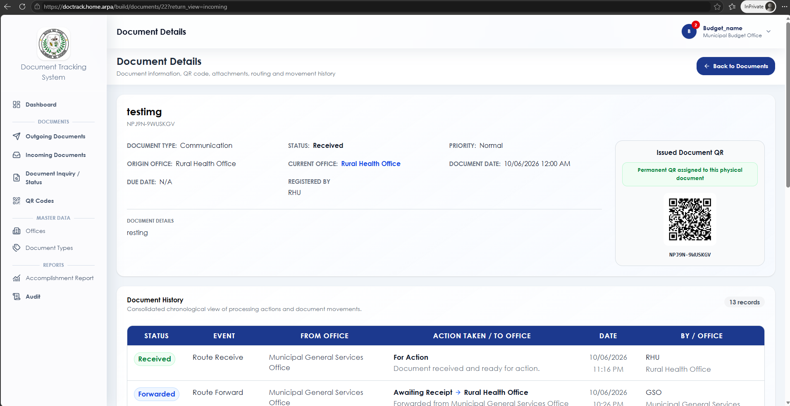
Figure 4.11. Document Details view: actual running application
Purpose: presents the complete information and current workflow state of a selected document.
The page displays document details, QR reference, routing history, receipt information, current action, processing notes, and status. Available actions depend on the user’s role, assigned office, and whether the document is currently held by that office.
Document Inquiry/ Status view
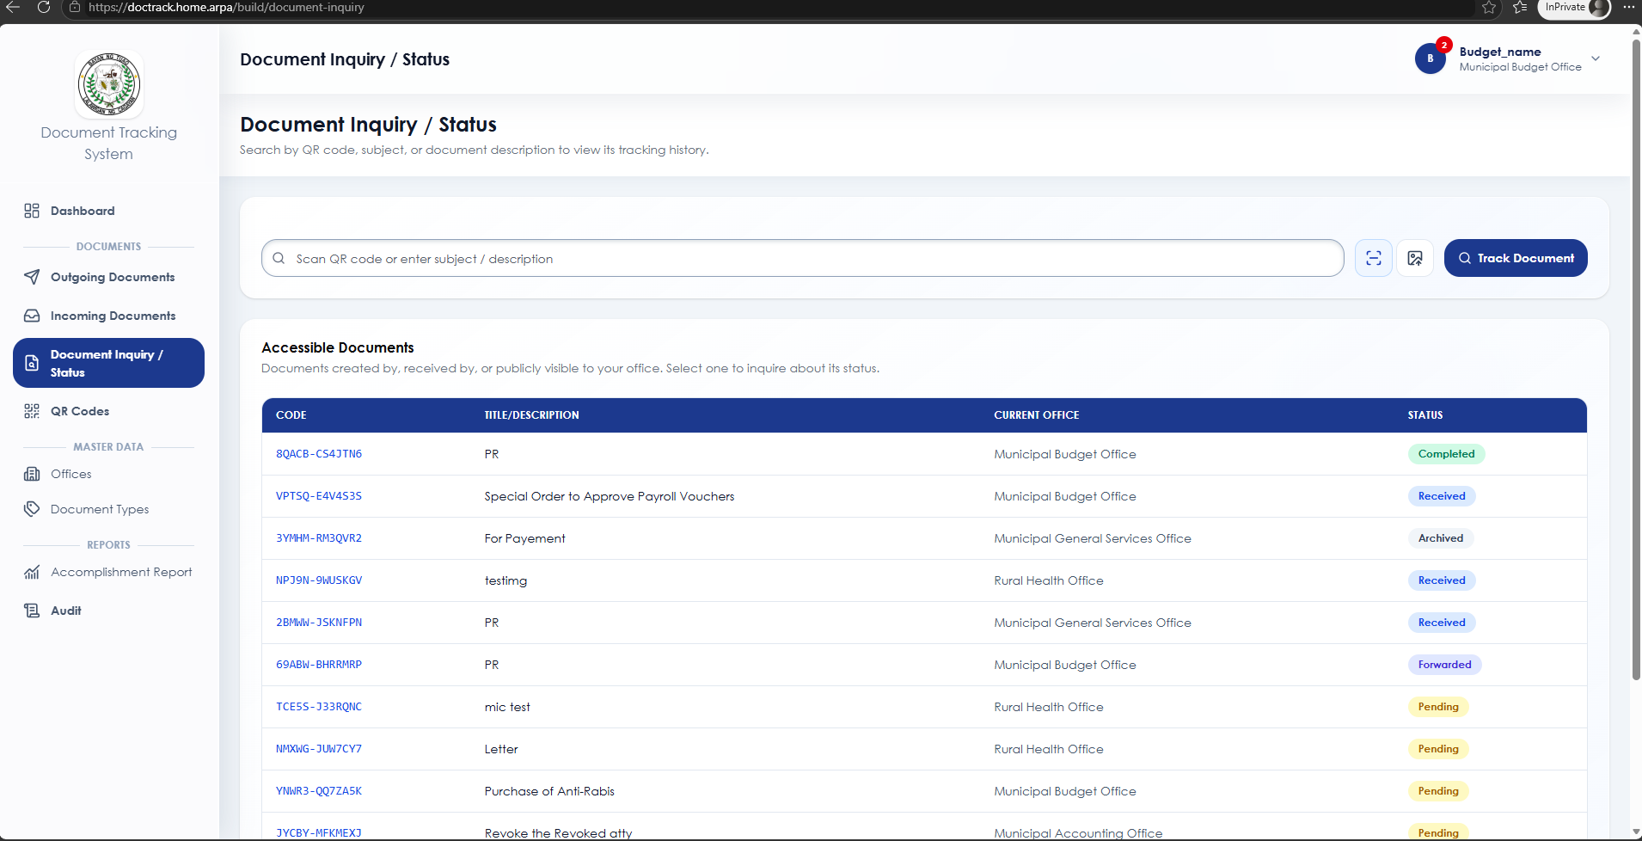
Figure 4.12. Document Inquiry/ Status view: actual running application
Purpose: allows authorized users to search for a document and check its current location and status.
Users may search using a document number, QR code, subject, or other available reference. The system displays the document’s current office, routing progress, status, and recorded history to support follow-up and accountability.
QR Code-Admin view
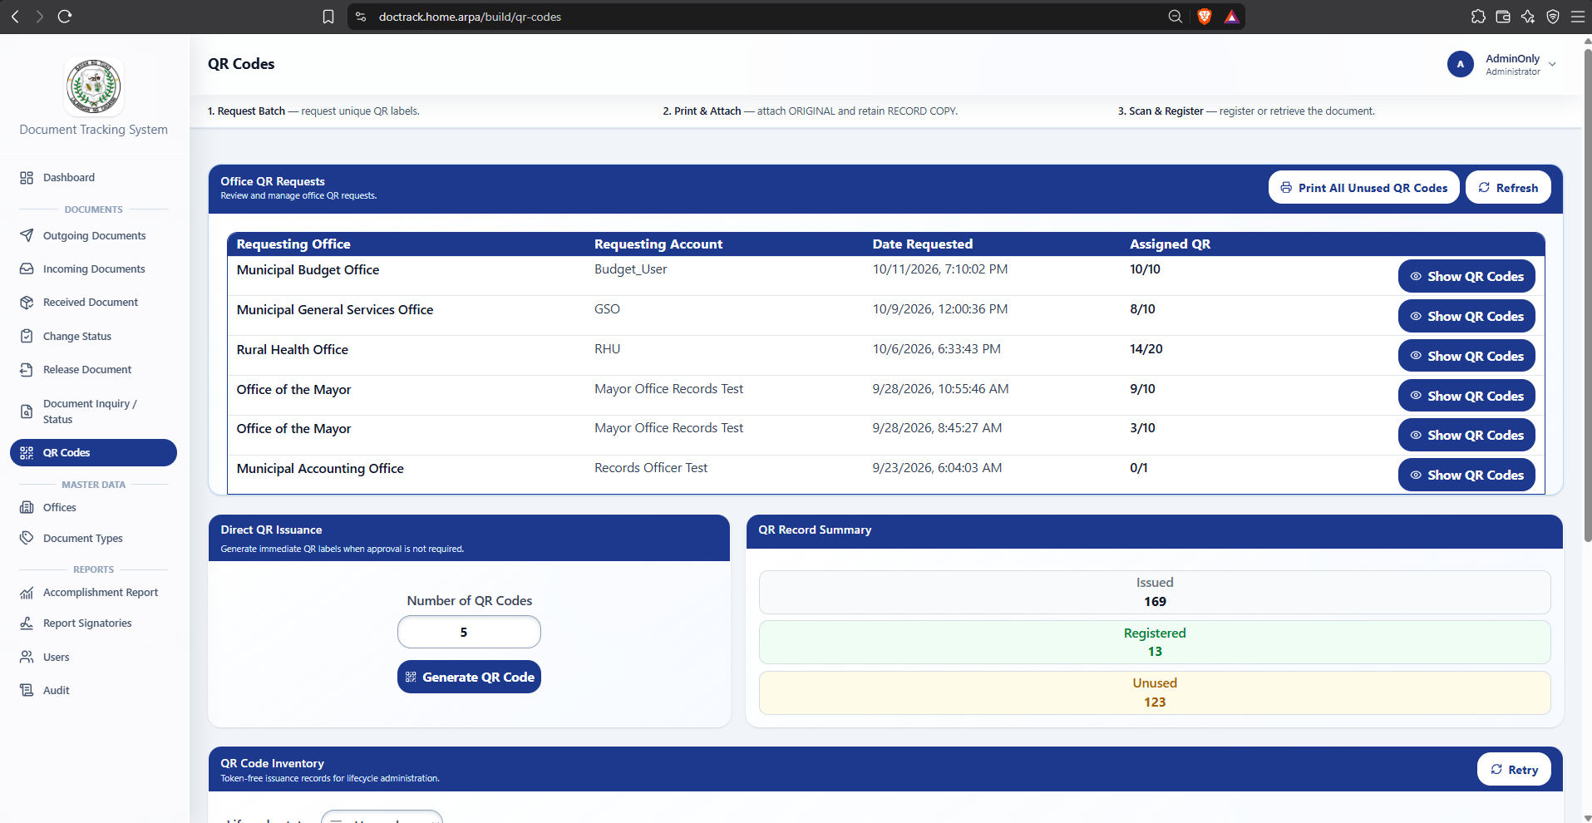
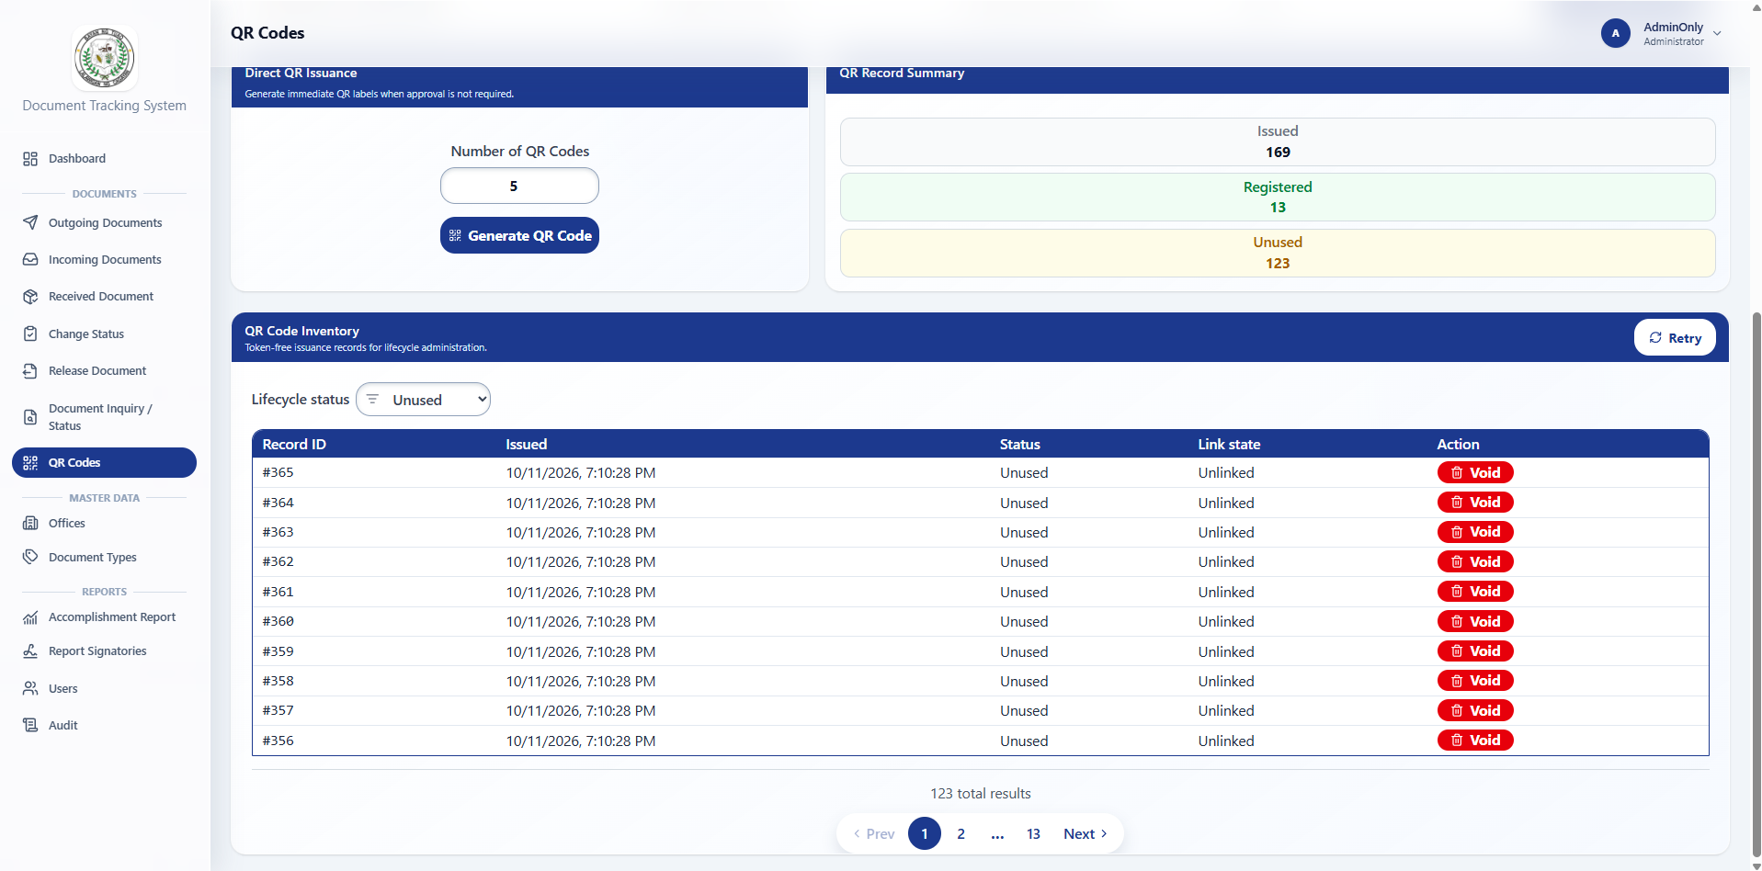
Figure 4.13. QR Code - Admin view: actual running application
Purpose: manages QR-related records and supports system-wide document tracking.

The Administrator can view QR records and perform authorized QR-related management functions. QR codes serve as unique references that help users retrieve the corresponding document record and routing information.
QR Code - User view
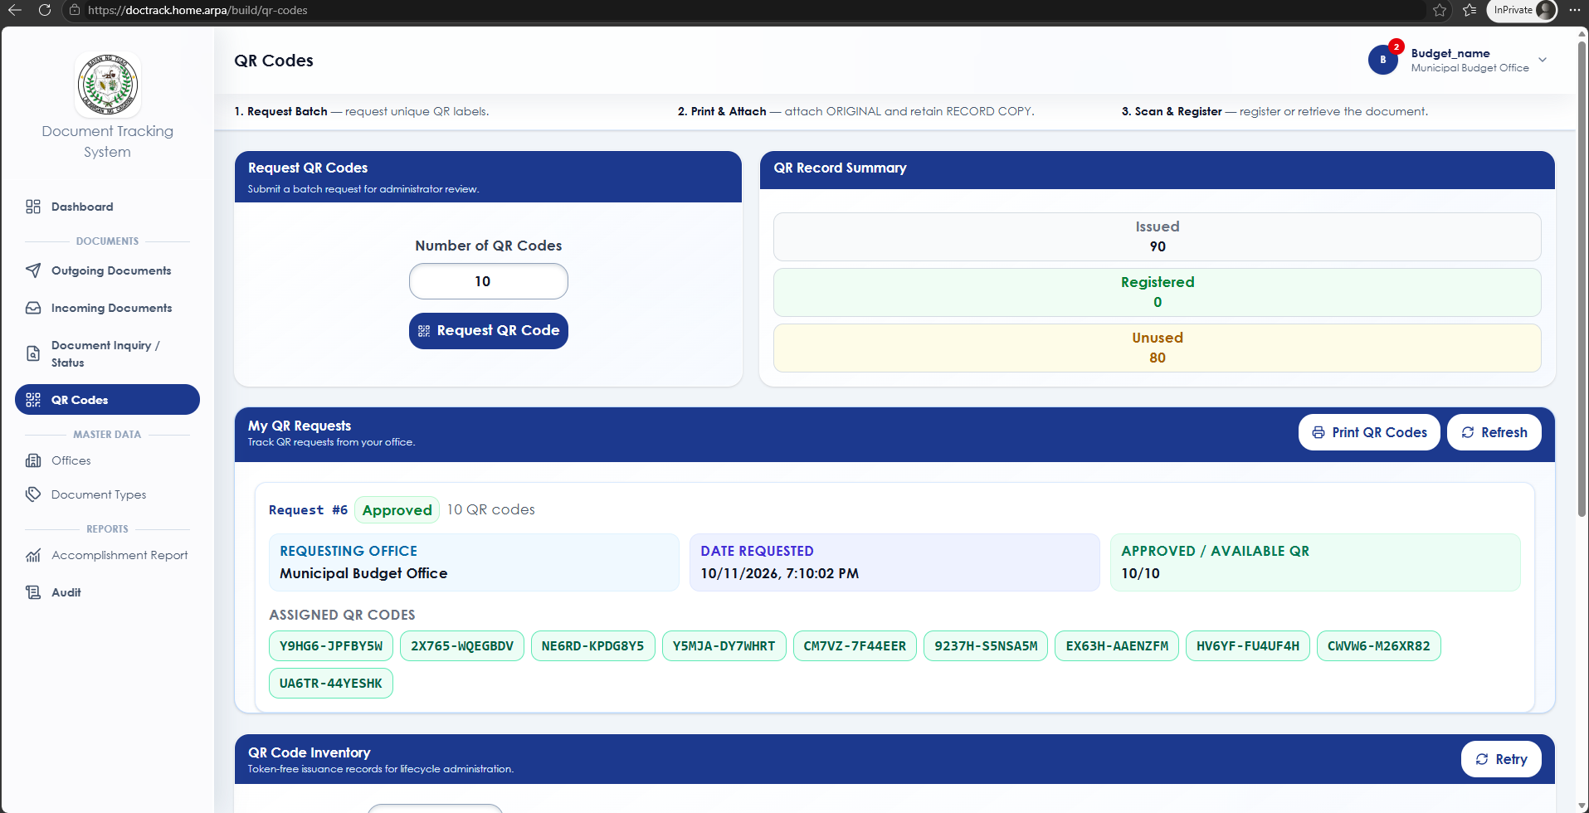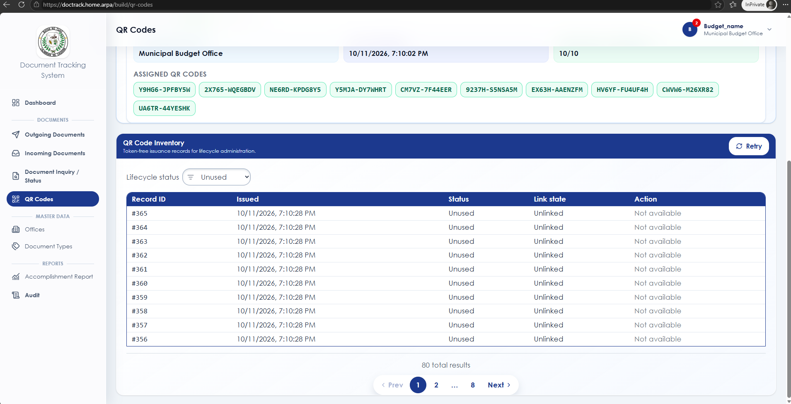
Figure 4.14. QR Code - User: actual running application
Purpose: allows authorized users to generate, scan, or use QR codes for document retrieval and tracking.
Users can use a document’s QR code to quickly locate the related record and view its authorized details. QR access supports faster document identification but remains subject to role and office-based access restrictions.
Bulk Receive Document view
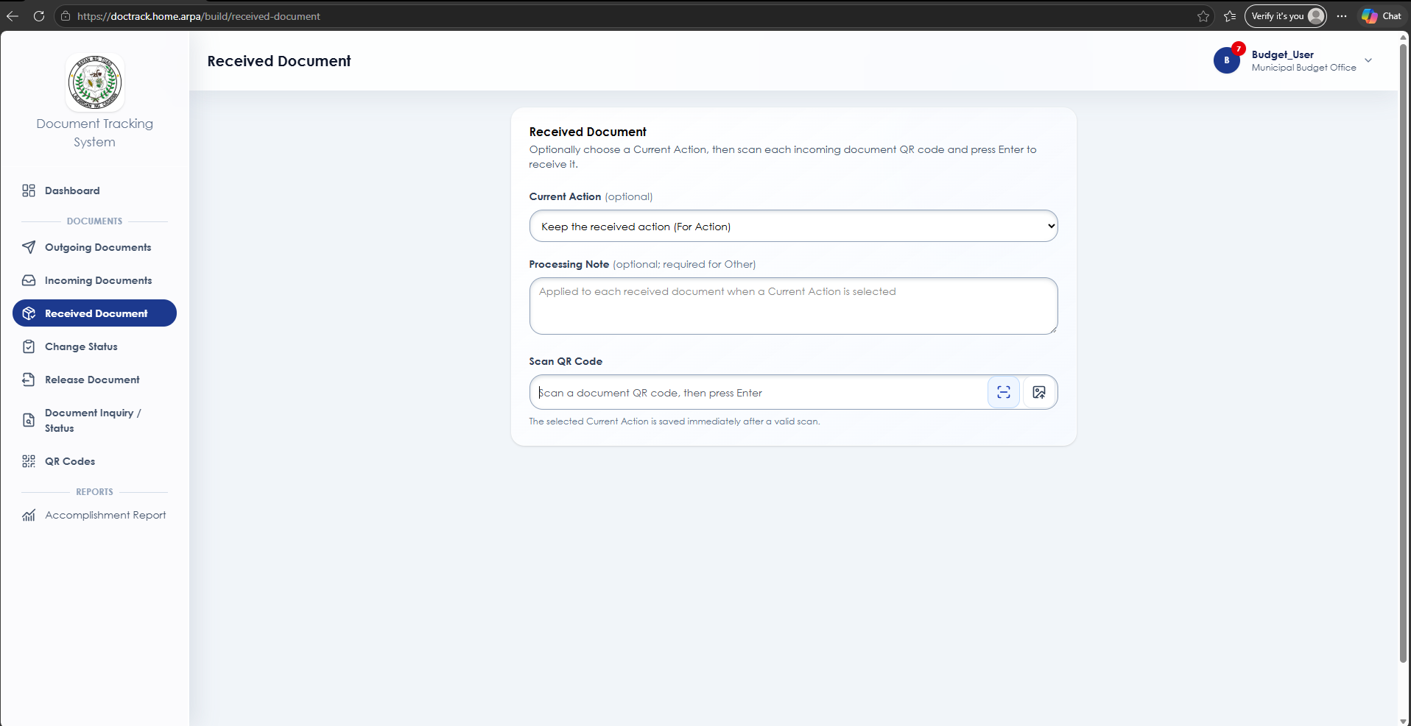
Figure 4.15. Bulk Receive view: actual running application
Purpose: receives multiple incoming documents for the assigned office in one action.
Authorized personnel select documents that are pending receipt by their office and confirm their receipt. The system updates the custody of each valid document while preserving its routing history.
Bulk Change Status view
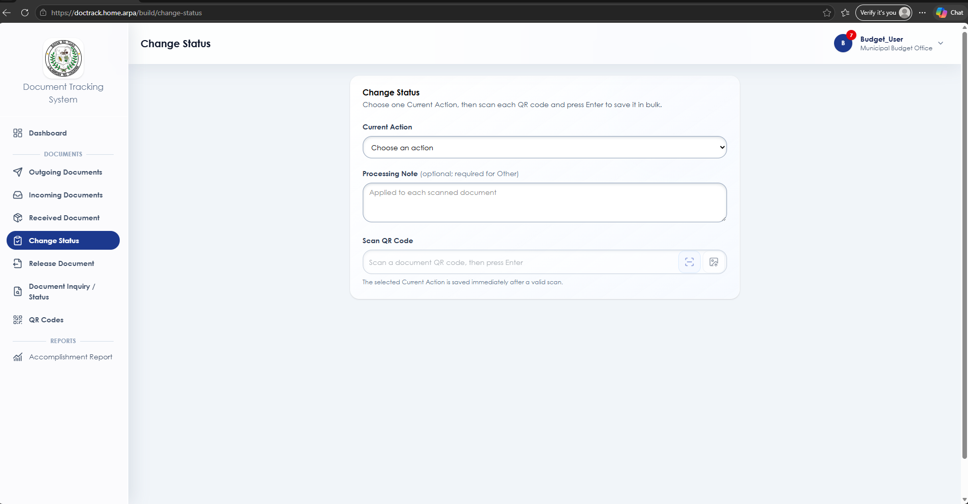
Figure 4.16. Bulk Change Status view: actual running application
Purpose: updates the status of multiple eligible documents efficiently.
Authorized users select documents that belong to their assigned office and apply an appropriate status update. The system should only update records that meet the required role, office, and workflow conditions.
Bulk Release view
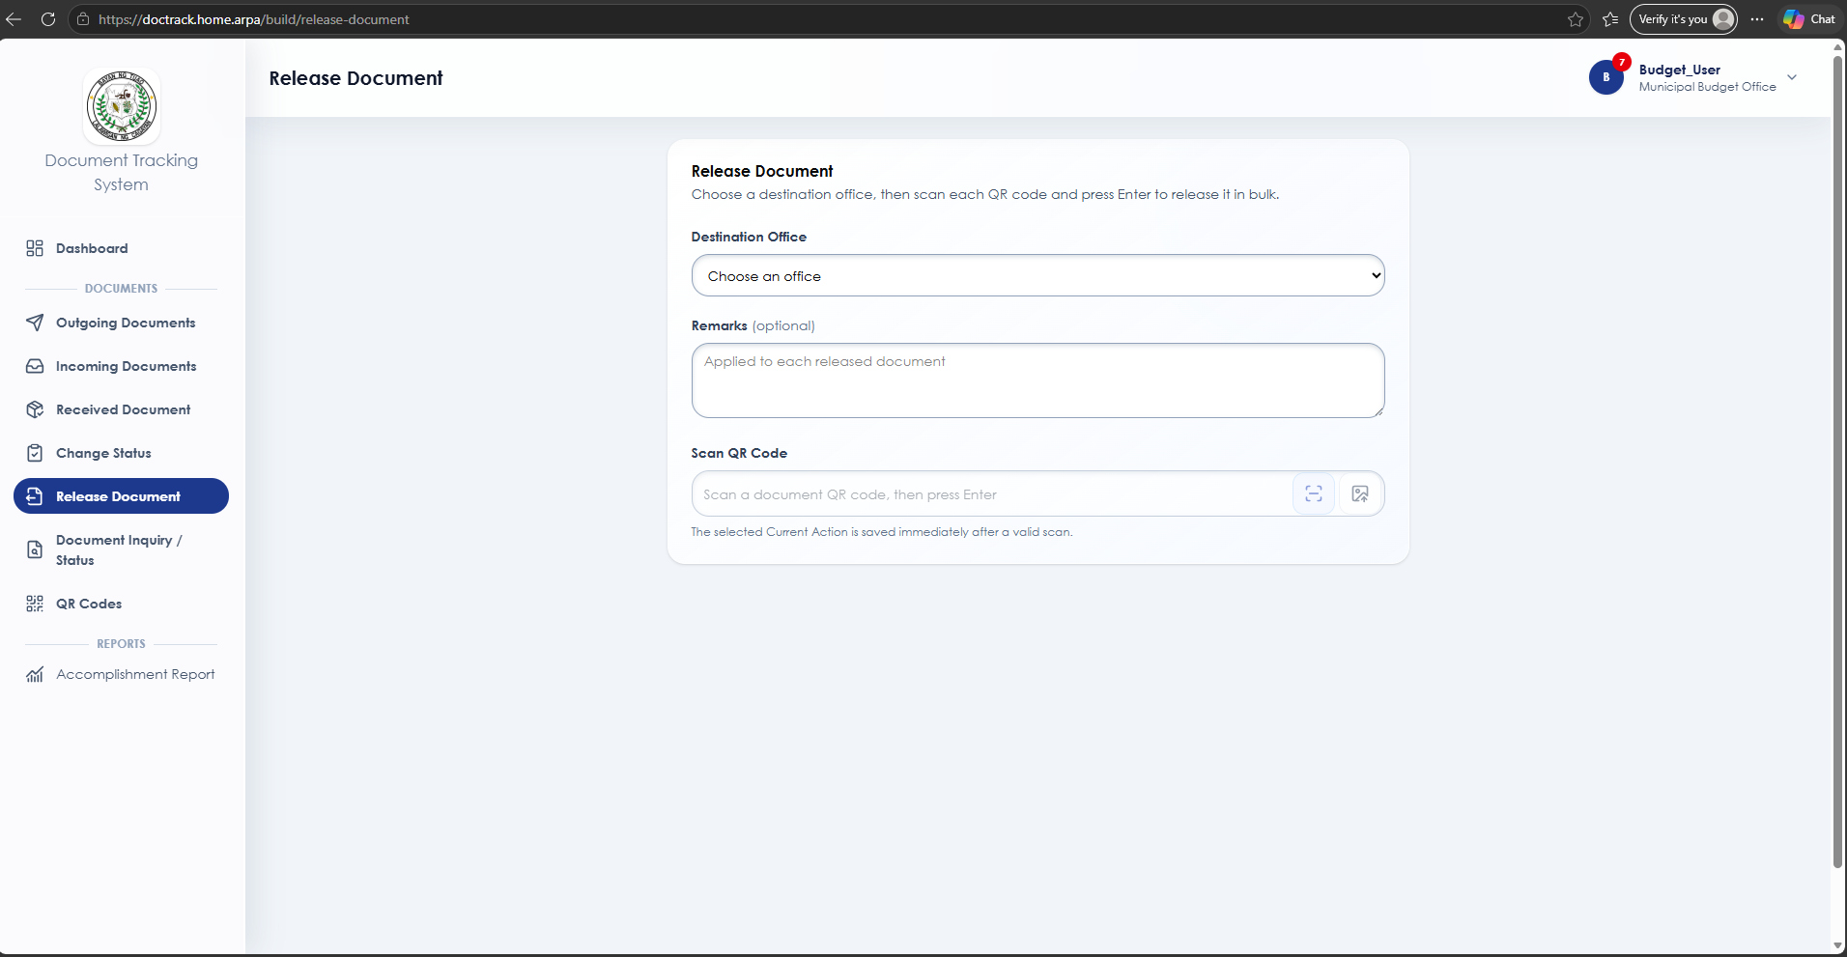
Figure 4.17. Bulk Release view: actual running application
Purpose: releases multiple documents from the assigned office for routing or transfer.
The user selects eligible documents currently held by their office and confirms their release. Each document must satisfy the system’s routing and custody rules before it can be released.
Office - Admin view
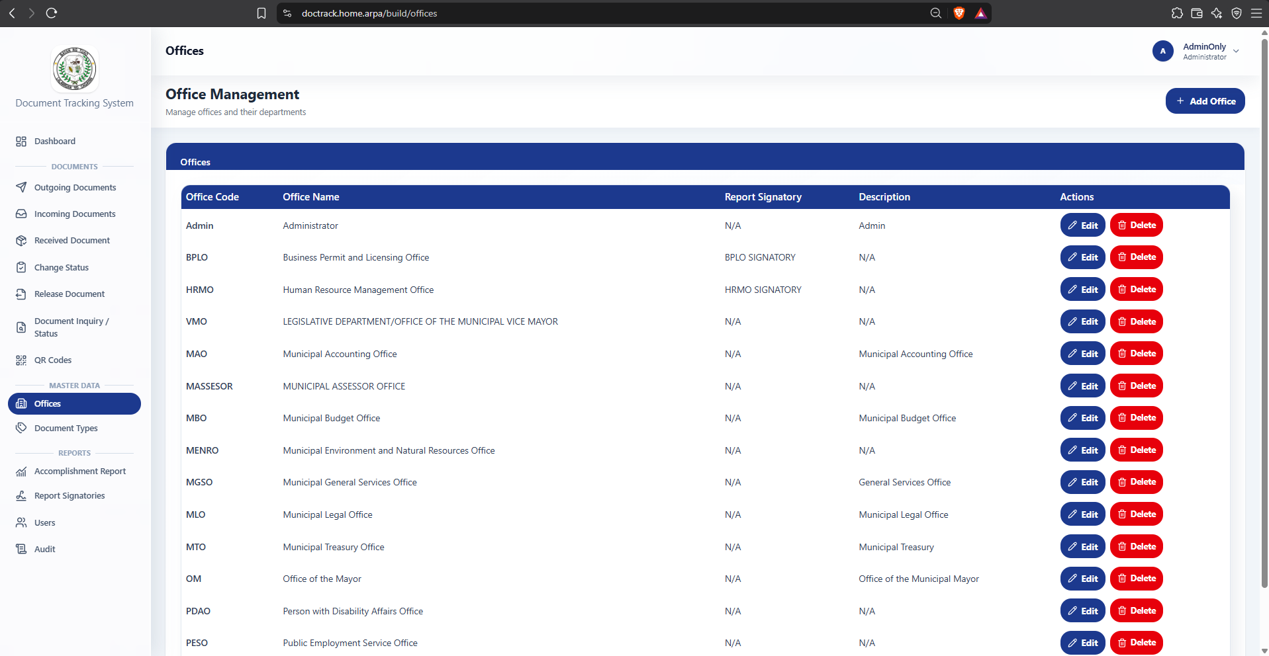
Figure 4.18. Office – Admin view: actual running application
Purpose: maintains the list of municipal offices and departments used in document routing.
The Administrator manages office information needed to identify document origins, destinations, and current custody. Accurate office records support proper routing, office-based access control, and reporting.
Document Type – Admin view
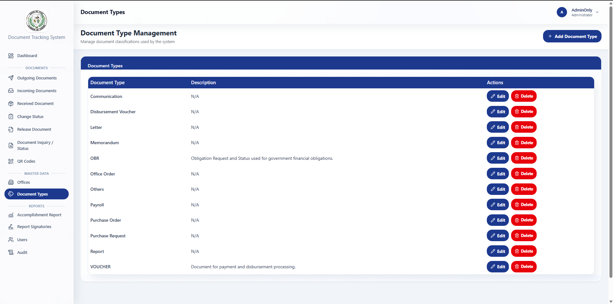
Figure 4.19. Document Type – Admin view: actual running application
Purpose: maintains the document classifications used during registration and reporting.
The Administrator can manage document types to help users consistently categorize official documents. This supports organized records, filtering, and report preparation.
Accomplishment Report view
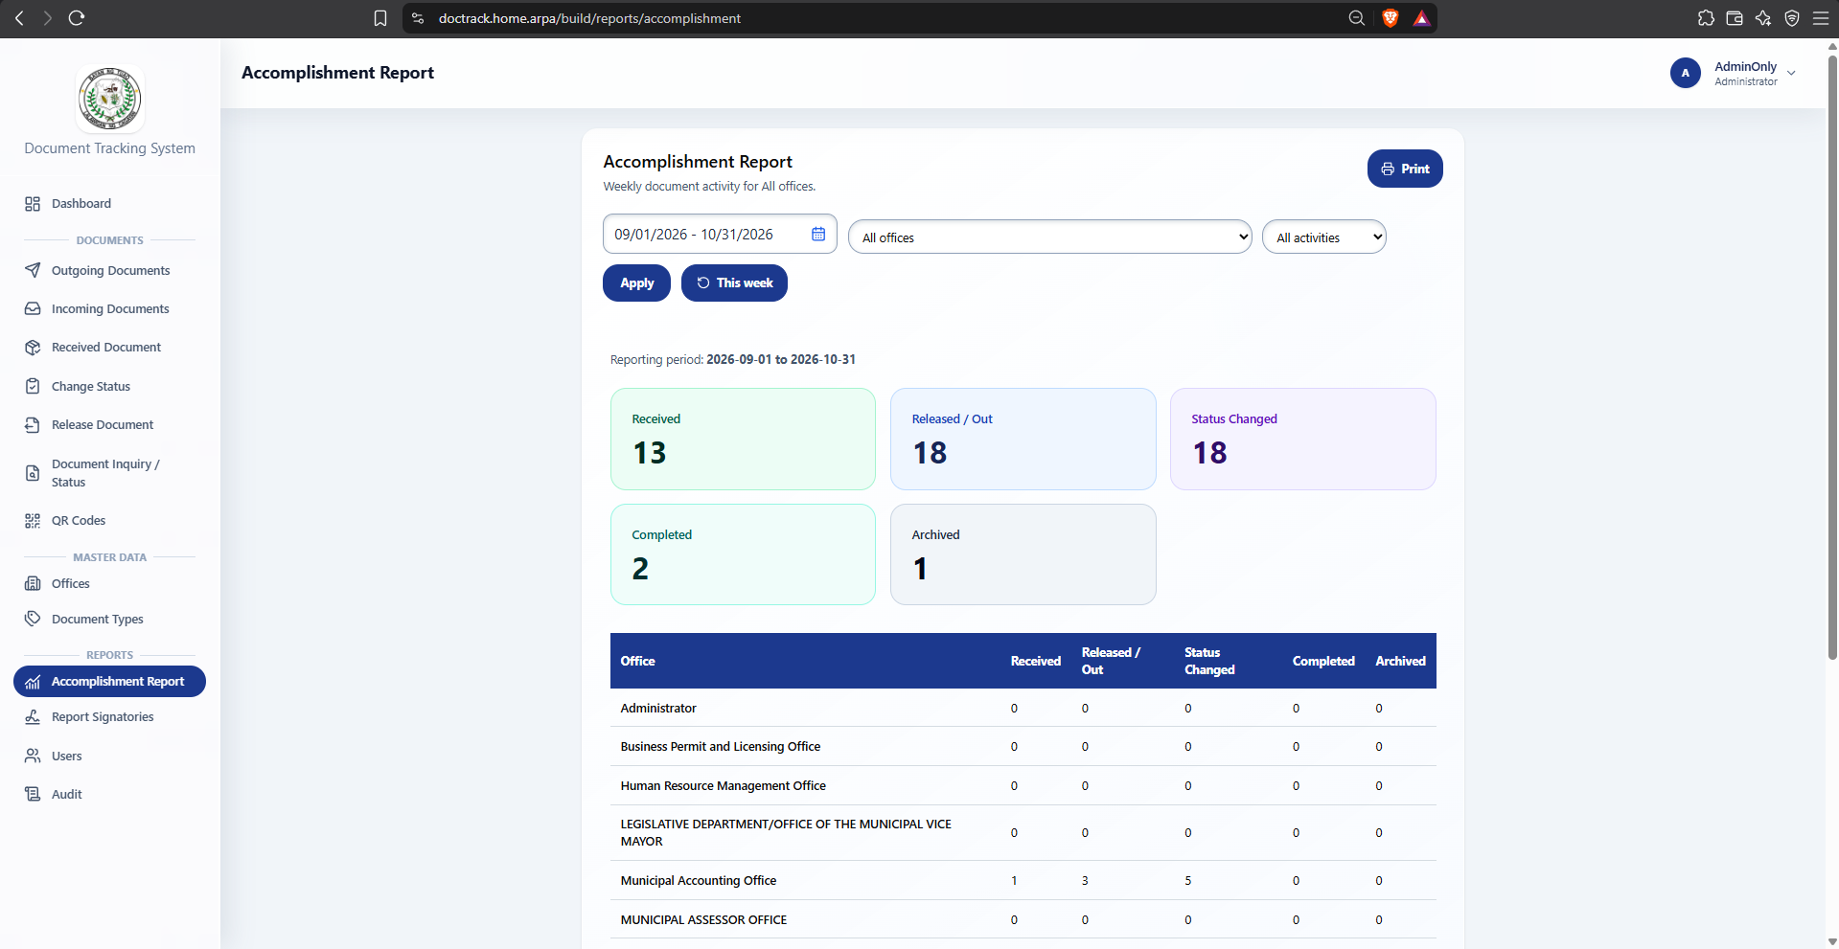
Figure 4.20. Accomplishment Report view: actual running application
Purpose: summarizes document-processing activities for monitoring and reporting.
Authorized users can generate reports based on available document records, routing activity, status, office, and selected reporting period. The report supports administrative monitoring and should be reviewed before use as an official record.
Signatories view
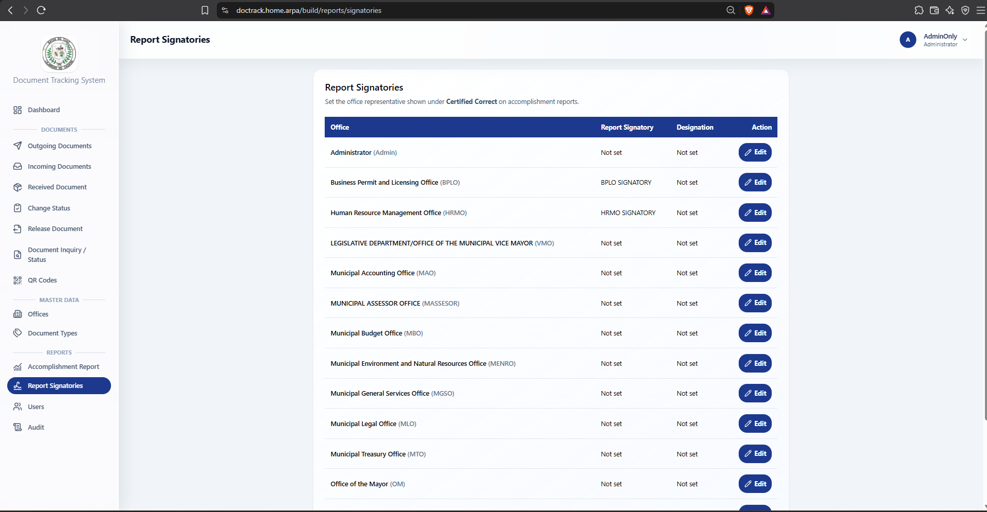
Figure 4.21. Personal settings view: actual running application
Purpose: manages signatory information used in generated reports.
The Administrator maintains the names, positions, and other approved signatory details that may appear in system-generated reports. This ensures that report outputs follow the Local Government Unit’s authorized reporting structure.
User Management view
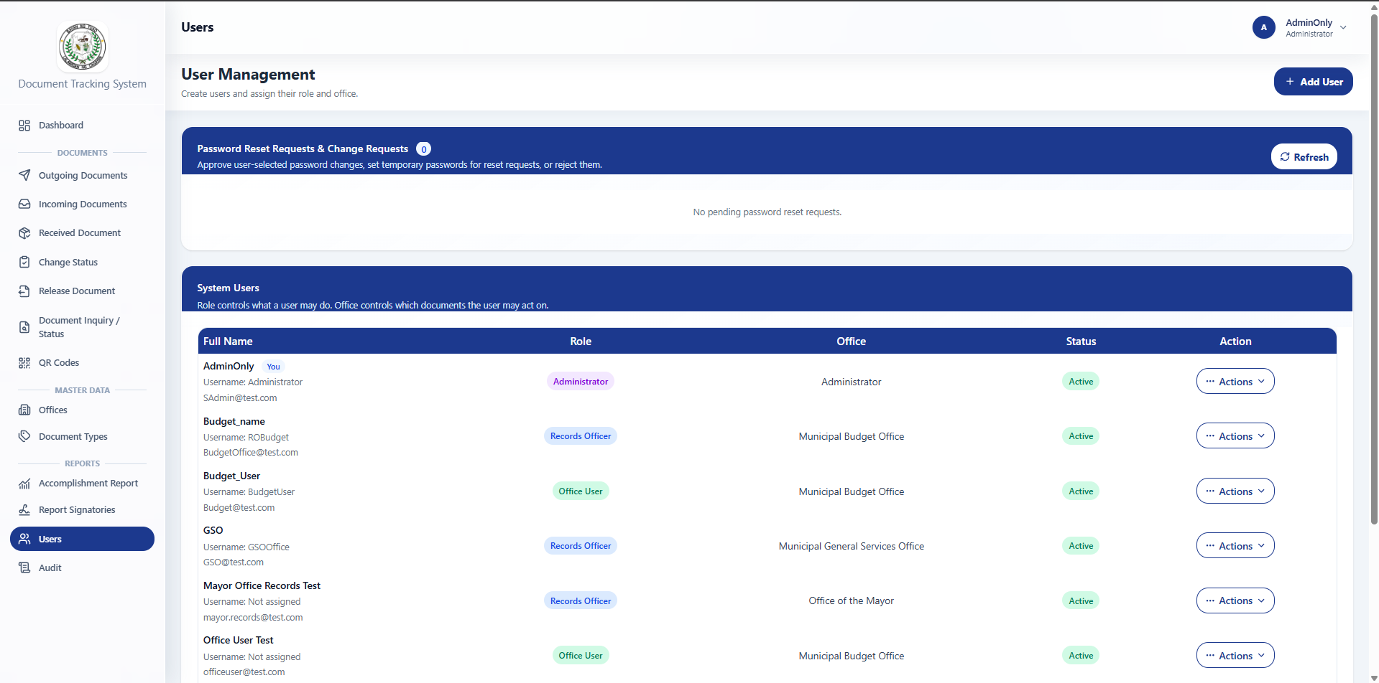
Figure 4.22. User Management view: actual running application
Purpose: manages system accounts, roles, and office assignments.
The Administrator creates, updates, activates, or deactivates user accounts and assigns the appropriate role and office. These settings determine what functions a user can access and which office-held documents they may handle.
Audit Logs view
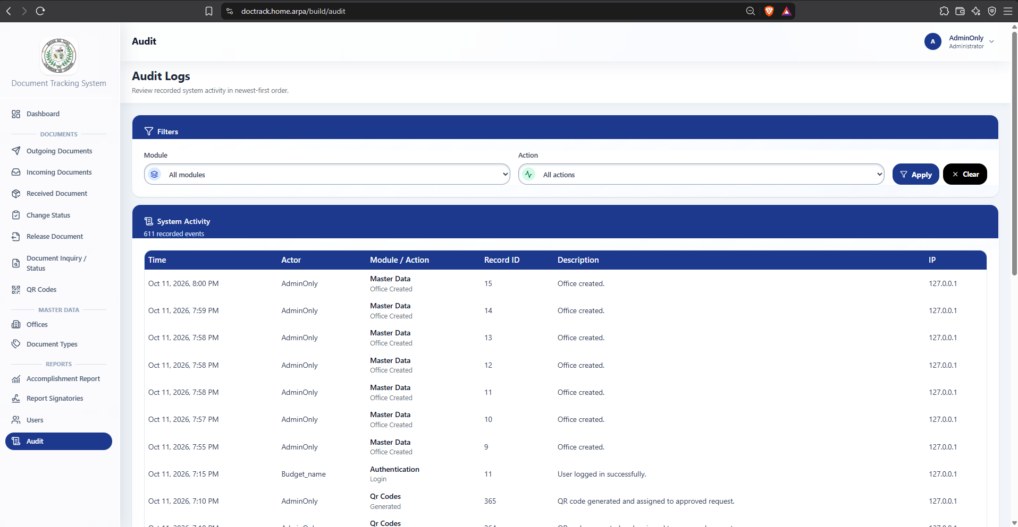
Figure 4.22. User Management view: actual running application
Purpose: records important system activities for accountability and review.
The page displays logged actions such as document transactions, user-related changes, and other recorded activities, where available. Audit logs help administrators trace actions to the responsible account, affected record, and recorded date and time.

4.2.3.2 Data Model
Table 11. Logical data domains
Domain | Principal objects | Relationship / purpose
Access Control | users; roles; offices | Defines user accounts, assigned roles, and office assignments for authorized system access.
Office and Master Data | offices; document types | Maintains office and document classification information used in registration, routing, filtering, and reports.
Document Records | documents | Stores the primary document information, including document number, subject, type, originating office, current office, and status.
QR Tracking | qr records | Links a QR reference to a document for faster retrieval, verification, and tracking.
Routing and Custody | document routes | Records document forwarding, receiving, source office, destination office, and routing history.
Processing History | processing records | Stores the current action and processing notes recorded by authorized personnel.
Accountability | audit logs | Records selected system activities, responsible users, affected records, and action details for review.

The logical data model organizes the information required by the Document Tracking System for the Local Government Unit of Tuao. The users table is associated with a role and an assigned office. These relationships support role-based access control and office-based restrictions on document actions.

The documents table serves as the central operational record. Each document is classified using a document type and is associated with an originating office and a current office. A document may have a corresponding QR record, multiple routing records, multiple processing records, and related audit-log entries throughout its lifecycle.

The document routes table preserves the movement of a document between offices, including forwarding and receipt information. The processing records table stores the action or note made by authorized users after the document has been received by their assigned office. The audit logs table supports accountability by recording selected activities performed in the system.

The figure presents a logical application-level design. The exact table names, column names, primary keys, foreign keys, and database constraints should be verified against the implemented database schema before finalizing the physical table-design documentation.

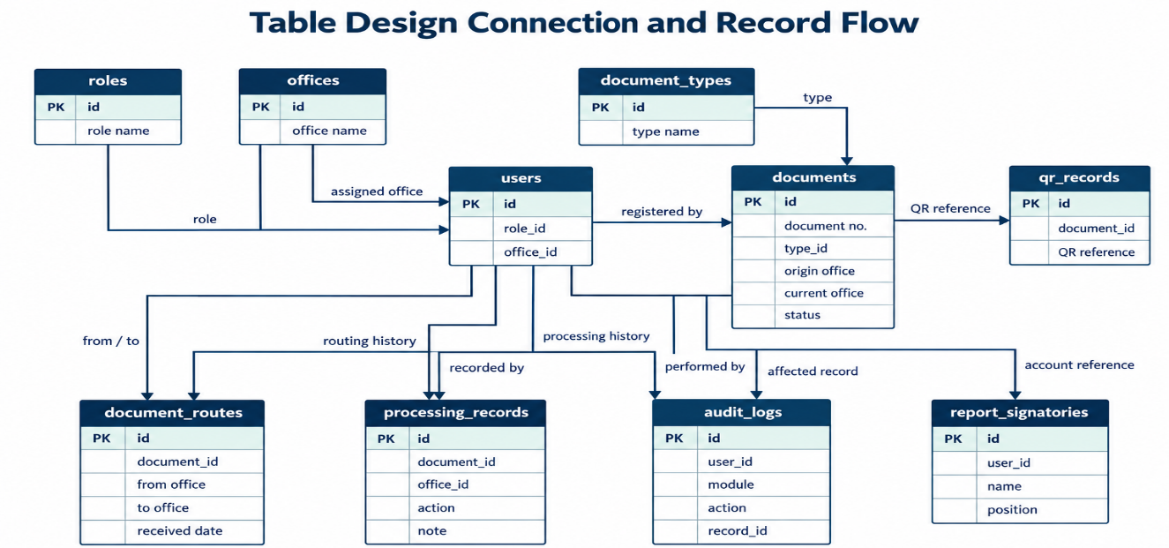
4.2.4 Table Design
Figure 4.22. Table design connection and record flow
The simplified flow follows the principal document-management path from user and office assignment through document registration, QR reference creation, routing, receipt, processing, and audit recording. Supporting roles, document types, report signatories, and report queries connect to this path without implying database constraints that have not been verified.
The diagram is a logical connection view based on the system’s documented workflow and data domains. Arrow direction indicates record relationships or information flow for documentation purposes; it does not, by itself, confirm that every relationship is enforced through a database foreign-key constraint.
Table 12. Table relationship and flow matrix
Source table | Connection field | Related table | Purpose
roles | role identifier | users | Assigns the permissions associated with a user account.
offices | office identifier | users | Assigns a user to an office for office-based access control.
document types | document-type identifier | documents | Classifies documents during registration and reporting.
users | registered-by reference | documents | Identifies the authorized account that registered a document.
offices | originating-office and current-office references | documents | Identifies the source office and current document custody.
documents | document identifier | QR records | Associates a QR reference with a document record.
documents | document identifier | document routes | Preserves each forwarding, receiving, and custody transaction.
offices | source-office and destination-office references | document routes | Identifies the offices involved in a routing transaction.
documents | document identifier | processing records | Connects a document to its current-action and processing-note history.
users | recorded-by reference | processing records | Identifies the user who recorded an authorized processing action.
offices | office reference | processing records | Identifies the office that performed the processing action.

The matrix summarizes the logical relationships that support document registration, QR tracking, routing, receipt, processing, accountability, and reporting. The documents record is the central operational object because it connects document classification, office custody, QR references, routing history, processing history, and report information.
The connection fields listed in the table describe the intended application relationships. The final physical table design should be checked against the implemented database schema to confirm the exact field names, indexes, and foreign-key constraints.
users
The users table stores account information for authorized system users. It includes the user’s identity details, login information, role, department, and assigned office. The role, department, and office references support role-based and office-based access control
Table 13. users column definitions
Field | SQL type | Null | Key
id | bigint(20) unsigned | No | PRI
name | varchar(255) | No | —
username | varchar(50) | Yes | UNI
designation | varchar(150) | Yes | —
email | varchar(255) | No | UNI
email_verified_at | timestamp | Yes | —
password | varchar(255) | No | —
must_change_password | tinyint(1) | No | —
deactivated_at | timestamp | Yes | —
remember_token | varchar(100) | Yes | —
created_at | timestamp | Yes | —
updated_at | timestamp | Yes | —
role_id | bigint(20) unsigned | Yes | FK
department_id | bigint(20) unsigned | Yes | FK
office_id | bigint(20) unsigned | Yes | FK

roles
The roles table stores the role classifications assigned to system users. These roles determine the functions that a user may access, while the user’s assigned office determines the documents that the user may handle.
Table 14. roles column definitions
Field | SQL type | Null | Key
id | bigint(20) unsigned | No | PRI
name | varchar(100) | No | —
description | text | Yes | —
created_at | timestamp | Yes | —
updated_at | timestamp | Yes | —

office
The offices table stores the offices that participate in document registration, routing, receipt, processing, and reporting. Each office may be associated with a department and has a unique office code for consistent identification within the system.
Table 15. office column definitions
Field | SQL type | Null | Key
id | bigint(20) unsigned | No | PRI
department_id | bigint(20) unsigned | Yes | FK
office_name | varchar(150) | No | —
office_code | varchar(20) | No | UNI
description | text | Yes | —
signatory_name | varchar(150) | Yes | —
signatory_designation | varchar(150) | Yes | —
created_at | timestamp | Yes | —
updated_at | timestamp | Yes | —

documents
The documents table is the central operational table. It stores the document’s reference details, classification, status, priority, confidentiality level, originating office, current office, processing information, and lifecycle dates.
Table 16. documents column definitions
Field | SQL type | Null | Key
id | bigint(20) unsigned | No | PRI
tracking_no | varchar(50) | No | Indexed
title | varchar(255) | No | —
description | text | Yes | —
document_type_id | bigint(20) unsigned | Yes | FK
status_id | bigint(20) unsigned | Yes | FK
priority_id | bigint(20) unsigned | Yes | FK
confidentiality_level_id | bigint(20) unsigned | Yes | FK
origin_office_id | bigint(20) unsigned | Yes | FK
current_office_id | bigint(20) unsigned | Yes | FK
current_action_id | bigint(20) unsigned | Yes | FK
processing_note | text | Yes | —
current_action_updated_by | bigint(20) unsigned | Yes | FK
current_action_updated_at | timestamp | Yes | —
created_by | bigint(20) unsigned | Yes | FK
document_date | date | Yes | —
due_date | date | Yes | —
completed_at | timestamp | Yes | —
completed_by | bigint(20) unsigned | Yes | FK
archived_at | timestamp | Yes | —
archived_by | bigint(20) unsigned | Yes | FK
state | varchar(255) | No | —
created_at | timestamp | Yes | —
updated_at | timestamp | Yes | —

departments
The departments table stores department information used to organize offices and user assignments
Table 17. departments column definitions
Field | SQL type | Null | Key
id | bigint(20) unsigned | No | PRI
department_name | varchar(150) | No | —
department_code | varchar(20) | No | UNI
description | text | Yes | —
created_at | timestamp | Yes | —
updated_at | timestamp | Yes | —

document_type
The document_types table stores the classifications used when registering documents. Standardized document types help users organize records, search documents, and prepare reports.
Table 18. document_type column definitions
Field | SQL type | Null | Key
id | bigint(20) unsigned | No | PRI
type_name | varchar(100) | No | UNI
description | text | Yes | —
created_at | timestamp | Yes | —
updated_at | timestamp | Yes | —

document_status
The document_statuses table stores the status values used to identify the current condition or progress of a document in the workflow.
Table 19. document_status column definitions
Field | SQL type | Null | Key
id | bigint(20) unsigned | No | PRI
status_name | varchar(50) | No | UNI
color | varchar(20) | Yes | —
created_at | timestamp | Yes | —
updated_at | timestamp | Yes | —

document_qr_codes
The document_qr_codes table stores QR-code records used to identify and retrieve document information. Each QR token is unique and may be associated with one document, a QR-code request, an assigned office, and the user who generated it.
Table 20. document_qr_codes column definitions
Field | SQL type | Null | Key
id | bigint(20) unsigned | No | PRI
qr_token | char(36) | No | UNI
status | varchar(20) | No | Indexed
document_id | bigint(20) unsigned | Yes | UNI
qr_code_request_id | bigint(20) unsigned | Yes | FK
assigned_office_id | bigint(20) unsigned | Yes | Indexed
generated_by | bigint(20) unsigned | Yes | FK
generated_at | timestamp | Yes | —
registered_at | timestamp | Yes | —
created_at | timestamp | Yes | —
updated_at | timestamp | Yes | —

document_routes
The document_routes table records the movement of documents between offices. It preserves the history of forwarding, receipt, rejection, cancellation, return routing, and related routing remarks.
Table 21. document_routes column definitions
Field | SQL type | Null | Key
id | bigint(20) unsigned | No | PRI
document_id | bigint(20) unsigned | No | FK
from_office_id | bigint(20) unsigned | No | FK
to_office_id | bigint(20) unsigned | No | FK
forwarded_by | bigint(20) unsigned | No | FK
received_by | bigint(20) unsigned | Yes | FK
rejected_by | bigint(20) unsigned | Yes | FK
cancelled_by | bigint(20) unsigned | Yes | FK
forwarded_at | timestamp | Yes | —
received_at | timestamp | Yes | —
rejected_at | timestamp | Yes | —
cancelled_at | timestamp | Yes | —
status_id | bigint(20) unsigned | No | FK
action_id | bigint(20) unsigned | Yes | FK
remarks | text | Yes | —
cancellation_reason | text | Yes | —
rejection_reason | text | Yes | —
return_route_id | bigint(20) unsigned | Yes | FK
created_at | timestamp | Yes | —
updated_at | timestamp | Yes | —

document_processing_logs
The document_processing_logs table stores the processing history of documents. Each record documents a processing event, the office and user involved, the selected processing action, and related notes.
Table 22. document_processing_logs column definitions
Field | SQL type | Null | Key
id | bigint(20) unsigned | No | PRI
document_id | bigint(20) unsigned | No | Indexed
office_id | bigint(20) unsigned | Yes | FK
user_id | bigint(20) unsigned | Yes | FK
processing_action_id | bigint(20) unsigned | Yes | FK
document_route_id | bigint(20) unsigned | Yes | FK
event_type | varchar(50) | No | Indexed
processing_note | text | Yes | —
event_note | varchar(1000) | Yes | —
created_at | timestamp | Yes | Indexed
updated_at | timestamp | Yes | —

processing_actions
The processing_actions table stores the standardized actions that authorized users may select while processing a document. It helps maintain consistent wording for current actions and processing-history records.
Table 23. processing_actions column definitions
Field | SQL type | Null | Key
id | bigint(20) unsigned | No | PRI
action_code | varchar(50) | No | UNI
action_name | varchar(100) | No | —
is_active | tinyint(1) | No | —
sort_order | smallint(5) unsigned | No | —
created_at | timestamp | Yes | —
updated_at | timestamp | Yes | —

audit_logs
The audit_logs table stores recorded system activities for accountability and review. It identifies the user who performed an action, the affected module or record, a description of the activity, and available request information.
Table 24. audit_logs column definitions
Field | SQL type | Null | Key
id | bigint(20) unsigned | No | PRI
user_id | bigint(20) unsigned | Yes | FK
module | varchar(100) | No | —
action | varchar(100) | No | —
record_id | bigint(20) unsigned | Yes | —
description | text | Yes | —
ip_address | varchar(45) | Yes | —
user_agent | varchar(255) | Yes | —
created_at | timestamp | Yes | —
updated_at | timestamp | Yes | —

qr_code_requests
The qr_code_requests table stores requests for QR codes submitted by authorized users or offices. It records the quantity requested, purpose, review details, and current request status.
Table 25. qr_code_requests column definitions
Field | SQL type | Null | Key
id | bigint(20) unsigned | No | PRI
requested_by_user_id | bigint(20) unsigned | No | Indexed
requested_office_id | bigint(20) unsigned | Yes | FK
quantity | smallint(5) unsigned | No | —
purpose | text | Yes | —
status | varchar(20) | No | Indexed
reviewed_by_user_id | bigint(20) unsigned | Yes | FK
reviewed_at | timestamp | Yes | —
review_note | text | Yes | —
created_at | timestamp | Yes | —
updated_at | timestamp | Yes | —

4.3 The Extent of Compliance of the Developed System to ISO 25010 Software Quality Standards
The developed Document Tracking System was evaluated by twenty-nine (29) respondents using an ISO/IEC 25010:2011-based software quality questionnaire. The assessment covered Functionality, Reliability, Usability, Efficiency, Maintainability, Portability, Compatibility, and Security. The respondents consisted of four (4) IT experts, one (1) administrator, eleven (11) office users, and thirteen (13) records officers.

Table 26. The Extent of Compliance of the Developed System to ISO 25010 Software Quality Standards
Quality Characteristic | Weighted Mean
Functionality | 4.56
Reliability | 4.39
Usability | 4.46
Efficiency | 4.66
Maintainability | 4.41
Portability | 4.45
Compatibility | 4.67
Security | 4.66
Overall Weighted Mean | 4.51

Table 26 presents the respondents’ evaluation of the developed Document Tracking System based on the selected ISO/IEC 25010:2011 software quality characteristics. The system obtained an overall weighted mean of 4.51, interpreted as Compliant to a Very High Extent. This indicates that the respondents found the system highly compliant with the selected software quality standards.
Compatibility received the highest weighted mean of 4.67, followed by Efficiency and Security, both with a weighted mean of 4.66. These findings indicate that the respondents found the system capable of supporting its required functions efficiently while maintaining controlled access to documents and associated records.
Functionality obtained a weighted mean of 4.56, indicating that the respondents found the system’s document registration, QR tracking, routing, receiving, processing updates, and history features appropriate to the intended workflow. Usability also received a very high evaluation, with a weighted mean of 4.46, indicating that the system’s interface, information, and workflow were generally understandable and straightforward for users.
Reliability obtained the lowest weighted mean of 4.39. Nevertheless, it was still interpreted as Compliant to a Very High Extent. The result suggests that backup and recovery procedures, error handling, and continuous system testing should remain priorities for improvement.

Table 27. Quality evidence and remaining evaluation
Characteristic | Inspected evidence | Required measurement / check
Functional Suitability | Document registration, QR code management, routing, receiving, processing, status inquiry, user management, and audit-log functions | End-to-end testing of registration, QR, routing, receipt, processing, and reporting workflows
Performance Efficiency | Web-based interface, document search, filtering, and database-supported document records | Timed task completion, concurrent-use testing, and resource-use monitoring
Compatibility | Browser-based Vue interface and Laravel API application structure | Testing using supported browsers and verification of system integrations
Usability | Role-based navigation, structured document forms, status displays, and workflow-oriented pages | User task observation and ISO/IEC 25010 questionnaire ratings
Reliability | Document-routing history, processing logs, document status records, and transactional data storage | Failure recovery, duplicate-submission, invalid-input, and retry testing
Security | Authenticated access, role-based permissions, office-based document restrictions, and audit-log structure | Direct unauthorized-access tests, wrong-office tests, and privacy review
Maintainability | Separation of frontend pages, backend routes/controllers, database tables, and master-data records | Change-impact assessment and regression testing after system modifications
Portability | Web-based deployment using Laravel, Vue, MySQL, and environment configuration | Clean installation, deployment, backup, and restoration verification

The available inspection confirmed the structure of the principal tables used by the system, including user accounts, roles, offices, document records, QR codes, document routes, processing logs, processing actions, audit logs, and QR-code requests. The system screenshots included in Section 4.2.3.1 show the visible user-interface layout and controls.
The verification did not conduct a formal participant evaluation, perform large-scale concurrent-use testing, execute destructive transactions, or produce a completed ISO/IEC 25010 questionnaire dataset. These limitations should be stated clearly. Numerical mean scores and descriptive interpretations should be added only after the completed questionnaires have been gathered, tallied, and analyzed.
Table 28. Functional acceptance scenarios for pilot execution
ID | Scenario | Expected result / evidence
F01 | Valid and invalid user sign-in | Valid credentials provide access based on the assigned account; invalid credentials are rejected.
F02 | Access a protected page without authentication | Access is denied and the user is returned to the sign-in workflow.
F03 | Register a document with complete and incomplete required details | A valid document record is saved; incomplete or invalid entries display validation feedback and are not saved.
F04 | Generate or assign a QR code to a document | A unique QR reference is associated with the selected document.
F05 | Search or retrieve a document using its tracking number or QR code | The correct authorized document record and status information are displayed.
F06 | Forward a document to another office | A routing record is created and the document reflects its pending or in-transit state.
F07 | Attempt to process a document with a pending route | The system prevents processing until the destination office has received the document.
F08 | Receive a routed document at the destination office | Document custody is transferred to the destination office and routing history is preserved.
F09 | Record a current action or processing note after receipt | The authorized office can save the action and note; a processing-history record is retained.
F10 | Attempt a document action from the wrong office or by a Viewer account | The system denies the unauthorized action through role-based and office-based restrictions.
F11 | Review document routing, processing, and audit information | Authorized users can view the available history and recorded activity for the selected document.
F12 | Generate an accomplishment report using a selected period or office | The report reflects the selected criteria and is checked against the corresponding source records.

All scenarios in the preceding table are acceptance specifications and must not be marked as passed unless they have been executed and documented. Formal test results should include the execution date, tester, application version, test-data reference, outcome, and defect identifier, where applicable.

CHAPTER V
SUMMARY OF FINDINGS AND RECOMMENDATIONS
This chapter presents the summary of findings, conclusions drawn from the results of the study, and recommendations based on the objectives of the study.

5.1 Summary of Findings

5.1.1 Objective 1: To identify the problems encountered in the existing document-management, routing, and tracking process of the Local Government Unit of Tuao.
The study identified several concerns in the existing handling of documents. These included difficulty in monitoring the current location and status of documents, delays in routing and receiving documents between offices, challenges in retrieving previous document actions and processing notes, and the additional effort required to prepare accomplishment reports and monitor document-related activities.
The existing process also presented limitations in maintaining a complete and accessible record of document movement, receipt, and processing across offices. These findings served as the basis for identifying the functional, operational, and information requirements of the developed system.

5.1.2 Objective 2: To design and develop a Document Tracking System
The Document Tracking System was developed as a web-based application.
The developed system provides functions for user authentication, role-based access control, office-based document access, document registration, QR-code management, document inquiry, incoming and outgoing document monitoring, document routing, receipt, release, current-action recording, processing notes, document-status updates, routing and processing history, user management, office and document-type management, audit logs, and accomplishment-report generation.

The developed system uses a centralized database to maintain related user, role, department, office, document type, document status, document, QR-code, routing, processing, and audit-log information.
The centralized structure allows authorized users to retrieve document information and routing history while maintaining restrictions based on user role and assigned office. It also maintains relationships between registered documents, QR-code references, routing records, receipt information, current actions, processing notes, and audit activities.
This structure supports document traceability, office-based custody, accountability, status monitoring, and the preparation of accomplishment reports.

5.1.3 Objective 3: To evaluate the software quality of the developed system using ISO/IEC 25010:2011.
The software quality of the developed system will be evaluated using the eight characteristics of ISO/IEC 25010:2011: functional suitability, performance efficiency, compatibility, usability, reliability, security, maintainability, and portability.
The evaluation will involve 37 purposively selected respondents: four IT experts, one system administrator, 24 designated office representatives, and eight office users. The respondents were selected because of their relevance to the technical evaluation, system administration, office-level workflow, and document-processing activities.
This subsection should present the actual computed weighted mean and descriptive interpretation for each quality characteristic after the completed questionnaires have been gathered, tallied, and analyzed. No numerical conclusion should be stated before the evaluation results are available.

5.2 Conclusions
Based on the findings of the study, the Document Tracking System for the Local Government Unit of Tuao was developed to address concerns related to document registration, routing, status monitoring, record retrieval, processing history, and accountability.
The system provides a centralized environment for managing user accounts, roles, offices, document types, document records, QR codes, routing transactions, receipt information, current actions, processing notes, document statuses, and audit-log information. It supports the controlled movement of documents between offices while preserving routing and processing history.
The development of the system demonstrates that the major functional requirements identified during the study were incorporated into the application. The system provides a structured approach to document tracking and office-based document custody. Its effectiveness and software quality should be supported by completed pilot-testing records and ISO/IEC 25010 evaluation results before full-scale implementation.

5.3 Recommendations
- The Local Government Unit of Tuao should continue testing and refining the system based on verified feedback from administrators, IT experts, office users, and records officers.
- Orientation and training should be provided to authorized personnel before full implementation, particularly on document registration, QR-code use, forwarding, receiving, processing notes, document release, status monitoring, and document-history viewing.
- User roles, office assignments, and access permissions should be reviewed regularly to ensure that users can perform only the actions authorized for their role and assigned office.
- The document-routing workflow should be monitored to ensure that documents are received before processing actions are recorded and that routing history remains complete, accurate, and traceable.
- QR-code issuance, assignment, and scanning procedures should be controlled to prevent duplicate, unauthorized, invalid, or improperly assigned QR references.
- Accomplishment reports and dashboard summaries should be checked against source document, routing, and processing records before they are used for official monitoring or decision-making.
- Regular database backups, restoration testing, server monitoring, error handling, and system maintenance should be conducted to improve reliability, support continuous operation, and protect document data.
- Audit-log records should be reviewed by authorized personnel to support accountability and identify unusual, unauthorized, or improper system activities.
- Future enhancements may include improved report filters, notification functions, additional dashboard indicators, enhanced search options, clearer user guidance, and other usability improvements based on operational requirements.

BIBLIOGRAPHY
Abdullah, R., & Chen, L. (2023). Balancing encryption and performance in government document systems: A Malaysian case study. Journal of Information Security and Applications, 74, 103456. https://doi.org/10.1016/j.jisa.2023.103456
Al Dallal, J. A., & Al Mukhtar, A. (2023). Secure QR code-based authentication mechanisms for information systems. International Journal of Information Security Research, 13(2), 145–158.
Alampay, E. A. (2020). Analyzing the socio-technical factors of e-government integration in the Philippines. Philippine Journal of Public Administration, 64(1), 1–30. https://paij.pup.edu.ph/index.php/paij/article/view/24
Alavi, M., & Leidner, D. E. (2001). Knowledge management and knowledge management systems: Conceptual foundations and research issues. MIS Quarterly, 25(1), 107–136. https://doi.org/10.2307/3250961
Allen, D. K. (2019). Information and records management: The case for a hybrid approach in the digital age. Routledge. https://doi.org/10.4324/9780429023745
Complex Tester. (2012). The Sashimi Model: Overlapping phases in SDLC. Software Testing Magazine. https://www.complextester.com/sashimi-model-sdlc
Department of the Interior and Local Government. (n.d.). Local Government Unit Support System. https://lguss.dilg.gov.ph/
Department of the Interior and Local Government Region IV-A. (2025, September 17). DILG to launch document management system for LGUs. https://calabarzon.dilg.gov.ph/dilg-to-launch-document-management-system-for-lgus/
Beck, K., Beedle, M., van Bennekum, A., Cockburn, A., Cunningham, W., Fowler, M., Grenning, J., Highsmith, J., Hunt, A., Jeffries, R., Kern, J., Marick, B., Martin, R. C., Mellor, S., Schwaber, K., Sutherland, J., & Thomas, D. (2001). Manifesto for Agile software development. https://agilemanifesto.org/
DENSO WAVE. (n.d.). What is a QR code? https://www.qrcode.com/en/about/
Garcia, M., & Lim, S. (2022). Measuring the impact of digital workflow automation in public administration. International Journal of Public Sector Management, 35(5), 521–539. https://doi.org/10.1108/IJPSM-03-2022-0078
International Organization for Standardization & International Electrotechnical Commission. (2011). Systems and software engineering: Systems and software Quality Requirements and Evaluation (SQuaRE): System and software quality models (ISO/IEC Standard No. 25010:2011). International Organization for Standardization. https://www.iso.org/standard/35733.html
International Organization for Standardization & International Electrotechnical Commission. (2023). Systems and software engineering: Systems and software Quality Requirements and Evaluation (SQuaRE): Product quality model (ISO/IEC Standard No. 25010:2023). International Organization for Standardization. https://www.iso.org/standard/78176.html
Laravel. (n.d.-a). Laravel Sanctum (Laravel 10.x documentation). https://laravel.com/docs/10.x/sanctum
Laravel. (n.d.-b). Task scheduling (Laravel 10.x documentation). https://laravel.com/docs/10.x/scheduling
Microsoft. (n.d.). Secure coding guidelines. https://learn.microsoft.com/en-us/dotnet/standard/security/secure-coding-guidelines
MySQL. (n.d.). MySQL 8.0 reference manual. Oracle. https://dev.mysql.com/doc/refman/8.0/en/
National Archives of the Philippines. (2025). General policies on electronic records management. https://nationalarchives.gov.ph/wp-content/uploads/2025/04/ERMP-PRIMER25.pdf
National Institute of Standards and Technology. (n.d.). Privacy framework. https://www.nist.gov/privacy-framework
National Privacy Commission. (2016). Implementing rules and regulations of Republic Act No. 10173, also known as the Data Privacy Act of 2012. https://privacy.gov.ph/implementing-rules-regulations-data-privacy-act-2012/
Open Web Application Security Project. (2021). OWASP Top 10:2021. https://top10.owasp.org/2021/
OWASP Foundation. (2025). OWASP application security verification standard (Version 5.0.0). https://github.com/OWASP/ASVS/tree/master/5.0
Republic of the Philippines. (2007). Republic Act No. 9470: National Archives of the Philippines Act of 2007. https://lawphil.net/statutes/repacts/ra2007/ra_9470_2007.html
Republic Act No. 10173, Data Privacy Act of 2012. (2012). https://privacy.gov.ph/data-privacy-act/
Republic of the Philippines. (2007). Republic Act No. 9470: National Archives of the Philippines Act of 2007. https://lawphil.net/statutes/repacts/ra2007/ra_9470_2007.html
Republic of the Philippines. (2012). Republic Act No. 10173: Data Privacy Act of 2012. https://lawphil.net/statutes/repacts/ra2012/ra_10173_2012.html
Republic of the Philippines. (2018). Republic Act No. 11032: Ease of Doing Business and Efficient Government Service Delivery Act of 2018. https://lawphil.net/statutes/repacts/ra2018/ra_11032_2018.html
Schwaber, K., & Sutherland, J. (2020). The Scrum guide: The definitive guide to Scrum: The rules of the game. https://scrumguides.org/scrum-guide.html
Vue.js. (n.d.). Introduction. https://vuejs.org/guide/introduction.html
Zadorozhnyi, O., Koval, V., & Melnyk, I. (2025). Digital transformation of document management through QR code integration. Journal of Digital Administration and Governance, 9(1), 23–39.

APPENDICES

Appendix A. Request Letter for Gathering Data

March 4, 2026

HON. FRANCISCO N. MAMBA II

Municipal Mayor

Local Government Unit of Tuao

Tuao, Cagayan

Dear Mayor Mamba:

The undersigned is a student of the Graduate School taking up Master of Science in Information Technology at Cagayan State University, Carig Campus.

As a requirement for the completion of our thesis, we respectfully request permission from your good office to conduct a study entitled, “Document Tracking System for the Local Government Unit of Tuao.”

The study aims to examine the existing document-registration, routing, tracking, and processing procedures of the Local Government Unit of Tuao. The information gathered will be used as the basis for developing and evaluating the proposed system.

Please be assured that all information collected will be treated with confidentiality and will be used solely for academic purposes. We would be very grateful for your favorable consideration of this request.

Thank you very much for your time and kind attention.

Respectfully yours,

KEVIN D. APIL

Student, MSIT

Appendix B. Request for Pilot Testing
REQUEST FOR PILOT TESTING AND SYSTEM EVALUATION
September 21, 2026

HON. FRANCISCO N. MAMBA II
Municipal Mayor
Local Government Unit of Tuao
Tuao, Cagayan

Dear Mayor Mamba:
The undersigned is a student of the Graduate School taking up Master of Science in Information Technology at Cagayan State University, Carig Campus.
In connection with the conduct of the study entitled, “Document Tracking System for the Local Government Unit of Tuao” the undersigned respectfully requests permission to conduct pilot testing and system evaluation among selected authorized personnel of the Local Government Unit of Tuao.
The activity will include system orientation, demonstration and testing of the major functions of the developed system, observation of system performance, and administration of the software-quality evaluation questionnaire based on ISO/IEC 25010:2011.
The pilot testing aims to determine whether the developed system supports the intended processes for document registration, QR-code management, document inquiry, routing, receipt, processing, document-status monitoring, user and office administration, audit logging, and accomplishment-report generation.
Comments, observations, and recommendations from the participants will also be gathered and used as the basis for the further improvement and refinement of the developed system.
Please be assured that all information gathered during the activity will be treated with confidentiality and will be used solely for academic and research purposes. Demonstration or test data may be used whenever necessary to avoid unnecessary disclosure of confidential official-document information.
Your favorable consideration and approval of this request will be highly appreciated.
Thank you very much for your time and kind attention.
Respectfully yours,

KEVIN D. APIL
Researcher / MSIT Student

Appendix C. Users Manual
DOCUMENT CONTROL
Table 31. Users manual document control
Item | Controlled information
Document Title | Document Tracking System Users Manual
System | Document Tracking System System for the Local Government Unit of Tuao
Version | Presentation Draft – October 2026
Prepared By | Kevin D. Apil
Institution | Cagayan State University - Graduate School, Carig Campus
Intended Users | Authorize Staff per Office of LGU Tuao
Review Status | For adviser, panel, and authorized Local Government Unit review

This manual follows the implemented browser-based workflow of the Document Tracking System. Available menus, labels, and actions may vary according to the user’s role, assigned office, and future system updates. Authorized accounts and the Local Government Unit’s assigned system address are required to access staff functions. Any localhost address shown in screenshots identifies the documentation or testing environment only.

C.1 Accessing the System
C.1.1 Access and Sign-In
System access establishes the user’s identity, role, and assigned office. These details determine the documents and functions that the user may access.
- Open the assigned web address of the Document Tracking System for the Local Government Unit of Tuao.
- Enter the assigned email address or username and password, then select Sign In.
- Verify that the displayed account name, role, and assigned office are correct before performing any document-related action.
- Complete the required password change when prompted. Do not use an account that is assigned to the wrong office or role.
- Select Logout when finished, especially when using a shared workstation.
C.1.2 Password Recovery
- Select Forgot Password or follow the Local Government Unit’s authorized password-reset procedure.
- Enter the required account information.
- Follow the instructions provided by the Administrator or authorized system personnel.
- Create a new password that is not shared with other users.
C.1.3 Account Menu and Settings
- The account menu displays the signed-in user’s account information and provides access to available account options.
- Select the account or profile menu.
- Review the displayed name, role, and assigned office.
- Update personal information or change the password only when the option is available.
- Report incorrect role or office information to the Administrator.
C.2 Registering and Monitoring Documents
C.2.1 Register Document
The Register Document page is used by authorized personnel to create a new document record.
- Open Register Document from the navigation menu.
- Enter the tracking number, title, document type, document date, originating office, priority, confidentiality level, and other required information.
- Review the entered information before saving.
- Select Save or Register Document.
- Confirm that the document appears in the document list and has a tracking reference.
- Only authorized personnel should register documents. Required fields must be completed before the record can be saved.
C.2.2 Outgoing Documents
- The Outgoing Documents page displays documents forwarded or released by the user’s assigned office.
- Open Outgoing Documents.
- Use the available search or filter options to locate a document.
- Review the document title, destination office, forwarding date, and routing status.
- Select a document to view its details or routing history.
C.2.3 Incoming Documents
- The Incoming Documents page displays documents routed to or received by the user’s assigned office.
- Open Incoming Documents.
- Review documents that are pending receipt or awaiting office action.
- Select a document to view its details and routing information.
- Receive or process the document only when the action is available to the user’s role and office.
C.3 Routing and Processing Documents
C.3.1 Document Details and Routing History
The Document Details page displays the complete available information for a selected document.
- Search for or select a document from the document list.
- Review the tracking number, title, document type, origin office, current office, status, and current action.
- Review the routing and processing-history sections to identify previous document movement and actions.
- Perform only the actions available to the signed-in role and assigned office.
C.3.2 Forwarding a Document
- Open the selected document’s details page.
- Confirm that the document is currently held by the user’s assigned office.
- Select Forward or the available routing action.
- Select the destination office and enter routing remarks when required.
- Review the destination office before confirming the action.
- Confirm the forwarding transaction.
- After forwarding, the document becomes pending or in transit until it is received by the destination office.
C.3.3 Receiving a Document
- Open Incoming Documents or the document details page.
- Select the routed document.
- Confirm that the document is intended for the user’s assigned office.
- Select Receive Document.
- Confirm the receipt action.
- Receiving the document transfers current custody to the destination office and preserves the routing history.
C.3.4 Recording Current Action and Processing Note
- Open the document details page after the document has been received by the assigned office.
- Select the available current action or processing action.
- Enter a processing note when necessary.
- Review the information and save the action.
- A document with a pending route should not be processed until it has been received by the destination office.
C.3.5 Releasing, Returning, or Changing Document Status
- Open the selected document.
- Confirm that the document is held by the assigned office.
- Select the available release, return, or status action.
- Provide a reason or remark when required.
- Confirm the transaction.
- The system records the action in the routing or processing history.
C.3.6 Bulk Receive, Bulk Release, and Bulk Change Status
These functions are used to process multiple eligible documents efficiently.
- Open the applicable document list.
- Select only documents that belong to the user’s assigned office.
- Select Bulk Receive, Bulk Release, or Bulk Change Status, when available.
- Review the selected documents and confirm the action.
- Check the resulting document statuses and routing history.
Documents that do not meet the required role, office, or workflow conditions should not be processed through bulk actions.

C.4 Document Inquiry, QR Codes, and Reports
C.4.1 Document Inquiry and Status
- Open Document Inquiry.
- Enter a tracking number, title, QR reference, or other available search information.
- Select the correct document from the results.
- Review the current office, status, routing history, and processing history.
Document inquiry provides read access only to information allowed by the user’s role and office permissions.
C.4.2 QR Code Management and Scanning
QR codes are used to identify and retrieve document records.
- Open the QR Code page or use the QR option on a document record.
- Generate, assign, request, or scan a QR code only when authorized.
- Verify that the QR code is associated with the correct document.
- Scan the QR code to retrieve the corresponding document record.
- Report unreadable, duplicate, or incorrectly assigned QR codes to the Administrator.
C.4.3 Dashboard
The Dashboard provides summary information for authorized users.
- Open Dashboard from the navigation menu.
- Select available date, office, or status filters.
- Review the displayed counts, summaries, and document-monitoring information.
- Use dashboard information for monitoring purposes and verify source records before using figures in an official report.

C.4.4 Accomplishment Reports
- Open Accomplishment Reports or Reports.
- Select the required reporting period, office, document status, or other available criteria.
- Generate the report.
- Review the report details against the corresponding source document records
- Save, print, or submit the report only after authorized review.
C.5 Administrative Functions
C.5.1 Office Management
This function is available to authorized Administrators.
- Open Offices
- Add, update, or deactivate records as authorized.
- Enter the office, code, and other required information.
- Review the information before saving.
Accurate office and department records are necessary for document routing and user assignment.
C.5.2 Document Types, Statuses, and Processing Actions
- Open the applicable master-data page: Document Types, Document Statuses, or Processing Actions.
- Add or update the required classification or action.
- Confirm that the name or code does not duplicate an existing record.
- Save the record.
Only active and correctly configured values should be used in document registration and processing.

C.5.3 User Accounts, Roles, and Office Assignments
- Open User Management.
- Add, update, activate, or deactivate a user account as authorized.
- Assign the correct role, department, and office.
- Verify the user’s email address or username.
- Save the account information.
Roles determine permitted functions, while office assignment determines which office-held documents a user may handle.
C.5.4 QR Code Requests
- Open QR Code Requests.
- Enter the requested quantity and purpose.
- Submit the request for review.
Authorized reviewers may review the request, add a review note, and update its status.
C.5.5 Audit Logs
The Audit Logs page is available only to authorized personnel.
- Open Audit Logs.
- Use available filters to locate relevant activities.
- Review the user, module, action, affected record, and date of the recorded activity.
- Use audit-log information for accountability and review purposes.
Table 32. Troubleshooting guide
Symptom | Check | Appropriate next step
Cannot sign in | Entered email address or username, password, account active status, and system availability | Use the authorized password-reset or support process; do not share accounts or credentials.
Session expired | Login state and possible inactivity | Sign in again and confirm whether unsaved work must be re-entered.
Incorrect role or office displayed | Assigned role, department, and office information | Stop performing document actions and request correction from the Administrator.
No document search match | Tracking number, QR reference, title, spelling, date, and applied filters | Verify the reference information and search again; ask authorized staff to confirm the document record when necessary.
Cannot receive a document | Destination office, routing status, and assigned office | Confirm that the document was routed to the user’s assigned office and remains pending receipt.
Cannot process a document | Current office, pending route, user role, and available processing action | Receive the document first if it is pending; ensure that the user has the required role and office assignment.
Cannot forward or release a document | Current document custody, destination office, required fields, and user permission | Confirm that the document is currently held by the assigned office and complete required routing information.
QR code cannot be scanned | Camera or scanner permission, QR-code quality, lighting, and supported browser | Allow camera access, improve scanning conditions, or use the tracking-number search option.
QR code does not retrieve the expected document | QR assignment, QR status, and document association | Stop processing the record and report the incorrect QR assignment to the Administrator.
Report cannot be generated | Selected report criteria, browser connection, and report-service availability | Retry with valid criteria; report the issue to authorized technical personnel if it continues.
System page does not load | Network connection, assigned system address, browser, and server availability | Refresh the page, verify the connection, and report the issue to the Administrator or technical custodian.

Appendix D. ISO 25010 Questionnaire
Survey-Questionnaire
Software Effectiveness Questionnaire of the System using ISO/IEC 25010:2011 or ISO 9126 Quality Standards
(This survey-questionnaire is designed to determine the efficiency of the _________________________________________________________).
Part I. Profile of the Respondents
Kindly fill-in the blanks with required information or by simply putting a (√) check mark.
Age: __ below 30 years old
__ 31 – 40 years old
__ 41 – 50 years old
__ 51 – 60 years old
__ above 60 years old
Sex: ___ Male ___ Female
Highest Educational Attainment:
College ___
Post-Graduate ___

Part II. Assessment of the Extent of Compliance to ISO 25010:2011 Software Quality
Instruction: Kindly indicate by putting a check mark (√) in the appropriate box your assessment on the extent of compliance to ISO 25010:2011 of the developed web-based performance measurement systemin terms of Functionality, Reliability, Usability, Efficiency, Maintainability, Portability and security using the following scale:
5 – Compliant to a very high extent
4 – Compliant to a high extent
3 – Compliant to a moderate extent
2 – Compliant to a low extent
1 – Compliant to a very low extent
- Functionality | 5 | 4 | 3 | 2 | 1 | Comments
- The required task is performed by the system satisfactorily
- The output generated by the system is correct.
- The system helps the user overcome any problem encountered while using it.
- The system regulates user access.
- Reliability | 5 | 4 | 3 | 2 | 1 | Comments
- Most errors have been corrected over time.
- The system is capable of maintaining its performance despite the presence of errors during operations.
- The system provides restore operation of lost data after a failure.
- Usability | 5 | 4 | 3 | 2 | 1 | Comments
- The user interface is intuitive and receptive to learning.
- The information generated by the system is easy to understand and act upon.
- The documentation is very informative.
- The system performs tasks in a straightforward manner.
- Efficiency | 5 | 4 | 3 | 2 | 1 | Comments
- The system responds immediately to user commands other input.
- The system maximizes the utilization of available resources (i.e. people, data, machines, and materials) efficiently.
- The system performs efficiently on intended tasks with ease and scalability.
Maintainability | 5 | 4 | 3 | 2 | 1 | Comments
Deficiencies can be easily diagnosed and modified from the system.
The system can be easily customized and modified.
The system continues functioning if changes are made.
The system can easily be tested.
F. Portability | 5 | 4 | 3 | 2 | 1 | Comments
The system performs its functions efficiently even it is moved to another environment.
The system can be installed easily.
The system can be installed easily.
The system complies with the portability standards.
The system can take the place of other software.
Compatibility | 5 | 4 | 3 | 2 | 1 | Comments
The system can perform its required functions efficiently
The degree to which the system can exchange information and use the information that has been exchange,
Security | 5 | 4 | 3 | 2 | 1 | Comments
The system has its security level access with pre-determined action.
The data is secured as well as its associated records.
Access to top-level management data is topped with necessary security credentials.

Source: ISO 25010:2011 Software Quality Model

Kindly list below YOUR PERCEIVED “BEST FEATURES OR STRENGTH” of the developed system.
- ____________________________________
- ____________________________________
- ____________________________________
- ____________________________________
- ____________________________________

Kindly list below YOUR PERCEIVED “LIMITATIONS OF THE SYSTEM NEEDED TO BE ADDRESSED”.
- ____________________________________
- ____________________________________
- ____________________________________
- ____________________________________
- ____________________________________

Suggestions:

__________________________________________________________________________________________

Appendix E. Source Code
TECHNICAL SOURCE APPENDIX
This appendix identifies the principal implementation files and includes selected verbatim excerpts from the inspected project. The complete repositories remain the implementation deliverable. Environment secrets, credentials, patient records, generated tokens, and dependency source are excluded from the manuscript.
Table 43. Source-code organization
Location | Responsibility
routes/api.php | API routes, authentication middleware, and protected system endpoints
app/Http/Controllers/ | Server-side document, QR-code, routing, processing, user-management, and report operations
app/Models/ | Eloquent models and relationships for users, offices, documents, QR codes, routes, processing logs, and audit logs
database/migrations/ | Versioned database schema changes for system tables and relationships
[Vue application folder]/src/router/ | Frontend page routes, navigation guards, and protected route handling
[Vue application folder]/src/pages/ | User-interface pages for dashboard, document registration, inquiry, routing, QR codes, reports, and administration
[Vue application folder]/src/components/ | Reusable interface components, forms, tables, dialogs, and document-status displays
[Vue application folder]/src/services/ | API request functions and frontend service logic, where implemented
app/Http/Middleware/ | Server-side authentication, role, and access-control checks, where implemented
E.1 Office-scoped document processing validation
Source: app/Http/Controllers/DocumentProcessingController.php, lines 287–319.
$document = Document::whereKey($documentId)
->lockForUpdate()
->firstOrFail();

if (
!$user->office_id ||
!DB::table('offices')->where('id', $user->office_id)->exists()
) {
abort(403, 'Your user account is not assigned to a valid office.');
}

if ((int) $user->office_id !== (int) $document->current_office_id) {
abort(403, 'You cannot update the processing action because this document is not currently assigned to your office.');
}

$currentStatus = DocumentStatus::whereKey($document->status_id)
->first();

if (
$currentStatus &&
in_array($currentStatus->status_name, ['Completed', 'Archived'], true)
) {
abort(409, 'Completed or archived documents cannot receive new processing updates.');
}

if (
DocumentRoute::where('document_id', $document->id)
->pending()
->lockForUpdate()
->exists()
) {
abort(409, 'This document must be received before its processing action can be updated.');
}
This control ensures that a processing action can only be updated by a user assigned to the office currently holding the document. It also prevents processing while the document is in transit and prevents changes to completed or archived documents.

E.2 QR request approval and controlled QR issuance
Source: app/Http/Controllers/QrCodeRequestController.php, lines 113–175.
$result = DB::transaction(function () use ($qrCodeRequest, $validated, $user) {
$lockedRequest = QrCodeRequest::whereKey($qrCodeRequest->id)
->lockForUpdate()
->firstOrFail();

if ($lockedRequest->status !== QrCodeRequest::STATUS_PENDING) {
throw new HttpResponseException(response()->json([
'message' => 'This QR code request has already been reviewed.',
], 409));
}

$qrCodes = collect();

for ($index = 0; $index < $lockedRequest->quantity; $index++) {
$qrCodes->push(DocumentQrCode::create([
'qr_token' => $this->generateQrToken(),
'status' => 'unused',
'document_id' => null,
'qr_code_request_id' => $lockedRequest->id,
'assigned_office_id' => $lockedRequest->requested_office_id,
'generated_by' => $user->id,
'generated_at' => now(),
]));
}

$lockedRequest->update([
'status' => QrCodeRequest::STATUS_APPROVED,
'reviewed_by_user_id' => $user->id,
'reviewed_at' => now(),
'review_note' => $validated['review_note'] ?? null,
]);
return [$lockedRequest->fresh([
'requestedBy',
'requestedOffice',
'reviewedBy',
'qrCodes',
]), $qrCodes];
});
This control prevents duplicate approval through a database transaction and record lock. Upon approval, unique unused QR codes are generated, linked to the request, and assigned to the requesting office.

E.3 Role-based API authorization
Source: app/Models/User.php, lines 50–85; routes/api.php, lines 261–294.
public const ROLE_PERMISSIONS = [
'Administrator' => ['*'],

'Records Officer' => [
'documents.view',
'documents.create',
'documents.edit',
'documents.process',
'documents.route',
'attachments.view',
'attachments.manage',
'qr.request',
'qr.view',
'qr.manage',
'master_data.view',
'reports.view',
'audit.view',
],

'Office User' => [
'documents.view',
'documents.process',
'documents.route',
'attachments.view',
'attachments.manage',
'qr.request',
'master_data.view',
'reports.view',
],

'Viewer' => [
'documents.view',
'attachments.view',
'master_data.view',
'reports.view',
],
];
Route::post(
'qr-code-requests/{qrCodeRequest}/approve',
[QrCodeRequestController::class, 'approve']
)->middleware('can:qr.approve');

Route::post(
'qr-code-requests/{qrCodeRequest}/reject',
[QrCodeRequestController::class, 'reject']
)->middleware('can:qr.approve');

Route::post(
'qr-codes/verify-registration',
[DocumentQrCodeController::class, 'verifyForRegistration']
)->middleware('can:documents.create'); }
This control separates permissions by role and enforces them on the Laravel API. Therefore, hiding a frontend button alone does not grant access: an unauthorized API request is still denied by server-side middleware.

CURRICULUM VITAE
Personal Data
Full Name: | KEVIN D. APIL | 
Date of Birth: | December 30, 1990
Place of Birth: | Enrile, Cagayan
Civil Status: | Married
Home Address: | P6 Mungo, Tuao, Cagayan

Professional Profile
An administrative and information technology support professional currently serving as an Administrative Aide III at the Provincial Government of Cagayan – Nuestra Señora de Piat District Hospital. Designated as the Information and Communications Technology (ICT) Focal Person, responsible for supporting the hospital’s clerical, technical, and information-system requirements.

Experienced in clerical and administrative work, computer maintenance, technical troubleshooting, user support, and system development. Assists in maintaining computer equipment, managing digital files and records, preparing reports and documents, and providing technical assistance to hospital personnel. Also involved in the development and enhancement of simple information-system solutions that support daily hospital operations and improve the organization of records and services.

Socials
Facebook: | https://www.facebook.com/kaidee.apil

Educational Background
Tertiary: | Bachelor of Science in Information Technology Cagayan State University, Carig Campus, Tuguegarao City, Cagayan,  2012-2016
Secondary: | Enrile Vocational Highschool, Enrile, Cagayan  2003-2007
Elementary: | Enrile North Central School, Enrile, Cagayan  1995-2003

Work Experience
2025 - Present | Administrative Aide III  Designated as ICT Focal Person  Administrative Section  Provincial Government of Cagayan - Nuestra Señora de Piat District Hospital
2016-2025 | Administrative Aide I (Job Order)  Administrative Section  Provincial Government of Cagayan - Nuestra Señora de Piat District Hospital

