DEVELOPMENT OF A WEB-BASED QR CODE-ENABLED DOCUMENT TRACKING, ROUTING AND MANAGEMENT SYSTEM FOR THE LOCAL GOVERNMENT UNIT OF TUAO
A Thesis Documentation
Presented to the Faculty of the Graduate School
Cagayan State University Carig Campus
Tuguegarao City

In Partial Fulfillment of the Requirements for the Degree
MASTER OF SCIENCE IN INFORMATION TECHNOLOGY

Prepared by
[RESEARCHER NAME TO BE SUPPLIED]
2026

APPROVAL SHEET
This thesis documentation entitled Development of a Web-Based QR Code-Enabled Document Tracking, Routing and Management System for the Local Government Unit of Tuao is submitted for examination and approval. Names, signatures, institutional identifiers, and defense date must be completed by the researcher and the institution before submission.
Required approval item | To be supplied before defense
Researcher | Name and signature
Adviser | Name, credentials, and signature
Panel members | Names, credentials, and signatures
Date and venue | Official defense record

ACKNOWLEDGEMENT
The researcher acknowledges the Local Government Unit of Tuao, the adviser, faculty members, participating personnel, family, and colleagues whose guidance and cooperation support the completion of this project documentation.

DEDICATION
This work is dedicated to public servants, records personnel, educators, family members, and future researchers who advocate accountable and responsive public service.

TABLE OF CONTENTS
Front Matter
Abstract
CHAPTER I. The Problem and Its Background
CHAPTER II. Review of Related Literature and Systems
CHAPTER III. Research Methodology
CHAPTER IV. System Design and Implementation
CHAPTER V. Testing, Findings, Conclusion, and Recommendations
References
Appendices
Curriculum Vitae
The heading structure is retained so the institution may generate or refresh a page-numbered Word table of contents after final title-page and approval information are supplied.

LIST OF TABLES
Table 1. Functional requirements
Table 2. Non-functional requirements
Table 3. Role and office-scope authorization matrix
Table 4. Core database data dictionary
Table 5. API endpoint summary
Table 6. Verified test-case evidence
Table 7. Information still required before final defense submission

LIST OF FIGURES
Figure 1. System architecture
Figure 2. Controlled document workflow
Figure 3. Role permission and office scope model
Figure 4. Core entity relationship view
Figure 5. Primary use cases
Figure 6. Document routing sequence
Figure 7. Login page
Figure 8. Dashboard
Figure 9. Outgoing documents view
Figure 10. QR code management
Figure 11. Document inquiry view
Figure 12. User management view
Figure 13. Office master data view
Figure 14. Audit-log view
Figure 15. Accomplishment report view

ABSTRACT
DocTrackTuao is a Laravel and Vue web application for internal document registration, QR-supported identification, routing, receipt, processing, controlled attachment handling, history, audit logging, and reporting for the Local Government Unit of Tuao. The implementation maintains server-side authorization and office custody rules: a permitted user may act only on a document held by the user's assigned office, and processing changes are blocked while a route remains pending. The application uses Laravel API routes, Sanctum authentication, Eloquent models, Vue pages and components, Vite, MySQL, and protected local file storage. This manuscript documents confirmed implementation behavior and identifies evidence that remains necessary for a formal defense, including institutional approvals, respondent information, completed evaluation instruments, and production deployment evidence. It does not report fabricated survey scores, performance metrics, or user-test results.
Keywords: document tracking, QR code, routing, Laravel, Vue, role-based access control, local government unit

CHAPTER I. THE PROBLEM AND ITS BACKGROUND

1.1 Introduction
Government offices require reliable records of document custody, processing activity, and routing history. A paper-oriented process can make it difficult to determine which office currently holds a document, whether it has been received, and what action has been recorded. DocTrackTuao addresses this information-management need through an internal web application that links physical documents to system records through issued QR codes while preserving workflow history.
The system is designed as a local-government document workflow tool. Its confirmed functions are document registration, QR issuance and registration verification, incoming and outgoing views, forwarding and receipt, current-action and processing-note updates, attachment controls, audit logs, dashboards, accomplishment reports, and role-aware navigation. The implementation aligns its handling of personal information with the need for appropriate safeguards recognized in the Data Privacy Act of 2012 (Republic Act No. 10173, 2012).

1.2 Conceptual Framework
The study uses an Input-Process-Output framework. Inputs are authorized users, office assignments, document metadata, an issued QR code, and active lookup values. The process applies authentication, authorization, validation, custody and pending-route checks, routing, receipt, processing, audit logging, and reporting. Outputs are a current document state, controlled workflow history, QR-linked identification, and reports available within the assigned access scope.
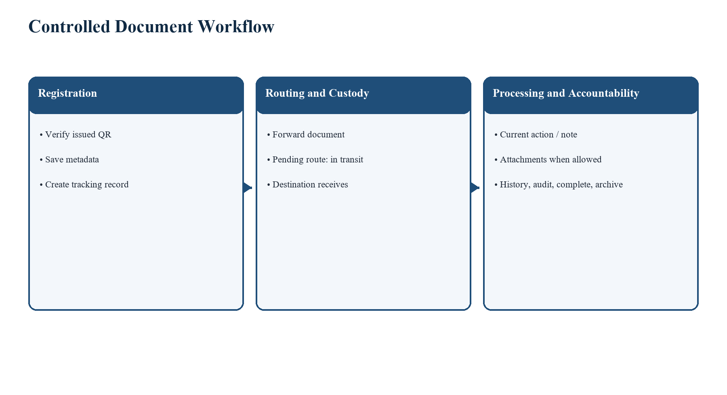
Figure 1. Controlled document workflow in DocTrackTuao.

1.3 Objectives of the Study

1.3.1 General Objective
To document and evaluate the implementation of a web-based QR code-enabled document tracking, routing, and management system for the Local Government Unit of Tuao.

1.3.2 Specific Objectives
- Document the implemented registration, QR, routing, receipt, processing, attachment, history, audit, and reporting functions.
- Document role permission and office-scope controls as implemented by Laravel routes, controllers, and models.
- Present the confirmed system architecture, data model, API surface, and test evidence.
- Identify the remaining institutional and evaluation evidence needed for formal defense completion.

1.4 Scope and Limitations
The documented scope is the internal DocTrackTuao application contained in the repository. It includes authenticated account functions, internal document workflow, QR code issuance and resolution, role permissions, office checks, attachment storage, audit logging, reports, and the Vue interface. The system does not by itself prove public internet accessibility, production HTTPS configuration, completed user evaluation, organization-wide deployment, or quantified operational improvement. Those claims require separate evidence.

1.5 Significance of the Study
For administrators, the system provides controlled reports and audit information. For records and office personnel, it provides a structured view of document custody and permitted next actions. For viewers, it provides read-only access within the established permissions. For the LGU, it provides a maintainable implementation record that can guide pilot testing, deployment, and future enhancement. For future researchers, it provides a repository-grounded case of QR-assisted internal document workflow design.

1.6 Definition of Terms
Term | Operational meaning in this study
Document custody | The office recorded as the document's current office.
Pending route | A document route that has not been received and has not been cancelled or rejected.
Office scope | The server-side restriction requiring a user's office to match the document office for relevant mutations.
Processing action | An active selected action recorded with an optional processing note.
QR record | A system-issued QR code associated with registration/tracking behavior.
Terminal status | Completed or Archived; these statuses block further processing and attachment mutations.

CHAPTER II. REVIEW OF RELATED LITERATURE AND SYSTEMS

2.1 Records Management and Digital Workflow
Records-management practice emphasizes reliable management of records throughout their use and retention. ISO 15489-1 frames records management around concepts and principles that support trustworthy information handling (International Organization for Standardization, 2016). In this project, separate document, routing, processing, attachment, and audit records preserve different forms of accountability rather than replacing history with a single current value.

2.2 QR Code Identification
QR identifiers can connect a physical item to a digital record without printing the full record content onto the physical label. In DocTrackTuao, QR records are generated, verified for registration, linked to a document, and resolved through defined routes. QR lifecycle behavior remains subject to backend validation and permissions; a UI control does not replace those server-side checks.

2.3 Web Application Architecture and Security
Laravel separates request routing, authentication, middleware, validation, and Eloquent data access. Its authentication documentation describes guards and providers as core authentication mechanisms (Laravel, 2026). Vue supports component-based interfaces and the Composition API used in the project's single-file components (Vue.js, 2026). The system also follows the security principle that authorization must be enforced on the server, not only by hidden controls. The Data Privacy Act of 2012 establishes the Philippine policy context for securing personal information in information and communications systems (Republic Act No. 10173, 2012).

2.4 Synthesis
The reviewed sources support an implementation that distinguishes identity, authorization, custody, workflow state, and retained history. DocTrackTuao applies that synthesis through a Laravel API guarded by Sanctum and permission middleware, a Vue presentation layer, and persistence models for documents, routes, processing logs, QR records, attachments, notifications, and audit logs.

CHAPTER III. RESEARCH METHODOLOGY

3.1 Research Design
This manuscript uses a developmental documentation approach. It examines the project repository as the implementation source of truth and documents confirmed routes, controllers, models, migrations, Vue pages, tests, and database relationships. It does not infer results from code inspection alone; test outcomes are separately identified as verified or not yet verified.

3.2 Development Approach
The codebase shows iterative development across workflow, security, reporting, and interface modules. The documented approach consists of requirements interpretation, model and API design, Vue implementation, focused testing, and review. The project guide requires small closure targets, role and office-scope checks, route/history side-effect checks, and review of code changes before advancing.

3.3 System Architecture
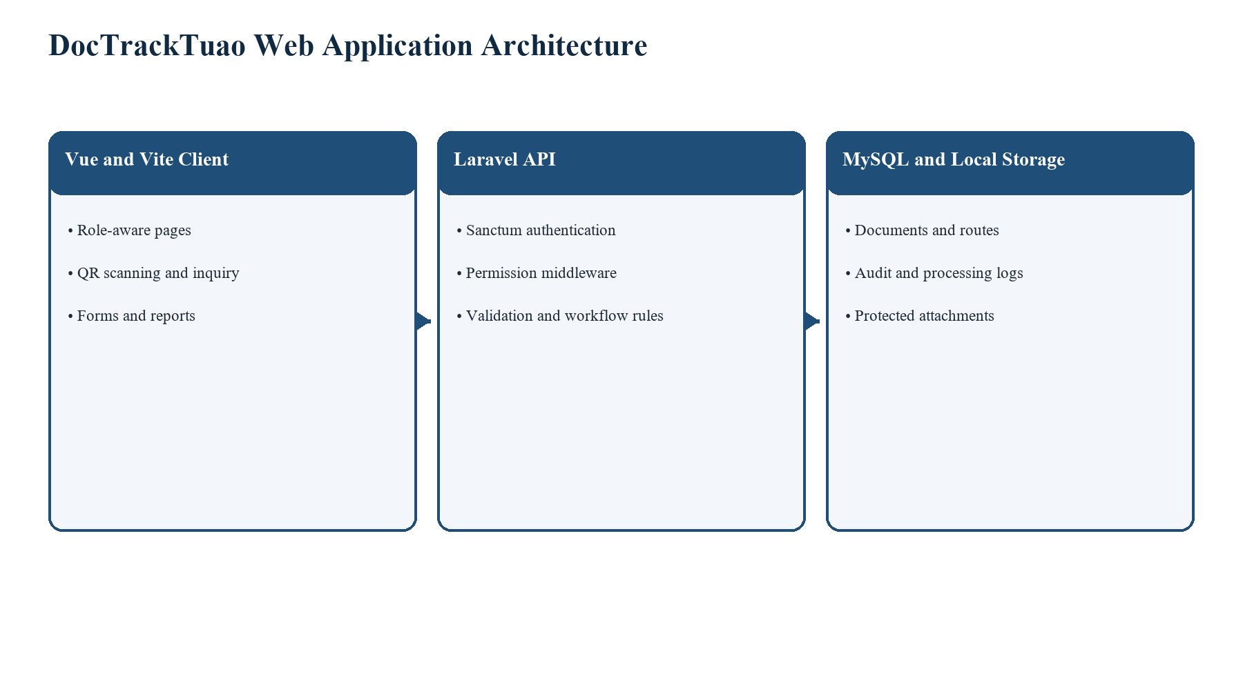
Figure 2. System architecture confirmed from the Vue, Laravel, MySQL, and attachment-storage implementation.

3.4 Role and Office-Scope Design
The User model maintains a role-to-permission map. The role answers what a user may do, while office assignment answers which currently held documents a user may act on. For processing, the current office must equal the user office and no pending route may exist. Relevant controllers return forbidden or conflict responses when these conditions are not met.
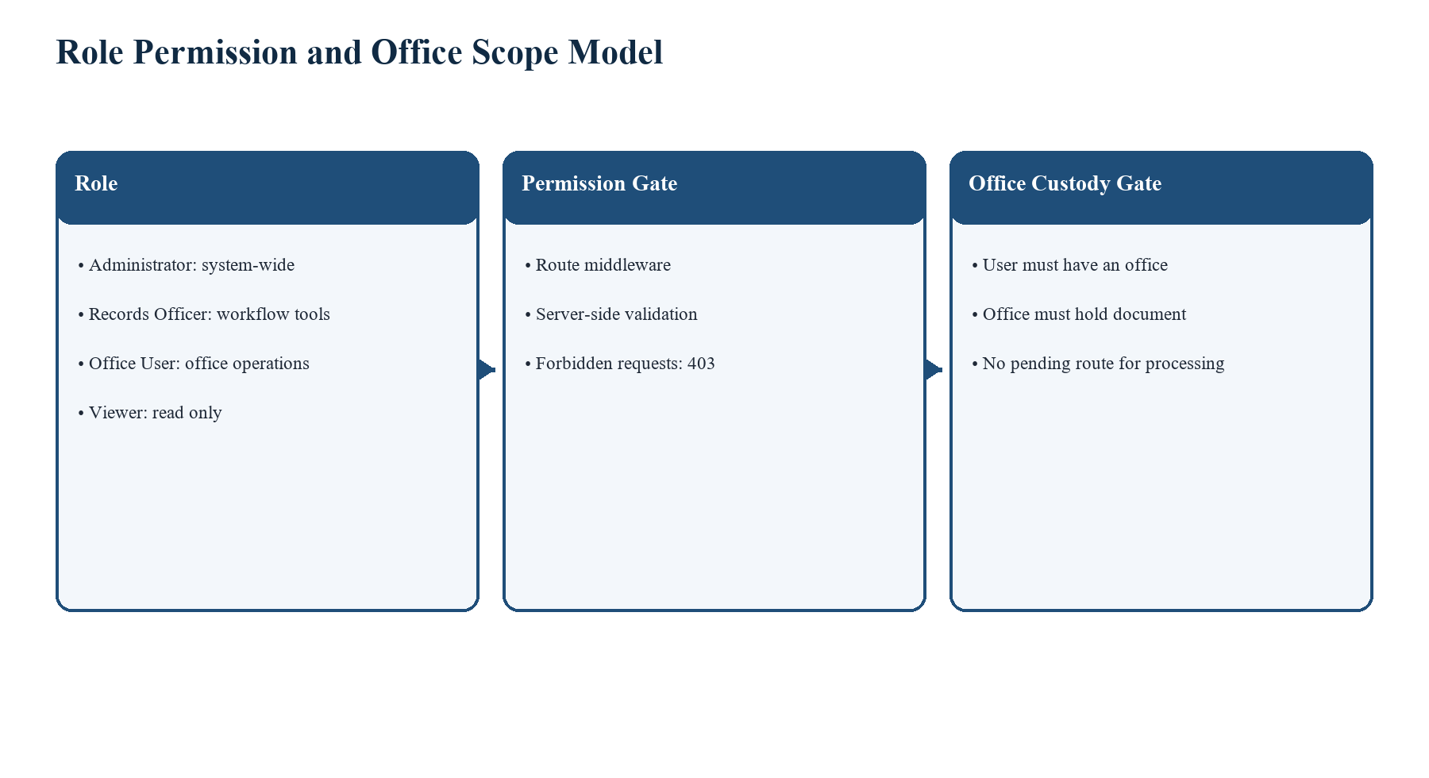
Figure 3. Role permission and office scope model.
Role | Confirmed capabilities | Important boundary
Administrator | All defined permissions, user and master-data administration, reports and audit. | Document actions still follow controller workflow checks.
Records Officer | Document registration, workflow, QR request/view/manage, audit and reports as mapped. | Role permission does not remove office-custody checks.
Office User | Document view, process, route, attachment management, QR request, reports. | No user management; mutations are office-scoped.
Viewer | Document/attachment/master-data/report reading. | No create, route, receive, process, attachment mutation, or user management.

3.5 Requirements
ID | Functional requirement | Repository evidence
FR-01 | Register a document after QR verification and save its core metadata. | DocumentController and Documents.vue.
FR-02 | Forward, receive, reject receipt, and undo pending forwarding subject to custody checks. | DocumentRoutingController and API routes.
FR-03 | Record an active processing action and optional note only when held and not in transit. | DocumentProcessingController.
FR-04 | Upload, list, download, and delete allowed attachment types under access rules. | DocumentAttachmentController.
FR-05 | Show history, audit logs, dashboard, and accomplishment reporting in permitted scope. | Routing, audit, and dashboard controllers.
ID | Non-functional requirement | Implementation basis
NFR-01 | Security | Sanctum authentication, permissions, validation, 403/409 enforcement, protected local storage.
NFR-02 | Traceability | Routes, processing logs, QR associations, and audit logs retain workflow events.
NFR-03 | Usability | Vue pages, QR input/scanner components, role-aware navigation, and confirmation dialogs.
NFR-04 | Maintainability | Laravel controllers/models/migrations; Vue pages/components; focused tests.
NFR-05 | Reliability | Database transactions/locks are used in custody-sensitive lifecycle paths.

3.6 Data Model
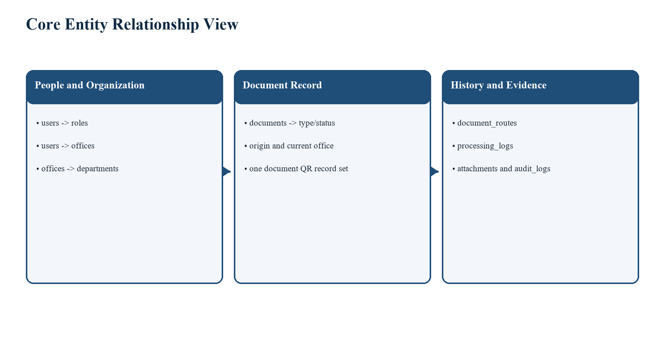
Figure 4. Core entity relationship view based on confirmed models and migrations.
Table | Key confirmed purpose | Selected relationships/fields
users | Authenticated accounts with role and office assignment. | role_id, office_id, department_id, must_change_password, deactivated_at
documents | Core tracking record and current state. | tracking_no; type/status/priority; origin_office_id; current_office_id; completion/archive fields
document_routes | Forwarding, receipt, cancellation, and rejection history. | document_id; from_office_id; to_office_id; forwarded_at; received_at
document_qr_codes | Issued/linked QR records and lifecycle data. | document_id and QR lifecycle fields
document_processing_logs | Retained processing/action events. | document_id; office_id; user_id; processing_action_id; event_type
document_attachments | Protected attachment metadata. | document_id; stored file information; uploaded_by
audit_logs | Safe activity logging. | user_id; module; action; record_id; description; IP/user agent

3.7 Use Cases and Routing Sequence
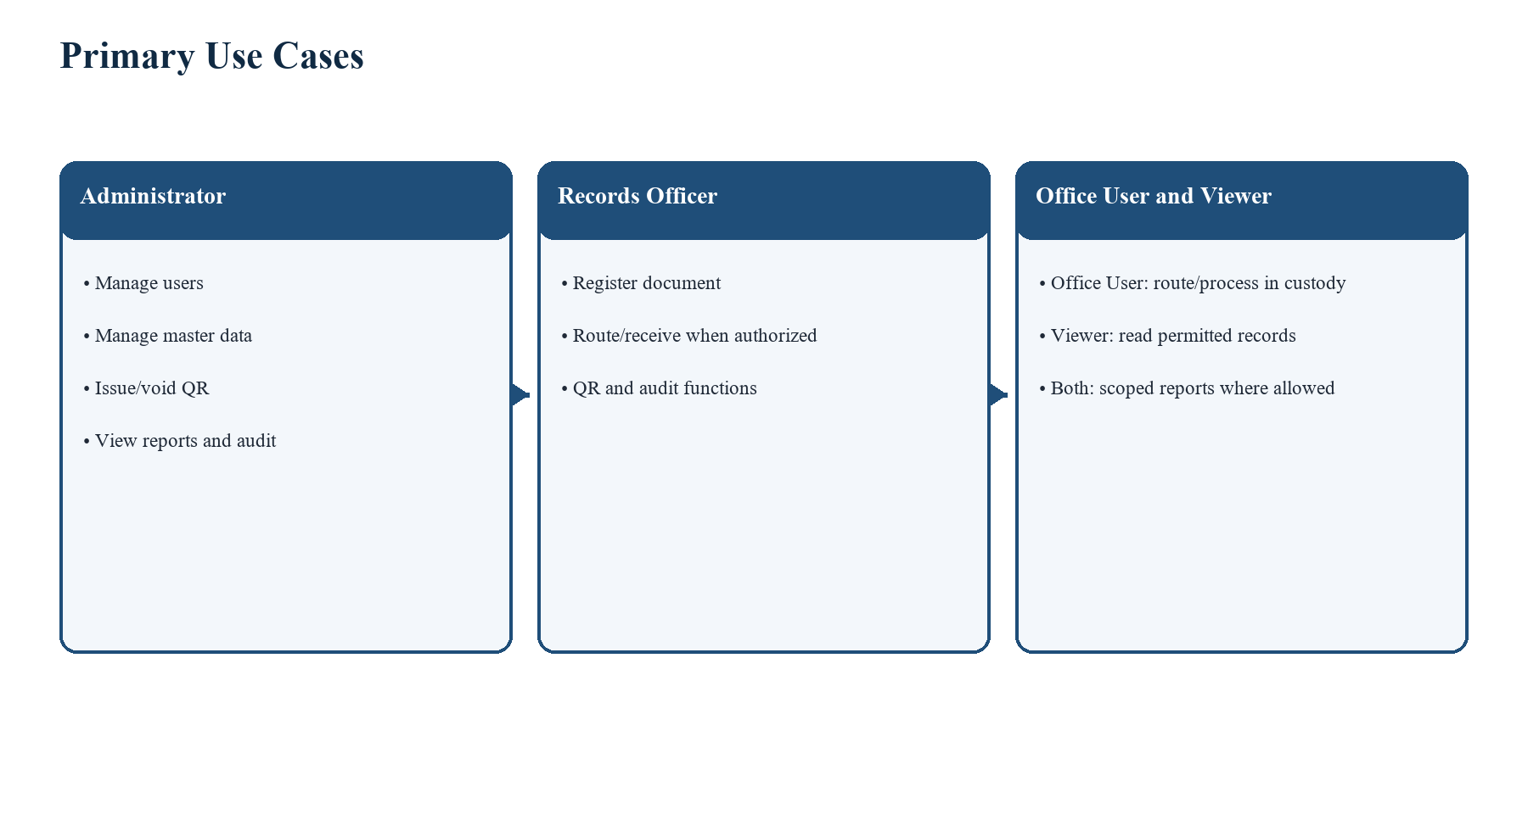
Figure 5. Primary actors and use cases.
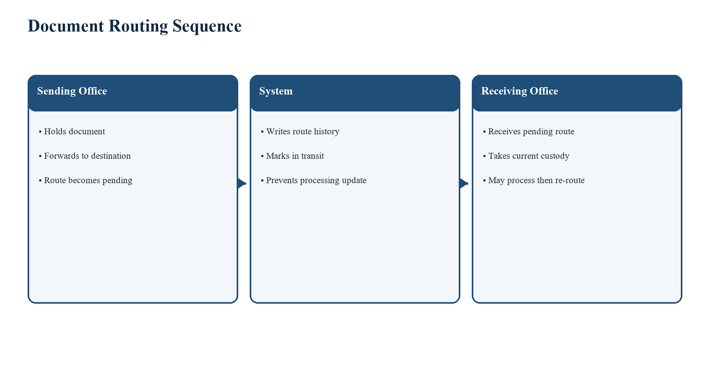
Figure 6. Document routing sequence.

CHAPTER IV. SYSTEM DESIGN AND IMPLEMENTATION

4.1 Application Modules
The Vue application includes dashboard, document registration/list/detail, incoming and outgoing views, document inquiry, QR code management, notifications, offices, user administration, audit logs, accomplishment reporting, profile functions, and report signatories. The Laravel API supplies protected routes for these modules and uses middleware to enforce authentication and permissions.

4.2 Workflow Controls
A forward action creates a route and leaves the document pending or in transit until receipt. The destination office must receive the pending route before it can update processing. The processing controller validates a selected active action, optional note length, office assignment, current custody, terminal state, and lack of a pending route. Completion requires current custody and no pending route. Archiving requires the document to be completed, currently held by the acting office, and free of a pending route.

4.3 Attachment Handling
Attachment uploads are restricted to the current office, blocked for terminal documents, and limited to PDF, Word, Excel, JPEG, and PNG files with a maximum request size of 10,240 KB. Files are placed on the local storage disk rather than the public web directory. Attachment list/download access is restricted to the current or origin office under the current controller rules.

4.4 API Endpoint Summary
Area | Selected endpoints | Access control
Authentication | POST /api/login; POST /api/logout; GET /api/user | Login public; logout/user authenticated.
Documents | GET/POST /api/documents; GET /api/documents/{id} | documents.view/create/edit/delete permissions.
Routing | POST forward, receive, reject-receipt, undo-forward; GET history/options | documents.route/view plus controller office checks.
Processing | GET/PUT /api/documents/{id}/processing | documents.view/process plus custody and pending-route checks.
QR | GET/POST /api/qr-codes; verify-registration; resolve /api/q/{token} | Permission-specific protected functions; public resolution is throttled.
Attachments | GET/POST document attachments; download/delete attachment | attachments.view/manage plus office rules.
Administration | users, offices, document-types, audit-logs, reports | Permission middleware controls each route.

4.5 Security Design
The implementation uses Bearer-token authentication through Sanctum, middleware permission checks, server-side validation, controlled error statuses, database transactions for related workflow changes, and audit logging. Sensitive file paths are not returned by ordinary attachment list responses. The code also contains rate-limited public tracking and QR-resolution routes; before any internet-facing deployment, their data-exposure policy, HTTPS configuration, trusted hosts, and operational monitoring require an explicit security review.

4.6 User Interface Screens
The following screenshots were captured from the local development system. Account labels and record-level areas were blurred where necessary. They demonstrate the implemented interface modules without disclosing passwords, bearer tokens, QR tokens, or document contents.
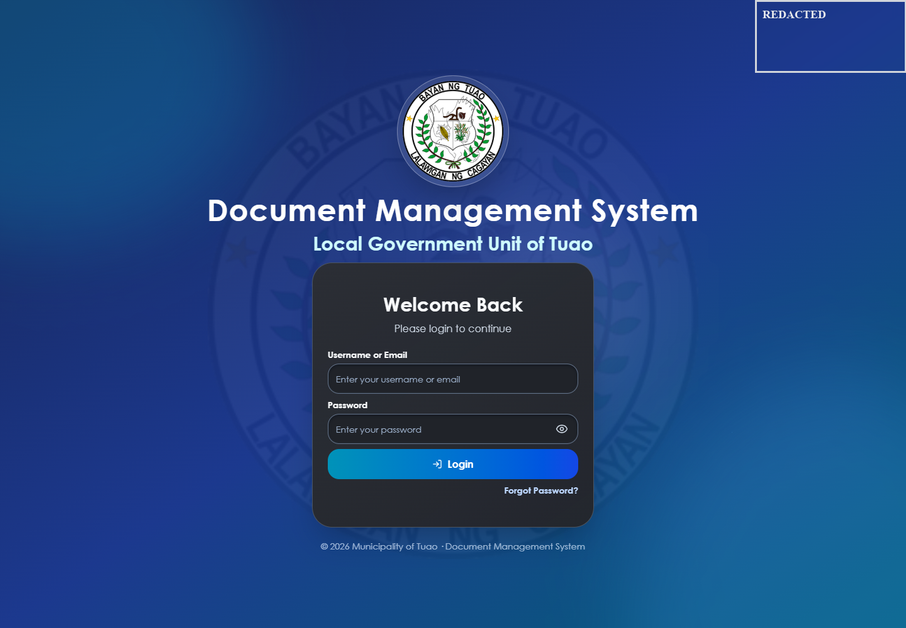
Figure 7. Login page with credential fields empty.

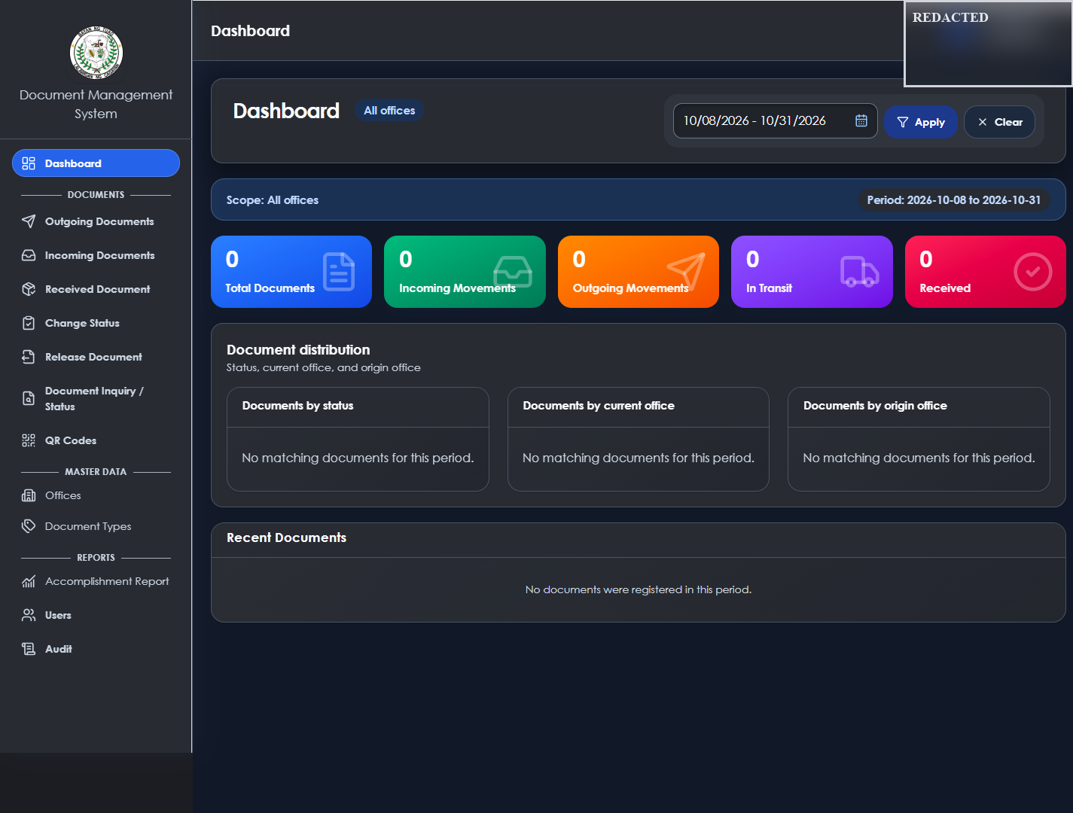
Figure 8. Dashboard with scope, date filter, status distribution, and movement summaries.

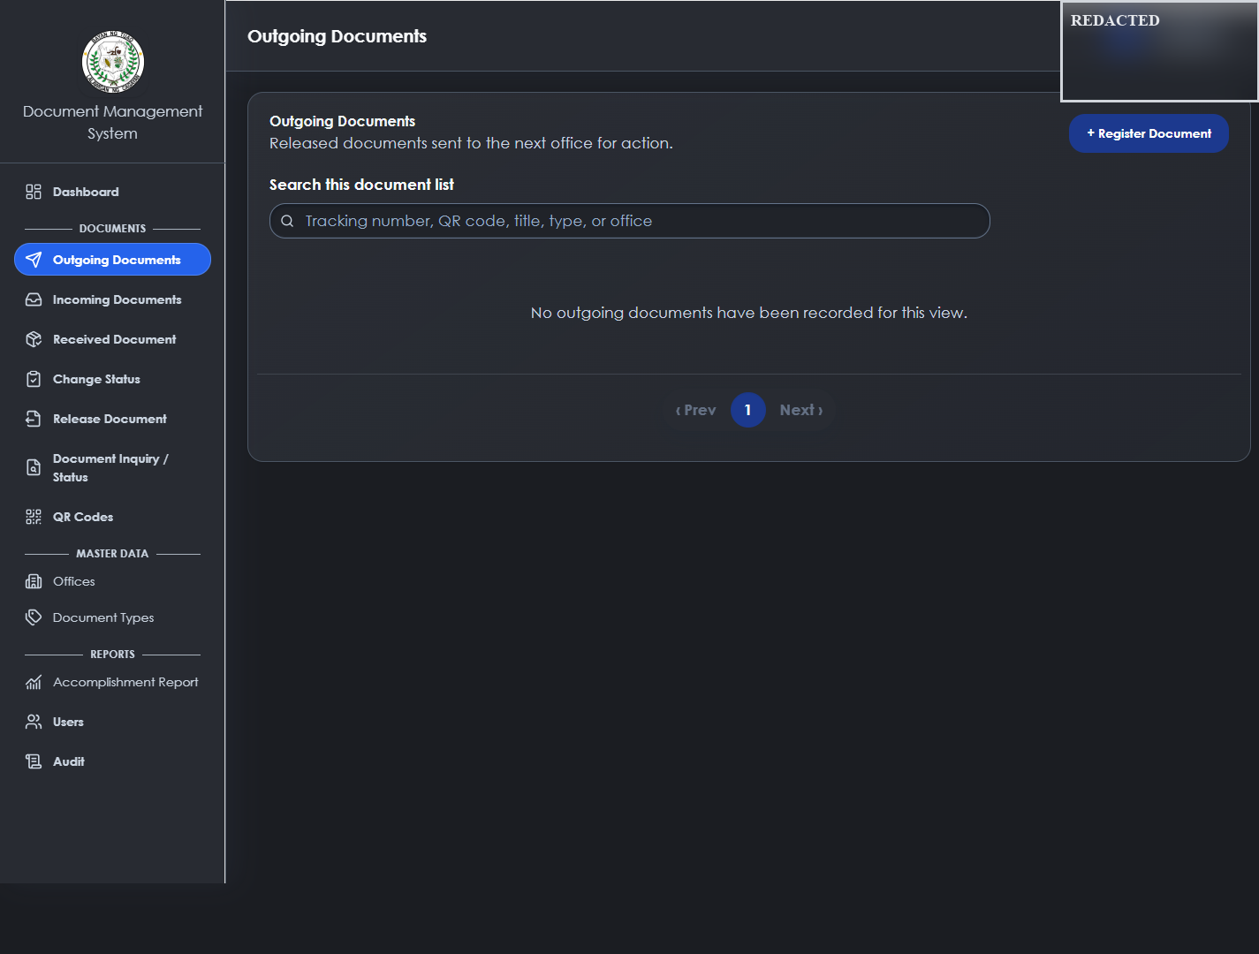
Figure 9. Outgoing documents view with a registration entry point and search field.

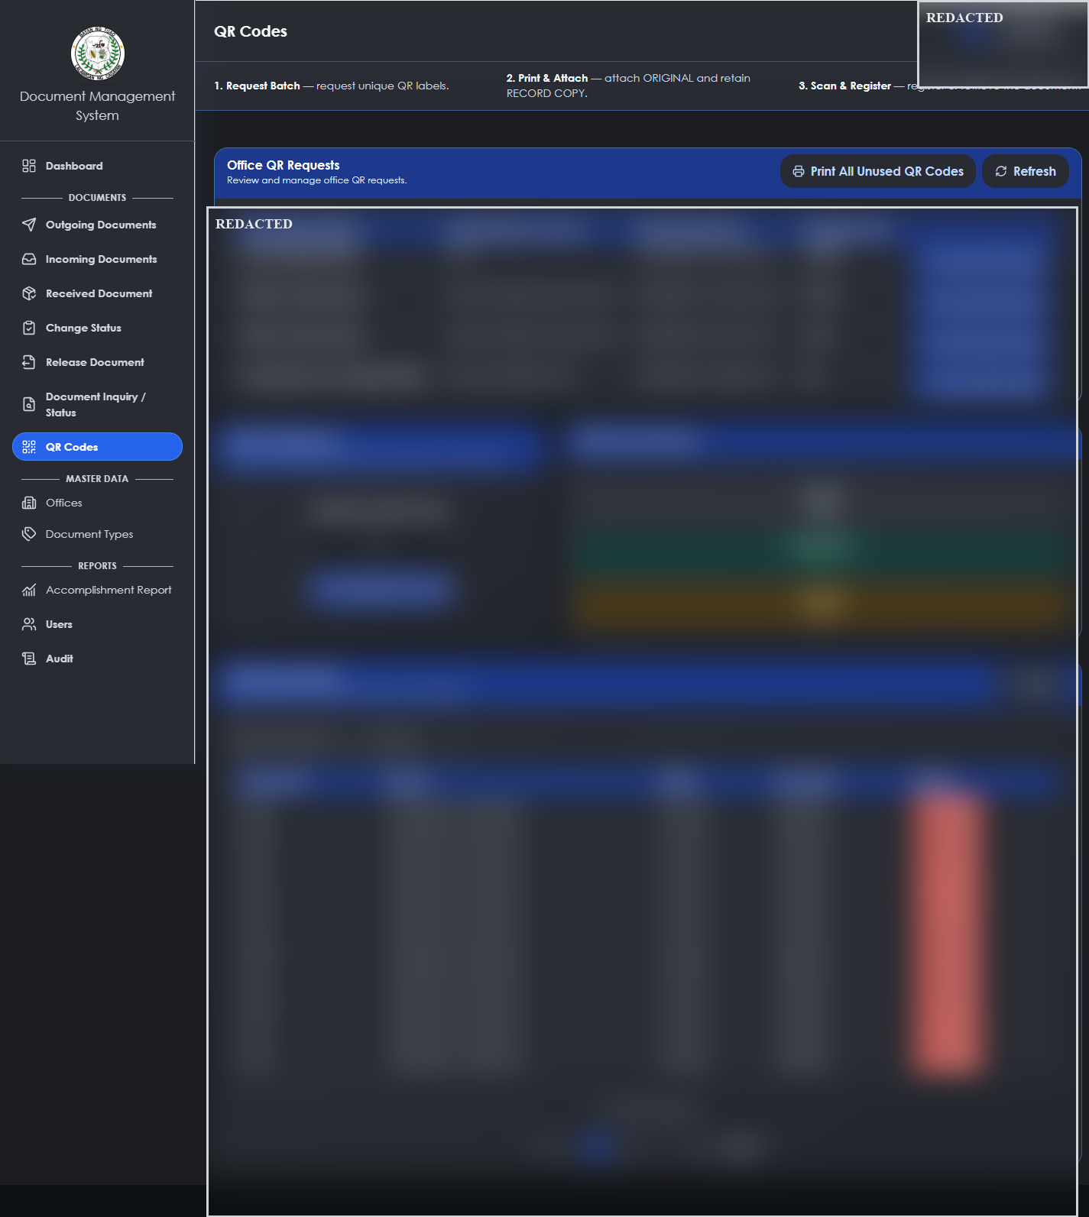
Figure 10. QR code management screen; request and inventory record areas are redacted.

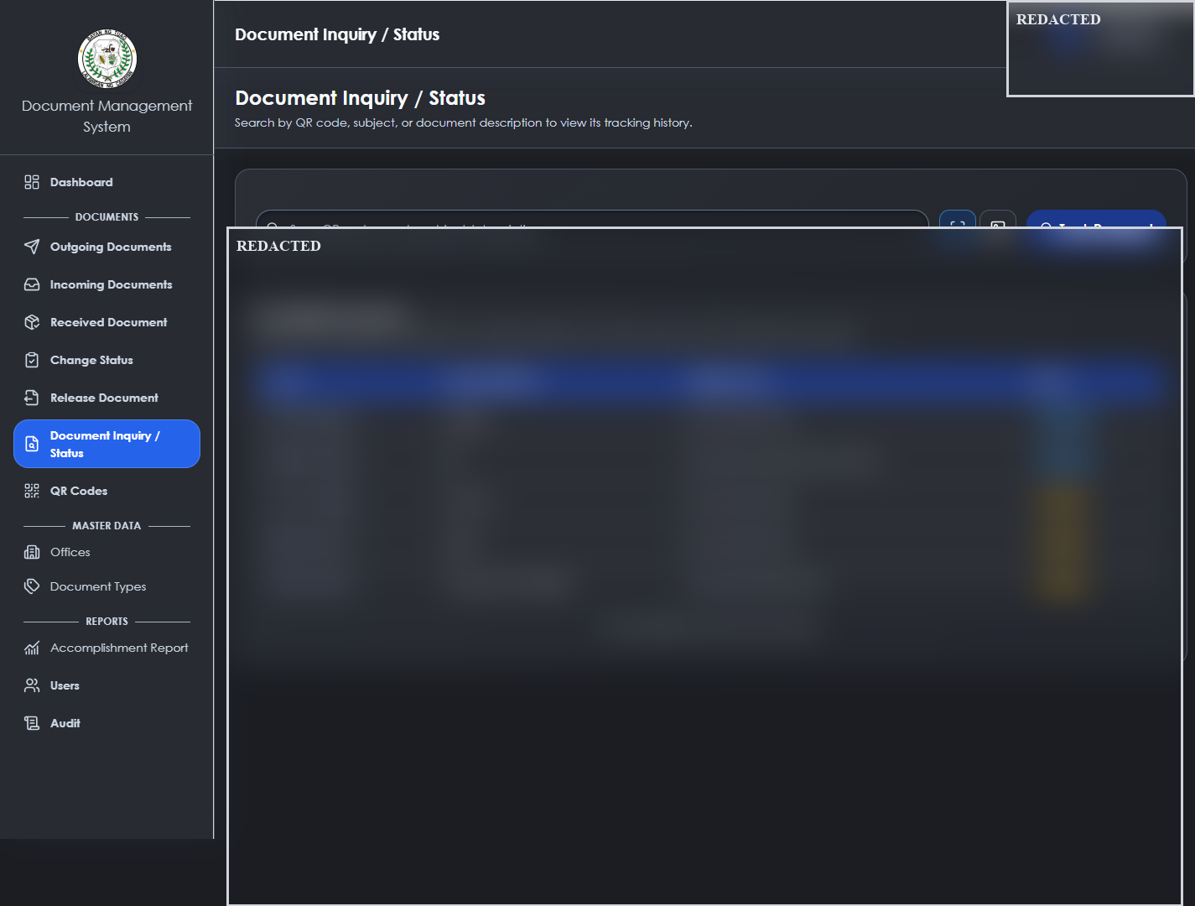
Figure 11. Document inquiry screen; document-record area is redacted.

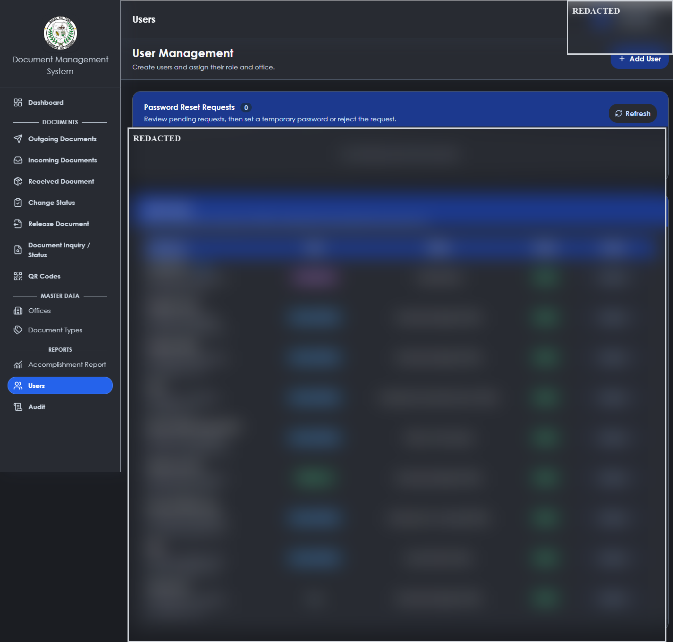
Figure 12. User-management screen; account record area is redacted.

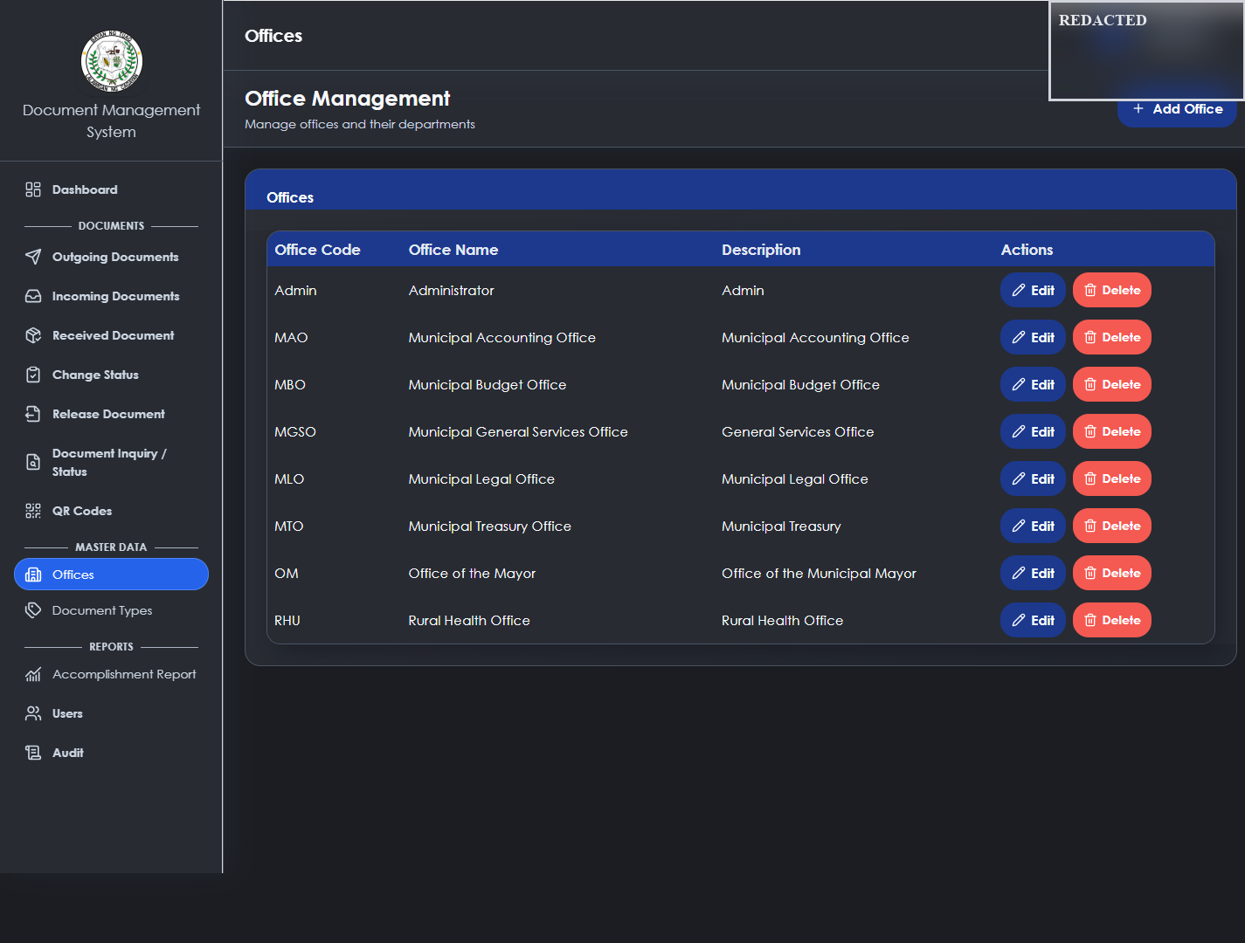
Figure 13. Office and master-data screen.

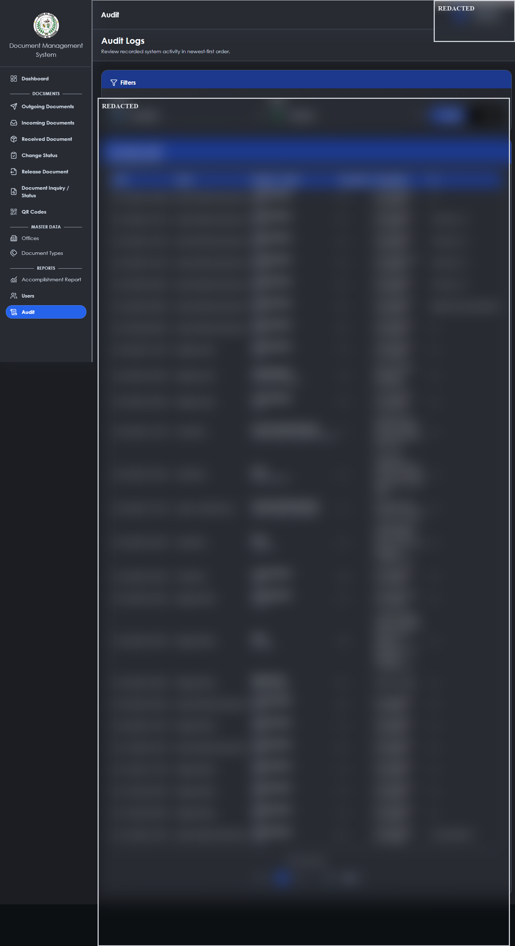
Figure 14. Audit-log screen; activity record area is redacted.

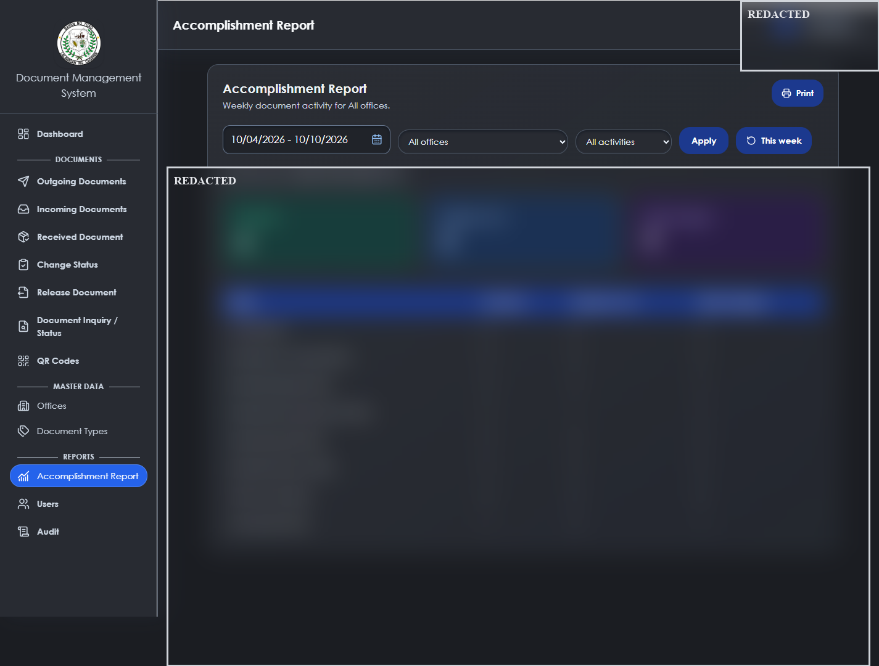
Figure 15. Accomplishment-report screen; report record area is redacted.

CHAPTER V. TESTING, FINDINGS, CONCLUSION, AND RECOMMENDATIONS

5.1 Testing Approach
The project guide requires focused automated checks, a positive path, a relevant forbidden or invalid path, inspection of history/audit side effects, and review of the working-tree diff. The following table contains only outcomes actually verified during the documented development session. It is not a substitute for the required end-to-end role and office testing program.
Test or check | Result | Evidence/status
Dashboard summary feature test | Passed | 18 tests and 174 assertions reported in the focused Laravel test run on 10 October 2026.
QR registration frontend test | Passed | 3 tests passed after Enter-key form-submission handling adjustment.
Document lifecycle frontend test | Passed | 15 tests passed for complete/archive behavior and related source checks.
Production frontend build | Passed | Vite production build completed after the most recent UI changes.
Complete end-to-end role matrix | Not yet verified | Do not claim complete until all roles and wrong-office paths are exercised.
ISO/IEC 25010 respondent evaluation | Not yet verified | No completed questionnaires or validated dataset supplied.
Production/LAN security deployment | Not yet verified | Requires HTTPS, host, backup, and deployment evidence.

5.2 Findings
Repository inspection confirms an implemented internal document workflow with QR association, routing history, receipt, controlled processing, protected attachments, audit support, reports, and role/office controls. The strongest implementation constraint is the combination of role permission and office custody. Code inspection also confirms that front-end visibility is not the sole authorization mechanism; protected routes and controller checks govern mutations.

5.3 Conclusion
DocTrackTuao provides a documented technical foundation for controlled internal document tracking in the Local Government Unit of Tuao. Its implementation separates the current document state from retained routing and processing history and applies server-side permission and office-custody rules to workflow mutations. The project is suitable for a defense discussion of its implemented architecture and workflow, provided that evaluation claims remain limited to verified evidence.

5.4 Recommendations
- Complete the full register-to-archive end-to-end test across Administrator, Records Officer, Office User, and Viewer accounts, including wrong-office and pending-route denial cases.
- Collect institutional approval, respondent profile, completed ISO/IEC 25010 instruments, and an auditable analysis dataset before reporting evaluation scores.
- Prepare a fresh database backup before any real-user pilot, then verify restore procedures and access controls.
- Before LAN or internet deployment, complete the focused security hardening and deployment checklist, including trusted hosts, HTTPS where applicable, authentication lifecycle, storage protections, and server backup procedures.
- Capture final screenshots only in a controlled environment with anonymized information.

REFERENCES
International Organization for Standardization. (2016). ISO 15489-1:2016 information and documentation: Records management: Part 1: Concepts and principles.
International Organization for Standardization. (2023). ISO/IEC 25010:2023 systems and software engineering: Systems and software quality requirements and evaluation: Product quality model.
Laravel. (2026). Authentication. https://laravel.com/docs/12.x/authentication
National Institute of Standards and Technology. (2020). Digital identity guidelines: Authentication and lifecycle management (Special Publication 800-63B). https://doi.org/10.6028/NIST.SP.800-63b
OWASP Foundation. (n.d.). File upload cheat sheet. https://cheatsheetseries.owasp.org/cheatsheets/File_Upload_Cheat_Sheet.html
Republic Act No. 10173. (2012). Data Privacy Act of 2012. Official Gazette of the Republic of the Philippines. https://officialgazette.gov.ph/2012/08/15/republic-act-no-10173/
Republic Act No. 11032. (2018). Ease of Doing Business and Efficient Government Service Delivery Act of 2018. Official Gazette of the Republic of the Philippines. https://officialgazette.gov.ph/2018/05/28/republic-act-no-11032/
Vue.js. (2026). Introduction and Composition API. https://vuejs.org/guide/introduction.html

APPENDICES

Appendix A. Repository Evidence Reviewed
Evidence group | Examples used in this documentation
Project guidance | AGENTS.md workflow, role, office-scope, backup, testing, and security rules.
Backend | routes/api.php; document, routing, lifecycle, processing, attachment, dashboard, audit, and QR controllers.
Models and migrations | Document, DocumentRoute, User, attachment, processing, QR, audit models and migration inventory.
Frontend | Vue pages/components for documents, details, tracking, QR, dashboard, reports, navigation, and authentication.
Tests and API reference | Focused frontend tests, Laravel tests, and api-tests/API-ENDPOINTS.md.

Appendix B. Information Required Before Institutional Submission
Required item | Why it is needed
Researcher, adviser, panel, signatures, defense date | Required front-matter and approval-sheet information.
Approved research title and degree wording | Institution-specific title-page compliance.
Respondent count, profiles, consent/approval, and completed instruments | Required for any survey/evaluation claim.
Validated calculation sheet for ISO/IEC 25010 results | Required before weighted means or verbal interpretations.
Pilot/deployment evidence and backup/restore record | Required before claiming operational rollout or production readiness.
Anonymized final screenshots | Optional visual evidence for the final defense manuscript.

Appendix C. Selected Workflow Rules
Processing updates require a valid assigned office, current custody by that office, an active action, and no pending route. Forwarded documents remain pending until received. Completion requires the acting office to hold the document and no pending route. Archiving requires the document to be completed, held by the acting office, and free of a pending route. Completed and archived documents cannot receive processing or attachment mutations.

Appendix D. ISO/IEC 25010 Evaluation Instrument Status
An evaluation instrument may be attached after it is approved by the institution. No completed respondent responses, weighted means, rankings, or compliance scores are included in this manuscript because they were not supplied for verification.

Appendix E. Source Code Areas
Area | Repository location | Purpose
API routes | routes/api.php | Defines public and protected endpoints plus permission middleware.
Role permissions | app/Models/User.php | Defines the application role-to-permission map.
Processing enforcement | app/Http/Controllers/DocumentProcessingController.php | Enforces office custody and no-pending-route processing rules.
Lifecycle enforcement | app/Http/Controllers/DocumentLifecycleController.php | Enforces completion/archive state transitions.
Routing enforcement | app/Http/Controllers/DocumentRoutingController.php | Handles forward, receive, receipt rejection, and undo behavior.
Document interface | resources/js/pages/Documents.vue and DocumentDetails.vue | Supports registration and controlled document actions.

CURRICULUM VITAE
To be completed by the researcher using the institution's required curriculum vitae format. Do not include unnecessary personal identifiers in a publicly distributed copy.

