DEVELOPMENT OF A WEB-BASED QR CODE-ENABLED DOCUMENT TRACKING, ROUTING AND MANAGEMENT SYSTEM FOR THE LOCAL GOVERNMENT UNIT OF TUAO
_____________________
A Thesis Presented to
the Faculty of the Graduate School
Cagayan State University Carig Campus
Tuguegarao City
_____________________
In Partial Fulfillment of the
Academic Requirements for the Degree
MASTER OF SCIENCE IN INFORMATION TECHNOLOGY
_____________________
By
KEVIN D APIL
2026

APPROVAL SHEET
In partial fulfillment of the requirements for the degree Master of Science in Information Technology, this thesis entitled Development of a Web-Based QR Code-Enabled Document Tracking, Routing and Management System for the Local Government Unit of Tuao is submitted by Kevin D. Apil for examination and approval.
EDISON D BRAVO DIT
Adviser
Approved by the Panel of Oral Examination
Panel Member | Designation
Arthur G Ibanez ASEAN Engr PhD | Chair
Roger P Rumpon | Member
Generino P Siddayao DIT | Member
Charmie S Calvo DIT | Member
Dennis Bacuyag | Member

ACKNOWLEDGEMENT
The researcher gratefully acknowledges the guidance of the adviser, panel members, Cagayan State University Graduate School, Local Government Unit of Tuao personnel, family, and all participants who contributed their time and expertise.

DEDICATION
This work is dedicated to public servants, records personnel, mentors, family, and future researchers committed to accountable public service.

TABLE OF CONTENTS
Open in Word and update fields to display the Table of Contents.

LIST OF TABLES
Open in Word and update fields to display the List of Tables.

LIST OF FIGURES
Open in Word and update fields to display the List of Figures.

Abstract
This documentation presents DocTrackTuao, a web based QR code enabled document tracking, routing and management system designed for the Local Government Unit of Tuao. The system records document registration, QR identification, inter office routing, receipt, processing actions, attachments, history, and role based accountability. It is implemented with Laravel, Vue, Vite, and MySQL. The documented implementation preserves office custody rules, server side authorization, validation, and auditable workflow history. Evaluation is structured through the attached ISO IEC 25010 questionnaire; because no completed respondent forms were supplied, this document does not claim numeric quality scores.

CHAPTER I THE PROBLEM AND ITS BACKGROUND

1.1 Introduction
Philippine LGUs process a high volume of administrative documents daily, including memoranda, official correspondence, reports, citizen requests, permits and compliance-related filings. These documents often require sequential routing across multiple offices, levels of approval and eventual archiving. However, a significant number of LGUs continue to depend on manual or semi-manual systems such as physical logbooks, paper-based filing, and handwritten notations for tracking (Santos, 2021). This reliance results in extended processing times, as documents must be physically transported between offices or barangays, frequently causing delays during high-volume periods, staff absences, or logistical disruptions.
These inefficiencies have broader governance implications. Prolonged document handling impedes timely service delivery to citizens, for instance, in issuing business permits, resolving complaints, or implementing local programs leading to diminished public trust and satisfaction (Department of the Interior and Local Government [DILG], 2025a). The lack of real-time status visibility reduces accountability, complicating supervisors' efforts to monitor progress, identify irregularities, or enforce standards. Paper-based records are susceptible to loss, environmental damage (e.g., flooding prevalent in regions like Cagayan Valley), tampering, or human error in logging, raising serious concerns for data integrity, security, and adherence to laws such as Republic Act No. 10173 (Data Privacy Act of 2012) and Republic Act No. 11032 (Ease of Doing Business and Efficient Government Service Delivery Act of 2018). High staff turnover in LGUs further exacerbates knowledge loss and perpetuates inconsistent practices, while limited budgets and technical capacity slow digital transitions (Ademola et al., 2012; International Journal of Frontiers in Multidisciplinary Research [IJFMR], 2025a).
Tuao, Cagayan, a rural municipality in the Cagayan Valley region divided by the Chico River (creating logistical challenges between "Tuao-East" and "Tuao-West") experiences intensified versions of these national LGU issues due to its agricultural economy, limited resources and geographical constraints. As a smaller, lower-class municipality, Tuao heavily depends on manual document processes because of inadequate infrastructure, funding shortages for technology and limited trained personnel. Routing documents across offices or barangays often encounters delays from physical transport difficulties especially during inclement weather or river-related barriers—resulting in misplaced files, inconsistent tracking logs, and extended resolution times for citizen requests (similar patterns noted in rural LGU studies; ISRG Publishers, 2025).
Additionally, the lack of a centralized automated system restricts administrative oversight in Tuao hindering municipal leaders' ability to pinpoint workflow bottlenecks, assess performance or produce reliable reports for compliance with oversight bodies like the DILG. Manual methods increase error risks, institutional knowledge loss during personnel changes, and opacity in processes, potentially undermining public confidence in local governance. While national programs such as the DILG's eLGU initiative (with over 900 LGUs adopting it for online services as of 2025) and the planned rollout of the Document Management System for LGUs (DMS4LGUs) in 2026 aim to promote digitization for efficiency and transparency under RA 11032 (DILG, 2025b; DILG, 2025c), adoption in rural settings like Tuao faces barriers including unreliable internet, insufficient IT support, and the need for context-specific, cost-effective solutions (IJFMR, 2025b).
Although challenges in LGU records management are increasingly recognized, notable gaps remain in both research and implementation. National initiatives including the DILG's eLGU system (now adopted by over 900 LGUs for streamlined permits and services) and the forthcoming DMS4LGUs under the Local Government Unit Support System (LGUSS), emphasize digitization to reduce delays, enhance transparency, and comply with RA 11032 (DILG, 2025b; DILG, 2025c; Philippine Information Agency, n.d.). However, these efforts are unevenly implemented, with rural or lower-class municipalities lagging due to infrastructure and capacity limitations. Much existing literature and case studies concentrate on urban or larger LGUs, offering limited insights into tailored adaptations for geographically challenged, resource-constrained areas like Tuao (ResearchGate publications on digital governance, 2025).
Furthermore, while web-based document tracking systems have proven effective in improving efficiency, real-time monitoring, centralized storage, and cost reductions in public sector contexts (International Business Machines Limited [IBML], n.d.; GovOS, 2024), few Philippine studies or implementations integrate QR code technology specifically for bridging physical and digital documents in routine municipal workflows. QR codes enable rapid scanning for status verification, metadata access or authentication demonstrated in government uses like project monitoring in Bacolod City or verification processes (Philippine News Agency, 2025; examples in educational and civil registry contexts) yet their application to everyday document routing, tracking, and management at the LGU level remains underexplored, particularly in scalable, low-infrastructure solutions suitable for rural settings (Journal of Information Systems Engineering and Management, 2024; IJFMR, 2023).
In response to these persistent challenges and identified gaps, this study aims to develop and propose a Web-Based Document Tracking System integrated with QR Code Technology for monitoring, routing and managing documents in the Local Government Unit of Tuao, Cagayan. The system is intended to enhance document traceability, streamline processing workflows, reduce delays and errors, promote accountability and transparency and ultimately foster more efficient, responsive and citizen-oriented local governance.

1.2 Conceptual Framework
The conceptual framework of this study is grounded in the Input-Process-Output (IPO) model, a widely adopted systems analysis and software engineering approach that systematically depicts how inputs are transformed through structured processes into desired outputs. This model provides a clear, logical structure for understanding system dynamics, identifying inefficiencies, and guiding development efforts in information systems research.
The inputs of the study include the existing document handling procedures of the Local Government Unit of Tuao as well as details of incoming and outgoing documents such as document type, source, destination and priority. The paradigm also considers the problems encountered in manual document tracking including delays, misplacement of documents and lack of real-time monitoring. In addition, the processing time and efficiency of current procedures are assessed. User requirements gathered from administrators, records personnel, and department heads form part of the inputs, together with system requirements guided by the ISO/IEC 25010 software quality standards.
The process stage involves the design and development of the Web-Based Document Tracking System with QR Code Technology for Monitoring, Routing, and Managing Documents using a structured system development approach. The development process includes requirements analysis, system design and architecture, system development and coding, QR code generation and integration, quality assurance and software testing, system implementation and maintenance. Data gathering techniques such as interviews, surveys, observation and document flow analysis are employed to evaluate the efficiency of the existing manual process and to validate system requirements.
Data analysis methods such as descriptive statistics, frequency counts, and comparative analysis are applied to assess system performance, usability, and workflow efficiency. The system development activities follow an iterative Software Development Life Cycle (SDLC) approach, allowing overlapping phases to ensure timely identification and resolution of issues encountered during system development.
The outputs of the study consist of an ISO/IEC 25010–compliant Web-Based Document Tracking System that supports centralized and organized document records. The system provides real-time document monitoring and routing, QR code–based document identification and retrieval, automated tracking logs and audit trails and consolidated monitoring and management reports to support effective decision-making.
The feedback mechanism enables system users to provide evaluations and recommendations for continuous system improvement.
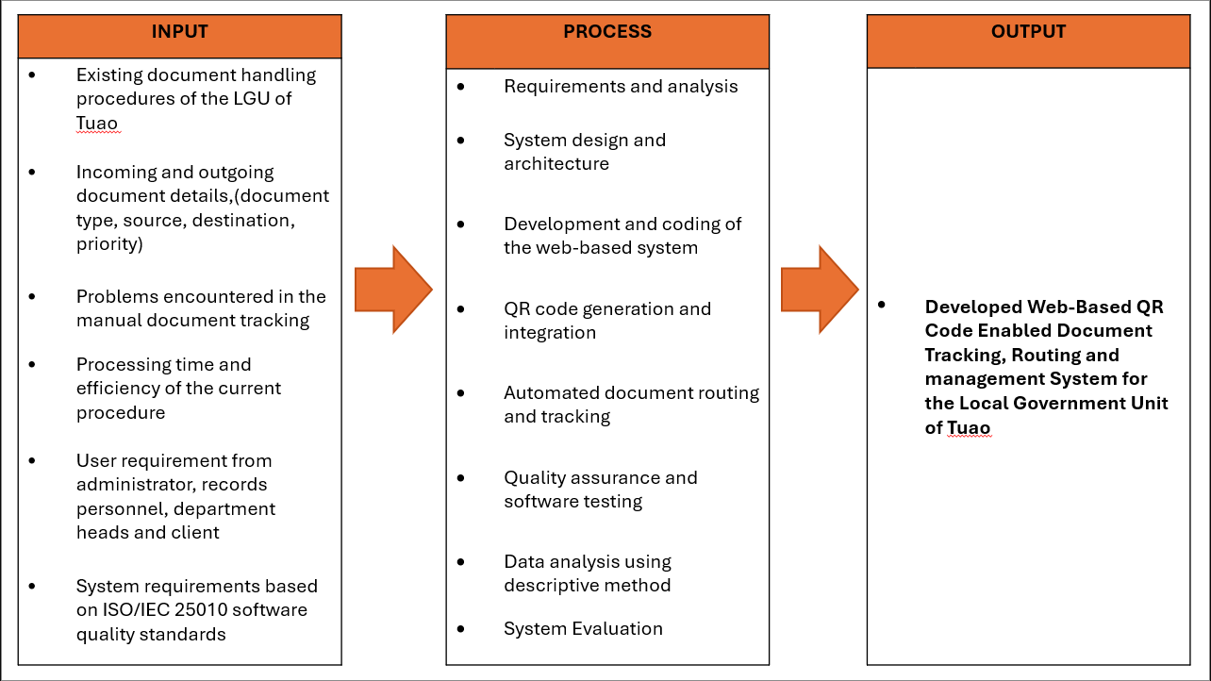
Figure 1. The Paradigm of the Study

1.3 Research Paradigm
The research paradigm is presented through the Input-Process-Output model described in the conceptual framework. It organizes the study around existing workflows, document and user requirements, QR-enabled system design and development, testing and evaluation, and outputs that include controlled tracking, audit trails, and management reports.

1.4 Objectives of the Study

1.4.1 General Objective
The study aims to develop a Web-Based QR Code-Enabled Document Tracking, Routing and Management System for the Local Government Unit of Tuao.

1.4.2 Specific Objectives
Identify the challenges encountered in using the existing document tracking process of the Local Government Unit of Tuao.
Design and develop a Web-Based Document Tracking System with QR Code Technology for the LGU of Tuao.
Evaluate the compliance of the developed system with ISO/IEC 25010 Software Quality Standards in terms of:
Functional Suitability
Performance Efficiency
Compatibility
Usability
Reliability
Security
Maintainability
Portability

1.5 Scope and Delimitation of The Study
This study develops and evaluates a web-based document tracking system with QR code technology exclusively for the Local Government Unit of Tuao, Cagayan.
The research focuses on digitizing internal document management by recording key metadata (sender, recipient, date, type), tracking document movement across departments in real time, generating summary reports on status and history and enabling fast retrieval via QR code scanning. The goal is to replace slow, error-prone manual processes with a simple, centralized digital tool that improves efficiency, transparency and accountability in daily LGU operations.
The study addresses Tuao’s specific challenges that is a delay from physical routing (especially across the Chico River), misplaced files, lack of real-time visibility, logging errors and limited oversight by providing a low-cost, context-appropriate solution suitable for a rural, resource-constrained setting.
Target users are Tuao LGU employees who handle documents daily: administrative staff, clerical personnel, records officers, department heads and other office workers.
The scope is deliberately limited to Tuao LGU offices only. The system requires internet access (no offline mode), excludes physical document storage or archiving, provides no legal validation or approval functions, has no integration with national or external databases, and uses only necessary sample documents for testing and evaluation. These boundaries keep the project focused, practical and achievable within Tuao’s rural context and available resources.

1.6 Significance of The Study
LGU Administrators
The system will provide administrators with a clearer and more comprehensive view of document movement and processing within the LGU. The availability of consolidated and accurate reports will support monitoring, evaluation, and strategic decision-making related to office operations, service efficiency, and governance accountability.
LGU Personnel
The development of the proposed system will enhance how LGU personnel manage, track and monitor documents within their offices. The system will reduce reliance on manual record-keeping and eliminate difficulties in locating document records and routing status. With a centralized information system and QR code–based document retrieval, transaction time and document handling will be significantly reduced.
Clients and Stakeholders
The developed system will improve service delivery to clients and stakeholders by enabling faster document processing and more organized routing. Automated email notifications will inform responsible staff of document status or required actions, minimizing delays and improving workflow efficiency. These features contribute to increased accountability, transparency, and trust in LGU services.
The Researcher
This study will enhance the researcher’s skills in analyzing real-world administrative problems and developing an information system that complies with recognized software quality standards. It will also expand technical knowledge in web-based system development, database management, and system evaluation within a local government context.
Future Researchers
The study will serve as a reference for future researchers interested in developing public sector information systems, conducting comparative studies between manual and computerized processes, or exploring the application of QR code technology and automated notification systems in government services.

1.7 Definition of Terms
Term | Meaning
Administrator | Higher-privilege user responsible for permitted user, report, settings, and monitoring functions.
Document Management | Recording, monitoring, updating, and routing documents within LGU offices.
Document Record | Digital record containing document details, status, and routing history.
ISO/IEC 25010 | Software quality model used by the evaluation instrument.
QR Code | Machine-readable reference used for fast retrieval of a document tracking record.
Workflow | Sequence of tasks for recording, tracking, routing, and managing documents.
Office scope | Restriction permitting operational actions only for documents held by the user's assigned office.

CHAPTER II REVIEW OF RELATED LITERATURE AND STUDIES

2.1 Foreign Literature
This Review of Related Literature (RRL) synthesizes the key insights from existing studies on web-based document tracking systems integrated with QR code technology. Organized into five thematic categories, it draws from a comprehensive literature review to highlight evolution, technical foundations, security considerations, practical applications and forward-looking trends. Each theme explores multiple perspectives including historical context, technological nuances, real-world implications, potential edge cases (e.g., scalability in resource-limited environments) and broader societal impacts such as sustainability and digital equity.

2.1.1 Document Management and Tracking Systems
Document management systems (DMS) are designed to facilitate the systematic storage, retrieval, tracking, and control of documents in digital form. Traditionally, government institutions relied on paper-based filing systems, physical routing slips, and manual logbooks to manage official documents. While these systems are simple and low-cost, they are often inefficient, prone to human error, and susceptible to document loss or damage.
According to Rellon et al. (2021), manual document tracking processes typically suffer from delayed routing, incomplete records, inconsistent logging practices, and limited monitoring capabilities. These limitations negatively affect service delivery and organizational efficiency. In government offices where documents pass through multiple departments for approval, the absence of real-time monitoring increases processing time and reduces accountability.
The shift toward computerized document management systems has significantly improved administrative efficiency. Web-based DMS platforms enable centralized databases, automated transaction logs, multi-user access, and role-based permissions. Nugroho et al. (2024) found that digital document tracking systems enhance workflow transparency by allowing supervisors and authorized personnel to monitor document movement in real time. Similarly, Zadorozhnyi et al. (2025) emphasized that electronic document management reduces operational overhead and improves institutional transparency.
Despite these advantages, many existing systems are implemented in urban institutions, universities, and large enterprises where technological infrastructure is stable. Limited research focuses on rural local government units (LGUs), which often face resource constraints, limited ICT personnel, and inconsistent internet connectivity. This highlights the need for context-specific document tracking systems tailored to rural administrative environments.

2.1.2 QR Code Technology in Information Systems
Quick Response (QR) codes are two-dimensional matrix barcodes capable of storing alphanumeric information, URLs, identifiers, and encrypted data. Developed for rapid scanning and high data capacity, QR codes are widely adopted in various industries including education, banking, retail, healthcare, and logistics.
In information systems, QR codes function as unique identifiers that connect physical items to digital records. When integrated into document management systems, QR codes allow users to scan a printed document and instantly retrieve its digital record, routing history, or status. This reduces manual searching time and minimizes encoding errors.
Pati et al. (2023) demonstrated the effectiveness of QR code-based systems in attendance monitoring, reporting faster data capture and improved record accuracy. Fajar et al. (2025) similarly found that QR-integrated inventory systems significantly reduced retrieval time and improved tracking precision.
There are two types of QR codes commonly used in systems development:
Static QR Codes – Contain fixed information that cannot be modified once generated.
Dynamic QR Codes – Link to database entries and allow updates without regenerating the code.
For document tracking systems, dynamic QR codes are more suitable because document status and routing history change over time. Instead of storing sensitive information within the QR code itself, it is best practice to encode only a unique identifier that connects to a secure database.
Although QR technology has been widely studied in business and academic settings, structured implementation in local government internal document routing remains limited, particularly in rural municipalities. This represents an area where further applied research is needed.

2.1.3 Web-Based System Architecture and Development Approaches
Web-based systems are commonly developed using a layered architecture composed of front-end interfaces, back-end processing logic, database management systems and server infrastructure.
The front-end typically utilizes HTML, CSS, and JavaScript to provide user-friendly interfaces. The back-end employs server-side scripting languages such as PHP to process user requests, manage data transactions, and implement business logic. Database systems such as MySQL or PostgreSQL store structured records, including document metadata, routing logs, and user credentials.
Nugroho et al. (2024) emphasized the importance of structured development methodologies such as Agile for ensuring adaptability and user-centered design. Agile development promotes incremental releases, continuous feedback integration, and iterative refinement. This approach allows system developers to respond quickly to user concerns and operational challenges.
Compared to the traditional Waterfall model, Agile provides flexibility in modifying system requirements as the project evolves. For government-based systems where workflows may change during implementation, Agile development improves system usability and adoption rates.
However, the effectiveness of web-based architecture depends on infrastructure reliability. In rural settings, system performance must account for possible internet instability and limited hardware capacity. Therefore, system design must prioritize simplicity, efficiency, and resource optimization.

2.1.4 Security Considerations in QR Code-Enabled Systems
While QR codes enhance operational efficiency, they also introduce potential vulnerabilities. Mukhammedali et al. (2025) identified risks such as QR code phishing (QRishing), unauthorized access, and malicious redirection. Insecure implementation may expose systems to data breaches or manipulation.
To mitigate these risks, QR-enabled document tracking systems must incorporate:
Role-based access control
Secure login authentication
Encrypted data transmission
Audit trail logging
Secure server-side validation
Al Dallal and Al Mukhtar (2023) recommended that QR codes should not store confidential data directly. Instead, they should contain only reference identifiers linked to secured databases.
For government institutions handling official documents, maintaining data integrity and confidentiality is essential. Thus, system security must be integrated at both application and database levels to ensure protection without sacrificing performance efficiency.

2.2 Local Literature
Philippine public-records and service-delivery policy provides the local context for controlled document handling. The National Archives of the Philippines Act of 2007, Data Privacy Act of 2012, and Ease of Doing Business and Efficient Government Service Delivery Act of 2018 support a solution that improves internal visibility while protecting personal information and preventing unauthorized transaction changes.

2.3 Synthesis
The reviewed literature reveals several similarities across studies. Most researchers agree that web-based document tracking systems improve efficiency, reduce manual errors, and enhance transparency. QR code integration consistently demonstrates faster document retrieval, better traceability, and improved monitoring compared to traditional paper-based systems.
However, differences are observed in terms of implementation context. Many existing systems were developed for universities, private organizations, and urban institutions with reliable internet connectivity and adequate ICT infrastructure. These environments differ significantly from rural local government units that face geographical challenges, limited resources, and dependency on manual processes.
A major gap identified in the literature is the limited focus on rural Philippine LGUs, particularly lower-class municipalities, in implementing QR code-enabled document tracking systems for internal routing and monitoring. Most studies address general document management or QR applications in other sectors but do not tailor solutions to the operational realities of geographically constrained municipalities.
This study addresses the identified gap by developing a Web-Based QR Code-Enabled Document Tracking, Routing and Management System specifically designed for the Local Government Unit of Tuao, Cagayan. The system is will be customized to support internal document routing, real-time monitoring and QR-based retrieval within a rural government context. By integrating ISO/IEC 25010 evaluation standards and adopting an Agile development approach, the study contributes a context-appropriate, scalable, and practical solution that extends existing research into rural local governance applications.

CHAPTER III RESEARCH METHODOLOGY

3.1 Research Design
The study utilized a developmental research design employing the Software Development Life Cycle (SDLC) as the primary framework for the design, development and evaluation of the proposed system entitled “Development of a Web-Based Document Tracking System with QR Code Technology for Monitoring, Routing and Managing Documents.” The SDLC approach provides a systematic and structured process that ensures the system is developed efficiently, meets user requirements, and complies with established software quality standards.
The methodology combines developmental system work with descriptive evaluation. Requirements and workflow evidence guide implementation; authorized intended users and qualified evaluators provide evaluation data through the ISO/IEC 25010-based instrument.

3.1.1 Requirements Gathering and Planning
The planning phase focused on identifying system requirements and understanding the existing document handling workflow. Data were gathered through interviews with administrators, records personnel, and department heads to determine common issues and expectations. Direct observation of document routing procedures was conducted to identify delays, redundancies, and inefficiencies in manual processing. In addition, document analysis of routing slips, logbooks, and forms was performed to determine the necessary data fields and tracking requirements.
The information collected was organized into a list of system requirements and prioritized features, including document registration, QR code generation, routing, status tracking, and report generation. These requirements guided the succeeding development cycles.

3.1.2 Design
In this phase, the overall system architecture and design were formulated based on the identified requirements. This included the development of system flowcharts, database design, and user interface layouts to ensure an organized and efficient workflow. The database structure was carefully designed to accommodate document records, routing history, user information, and tracking data.
User interface prototypes were created to provide a clear visualization of system functions such as document entry, QR code scanning, routing, and monitoring. Emphasis was placed on simplicity, accessibility, and user-friendliness to ensure that personnel can easily navigate the system. Additionally, system workflows were structured to align with the existing processes of the Local Government Unit (LGU) while minimizing delays and redundancies.
The design phase served as the blueprint for development, ensuring that all system components were logically structured and aligned with user requirements.

3.1.3 Development
During this phase, the system was designed and developed based on the identified requirements. The development process included creating the database structure, designing user interfaces, and establishing workflow processes. Core modules such as document entry, QR code generation, routing, real-time tracking, and reporting were built incrementally.
The iterative nature of Agile allowed system components to be developed in manageable portions rather than all at once. This ensured that each feature could be reviewed and improved before proceeding to the next development cycle. Emphasis was placed on usability, efficiency, and alignment with the daily operational workflow of the LGU.

3.1.4 Testing
Testing was conducted to ensure that each developed module functioned accurately and reliably. Functional testing verified that system features performed according to requirements, including document recording, QR code scanning, routing updates, and status monitoring. Usability testing evaluated the system’s ease of use, navigation, and clarity of interface design.
Errors, inconsistencies, and performance issues were identified during testing and immediately corrected. Continuous testing ensured system reliability and minimized operational disruptions when the system is used in real office settings.

3.1.5 Deployment
Once system features were validated and approved, they were deployed in the target environment for actual use. User orientation sessions were conducted to familiarize personnel with system functions such as document registration, QR code scanning, and status tracking. Deployment allowed the system to support real-time document processing and monitoring within the facility.
This phase ensured that users could effectively integrate the system into their daily tasks and that the system operated properly within the existing technological environment.

3.1.6 Review
Following deployment, user review and evaluation results were analyzed to identify areas for enhancement. Suggestions regarding interface improvements, workflow adjustments, and performance optimization were carefully reviewed. Necessary refinements were implemented to improve system functionality, usability, and efficiency.
This continuous improvement cycle was guided by the ISO/IEC 25010 Software Quality Model, ensuring the system meets quality standards in functionality, usability, reliability, performance efficiency, and security. The iterative nature of Agile allowed enhancements to be incorporated until the system achieved optimal performance and user satisfaction.
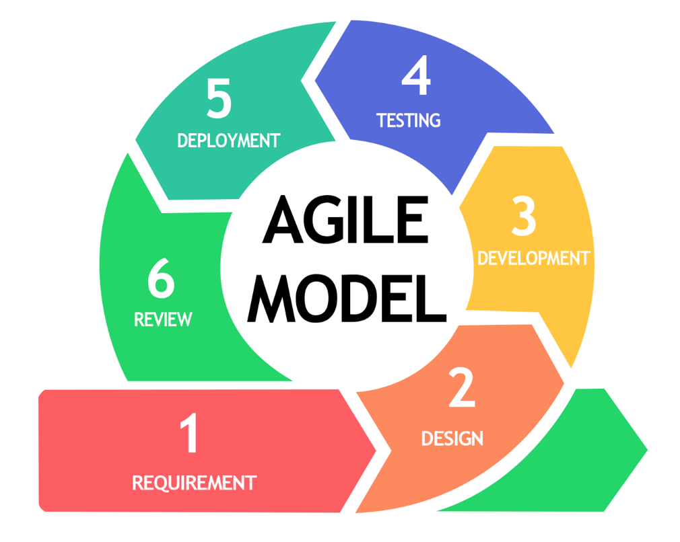
Figure 1. Agile Model

3.2 System Architecture
Figure 3.2 Web Application Architecture
The implemented application uses Vue for the user interface, Laravel for authenticated API and authorization controls, and MySQL for users, documents, routes, QR records, processing logs, attachments, and audit data.
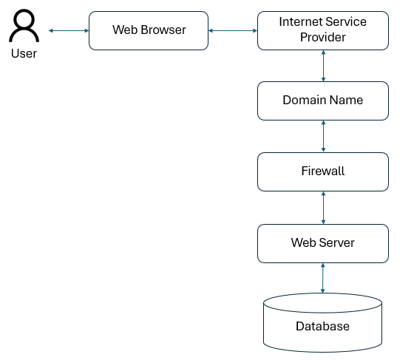
Figure 1. Web Application Architecture

3.3 Use Case Diagram
The Use Case Diagram illustrates the interactions between system users and the document tracking system. The main actors include the Administrator, Records Personnel, Department Head, Authorized Staff and Requesters/Clients. Key use cases include document registration, QR code generation, document routing, document status tracking, report generation, user management, and audit log viewing. This diagram defines system boundaries and clarifies functional requirements.
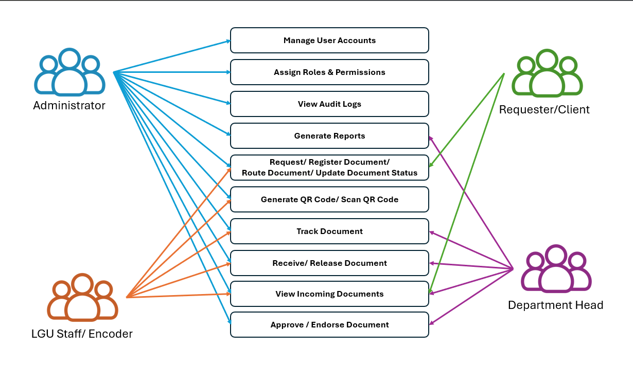
Figure 1. Use Case Diagram

3.4 Context Level Data Flow Diagram
The Context Level Data Flow Diagram (DFD) presents the system as a single process and shows how external entities interact with it. External entities include system users such as administrators and staff. Data flows consist of document information, routing requests, tracking updates, and report outputs. The diagram provides a high-level view of how data enters, is processed by, and exits the system.
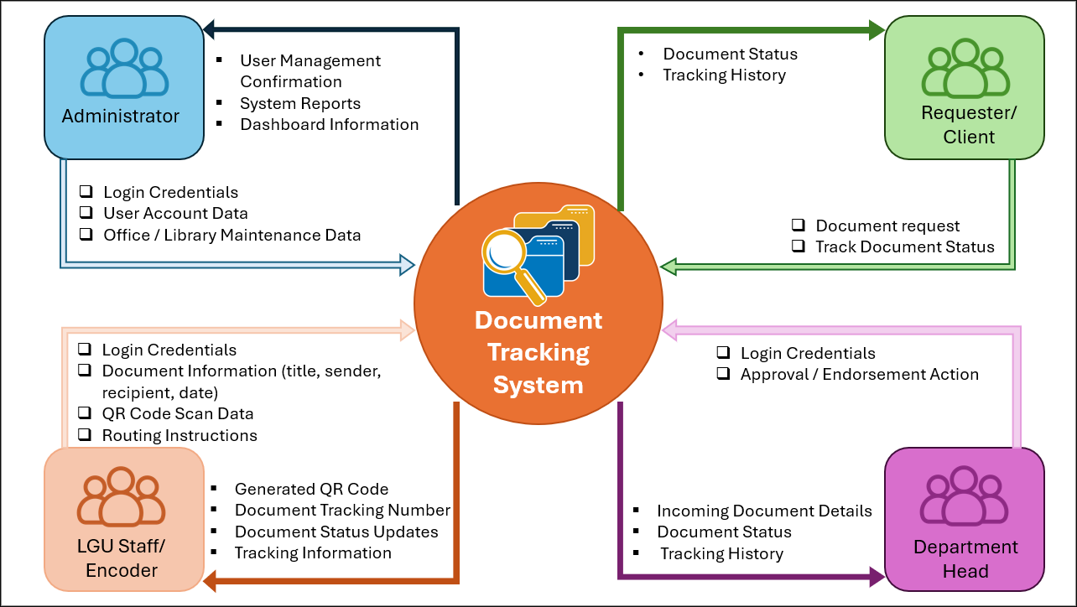
Figure 1. Context Level Data Flow Diagram

3.5 Hierarchical Input Process Output HIPO
3.3 Hierarchical Input–Process–Output (HIPO)
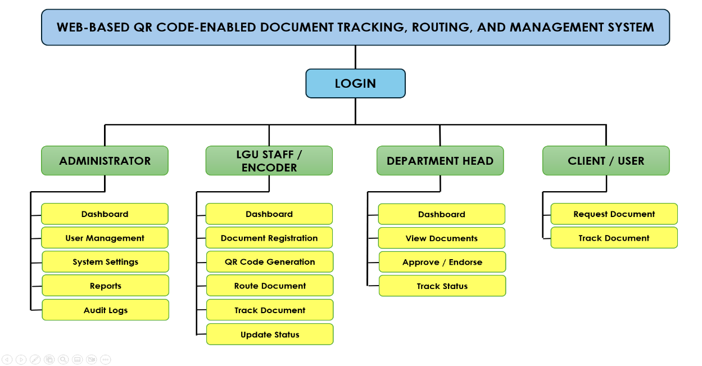
Figure 1. Hierarchical Input Process Output Diagram

3.6 Input Process Output Diagram
3.4 Input Process Output
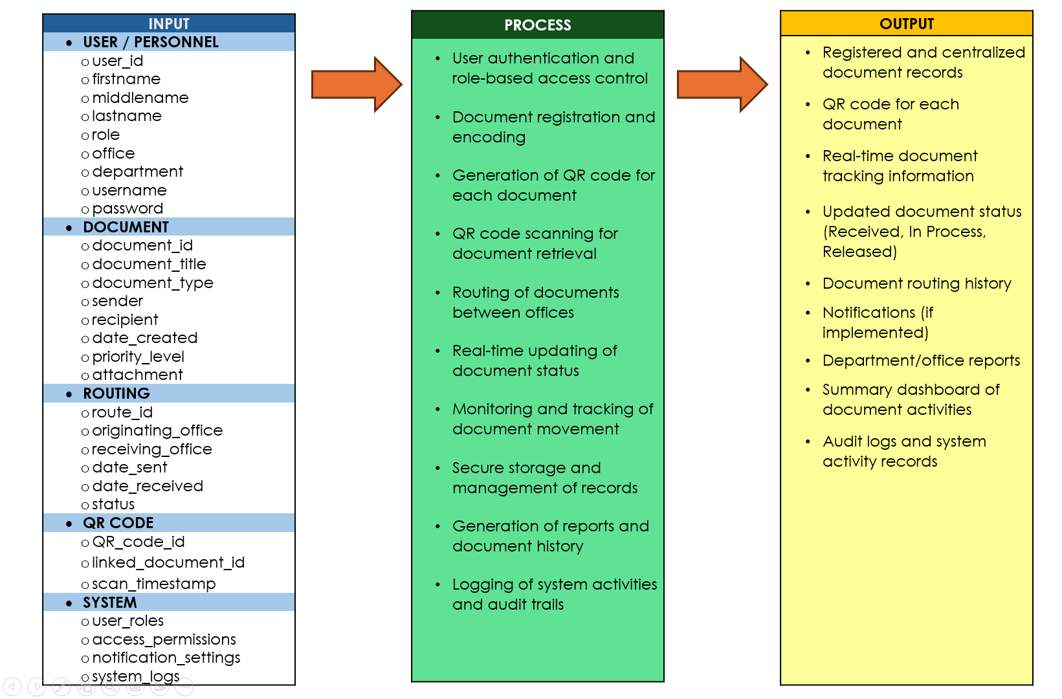
Figure 1. Input Process Output Diagram

3.7 Software and Hardware Requirements
The development environment and minimum operating requirements are summarized below. Equivalent or higher-capacity equipment may be used during deployment.
Category | Specification
Operating system | Windows or Linux server environment
Application stack | PHP / Laravel; JavaScript / Vue / Vite
Database | MySQL
Web server | Apache
Browser | Current Chrome, Firefox, Edge, or Brave
Processor | Intel Core i5 or comparable, or higher
Memory | 8 GB RAM or higher
Storage | 256 GB SSD or higher
QR access | QR scanner or mobile device with camera

3.8 Respondents of The Study
The researcher used the total enumeration sampling method, wherein the respondents of the study were employees of the Local Government Unit (LGU) of Tuao who are directly involved in the processing, routing, recording, and management of official documents. These employees regularly handle incoming and outgoing communications and administrative records within their respective offices, making them suitable participants for the study.
The respondents were selected because they are actively engaged in document handling and routing processes, which are essential in identifying the existing challenges and requirements for the development of a Web-Based QR Code-Enabled Document Tracking, Routing, and Management System for the Local Government Unit of Tuao.
In addition, information technology (IT) experts and system evaluators were involved to evaluate the developed system and determine its compliance with the ISO/IEC 25010 Software Quality Standards, particularly in terms of functional suitability, usability, reliability, performance efficiency, security, maintainability, and portability. Their evaluation ensured that the system meets the required software quality standards
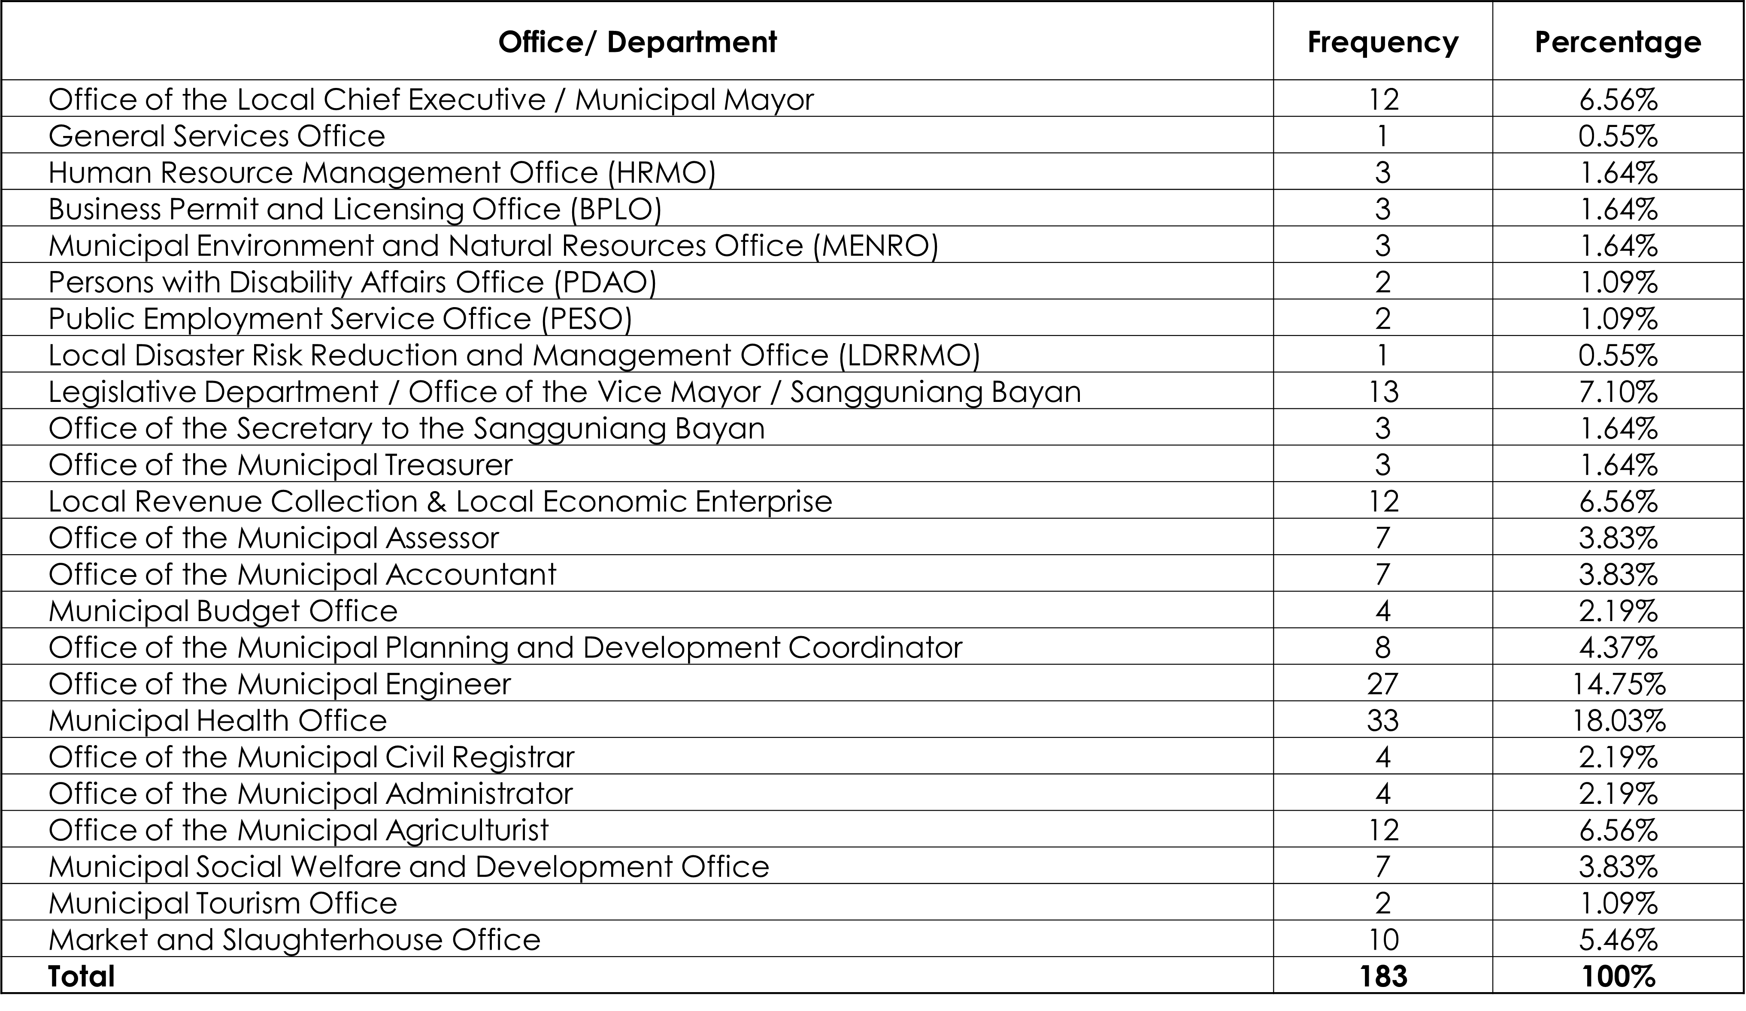
Figure 1. Respondents of the Study

3.9 Research Instrument
The primary research instrument used in the study is a structured questionnaire based on the ISO/IEC 25010 Software Quality Model. The questionnaire evaluates the system in terms of functional suitability, performance efficiency, usability, reliability, security, maintainability, and portability. Interviews and observation checklists were also used to gather additional qualitative data.
The questionnaire is included in Appendix D. It is an evaluation instrument, not evidence of a result by itself; numeric compliance ratings must only be added after completed and auditable respondent forms are collected and analyzed.

3.10 Locale of The Study
The study will be conducted at the Local Government Unit of Tuao, Cagayan. The LGU was selected as the locale due to its active involvement in document processing and administrative operations, making it suitable for evaluating the effectiveness of the proposed document tracking system.

3.11 Data Gathering Procedure
Data gathering was conducted in three phases. First, preliminary data were collected through interviews, observation, and document review to assess the existing manual process. Second, requirements data were gathered from system users to guide system development. Third, evaluation data were collected after system implementation using the ISO/IEC 25010–based questionnaire.
The implementation documentation also records system inspection, workflow testing, and captured interface evidence. Research participation and any collection of operational records remain subject to institutional approval and LGU procedures.

3.12 Data Analysis
Descriptive statistics such as frequency count, and mean will be used in the analysis of the data specifically in the determination of the extent of compliance of the web-based document tracking to Software Quality Standards known as ISO 25010:2011 as assessed by IT experts and users. The following scale will be used:
The results of the feedback will be evaluated using the average Weighted Mean. The average of these scores will be assessed according to the scale outlined below:
No completed questionnaire dataset was supplied for this manuscript; therefore, Chapter IV reports implemented features and testable design evidence rather than invented weighted means, percentages, or acceptability ratings.

CHAPTER IV RESULTS AND DISCUSSIONS

4.1 Problems Encountered in The Existing System
Typical concerns addressed are delayed status confirmation, fragmented routing records, difficult document lookup, unclear custody, and limited visibility of processing progress. In a paper-led flow, staff may need to contact several offices to determine whether a document is in transit, received, or acted upon. The developed system addresses these concerns by recording a current state and retaining the underlying routing and processing events.

4.2 The Developed System
DocTrackTuao implements a controlled lifecycle: Register document, generate or use QR, forward, mark in transit, receive at destination, record current action or processing note, attach supporting files, forward again as necessary, and view history and audit information.

4.2.1 Entity Relationship Diagram ERD
Key data entities are users, roles, offices, documents, document QR codes, document routes, document processing logs, attachments, processing actions, notifications, and audit logs. Document routes preserve movement history; processing logs preserve action history; QR codes remain associated with documents.
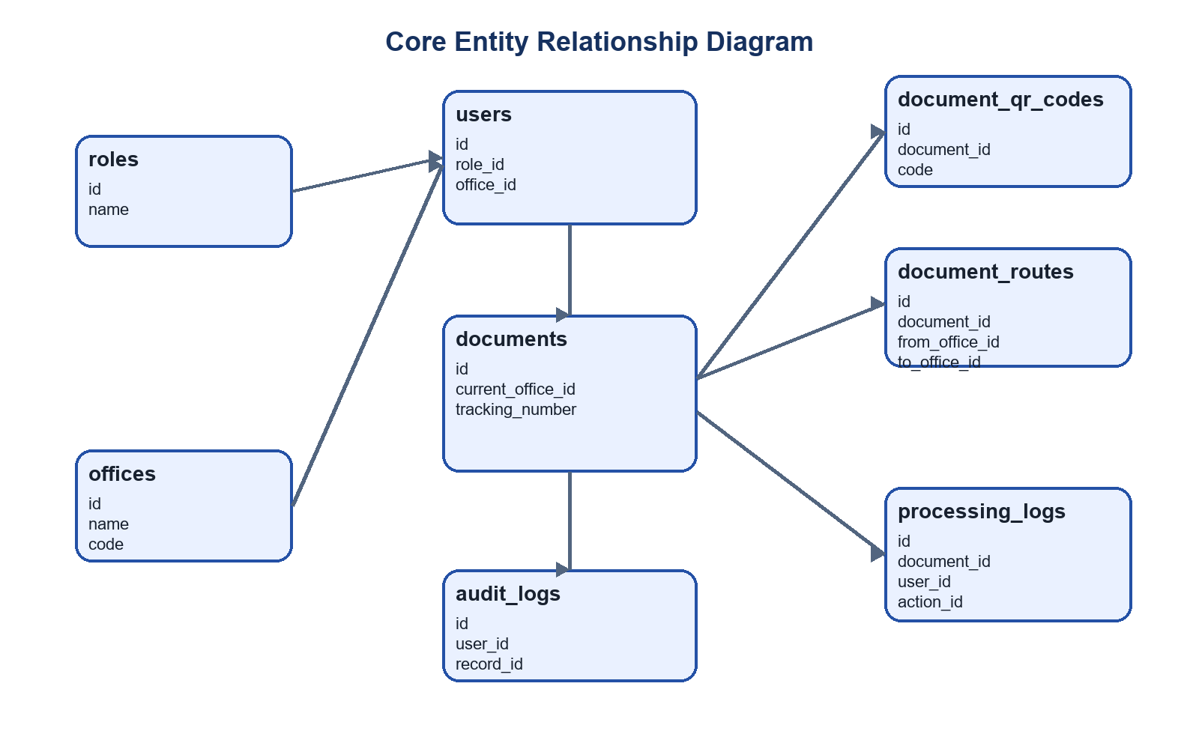
Figure 1. Core Entity Relationship Diagram

4.2.1.1 User View
Users view only the functions allowed by their role and the documents available to their assigned office. Administrators manage users and master data; operational users register, route, receive, and process documents only within permitted workflow rules.

4.2.1.2 Data Model
Documents are linked to QR records, routing records, processing logs, attachments, and audit events. This structure keeps custody and processing history separate from the current document state.

4.2.2 Table Design
Table | Purpose
users | Stores authenticated accounts, role and office assignment.
documents | Stores registered document identity and current custody.
document_qr_codes | Stores QR tokens associated with documents.
document_routes | Stores forwarding and receipt history.
document_processing_logs | Stores current action and note history.
audit_logs | Stores accountability events.

4.2.3 System Interface Screens
The following figures are captured from the running local DocTrackTuao system using an authorized administrator session. Values shown reflect the current development database at the time of capture.
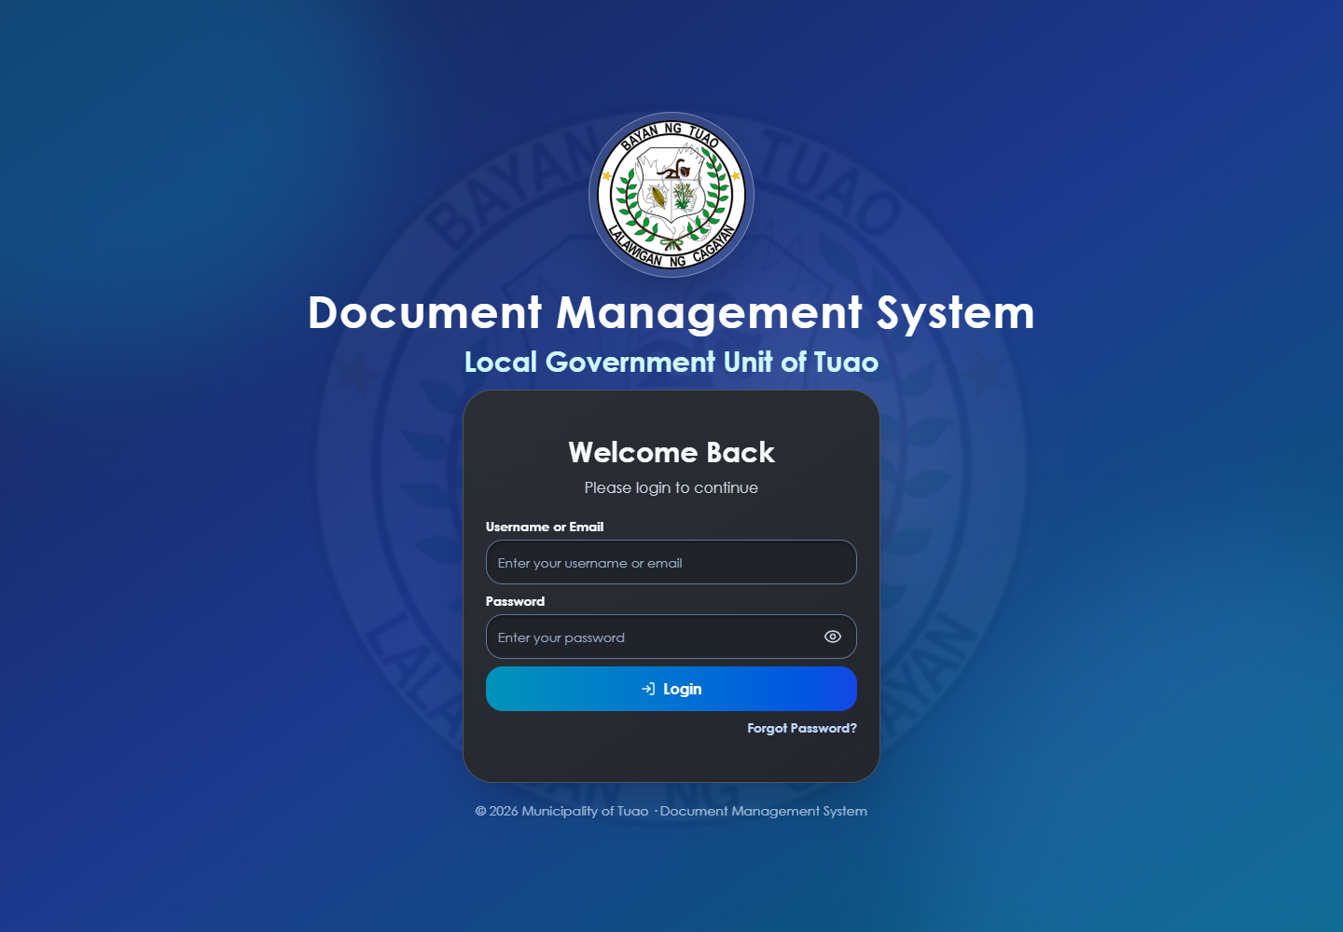
Figure 1. Login Page
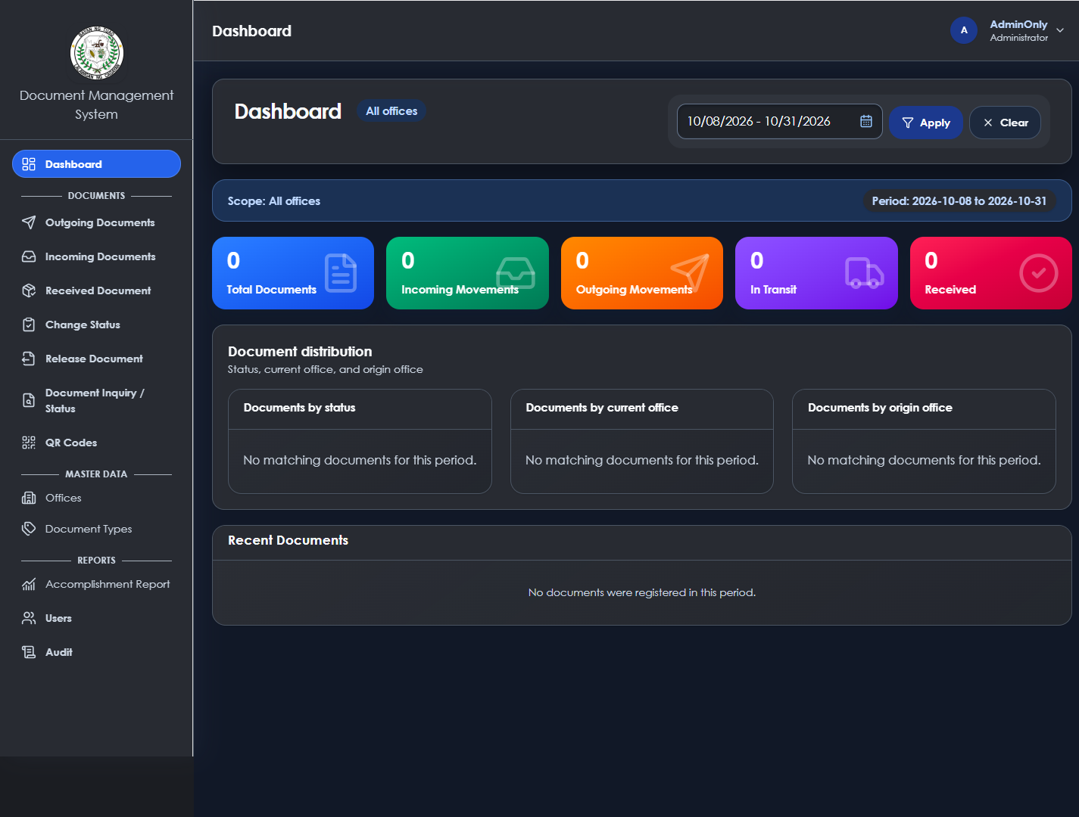
Figure 1. Dashboard
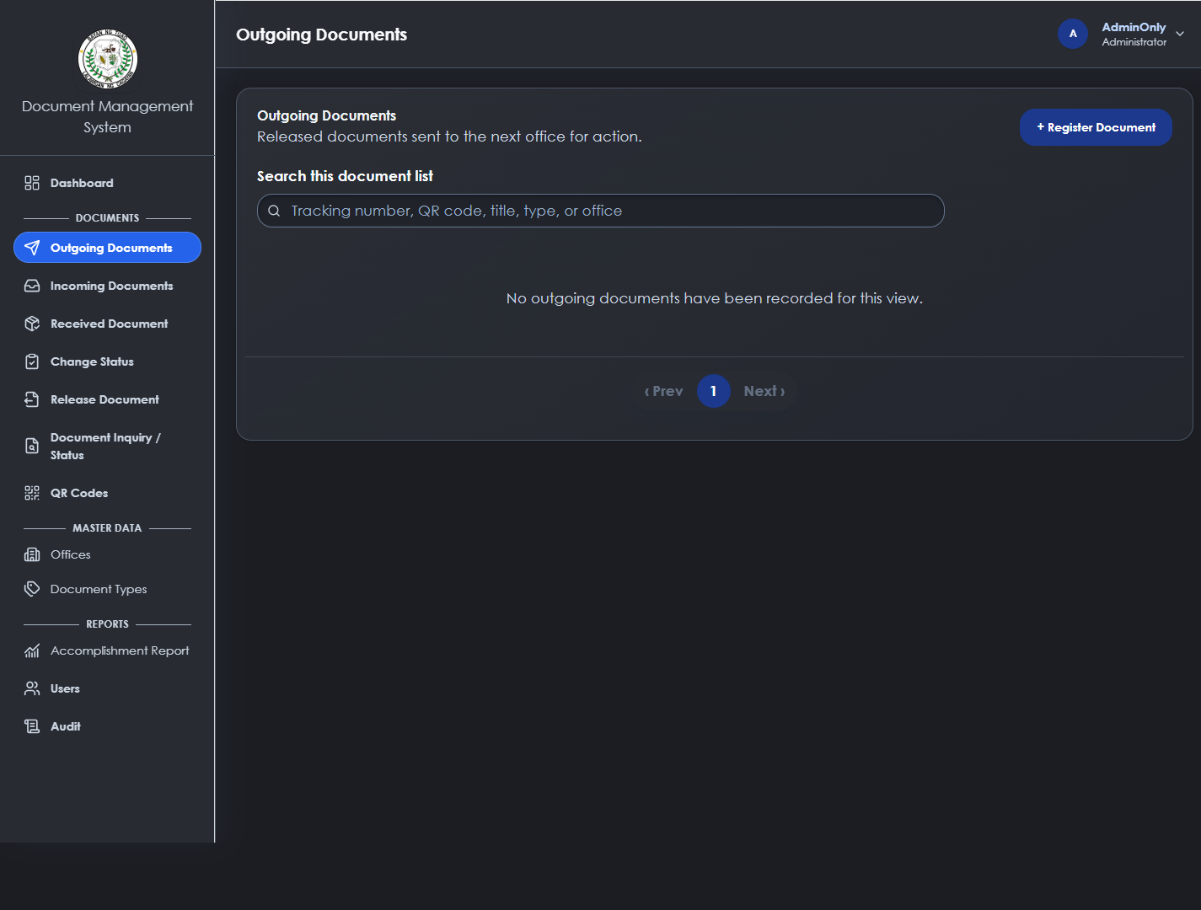
Figure 1. Outgoing Documents
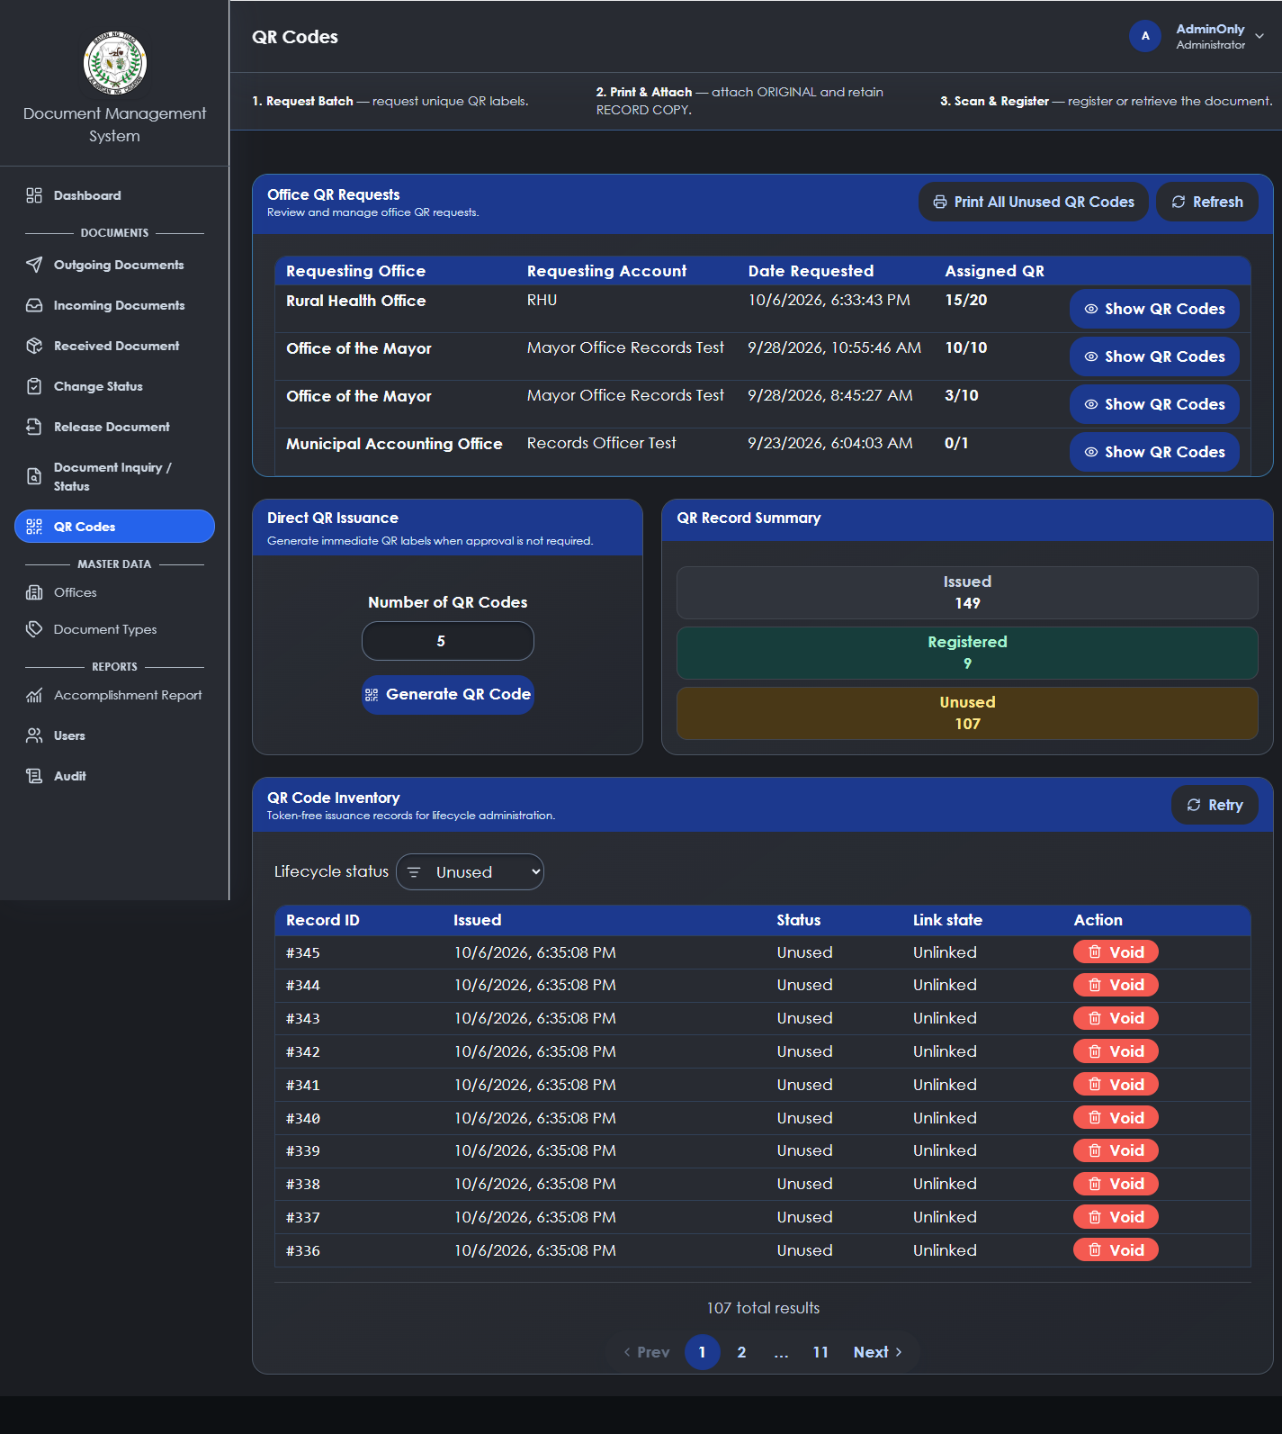
Figure 1. QR Codes
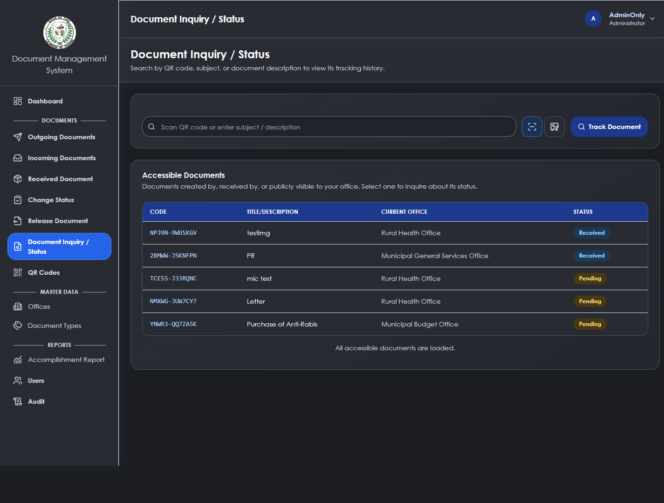
Figure 1. Document Inquiry
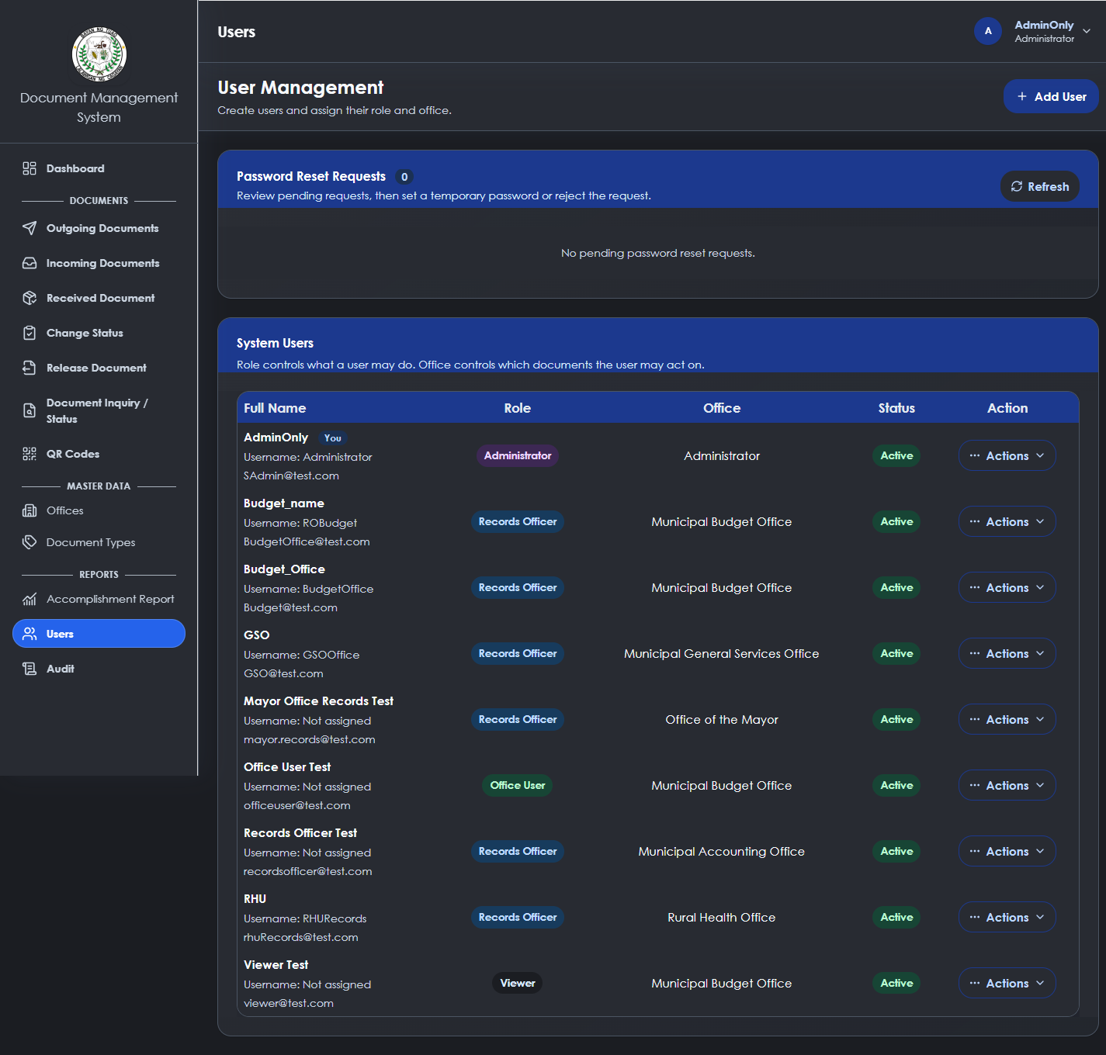
Figure 1. User Management
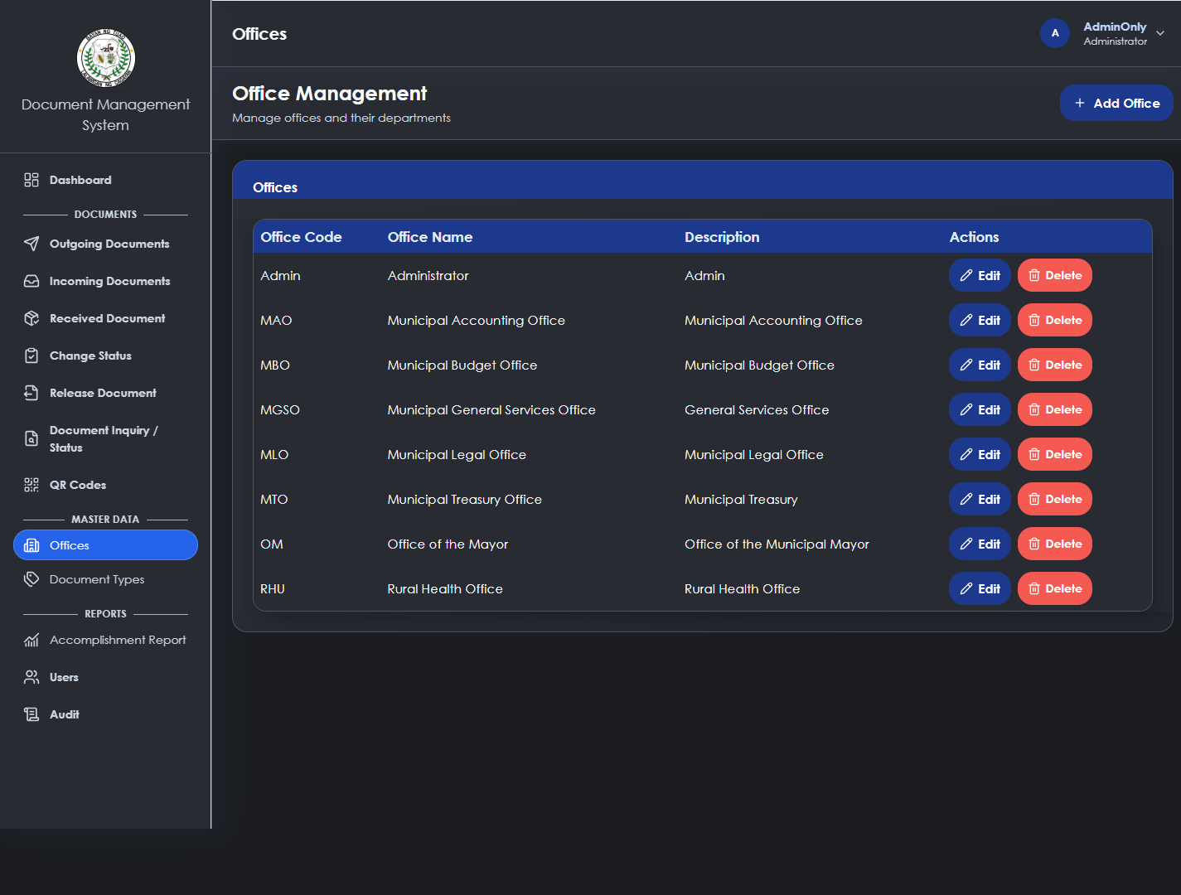
Figure 1. Office Master Data
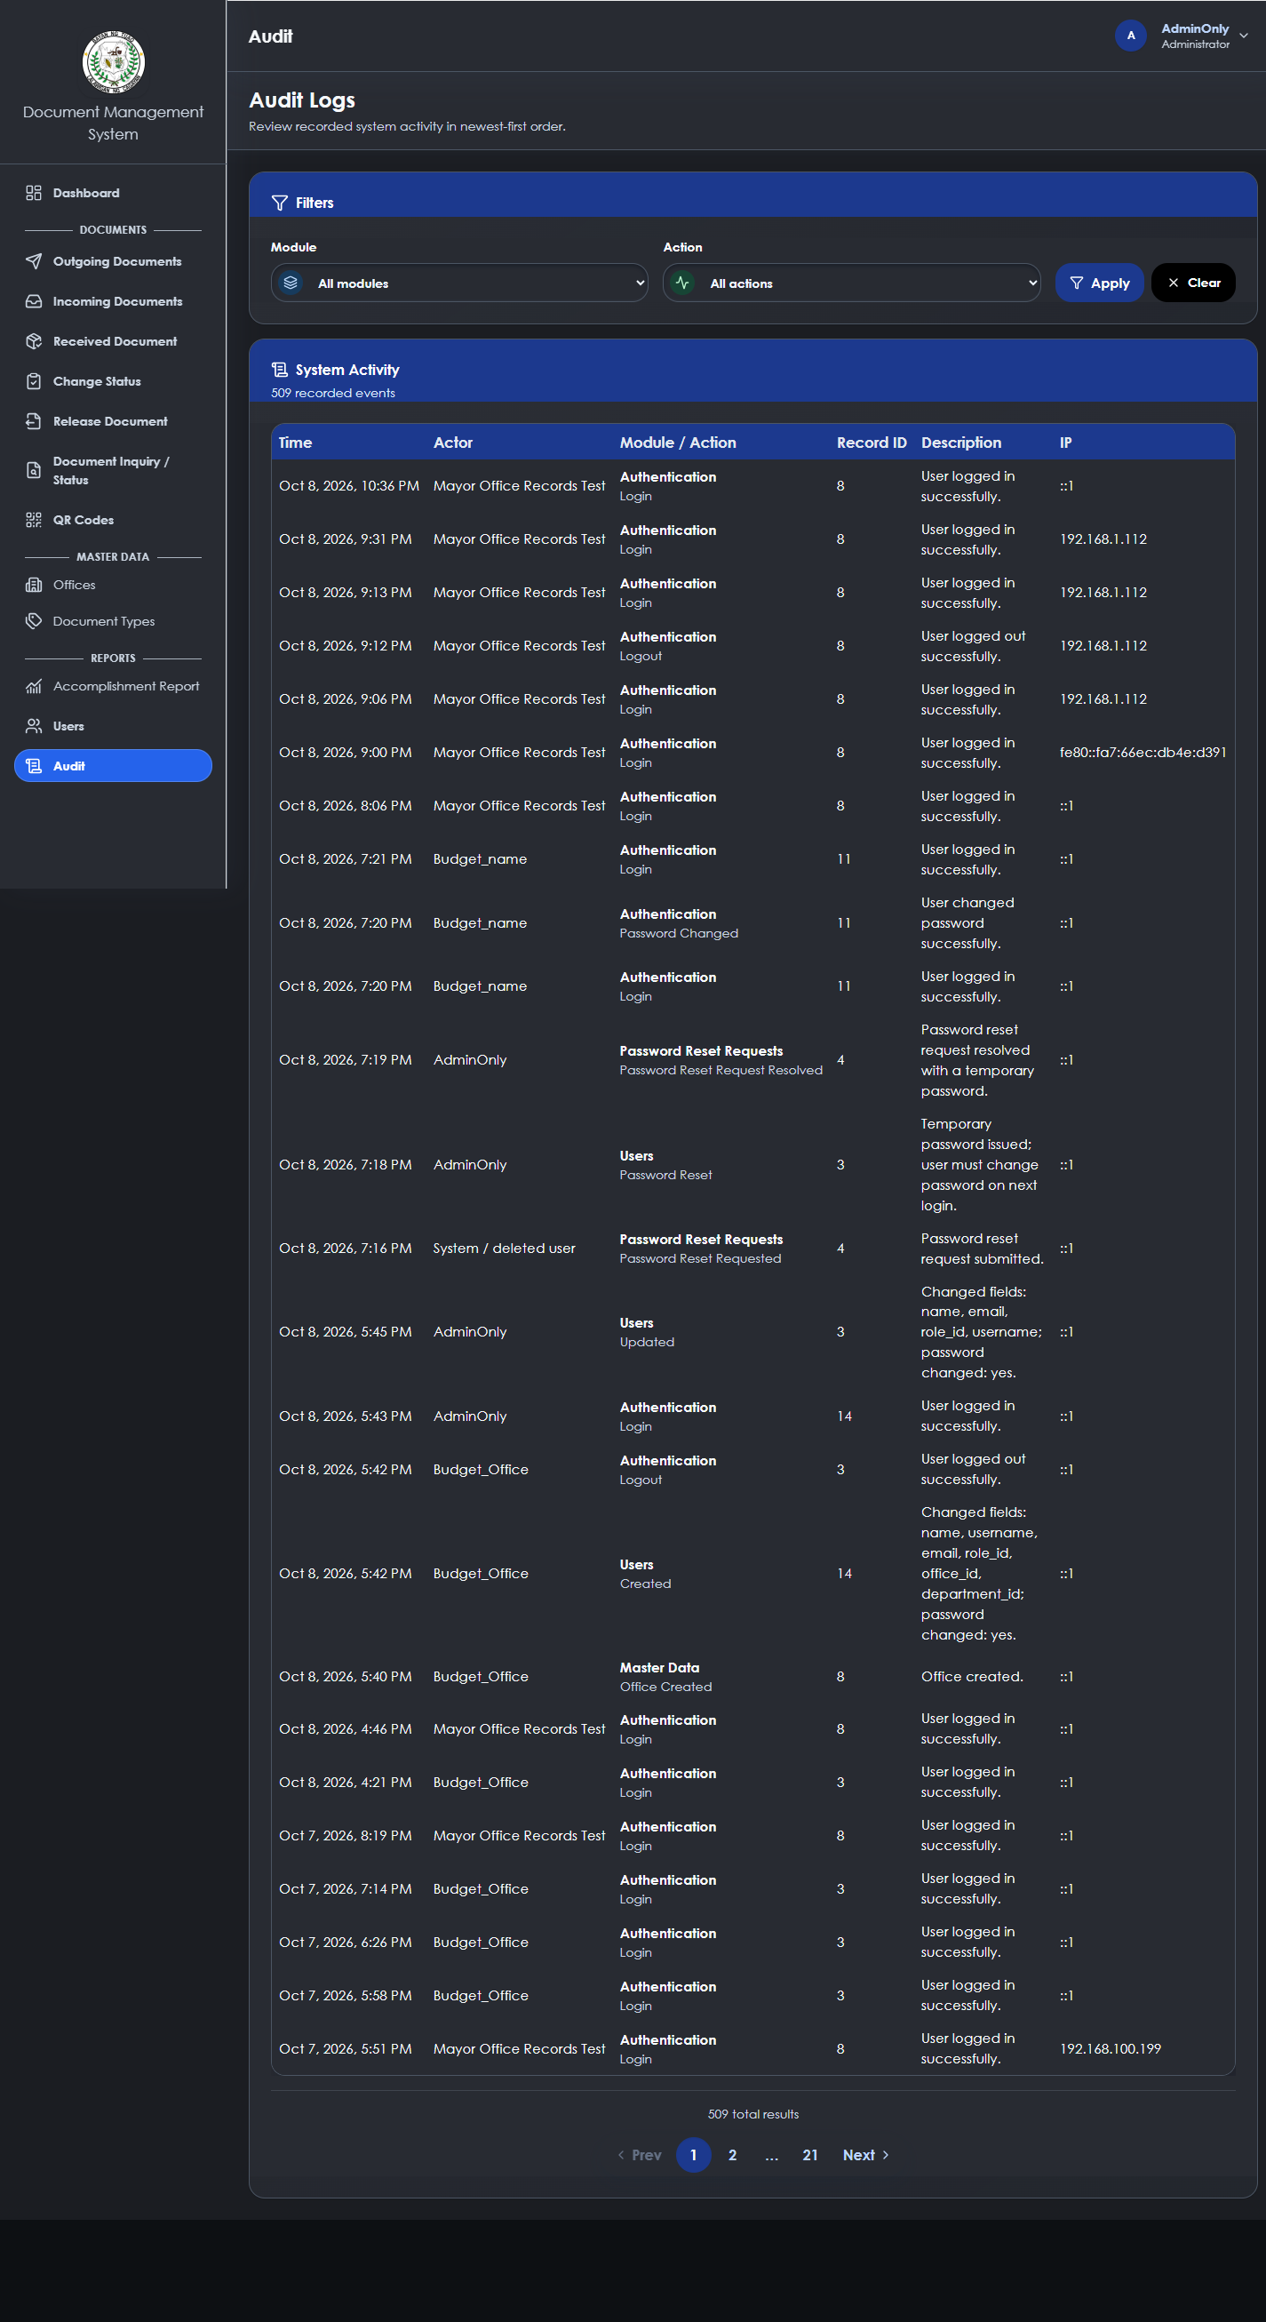
Figure 1. Audit Logs
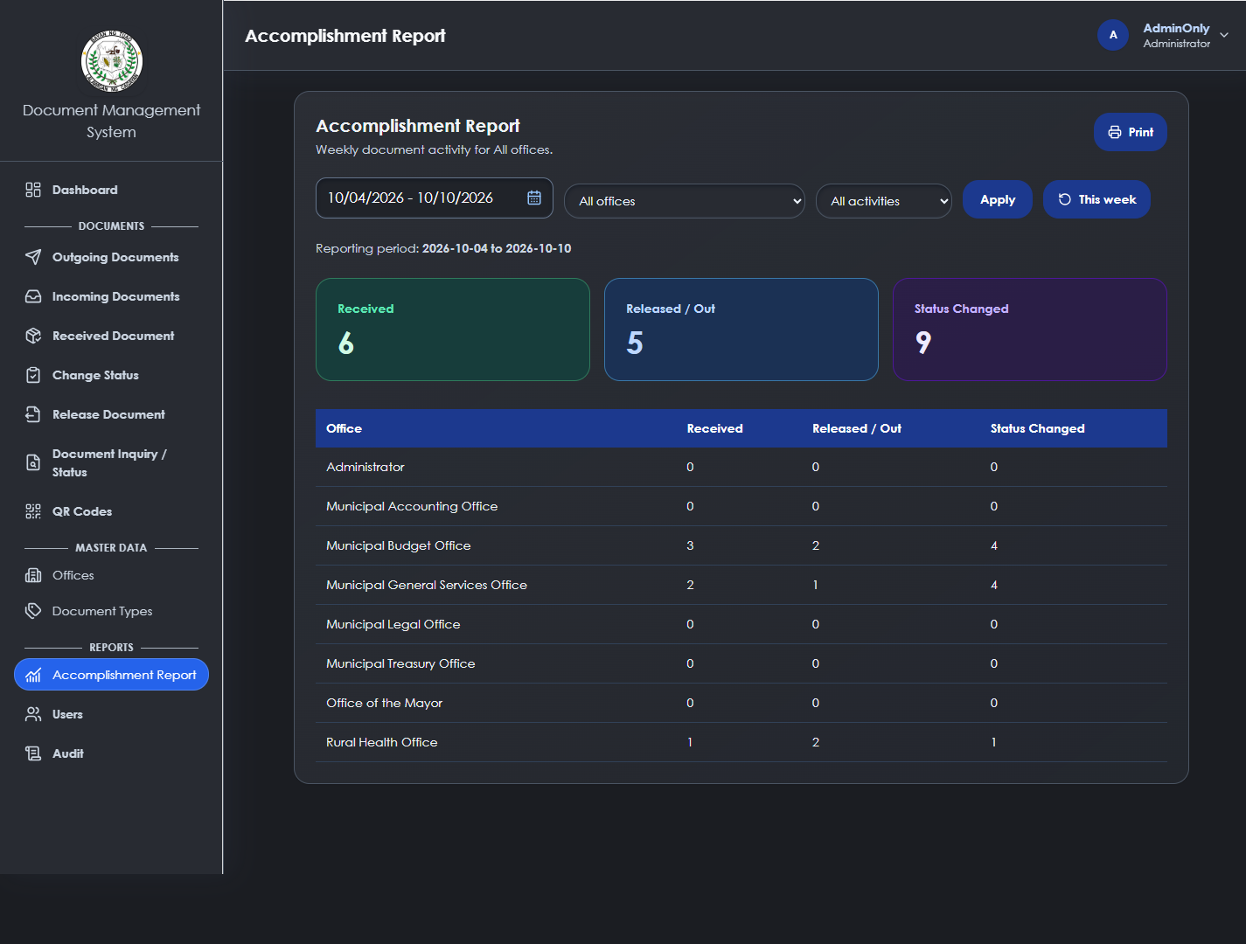
Figure 1. Accomplishment Report

4.3 Extent of Compliance to ISO 25010
The system includes evidence relevant to ISO 25010: role and office controls support security; guarded workflow transitions support reliability; QR, manual entry, and image capture support usability; server validation and restricted APIs support functional suitability. Completed questionnaires are required before presenting extent of compliance ratings.

CHAPTER V SUMMARY OF FINDINGS AND RECOMMENDATIONS

5.1 Summary of Findings
The developed system provides end to end internal document tracking with QR assisted retrieval and controlled routing. Its main implementation value is preservation of current custody and historical accountability.

5.2 Conclusions
DocTrackTuao is a suitable platform for structured document tracking when deployment, data backup, and user evaluation procedures are completed. The system must retain server side authorization and office scope enforcement as it evolves.

5.3 Recommendations
• Conduct pilot testing with representative offices and analyze completed ISO 25010 questionnaires.
• Deploy with HTTPS so mobile live camera scanning is available without browser limitations.
• Maintain scheduled database backups and verify restore procedures.
• Complete production hardening, dependency review, and end to end role based tests before release.
• Add APA 7th edition references and at least twenty five sources to the final thesis manuscript.

Bibliography
Brooke, J. (1996). SUS: A quick and dirty usability scale. In P. W. Jordan, B. Thomas, B. A. Weerdmeester, & I. L. McClelland (Eds.), Usability evaluation in industry (pp. 189-194). Taylor & Francis.
Davis, F. D. (1989). Perceived usefulness, perceived ease of use, and user acceptance of information technology. MIS Quarterly, 13(3), 319-340. https://doi.org/10.2307/249008
DeLone, W. H., & McLean, E. R. (2003). The DeLone and McLean model of information systems success: A ten-year update. Journal of Management Information Systems, 19(4), 9-30. https://doi.org/10.1080/07421222.2003.11045748
International Organization for Standardization. (2016). ISO 15489-1:2016 information and documentation - Records management - Part 1: Concepts and principles.
International Organization for Standardization. (2023). ISO/IEC 25010:2023 systems and software engineering - Systems and software Quality Requirements and Evaluation - Product quality model.
Koyuncu Tunc, A. (2025). Comparative analysis of four usability assessment techniques for electronic record management systems. Advances in Human-Computer Interaction, 2025, Article 8693889. https://doi.org/10.1155/ahci/8693889
Laravel. (2026). Laravel documentation. https://laravel.com/docs
McLeod, J., & Childs, S. (2013). A strategic framework for managing records in the digital age: The records continuum model. Records Management Journal, 23(1), 18-32.
National Institute of Standards and Technology. (2020). Digital identity guidelines: Authentication and lifecycle management (Special Publication 800-63B). https://doi.org/10.6028/NIST.SP.800-63b
National Privacy Commission. (2016). Implementing rules and regulations of Republic Act No. 10173, known as the Data Privacy Act of 2012.
Nielsen, J. (1994). Usability engineering. Morgan Kaufmann.
OWASP Foundation. (2021). OWASP Top 10: The ten most critical web application security risks. https://owasp.org/Top10/
OWASP Foundation. (2025). Application Security Verification Standard 5.0. https://owasp.org/www-project-application-security-verification-standard/
PHP Group. (2026). PHP manual. https://www.php.net/manual/en/
Republic of the Philippines. (2007). Republic Act No. 9470: National Archives of the Philippines Act of 2007. https://lawphil.net/statutes/repacts/ra2007/ra_9470_2007.html
Republic of the Philippines. (2012). Republic Act No. 10173: Data Privacy Act of 2012. https://lawphil.net/statutes/repacts/ra2012/ra_10173_2012.html
Republic of the Philippines. (2018). Republic Act No. 11032: Ease of Doing Business and Efficient Government Service Delivery Act of 2018. https://lawphil.net/statutes/repacts/ra2018/ra_11032_2018.html
Seddon, P. B. (1997). A respecification and extension of the DeLone and McLean model of IS success. Information Systems Research, 8(3), 240-253. https://doi.org/10.1287/isre.8.3.240
Shepherd, E., & Yeo, G. (2003). Managing records: A handbook of principles and practice. Facet Publishing.
The Document Foundation. (2026). LibreOffice documentation. https://documentation.libreoffice.org/
Vue.js. (2026). Vue.js documentation. https://vuejs.org/guide/
World Wide Web Consortium. (2024). Web Authentication: An API for accessing public key credentials. https://www.w3.org/TR/webauthn-3/
Zafra, J. M., & Reyes, M. A. (2025). Enhancement of a document tracking system through iterative approach. 2025 International Conference on Computing and Applied Informatics. https://doi.org/10.1109/ICCAI65301.2025.11279430
Zaman, M. S., Saha, A., & Hossain, M. S. (2023). Design and development of information management system using QR code based technique. 2023 International Institute of Technology Conference on Electrical Engineering and Computing. https://doi.org/10.1109/IITCEE57236.2023.10091058
Zhao, L., Lu, Y., & Wang, B. (2025). Interaction between users, technology, and computerized document archival management system: Theoretical insights. InCID: Revista de Ciencia da Informacao e Documentacao. https://doi.org/10.11606/issn.2178-2075.incid.2025.217194
Abdullah, R., & Chen, L. (2023). Balancing encryption and performance in government document systems: A Malaysian case study. Journal of Information Security and Applications, 74, 103456. https://doi.org/10.1016/j.jisa.2023.103456
Al Dallal, J. A., & Al Mukhtar, A. (2023). Secure QR code-based authentication mechanisms for information systems. International Journal of Information Security Research, 13(2), 145–158.
Alampay, E. A. (2020). Analyzing the socio-technical factors of e-government integration in the Philippines. Philippine Journal of Public Administration, 64(1), 1–30. https://paij.pup.edu.ph/index.php/paij/article/view/24
Alavi, M., & Leidner, D. E. (2001). Knowledge management and knowledge management systems: Conceptual foundations and research issues. MIS Quarterly, 25(1), 107–136. https://doi.org/10.2307/3250961
Allen, D. K. (2019). Information and records management: The case for a hybrid approach in the digital age. Routledge. https://doi.org/10.4324/9780429023745
Banks, M. (2021). Modern software development life cycles: From Waterfall to DevSecOps. TechPress.
Chen, L., Wang, Y., & Zhang, H. (2022). National document automation systems: A case study of South Korea's implementation. Journal of Digital Governance, 15(3), 201–220. https://doi.org/10.1016/j.jdg.2022.08.003
Complex Tester. (2012). The Sashimi Model: Overlapping phases in SDLC. Software Testing Magazine. https://www.complextester.com/sashimi-model-sdlc
Constantino, R., Santos, M., & Cruz, J. (2020). Development and evaluation of an electronic documents location tracking system for Isabela State University. Philippine Journal of Information Technology, 12(2), 45–58. https://doi.org/10.54321/pjit.2020.1202.45
Cordella, A., & Bonina, C. M. (2022). A public value perspective for ICT enabled public sector reforms: A theoretical reflection. Government Information Quarterly, 39(2), 101462. https://doi.org/10.1016/j.giq.2021.101462
Dalkir, K. (2017). Knowledge management in theory and practice (3rd ed.). MIT Press. https://doi.org/10.7551/mitpress/10474.001.0001
Dumas, M., La Rosa, M., Mendling, J., & Reijers, H. A. (2018). Fundamentals of business process management (2nd ed.). Springer. https://doi.org/10.1007/978-3-662-56509-4
Fajar, M., Rahman, A., & Putra, D. (2025). Implementation of QR code-based inventory management system for improved tracking accuracy. Journal of Information Systems Engineering and Management, 10(1), 1–12.
Garcia, M., & Lim, S. (2022). Measuring the impact of digital workflow automation in public administration. International Journal of Public Sector Management, 35(5), 521–539. https://doi.org/10.1108/IJPSM-03-2022-0078
International Organization for Standardization (ISO). (2021). ISO/IEC 25010: Systems and software engineering—Systems and software quality requirements and evaluation (SQuaRE). https://www.iso.org/standard/35733.html
Lingaya, R. (2019). Design and implementation of a document tracking system for state universities and colleges. Philippine Computing Journal, 15(1), 34–49. https://doi.org/10.54321/pcj.2019.1501.34
Mergel, I., Edelmann, N., & Haug, N. (2019). Defining digital transformation: Results from expert interviews. Government Information Quarterly, 36(4), 101385. https://doi.org/10.1016/j.giq.2019.06.002
Mukhammedali, A., Nurmaganbetova, A., & Tleubergenova, M. (2025). Security threats and mitigation strategies in QR code applications. Journal of Cybersecurity and Information Management, 7(1), 34–48.
Müller, A., & Schmidt, R. (2021). Workflow automation in federal document management: Germany's integrated approach. Government Information Quarterly, 38(2), 101567. https://doi.org/10.1016/j.giq.2021.101567
National Economic and Development Authority (NEDA). (2022). Philippine Development Plan 2023–2028: Digital transformation chapter. https://pdp.neda.gov.ph
Nugroho, Y., Santoso, H., & Wijaya, R. (2024). Agile-based development of web document management systems in public institutions. International Journal of Advanced Computer Science and Applications, 15(3), 210–218.
Pati, R., Sharma, K., & Verma, S. (2023). QR code-based automated attendance monitoring system. International Journal of Emerging Technologies in Engineering Research, 11(4), 55–61.
Placido, G. (2020). The state of e-governance in the Philippines: Policy versus practice. Journal of Philippine Public Administration, 64(2), 45–68. https://paij.pup.edu.ph/index.php/paij/article/view/31
Rellon, L. P., Garcia, M. T., & Cruz, J. R. (2021). Evaluation of document management systems using ISO/IEC 25010 software quality standards. Philippine Journal of Information Technology Research, 5(2), 78–90.
Rellon, M., Cortez, A., & Dela Cruz, L. (2020). Barcode-based document tracking with SMS notification. Journal of Philippine Technological Education, 7(4), 78–92. https://doi.org/10.54321/jpted.2020.0704.78
Republic Act No. 8792. (2000). Electronic Commerce Act of 2000. https://www.officialgazette.gov.ph/2000/06/14/republic-act-no-8792
Republic Act No. 10173. (2012). Data Privacy Act of 2012. https://www.officialgazette.gov.ph/2012/08/15/republic-act-no-10173/
Santos, P., & Ocampo, R. (2023). User acceptance and productivity outcomes in the digitalization of LGU document processes. Philippine Journal of Public Administration, 67(1), 45–68. https://doi.org/10.52567/pjpa.v67i1.412
Stallings, W. (2021). Cryptography and network security: Principles and practice (8th ed.). Pearson.
Tan, K., & Wong, A. (2023). Time-motion studies for process improvement in digital government. Journal of Organizational Efficiency, 18(2), 134–152.
Thompson, E., & Rodriguez, M. (2022). Academic document workflow automation: Implementation at Cambridge University. Journal of Academic Administration, 29(1), 88–105.
United Nations Department of Economic and Social Affairs. (2022). UN E-Government Survey 2022. https://publicadministration.un.org/egovkb
University of the Philippines Information Technology Development Center. (2022). UP Document Tracking System: Technical documentation and implementation guide. https://itdc.up.edu.ph
Van der Aalst, W. M. P. (2018). Process mining: Data science in action (2nd ed.). Springer. https://doi.org/10.1007/978-3-662-49851-
Venkatesh, V., & Bala, H. (2022). Technology acceptance model 3 and a research agenda on interventions. Decision Sciences, 53(2), 138–177. https://doi.org/10.1111/deci.12098
Zadorozhnyi, O., Koval, V., & Melnyk, I. (2025). Digital transformation of document management through QR code integration. Journal of Digital Administration and Governance, 9(1), 23–39.

APPENDICES

Appendix A Request Letter for Gathering Data
Date: ____________________
The Municipal Mayor
Local Government Unit of Tuao
Tuao, Cagayan
Dear Sir/Madam:
I am Kevin D. Apil, a Master of Science in Information Technology student at Cagayan State University Carig Campus. I respectfully request permission to gather workflow requirements and non-confidential operational feedback needed for the study entitled Development of a Web Based QR Code Enabled Document Tracking Routing and Management System for the Local Government Unit of Tuao. The activity will focus on document-routing practices, user requirements, and system evaluation. No confidential document content, credentials, or personal information beyond approved research data will be collected.
All collected information will be handled in accordance with institutional research requirements and the Data Privacy Act of 2012. Participation will be voluntary and will not affect any employee status or service. Your favorable consideration is respectfully requested.
Respectfully yours,
KEVIN D. APIL
Researcher

Appendix B Request for Pilot Testing
Date: ____________________
The Head of Office
Local Government Unit of Tuao
Tuao, Cagayan
Dear Sir/Madam:
I respectfully request authority to conduct controlled pilot testing of DocTrackTuao with authorized personnel. Pilot activities will include account access, document registration, QR lookup, controlled forwarding and receipt, processing-note recording, history review, and ISO IEC 25010 evaluation. Test documents must contain no confidential or sensitive information unless separately approved under applicable LGU procedures.
The pilot will observe existing authorization, office-custody, and records-management rules. Issues identified during testing will be documented and addressed before deployment. Thank you for considering this request.
Respectfully yours,
KEVIN D. APIL
Researcher

Appendix C Users Manual
This manual explains the principal DocTrackTuao functions using the screens captured from the running system. User access is role-aware; an available menu item does not replace server-side validation, office assignment, or custody requirements.

C.1 Accessing the System

Login And Password Recovery
Open the authorized system address, enter the username or email and password, then select Login. A successful login opens the dashboard. The Forgot Password option initiates the organization-approved recovery process. Do not share passwords or authentication tokens.
Appendix Figure C1. Login and password recovery entry screen

Account Menu
The upper-right profile menu displays the current account identity and gives access to the profile, notifications, dark-mode preference, and logout. Users should log out after shared-device use.

Account Settings
A temporary-password account must change its password before accessing operational modules. Password changes should use a unique value that complies with the configured security requirements.

C.2 Registering a Document

Log New Document Form
Select Register Document from the outgoing-document view. Enter the required document details, select the appropriate document type and office data, then submit. The system validates the data before creating the record and associated QR identity.

Outgoing Documents
Outgoing Documents lists documents that have been released or forwarded for action. Use the search box to locate a document by tracking number, QR code, title, type, or office. Open a matching record to inspect its details and route history.
Appendix Figure C2. Outgoing Documents search and registration entry

Incoming Documents
Incoming or received-document views show records that require action from the destination office. A destination office must receive a pending route before recording processing activity or forwarding the document again.

C.3 Routing and Acting on a Document

Document Details And Recipient Flow
Open a document from a list or search result to review its current office, status, routing history, processing history, and attachments. Confirm the destination office before forwarding. The system records a pending route and places the document in transit.

Forward Receive And Process
Only an authorized user assigned to the office that currently holds the document may forward it. The destination office receives the route to transfer custody, then selects a current action and optional processing note. This sequence preserves the custody boundary and historical record.

Release And Status Actions
Use Release Document and Change Status only when the document is held by the assigned office and workflow rules allow the action. Invalid actions, a missing office assignment, or a pending route are rejected by the server.

C.4 Search Notifications QR and Reports

Dashboard
The dashboard summarizes document counts, incoming and outgoing activity, in-transit records, received records, and status distributions for the selected date period and permitted office scope.
Appendix Figure C3. Dashboard with date filter and document indicators

Document Inquiry
Document Inquiry supports authorized lookup by tracking details or QR information. Use the result to review the document state and historical events rather than relying on verbal confirmation.
Appendix Figure C4. Document inquiry and status lookup

QR Code Generator And Inventory
QR Codes supports request, issuance, print, scan, registration, and lifecycle review of QR records. Use scan or image capture to retrieve a QR-associated document. Void actions are restricted to authorized users and must be used only for records that should no longer be available.
Appendix Figure C5. QR request, issuance, and inventory management

Notifications And Reports
Notifications provide workflow awareness for authorized recipients. The Accomplishment Report provides report-oriented information based on the selected filters and accessible data scope.
Appendix Figure C6. Accomplishment report screen

C.5 Administrative Functions

Office Directory And Document Types
Administrators maintain offices and document-type reference data. Records Officers may view master data but do not receive management controls unless the backend authorizes them.
Appendix Figure C7. Office master-data management

User Accounts And Permissions
User Management is restricted to the Administrator role. Create or update an account only with the correct role and office assignment. Changes to credentials, email, role, or office can affect active authentication and must be performed deliberately.
Appendix Figure C8. User management interface

Audit Logs
Audit Logs provide accountable review of supported actions. Review entries by module, actor, date, and description where permitted. Audit review does not grant authority to modify the underlying document.
Appendix Figure C9. Audit-log review interface

C.6 Basic Troubleshooting
If access is denied, confirm the account role, assigned office, active authentication, and document custody. If a QR lookup does not find a document, verify the complete code and its lifecycle status. If camera scanning is unavailable on a mobile device over HTTP, use image capture or deploy the system through HTTPS. Report persistent errors with the page name, time, and safe error message, but never include passwords or bearer tokens.

Appendix D ISO 25010 Questionnaire
Instructions: Please evaluate the DocTrackTuao system by placing one check mark under the rating that best represents your assessment. Use the following scale: 5 - Strongly Agree; 4 - Agree; 3 - Moderately Agree; 2 - Disagree; 1 - Strongly Disagree.
Respondent Code: ____________________ Office: ____________________ Date: ____________________
Quality characteristic and statement | 5 | 4 | 3 | 2 | 1
Functional suitability: The system supports the required document registration, routing, receipt, and tracking tasks.
Reliability: The system maintains document history and prevents invalid workflow actions.
Usability: The pages, labels, QR functions, and feedback messages are understandable and practical.
Performance efficiency: The system returns document status and history information within an acceptable time.
Compatibility: The system works with the approved browser and available office devices.
Security: Role controls and office restrictions protect document actions from unauthorized users.
Maintainability: The system structure allows authorized technical personnel to correct or improve functions.
Portability: The system can be deployed or operated in the intended local or network environment.
Strengths observed: ____________________________________________________________________________________
Limitations observed: __________________________________________________________________________________
Suggestions: _________________________________________________________________________________________

Appendix E Source Code
The DocTrackTuao source code is maintained in the project repository. The following implementation inventory identifies the principal source areas reviewed in this documentation.
Source area | Implementation responsibility
routes/api.php | Authenticated API endpoints and public tracking endpoints.
app/Http/Controllers | Registration, routing, receipt, processing, users, QR, reports, audit, and authentication behavior.
app/Models and migrations | Data model, relationships, database schema, and lookup records.
resources/js/pages | Vue views for dashboard, documents, QR, tracking, users, audit, and reports.
resources/js/components | Reusable navigation, notification, scanner, table, and form components.
tests/Feature and tests/frontend | Workflow, authorization, security, API-contract, and frontend regression tests.

Selected API Route Definitions
The following excerpt shows the authenticated API organization and the public login endpoint used by the Vue application.
<?php
use App\Http\Controllers\AccountPasswordController;
use App\Http\Controllers\AuditLogController;
use App\Http\Controllers\AuthController;
use App\Http\Controllers\DashboardController;
use App\Http\Controllers\DocumentAttachmentController;
use App\Http\Controllers\DocumentController;
use App\Http\Controllers\DocumentLifecycleController;
use App\Http\Controllers\DocumentProcessingController;
use App\Http\Controllers\DocumentQrCodeController;
use App\Http\Controllers\DocumentRoutingController;
use App\Http\Controllers\DocumentTrackingController;
use App\Http\Controllers\DocumentTypeController;
use App\Http\Controllers\NotificationController;
use App\Http\Controllers\OfficeController;
use App\Http\Controllers\PasswordResetRequestController;
use App\Http\Controllers\QrCodeRequestController;
use App\Http\Controllers\UserManagementController;
use App\Http\Middleware\EnsurePasswordChangeIsComplete;
use Illuminate\Http\Request;
use Illuminate\Support\Facades\Route;
/*
|--------------------------------------------------------------------------
| AUTH ROUTES
|--------------------------------------------------------------------------
*/
Route::post(
'/login',
[AuthController::class, 'login']
);
Route::post(
'/logout',
[AuthController::class, 'logout']
)->middleware('auth:sanctum');
Route::post(
'/password-reset-requests',
[PasswordResetRequestController::class, 'store']
);
/*
|--------------------------------------------------------------------------
| PUBLIC DOCUMENT TRACKING
|--------------------------------------------------------------------------
|
| No authentication is required.
| Only safe tracking information is exposed.
|
*/
Route::get(
'/track/{trackingNo}',
[DocumentTrackingController::class, 'show']
)
->where('trackingNo', '.*')
->middleware('throttle:public-document-tracking');
/*
|--------------------------------------------------------------------------
| PUBLIC QR RESOLUTION
|--------------------------------------------------------------------------
|
| Scanning an issued QR calls this endpoint.
|
| unused -> document registration
| registered -> document tracking

Selected Authentication Implementation
The authentication controller validates credentials, creates a bearer token, and returns the authenticated user payload. Full implementation remains in the repository.
<?php
namespace App\Http\Controllers;
use App\Models\AuditLog;
use App\Models\User;
use App\Services\AuditLogger;
use Carbon\CarbonImmutable;
use Illuminate\Http\Request;
use Illuminate\Support\Facades\Auth;
use Illuminate\Support\Facades\DB;
use Illuminate\Support\Facades\Hash;
use Illuminate\Support\Facades\RateLimiter;
class AuthController extends Controller
{
/**
* LOGIN
*/
public function login(Request $request, AuditLogger $auditLogger)
{
$policy = $this->authenticationPolicy();
if ($policy === null) {
return response()->json([
'message' => 'Authentication is temporarily unavailable.',
], 500);
}
$limiterKey = $this->loginLimiterKey($request);
if (RateLimiter::tooManyAttempts(
$limiterKey,
$policy['login_max_attempts']
)) {
return response()->json([
'message' => 'Too many login attempts. Please try again later.',
], 429);
}
// Count every accepted login request, including malformed, failed, and
// successful attempts. This prevents rapid successful re-authentication
// from bypassing the request boundary.
RateLimiter::hit(
$limiterKey,
$policy['login_decay_seconds']
);
$credentials = $request->validate([
// `email` remains accepted for existing clients while the SPA uses
// the neutral `login` identifier for either account name or email.
'login' => ['nullable', 'string', 'max:255', 'required_without:email'],
'email' => ['nullable', 'email', 'required_without:login'],
'password' => ['required'],
]);
$identifier = trim((string) ($credentials['login'] ?? $credentials['email']));
$loginCredentials = [
filter_var($identifier, FILTER_VALIDATE_EMAIL) ? 'email' : 'username' => $identifier,
'password' => $credentials['password'],
];
if (!Auth::guard('web')->attempt($loginCredentials)) {
return response()->json([
'message' => 'Invalid credentials',
], 401);
}
$user = Auth::guard('web')->user();
if ($user->deactivated_at !== null) {
Auth::guard('web')->logout();
return response()->json([
'message' => 'This account has been deactivated.',
], 403);
}
$expiresAt = CarbonImmutable::now()->addMinutes(
$policy['token_lifetime_minutes']
);
$token = DB::transaction(function () use (
$user,
$loginCredentials,

Selected Frontend Authentication Implementation
The frontend stores only the bearer token, retrieves the current user through the protected API, and clears stale credentials after a 401 response.
import { computed, ref } from 'vue'
const currentUser = ref(null)
const authLoading = ref(false)
const authError = ref('')
let activeRequest = null
let resolvedToken = null
const AUTHENTICATION_REQUIRED_MESSAGE =
'Authentication is required.'
const AUTHENTICATION_TEMPORARY_ERROR_MESSAGE =
'Unable to verify authentication right now.'
export const getToken = () => {
return localStorage.getItem('auth_token')
}
export const clearCurrentUser = () => {
currentUser.value = null
authError.value = ''
authLoading.value = false
activeRequest = null
resolvedToken = null
}
export const ensureCurrentUser = async (force = false) => {
const token = getToken()
if (!token) {
clearCurrentUser()
return null
}
if (
!force &&
currentUser.value &&
resolvedToken === token
) {
return currentUser.value
}
if (!force && activeRequest) {
return activeRequest
}
authLoading.value = true
authError.value = ''
activeRequest = (async () => {
try {
const response = await fetch('/api/user', {
headers: {
Accept: 'application/json',
Authorization: `Bearer ${token}`,
},
})
if (response.status === 401) {
localStorage.removeItem('auth_token')
localStorage.removeItem('auth_user')
clearCurrentUser()
throw new Error(
AUTHENTICATION_REQUIRED_MESSAGE
)
}
if (!response.ok) {
throw new Error(
AUTHENTICATION_TEMPORARY_ERROR_MESSAGE
)
}
const data = await response.json()
localStorage.removeItem('auth_user')
currentUser.value = data
resolvedToken = token
return data
} catch (error) {
const message =
error?.message === AUTHENTICATION_REQUIRED_MESSAGE
? AUTHENTICATION_REQUIRED_MESSAGE
: AUTHENTICATION_TEMPORARY_ERROR_MESSAGE
authError.value = message
throw new Error(message)
} finally {
authLoading.value = false
activeRequest = null
}
})()

Curriculum Vitae
Item | Information
Name | Kevin D. Apil
Graduate program | Master of Science in Information Technology
Institution | Cagayan State University Carig Campus
Thesis title | Development of a Web Based QR Code Enabled Document Tracking Routing and Management System for the Local Government Unit of Tuao
Research focus | Information systems, public-sector document workflow, QR-enabled tracking, and software quality evaluation.

