FINAL EXAMINATION IN SOFTWARE DESIGN LAB  Course: 304L - Software Design (Lab) | TOTAL SCORE: ______ / 100
Group Name / No.: G2 – Group 1 (Group 2-1)  Assigned Mini-System: Casa de Stella Catering Services – Event Management Website (Client System) | Course / Year / Sec: CPE 304L / _____ / _____
Group Members:  1. Lopez, Cyrus Angelo S.  2. Roque, Francis Benedict S.  3. Santos, John Carlo  4. Santos, Mark Kean G. | Date Submitted: _______________  MS Teams Turn-in Time: ________  Instructor: Engr. William C. Dionisio
COURSE FINAL PROJECT
CPE 304L - SOFTWARE DESIGN LABORATORY
CAPSTONE EVALUATION: CLIENT SYSTEM SOFTWARE PROTOTYPE & TECHNICAL COMPILATION

SECTION I: GENERAL INSTRUCTIONS & MS TEAMS SUBMISSION RULES
1. Capstone Nature of the Evaluation: This Course Final Project serves as the comprehensive capstone evaluation for CPE 304L (Software Design Laboratory). In accordance with the course syllabus, your group project output, consisting of the fully functional Client System Software Prototype, Client SRS Requirement Traceability, System Architecture, and Client UX Refinement Backlog, shall be evaluated as your Final Project grade.
2. MS Teams Online Submission Setup: All project deliverables must be submitted online via our official Class MS Teams under the Assignments Tab ('CPE 304L Course Final Project: Client System'). Exactly ONE member per group (preferably the designated Group Leader) shall turn in the final submission package on behalf of the entire team.
3. File Naming Convention: Use the file naming convention- CPE304L_Project_Grp[No] (Example: CPE304L_Project_Grp1).
4. Software Repository and Application Link: The submitted document must contain an active, accessible link to your group's software repository (GitHub, GitLab, or cloud deployment URL) or live executable application package. Verify that repository access permissions are properly set so the instructor can review code commits, inspect backend logic, and verify database schemas.

SECTION II: INTENDED LEARNING OUTCOMES (ILOs) EVALUATED
This Course Final Project evaluates student achievement across the following Course Outcomes [CO2 & CO3]:
• ILO-1 [CO2]: Engineer functional Client System software prototypes from client requirement specifications (SRS) and normalized database schemas (3NF ERD).
• ILO-2 [CO2]: Execute empirical client usability testing protocols (Activity No. 5), analyze stakeholder feedback, apply Nielsen's 10 Usability Heuristic principles, and assign standardized Severity Ratings (0 to 4).
• ILO-3 [CO2]: Refine software prototypes and backend interfaces based on empirical client feedback, resolving usability catastrophes and workflow bottlenecks prior to final deployment.
• ILO-4 [CO3]: Maintain end-to-end logical consistency across client requirements (SRS), database tables, server-side business logic, and presentation layer touch interfaces (> 44px x 44px).

SECTION III: COMPREHENSIVE FINAL PROJECT DELIVERABLES
Your turned-in technical report on MS Teams must contain the following three core sequential phases:

PHASE 1: CLIENT REQUIREMENTS ENGINEERING & TRACEABILITY MATRIX
• Client SRS Executive Summary: Provide the updated problem statement, stakeholder classes, and core functional requirements (FR-001, FR-002, etc.) established during the Client System design phase.
• Screen-to-Requirement Traceability Matrix: Construct a complete matrix mapping every user interface viewport, input form, action button, and data table to its corresponding Functional Requirement (FR) and database table/column. Tag supporting navigation elements as [Supporting UI Control / Implementation Detail] without altering baseline ERD tables.

PHASE 2: WORKING SOFTWARE PROTOTYPE, SYSTEM ARCHITECTURE & BACKEND EXECUTION
• Software Repository and Application Link: Embed the active URL pointing directly to your group's public/private GitHub repository, GitLab repository, or live cloud application host.
• Core Interface Viewports (Minimum 3 Views): Provide high-resolution annotated screenshots of Screen 1 (Primary Client Task Interface), Screen 2 (Feedback / Modal Overlay Viewport), and Screen 3 (Administrative / Data Management Dashboard).
• Technical Implementation & Backend Depth: Demonstrate working backend logic (e.g. PHP/Laravel, Node/Express, Python/Django, MariaDB/MySQL), database persistence, ACID atomic transactions, data validation, and features exceeding baseline MVP requirements. Full credit is awarded for functional software execution.
• Touch Target Accessibility: Ensure all interactive controls and touch targets meet or exceed the 44px x 44px minimum touch target dimension requirement for desktop and mobile accessibility.

PHASE 3: CLIENT UX EVALUATION & REFINEMENT BACKLOG (ACTIVITY NO. 5 INTEGRATION)
• Client Evaluation Summary: Include the Bug Analysis Log conducted during client usability testing (Activity No. 5), detailing executed scenarios, stakeholder friction points, Nielsen heuristics violated, and severity ratings (0 to 4).
• Refinement Action Plan & Proof of Revision: Provide side-by-side 'Before vs. After' screenshots showing how your group modified the client system software prototype to resolve identified Severity 3 and Severity 4 usability blockers.

SECTION IV: OFFICIAL FINAL PROJECT EVALUATION RUBRIC (100 POINTS)
The course final project output will be evaluated strictly according to the following 100-point rubric:
Evaluation Criteria | Performance Standards (Exemplary Level) | Points
Requirement Traceability & Client Alignment | All software interfaces, form controls, data tables, and modal views explicitly map back to Client SRS Functional Requirements (FRs) and ERD database attributes. Supporting UI controls are correctly tagged. | 25 pts
System Implementation & Backend Execution | Demonstrates working backend logic, database persistence, ACID atomic transactions, input validation, and server-side data processing. Full credit is awarded for functional execution and features exceeding MVP baseline. | 25 pts
UI/UX Accessibility & Interface Design | Adherence to professional visual standards: clean layout hierarchy, high-contrast brand color palette, intuitive client task workflows, and touch controls maintaining > 44px x 44px target dimensions. | 20 pts
UX Evaluation & Refinement Backlog | Rigorous client usability bug analysis log using Nielsen's 10 Heuristics and Severity Ratings (0 to 4). Clear side-by-side evidence of resolving Severity 3 and 4 usability catastrophes in the refined software. | 20 pts
Documentation & MS Teams Delivery | Flawless technical report structure, high-resolution annotated screenshots, active software repository link, correct MS Teams file naming (CPE304L_Project_Grp[No].docx), and zero grammatical errors. | 10 pts

SECTION V: OFFICIAL GROUP CERTIFICATION & MS TEAMS SUBMISSION COVER SHEET
Include this completed verification checklist and team rationale matrix on your compiled technical report prior to turning in on MS Teams:
Group Certification and Submission Statement:
We hereby certify that the attached software project and technical compilation represent the original engineering work of our group. All contributions have been transparently documented, all client evaluation feedback has been systematically addressed, and all code components have been verified prior to turning in on MS Teams.
Student Member Name | Assigned Project Role | Component Contribution | Signature
Lopez, Cyrus Angelo S.
Roque, Francis Benedict S.
Santos, John Carlo
Santos, Mark Kean G.

TECHNICAL REPORT
Casa de Stella Catering Services – Event Management Website (Client System)
CPE 304L Course Final Project · G2 – Group 1
Item | Details
Live Application (cloud host) | https://stella-catering-82j.pages.dev/
Software Repository | https://github.com/kuyacarlo/softdev
Backend API (same origin) | https://stella-catering-82j.pages.dev/api/health
Technology Stack | HTML/CSS/JavaScript single-page app on Cloudflare Pages · Cloudflare Workers API (TypeScript, Hono + Zod OpenAPI) · Cloudflare D1 (SQLite) via Drizzle ORM · Cloudflare R2 object storage
Report Date | November 9, 2026

PHASE 1: CLIENT REQUIREMENTS ENGINEERING & TRACEABILITY MATRIX

1.1 Client SRS Executive Summary
Updated Problem Statement
Casa de Stella Catering Services (Malolos, Bulacan) handles inquiries and reservations manually through phone calls, social media messages and walk-ins. This causes delayed responses, inconsistent access to package and pricing information, inefficient scheduling of event dates, and a growing administrative workload as inquiry volume rises. The root cause is the absence of a centralized web platform for service information and booking management.
The Client System addresses this with a public package catalog, an online booking request form with a unique tracking token, self-service status tracking, and a secure staff portal for managing reservations, packages and guest accounts. Design update after the requirements phase: booking now requires a free guest account (username or email sign-in) so that guests can see every reservation on a personal dashboard and recover their account by email OTP. Anonymous tracking by token is still supported.
Stakeholder Classes
Stakeholder Class | Description | Primary Goals in the System
Customers / Guests | General public planning weddings, debuts, birthdays, corporate and special events; basic web-browser skills. | Browse packages and prices, submit a date request, track status, review own reservations.
Events Manager (Administrator) | Staff member who reviews and decides on booking requests. | Review pending requests, confirm/decline/complete reservations, search by token or date.
Site Administrator | Staff member who maintains catalog content and accounts. | Create/edit/unpublish packages, inclusions and prices; manage guest accounts; export data.
Business Owner (Client) | Owner of Casa de Stella Catering Services. | Faster response to inquiries, accurate pricing information, fewer manual records.
Logistics / Kitchen Coordinators | Operational staff who act on confirmed events. | See confirmed dates, guest counts, venues and theme notes for planning.

Core Functional Requirements
FR ID | Requirement (SRS §3.2) | Implemented Feature | Status
FR-001 | Automatically generate a unique booking identifier. | booking_id (autoincrement) and UUID tracking_token generated on POST /api/bookings. | Implemented
FR-002 | Record the timestamp of booking submissions. | created_at / updated_at default CURRENT_TIMESTAMP. | Implemented
FR-003 | Validate required fields (Date, Venue, Guest Count). | Client checks plus server Zod schema: name, PH mobile, email, ≥ 7-day lead, venue ≥ 5 chars, guests ≥ package min_pax. | Implemented
FR-004 | Allow customers to request specific appointment dates/times. | Event date requested on the booking form (date picker, minimum 7 days ahead). | Implemented (date)
FR-005 | Display appointment status (Pending, Confirmed, Declined). | Status badges on Track, guest Dashboard and staff Reservations; statuses Pending, Confirmed, Declined, Completed, Cancelled. | Implemented
FR-006 | Allow administrators to reschedule appointments. | Staff can update reservation status with internal notes; event-date change is handled by decline and re-request. | Partial
FR-007 | Allow administrators to add/edit/delete catering packages. | Staff Packages manager: create, edit, unpublish/delete with confirmation. | Implemented
FR-008 | Allow administrators to update food menu items and pricing. | Package form edits base price, minimum pax and inclusion (menu) items. | Implemented
FR-009 | Support image uploads for event design galleries. | Guests upload an inspiration photo (JPEG/PNG/WebP/AVIF ≤ 5 MB) stored in R2. | Partial (booking images)
FR-010 | Generate notifications for bookings, confirmations and inquiries. | Email OTP for password reset; on-screen confirmation and status tracking for bookings. | Partial
FR-011 | Filter catering packages by event type. | Category chips on Packages (Wedding, Debut, Birthday, Corporate, Special Event) with empty state. | Implemented
FR-012 | View pricing details for all services. | Base price, minimum guests and inclusions on cards, detail view and booking dropdown. | Implemented

1.2 Screen-to-Requirement Traceability Matrix
Each viewport, input, action button and data table of the deployed system is mapped to its Functional Requirement and to the baseline ERD table/column (backend/drizzle/0000_futuristic_cardiac.sql). Navigation and convenience controls are tagged [Supporting UI Control / Implementation Detail]; they do not alter the baseline ERD tables.
Screen / Viewport | UI Element | Type | FR | Database Table.Column
Global header & footer | Brand link, Home/Packages/Book/Track/Sign in/Dashboard links, Sign out, Staff login | Navigation | [Supporting UI Control / Implementation Detail] | —
Home (#/) | "Book a date" / "View packages" hero buttons | Action button | [Supporting UI Control / Implementation Detail] | —
Home (#/) | "How to book" step list | Content block | [Supporting UI Control / Implementation Detail] | —
Home (#/) | Featured package cards (name, category, price, min guests, availability) | Data list | FR-012 | catering_package.package_name, event_category, base_price, min_pax, is_available
Home / Packages | Card "Details" and "Book" buttons | Action button | [Supporting UI Control / Implementation Detail] | Passes catering_package.package_id in URL
Packages (#/packages) | Category filter chips (All, Wedding, Debut, Birthday, Corporate, Special Event) | Filter control | FR-011 | catering_package.event_category
Packages (#/packages) | Package grid (available packages only) | Data list | FR-011, FR-012 | catering_package.* WHERE is_available = 1
Packages (#/packages) | "No packages in this category" empty state | Feedback | FR-011 | —
Package Detail (#/packages/:id) | Name, category, base price, minimum guests | Data view | FR-012 | catering_package.package_name, event_category, base_price, min_pax
Package Detail (#/packages/:id) | Inclusions list | Data list | FR-008, FR-012 | catering_package.inclusions (JSON array)
Package Detail (#/packages/:id) | "Book this package" button / "currently unavailable" notice | Action / Feedback | FR-012 | catering_package.is_available
Sign in (#/login) | Email or username, Password, Show/Hide toggle, Sign in button | Input form | [Supporting UI Control / Implementation Detail] | customer.email (guest credential store is an implementation extension)
Create account (#/register) | Full name, Username, Mobile number, Email, Password, Create account button | Input form | FR-003 | customer.full_name, contact_number, email (username/password: implementation extension)
Reset password (#/forgot) | Username, Email, Verification code, New password, "Email me a code", "Update password" | Input form | FR-010 | customer.email (OTP: implementation extension)
Booking gate (#/book, signed out) | "Sign in to request a date" panel with Sign in / Create account | Feedback / Navigation | [Supporting UI Control / Implementation Detail] | —
Booking Form (#/book) | Full name | Input | FR-003 | customer.full_name
Booking Form (#/book) | Mobile number (09XXXXXXXXX / +639XXXXXXXXX) | Input | FR-003 | customer.contact_number
Booking Form (#/book) | Email (read-only from session) | Input | FR-003 | customer.email
Booking Form (#/book) | Package dropdown (name · price · min) | Select | FR-012 | booking.package_id → catering_package.package_id
Booking Form (#/book) | Event date (min = today + 7 days) | Input | FR-003, FR-004 | booking.event_date
Booking Form (#/book) | Guest count (min = package min_pax) | Input | FR-003 | booking.guest_count (validated against catering_package.min_pax)
Booking Form (#/book) | Venue | Input | FR-003 | booking.venue_location
Booking Form (#/book) | Design & theme notes | Textarea | FR-003 | booking.design_theme_notes
Booking Form (#/book) | Inspiration photo upload | File input | FR-009 | booking.reference_image_url (file stored in R2)
Booking Form (#/book) | "Submit booking request" button | Action button | FR-001, FR-002, FR-003 | INSERT booking (booking_id, customer_id, tracking_token, status = 'Pending', created_at)
Booking Form (#/book) | Success panel: booking number, status, tracking token | Feedback viewport | FR-001, FR-005 | booking.booking_id, status, tracking_token
Booking Form (#/book) | "Track this booking" link in success panel | Navigation | [Supporting UI Control / Implementation Detail] | —
Booking Form (#/book) | Validation / error alert | Feedback viewport | FR-003 | —
Track (#/track) | Tracking token input and "Look up" button | Input form | FR-005 | booking.tracking_token (UNIQUE)
Track (#/track/:token) | Result card: status badge, package, price, guest name, date, guests, venue, notes, photo, updated | Data view | FR-005 | booking.status, event_date, guest_count, venue_location, design_theme_notes, reference_image_url, updated_at; catering_package.package_name, event_category, base_price; customer.full_name
Track (#/track/:token) | "No catering reservation found" alert | Feedback viewport | FR-005 | —
Guest Dashboard (#/account) | Profile line (username · email · mobile) | Data view | [Supporting UI Control / Implementation Detail] | customer.full_name, email, contact_number
Guest Dashboard (#/account) | Counters: Reservations, Pending, Confirmed, Completed | Data summary | FR-005 | COUNT(booking) GROUP BY booking.status
Guest Dashboard (#/account) | Shortcut tiles (Request a date, Browse packages, Track) and "New booking" | Navigation | [Supporting UI Control / Implementation Detail] | —
Guest Dashboard (#/account) | Reservation cards with token and "Track" button | Data list | FR-001, FR-005 | booking.status, event_date, guest_count, venue_location, tracking_token
Staff Sign in (#/admin) | Email or username, Password, Sign in | Input form | NFR-005 (RBAC) | administrator.username, email, password_hash
Staff Dashboard (#/admin/dashboard) | Status counters and "Review pending" shortcut | Data summary | FR-005 | COUNT(booking) GROUP BY status
Staff Dashboard (#/admin/dashboard) | Upcoming requests table (ID, Guest, Package, Date, Status, Open) | Data table | FR-005 | booking.booking_id, event_date, status; customer.full_name; catering_package.package_name
Reservations (#/admin/reservations) | Filters: token search, status, start date, end date, Search | Filter form | FR-005 | booking.tracking_token, status, event_date
Reservations (#/admin/reservations) | Reservations table (ID, Guest, Package, Date, Pax, Token, Status) with Open / Delete | Data table | FR-005 | booking.*, customer.full_name, catering_package.package_name
Reservation Detail (#/admin/reservations/:id) | Update status select, Internal notes, "Save status" | Input form | FR-005, FR-006 | booking.status, approved_by, updated_at
Reservation Detail (#/admin/reservations/:id) | "Delete reservation" with confirm dialog | Action / Modal | FR-006 | DELETE booking
Packages Manager (#/admin/packages) | Packages table (Name, Category, Price, Min pax, Available) with Edit / Delete | Data table | FR-007 | catering_package.*
Package Form (#/admin/packages/:id) | Name, Category, Base price, Minimum pax, Description, Available, Inclusions (+ Add / Remove), Save | Input form | FR-007, FR-008 | catering_package.package_name (UNIQUE), event_category, base_price, min_pax, is_available, inclusions
Guest Accounts (#/admin/accounts) | Accounts table with Activate/Deactivate and Delete | Data table | [Supporting UI Control / Implementation Detail] | customer.* (active flag: implementation extension)
Database Studio (#/admin/database) | Counters, table tabs (Packages, Inclusions, Customers, Reservations, Staff), search, Export CSV, schema diagram | Data table | [Supporting UI Control / Implementation Detail] | customer, catering_package, booking, administrator (read-only view)

PHASE 2: WORKING SOFTWARE PROTOTYPE, SYSTEM ARCHITECTURE & BACKEND EXECUTION

2.1 Software Repository and Application Link
Resource | URL | Access
Live application (Cloudflare Pages) | https://stella-catering-82j.pages.dev/ | Public
API health check | https://stella-catering-82j.pages.dev/api/health | Public (returns {"status":"healthy"})
GitHub repository | https://github.com/kuyacarlo/softdev | Public – commits, backend, schema and migrations
Database schema / migration | https://github.com/kuyacarlo/softdev/blob/main/backend/drizzle/0000_futuristic_cardiac.sql | Public

2.2 System Architecture
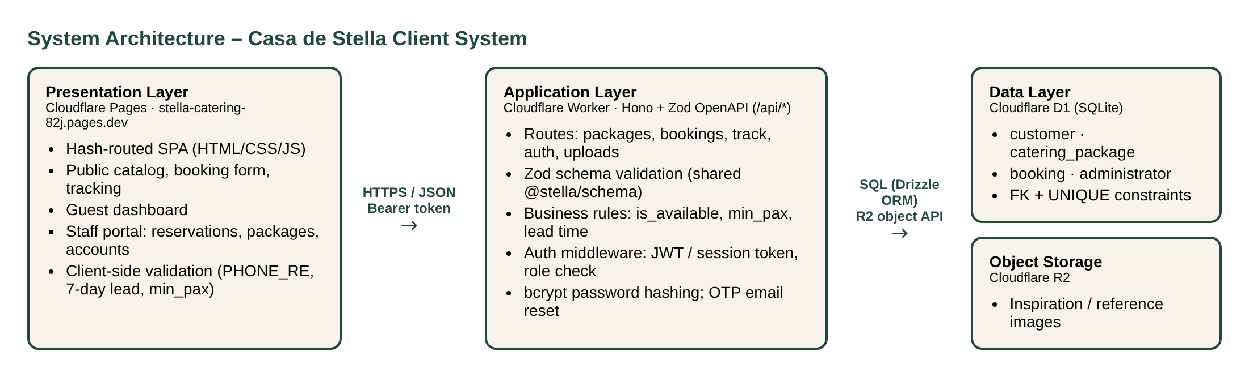
Figure 1. Three-tier architecture of the Client System on Cloudflare's edge platform.
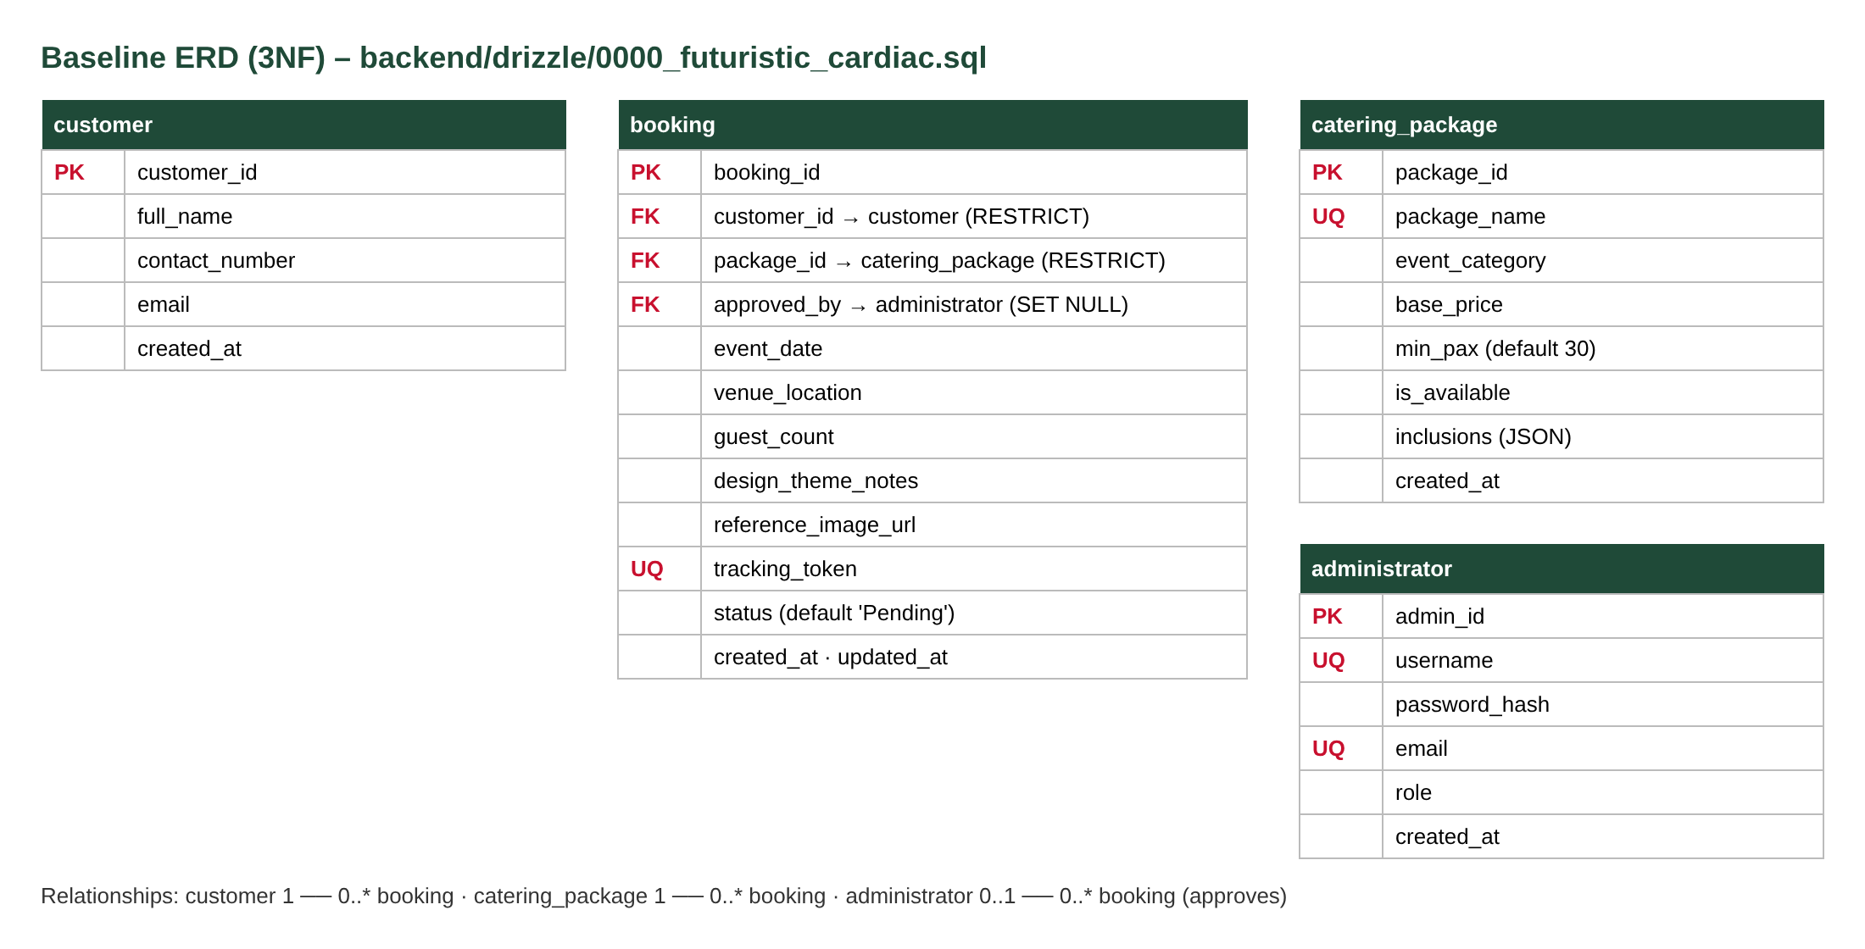
Figure 2. Baseline 3NF ERD: four tables with foreign-key and unique constraints.

2.3 Core Interface Viewports
Screen 1 – Primary Client Task Interface: Booking Request Form (#/book)
The guest selects a package, enters event details and submits a date request. Every field is annotated with its FR and the database column it populates.
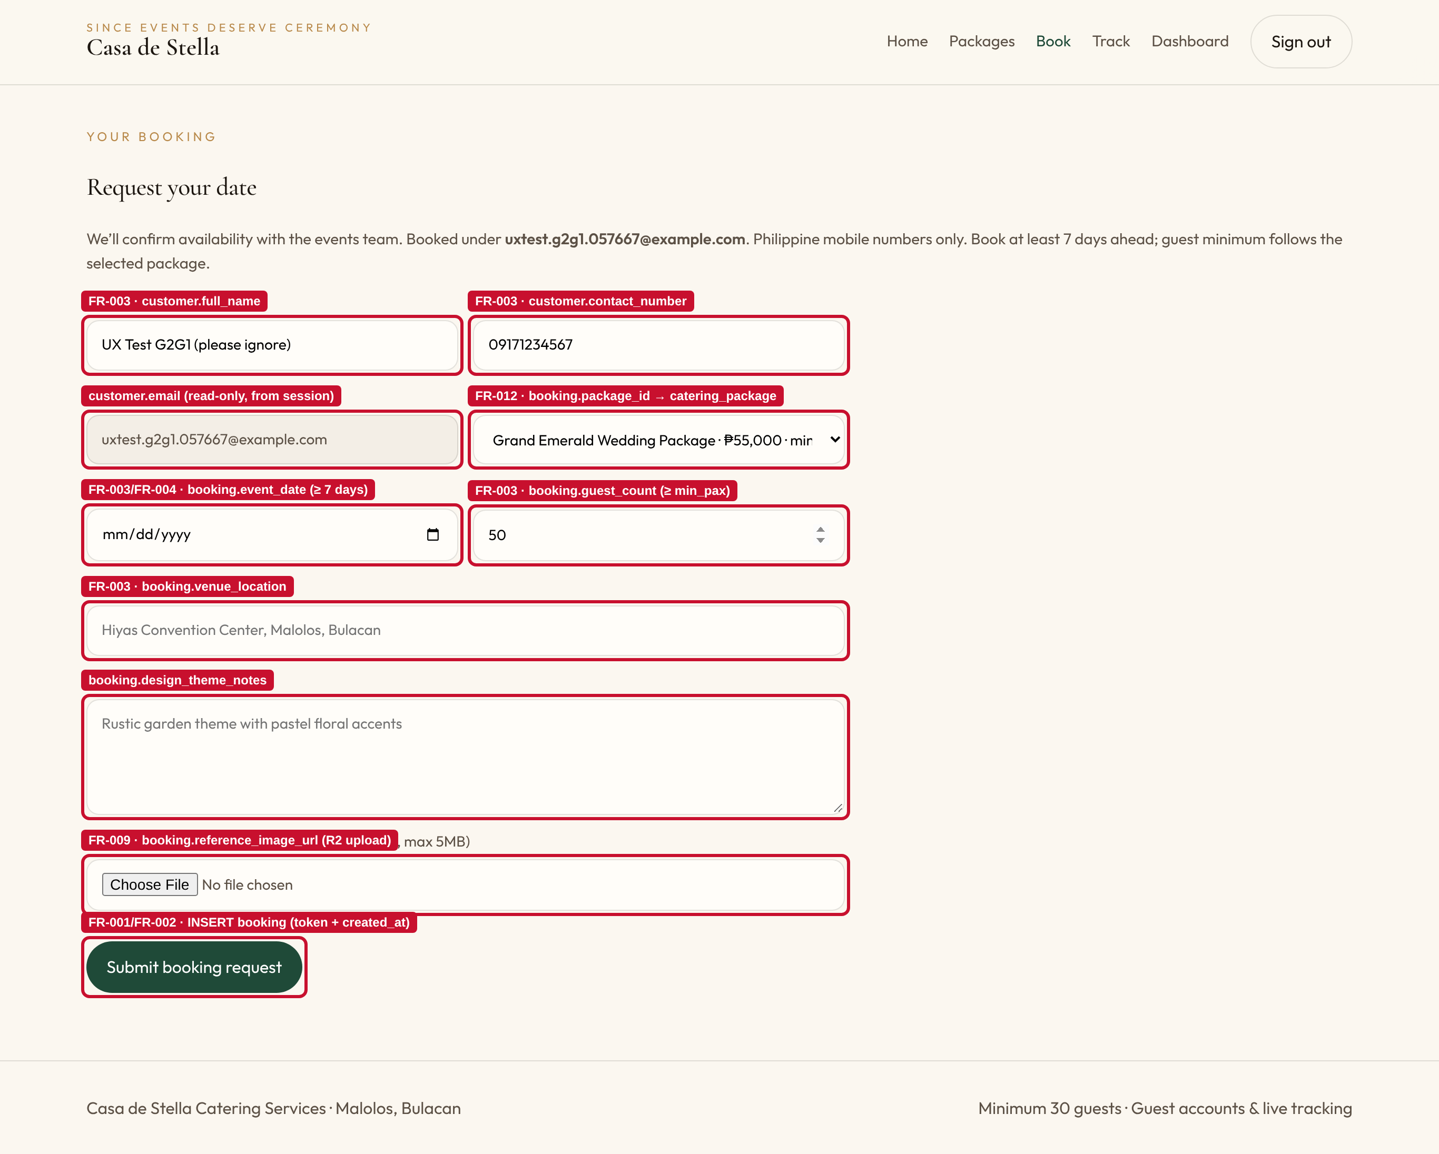
Figure 3. Booking form annotated with FR and ERD mappings.
Screen 2 – Feedback Viewport: Booking Confirmation and Error Alerts
After a successful POST /api/bookings, the server returns the new booking ID, status and tracking token, which the interface displays in a confirmation panel. Failed lookups and rejected inputs are shown in an alert panel.
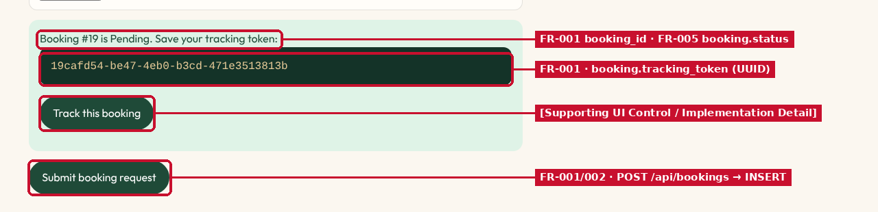
Figure 4. Confirmation panel after submitting Booking #19 (status Pending, UUID tracking token).
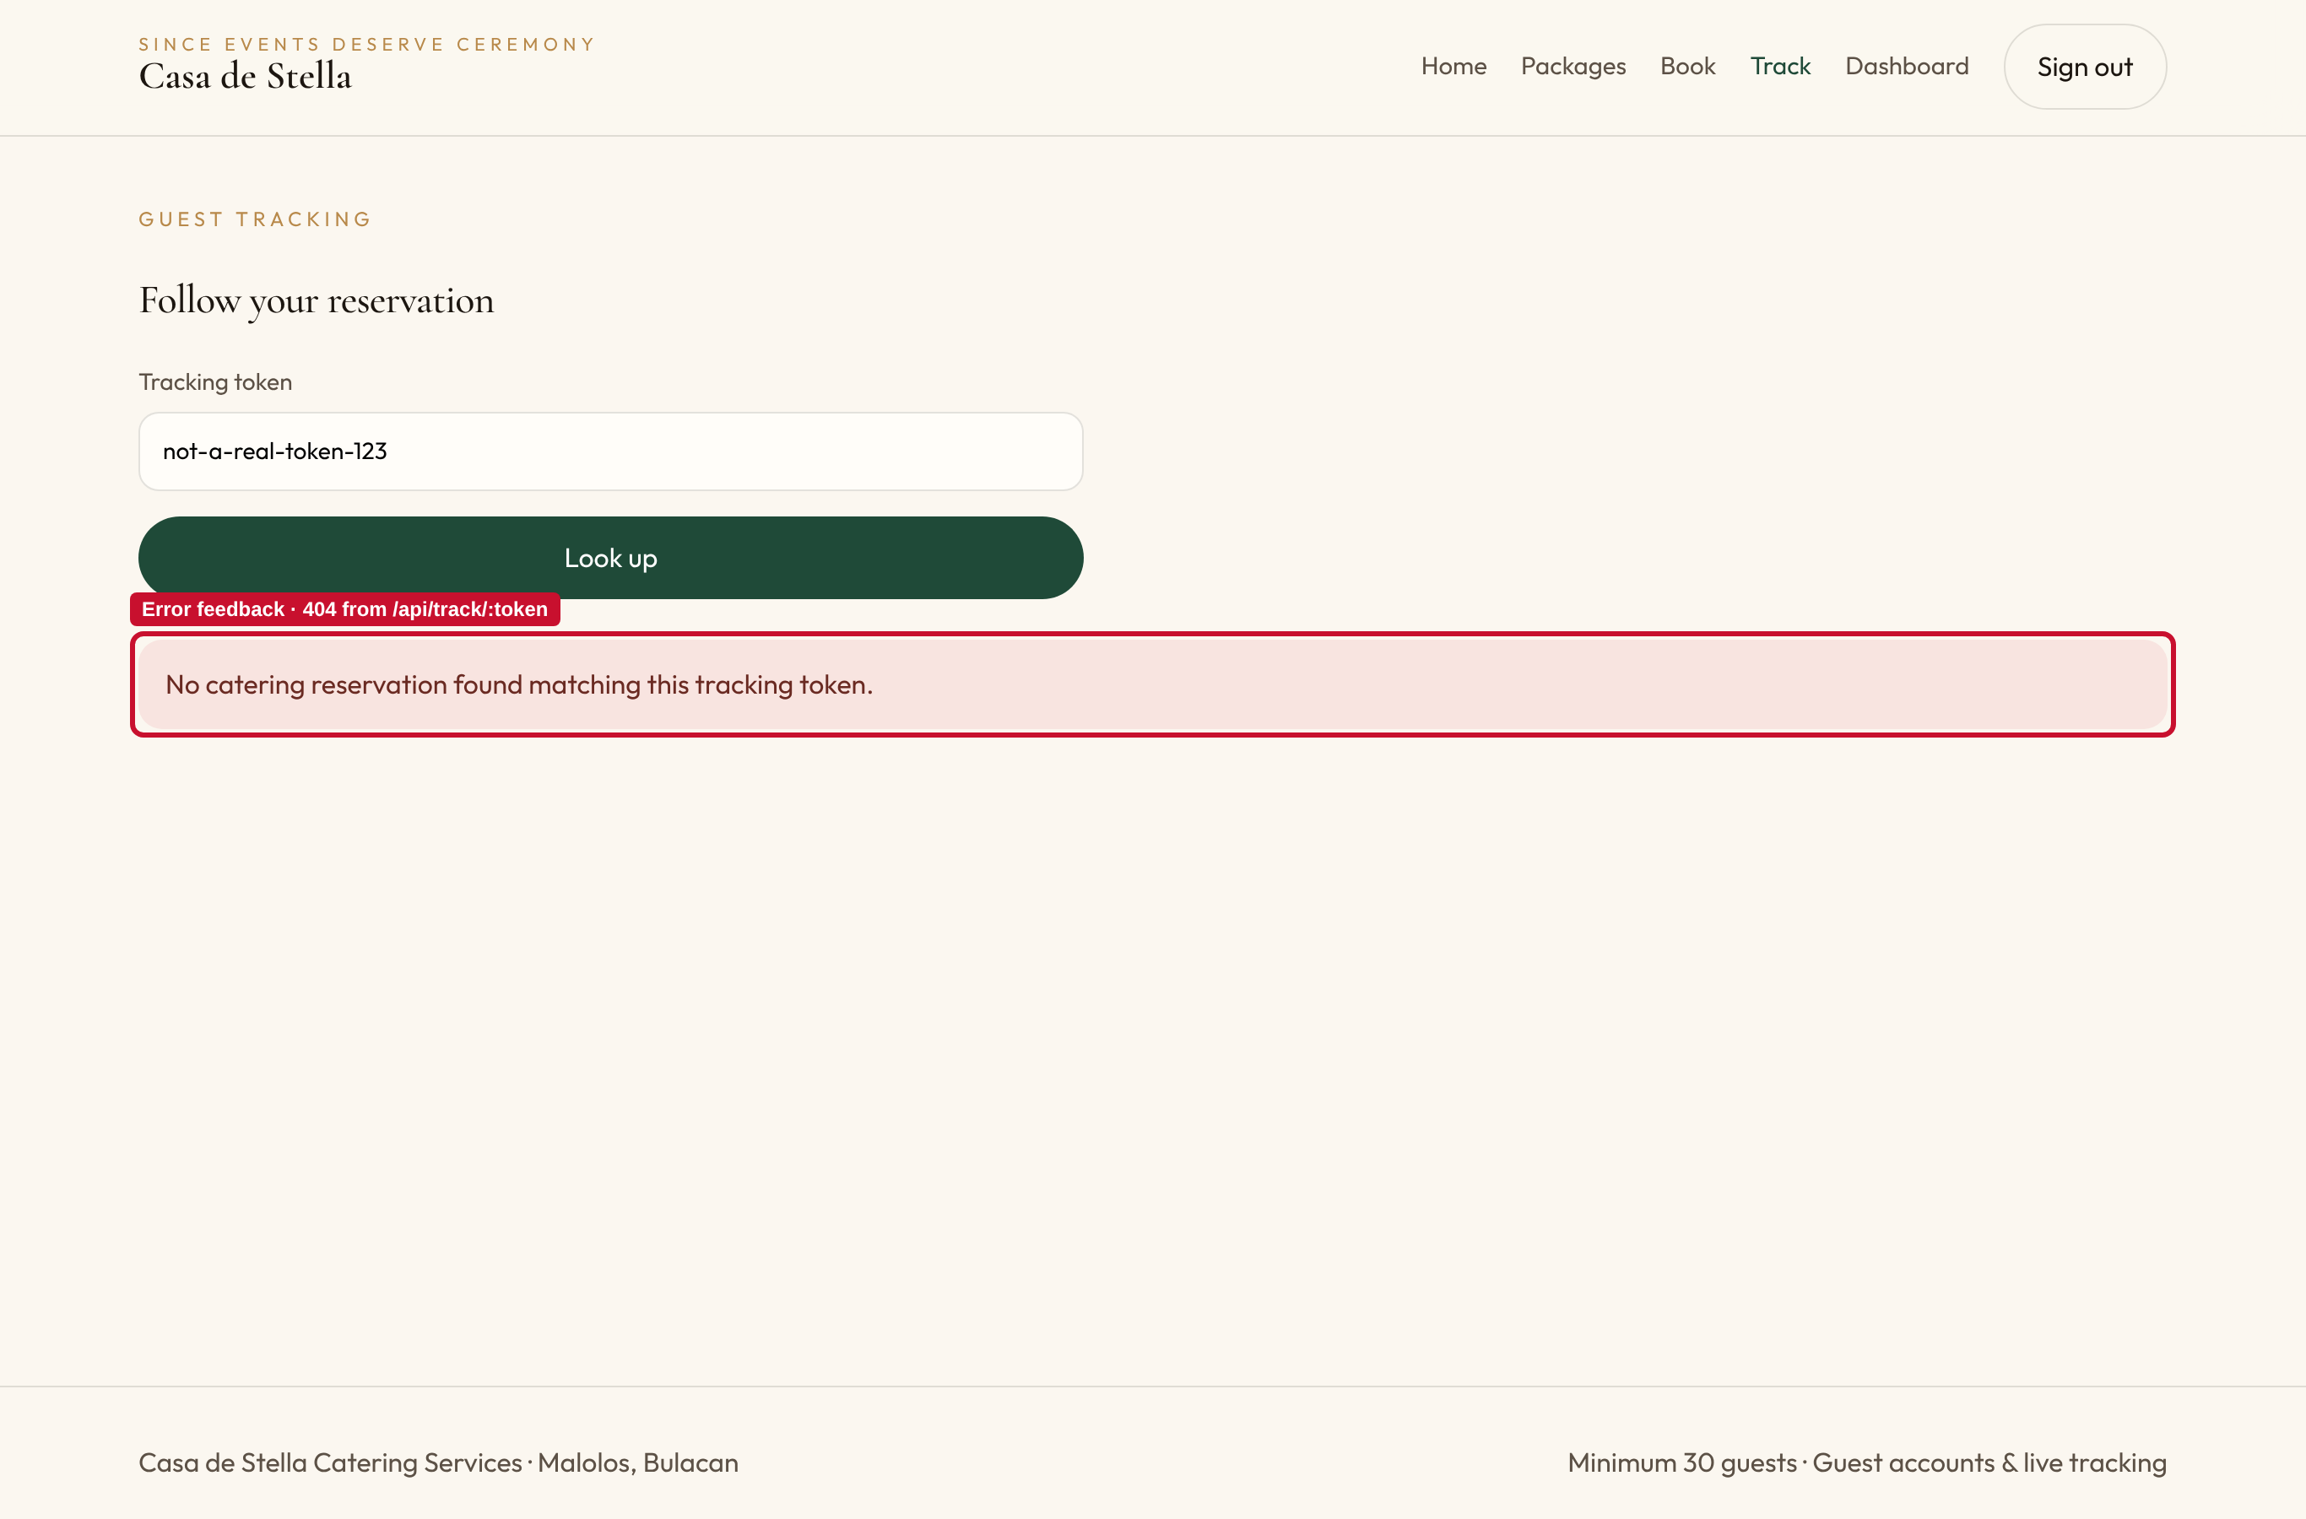
Figure 5. Error feedback for an invalid tracking token (HTTP 404 from /api/track/:token).
Screen 3 – Administrative / Data Management Dashboard (#/admin/dashboard, #/admin/database)
[INSERT SCREENSHOT: sign in at https://stella-catering-82j.pages.dev/#/admin with a staff account and capture the Staff Dashboard (status counters + Upcoming requests table) and the Database Studio. Annotate: counters → FR-005 COUNT(booking) GROUP BY status; table → booking / customer / catering_package columns; Open/Delete → Supporting UI Control.]
Supplementary data view – the guest-facing reservation dashboard backed by GET /api/my/bookings:
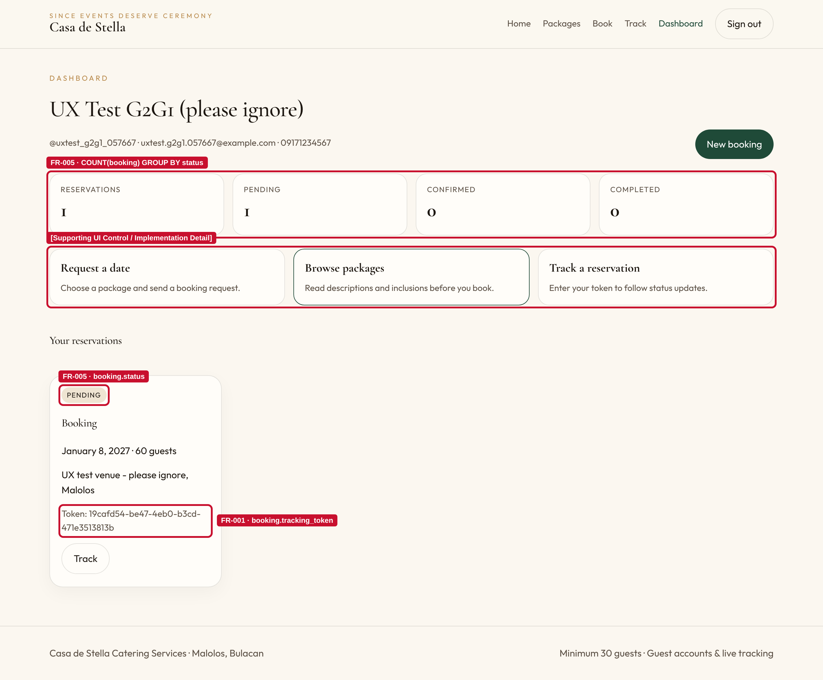
Figure 6. Guest Dashboard: status counters and reservation cards (FR-005, FR-001).
Additional Views
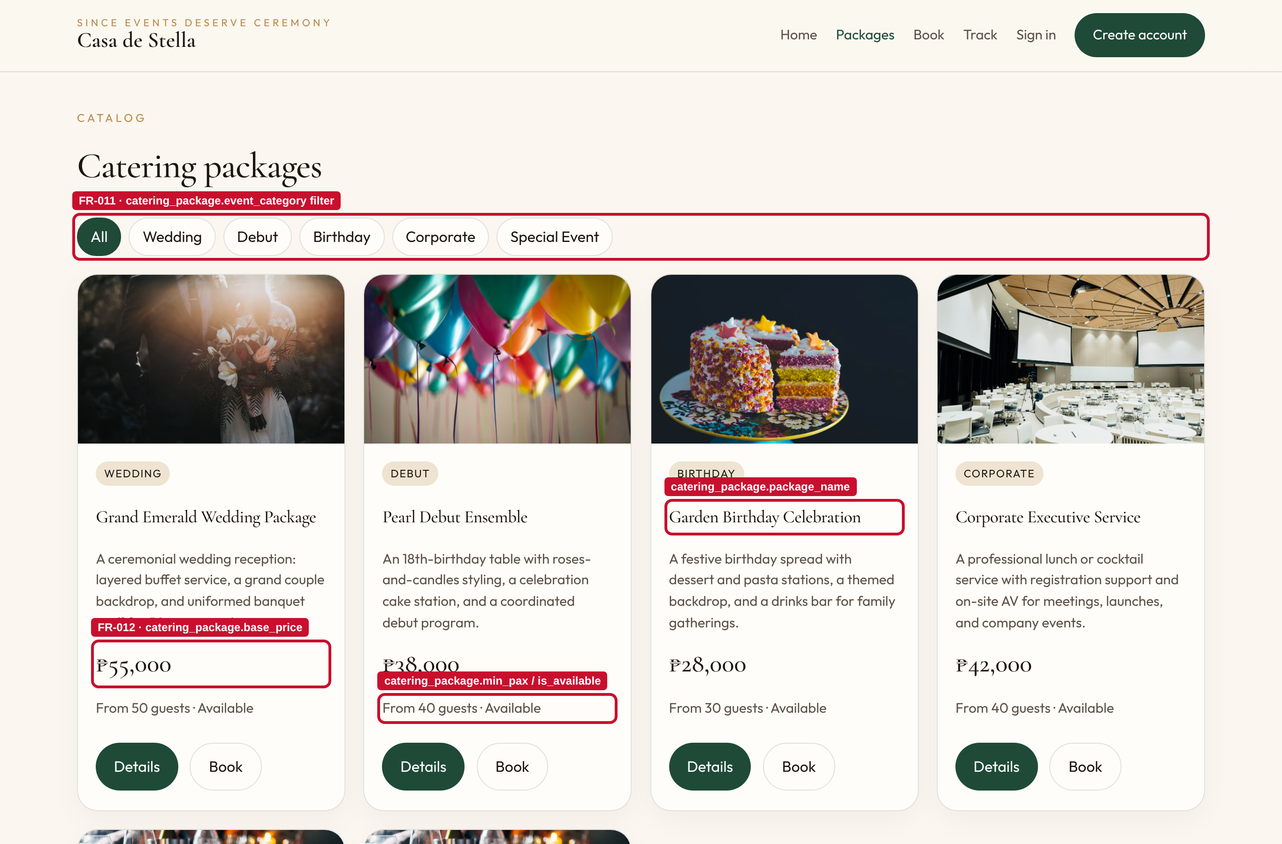
Figure 7. Package catalog with category filter (FR-011) and pricing (FR-012).
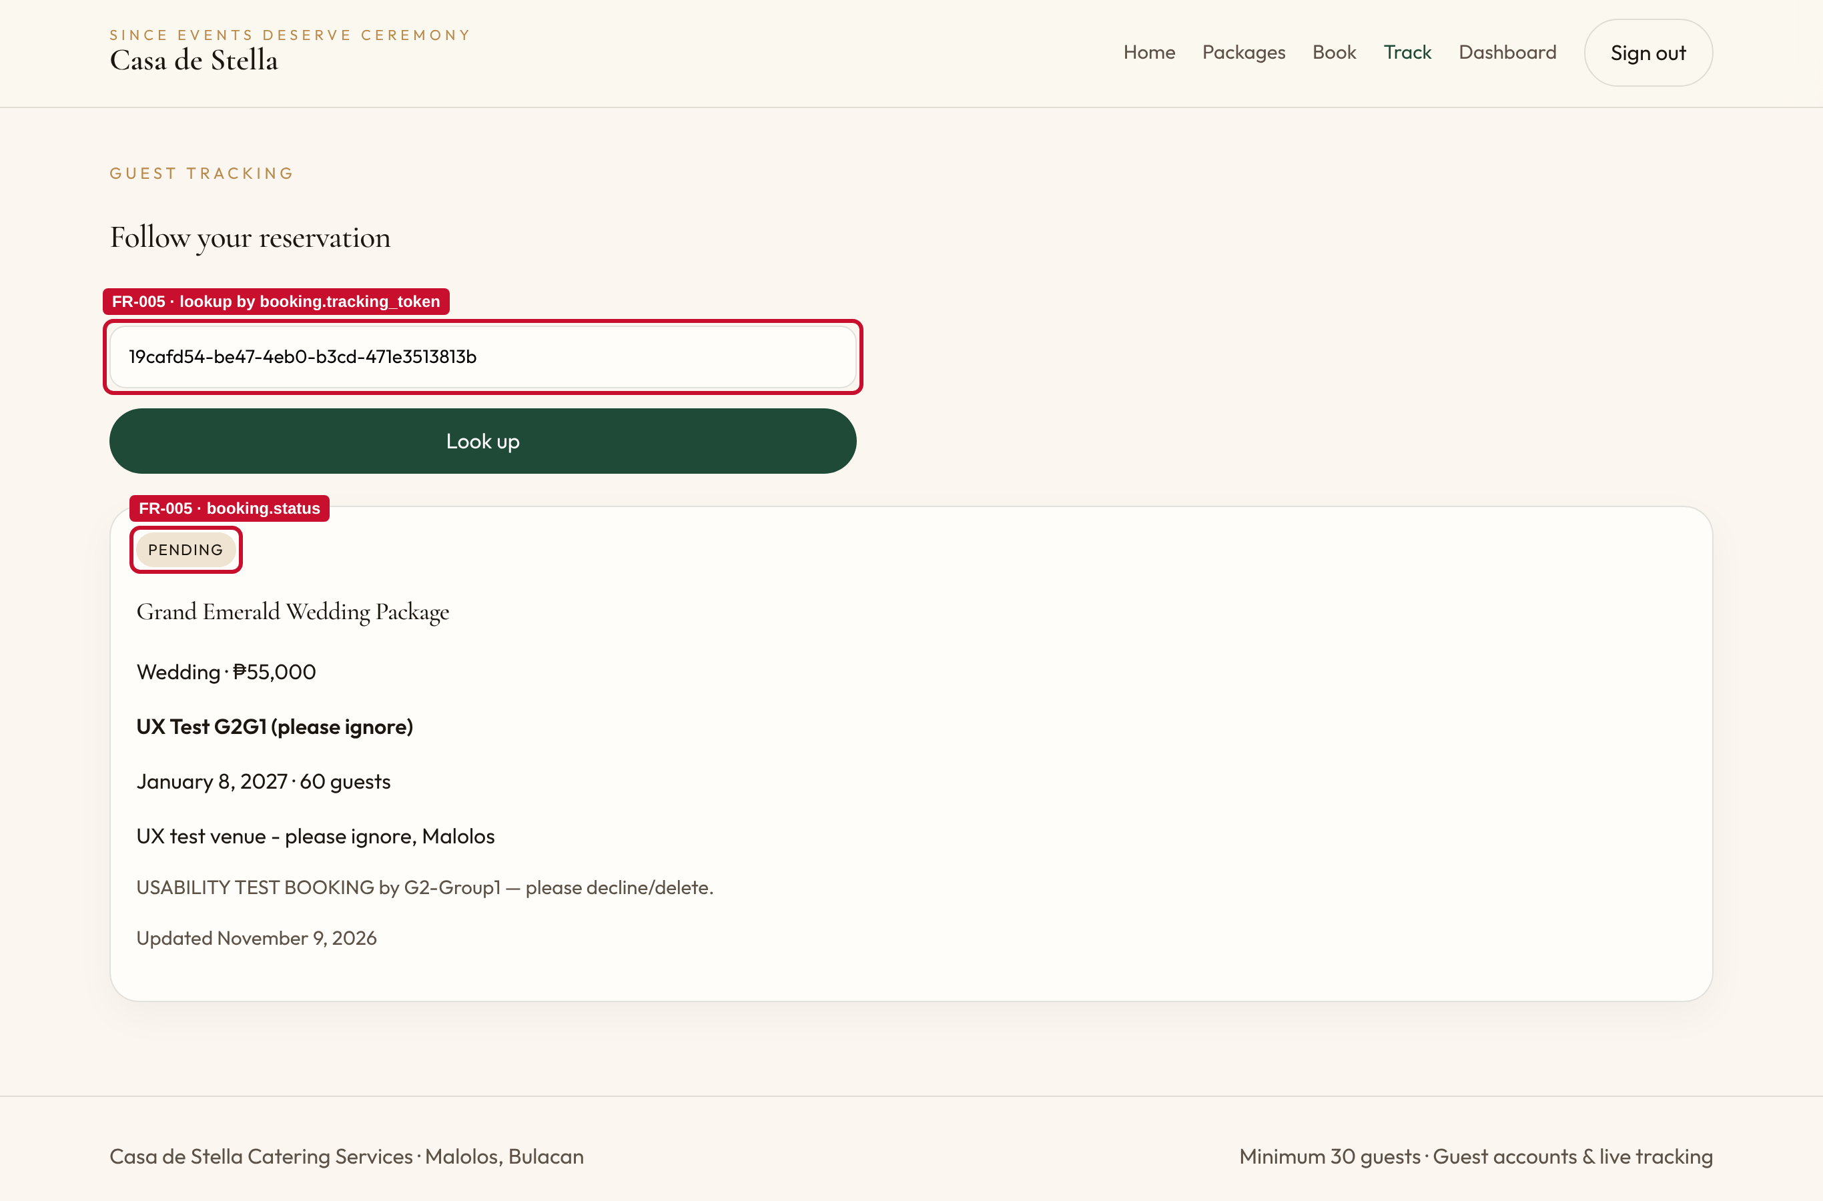
Figure 8. Self-service tracking result for a valid token (FR-005).

2.4 Technical Implementation & Backend Depth
REST API Endpoints (Cloudflare Worker, Hono + Zod OpenAPI)
Method | Endpoint | Auth | Purpose | FR
GET | /api/packages?category=&availableOnly= | Public | List/filter catalog | FR-011, FR-012
GET | /api/packages/:id | Public | Package detail and inclusions | FR-012
POST / PUT / DELETE | /api/packages[/:id] | Staff | Create, edit, unpublish/delete packages | FR-007, FR-008
POST | /api/bookings | Guest/Staff | Validate and insert booking; returns ID + token | FR-001–FR-004
GET | /api/my/bookings | Guest | Signed-in guest's reservations (joined with package) | FR-005
GET | /api/bookings?status=&startDate=&endDate= | Staff | Filtered reservation list with customer and package | FR-005
PATCH | /api/bookings/:id/status | Staff | Change status, record reviewer | FR-005, FR-006
GET | /api/track/:token | Public | Token-based status lookup | FR-005
POST | /api/auth/register · customer-login · login · otp · reset · logout | Mixed | Guest and staff authentication, OTP reset | NFR-005, FR-010
GET / PATCH / DELETE | /api/customers[/:id] | Staff | Guest account management | Supporting
POST | /api/uploads/presigned-url | Guest/Staff | Upload inspiration image to R2 | FR-009
GET | /api/health | Public | Service health and environment | NFR-003

Server-Side Data Validation (live evidence)
The server re-validates every request with the shared Zod schema in @stella/schema, independent of the browser. The following responses were captured from the live API on November 9, 2026 using a test guest account:
Request | Server Response
POST /api/bookings with name "X", phone "12345", venue "abc", 10 guests, date 1 day ahead | HTTP 400 ZodError  • fullName: Full name is required (min 2 characters)  • contactNumber: Must be a valid Philippine mobile number (e.g. 09171234567 or +639171234567)  • venueLocation: Venue location is required (min 5 characters)  • guestCount: Minimum guest count is 30 pax  • eventDate: Event date must be at least 7 days in advance
POST /api/bookings for Grand Emerald Wedding Package with 35 guests (min_pax = 50) | HTTP 400 PAX_REQUIREMENT_UNMET – "The package \"Grand Emerald Wedding Package\" requires a minimum of 50 guests."
POST /api/packages without a token | HTTP 401 UNAUTHORIZED – "Authentication required. Bearer token missing."
GET /api/bookings (staff list) with a guest token | HTTP 401 Unauthorized – role-based access enforced (NFR-005)

Database Persistence and Transaction Integrity
- Persistence: Booking #19 created through the form was returned unchanged by GET /api/my/bookings and GET /api/track/:token in later sessions, which shows the data is stored in Cloudflare D1, not in the browser.
- Referential integrity: booking.customer_id and booking.package_id are foreign keys with ON DELETE RESTRICT, so a package or customer with reservations cannot be deleted and leave orphaned bookings; approved_by uses ON DELETE SET NULL.
- Constraints: UNIQUE indexes on booking.tracking_token, catering_package.package_name, administrator.username and email; NOT NULL and DEFAULT constraints on all required columns (status = 'Pending', min_pax = 30, timestamps).
- Atomicity: every INSERT/UPDATE runs as an atomic SQLite statement in D1. Business rules (package exists, is_available, guest_count ≥ min_pax) are checked before the write, so a rejected request leaves no partial record.
- Security: passwords are hashed with bcrypt; sessions use signed bearer tokens; tracking tokens use crypto.randomUUID().
Features Beyond the MVP Baseline
- Guest accounts with a personal reservation dashboard and email OTP password reset.
- Inspiration photo upload to Cloudflare R2 with type and 5 MB size checks.
- Staff Database Studio: live table browser, search, schema diagram and CSV export.
- Staff guest-account management (activate/deactivate, delete with confirmation).
- Package soft-delete (unpublish) to preserve booking history.
- Shared validation schema package (@stella/schema) used by both API documentation (OpenAPI) and request validation.
- Serverless edge deployment (Cloudflare Pages + Workers + D1) with no server to maintain.

2.5 Touch Target Accessibility (≥ 44 px × 44 px)
All interactive elements on 10 views (Home, Packages, Package Detail, Track, Sign in, Register, Reset password, Staff sign in, Booking form, Guest Dashboard) were measured with an automated script at 1366 × 850 (desktop) and 390 × 664 (iPhone 13 emulation).
Control Group | Measured Size | Result
Primary and secondary buttons (Book a date, Details, Book, Submit booking request, Sign in, Create account, Track, Save) | ≥ 44 px in both dimensions | Pass
Text inputs, selects, date and number inputs, textareas, file input | ≥ 44 px in both dimensions | Pass
Password Show/Hide toggle | ≥ 44 px in both dimensions | Pass
Header navigation links (Home, Packages, Book, Track, Sign in, Dashboard) | 33–74 × 23 px | Below target
Category filter chips (All … Special Event) | 47–124 × 41 px | Below target (height)
Inline text links (See all, Forgot password?, Create an account, Sign in, Staff login) | 15–25 px high | Below target

Remediation for the text-link controls (CSS only, no change to markup or data): give .nav a, .chip, .auth-switch a, .section-head a and a.staff-link a min-height of 44px with display:inline-flex; align-items:center; padding-inline:12px. On mobile, the header links move into a 44 px menu button (see the UX backlog, item B-07).

PHASE 3: CLIENT UX EVALUATION & REFINEMENT BACKLOG (ACTIVITY NO. 5 INTEGRATION)

3.1 Client Evaluation Summary
Item | Details
Evaluating Peer Group | [Peer group name and members]
Evaluation Date | [Date]
Tester / Observer Roles | [Names]
Prototype / Build Tested | https://stella-catering-82j.pages.dev/

Executed Task Scenarios
ID | Scenario | Result
S1 | [Scenario executed by the peer group] | [Completed / Completed with friction / Failed]
S2 | [Scenario executed by the peer group] | [Completed / Completed with friction / Failed]
S3 | [Scenario executed by the peer group] | [Completed / Completed with friction / Failed]
S4 | [Scenario executed by the peer group] | [Completed / Completed with friction / Failed]

Bug Analysis Log (Nielsen's 10 Heuristics, Severity 0–4)
Bug # | Scenario / Task | Stakeholder Friction Point | Heuristic Violated | Severity (0-4)
B-01 | [ ] | [ ] | [ ] | [ ]
B-02 | [ ] | [ ] | [ ] | [ ]
B-03 | [ ] | [ ] | [ ] | [ ]
B-04 | [ ] | [ ] | [ ] | [ ]
B-05 | [ ] | [ ] | [ ] | [ ]

Totals by severity: Catastrophe (4): ___ | Major (3): ___ | Medium (2): ___ | Minor (1): ___

3.2 Refinement Action Plan & Proof of Revision
Severity 3 and Severity 4 items from the peer evaluation are resolved in the software prototype. Each row shows the screen before and after the change on the same viewport.
Bug # | Severity | Refinement Applied | Files / Endpoints Changed | Expected Outcome
B-0_ | [3/4] | [ ] | [ ] | [ ]
B-0_ | [3/4] | [ ] | [ ] | [ ]

Before vs. After – B-0_ (Item 1)
BEFORE | AFTER
[Insert 'before' screenshot] | [Insert 'after' screenshot]
[Caption: screen, route, issue] | [Caption: what changed]

Before vs. After – B-0_ (Item 2)
BEFORE | AFTER
[Insert 'before' screenshot] | [Insert 'after' screenshot]
[Caption: screen, route, issue] | [Caption: what changed]

