IoT-Based Mobile and Web Emergency Response System with First Aid Support and AI Assistance for the Bureau of Fire Protection (Respondo BFP)

A Project Proposal in System Analysis and Design 2
Presented to
The Faculty of the College of Computing and Multimedia
Studies, Camarines Norte State College

In Partial Fulfillment of the Requirements
For IS119: System Analysis & Design 2

By:
ENOVA, Kerby
FERRER, John Robert
ROSTROLLO, Alvin Jan

Spencer Saludes, MIT
Instructor

Background of the Study
The Bureau of Fire Protection (BFP) is mandated to respond to fire incidents, medical crises, and trauma emergencies within its jurisdiction. In conventional emergency reporting, citizens and bystanders rely primarily on telephone hotlines, direct walk-ins, or unstructured text messages. These conventional channels present acute operational bottlenecks: they lack real-time geographic coordinates, provide no structured triage of casualty severity, and fail to convey the medical status or physical entrapment of victims. Consequently, emergency dispatchers face delayed mobilization, risk misallocating apparatus (such as deploying fire engines without medical rescue ambulances), and encounter caller confusion when multiple individuals report the same scene.
Citizens experiencing acute trauma, smoke inhalation, cardiac arrest, or physical entrapment are frequently incapacitated and unable to communicate verbally. Furthermore, bystanders present at emergency scenes often lack verified, step-by-step guidance to administer lifesaving first aid while awaiting emergency response units. There is an urgent operational requirement for a closed-loop system capable of transmitting structured alerts via a physical accessory trigger or mobile interface, providing immediate situational awareness to dispatchers while guiding bystanders through emergency stabilization.
To resolve these systemic challenges, this project introduces Respondo BFP: An IoT-Based Mobile and Web Emergency Response System with First Aid Support and AI Assistance. The system integrates an ESP32-based accessory SOS device, a dual-client citizen interface (native Android application and progressive web application), and an emergency operations console (Android admin application and responsive web dispatch dashboard). When an SOS alert is triggered, the system transmits precise GPS coordinates, caller identification, and multi-patient trauma triage data to a central Cloud Firestore backend. Serverless Cloud Functions broadcast push notifications to on-duty officers, while the dispatch console visualizes alerts on interactive GIS heatmaps and calculates turn-by-turn routes from official BFP stations. In addition, an AI-powered voice assistant (utilizing Gemini and Claude models) provides hands-free first aid instruction, and comprehensive multi-sheet reporting enables operational export to Excel and PDF formats.

Statement of the Problem
The current emergency reporting process for the Bureau of Fire Protection suffers from the following specific problems:
- Lack of Real-Time Structured Geolocation and Multi-Casualty Triage Data - In the conventional approach, emergencies are reported through voice calls or manual messaging. Callers under acute stress struggle to describe landmarks, and dispatchers receive no automatic GPS coordinates, casualty counts, or clinical trauma details (e.g., consciousness levels, burn degrees, or known allergies). As a result, responder triage and apparatus deployment are severely compromised.
- Absence of Closed-Loop Dispatch Acknowledgment and Situational Feedback - When citizens transmit an emergency call, traditional protocols offer no dynamic visual or haptic feedback confirming that responders have claimed the incident. This lack of confirmation exacerbates panic and causes hotline congestion from redundant duplicate calls. Furthermore, field personnel lack scene data before arrival.
- Absence of Automated GIS Hotspot Analytics and Standardized Incident Reporting - Fire stations lack automated systems that capture spatial emergency coordinates and clinical casualty records in real time. This impedes long-term spatial analysis of high-risk fire and trauma hotspots and forces personnel to manually compile official post-incident reports for Bureau records and municipal planning.
Project Objectives
General Objective
To design, develop, and evaluate Respondo BFP: an IoT-based mobile and web emergency response platform featuring accessry Bluetooth SOS triggering, multi-patient scene reporting, AI-assisted first aid instruction, and web-based dispatch management with GIS spatial heatmaps for the Bureau of Fire Protection.

Specific Objectives
- To develop a cross-platform citizen reporting suite (Android application and PWA) providing one-touch SOS activation, high-accuracy GPS acquisition, a multi-patient casualty reporting sheet, and an AI-driven voice first aid assistant powered by Gemini and Claude APIs.
- To engineer an ESP32-based IoT device equipped with a physical panic button, Bluetooth Low Energy (BLE) GATT profile communication, and tactile/visual feedback for emergency transmission.
- To build a synchronized dispatch management console (web application and Android admin dashboard) featuring real-time Firestore listeners, multi-tone siren alerts, Leaflet GIS density heatmaps, and turn-by-turn routing from registered BFP stations.
- To integrate an automated reporting engine capable of generating multi-sheet Microsoft Excel workbooks (Alerts, Patient Records, Summary Statistics, and Heatmap Coordinates) and print-ready PDF reports for official record-keeping.

Scope and Delimitation of the Project
Scope
The project encompasses the design, development, and implementation of Respondo BFP, integrating an ESP32 accessory trigger, a native Android citizen mobile application, a responsive citizen PWA (sos.html), an Android admin application, and a responsive web dispatch console (index.html). The accessory connects via Bluetooth Low Energy (BLE) to transmit hardware SOS signals to paired smartphones. The citizen application automatically acquires WGS84 GPS coordinates through Android FusedLocationProviderClient and HTML5 Geolocation APIs, dispatching structured alerts to Google Cloud Firestore.
Following SOS activation, the citizen client provides a Multi-Patient Accident Report Sheet, enabling bystanders to report casualty counts, accident classifications (Fire, Medical, Vehicular, Structural, Other), nature and mode of injury, and individual casualty records with AVPU consciousness scales (Alert, Verbal, Pain, Unresponsive), seizure indicators, and allergies. The mobile app also incorporates an interactive First Aid Library and an AI Voice Assistant integrating Google Gemini and Anthropic Claude APIs for hands-free guidance during emergencies.
The dispatcher console provides real-time emergency queues, multi-frequency siren audio notifications, station-to-scene route visualization via Google Maps and Directions APIs, and an interactive Leaflet GIS heatmap for spatial density analysis. Incident logs can be exported directly into multi-sheet Excel spreadsheets and printable PDF formats. Administrative user management and secure authentication are enforced through Firebase Authentication.
The mobile application provides verified first aid procedures across medical trauma and fire emergencies, with speech recognition and voice synthesis to support bystanders. Furthermore, the dispatch system maintains historical records across all registered incidents, compiling operational logs into PDF and Excel formats.

Delimitations
The system is limited to emergency alert transmission, multi-patient trauma triage, and first aid guidance. It does not replace VHF/UHF tactical radio channels or municipal telephone hotlines. The prototype does not include automated environmental sensors (such as smoke, gas, or flame detectors) beyond the physical SOS trigger.
The accessory prototype operates exclusively over Bluetooth Low Energy (BLE) within standard short-range parameters; it does not feature an onboard GSM or LoRa transceiver. The mobile application is targeted for Android devices (API Level 26+), with web cross-compatibility provided via the PWA. Bystander-reported clinical parameters represent preliminary scene assessments and are not medically certified diagnoses.
Furthermore, the system’s accuracy depends on the quality of GPS signals and user-entered medical tags, which are not medically verified. The prototype will not undergo full security penetration testing or clinical validation. The study is limited to the design, development, and testing of the system prototype within the given academic timeframe. The following specific limitations are documented but not fully solved in code:
- Battery depletion – handled by fallback (in-app SOS button).
- No internet – handled by caching and user instruction to call emergency hotline.
- Limited Communication Range – The accessory device has a limited communication range due to its reliance on Bluetooth Low Energy.
- Smartphone Dependency – The accessory device depends on a compatible smartphone to relay emergency alerts to the system. It cannot independently transmit emergency reports directly to the BFP server. Physical obstructions, walls, and interference may affect its connection to the mobile device.

Significance of the Project
This project is significant for the following stakeholders:
- Bureau of Fire Protection (BFP) - Equips dispatchers and firefighters with real-time geographic locations, incident categories, victim counts, and pre-hospital casualty statuses. This eliminates verbal interrogation delays, optimizes apparatus dispatch, and automates official documentation through multi-sheet reporting.
- Citizens and Community Members - Provides an immediate, panic-resilient SOS trigger operable by physical button or mobile screen, guaranteeing emergency notification even when victims are incapacitated or unable to speak.
- Bystanders and First Aiders - Empowers laypersons at disaster scenes with interactive first aid procedures and hands-free AI voice assistance (Gemini/Claude), helping stabilize casualties during the golden hour before professional rescuers arrive.
- Local Government Units and Disaster Planners - Delivers data-driven GIS heatmaps and historical incident logs that highlight high-risk municipal zones, supporting the strategic placement of fire hydrants, auxiliary fire substations, and emergency medical outposts.
By addressing delayed reporting, lack of structured emergency data, absence of responder acknowledgment, and missing first aid guidance, the project directly contributes to the national goal of reducing emergency response time and improving public safety outcomes.
Conceptual Framework

The development of the IoT‑based Mobile Emergency Response System is guided by three interconnected concepts: IoT‑enabled alert triggering, smart triage and response coordination, and feedback‑driven incident reporting.

First, IoT‑enabled alert triggering combines a accessory ESP32 device with a paired mobile application. When the user presses the SOS button, the device sends a wireless signal to the mobile app. The app then automatically collects the user’s real‑time GPS coordinates and any pre‑stored medical tags (blood type, allergies). This concept ensures that even if the user cannot speak, structured emergency data is transmitted instantly.

Second, smart triage and response coordination applies three sub‑concepts on the responder dashboard:
- Triage categorization – Incoming alerts are labeled as “Fire” or “Medical” using color‑coded icons, enabling dispatchers to send the appropriate resources.

- Proximity clustering – Multiple SOS alerts originating within 100 meters of each other are grouped into a single incident, preventing duplicate responses.
- Two‑way acknowledgment – When a responder accepts an alert, the dashboard writes a confirmation flag back to the database; the mobile app reads this flag and commands the ESP32 to show a LED or vibrate, reassuring the user that help is on route.

Third, feedback‑driven incident reporting transforms raw SOS logs into strategic information. The dashboard includes a reporting tab that visualizes incidents over the last 30 days (map heatmap or list). Users can export these logs as PDF or Excel files for official record‑keeping and city planning. This concept turns daily operational data into long‑term decision support.

All three concepts operate within documented fallback procedures for battery failure, loss of internet, and GPS inaccuracy, ensuring the framework is realistic and testable.
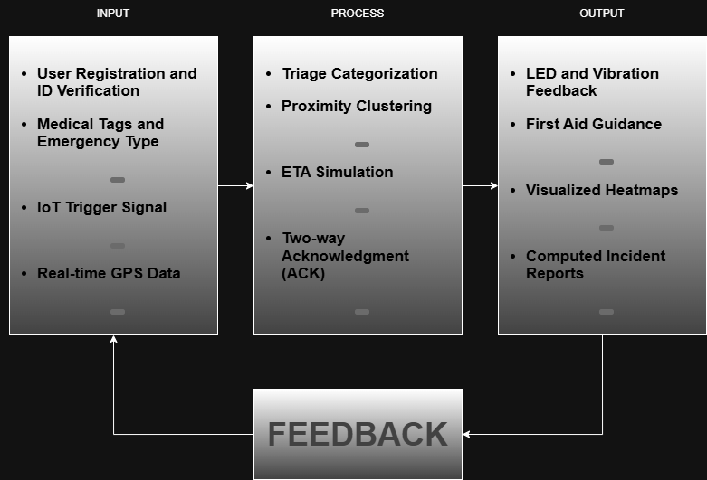
Definition of Terms
This section presents the definition of key terms used in the study to provide a clear understanding of concepts related to the development of the IoTbased Mobile Emergency Response System for the Bureau of Fire Protection.
A. Definition of Terms
- ESP32 – A low-cost, low-power microcontroller with built-in Bluetooth, used as the accessory device’s main processor.
- SOS Alert – An emergency signal triggered by pressing the accessory device’s button, containing the user’s location, emergency type, and medical tags.
- Accessory Device – The ESP32-based hardware prototype worn by the user, equipped with an SOS button, an LED indicator, and a vibration motor.
- First Aid Guide – A set of text or image instructions provided within the mobile application to assist bystanders in performing basic life-saving procedures (e.g., CPR, burn care) while waiting for emergency responders.
- GPS (Global Positioning System) – A satellite-based navigation system used by the mobile application to obtain the user’s real-time geographic coordinates (latitude and longitude) during an SOS alert.
- Triage Categorization – The process of classifying an incoming SOS alert as “Fire” or “Medical” to help dispatchers decide which type of responder (fire truck or ambulance) to send.
- Proximity Clustering – The automatic grouping of multiple SOS alerts that originate within a predefined distance (e.g., 100 meters) into a single incident record to avoid duplicate response efforts.
- Two-way Acknowledgment – A feedback mechanism where the responder dashboard sends a confirmation signal back to the accessory device, causing an LED color change (blue) or vibration to indicate “Help is on the way.”
- Medical Tags – Voluntary information provided by the user (blood type, allergies, pre-existing conditions) stored in the mobile application and only revealed to the responder dashboard after an SOS alert is triggered.
- Responder Dashboard – A interface used by BFP personnel to view incoming SOS alerts, triage by emergency type, accept alerts, send acknowledgment signals, and generate incident reports.
- Incident Report – A structured record of an SOS event, including timestamp, GPS location, emergency type, user ID, medical tags, and responder acknowledgment status.
- Confidence Radius – A margin of error (e.g., ±50 meters) displayed with GPS location when accuracy is low, helping responders understand possible location.
- Fallback Procedure – A documented action that the user or responder takes when a system component fails (e.g., battery dead, no internet), such as using the in-app SOS button or calling the emergency hotline directly.
- Administrator (Admin) – A user with full access to the responder dashboard responsible for managing alerts, generating reports, and monitoring system activity.

B. Data Dictionary

Field Name | Description | Data Type
--- Collection: sos_alerts (Primary Incident Entity) --- | Entity Group | Schema Section
alertId | Unique identifier generated for the emergency document (Document Key) | String (AutoID)
userId | Unique identifier of the reporting citizen or device token | String (UUID/Token)
latitude | WGS84 decimal latitude coordinates captured from GPS | Double (Float64)
longitude | WGS84 decimal longitude coordinates captured from GPS | Double (Float64)
timestamp | Exact server timestamp when the SOS alert was created in Firestore | Timestamp (Server)
status | Current operational status of the emergency incident: active or resolved | String (Enum)
source | Transmitting client platform indicator: android, pwa, or hardware_ble | String (Enum)
deviceToken | FCM device token of the sending client for targeted status push updates | String
reportSubmitted | Boolean flag indicating whether detailed casualty data has been attached | Boolean
countOfVictims | Total number of casualties or injured individuals at the scene | Integer
accidentType | Emergency categorization: Fire, Medical, Vehicular, Structural, or Other | String (Enum)
natureOfInjury | Clinical nature of trauma sustained (e.g., Burns, Fracture, Laceration, Asphyxiation) | String
modeOfInjury | Physical cause leading to injury (e.g., Vehicular Crash, Fall, Flame, Smoke Inhalation) | String
patients | Embedded array of structured patient records detailing casualty assessments | Array of Maps
--- Nested Entity: patients (Embedded inside sos_alerts) --- | Entity Group | Schema Section
name | Full or provisional name of the casualty (defaults to Unknown) | String
age | Age of the casualty in completed years | Integer
birthdate | Date of birth of the casualty (YYYY-MM-DD format) | String (Date)
address | Residential or recovery address of the victim | String
allergies | Documented medicinal or environmental adverse reactions (e.g., Penicillin) | String
emergencyContact | Primary emergency contact person name and telephone number | String
levelOfConsciousness | Victim responsiveness evaluated on AVPU scale: Alert, Verbal, Pain, Unresponsive | String (Enum)
condition | Clinical synopsis of visible symptoms or injury descriptions | String
seizure | Clinical indicator of active or recent convulsive/seizure episodes | Boolean
--- Collection: first_aid (Protocols & Guides Entity) --- | Entity Group | Schema Section
id | Unique document identifier for the first aid protocol item | String (Slug/AutoID)
title | Official medical title of the protocol (e.g., Adult CPR Procedure, Severe Burn Care) | String
category | Emergency category: Medical, Fire, Trauma, or Respiratory | String (Enum)
description | Comprehensive overview explaining protocol indications and precautions | String
steps | Ordered array of sequential textual instructions for bystander execution | Array of Strings
iconEmoji | Visual emoji symbol representing the emergency protocol (e.g., Heart, Fire, Bandage) | String (UTF-8)
videoUrl | Hyperlink to external video streaming demonstration resource | String (URL)
storageVideoUrl | Firebase Cloud Storage URI for cached offline video playback | String (URI)
photoUrls | Array of image URLs illustrating procedural steps and anatomical markers | Array of Strings
--- Collection: bfp_stations (Fire Station Landmarks Entity) --- | Entity Group | Schema Section
id | Unique identifier code for the fire station facility (e.g., daet_central_01) | String
name | Official designation of the Bureau of Fire Protection facility | String
latitude | WGS84 decimal latitude coordinates of the station depot | Double (Float64)
longitude | WGS84 decimal longitude coordinates of the station depot | Double (Float64)
contactNumber | Official landline, hotline, or radio callsign of the station | String
--- Collection: admin_tokens (FCM Dispatch Tokens Entity) --- | Entity Group | Schema Section
uid | Firebase Authentication User Identifier of the authorized officer (matches request.auth.uid) | String (UID)
fcmToken | Firebase Cloud Messaging client registration token for multicast push siren dispatching | String
lastUpdated | Server timestamp when the officer device token was last synchronized | Timestamp
--- Hardware BLE Profile (ESP32 Accessory Device) --- | Entity Group | Schema Section
Service UUID | 12345678-1234-1234-1234-123456789abc - Primary BFP emergency trigger service | GATT Service
Characteristic UUID | 87654321-4321-4321-4321-cba987654321 - Carries SOS trigger byte notifications | GATT Characteristic
CCCD UUID | 00002902-0000-1000-8000-00805f9b34fb - Client Characteristic Configuration Descriptor | GATT Descriptor
Device Name | BFP-SOS-Device - Broadcast name filtered by Android BLE scanner | BLE Advertising
--- Export Schema: Excel Workbooks (Generated via SheetJS) --- | Entity Group | Schema Section
Sheet: Alerts | Columns: No, Date & Time, Latitude, Longitude, User ID, Status, Accident Type, Victims, Nature, Mode, Patients | Workbook Sheet 1
Sheet: Patient Records | Columns: Alert No, Date, Status, Type, Patient No, Name, Age, Birthdate, Address, Allergies, Contact, AVPU, Condition, Seizure | Workbook Sheet 2
Sheet: Summary | Aggregates: Total Alerts, Active Count, Resolved Count, Total Patients, Breakdown by Accident Type | Workbook Sheet 3
Sheet: Heatmap Coordinates | Columns: Alert No, Date & Time, Latitude, Longitude, Status, Accident Type, Victims, Nature | Workbook Sheet 4

Review of Related Literature or Studies

This section discusses the features, capabilities, and limitations of existing research and software that are relevant to the IoT‑based Mobile Emergency Response System. The reviewed works are arranged by area, starting with general IoT‑based public safety frameworks, followed by emergency response systems developed in the Philippine context, and finally accessory SOS devices. A consistent format is used for each entry: the author(s) and year, the title, a summary of the system or study, its relevance to the present project, and its limitations.

Related Literature

The foundation of modern emergency response systems relies heavily on robust IoT architectures and sensor fusion. Zhang et al. (2025) established a highly scalable framework combining distributed sensors with edge computing, achieving 95% accuracy and sub-450 ms latency for fire and gas leak detection. Reinforcing this approach, Kumar et al. (2024) comprehensively reviewed IoT-enabled fire safety systems, highlighting that sensor fusion—combining smoke, thermal, and ambient data—radically reduces false positives and triangulates hazards accurately. Similarly, Varsha et al. (2026) proved that integrating artificial intelligence and machine learning (AI/ML) with high-speed networks further enhances data accuracy and cuts response times in smart buildings. For trauma and rapid-impact scenarios, Uday (2025) and Saminathan et al. (2026) demonstrated automated trigger frameworks utilizing vehicle-mounted accelerometers, gyroscopes, and smart sensors to instantly dispatch GPS coordinates upon collision, laying the groundwork for automated hardware triggers in emergency applications.

Transitioning raw data from hardware into actionable intelligence requires sophisticated AI and cloud network integration. Vishwakarma et al. (2025) developed a holistic AI-driven rescue model using geolocation to connect emergencies with the nearest equipped rescue teams, projecting a 30-40% reduction in urban fatalities during simulations. Expanding on disaster management, Wang et al. (2025) introduced the "ResQ" system, leveraging deep learning to process real-time alerts, weather services, and user-generated reports into predictive situational updates. For localized data handling, Rao et al. (2024) validated the use of the ThingSpeak cloud for autonomously logging emergency data. However, cloud-dependent systems frequently fail during disaster-induced network outages. To address this, Niranjane et al. (2025) pioneered "ResQnet," a solar-powered localized Wi-Fi hotspot that allows trapped users to submit offline emergency requests via a captive portal, proving the viability of cloudless operability.

The crucial bridge between automated hardware and human survivors is the mobile application interface. Basabe et al. (2023) set a strong baseline with "AlarmaPh," an application specifically tailored for the Philippines that allows users to send distress calls while accessing integrated basic first-aid manuals. Expanding on this medical guidance, Romeo et al. (2026) and Vipulasena et al. (2025) proved the necessity of integrating AI-assisted, multilingual first-aid instructions to empower laypersons to stabilize victims before responders arrive. Furthermore, Perez et al. (2026) advanced mobile inclusivity by developing a mobile-first architecture that dynamically recalculates evacuation routes for visually impaired users during fires, processing sensor data directly on the smartphone to ensure reliability even if the building's infrastructure fails.

Monitoring the physical status of victims and first responders has become a focal point of recent IoT deployments. Dev et al. (2025) engineered an AI-based system utilizing heartbeat and respiratory sensors to upload patient vitals preemptively to a hospital's ICU. Paralleling this, Wu et al. (2025) emphasized the necessity of tracking disaster responders themselves, analyzing how accessory biosensors and fog computing ensure operational continuity and safety in hazardous zones. Before human responders even arrive, autonomous robotics integrated with IoT offer crucial early intervention. Jadhav et al. (2024) and Alfarabi et al. (2025) showcased ESP32-powered robots capable of navigating indoor environments for fire detection and providing evacuation support, successfully enhancing situational awareness despite current limitations with uneven terrain mobility.

Optimizing the physical path of emergency vehicles and evacuees directly dictates the speed of a successful rescue. Al-Hady et al. (2023) integrated IoT with Building Information Modelling (BIM) to facilitate dynamic 3D evacuation routing during academic building fires. For vehicular responders, Ali & Nijar (2025) created a Firebase-backed alert system to preemptively notify civilian drivers of approaching emergency vehicles within a 3.0 km radius, expediting traffic clearance. To ensure these communication lines remain open, Daganato et al. (2024) and Vidyadhari et al. (2023) proved the viability of sustainable, low-cost power fallbacks, utilizing solar-powered setups and GSM (SMS/call) modules to guarantee uninterrupted distress signaling. Finally, a comprehensive review by Ali et al. (2025) across over 100 recent IoT emergency studies confirmed that combining real-time IoT positioning, robust power setups, and intelligent routing algorithms remains the most reliable strategy for holistic emergency incident management

Related Studies

Based on the study of Zhang et al. (2025) titled "Developing real-time IoT-based public safety alert and emergency response systems," the researchers designed a system combining distributed sensors, edge computing, and cloud platforms to detect emergencies like fires and gas leaks. The prototype achieved 95% detection accuracy and alert latencies under 450 ms across 12,000 devices. Its relevance to the present project lies in its highly scalable and low-latency architectural framework for real-time alerts. However, its limitations include a heavy reliance on cloud connectivity, highlighting a need for future cloudless operational capabilities.

To support this holistic approach to urban safety, Vishwakarma et al. (2025) developed "Reducing Urban Emergency Fatalities: A Holistic AI-Driven Rescue Model." The study created a Rescue Squad Web Project that uses AI and geolocation to connect emergencies with the nearest equipped rescue teams, successfully aiming to reduce urban fatalities by 30-40% in simulations. This is highly relevant for optimizing resource allocation in your proposed system; although, its limitations revolve around the current lack of predictive analytics and drone integration, which are still slated for future enhancements.

Also, according to Romeo et al. (2026) in "AI-based Emergency Help Service," the need for fast communication is paramount. They created an Agile-developed application providing emergency notifications, real-time location, and AI-driven first aid. This study proves the necessity of a user-friendly UI for your project. However, it currently lacks predictive AI and multiple broader communication channels. Similarly, focusing on user-accessible first aid, Vipulasena et al. (2025) in "Application on basic life support and first aid" created a localized, multilingual mobile app for Sri Lanka featuring AI-assisted guidance and GPS routing. This is relevant as it shows how to integrate layperson first-aid features; although, its limitations include offline usability challenges and a need for improved AI accuracy.

To support faster emergency navigation, Ali & Nijar (2025) in their study "Feasibility Study of Real-Time IoT Based Emergency Vehicle Alert System for Road Safety" developed a NodeMCU and Firebase-based system to notify civilian drivers of approaching emergency vehicles within a 3.0 km radius. This demonstrates a reliable method for GPS data transmission relevant to your project's mapping features. However, its scope is limited strictly to clearing traffic rather than holistic incident management. Similarly, Uday (2025) in "IOT Based Accident Detection and Rescue System" utilized vehicle-mounted accelerometers and gyroscopes to automatically detect crashes and dispatch GPS coordinates. This provides a clear framework for automated accident triggers; however, it focuses primarily on vehicular hardware rather than a versatile mobile user system.

Based on the study of Varsha et al. (2026) titled "IOT-Based Fire Alarm and Location Tracking System," the integration of AI/ML with 5G networks significantly reduces false positives and improves emergency response times for smart buildings. This is relevant for ensuring data accuracy in your system. However, the limitation is its dependency on high-speed 5G infrastructure, which may not be universally available. To support off-grid reliability, Daganato et al. (2024) introduced "Design and Development of a Solar-Powered IoT-Based Fire Alarm System with Integrated GPS and GSM for Enhanced Emergency Response." Their study proved that combining solar power with GSM/GPS ensures uninterrupted emergency communication. This is highly relevant for power-resilient design, though it is limited to localized hardware implementations. Furthermore, Vidyadhari et al. (2023) in "A Sustainable and Efficient IoT Approach for Fire Department Alerting System" utilized a simple Arduino and SIM800L module to send SMS/calls upon flame detection. This proves the viability of low-cost GSM fallbacks; however, its limitation is the lack of a comprehensive mobile application interface.

Additionally, multiple studies explore IoT integration with autonomous robotics to manage fires before responders arrive. Based on the study of Jadhav et al. (2024), "Fire Fighter Robot Using IOT and Mobile Application," an ESP32-powered robot can detect fires and be controlled remotely via an Android app. This highlights effective real-time mobile-to-hardware communication relevant to your project. However, limitations include the physical constraints of the robot navigating complex debris. To support this, Rao et al. (2024) in "IoT Enabled Fire Fighting Robot Integrated With Thingspeak Cloud For Emergency" utilized ThingSpeak to log emergency data autonomously, demonstrating effective cloud logging, though it relies heavily on stable Wi-Fi. Also according to Alfarabi et al. (2025) in "Development of an IoT-Based Autonomous Robot for Indoor Fire Detection and Evacuation Support," testing showed these robots reliably enhance situational awareness, though they remain limited by uneven terrain mobility. Addressing broader building management, Al-Hady et al. (2023) in "Development of IoT-Based Automated Dynamic Emergency Response System Against Fire Incidents in Academic Building" integrated IoT with Building Information Modelling (BIM) for 3D evacuation routing. This is highly relevant for spatial mapping, though it requires complex pre-existing architectural models.

Although cloud systems are powerful, network outages during disasters are common. To address this, Niranjane et al. (2025) developed "ResQnet- Internet of Things (IoT) Based Emergency Response System for Network Deprived Area." This study created a solar-powered ESP32 local Wi-Fi hotspot where users can submit emergency requests offline via a captive portal. This is incredibly relevant for your system's offline functionality requirements. Its limitation, however, is that alerts remain localized until connectivity is restored or manual intervention occurs.

Based on the study of Basabe et al. (2023) titled "AlarmaPh: A Mobile Swiss Knife for Quick Response Incidents," the researchers developed an application specifically tailored for Cebu City, allowing users to send distress calls to local police, fire, and ambulance departments while integrating basic first-aid manuals. The study, evaluated by local government and rescue agencies, proved highly acceptable to users. The relevance to the present project is massive, as it provides a localized benchmark for user interfaces and agency coordination in the Philippines. However, its limitations lie in its localized scope and the need for further evaluation regarding its scalability to a wider, nationwide IoT infrastructure.

To support the safety of the responders themselves, Wu et al. (2025) in "IoT-Based Approaches to Personnel Health Monitoring in Emergency Response" analyzed the integration of accessory biosensors and ad hoc networks (edge/fog computing) to continuously track the vitals of disaster responders. The study found that proactive monitoring significantly improves operational continuity. This is relevant to your project if expanding into accessory SOS or responder-tracking modules. However, the study identifies a major limitation: creating a seamless "system-of-systems" that functions properly in infrastructure-denied zones remains highly complex.

Similarly, focusing on patient monitoring, Dev et al. (2025) in "AI Based Emergency Assist System for Ambulance" developed a microcontroller-enabled system using heartbeat and respiratory sensors coupled with an AI voice assistant. This system uploads patient vitals to an IoT cloud while notifying the hospital's ICU preemptively. This is highly relevant for integrating personal health data into your emergency response application. Its limitation is the requirement for uninterrupted sensor contact and the necessity of secure fingerprint authentication, which could cause friction during high-stress, rapid-response scenarios.
Project Methodology
This section outlines the specific steps and activities that the proponents will undertake to accomplish the development of the IoT-based Mobile Emergency Response System with First Aid Support for the Bureau of Fire Protection (BFP). The methodology covers all activities from the proposal stage to the final stage of the project. Initially, the proponents will conduct inquiry and literature review by researching existing emergency response systems, IoT devices, and accessory technologies. This activity will involve consulting professors, and other academic resources to identify gaps in traditional reporting methods and establish best practices.
Following this, surveys and consultations will be conducted with BFP staff, local government representatives, and other relevant stakeholders to gather real-world requirements, understand current emergency processes, and identify the challenges faced by responders and citizens during emergencies. The proponents will then engage in brainstorming and system design sessions, with guidance from mentors and advisers, to plan the architecture of the device, mobile application, and responder dashboard. This stage ensures that the system meets the operational needs of both users and responders.
The next phase involves the development of the prototype, including programming the ESP32 SOS device, implementing mobile application functionalities, and integrating features such as GPS location tracking, emergency type selection, and medical tag transmission. Simultaneously, the responder dashboard will be developed to include triage categorization, proximity-based incident clustering, two-way acknowledgment, estimated time of arrival simulation, and reporting modules for incident visualization and export.
After development, rigorous testing and experimentation will be performed to evaluate the functionality of the system under different scenarios. This includes verifying SOS alert transmission, LED or vibration feedback, GPS accuracy, and the effectiveness of the reporting module. Proponents may involve BFP personnel during testing to simulate real emergency condition.
System Overview
Overview of the System
The Respondo BFP platform establishes a resilient, closed-loop emergency alerting and pre-hospital triage network for the Bureau of Fire Protection. The system unites four core operational tiers: a accessory ESP32 IoT trigger, a cross-platform citizen reporting suite (Android and PWA), a cloud-native Firebase backend, and dual dispatch consoles (Web and Android Admin).
- Accessory SOS Trigger – The user wears an ESP32-based device with a physical SOS button, an LED indicator, and a vibration motor. Pressing the button instantly sends an alert signal to the paired mobile application via Bluetooth or Wi-Fi.
- Mobile Application (User Side) – The mobile app handles user registration, storage of voluntary medical tags (blood type, allergies, pre-existing conditions), and GPS location acquisition. Upon receiving an SOS signal from the accessory, the app automatically transmits the user’s real-time GPS coordinates, selected emergency type (Fire or Medical), and medical tags to the cloud database. The app also provides built-in first aid guides (text and images) that bystanders can follow while waiting for responders. When the responder dashboard accepts the alert, the app receives an acknowledgment and commands the accessory to show a blue LED and vibrate, reassuring the user that help is on the way.
- Responder Dashboard (BFP Side) – The dashboard allows BFP personnel to view incoming SOS alerts on a map. Each alert is color-coded (red for Fire, blue for Medical) for triage categorization. The dashboard automatically groups multiple alerts originating within 100 meters of each other into a single incident to avoid duplicate responses. Responders can click “Accept” to claim an incident, which triggers the two-way acknowledgment signal. The dashboard also simulates an estimated time of arrival (ETA) based on the responder’s fixed location.
- First Aid Support Module – The mobile application contains a library of first aid procedures for fire-related injuries (burns, smoke inhalation) and medical emergencies (CPR, allergic reactions, bleeding). This feature empowers bystanders to take immediate action before professional help arrives.
- Incident Reporting and Analytics – The dashboard includes a “Reporting” tab that displays a map or list of SOS incidents that occurred over the last 30 days. This historical data helps BFP identify emergency hotspots for strategic planning. Reports can be exported in PDF or Excel format for official record-keeping.
- Failure Handling and Fallbacks – The system documents clear fallback procedures for common failure scenarios: battery depletion (user can use in-app SOS button), loss of internet connectivity (app caches the alert and retries; user advised to call emergency hotline), and GPS inaccuracy (dashboard shows confidence radius ±50m and prompts responder to call the user).
All communication between the mobile app and the cloud database uses secure HTTPS requests. The responder dashboard polls the database in real time to display new alerts. The system is designed as a simulation prototype for academic demonstration and is not directly integrated with live BFP infrastructure.

System Requirements
The following requirements outline the necessary functionalities, quality attributes, and user-centric features required for the successful implementation of the IoT-Based Mobile Emergency Response System.

Functional Requirements
Functional requirements define the specific actions the system must perform to meet the needs of citizens and the Bureau of Fire Protection (BFP).
Req ID | Feature Category | Description
FR-01 | User Registration & Profile | The system must allow citizens to create accounts, upload government-issued ID for verification, and store voluntary medical tags such as blood type and allergies.
FR-02 | Emergency Alert Triggering | The system must support SOS alert activation via a physical button on the accessory ESP32 device or through a fallback button within the mobile application.
FR-03 | Real-Time Data Transmission | Upon activation, the system must automatically capture and transmit the user's real-time GPS coordinates, emergency type (Fire or Medical), and stored medical tags to the responder dashboard.
FR-04 | Incident Clustering | The responder dashboard must automatically group multiple SOS alerts originating within a 100-meter radius into a single incident to prevent redundant dispatches.
FR-05 | Two-Way Acknowledgment | The system must provide a mechanism for responders to accept an alert, which triggers a visual (LED) and haptic (vibration) confirmation signal back to the user's accessory device.
FR-06 | First Aid Support | The mobile application must provide a library of text and image-based first aid guides (e.g., CPR, burn care) accessible to bystanders during an emergency.
FR-07 | Automated Reporting | The system must generate 30-day incident reports and heatmaps, allowing for data export in PDF or Excel formats for official record-keeping and strategic planning.

User Requirements
User requirements describe what the different stakeholders expect from the system in terms of daily utility and impact.
Req ID | Stakeholder / User | User Need / Expectation
UR-01 | Citizens | A simple, accessory method to summon help instantly without the need to speak or dial a number during a panic situation.
UR-02 | BFP Responders | Access to structured, real-time data (exact location and medical needs) to improve triage decisions and reduce response times.
UR-03 | Administrators | An efficient way to verify citizen identities and manage the deployment of responder accounts.
UR-04 | Local Government Units (LGUs) | Data-driven insights from incident heatmaps to assist in resource allocation, such as identifying where to install fire hydrants.

System Design
The system design phase translates the established requirements into logical and structural blueprints. The following diagrams and models illustrate the architectural flow, user interactions, and database entities of the IoT-Based Mobile Emergency Response System.

Use Case Diagram
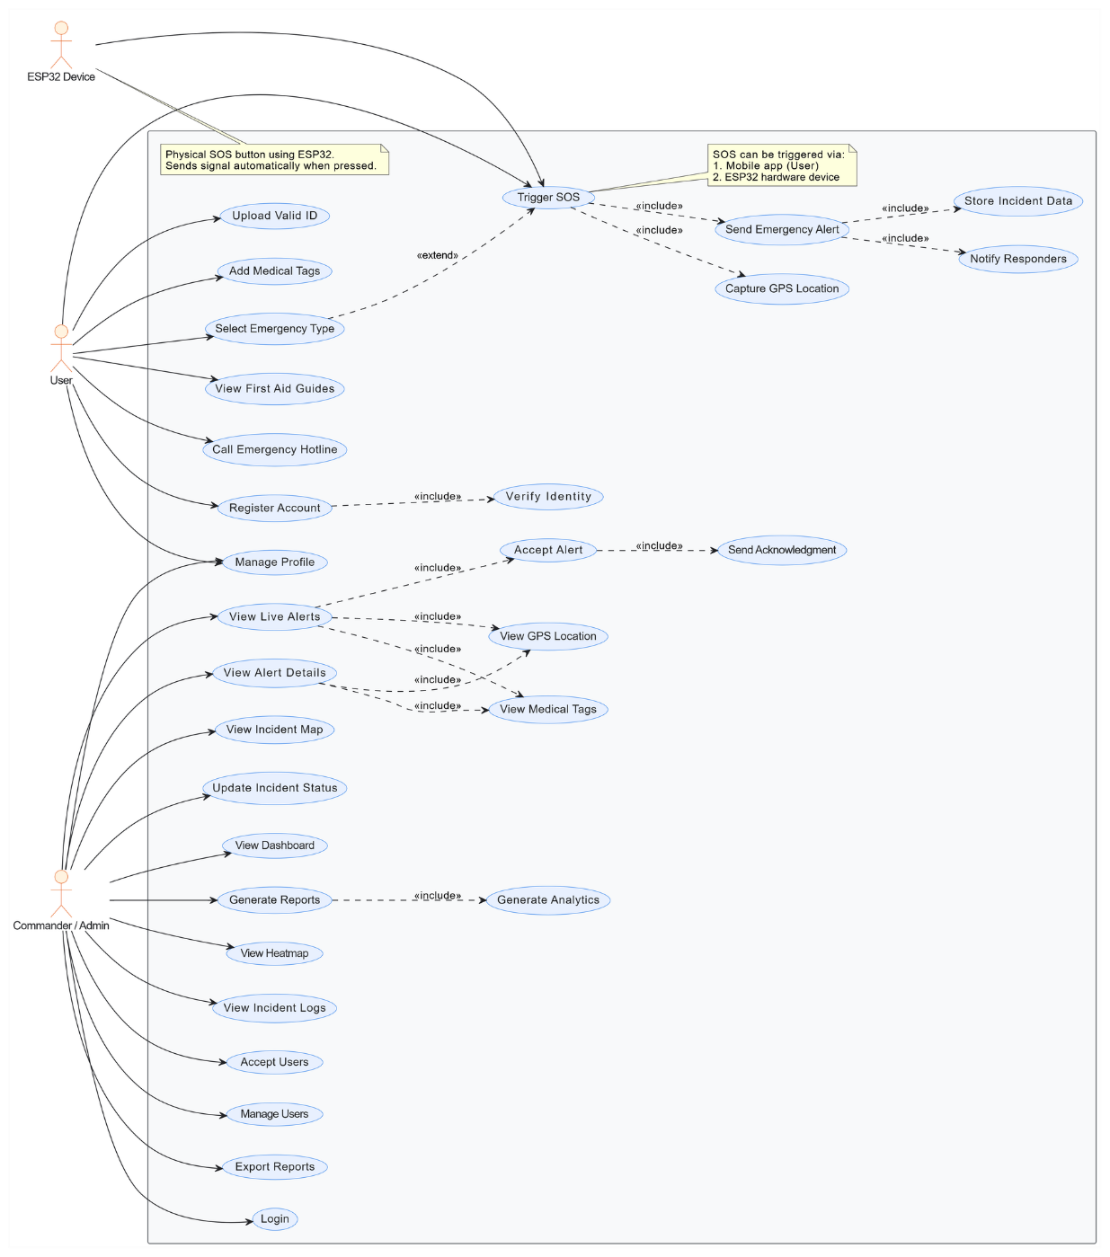
The Use Case Diagram models the dynamic interactions between the system’s primary endpoint actors: the Citizen, the ESP32 Accessory, and the Admin/Responder.

As illustrated in the diagram, the system boundary encapsulates the core functionalities of the accessory hardware, mobile application. On the user front, the Citizen interacts with the system to register their profile, upload valid identification, and set critical medical tags like blood type and allergies. The ESP32 Accessory acts as a hardware actor that triggers the SOS signal and receives physical feedback. On the responder side, BFP Personnel possess access to view live triage alerts, accept incidents, and view citizen medical details to prepare for arrival. High-level administrative tasks are handled by the Admin, who verifies citizen IDs, manages user accounts, and utilizes the reporting module to view hotspot heatmaps and export strategic 30-day reports.
Data Flow Diagram (Context Level)
The Data Flow Diagram (DFD) illustrates how information passes among processes within the system. The Level 0 (Context) diagram models the highest level of data exchange between the emergency system’s core architecture and its primary users.
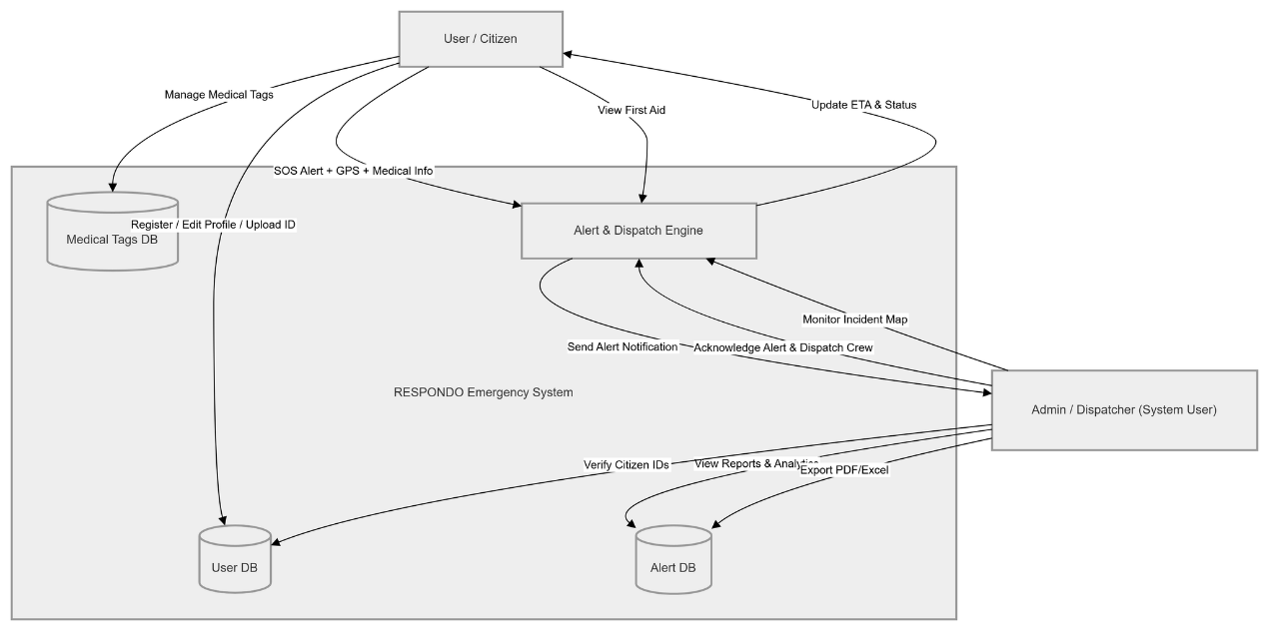

The Context-Level DFD maps the primary inputs and outputs that drive the platform. The central process represents the Cloud API, which validates and stores all incoming data. As mapped, the Citizen inputs registration data, GPS coordinates, and emergency types into the system, receiving two-way acknowledgment signals (LED/vibration) in return. The ESP32 Accessory provides the initial hardware trigger signal to the mobile application. Finally, the BFP Responder/Admin inputs "Accept" commands and ID verification statuses. In return, the system processes this data to output real-time incident clusters, ETA simulations, and exported PDF/Excel incident reports for official BFP record-keeping.
Entity-Relationship Diagram (ERD)
The Entity-Relationship Diagram maps the logical structure of the system’s backend database, defining the core data entities, their attributes, and their relational dependencies to ensure data integrity.

The database architecture is structured around several primary entities. The CITIZENS table serves as the user root, managing profiles and medical tags. It shares a 1-to-Many relationship with the SOS_ALERTS table, which captures the real-time GPS coordinates, emergency type, and status of every trigger. To optimize responder coordination, the SOS_ALERTS entity is linked to INCIDENT_CLUSTERS, which groups multiple nearby alerts into a single record to prevent duplicate dispatches. The APP_USERS entity manages role-based access for BFP staff and is linked to RESPONSE_ACTIONS to track ETA and resolution times. Finally, the INCIDENT_REPORTS table aggregates data from these entities to generate 30-day historical logs. This normalized structure ensures that life-saving medical information and location data remain accurate and accessible during high-pressure scenarios.
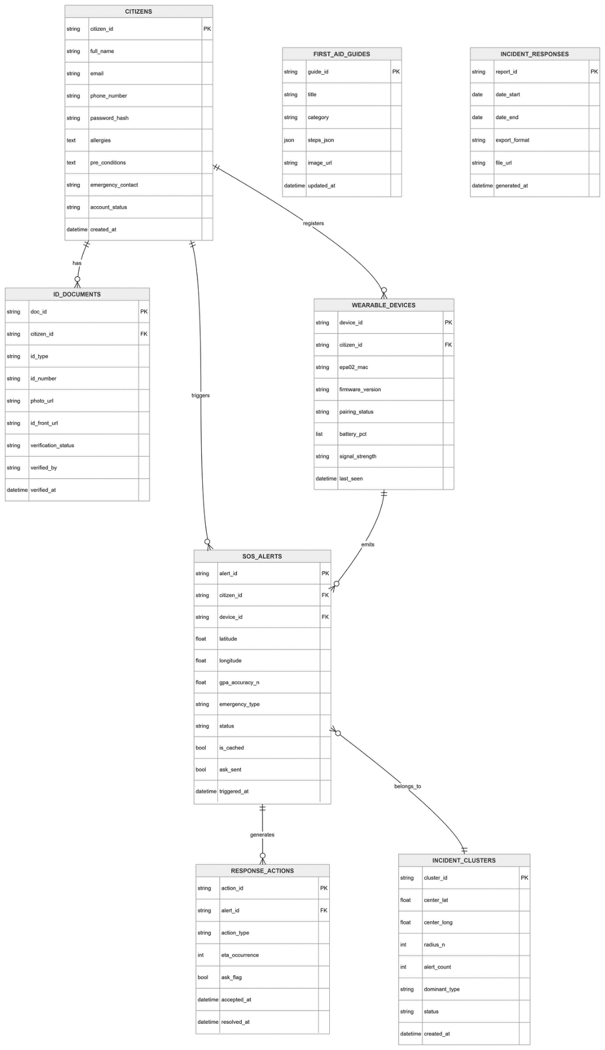

The database architecture is structured around several primary entities. The CITIZENS table serves as the user root, managing profiles and medical tags. It shares a 1-to-Many relationship with the SOS_ALERTS table, which captures the real-time GPS coordinates, emergency type, and status of every trigger. To optimize responder coordination, the SOS_ALERTS entity is linked to INCIDENT_CLUSTERS, which groups multiple nearby alerts into a single record to prevent duplicate dispatches. Finally, the INCIDENT_REPORTS table aggregates data from these entities to generate 30-day historical logs. This normalized structure ensures that life-saving medical information and location data remain accurate and accessible during high-pressure scenarios.

Wireframes (User Interface Design)
The wireframes represent the skeletal framework of the mobile application. They prioritize rapid navigation and clear data visualization to support users during emergencies.

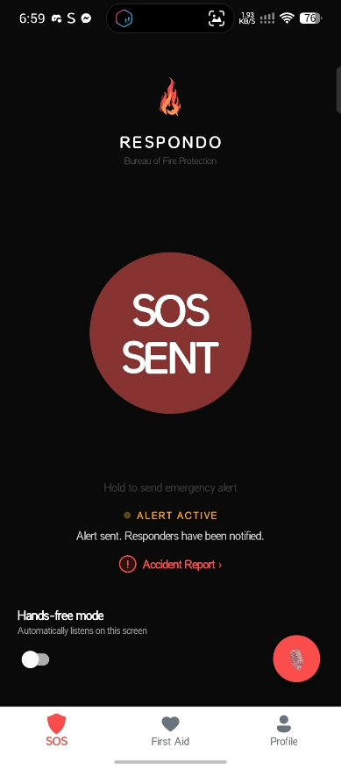
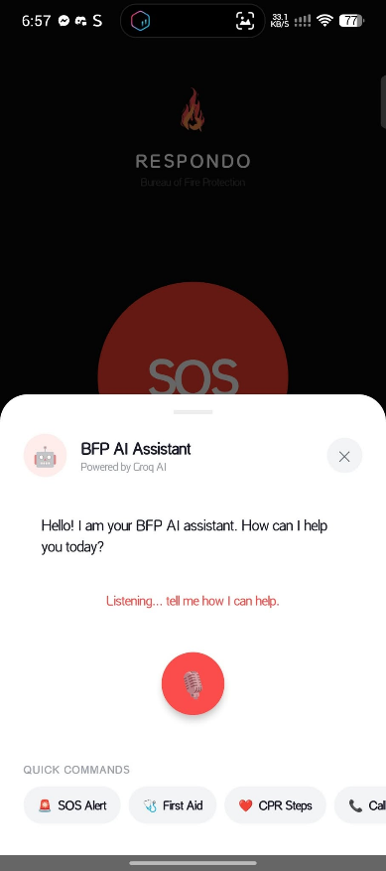
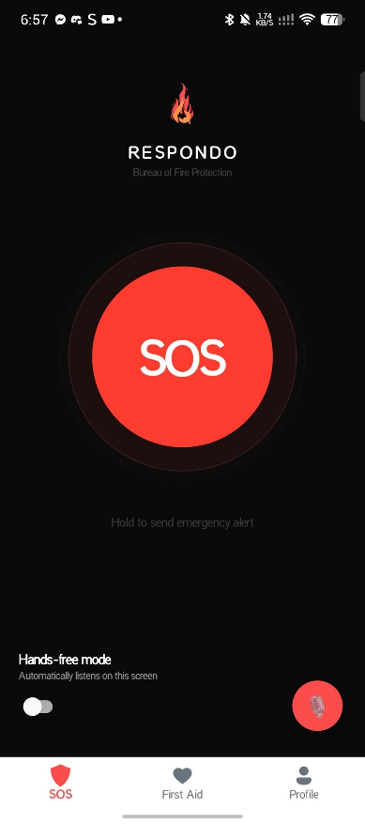
Citizen
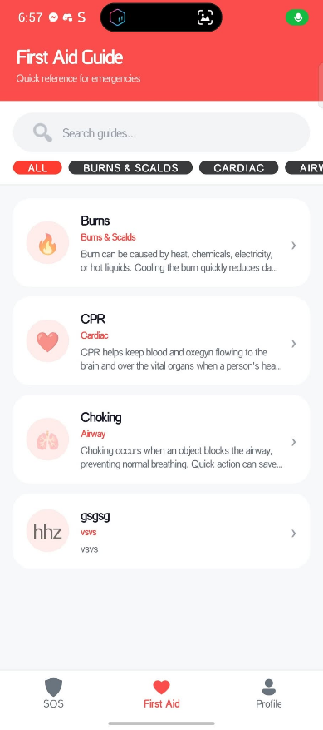
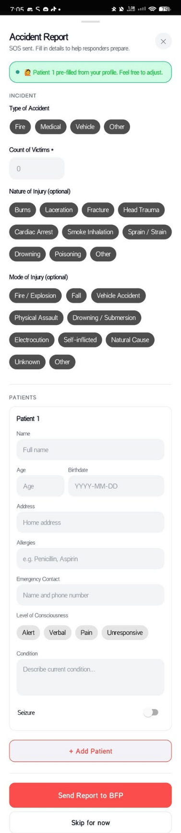
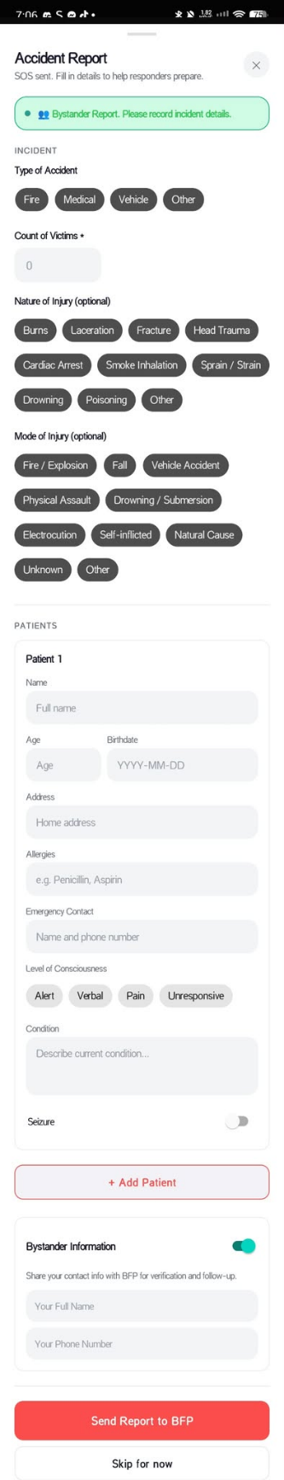

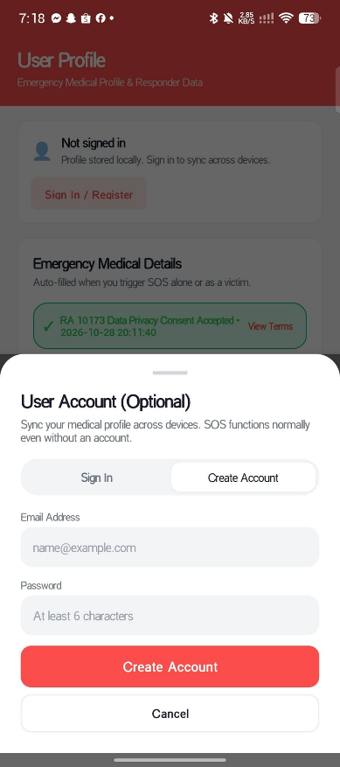
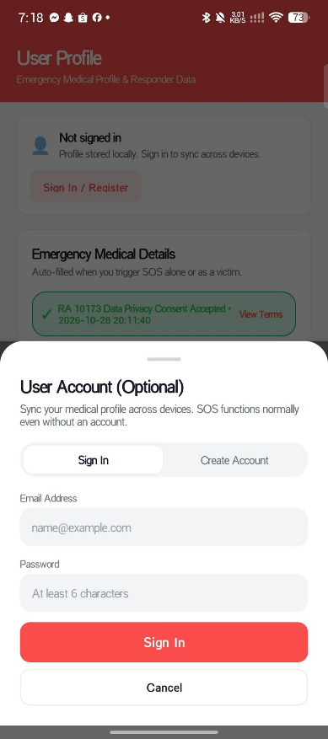
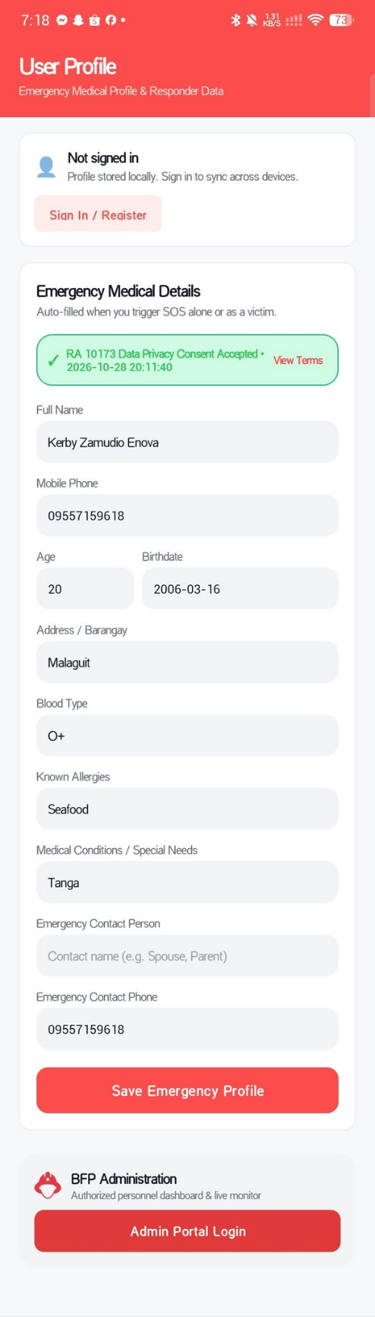
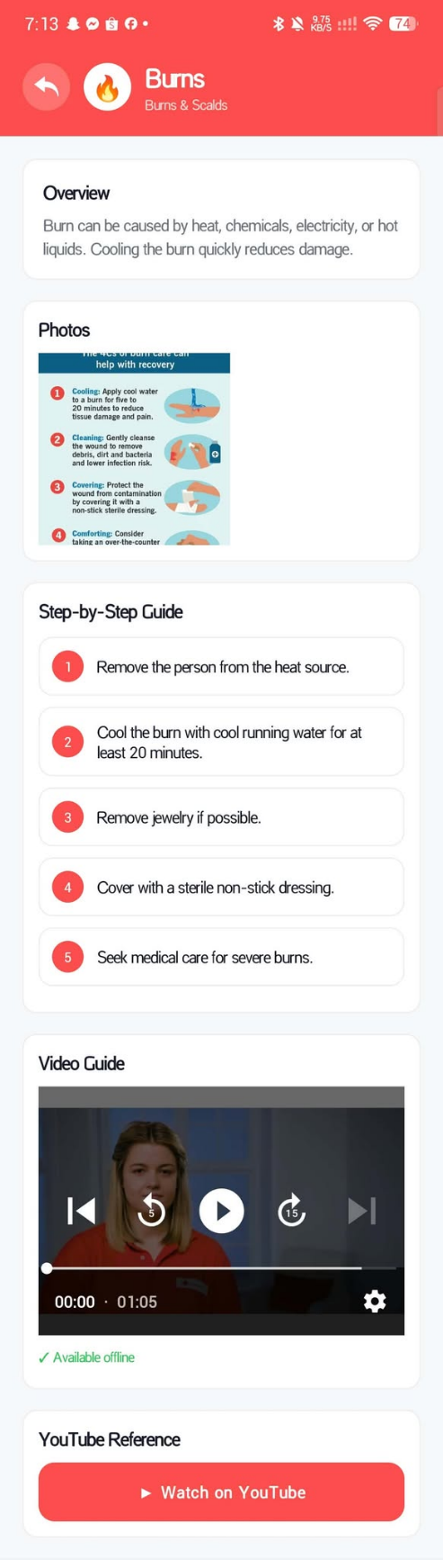
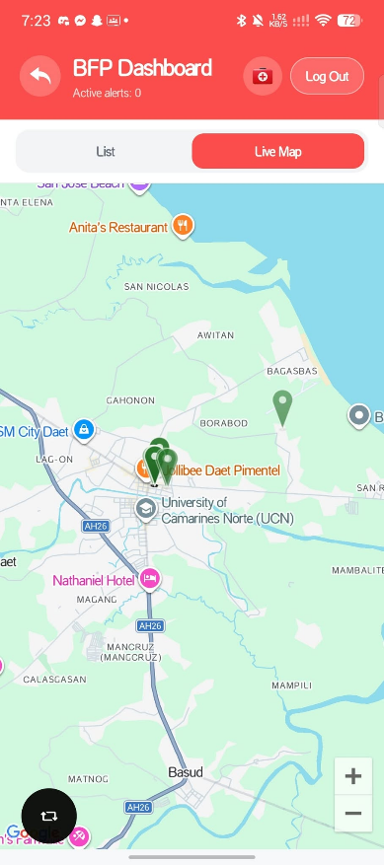
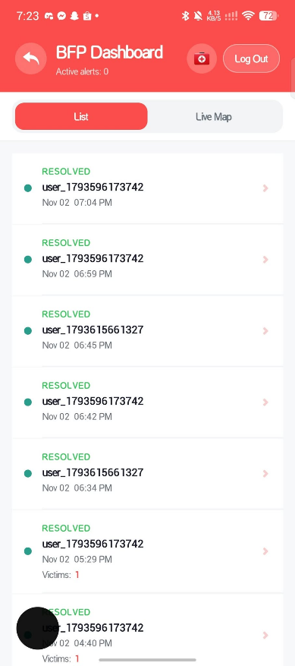
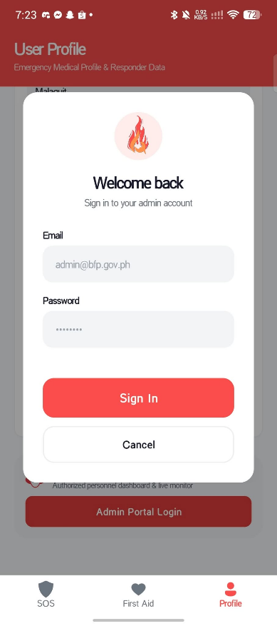
Admin

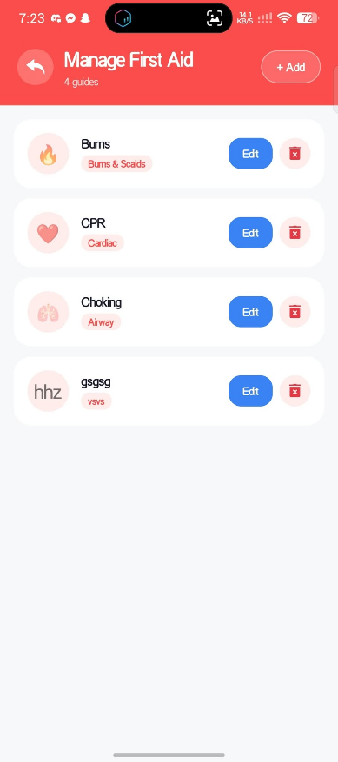

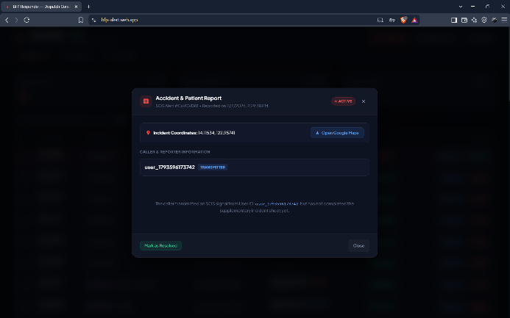
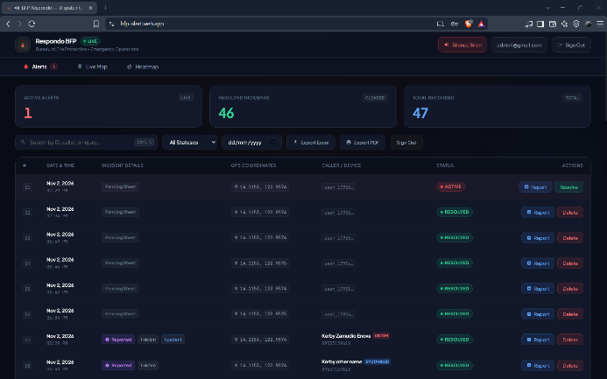
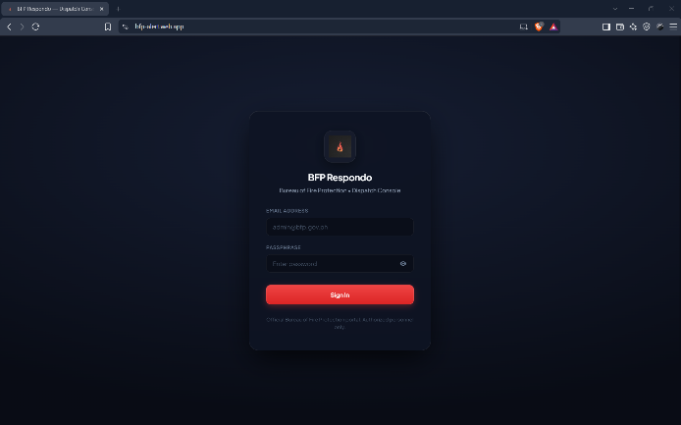
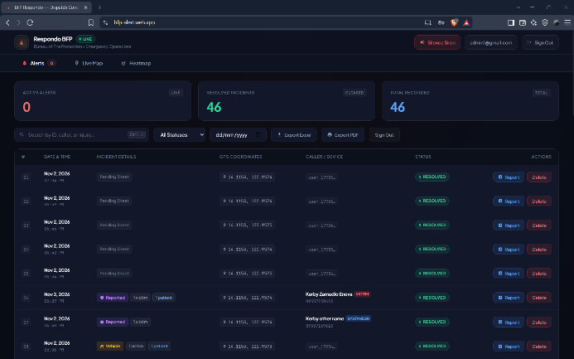

The interface employs a high-contrast, functional design tailored to specific user roles. The Citizen App features a prominent, pulse-animated SOS button and clear, step-by-step first aid guides to empower bystanders during panic. Conversely, the Responder Dashboard utilizes a modular layout, presenting a live incident map with color-coded triage pins (Red for Fire, Blue for Medical) on a single interface. This layout allows dispatchers to manage the triage queue and view citizen medical tags simultaneously, minimizing page reloads and streamlining the coordination of emergency services.
Component Diagram
The component diagram is represent the a 4-layer architecture with color-coded container regions: Hardware, Citizen App, Admin/Responder App, and Cloud Backend. Each layer lists its key components with clear subtitles—sensors and accessory modules in Hardware, user interface and SOS modules in Citizen App, responder management and queue modules in Admin/Responder App, and database, API, and notification services in the Cloud Backend.
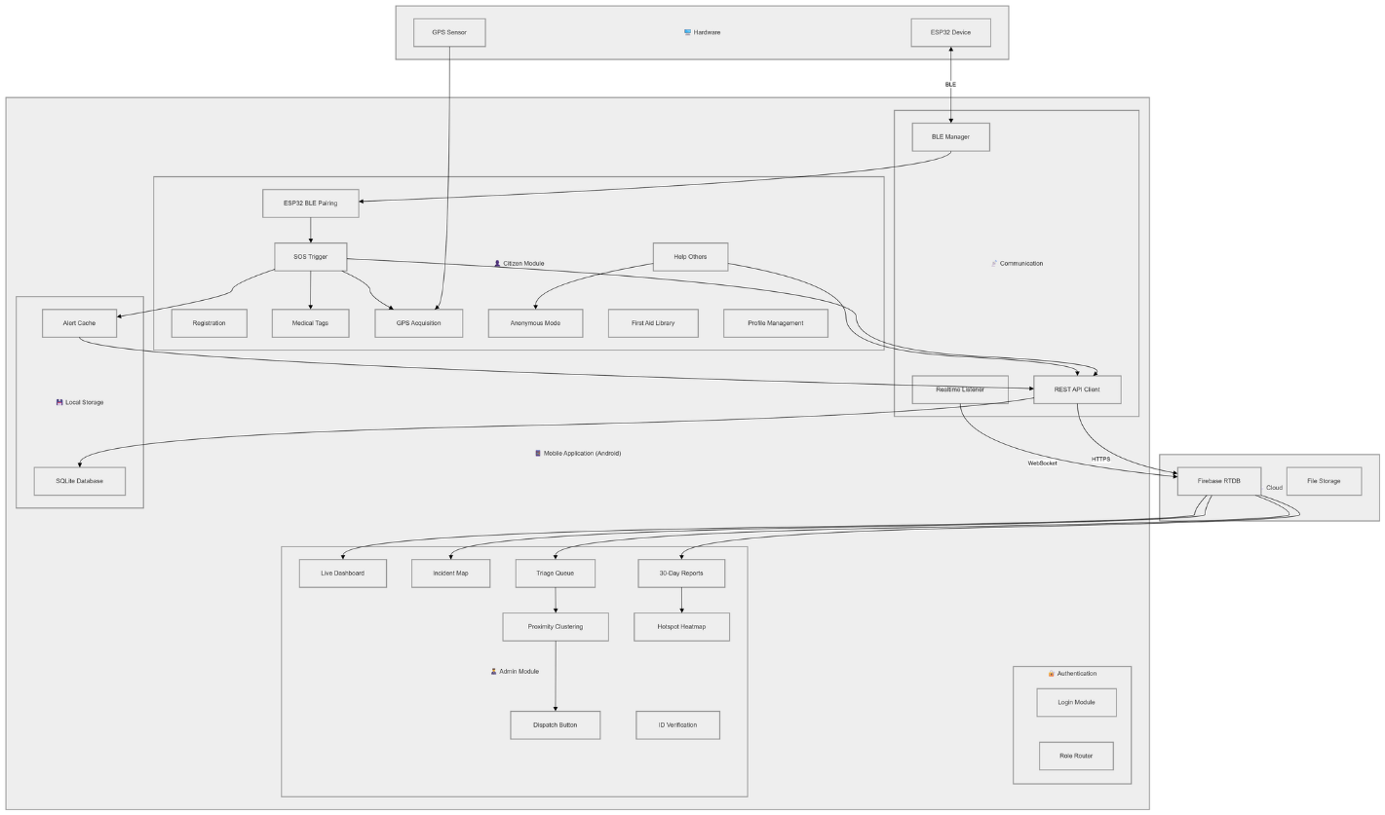
Cross-layer interactions are shown with color-coded arrows to indicate caller type (red = citizen, teal = responder, amber = admin, purple = reports, gray dashed = BLE/internal), and interface labels (BLE, HTTPS) are placed directly on the connectors for clarity. This design highlights real-time data flows, role-specific communication paths, and system modularity, ensuring that each component can operate independently while maintaining synchronized emergency operations across the network.
Deployment Diagram
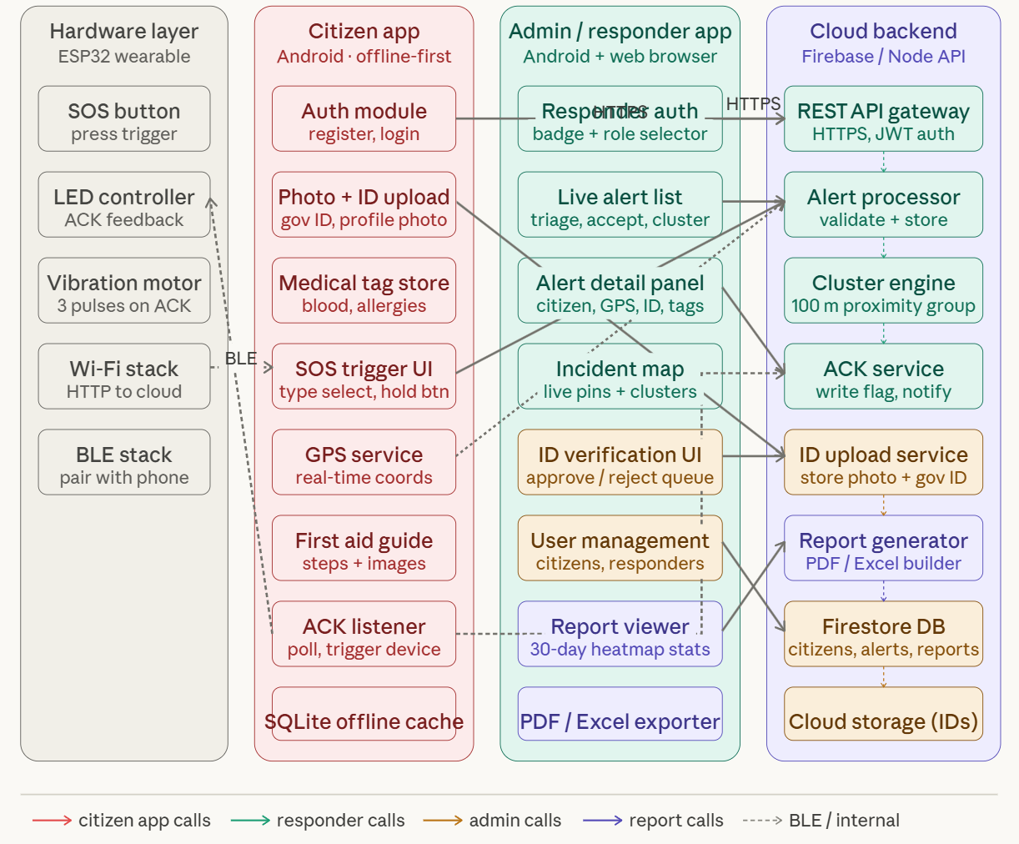
The database schema is structured to support a distributed system built across six clearly separated physical and cloud nodes: ESP32 Accessory, Citizen Android App, Cloud Server, Admin Android App, and Offline Fallback. The schema centralizes critical data on the Cloud Server, while each node interacts with it through well-defined communication protocols (BLE, HTTPS, ACK/poll, and fallback).
Tables are organized to reflect distinct user roles and system functions. Citizen records store registration data, GPS coordinates, and emergency history, while Responder records maintain credentials, status, and assignment logs. Incidents and TriageQueue tables track real-time emergencies, triage priorities, and timestamps, enabling both the Admin Android App to visualize and manage ongoing situations. MedicalTags link vital health information to citizens for instant first-aid guidance.
The schema is optimized for high availability and rapid retrieval, ensuring that data flows efficiently across all nodes while respecting the Internet/Wi-Fi boundary. Relationships are enforced with primary and foreign keys, supporting synchronized updates between mobile apps, and offline fallback operations, thereby maintaining operational continuity even when connectivity is interrupted.
System Functions
This section details the specific functions performed by the IoT-Based Mobile Emergency Response System, categorized by the core components: the Citizen App and the Admin/Responder Dashboard.
Citizen Mobile Application Functions
- User Identity & Account Management: Facilitates authenticated profile management for citizens and emergency personnel, maintaining secure credentials and push tokens.
- Medical Profile & Allergy Tags: Allows users to record voluntary medical information (blood type, known allergies, pre-existing conditions) stored securely and transmitted during active emergencies.
- BLE Hardware Pairing & Trigger: Continuously scans for the BFP-SOS-Device via custom GATT UUIDs, capturing hardware button interrupts to trigger emergency workflows.
- One-Touch Emergency SOS: Automatically acquires high-accuracy GPS coordinates (latitude, longitude) and transmits alert documents to Firestore with server timestamps.
- Multi-Patient Casualty Reporting: Opens a dynamic bottom sheet allowing users to report victim headcounts, accident categories (Fire, Medical, Vehicular, Structural), nature and mode of injury, and per-patient profiles with AVPU consciousness levels, seizure states, and allergies.
- AI Voice First Aid Assistant: Hands-free voice-activated emergency medical consultation powered by Google Gemini and Anthropic Claude APIs, providing spoken step-by-step instructions during ongoing CPR or trauma stabilization.
- First Aid Protocol Library: Provides immediate access to step-by-step text and visual guides for medical and trauma emergencies (CPR, burn management, hemorrhage control).
- Offline Media Caching: Utilizes local video caching and Glide image management so that procedural first aid demonstrations remain accessible during cellular network degradation.
- Bystander Scene Reporting: Enables callers to report incidents on behalf of others, transmitting structured victim counts and injury modes directly to dispatchers.
Admin & Responder Dashboard Functions
- Real-Time Audible Dispatch Queue: Sub-second Firestore snapshot listeners render active emergency cards, triggering multi-tone siren sounds (alert.mp3, medical.mp3, vehicle.mp3) to alert station personnel.
- GIS Hotspot Heatmap: Interactive Leaflet map visualizing emergency incident density with configurable kernel blur, radius (10-100px), and opacity sliders.
- Turn-by-Turn Response Routing: Computes optimal driving paths from registered BFP station coordinates (bfp_stations collection) to incident coordinates using Google Maps and Directions APIs.
- Incident Lifecycle Management: Enables dispatchers to inspect full patient sheets, mark alerts as resolved, or remove resolved records with confirmation guards.
- First Aid Content Management: Allows administrators to create, edit, or delete first aid protocols, descriptions, procedural steps, and rich media links.
- Multi-Sheet Spreadsheet & PDF Export: Client-side export engine powered by SheetJS compiling complete incident logs into formatted Excel workbooks (Alerts, Patient Records, Summary, Heatmap Coordinates) and print-ready PDF reports.

Report Formats
Respondo BFP provides automated reporting capabilities designed to transform raw incident telemetry into official documentation for the Bureau of Fire Protection and local authorities.
The system generates a multi-sheet Microsoft Excel workbook comprising: (1) Alerts Sheet detailing timestamps, coordinates, caller IDs, status, incident types, victim counts, and injury classifications; (2) Patient Records Sheet disaggregating clinical casualty profiles, including age, birthdate, address, allergies, emergency contacts, AVPU consciousness scores, and seizure activity; (3) Summary Statistics Sheet aggregating total, active, and resolved emergency tallies alongside incident type distributions; and (4) Heatmap Coordinates Sheet cataloging GPS coordinates for GIS integration. Furthermore, a formatted PDF export generates print-ready operational logs for fire station audit compliance.
Physical Environment
The implementation and execution of the IoT-Based Mobile Emergency Response System require a coordinated set of hardware and software resources to facilitate real-time emergency communication.
Hardware Resources
The system relies on specific hardware components to bridge the gap between physical emergency triggers and digital response coordination:
- ESP32 Microcontroller: 32-bit dual-core microcontroller equipped with BLE 4.2, serving as the accessory panic button host.
- Accessory Components: Momentary tactile push button, multi-color status indicator LED, and haptic vibration feedback motor.
- Android Smartphone & Workstation: Host smartphone with GPS sensor and Bluetooth adapter for citizen use, and modern dispatch terminal workstations for fire station personnel.
Software Resources
The software environment ensures secure data transmission and efficient management of emergency logs:
- Mobile & Web Platforms: Android OS (API 26+) and standard W3C-compliant modern web browsers (Chrome, Edge, Firefox) supporting HTML5 Geolocation, Web Audio, and Service Workers.
- Cloud Backend & Database: Google Cloud Firestore (NoSQL document database), Firebase Cloud Messaging (FCM multicast), and serverless Cloud Functions (Node.js runtime).
- APIs & Libraries: Google Gemini & Anthropic Claude APIs, Google Maps & Directions API, Leaflet.js with Leaflet.heat plugin, and SheetJS (xlsx) spreadsheet engine.
User Specifications
The system is designed for two distinct sets of target users, each with specific technical requirements:
- Citizens: General community members who require no advanced technical expertise; the system is optimized for high usability to allow users to summon help even during panic or when unable to speak.
- BFP Personnel and Administrators: Authorized staff who must possess basic technical literacy to navigate the responder dashboard, manage triage queues, and interpret GPS data and medical tags.
Uncommon Resource Justification
The ESP32 Microcontroller is a specialized resource essential to this project because it provides a low-cost, low-power solution for accessory technology. Unlike standard smartphones, a dedicated accessory trigger ensures that an SOS signal can be sent instantly via a physical button press, which is critical in scenarios where a user may not be able to interact with a touchscreen or navigate a mobile app during a life-threatening event.

Design and Implementation Issues
During the design and implementation of the IoT-based Mobile Emergency Response System, several technical and operational challenges were addressed to ensure system reliability and usability.
Accessory Battery Depletion & Connection Loss - Mitigated by providing dual triggering paths: citizens can activate SOS directly via the mobile app or PWA interface if the accessory device's battery is depleted.
Bystander Stress & Medical Knowledge Gap - Mitigated by integrating step-by-step first aid guides with an AI voice assistant (Gemini/Claude) capable of hands-free speech guidance during resuscitation.
Cellular Network Inconsistency - Handled via local HTTP caching, offline video storage, and progressive web application service workers.
Station Dispatch Coordination - Solved by automated station-to-scene routing, multi-frequency audible alarms, and real-time Firestore listeners.
Data Privacy & Sensitive Clinical Information - Secured through Firebase Authentication, role-based Firestore security rules, and encrypted HTTPS/TLS transmission.
Hardware and Software Synchronization - Solved through BLE GATT notification listeners on mobile and real-time WebSocket/Firestore listeners across web dispatch consoles.
By addressing these design and implementation issues, the system provides reliable real-time emergency alerting, two-way acknowledgment, first aid guidance, and structured incident reporting, while maintaining functionality through fallback solutions.

Conclusions
The IoT-Based Mobile and Web Emergency Response System with First Aid Support and AI Assistance (Respondo BFP) addresses the critical deficiencies of traditional emergency reporting by establishing a fast, structured, and closed-loop emergency response pipeline for the Bureau of Fire Protection.
Through the seamless integration of an ESP32 accessory trigger, a native Android mobile application, a progressive web application, and synchronized admin dispatch consoles, the system guarantees instant GPS location acquisition and comprehensive casualty triage. The inclusion of multi-patient reporting, AI-driven voice first aid assistance, real-time siren dispatching, GIS hotspot heatmaps, and automated multi-sheet Excel/PDF export significantly elevates operational readiness, shortens response times, and improves pre-hospital survival outcomes.
Furthermore, the system’s reporting and analytics module contributes to long-term planning and decision-making by allowing the Bureau of Fire Protection and local government units to identify emergency hotspots and improve resource allocation. Despite certain limitations such as reliance on internet connectivity and device battery life, the system incorporates fallback mechanisms to maintain functionality during failures.
Overall, the project demonstrates that the integration of Internet of Things (IoT) technology with mobile platforms can significantly improve emergency response efficiency, coordination, and public safety. The system serves as a functional prototype and a foundation for future enhancements, including broader system integration, improved connectivity solutions, and advanced automation features.
Appendix B. Reference

S. Jadhav, S. Bhosale, V. Shelar, Parth Patil, Suraj Sayyad Jamadar (2024). Fire Fighter Robot Using IOT and Mobile Application. https://doi.org/10.55529/ijrise.46.49.57

Syed Mohammed Zakaria Al-Hady, Md. Rafiqul Islam, M. Rashid (2023). Development of IoT-Based Automated Dynamic Emergency Response System Against Fire Incidents in Academic Building. https://doi.org/10.26776/ijemm.08.03.2023.03

Afraim Uzzaman Romeo, M. Diya, Ataur Rahman, Mahady Hasan (2026). AI-based Emergency Help Service. https://doi.org/10.1109/ICSADL67539.2026.11452043

Han Zhang, Runze Zhang, Jiamanzhen Sun (2025). Developing real-time IoT-based public safety alert and emergency response systems. Scientific Reports, 15. https://doi.org/10.1038/s41598-025-13465-7

Jialin Wu, Yongqi Tang, Feifan He, Zhichao He, Yunting Tsai, Wenguo Weng (2025). IoT-Based Approaches to Personnel Health Monitoring in Emergency Response. https://doi.org/10.3390/su18010365

Muhammad Azzam Alfarabi, Rayyan Athaillah Muntazhar, Afryansyah Afryansyah (2025). Development of an IoT-Based Autonomous Robot for Indoor Fire Detection and Evacuation Support. https://doi.org/10.58836/jpma.v16i2.28419

Abishai Sakthi Dev, Dhammodharan S, M. Ponrani (2025). AI Based Emergency Assist System for Ambulance. https://doi.org/10.1109/IDCIOT64235.2025.10914913

K. Rao, K. Krishna, D. Rohith, B. Sravani, B. Uma, Satya Prasad (2024). IoT Enabled Fire Fighting Robot Integrated With Thingspeak Cloud For Emergency. https://doi.org/10.56726/irjmets51931

R.D.R.P.S. Vipulasena, S. Weerakoon, Pulsarani Wickramasinghe, S. Wickremasinghe, M.G.B. Wijebahu, S. Samarasinghe, G. Ganegoda (2025). Application on basic life support and first aid. https://doi.org/10.31705/fomaas.2025.029

Ch. Vidyadhari, P. Pavan, M. Tharun, Vinayak Kundu, Kanika Dulta (2023). A Sustainable and Efficient IoT Approach for Fire Department Alerting System. https://doi.org/10.1051/e3sconf/202343001094

Prof. V. B. Niranjane, Unnati Ambagade, Sneha Bhoyar, Tanishka Shende, Fardin Sheikh, V. Parate (2025). ResQnet- Internet of Things (IoT) Based Emergency Response System for Network Deprived Area. https://doi.org/10.1109/ICEC2NT65402.2025.11380016

Neil Basabe, Christine Jhoy Carubio, Joshua Del Mar, Carlo Saberon (2023). AlarmaPh: A Mobile Swiss Knife for Quick Response Incidents. https://doi.org/10.32996/jcsts.2023.5.3.747
Farahani Ali, W. E. Nijar (2025). FEASIBILITY STUDY OF REAL-TIME IOT BASED EMERGENCY VEHICLE ALERT SYSTEM FOR ROAD SAFETY. https://doi.org/10.54554/jet.2025.16.2.019

P. Varsha, P. K. Chary, P. Sathvik, N. V. Varma, S. rahul, Dr.M., Saravanam, D. Dharnasi (2026). IOT-Based Fire Alarm and Location Tracking System. https://doi.org/10.15662/ijrpetm.2026.0902007

John Paul O. Daganato, Rovil S. Berido, Jeffrey T. Dellosa, Alexander M. Platino (2024). Design and Development of a Solar-Powered IoT-Based Fire Alarm System with Integrated GPS and GSM for Enhanced Emergency Response. https://doi.org/10.1109/ASIANCON62057.2024.10838125

S. Uday (2025). IOT Based Accident Detection and Rescue System. https://doi.org/10.55041/ijsrem46091

Amit Vishwakarma, A. Vishwakarma, Ravindra Chauhan (2025). Reducing Urban Emergency Fatalities: A Holistic AI-Driven Rescue Model. https://doi.org/10.36948/ijfmr.2025.v07i03.43874
Alfarabi, M. A., Muntazhar, R. A., & Afryansyah, A. (2025). Development of an IoT-Based Autonomous Robot for Indoor Fire Detection and Evacuation Support. Journal of Robotics, 16(2).
Al-Hady, S. M. Z., Islam, M. R., & Rashid, M. (2023). Development of IoT-Based Automated Dynamic Emergency Response System Against Fire Incidents in Academic Building. IJEMM, 8(3).
Ali, A. F., & Nijar, W. E. (2025). Feasibility Study of Real-Time IoT Based Emergency Vehicle Alert System for Road Safety. JET, 16(2).
Ali, M., et al. (2025). A Review of Internet of Things Approaches for Vehicle Accident Detection and Emergency Notification. MDPI Sustainability, 17(14).
Basabe, N., Carubio, C. J., Del Mar, J., & Saberon, C. (2023). AlarmaPh: A Mobile Swiss Knife for Quick Response Incidents. JCSTS, 5(3).
Daganato, J. P. O., Berido, R. S., Dellosa, J. T., & Platino, A. M. (2024). Design and Development of a Solar-Powered IoT-Based Fire Alarm System with Integrated GPS and GSM for Enhanced Emergency Response. IEEE ASIANCON.
Dev, A. S., Dhammodharan, S., & Ponrani, M. (2025). AI Based Emergency Assist System for Ambulance. IEEE IDCIOT.
Jadhav, S., Bhosale, S., Shelar, V., Patil, P., & Jamadar, S. S. (2024). Fire Fighter Robot Using IOT and Mobile Application. IJRISE, 4(6).
Kumar, S., et al. (2024). From Inception to Innovation: A Comprehensive Review and Bibliometric Analysis of IoT-Enabled Fire Safety Systems. MDPI Fire, 11(2).
Niranjane, V. B., Ambagade, U., Bhoyar, S., Shende, T., Sheikh, F., & Parate, V. (2025). ResQnet- Internet of Things (IoT) Based Emergency Response System for Network Deprived Area. IEEE ICEC2NT.
Perez, L., et al. (2026). Assistive Mobile Application for Fire Emergency Evacuation of Visually Impaired People. MDPI Sensors, 26(5).
Rao, K., Krishna, K., Rohith, D., Sravani, B., Uma, B., & Prasad, S. (2024). IoT Enabled Fire Fighting Robot Integrated With Thingspeak Cloud For Emergency. IRJMETS.
Romeo, A. U., Diya, M., Rahman, A., & Hasan, M. (2026). AI-based Emergency Help Service. IEEE ICSADL.
Saminathan, V., et al. (2026). IoT Based Collision Alert and Smart Accident Detection System. IARJSET, 13(1).
Uday, S. (2025). IOT Based Accident Detection and Rescue System. IJSREM.
Varsha, P., Chary, P. K., Sathvik, P., Varma, N. V., rahul, S., Saravanam, M., & Dharnasi, D. (2026). IOT-Based Fire Alarm and Location Tracking System. IJRPETM, 9(2).
Vidyadhari, Ch., Pavan, P., Tharun, M., Kundu, V., & Dulta, K. (2023). A Sustainable and Efficient IoT Approach for Fire Department Alerting System. E3S Web of Conferences.
Vipulasena, R. D. R. P. S., et al. (2025). Application on basic life support and first aid. FOMAAS.
Vishwakarma, A., Vishwakarma, A., & Chauhan, R. (2025). Reducing Urban Emergency Fatalities: A Holistic AI-Driven Rescue Model. IJFMR, 7(3).
Wang, Y., et al. (2025). ResQ – Intelligent Real-Time Disaster Management Using Machine Learning and IoT. IEEE ICSES.

Wu, J., Tang, Y., He, F., He, Z., Tsai, Y., & Weng, W. (2025). IoT-Based Approaches to Personnel Health Monitoring in Emergency Response. MDPI Sustainability, 18(1).
Zhang, H., Zhang, R., & Sun, J. (2025). Developing real-time IoT-based public safety alert and emergency response systems. Scientific Reports, 15.

