**POMELO *(Citrus Maxima)* DISEASE IDENTIFIER**

**USING MOBILE APPLICATION**

**GIAN KAYLE M. FEROLINO**

Thesis Manuscript Submitted to the Department of Computing and Library Information Science, College of Engineering and Information

Technology, University of Southern Mindanao, Kabacan,

Cotabato in Partial Fulfilment of The

Requirements for the Degree of

**BACHELOR OF SCIENCE IN COMPUTER SCIENCE**

****

**JUNE 2024**

|  |
| --- |
| Description: C:\Users\Jane\AppData\Local\Packages\microsoft.windowscommunicationsapps_8wekyb3d8bbwe\LocalState\Files\686\224\USM logo [568108].jpg  **UNIVERSITY OF SOUTHERN MINDANAO**  Kabacan, Cotabato  Philippines |
| APPROVAL OF THESIS MANUSCRIPT |

|  |  |
| --- | --- |
| **Name** | **GIAN KAYLE M. FEROLINO** |
| **Major** | **N/A** |
| **Degree Sought** | **BACHELOR OF SCIENCE IN COMPUTER SCIENCE** |
| **Specialization** | **N/A** |
| **Thesis Title** | **POMELO (CITRUS MAXIMA) DISEASE IDENTIFIER USING**  **MOBILE APPLICATION** |

**APPROVED BY THE GUIDANCE COMMITTEE**

**JANICE T. PALMAERA**

Adviser Co-Adviser

(Optional)

**\_\_\_\_\_\_\_\_\_\_\_\_\_\_ \_\_\_\_\_\_\_\_\_\_\_\_\_**

Date Date

**\_\_\_\_\_\_\_\_\_\_\_\_\_\_\_\_\_\_\_\_\_\_\_\_\_\_\_\_ NOR-AINE M. CORPUZ**

Statistician Department Research Coordinator (Optional)

**\_\_\_\_\_\_\_\_\_\_\_\_\_\_ \_\_\_\_\_\_\_\_\_\_\_\_\_**

Date Date

**DANILYN A. FLORES**

Department Chairperson

**\_\_\_\_\_\_\_\_\_\_\_\_\_\_**

Date

­­­­­­­

**NOR-AINE M. CORPUZ MARICEL G. DAYADAY, DTE**

College Research Coordinator Dean

**\_\_\_\_\_\_\_\_\_\_\_\_\_\_\_\_\_\_\_\_\_\_ \_\_\_\_\_\_\_\_\_\_\_\_\_\_\_\_\_\_\_\_\_\_**

Date Date

Study No: **DCLIS-CS-2024-01**

Index No: **MC-CEIT-012960**

Recorded by: \_\_\_\_\_\_\_\_\_\_\_\_\_

**RECORDED:**

**LYDIA C. PASCUAL**

Director for Research and Development Office

**\_\_\_\_\_\_\_\_\_\_\_\_\_\_\_\_\_**

Date

Recorded by: \_\_\_\_\_\_\_\_\_\_

USM-EDR-F04-Rev.4.2020.11.16

USM-EDR-F04-Rev.4.2020.11.16

USM-EDR-F04-Rev.4.2020.11.16

**TABLE OF CONTENT**

PRELIMINARIES Page

Title Page i

Approval of Thesis Outline ii

Table of Contents iii

List of Tables v

List of Figures vi

List of Appendices vii

**INTRODUCTION** 1

Background of the Study 1

Significance of theStudy 3

Objectives of the Study 3

Expected Outputs of the Study 4

Place and Time of the Study 4

Scope and Limitations 4

Operational Definition of Terms 5

Conceptual Framework 7

**REVIEW OF RELATED LITERATURE** 10

Convolutional Neural Network (CNN) 10

Black Spot (Phyllosticta citricarpa) in Pomelo (Citrus Maxima) Leaf 13

Fungi in Pomelo (Citrus Maxima) Trunks 17

CNN in Disease Detection 19

**METHODOLOGY** 23

Research Design 23

Role of the Researcher 23

Research Participants and Materials 23

Data Gathering Producers 24

Validity 24

Development Methodology 25

Training Phase 26

Evaluation Measures 26

**LITERATURE CITED** 29

**APPENDICES** 33

**CURRICULUM VITAE** 39

# LIST OF TABLES

**Table Title Page**

1 Hardware Requirements 28

2 Software Requirements 28

# LIST OF FIGURES

**Figure Title Page**

1 Conceptual Framework of the Study 9

# LIST OF APPENDICES

**Appendix Title Page**

[A Application for Research Adviser 3](file:///C:\\Users\\user\\Desktop\\RDO\\Template\\January%202021\\Undergrad-Thesis-Outline-Template_Qualitative_MTNC_fin.docx" \l "_Toc64044506)4

[B Application for Research Title 3](file:///C:\\Users\\user\\Desktop\\RDO\\Template\\January%202021\\Undergrad-Thesis-Outline-Template_Qualitative_MTNC_fin.docx" \l "_Toc64044507)5

[C Estimated Budget of the Research 3](file:///C:\\Users\\user\\Desktop\\RDO\\Template\\January%202021\\Undergrad-Thesis-Outline-Template_Qualitative_MTNC_fin.docx" \l "_Toc64044508)6

[D Application for Thesis Outline Defense](file:///C:\\Users\\user\\Desktop\\RDO\\Template\\January%202021\\Undergrad-Thesis-Outline-Template_Qualitative_MTNC_fin.docx" \l "_Toc64044509) 37

E Certification of English Critic 38

**ABSTRACT**

**FEROLINO, GIAN KAYLE MAURIN. 2025.** Pomelo (Citrus Maxima) Disease Identifier Using Mobile Application. BSCS Thesis. College Of Engineering and Information Technology, Department Of Computing And Library Information Science, University of Southern Mindanao, Kabacan, Cotabato.60 pp

Adviser: **JANICE T. PALMAERA**

This study developed a mobile application to assist pomelo farmers in identifying common plant diseases, specifically Canker (Blackspot) and Fungal Diseases. By leveraging image processing and convolutional neural networks (CNN), the application provides accurate disease detection through user-captured images. The system was trained on a dataset of 2,000 pomelo images, achieving a testing accuracy of 96%. Along with detection, the app offers detailed descriptions of the diseases and actionable management tips, enabling farmers to make informed decisions in real time.The findings show that the mobile application is highly effective in diagnosing pomelo diseases and providing practical recommendations for disease management. Its user-friendly interface and high detection accuracy make it an essential tool for reducing crop losses and improving farm productivity.

**Keywords:** Canker (Blackspot) Disease, Convolutional Neural Networks

(CNN), Fungal Disease, Image Processing, Mobile Application

# INTRODUCTION

# Background of the Study

The primary challenge in agriculture is the prevalence of plant diseases, leading to a decrease in crop yield and production, resulting in significant economic losses and instability in the food supply. Citrus, a fruit crop of substantial economic importance cultivated in approximately 140 countries, faces widespread challenges such as pests and diseases, causing notable declines in yield and quality.

In recent times, the application of computer vision and machine learning has become prevalent for detecting and classifying plant diseases, offering opportunities for early identification and advancements in agriculture. Swift and accurate disease detection plays a crucial role in minimizing disease spread and crop damage. The study by Syed-Ab-Rahman et al. (2022) highlighted a proposed model capable of identifying and distinguishing three distinct citrus diseases—citrus black spot, citrus bacterial canker, and Huanglongbing. This model stands as a valuable decision support tool for growers and farmers in recognizing and categorizing citrus diseases.

According to Yang et al. (2020) Pomelo (Citrus grandis Osbeck) from the Rutaceae family is renowned for its numerous health benefits, including antiaging, antioxidant, anticancer, and hypoglycemic properties. This citrus fruit is alternatively known as Citrus grandis (L.) Osbeck or Citrus maxima (Burm.) Merr., is notably large and widely enjoyed in Taiwan. Its nutritional profile is exceptionally rich, featuring essential trace elements and potassium, making it particularly beneficial for individuals with hypertension, cardiovascular issues, cerebral vascular conditions, and kidney diseases. Typically, C. grandis is consumed either in its entirety or in the form of beverages like juice, boasting a wealth of vitamins, minerals, and valuable organic compounds.

Conducting the study "Pomelo (Citrus Maxima) Disease Identifier Using Mobile Application" is essential in addressing critical challenges in agriculture by providing farmers with early and accurate disease detection, preventing significant financial losses, and ensuring market stability. This mobile application leverages ubiquitous technology to offer real-time, accessible solutions, enhancing agricultural efficiency; it promotes sustainable practices by reducing chemical usage and optimizing resource allocation, contributing to environmental conservation. Additionally, the app serves as an educational tool, facilitating knowledge sharing and personalized farming advice, which supports precision agriculture. By protecting crops and improving food security, the study has global implications, potentially scaling to other pomelos and advancing agricultural technology, ultimately benefiting economic stability, public health, and environmental sustainability.

The study entitled "Pomelo (Citrus Maxima) Disease Identifier Using Mobile Application" aims to provide significant benefits. It offers a useful method for the agricultural sector to monitor and manage pomelo diseases, by this means supporting the sustainability and productivity of the industry. For local communities in the Philippines, the study provides a valuable tool for identifying pomelo diseases, promoting better crop. Additionally, the research is to support future researchers by offering multiple areas of focus, allowing them to build upon the study's findings and validate their initial research efforts.

The main objective of this study was to develop a mobile application for identifying pomelo diseases. Specifically, the study aimed to gather a dataset of images related to the disease, develop a framework and design a model capable of identifying diseases at an early stage using the Convolutional Neural Network algorithm, and create a mobile application that could capture images of diseases and display results. The study also sought to evaluate the accuracy of the framework, ensuring that the application could reliably detect diseases in pomelo crops.

The expected output of this study was the development of a mobile application that farmers could use to identify black spot and fungal diseases on pomelo. The results of the test dataset, applied to a trained model infected with the disease, were expected to train and test the datasets and evaluate the accuracy of the application.

This study focused on the application by adding datasets and integrating the framework into a mobile application. The datasets were gathered through the actual capturing of pomelo at Matalam, Cotabato. The application displayed whether the fruit was infected with black spot disease and fungal disease or not.

The study was conducted at Poblacion, Matalam, Cotabato, from August 2024 to December 2024.

**Operational Definition of Terms**

Here are some common keywords that will be present and specified.

**Accuracy –** refers to a measure of how well a model, such as machine learning model, can correctly predict the output or classification of a given input.

**Algorithm** – refers to a set of precise instructions that must be followed in a specific order in order to finish a task or solve an issue.

**Application** – refers to a software or computer program created to carry out a certain task or group of duties for the user.

**Disease** – refers to a condition in which an organ or section of the body is unable to operate normally causes damage to the body or structure of a human, animal, or plant is called a sickness.

**Framework** – refers to a set of rules, maxims, or principles that you use when making decisions or resolving problems.

**Identification** – refers to the process of recognizing based on specific types.

**Testing** – refers to the process of evaluating a system or component to determine whether it meets specified requirements and performs its intended function without errors or defects.

**Validation** – refers to the process of making sure something is correct or accurate.

**Conceptual Framework**

Figure 1 demonstrated the implementation of a mobile application for identifying pomelo diseases using image processing techniques and the CNN algorithm. It showed the method's process for identifying the disease.

The process began by identifying the problem, where the researcher clearly defined the problem that the study aimed to address with the pomelo disease identifier. This helped to define the scope of the project, including the target audience and the objectives of the mobile app. The study also conducted a literature review to understand existing research, methodologies, and technologies related to pomelo disease identification and CNNs, identifying relevant studies, datasets, and techniques. The dataset consisted of 1,000 images of pomelos exhibiting different types of diseases, namely Blackspot and Fungal. Each image contained multiple angles and was taken using an Android camera. The diseases were photographed in an uncontrolled environment from several angles and at different times of the day to approximate the observation of the planter. The images were captured under the supervision of an expert to ensure image quality and consistency.

In the second step, the researcher developed the framework by preprocessing the data to improve its quality and facilitate analysis. This included applying the CLAHE algorithm to enhance the contrast of the images, labeling the images to reduce identification errors, and extracting and augmenting the data to increase the size of the dataset.

In the third step, the researcher converted the images to HSV, Lab, and Luv color spaces to analyze the colors and shades of the pods more accurately. The fourth step involved extracting features from the images using the MobileNet CNN techniques. These two feature extraction techniques were used to maximize the accuracy of classification.

In the fifth step, the data was divided into two parts: one containing images of pods affected by Blackspot disease and the other containing images of fungal disease. This step helped to understand the distinctive characteristics of the two types of diseases.

Finally, for training and evaluating the models, the data was divided into three sets: the training set, the validation set, and the test set. This division enabled the evaluation and validation of the model's performance. To tackle the disease detection task, the researcher adopted XGBoost and deep learning methods based on the MobileNetV2 network using CNN algorithms. The researcher applied hybrid methods, recognizing the complementary power that merged the potential of the MobileNetV2 network with a set of machine learning algorithms. To assess the effectiveness of each model, the researcher carefully evaluated its ability to identify diseases in the developed project. This crucial phase enabled the researcher to quantify and compare the performance of each approach.

In the sixth step, the researcher used similarity algorithms to measure the similarities between the test data and the essential characteristics of each disease type. The study then performed the classification using these results, which was crucial to ensure the accuracy of the final identification.

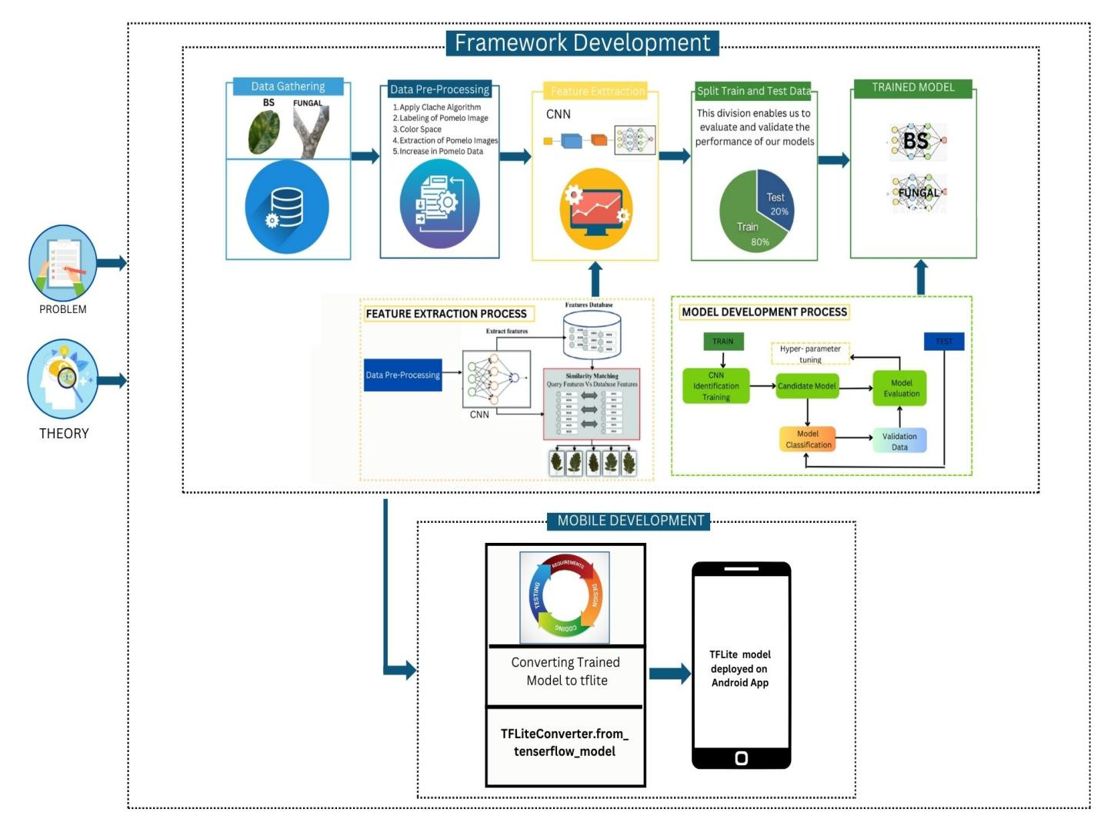

Figure 1. Conceptual Framework of the Study

# REVIEW OF RELATED LITERATURE

This section contains the relevant literature to consider in strengthening the claim and importance of the current study.

**Convolutional Neural Network (CNN)**

Over the past years, Convolutional Neural Networks have produced ground-breaking findings in a range of pattern recognition-related domains, including speech recognition and image processing. The reduction of ANN's parameter count is CNNs' most advantageous feature. Because of this accomplishment, researchers and developers are now able to tackle more complex jobs with larger models, previously not achievable with traditional ANNs (Albawi et al., 2017). Getting abstract features as input moves through the layers is a crucial part of CNN.

In picture classification, for instance, the edge may be identified in the first layers, followed by simpler shapes in the second levels, and higher-level characteristics like faces in the subsequent layers, Convolutional Neural Networks (CNNs) are made up of neurons that learn to optimize themselves. ANNs are based on the fact that every neuron will continue to receive an input and carry out an operation (scalar product followed by a non-linear function). The last will contain loss functions associated with the classes, and all of the standard advice and techniques created for traditional ANNs still apply.

Convolutional neural networks are different from other types of artificial neural networks in that they utilize specific input knowledge rather than concentrating on the problem domain as a whole. Consequently, this makes it possible to put up a considerably simpler network design. In essence, a convolutional neural network (CNN) is a neural network that uses the convolution function as one of its layers rather than a fully connected layer. When dealing with issues where the input data on which predictions are to be made that has a known grid-like topology, such as a time series (a 1-D grid) or an image (a 2-D grid), CNNs have proven to be an enormously successful method. By resolving one of the most important computational issues in the digital era of computer vision, bringing deep learning into the present day. The widespread use of CNNs led to an increase in deep learning research that is still going strong today (Ketkar & Moolayil, 2021).

Conventional machine learning algorithms need feature extraction, which necessitates the involvement of a domain expert (Indolia et al., 2018). Convolution Neural Network (CNN), often known as ConvNet, has a deep feed-forward architecture; amazing capacity to generalize in a better way than networks with fully linked layers (Phan et al., 2017).

The following are some of the major reasons why CNN is preferred over other classical models. First, the main reason for utilizing CNN is the concept of weight sharing, which significantly reduces the number of parameters that need to be trained, resulting in improved generalization. In addition, because of the fewer parameters, CNN may be trained quickly and without overfitting (Indolia et al., 2018). Second, the classification stage is combined with the feature extraction stage, and use a learning process. Third, it is significantly more difficult to create big networks using general artificial neural network (ANN) models than it is to implement CNNs (Nwosu et al., 2017).

Deep learning has a significant advantage over standard machine learning techniques that it can find meaningful features in high-dimensional data independently. There is a large body of literature on various deep learning approaches, including recurrent neural networks, deep belief networks, and CNN. CNN has evolved as a popular technique for classification based on contextual data. It has a remarkable ability to learn contextual features, overcoming the challenges of pixel-wise classification. It significantly minimizes the number of required parameters.

CNN is widely utilized for classification in remote sensing (Maggiori et al., 2017), ocean front recognition (Lima et al., 2017), high resolution data, traffic sign recognition (Jin et al., 2014), audio scene, and image segmentation (Moeskops et al., 2016). The study will provide a wide insight to scholars interested in this sector. It will serve as a resource for students, researchers, and those who are interested in this topic.

**Black Spot (Phyllosticta citricarpa) in Pomelo (Citrus Maxima) Leaf**

*Citrus maxima*, sometimes known as shaddock, is a tropical plant species originated in Southeast Asia and is widely grown in some parts of West Africa. A citrus maximum is made up of two parts: the peel and the pulp, which are easily separated. The pulp is light-colored or pink, gritty, and contains big, spindle-shaped juice sacks. The fruit has a big shape and colorful skin, particularly when fully ripe, are the primary reasons it is grown as an attractive tree (Ani & Abel, 2018). Pomelo (*Citrus maxima or Citrus grandis*), a citrus fruit native to Southeast Asia with a significant amount of peel waste collected in Thailand and Malaysia due to high domestic consumption and export demand, has lately been investigated as a potential source of pectin.

It is also worth noting that the pomelo albedo (spongy white peel) accounts for roughly 30% of the pomelo fruit weight, making it a prospective source for pectin extraction (Methacanon et al., 2014). It thrives in temperatures ranging from 25-32°C with rainfall of 1,500-2,500 mm over a 3–4 month dry season. It grows well in rocky sand to thick clay, but the fruit prefers fertile soils (Sapkota et al., 2022). Its ethnomedicinal properties have been thoroughly reported in numerous countries, specifically used as stomach tonics, appetizers, heart stimulants, and to treat inflammatory conditions, cough, asthma, obesity, leprosy, mental illnesses, epilepsy, headache, and diarrhea (Sidana et al., 2013), as well as antipyretic and antiemetic medicines (Vijaylakshmi et al., 2015).

The Citrus Black Spot (CBS), caused by the fungus *Phyllosticta citricarpa*, is a major citrus disease that affects most humid tropical and subtropical growing zones around the world, including mainland Australia, Asia, South America, Africa, and North America (Tran et al., 2019). Several Phyllosticta species have been identified citrus pathogens, causing a variety of disease signs such as leaf and fruit spots. Perhaps the largest and most significant species is P. citricarpa, generating citrus black marks on the leaves and fruits. Multilocus DNA sequence data is the most effective way to separate Phyllosticta species that live on citrus from P. citricarpa. The P. citricarpa is heterothallic fungi and has successfully mated in the laboratory. Since citrus domestication, many clones of P. citricarpa have spread from Asia to other countries via trade channels, with apparent disease management repercussions (Guarnaccia et al., 2019).

P. citricarpa causes a variety of symptoms, including hard spots, virulent spots, false melanose, and freckle spots on fruit, as well as necrotic spots on leaves and twigs. *Phyllosticta citricarpa* is to identify from P. capitalensis, a morphologically comparable but nonpathogenic species known as the asexual morph or the reproductive stage of Guignardia mangiferae. A multilocus analysis was devised to identify P. citricarpa from P. capitalensis and other Phyllosticta species, allowing for accurate identification and detection (Guarnaccia et al., 2019).

The earliest report of P. citricarpa producing CBS disease came from Australia in the late nineteenth century, notably in the coastal districts of New South Wales by A.H. Benson in 1895. Eight (8) Phyllosticta species have been associated with citrus, including P. citricarpa and P. capitalensis, which are found on all continents on where citrus is grown. Phyllosticta paracapitalensis has been reported from Europe and New Zealand, while P. paracitricarpa is found in Asia and Europe. Phyllosticta citrichinaensis, P. citriasiana, and P. citrimaxima were discovered solely in Asia, and the endophyte P. citribraziliensis has only been documented in South America (Guarnaccia et al., 2019). Current understanding of the location of Phyllosticta species indicates that the majority of them are found in Asia, where citrus has originated (Wu et al., 2018). Citrus cultivation has led to incursions of P. citricarpa and other Phyllosticta species, which are possibly present in many citrus-producing countries due to long-range dispersal through infected plant propagation material.

*Phyllosticta citricarpa* attacks the fruits, leaves, and branches of many citrus hosts. The primary sign is a hard spot, which is characterized by deep, pale brown necrotic spots with a dark reddish brown raised border and abundant pycnidia. Additional symptom kinds have been described, such as virulent spot, which are deep necrotic spots with no defined borders that generally emerge on mature fruit; false melanose, which comprises little black blisters with a tear stain pattern; and freckle, broken or speckled spot. Leaf and twig symptoms are uncommon on oranges, mandarins, and other commercial citrus species, but are widespread on lemons. They appear as circular, small, depressed necrotic spots with a yellow halo (Guarnaccia et al., 2019). CBS symptoms typically appear months later, following a latent phase. False melanose lesions form on green sweet orange fruit forty to one hundred ten days after immunization, followed by hard patches 110 to 360 days later. Fruit diameter and inoculum concentration are (2) characteristics that impact the amount of time of the latent period (Frare et al., 2019).

Furthermore, raising the temperature from 20 to 27 °C once the fruit is mature might encourage the formation of CBS indicators and result in the manifestation of an extensive amount of fruit lesions. High light intensity causes greater fruit lesion development, so the shaded side that is most vulnerable to light exhibits more symptoms. Under dry conditions, the expression of CBS symptoms may worsen. Age and stress also have a connection with CBS development, as symptoms typically more severe in older trees than in healthy, young plants. Infection by ascospores or conidia requires at least 12 or 15 hours of leaf or fruit wetness at optimal temperatures (27 °C), whereas longer periods are needed at sub- or super-optimal temperatures ranging from fifteen to thirty-five degree celcius (Delia M. Dummel et al., 2015). In the presence of moisture, the spores germinate and create specialized cells or adhesion structures produced by fungi from which a penetration peg emerges that pierces or enters the host tissues. As a latent infection, the spores penetrate the cuticle and expand into a tiny mass of fungal threads between the cuticle and the epidermal wall.

**Fungi in Pomelo (Citrus Maxima) Trunks**

Trunk infection’s official role, known as Trunk infeting is caused by a diverse group of taxonomically different fungi that typically infect wood hosts via winter pruning wounds, populating the vascular tissues. This group of fungus includes members of the genera Botryosphaeriaceae, Togninaceae, Diatrypaceae, Diaporthaceae, and a few basidiomycetes. Diatrypaceae (Xylariales) members are frequently found on decaying wood and bark from a variety of plant species all over the world. Nonetheless, certain members of this family have been identified as potential plant pathogens affecting fruit, ornamental, and forest trees (Espargham et al., 2020). External symptoms of the illness included green sicknes of the leaves, deforest, which branch and shoot cankering, and dieback (Soltaninejad et al., 2017). Wood symptoms included brown to black wood streaking, black patches, wedge-shaped necrosis, uneven wood discolouration, core necrosis, and arch-shaped necrosis. Many fungi linked with trunk disorders have been identified from multiple woody hosts.

Deuterophoma tracheiphila was the original name for the mal secco fungus in the Deuteromycota family. *P. tracheiphila* was later categorized as an organism of the subgenus Plenodomus due to its abundance of robust cells in tissues. Although a molecular phylogenetic analysis revealed a link amongst P. tracheiphila and Leptosphaeria organisms, the sexual state of a fungus mal secco has yet to be found (Khanchouch et al., 2017). Other one fungi in pomelo tree trunks is the stem rot disease, caused by *Lasiodiplodia theobromae*, is one of the most common diseases of Pomelo. It causes golden yellow leakage from the trunks or branches, that impacted dries and peeling off, and the disease spreads to the bark, causing irregular lesions that are broad but shallow.

Deadwood ranges in color from green to black. The pathogen-infected begins to dry out and peel. Trunk rot spreads surrounding the trunk and branches, leading to mortality (Agustina et al., 2019). The pathogen, L. Theobromae, which causes stem rot, has a range of hosts in tropical and subtropical countries, and more than 280 species of host plants have been reported, including papaya, jackfruit, mangosteen, almonds, bananas, mangoes, guavas, rubber, cocoa, cashews, oranges, and sweet potatoes (Ogunsola et al., 2020).

*Lasiodiplodia theobromae* can be distributed via the air, splashing of water, and through the movement of water along with the soil, but it can also be carried through seeds (grafting), soil that surrounds the seeds, and insect vectors. Apart from being carriers, insects cause lesions on plants, which can aid L. Theobromae spread from infected to plants that are healthy when insects burrow or devour plant tissue. Citrus tree branches, both healthy and dead, can also harbor pathogenic inoculums. Fungi can still live in both alive and deceased plant tissue (Dwiastuti & Sugiyatno, 2018).

**CNN in Disease Detection**

With the world's population predicted increases, finding strategies for detecting and mitigating plant diseases has the twin objective of increasing crop productivity while lowering pesticide use. Along with the creation of new crop varieties, identifying diseases is a critical goal for ensuring food security. The conventional approach of disease identification has been manual examination by farmers or professionals, which may be time-consuming and expensive, making it unfeasible for hundreds of thousands of small and medium-sized farms worldwide.

On the study of Sharma et al. (2020), they developed (2) CNN models. The first was trained on a dataset of complete leaf photos with varied backgrounds and disease progressions. The second model, hereafter referred to statistical convolutional neural network, was trained on a dataset derived from the same images used to train fully convolutional neural network, but segmented to contain only regions of interest with illness. The regions of focus were chosen to include many spots/lesions with similar illness. A user created interface that enables for quick picture segmentation, processing hundreds of images each hour. A user train and test the data, got a 98.6%. accuracy in identifying plant diseases. Similar study was conducted by Shrestha and their team in 2020 where they test CNN in disease identification and obtain an accuracy rate of 88.80%, with no overfitting. There is still space for improvement because the remaining 12.20% is covered.

Deepalakshmi et al. (2021)., also used CNN as their algorithm to identify damaged and healthy leaves by extracting features from input photos using the CNN algorithm. The extracted features assist in determining the most relevant class for photos from the databases. The authors found that the suggested system takes an average of 3.8 seconds to identify the image class with more than 94.5% accuracy.

On the study of Ajra et al. in (2020), the (2) deep learning techniques, ResNet-50 is CNN architecture that belongs to the ResNet (Residual Networks) family, a series of models designed to address the challenges associated with training deep neural networks and AlexNet architectures is a convolutional neural network that is 8 layers deep, are utilized to detect illnesses in pomelo leaves. The classification-based CNN model in the image processing system primarily uses trained and tested data of leaf pictures to categorize leaf diseases. Models are used to automatically identify potato and tomato leaf images into healthy, early blight, and late blight disease classes. First, the AlexNet and ResNet50 architectures are used to a collection of 6000 diverse leaf photos to categorize them into (2) categories: healthy and unhealthy leaf images. The structures are applied to unhealthy leaf photos to identify (4) disease classes: potato early blight, potato late blight, tomato early blight, and tomato late blight. As a result, may identify leaf disease groups using leaf photos from potato and tomato plants. The overall accuracy of ResNet-50 is 96.1%, while AlexNet's is 95.3%. Based on all of the comparisons, Resnet-50 outperforms AlexNet and they conclude that CNN was a better performer in terms of disease detection.

Radha and Swathika (2021) also conducted a study where they use CNN as their algorithm. Their goal is to propose a technique for monitoring the plant and detecting disease at an early stage. Automated plant disease detection tools can help detect disease symptoms early in large farms. The dataset that will be used contains photos of numerous plants, including both damaged and healthy leaves. Convolution Neural Network (CNN) is used to train the model that detects plant illnesses. Corn, strawberry, grape, tomato, and potato plants were all taken into consideration. The model predicts the health of the majority of plants, with an optimal prediction accuracy of 85% and a minor loss of 0.25 seen throughout data training.

In the study of (Pandian et al. 2022) developed a novel 14-layered deep convolutional neural network (14-DCNN) for detecting plant leaf diseases using leaf pictures. A new dataset was constructed using multiple free datasets. The dataset's individual class sizes were balanced using data augmentation techniques. Three image augmentation approaches were utilized: basic image manipulation (BIM), deep convolutional generative adversarial network (DCGAN), and neural style transfer (NST). The dataset includes 147,500 photos of 58 healthy and ill plant leaf classes, as well as one leafless class. The proposed DCNN model was trained over 1000 epochs using multi-graphics processing units (MGPUs). On the 8850 test images, the proposed DCNN model had 99.9655% overall classification accuracy, 99.7999% weighted average precision, 99.7966% weighted average recall, and 99.7968% weighted average F1 score. In addition, the suggested DCNN model outperformed existing transfer learning algorithms.

Geetharamani and Arun (2020) proposed a new plant leaf disease detection model based on a deep convolutional neural network. The Deep CNN model is trained on an open dataset containing 39 different types of plant leaves and background photos. Six methods of data augmentation were used: picture flipping, gamma correction, noise injection, principal component analysis (PCA), color augmentation, rotation, and scaling. Following rigorous simulation, the suggested model achieved a classification accuracy of 96.46%. The accuracy of the suggested work exceeds that of typical machine learning methodologies. The proposed model is further examined for consistency and reliability.

# METHODOLOGY

This section contains the research designs including the methods that were used in the study.

**Research Design**

The researcher used an experimental research design in which a camera served as the primary device. The camera captured images and fed them to the framework as input data to identify pomelo diseases.

**Role of the Researcher**

The researcher developed a mobile application for identifying pomelo diseases. The researcher also gathered data for the datasets of black spot and fungal diseases on pomelo. For future use, this study could serve as a reference for other researchers in developing a fully functional identifier for pomelo diseases.

**Research Participants and Materials**

The research instrument used in this study was a high-definition camera that captured images of black spot and fungal diseases on pomelo. The captured data was used for training and testing in convolutional neural networks, and the data was validated by an expert. Additionally, software tools were used for application development.

**Data Gathering Producers**

The researcher gathered data by capturing images of fungal and black spot diseases on pomelo using an Android mobile phone camera to create a new dataset. For each dataset, the researcher collected 2,000 images under the supervision of an expert.

**Validity**

The researcher gathered 2,000 images of fungal and black spot diseases that served as datasets, and these were validated by experts from the plant pathology department at the College of Agriculture, University of Southern Mindanao.

**Development Methodology**

The following are the procedures for the development of the application.

a. Identification of the Problem

The problem of the proposed study is about the classification of the plant’s diseases that farmers tend to have difficulty to identify.

b. Analysis of the Problem

Develop a mobile application allowing farmers to easily and quickly identify the diseases affecting their crops.

1. Input Requirements

* The user takes a picture of a pomelo with the mobile app camera

1. Output Requirements

* A developed application that can identify the blackspot and fungal disease of pomelo.
* The application will display black spot or fungal disease and its accuracy.

c. Implementation/Coding

Utilizing programming languages such as Python and relevant libraries (e.g., TensorFlow, Keras) enabled the implementation of CNN algorthm, model development, and application coding. The development of the mobile application for pomelo desease identification used the Flutter framework to create a cross-platform user experience. Flutter's versatile and customizable widgets were employed to design a user interface, wth features for image upload, result display, and user interactions. The Dart programming language, native to Flutter, handled the application's logic, ensuring smooth communication with the TensorFlow Lite model for MobileNetV2 CNN integration.

**Training Phase**

This section shows the processes taken to prepare the datasets for the convolutional neural network method. As opposed to the outputs, which include using Python programming to identify which particular blackspot and fungal disease on pomelo, and the training datasets will be made up of 1000 photos.

**Evaluation Measures**

The final phase of this study is the use of confusion matrix to assess the algorithms accuracy. Specifically, it breaks down the outcomes into four categories.

1. True Positive (TP): the model correctly predicts a particular Pomelo disease as positive.
2. True Negative (TN): the model correctly predicts a class other than the one under consideration.
3. False Positive (FP): the model incorrectly predicts the current class as positive.
4. False Negative (FN): the model incorrectly predicts another class when the true class is the one under consideration.

(1) the accuracy is calculated by dividing the total count of data instances by the number of instances that have been accurately classified.

Accuracy =

(2) precision will be computed in circumstances where false negative is more crucial than false positive, especially when accurately predicting positive outcomes.

Precision =

(3) recall is performed when incorrectly identified positive outcomes are more significant than incorrectly identified negative ones, especially when the application accurately predicts a significant number of actual positive cases.

Recall =

**Hardware and Software Requirements**

Table 1 shows the minimum and recommended hardware requirements of the framework. It is required for the framework to run efficiently.

Table 1. Hardware Requirements

|  |  |  |
| --- | --- | --- |
| **Hardware** | **Specification** | |
| **Minimum** | **Recommended** |
| Processor | i3 -4010U | i5 – 6300U |
| Memory | 8 GB | 16 GB |
| Hard Disk | 240 GB | 1 TB |

Table 2 shows the minimum and recommended software requirements of the framework. It is required for the framework to run efficiently.

Table 2. Software Requirements

|  |  |  |
| --- | --- | --- |
| **Software** | **Specification** | |
| **Minimum** | **Recommended** |
| Operating System | Windows 11 Pro | Windows 11 Pro |
| Programming Language | Python 3.6 | Python 4.6 |
| IDE | VS Code 2012 | VS Code 2012 |
| Library | Tenser Flow | Tenser Flow |

**RESULTS AND DISCUSSION**

This chapter discusses the results of the study and provides a detailed analysis of each objective, including the findings, the implications, and how the framework performed in identifying pomelo diseases. The study focused on using a mobile application powered by Convolutional Neural Networks (CNN) to identify Canker or Blackspot and fungal diseases in pomelos. The framework's performance, accuracy, and overall effectiveness were evaluated throughout the research process.

**Gather a dataset of images containing to add your disease**

The first objective of gathering a dataset of images representing Canker or Blackspot and fungal diseases was successfully completed. A total of 2,000 images were collected, ensuring a diverse set of conditions, such as varying angles and lighting. These images were labeled and organized into two categories: Class 1 (Blackspot or Canker Diseases) and Class 2 (Fungal Diseases). The dataset proved to be critical in ensuring that the mobile application could identify diseases in various environmental conditions. By capturing the images from different angles, the study simulated a real-world environment, which is key for the practical application of the technology. The

dataset’s validity was further reinforced by expert validation, ensuring that the images accurately represented the disease symptoms. The dataset was used to train, validate, and test the model.

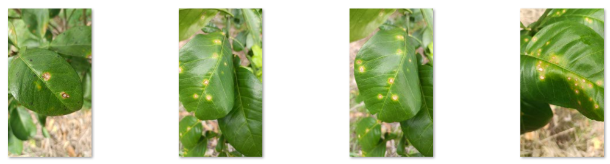

**Figure 2** Canker or Blackspot Diseases dataset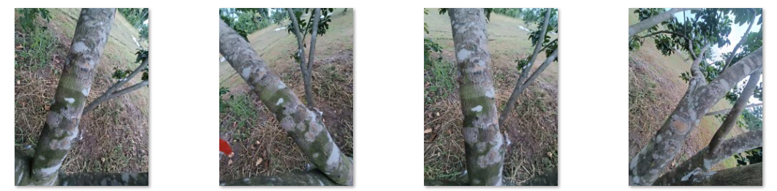

**Figure 3** Fungal Diseases dataset

**Model Development and Design to Identify Diseases Using CNN**

The second objective of the study focused on developing a reliable image classification model capable of identifying Canker or Blackspot and Fungal diseases in pomelo leaves. Rather than building a model from scratch—which demands extensive data and computational resources—the study leveraged MobileNetV2, a lightweight and efficient convolutional neural network pretrained on the ImageNet dataset. MobileNetV2 was chosen for its speed, accuracy, and suitability for deployment in mobile applications, making it ideal for real-time field use by farmers and agricultural workers.

**Model Architecture and Workflow**

The development process of the classification framework was structured into key stages:

**Preprocessing of Images**

All images were resized to 224x224 pixels to align with MobileNetV2’s input size. Beyond conventional resizing and normalization, the study incorporated a custom preprocessing pipeline that simulated segmentation effects to emphasize disease-affected regions while removing background noise.

The pipeline included steps such as:

* **Aspect ratio-preserving resizing:** the input image is resized while maintaining its aspect ratio, then padded with black borders to fit the 224x224 resolution. This ensures that the leaf structure is preserved without distortion.
* **Conversion to LAB color space:** the image is converted to the LAB color space, where **L** represents lightness and **A/B** represent color dimensions. This space is beneficial for highlighting subtle contrasts in plant lesions that are not always evident in RGB.
* **L Channel Extraction**: The lightness channel (L) is extracted from the LAB image. This isolates brightness-related features and plays a crucial role in identifying faded, discolored, or dark disease patches.
* **Combined Mask Creation**: Using adaptive thresholding (Otsu and Triangle methods), binary masks are created to highlight the leaf and potential disease areas. These masks are combined to generate a **composite binary mask** that includes both the leaf and visible disease spots.
* **Final Mask (Contour Selection)**: Morphological operations are applied to clean up the mask, and the **largest contour** representing the isolated area. This step removes small noisy regions and focuses attention on the main infected leaf.
* **Masked LAB Image**: The final mask is applied to the LAB image, keeping only the regions of interest (the leaf and its lesions) and removing the background entirely.
* **Final Enhanced Image**: A CLAHE (Contrast Limited Adaptive Histogram Equalization) filter is applied to the L channel to enhance local contrast and highlight subtle texture differences caused by disease. The image is then converted back to RGB and normalized to prepare it for the model.

This approach enabled **region-focused learning**, enhancing the model’s ability to recognize disease-specific patterns like lesion shape and spot distribution, even under complex lighting or environmental noise. While not full semantic segmentation, this method effectively simulated segmentation by refining visual attention to the leaf and affected areas. Figure 4 visually illustrates each step of the preprocessing pipeline. From the original image, the transformation through LAB color space, masking, and contrast enhancement ultimately produces a focused image, allowing the model to better extract disease-related features during training.

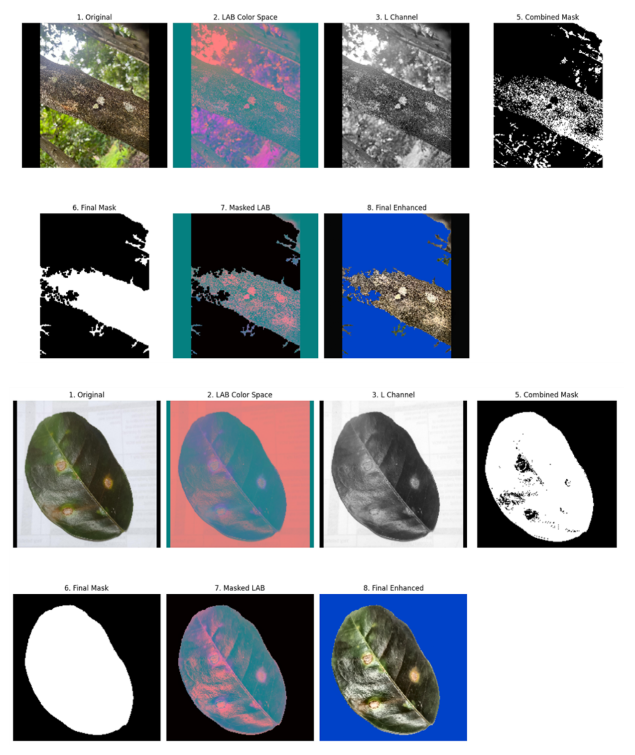

Figure 4. Image preprocessing

**Feature Extraction Phase**

Initially, the base layers of MobileNetV2 were frozen to retain the general features learned from ImageNet (e.g., shapes, textures, and contours). A custom classification head was then added, consisting of:

* A Global Average Pooling layer,
* A Dropout layer to reduce overfitting, and
* A Dense layer with Softmax activation for binary classification.

This setup allowed the model to learn pomelo-specific disease cues while maintaining the efficiency of MobileNetV2.

**Fine-Tuning Phase**

After training the classification head, the final layers of the base model were unfrozen and retrained on the pomelo dataset using a lower learning rate. This fine-tuning step allowed MobileNetV2 to adapt its higher-level filters to detect domain-specific features, such as subtle discolorations or fungal patterns unique to pomelo diseases.

**Model Performance and Findings**

The fine-tuned model achieved strong performance across both training and validation sets:

* **Training Accuracy:** 98.87%
* **Validation Accuracy:** 100.00%
* **Training Loss:** 0. 205
* **Validation Loss:** 0. 125

As shown in **Figure 4**, the training curves illustrate a steady decline in training loss and a consistent improvement in accuracy over the course of training. Although the validation loss fluctuated slightly, the validation accuracy remained high, ultimately reaching a perfect score.

This minimal gap between training and validation accuracy suggests that the model generalized well without signs of overfitting. The consistently strong performance across epochs confirms the stability and reliability of the training process.

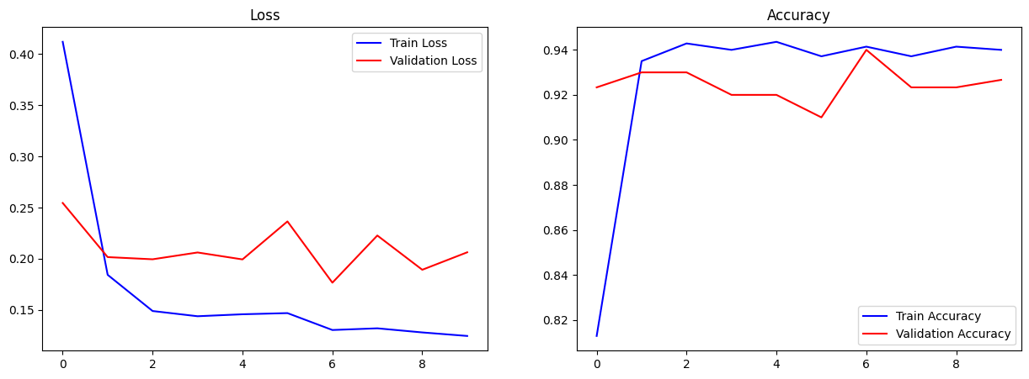

**Figure 4**: Training and validation accuracy and loss

**Mobile Application Usability**

The third objective was to develop the mobile application for capturing images and displaying disease results. The application was designed with a user-friendly interface, allowing farmers to easily use their mobile phones to capture images of their pomelos and receive immediate feedback. The application correctly identified the diseases and displayed the results with their associated confidence levels. The success of this objective demonstrated the practical application of the CNN framework in an easily accessible format for farmers.

The figure 5 shows the app features interface designed to assist farmers in diagnosing plant health issues. Upon analyzing an image of a pomelo plant, the app displays the detected disease along with relevant details. Each result is presented with a high-quality image of the affected area to help users visually confirm the disease. Additional sections labeled "About the Disease" and "Management Tips" provide detailed descriptions of the disease, its causes, and recommended management practices.

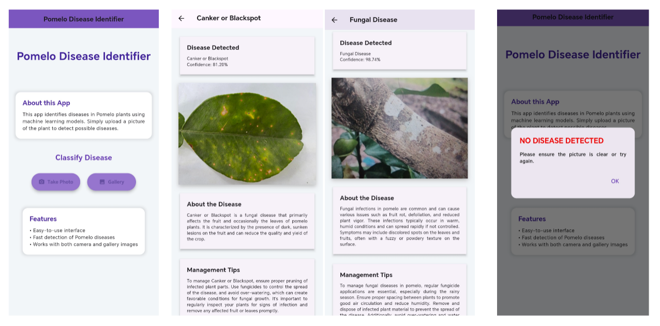

**Figure 5**: Develop mobile application

**Evaluation of Accuracy and Future Implications**

The final objective was to evaluate the accuracy of the framework using a separate validation dataset. The final validation accuracy achieved was 100.00%, demonstrating outstanding model performance. This result confirms that the framework can accurately identify pomelo diseases, effectively generalizing to new, unseen data.

To further support this evaluation, a confusion matrix was generated (see Figure 6), and the results were

* **Blackspot or Canker Diseases**: 200 true positives, 0 false negatives.
* **Fungal Diseases**: 200 true positives, 0 false positives.

**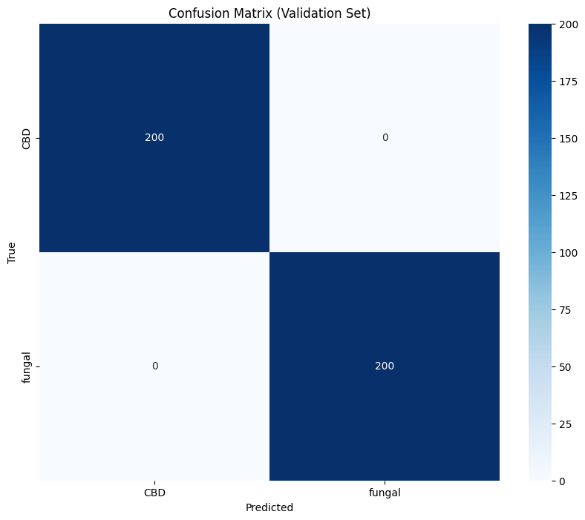 Figure 6**: Confusion matrix

The confusion matrix in Figure 6 shows that the model perfectlyclassified all samples from both disease classes, with no misclassifications. This indicates exceptional precision and recall for both Blackspot or Canker Diseases and fungal diseases. The overall performance reflects a highly reliable model that is suitable for deployment in real-world scenarios involving pomelo disease detection.

Moving forward, while current results are optimal on the validation set, future work may include testing the model on a broader, more diverse dataset or in-field conditions to ensure its robustness and adaptability under different environments.

.

**Insights and Implications**

The results highlight several key insights:

* The preprocessingplayed a significant role in helping the model focus on relevant features by mimicking segmentation, improving disease visibility while reducing background noise.
* Fine-tuning the pretrained MobileNetV2 enhanced the model's ability to detect subtle visual variations between disease types.
* The high validation accuracy shows the model’s capability to generalize to real-world leaf images that differ from the training set.
* Most importantly, MobileNetV2’s lightweight nature ensures that this solution can be integrated into **mobile apps**, enabling **offline, on-the-spot disease detection** without requiring internet connectivity or cloud resources.

**SUMMARY, CONCLUSION AND RECOMMENDATION**

**Summary**

This study focused on the development of a mobile application for identifying diseases in pomelo plants, specifically Canker (Blackspot) and Fungal Diseases. Utilizing image processing and convolutional neural network techniques, the application was trained on a dataset of 2,000 images and achieved high accuracy during testing. The app provides farmers with a simple yet powerful tool for identifying plant diseases, understanding their effects, and implementing proper management techniques. Its user-friendly interface ensures accessibility, while the disease detection results and management tips aim to reduce crop losses and improve farming productivity.

The developed system successfully met the study's objectives, including efficient image-based disease detection, providing actionable insights for disease management, and developing a functional mobile application to aid farmers in their daily agricultural practices.

**Conclusion**

The development of the mobile application for identifying pomelo diseases marks a significant step forward in supporting farmers with timely and accurate disease detection. By employing advanced image processing techniques and leveraging convolutional neural networks, the application successfully classifies pomelo diseases, specifically Canker (Blackspot) and Fungal Diseases, with high accuracy during testing. The application not only provides disease identification but also equips farmers with relevant information about the disease and practical management tips to address it effectively. The inclusion of user-friendly features and clear disease descriptions ensures the app’s usability and accessibility, even for non-technical users. This tool has the potential to reduce crop losses and enhance the productivity of pomelo farming.

Overall, the objectives of this study were met, demonstrating the feasibility of integrating modern machine learning techniques with practical agricultural needs to create an impactful solution.

**Recommendations**

To further enhance the model's utility and impact, several recommendations are proposed:

* Include additional pomelo diseases in future versions of the app to cover a wider range of potential issues.
* Consider adding features that utilize environmental data for predicting disease outbreaks, providing farmers with proactive solutions.

**LITERATURE CITED**

Agustina, D., Triasih, U., Dwiastuti, M. E., & Wicaksono, R. C. (2019). Potential of Antagonistic Fungi in Inhibiting the Growth of Botryodiplodia theobromae Fungi Causes Stem Rot Disease in Citrus. *Jurnal Agronida*, *5*(1). <https://doi.org/10.30997/jag.v5i1.1852>

Ajra, H., Nahar, M. K., Sarkar, L., & Islam, M. S. (2020). Disease Detection of Plant Leaf using Image Processing and CNN with Preventive Measures. *Emerging Technology in Computing, Communication and Electronics (ETCCE).* <https://doi.org/10.1109/etcce51779.2020.9350890>

Albawi, S., Mohammed, T. A., & Al-Zawi, S. (2017). Understanding of a convolutional neural network. *International Conference on Engineering and Technology (ICET),*. <https://doi.org/10.1109/icengtechnol.2017.8308186>

Ani, P. N., & Abel, H. C. (2018). Nutrient, phytochemical, and antinutrient composition of Citrus maxima fruit juice and peel extract. *Food Science and Nutrition*, *6*(3), 653–658. <https://doi.org/10.1002/fsn3.604>

Deepalakshmi, P., Krishna, T. P., Chandana, S., Lavanya, K., & Srinivasu, P. N. (2021). Plant leaf disease detection using CNN algorithm. *International Journal of Information System Modeling and Design (Print)*, *12*(1), 1–21. <https://doi.org/10.4018/ijismd.2021010101>

Donahue, J., Jia, Y., Vinyals, O., Hoffman, J., Zhang, N., Tzeng, E., & Darrell, T. (2014). DeCAF: A Deep Convolutional Activation Feature for Generic Visual Recognition. *Proceedings of the 31st International Conference on Machine Learning*, 647–655. <http://jmlr.org/proceedings/papers/v32/donahue14.pdf>

Dummel, D. M., Agostini, J. P., & Moschini, R. C. (2015). PREDICTIVE MODEL FOR ASCOSPORE RELEASE OF GUIGNARDIA CITRICARPA USING CLIMATOLOGICAL DATA. *Acta Horticulturae*, *1065*, 953–963. <https://doi.org/10.17660/actahortic.2015.1065.119>

Erti, D. M., & Sugiyatno, A. (2018). THE POTENCIAL OF INTERSTOCK USE TO REDUCE DIPLODIA DISEASE (BOTRYODIPLODIA THEOBROMAE PATH.) ON CITRUS PLANT. *Russian Journal of Agricultural and Socio-economic Sciences*, *78*(6), 476–487. https://doi.org/10.18551/rjoas.2018-06.56

Esparham, N., Mohammadi, H., & Gramaje, D. (2020). A Survey of Trunk Disease Pathogens within Citrus Trees in Iran. *Plants*, *9*(6), 754. <https://doi.org/10.3390/plants9060754>

*First report of phyllosticta citricarpa in Tunisia*. (2019, July). EPPO Global Database. <https://gd.eppo.int/reporting/article-6571>

Frare, G. F., Da Silva, G. J., Lanza, F., Bassanezi, R. B., Ramires, T. G., & Amorim, L. (2019). Sweet orange fruit age and inoculum concentration affect the expression of citrus black spot symptoms. *Plant Disease*, *103*(5), 913–921. <https://doi.org/10.1094/pdis-03-18-0492-re>

Geetharamani, G., & Pandian, J. A. (2019). Identification of plant leaf diseases using a nine-layer deep convolutional neural network. *Computers & Electrical Engineering*, *76*, 323–338. <https://doi.org/10.1016/j.compeleceng.2019.04.011>

Guarnaccia, V., Gehrmann, T., Da Silva, G. J., Fourie, P., Haridas, S., Vu, D., Spatafora, J. W., Martin, F., Robert, V., Grigoriev, I. V., Groenewald, J. Z., & Crous, P. W. (2019). Phyllosticta citricarpa and sister species of global importance to Citrus. *Molecular Plant Pathology*, *20*(12), 1619–1635. <https://doi.org/10.1111/mpp.12861>

Indolia, S., Goswami, A. K., Mishra, S., & Asopa, P. (2018). Conceptual understanding of Convolutional Neural Network- a deep learning approach. *Procedia Computer Science*, *132*, 679–688. <https://doi.org/10.1016/j.procs.2018.05.069>

Jin, J., Fu, K., & Zhang, C. (2014). Traffic sign recognition with hinge loss trained convolutional neural networks. *IEEE Transactions on Intelligent Transportation Systems*, *15*(5), 1991–2000. <https://doi.org/10.1109/tits.2014.2308281>

Ketkar, N., & Moolayil, J. (2021). Convolutional neural networks. In *Apress eBooks* (pp. 197–242). <https://doi.org/10.1007/978-1-4842-5364-9_6>

Khanchouch, K., Pane, A., Chriki, A., & OlgaCacciola, S. (2017). Major and emerging fungal diseases of citrus in the Mediterranean region. In *InTech eBooks*. <https://doi.org/10.5772/66943>

Lima, E., Sun, X., Dong, J., Wang, H., Yang, Y., & Liu, L. (2017). Learning and transferring convolutional neural network knowledge to ocean front recognition. *IEEE Geoscience and Remote Sensing Letters*, *14*(3), 354–358. https://doi.org/10.1109/lgrs.2016.2643000

Luo, X., Shen, R., Hu, J., Deng, J., Hu, L., & Guan, Q. (2017). A deep convolution neural network model for vehicle recognition and face recognition. *Procedia Computer Science*, *107*, 715–720. <https://doi.org/10.1016/j.procs.2017.03.153>

Maggiori, E., Tarabalka, Y., Charpiat, G., & Alliez, P. (2017). Convolutional neural networks for Large-Scale Remote-Sensing Image Classification. *IEEE Transactions on Geoscience and Remote Sensing*, *55*(2), 645–657. <https://doi.org/10.1109/tgrs.2016.2612821>

Methacanon, P., Krongsin, J., & Gamonpilas, C. (2014). Pomelo (Citrus maxima) pectin: Effects of extraction parameters and its properties. *Food Hydrocolloids*, *35*, 383–391. <https://doi.org/10.1016/j.foodhyd.2013.06.018>

Moeskops, P., Viergever, M. A., Mendrik, A. M., De Vries, L. S., Benders, M. J. N. L., & Išgum, I. (2016). Automatic segmentation of MR brain images with a convolutional neural network. *IEEE Transactions on Medical Imaging (Print)*, *35*(5), 1252–1261. <https://doi.org/10.1109/tmi.2016.2548501>

Nwosu, L., Wang, H., Lu, J., Unwala, I., Yang, X., & Zhang, T. (2017). Deep Convolutional Neural Network for Facial Expression Recognition Using Facial Parts. *2017 IEEE 15th Intl Conf on Dependable, Autonomic and Secure Computing, 15th Intl Conf on Pervasive Intelligence and Computing, 3rd Intl Conf on Big Data Intelligence and Computing and Cyber Science and Technology Congress(DASC/PiCom/DataCom/CyberSciTech)*. <https://doi.org/10.1109/dasc-picom-datacom-cyberscitec.2017.213>

Ogunsola, J. F., Ikotun, B., & Ogunsola, K. E. (2020). Incidence of leaf blight disease of Egusi melon in South-west Nigeria. *African Crop Science Journal*, *28*(2), 255–265. <https://doi.org/10.4314/acsj.v28i2.10>

Pandian, J. A., Kumar, D., Geman, O., Hnatiuc, M., Arif, M., & Kanchanadevi, K. (2022). Plant disease detection using deep convolutional neural network. *Applied Sciences (Basel)*, *12*(14), 6982. <https://doi.org/10.3390/app12146982>

Phan, H., Hertel, L., Maaß, M., Koch, P., Mazur, R., & Mertins, A. (2017). Improved audio scene classification based on Label-Tree embeddings and convolutional neural networks. *IEEE/ACM Transactions on Audio, Speech, and Language Processing (Print)*, *25*(6), 1278–1290. <https://doi.org/10.1109/taslp.2017.2690564>

Pratt, H., Coenen, F., Broadbent, D., Harding, S., & Zheng, Y. (2016). Convolutional neural networks for diabetic retinopathy. *Procedia Computer Science*, *90*, 200–205. <https://doi.org/10.1016/j.procs.2016.07.014>

Radha, N., & Swathika, R. (2021). A Polyhouse: Plant Monitoring and Diseases Detection using CNN. *2021 International Conference on Artificial Intelligence and Smart Systems (ICAIS)*. <https://doi.org/10.1109/icais50930.2021.9395847>

Sapkota, B., Devkota, H. P., & Poudel, P. (2022). Citrus maxima (Brum.) Merr. (Rutaceae): Bioactive Chemical Constituents and Pharmacological Activities. *Evidence-based Complementary and Alternative Medicine (Print)*, *2022*, 1–16. <https://doi.org/10.1155/2022/8741669>

Shrestha, G., Deepsikha, Das, M., & Dey, N. (2020). Plant Disease Detection Using CNN. *2020 IEEE Applied Signal Processing Conference (ASPCON)*. https://doi.org/10.1109/aspcon49795.2020.9276722

Soltaninejad, N., Mohammadi, H., & Massumi, H. (2017). Isolation, Identification and Pathogenicity of Botryosphaeriaceae and Phaeoacremonium Species Associated with Decline of Prunus Species in Iran. *Journal of Plant Pathology*, *99*(3), 571–581. <http://www.jstor.org/stable/44687126>

Tran, N. T., Miles, A. K., Dietzgen, R. G., & Drenth, A. (2019). Phyllosticta capitalensis and P. paracapitalensis are endophytic fungi that show potential to inhibit pathogenic P. citricarpa on citrus. *Australasian Plant Pathology*, *48*(3), 281–296. <https://doi.org/10.1007/s13313-019-00628-0>

Vijaylakshmi, P., & Radha, R. (2015). An overview: Citrus maxima. *The Journal of Phytopharmacology*, *4*(5), 263–267. <https://doi.org/10.31254/phyto.2015.4505>

Wu, G. A., Terol, J., Ibáñez, V., López‐García, A., Pérez-Román, E., Borredá, C., Domingo, C., Tadeo, F. R., Carbonell-Caballero, J., Alonso, R., Curk, F., Du, D., Ollitrault, P., Roose, M. L., Dopazo, J., Gmitter, F. G., Rokhsar, D. S., & Talón, M. (2018). Genomics of the origin and evolution of Citrus. *Nature (London)*, *554*(7692), 311–316. <https://doi.org/10.1038/nature25447>

Xu, W., Wang, Z., You, X., & Zhang, C. (2017). Efficient fast convolution architectures for convolutional neural network. *2017 IEEE 12th*

*International Conference on ASIC (ASICON)*. <https://doi.org/10.1109/asicon.2017.8252623>

# APPENDICES

Appendix A. Application for Research Adviser

Application for Research Adviser

|  |
| --- |
| Description: C:\Users\Jane\AppData\Local\Packages\microsoft.windowscommunicationsapps_8wekyb3d8bbwe\LocalState\Files\686\224\USM logo [568108].jpg  **UNIVERSITY OF SOUTHERN MINDANAO**  **Kabacan, Cotabato**  **Philippines** |
| **APPLICATION FOR RESEARCH ADVISER** |

**October 17, 2023**

**JANICE T. PALMAERA**

Department of Computing and Library Information Science

College of Engineering and Information Technology

USM, Kabacan, Cotabato

Ma’am:

I would like to request that you will be my Research adviser effective 1st semester, SY 2023-2024. I intend to work on **POMELO (CITRUS MAXIMA) DISEASE IDENTIFIER USING MOBILE IDENTIFIER.**

I am hoping for your most favorable approval on this request. Thank you very much.

Very truly yours,

**GIAN KAYLE M. FEROLINO**

Printed Name and Signature of Student

|  |
| --- |
| **APPROVED** |
| **JANICE T. PALMAERA**  Adviser  **\_October 19, 2023\_**  Date |

USM-EDR-F01-Rev.4.2022.10.18

|  |
| --- |
| Description: C:\Users\Jane\AppData\Local\Packages\microsoft.windowscommunicationsapps_8wekyb3d8bbwe\LocalState\Files\686\224\USM logo [568108].jpg  Appendix B. Application for Research Title  Appendix B. Application for Research Title  **UNIVERSITY OF SOUTHERN MINDANAO**  Kabacan, Cotabato  Philippines |
| **APPLICATION FOR RESEARCH TITLE** |

Date: **November 15, 2023**

**DANILYN A. FLORES**

Chairperson, Department of Computing and Library Information Science

MADAM:

I would like to request your office to allow me to research on the study entitled “**POMELO (CITRUS MAXIMA) DISEASE IDENTIFIER USING MOBILE APPLICATION.”**

The study has the following objectives:

1. Gather a dataset of images containing to add your disease.
2. Develop a framework and design the model to identify diseases at an early stage using Convolutional Neural Network algorithm.
3. Develop a mobile application
4. Evaluate the results of the accuracy.

Very truly yours,

**GIAN KAYLE M. FEROLINO**

Printed Name and Signature of Student

|  |  |
| --- | --- |
| **NOTED** | |
| **JANICE T. PALMAERA**  Adviser | \_\_\_\_\_\_\_\_\_\_\_\_\_\_\_\_  Date |
| **NOR-AINE M. CORPUZ**  Department Research Coordinator | \_\_\_\_\_\_\_\_\_\_\_\_\_\_\_\_  Date |
| **NOR-AINE M. CORPUZ**  College Research Coordinator | \_\_\_\_\_\_\_\_\_\_\_\_\_\_\_\_  Date |
| **APPROVED** | |
| **DANILYN A. FLORES**  Department Chairperson | \_\_\_\_\_\_\_\_\_\_\_\_\_\_\_\_  Date |

USM-EDR-F02-Rev.4.2021.11.04

|  |
| --- |
| Description: C:\Users\Jane\AppData\Local\Packages\microsoft.windowscommunicationsapps_8wekyb3d8bbwe\LocalState\Files\686\224\USM logo [568108].jpg  **UNIVERSITY OF SOUTHERN MINDANAO**  Kabacan, Cotabato  Philippines |
| **ESTIMATED BUDGET OF THE RESEARCH** |

Appendix C. Estimated Budget of the Research

Appendix C. Estimated Budget of the Research

**Title of Study:**

**POMELO (*CITRUS MAXIMA*) DISEASE IDENTIFIER USING MOBILE APPLICATION.**

ITEMS/DESCRIPTION ESTIMATED COST



Computing and Printing 350.00

Internet 1000.00

Travel and Other Expenses 1000.00



Honorarium 775.00

Grand Total 3125.00

Prepared and submitted by:

**GIAN KAYLE M. FEROLINO**

Printed Name and Signature of the Student

|  |  |
| --- | --- |
| **NOTED** | |
| **JANICE T. PALMAERA**  Adviser | \_\_\_\_\_\_\_\_\_\_\_\_\_\_\_\_\_\_\_\_\_\_\_\_\_\_\_  Date |
| **NOR-AINE M. CORPUZ**  Department Research Coordinator | \_\_\_\_\_\_\_\_\_\_\_\_\_\_\_\_\_\_\_\_\_\_\_\_\_\_\_  Date |
| **DANILYN A. FLORES**  Department Chairperson | \_\_\_\_\_\_\_\_\_\_\_\_\_\_\_\_\_\_\_\_\_\_\_\_\_\_\_  Date |

USM-EDR-F06-Rev.3.2020.02.24

|  |
| --- |
| Description: C:\Users\Jane\AppData\Local\Packages\microsoft.windowscommunicationsapps_8wekyb3d8bbwe\LocalState\Files\686\224\USM logo [568108].jpg  **UNIVERSITY OF SOUTHERN MINDANAO**  Kabacan, Cotabato  Philippines |
| **APPLICATION FOR THESIS OUTLINE DEFENSE** |

Appendix D. Application for Thesis Outline Defense

|  |  |
| --- | --- |
| Name | **GIAN KAYLE M. FEROLINO** |
| Degree/Major | **BACHELOR OF SCIENCE IN COMPUTER SCIENCE** |
| Thesis Title | **POMELO (CITRUS MAXIMA) DISEASE IDENTIFIER USING MOBILE**  **APPLICATION** |
| Date of Examination | January 22, 2024 |
| Time | 4:00 |
| Place | ICT BUILDING |

**MEMBERS OF THE EXAMINING COMMITTEE**

Name Signature Date

**NELSON BALNEG** \_\_\_\_\_\_\_\_\_\_\_\_\_\_ \_\_\_\_\_\_\_\_\_\_\_\_

**RYAN GONZAGA** \_\_\_\_\_\_\_\_\_\_\_\_\_\_ \_\_\_\_\_\_\_\_\_\_\_\_

**CLARENCE DAVE GALAS** \_\_\_\_\_\_\_\_\_\_\_\_\_\_ \_\_\_\_\_\_\_\_\_\_\_\_

**RECOMMENDING APPROVAL:**

**JANICE T. PALMAERA \_\_\_\_\_\_\_\_\_\_\_\_\_\_\_\_\_\_\_\_\_\_\_\_\_\_**

Adviser Co-Adviser (Optional)

**APPROVED:**

\_\_\_\_\_\_\_\_\_\_\_\_\_\_\_\_\_\_\_\_\_\_\_\_\_\_\_\_\_\_\_ **NOR-AINE M. CORPUZ**

College Statistician Department Research Coordinator

(Optional)

**DANILYN A. FLORES**

Department Chairperson

**REPORT ON THE RESULT OF EXAMINATION**

Name Signature Remarks

**NELSON BALNEG** \_\_\_\_\_\_\_\_\_\_\_\_\_\_\_\_\_\_ \_\_\_\_\_\_\_\_\_\_\_\_\_\_\_\_\_\_

**RYAN GONZAGA**  \_\_\_\_\_\_\_\_\_\_\_\_\_\_\_\_\_\_ \_\_\_\_\_\_\_\_\_\_\_\_\_\_\_\_\_\_

**CLARENCE DAVE GALAS \_\_\_\_\_\_\_\_\_\_\_\_\_\_\_\_\_\_ \_\_\_\_\_\_\_\_\_\_\_\_\_\_\_\_\_\_**

**­­­­­­­**

**APPROVED:**

**NOR-AINE M. CORPUZ**

Department Research Coordinator

\_\_\_\_\_\_\_\_\_\_\_\_\_\_\_\_\_\_\_\_\_

Date

USM-EDR-F07-Rev.3.2020.02.24

USM-EDR-F07-Rev.3.2020.02.24

USM-EDR-F07-Rev.3.2020.02.24

USM-EDR-F08-Rev.3.2020.02.24

|  |
| --- |
| **D:\THESIS\ceit.pngDescription: C:\Users\Jane\AppData\Local\Packages\microsoft.windowscommunicationsapps_8wekyb3d8bbwe\LocalState\Files\686\224\USM logo [568108].jpg**  **UNIVERSITY OF SOUTHERN MINDANAO**  **Kabacan, Cotabato**  **Philippines** |
| **CERTIFICATION OF ENGLISH CRITIC** |

Appendix E. Certification of English Critic

Appendix D. Application for Thesis Outline Defense

This is to certify that the study outline entitled **POMELO (CITRUS MAXIMA) DISEASE IDENTIFIER USING MOBILE APPLICATION.**

Conducted by: **GIAN KAYLE M. FEROLINO**

Was edited by the undersigned

\_\_\_\_\_\_\_\_\_\_\_\_\_\_\_\_\_\_\_\_\_\_\_\_\_\_\_\_\_\_ \_\_\_\_\_\_\_\_\_\_\_\_\_\_\_\_\_\_\_

Signature over Printed Name Date

I confirm that this study has been checked by the English Critic

\_\_\_\_\_\_\_\_\_\_\_\_\_\_\_\_\_\_\_\_\_\_\_\_\_\_\_\_\_\_\_\_\_ \_\_\_\_\_\_\_\_\_\_\_\_\_\_\_\_\_\_\_

Adviser’s Signature over Printed Name Date

|  |
| --- |
| Description: C:\Users\Jane\AppData\Local\Packages\microsoft.windowscommunicationsapps_8wekyb3d8bbwe\LocalState\Files\686\224\USM logo [568108].jpg  **UNIVERSITY OF SOUTHERN MINDANAO**  Kabacan, Cotabato  Philippines |
| **CURRICULUM VITAE** |



**GIAN KAYLE M. FEROLINO**

Poblacion, Pikit, North Cotabato

+639122741097

kaylemaurin@gmail.com

|  |  |
| --- | --- |
| **PERSONAL INFORMATION** |  |
| Last Name | **FEROLINO** |
| First Name | **GIAN KAYLE** |
| Middle Name | **MAURIN** |
| Nickname | **KAYLE** |
| Age | **22 YEARS OLD** |
| Nationality | **FILIPINO** |
| Religion | **ROMAN CATHOLIC** |
| Civil Status | **SINGLE** |
| Father’s Name | **DANTE T. FEROLINO** |
| Mother’s Name | **HAYDEE M. FEROLINO** |
| **Educational Background** |  |
| Elementary | **PIKIT CENTRAL ELEMENTARY SCHOOL S. Y. 2008 - 2014** |
| Junior High School | **NOTRE DAME OF PIKIT INC,**  **S. Y. 2014 - 2018** |
| Senior High School | **ST. MARY’S ACADEMY OF MIDSAYAP S. Y. 2018 - 2020** |
| Tertiary | **UNIVERSITY OF SOUTHERN MINDANAO (PRESENT)** |