Макет №1:

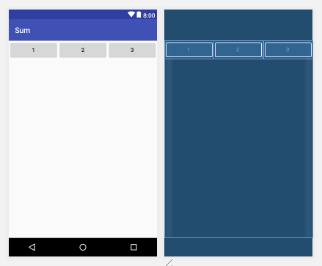

*<?***xml version="1.0" encoding="utf-8"***?>*<**LinearLayout xmlns:android="http://schemas.android.com/apk/res/android"  
 xmlns:app="http://schemas.android.com/apk/res-auto"  
 xmlns:tools="http://schemas.android.com/tools"  
 android:layout_width="match_parent"  
 android:layout_height="match_parent"  
 tools:context="ru.kuzmiankou.sum.Linear"  
 android:orientation="horizontal"**>  
  
 <**Button  
 android:layout_weight="1"  
 android:layout_width="match_parent"  
 android:layout_height="wrap_content"  
 android:text="1"**/>  
 <**Button  
 android:layout_weight="1"  
 android:layout_width="match_parent"  
 android:layout_height="wrap_content"  
 android:text="2"**/>  
 <**Button  
 android:layout_weight="1"  
 android:layout_width="match_parent"  
 android:layout_height="wrap_content"  
 android:text="3"**/>  
  
</**LinearLayout**>

Макет №2:

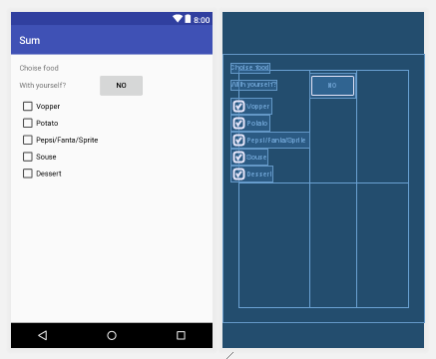

*<?***xml version="1.0" encoding="utf-8"***?>*<**GridLayout xmlns:android="http://schemas.android.com/apk/res/android"  
 xmlns:app="http://schemas.android.com/apk/res-auto"  
 xmlns:tools="http://schemas.android.com/tools"  
 android:layout_width="match_parent"  
 android:layout_height="match_parent"  
 tools:context="ru.kuzmiankou.sum.Grid"  
 android:columnCount="2"  
 android:orientation="horizontal"  
 android:padding="16dp"  
 android:layout_gravity="top"**>  
  
 <**TextView  
 android:layout_column="0"  
 android:layout_width="wrap_content"  
 android:layout_height="wrap_content"  
 android:text="Choise food"**/>  
  
 <**TextView  
 android:layout_column="0"  
 android:layout_width="wrap_content"  
 android:layout_height="wrap_content"  
 android:text="With yourself?"**/>  
  
 <**Button  
 android:layout_column="1"  
 android:layout_width="wrap_content"  
 android:layout_height="wrap_content"  
 android:text="No"**/>  
  
 <**CheckBox  
 android:layout_column="0"  
 android:layout_width="wrap_content"  
 android:layout_height="wrap_content"  
 android:text="Vopper"**/>  
  
 <**CheckBox  
 android:layout_column="0"  
 android:layout_width="wrap_content"  
 android:layout_height="wrap_content"  
 android:text="Potato"**/>  
  
 <**CheckBox  
 android:layout_column="0"  
 android:layout_width="wrap_content"  
 android:layout_height="wrap_content"  
 android:text="Pepsi/Fanta/Sprite"**/>  
  
 <**CheckBox  
 android:layout_column="0"  
 android:layout_width="wrap_content"  
 android:layout_height="wrap_content"  
 android:text="Souse"**/>  
  
 <**CheckBox  
 android:layout_column="0"  
 android:layout_width="wrap_content"  
 android:layout_height="wrap_content"  
 android:text="Dessert"**/>  
  
</**GridLayout**>

Макет №3:

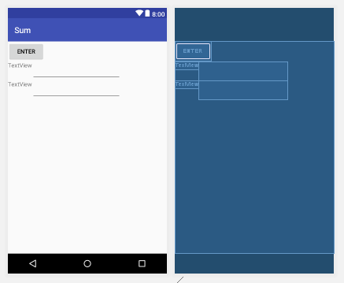

*<?***xml version="1.0" encoding="utf-8"***?>*<**RelativeLayout xmlns:android="http://schemas.android.com/apk/res/android"  
 xmlns:app="http://schemas.android.com/apk/res-auto"  
 xmlns:tools="http://schemas.android.com/tools"  
 android:layout_width="match_parent"  
 android:layout_height="match_parent"  
 tools:context="ru.kuzmiankou.sum.Relative"**>  
  
 <**Button  
 android:id="@+id/button"  
 android:layout_width="wrap_content"  
 android:layout_height="wrap_content"  
 android:layout_alignParentStart="true"  
 android:layout_alignParentTop="true"  
 android:text="Enter"** />  
  
 <**TextView  
 android:id="@+id/textView"  
 android:layout_width="wrap_content"  
 android:layout_height="wrap_content"  
 android:layout_alignParentStart="true"  
 android:layout_below="@+id/button"  
 android:text="TextView"** />  
  
 <**TextView  
 android:id="@+id/textView2"  
 android:layout_width="wrap_content"  
 android:layout_height="wrap_content"  
 android:layout_alignParentStart="true"  
 android:layout_below="@+id/editText"  
 android:text="TextView"** />  
  
 <**EditText  
 android:id="@+id/editText"  
 android:layout_width="wrap_content"  
 android:layout_height="wrap_content"  
 android:layout_below="@+id/button"  
 android:layout_toEndOf="@+id/textView"  
 android:ems="10"** />  
  
 <**EditText  
 android:id="@+id/editText2"  
 android:layout_width="wrap_content"  
 android:layout_height="wrap_content"  
 android:layout_alignStart="@+id/editText"  
 android:layout_below="@+id/editText"  
 android:ems="10"** />  
</**RelativeLayout**>

Макет №4:

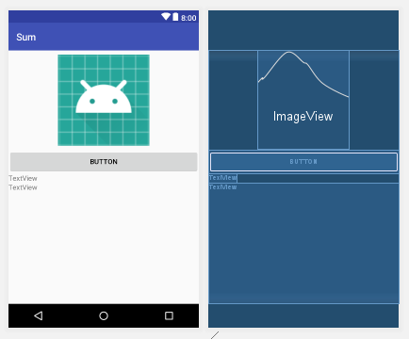

*<?***xml version="1.0" encoding="utf-8"***?>*<**LinearLayout xmlns:android="http://schemas.android.com/apk/res/android"  
 xmlns:app="http://schemas.android.com/apk/res-auto"  
 xmlns:tools="http://schemas.android.com/tools"  
 android:layout_width="match_parent"  
 android:layout_height="match_parent"  
 tools:context="ru.kuzmiankou.sum.Linear2"  
 android:orientation="vertical"**>  
  
 <**ImageView  
 android:id="@+id/imageView"  
 android:layout_width="match_parent"  
 android:layout_height="200dp"  
 app:srcCompat="@mipmap/ic_launcher"  
 android:layout_marginLeft="100dp"  
 android:layout_marginRight="100dp"**/>  
  
 <**Button  
 android:id="@+id/button2"  
 android:layout_width="match_parent"  
 android:layout_height="wrap_content"  
 android:text="Button"** />  
  
 <**TextView  
 android:layout_width="wrap_content"  
 android:layout_height="wrap_content"  
 android:text="TextView"** />  
  
 <**TextView  
 android:id="@+id/textView3"  
 android:layout_width="match_parent"  
 android:layout_height="match_parent"  
 android:text="TextView"** />  
</**LinearLayout**>

Макет №5:

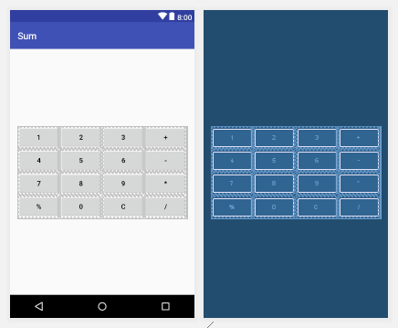

*<?***xml version="1.0" encoding="utf-8"***?>*<**GridLayout xmlns:android="http://schemas.android.com/apk/res/android"  
 xmlns:app="http://schemas.android.com/apk/res-auto"  
 xmlns:tools="http://schemas.android.com/tools"  
 android:layout_width="wrap_content"  
 android:layout_height="wrap_content"  
 tools:context="ru.kuzmiankou.sum.Grid2"  
 android:layout_gravity="center"  
 android:columnCount="4"  
 android:orientation="horizontal"**>  
 <**Button android:text="1"** />  
 <**Button android:text="2"** />  
 <**Button android:text="3"** />  
 <**Button android:text="+"** />  
 <**Button android:text="4"** />  
 <**Button android:text="5"** />  
 <**Button android:text="6"** />  
 <**Button android:text="-"** />  
 <**Button android:text="7"** />  
 <**Button android:text="8"** />  
 <**Button android:text="9"** />  
 <**Button android:text="*"** />  
 <**Button android:text="%"** />  
 <**Button android:text="0"** />  
 <**Button android:text="C"** />  
 <**Button android:text="/"** />  
</**GridLayout**>

repository: https://github.com/kuzanatoliy/itmo.mobile.sum.git