Screen:

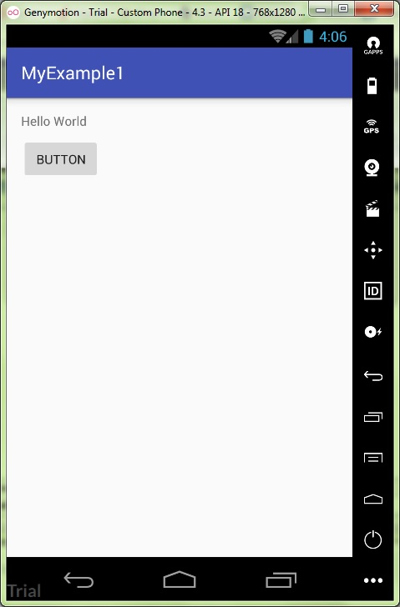

Repository:

https://github.com/kuzanatoliy/itmo.mobile.task0.git