Screens:

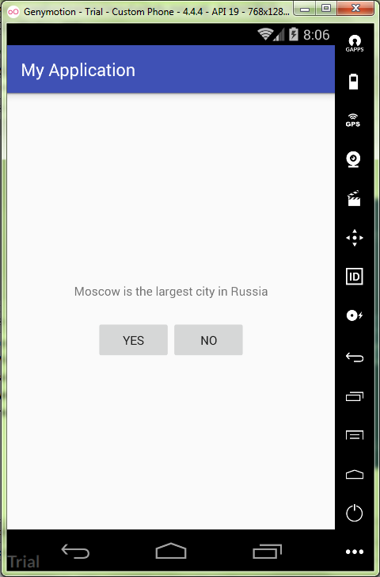

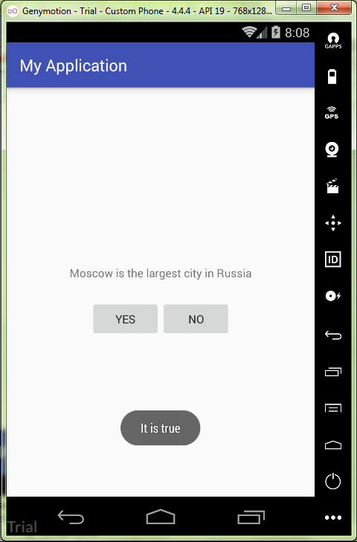

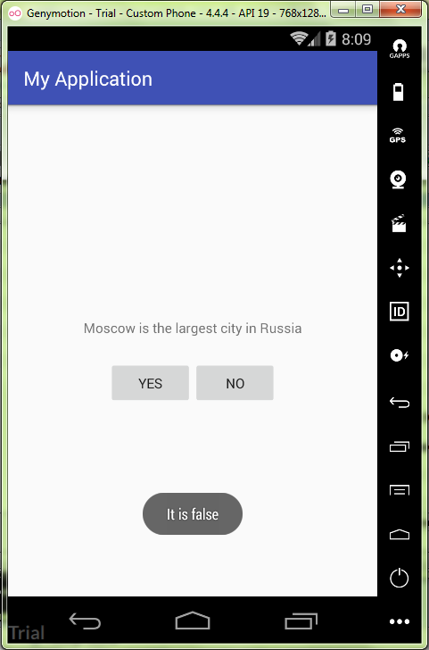

activity_main.xml:

*<?***xml version="1.0" encoding="utf-8"***?>*<**LinearLayout  
 xmlns:android="http://schemas.android.com/apk/res/android"  
 android:layout_width="match_parent"  
 android:layout_height="match_parent"  
 android:gravity="center"  
 android:orientation="vertical"** >  
  
 <**TextView  
 android:layout_width="wrap_content"  
 android:layout_height="wrap_content"  
 android:padding="24dp"  
 android:text="@string/question_go"** />  
 <**LinearLayout  
 android:layout_width="wrap_content"  
 android:layout_height="wrap_content"  
 android:orientation="horizontal"** >  
 <**Button  
 android:id="@+id/yes_button"  
 android:layout_width="wrap_content"  
 android:layout_height="wrap_content"  
 android:text="@string/yes_button"** />  
 <**Button  
 android:id="@+id/no_button"  
 android:layout_width="wrap_content"  
 android:layout_height="wrap_content"  
 android:text="@string/no_button"** />  
 </**LinearLayout**>  
</**LinearLayout**>

string.xml:

<**resources**>  
 <**string name="app_name"**>My Application</**string**>  
 <**string name="question_go"**>Moscow is the largest city in Russia</**string**>  
 <**string name="yes_button"**>Yes</**string**>  
 <**string name="no_button"**>No</**string**>  
 <**string name="action_settings"**>Settings</**string**>  
 <**string name="correct_answer"**>It is true</**string**>  
 <**string name="incorrect_answer"**>It is false</**string**>  
</**resources**>

MainActivity.java:

**package** ru.kuzmiankou.myapplication;  
  
**import** android.support.v7.app.AppCompatActivity;  
**import** android.os.Bundle;  
**import** android.view.View;  
**import** android.widget.Button;  
**import** android.widget.Toast;  
  
**public class** MainActivity **extends** AppCompatActivity {  
 **private** Button **mYesButton**;  
 **private** Button **mNoButton**;  
  
 @Override  
 **protected void** onCreate(Bundle savedInstanceState) {  
 **super**.onCreate(savedInstanceState);  
 setContentView(R.layout.***activity_main***);  
  
 **mYesButton** = (Button) findViewById(R.id.***yes_button***);  
 **mYesButton**.setOnClickListener(**new** View.OnClickListener() {  
 @Override  
 **public void** onClick(View view) {  
 Toast.*makeText*(MainActivity.**this**,  
 R.string.***correct_answer***,  
 Toast.***LENGTH_LONG***).show();  
 }  
 });  
  
 **mNoButton** = (Button) findViewById(R.id.***no_button***);  
 **mNoButton**.setOnClickListener(**new** View.OnClickListener() {  
 @Override  
 **public void** onClick(View view) {  
 Toast.*makeText*(MainActivity.**this**,  
 R.string.***incorrect_answer***,  
 Toast.***LENGTH_LONG***).show();  
 }  
 });  
 }  
};

repository: https://github.com/kuzanatoliy/itmo.mobile.task1.git