Screens:

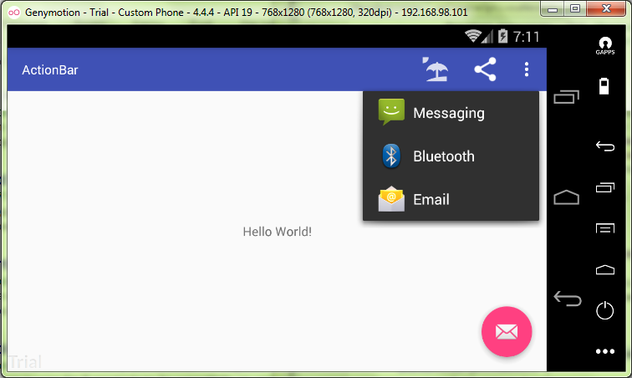

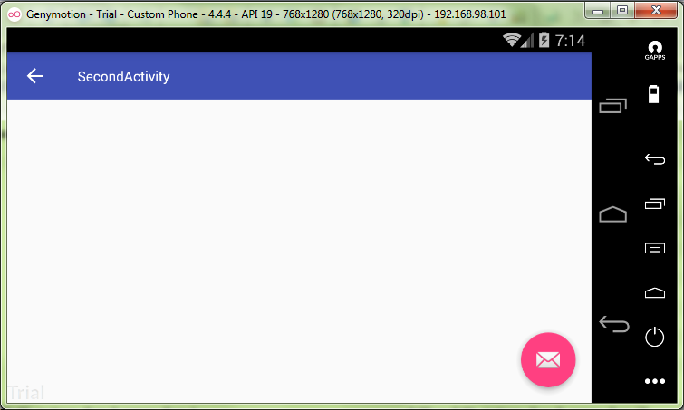

MainActivity.java:

**package** ru.kuzmiankou.actionbar;  
  
**import** android.content.Intent;  
**import** android.os.Bundle;  
**import** android.support.design.widget.FloatingActionButton;  
**import** android.support.design.widget.Snackbar;  
**import** android.support.v4.view.MenuItemCompat;  
**import** android.support.v7.app.AppCompatActivity;  
**import** android.support.v7.widget.ShareActionProvider;  
**import** android.support.v7.widget.Toolbar;  
**import** android.view.View;  
**import** android.view.Menu;  
**import** android.view.MenuItem;  
  
**public class** MainActivity **extends** AppCompatActivity {  
 **private** ShareActionProvider **mShareActionProvider**;  
  
 @Override  
 **protected void** onCreate(Bundle savedInstanceState) {  
 **super**.onCreate(savedInstanceState);  
 setContentView(R.layout.***activity_main***);  
 Toolbar toolbar = (Toolbar) findViewById(R.id.***toolbar***);  
 setSupportActionBar(toolbar);  
  
 FloatingActionButton fab = (FloatingActionButton) findViewById(R.id.***fab***);  
 fab.setOnClickListener(**new** View.OnClickListener() {  
 @Override  
 **public void** onClick(View view) {  
 Snackbar.*make*(view, **"Replace with your own action"**, Snackbar.***LENGTH_LONG***)  
 .setAction(**"Action"**, **null**).show();  
 }  
 });  
 }  
  
 @Override  
 **public boolean** onCreateOptionsMenu(Menu menu) {  
 *// Inflate the menu; this adds items to the action bar if it is present.* getMenuInflater().inflate(R.menu.***menu_main***, menu);  
 MenuItem item = menu.findItem(R.id.***action_share***);  
 **mShareActionProvider** = (ShareActionProvider) MenuItemCompat.*getActionProvider*(item);  
 setIntent(**"Send pattern of message"**);  
 **return super**.onCreateOptionsMenu(menu);  
 }  
  
 **private void** setIntent(String text) {  
 Intent intent = **new** Intent(Intent.***ACTION_SEND***);  
 intent.setType(**"text/plain"**);  
 intent.putExtra(Intent.***EXTRA_TEXT***, text);  
 **mShareActionProvider**.setShareIntent(intent);  
 }  
  
 @Override  
 **public boolean** onOptionsItemSelected(MenuItem item) {  
 **switch**(item.getItemId()) {  
 **case** R.id.***action_beach***:  
 Intent intent = **new** Intent(**this**, SecondActivity.**class**);  
 startActivity(intent);  
 **return true**;  
 **case** R.id.***action_settings***:  
 **return true**;  
 **default**:  
 **return super**.onOptionsItemSelected(item);  
 }  
 }  
}

main_menu.xml:

<**menu xmlns:android="http://schemas.android.com/apk/res/android"  
 xmlns:app="http://schemas.android.com/apk/res-auto"  
 xmlns:tools="http://schemas.android.com/tools"  
 tools:context="ru.kuzmiankou.actionbar.MainActivity"**>  
  
 <**item  
 android:id="@+id/action_settings"  
 android:orderInCategory="3"  
 android:title="@string/action_settings"  
 app:showAsAction="never"** />  
  
 <**item  
 android:id="@+id/action_beach"  
 android:title="@string/action_beach"  
 android:icon="@drawable/ic_beach"  
 android:orderInCategory="1"  
 app:showAsAction="ifRoom"** />  
  
 <**item  
 android:id="@+id/action_share"  
 android:title="@string/action_share"  
 android:orderInCategory="2"  
 app:showAsAction="ifRoom"  
 app:actionProviderClass="android.support.v7.widget.ShareActionProvider"** />  
</**menu**>

Repository: https://github.com/kuzanatoliy/itmo.mobile.task10.git