Screens:

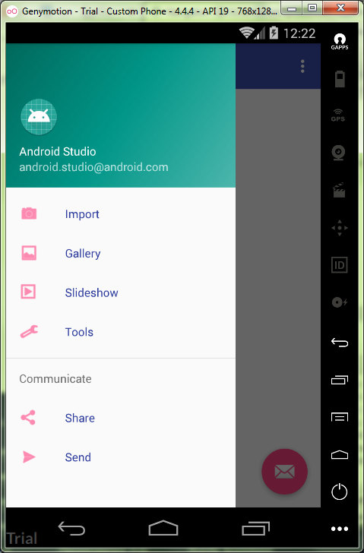

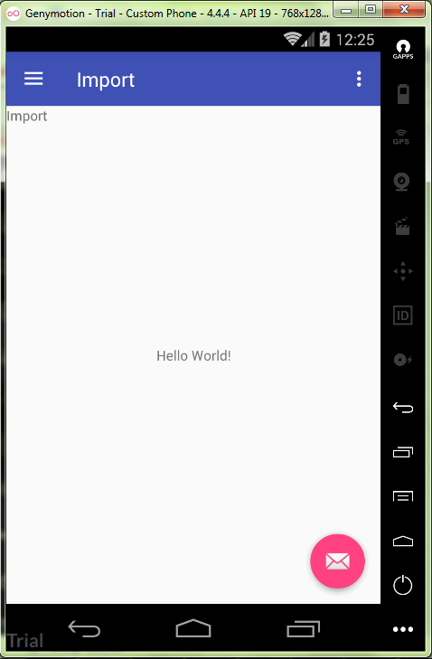

MainActivity.java:

**package** ru.kuzmiankou.navigation;  
  
**import** android.os.Bundle;  
**import** android.support.design.widget.FloatingActionButton;  
**import** android.support.design.widget.Snackbar;  
**import** android.support.v4.app.Fragment;  
**import** android.support.v4.app.FragmentManager;  
**import** android.view.View;  
**import** android.support.design.widget.NavigationView;  
**import** android.support.v4.view.GravityCompat;  
**import** android.support.v4.widget.DrawerLayout;  
**import** android.support.v7.app.ActionBarDrawerToggle;  
**import** android.support.v7.app.AppCompatActivity;  
**import** android.support.v7.widget.Toolbar;  
**import** android.view.Menu;  
**import** android.view.MenuItem;  
**import** android.widget.Toast;  
  
**public class** MainActivity **extends** AppCompatActivity  
 **implements** NavigationView.OnNavigationItemSelectedListener {  
  
 @Override  
 **protected void** onCreate(Bundle savedInstanceState) {  
 **super**.onCreate(savedInstanceState);  
 setContentView(R.layout.***activity_main***);  
 Toolbar toolbar = (Toolbar) findViewById(R.id.***toolbar***);  
 setSupportActionBar(toolbar);  
  
 FloatingActionButton fab = (FloatingActionButton) findViewById(R.id.***fab***);  
 fab.setOnClickListener(**new** View.OnClickListener() {  
 @Override  
 **public void** onClick(View view) {  
 Snackbar.*make*(view, **"Replace with your own action"**, Snackbar.***LENGTH_LONG***)  
 .setAction(**"Action"**, **null**).show();  
 }  
 });  
  
 DrawerLayout drawer = (DrawerLayout) findViewById(R.id.***drawer_layout***);  
 ActionBarDrawerToggle toggle = **new** ActionBarDrawerToggle(  
 **this**, drawer, toolbar, R.string.***navigation_drawer_open***, R.string.***navigation_drawer_close***);  
 drawer.addDrawerListener(toggle);  
 toggle.syncState();  
  
 NavigationView navigationView = (NavigationView) findViewById(R.id.***nav_view***);  
 navigationView.setNavigationItemSelectedListener(**this**);  
 }  
  
 @Override  
 **public void** onBackPressed() {  
 DrawerLayout drawer = (DrawerLayout) findViewById(R.id.***drawer_layout***);  
 **if** (drawer.isDrawerOpen(GravityCompat.***START***)) {  
 drawer.closeDrawer(GravityCompat.***START***);  
 } **else** {  
 **super**.onBackPressed();  
 }  
 }  
  
 @Override  
 **public boolean** onCreateOptionsMenu(Menu menu) {  
 *// Inflate the menu; this adds items to the action bar if it is present.* getMenuInflater().inflate(R.menu.***main***, menu);  
 **return true**;  
 }  
  
 @Override  
 **public boolean** onOptionsItemSelected(MenuItem item) {  
 *// Handle action bar item clicks here. The action bar will  
 // automatically handle clicks on the Home/Up button, so long  
 // as you specify a parent activity in AndroidManifest.xml.* **int** id = item.getItemId();  
  
 *//noinspection SimplifiableIfStatement* **if** (id == R.id.***action_settings***) {  
 **return true**;  
 }  
  
 **return super**.onOptionsItemSelected(item);  
 }  
  
 @SuppressWarnings(**"StatementWithEmptyBody"**)  
 @Override  
 **public boolean** onNavigationItemSelected(MenuItem item) {  
 *// Handle navigation view item clicks here.* Fragment fragment = **null**;  
 Class fragmentClass = **null**;  
 **int** id = item.getItemId();  
  
 **if** (id == R.id.***nav_camera***) {  
 Toast.*makeText*(getApplicationContext(),  
 **"You chose camera"**,  
 Toast.***LENGTH_SHORT***).show();  
 fragmentClass = ImportFragment.**class**;  
 } **else if** (id == R.id.***nav_gallery***) {  
 Toast.*makeText*(getApplicationContext(),  
 **"You chose gallery"**,  
 Toast.***LENGTH_SHORT***);  
 fragmentClass =GalleryFragment.**class**;  
 } **else if** (id == R.id.***nav_slideshow***) {  
 Toast.*makeText*(getApplicationContext(),  
 **"You chose sLideshow"**,  
 Toast.***LENGTH_SHORT***);  
 } **else if** (id == R.id.***nav_manage***) {  
 Toast.*makeText*(getApplicationContext(),  
 **"You chose manage"**,  
 Toast.***LENGTH_SHORT***);  
 } **else if** (id == R.id.***nav_share***) {  
 Toast.*makeText*(getApplicationContext(),  
 **"You chose share"**,  
 Toast.***LENGTH_SHORT***);  
 } **else if** (id == R.id.***nav_send***) {  
 Toast.*makeText*(getApplicationContext(),  
 **"You chose send"**,  
 Toast.***LENGTH_SHORT***);  
 }  
  
 **try** {  
 fragment = (Fragment) fragmentClass.newInstance();  
 }  
 **catch** (Exception e) {  
 e.printStackTrace();  
 }  
  
 FragmentManager fragmentManager = getSupportFragmentManager();  
 fragmentManager.beginTransaction().replace(R.id.***container***, fragment).commit();  
  
 item.setChecked(**true**);  
 setTitle(item.getTitle());  
  
 DrawerLayout drawer = (DrawerLayout) findViewById(R.id.***drawer_layout***);  
 drawer.closeDrawer(GravityCompat.***START***);  
 **return true**;  
 }  
}

Repository: https://github.com/kuzanatoliy/itmo.mobile.task11.git