Screens:

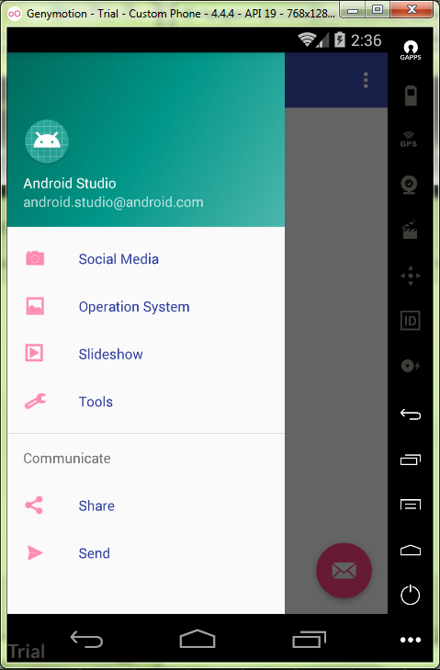

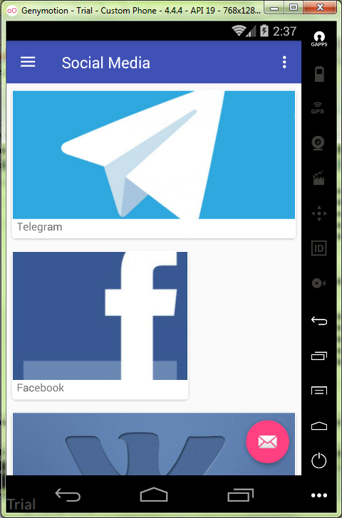

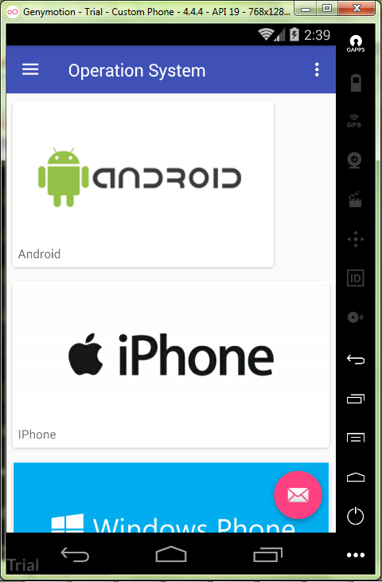

Media.java:

**package** ru.kuzmiankou.navigation;  
  
*/**  
 * Created by Anatoliy on 11.11.2017.  
 */***public class** Media {  
 **private** String **name**;  
 **private int imageResourceId**;  
  
 **public static final** Media[] ***medias*** = {  
 **new** Media(**"Telegram"**, R.drawable.***tl***),  
 **new** Media(**"Facebook"**, R.drawable.***fb***),  
 **new** Media(**"Vkontakte"**, R.drawable.***vk***),  
 **new** Media(**"Instagram"**, R.drawable.***inst***)  
 };  
  
 **private** Media(String name, **int** imageResourceId) {  
 **this**.**name** = name;  
 **this**.**imageResourceId** = imageResourceId;  
 }  
  
 **public** String getName() {  
 **return name**;  
 }  
  
 **public int** getImageResourceId() {  
 **return imageResourceId**;  
 }  
}

System.java:

**package** ru.kuzmiankou.navigation;  
  
*/**  
 * Created by Anatoliy on 11.11.2017.  
 */***public class** System {  
 **private** String **name**;  
 **private int imageResourceId**;  
  
 **public static final** System[] ***systems*** = {  
 **new** System(**"Android"**, R.drawable.***android***),  
 **new** System(**"IPhone"**, R.drawable.***iphone***),  
 **new** System(**"Windows Phonw"**, R.drawable.***windows***),  
 **new** System(**"BlackBerry"**, R.drawable.***black***)  
 };  
  
 **private** System(String name, **int** imageResourceId) {  
 **this**.**name** = name;  
 **this**.**imageResourceId** = imageResourceId;  
 }  
  
 **public** String getName() {  
 **return name**;  
 }  
  
 **public int** getImageResourceId() {  
 **return imageResourceId**;  
 }  
}

SocialMediaFragment.java:

**package** ru.kuzmiankou.navigation;  
  
**import** android.os.Bundle;  
**import** android.support.v4.app.Fragment;  
**import** android.support.v7.widget.LinearLayoutManager;  
**import** android.support.v7.widget.RecyclerView;  
**import** android.view.LayoutInflater;  
**import** android.view.View;  
**import** android.view.ViewGroup;  
  
**public class** SocialMediaFragment **extends** Fragment {  
  
 @Override  
 **public** View onCreateView(LayoutInflater inflater, ViewGroup container,  
 Bundle savedInstanceState) {  
 RecyclerView mediaRecycler = (RecyclerView)inflater.inflate(R.layout.***fragment_social_media***,  
 container, **false**);  
 String[] mediaNames = **new** String[Media.***medias***.**length**];  
 **for**(**int** i = 0; i < mediaNames.**length**; i++) {  
 mediaNames[i] = Media.***medias***[i].getName();  
 }  
 **int**[] mediaImages = **new int**[Media.***medias***.**length**];  
 **for** (**int** i = 0; i < mediaImages.**length**; i++) {  
 mediaImages[i] = Media.***medias***[i].getImageResourceId();  
 }  
  
 CardViewAdapter adapter = **new** CardViewAdapter(mediaNames, mediaImages);  
 mediaRecycler.setAdapter(adapter);  
 LinearLayoutManager layoutManager = **new** LinearLayoutManager(getActivity());  
 mediaRecycler.setLayoutManager(layoutManager);  
 **return** mediaRecycler;  
 }  
}

fragment_social_media.xml:

<**android.support.v7.widget.RecyclerView  
 xmlns:android="http://schemas.android.com/apk/res/android"  
 android:id="@+id/media_recycler"  
 android:scrollbars="vertical"  
 android:layout_width="match_parent"  
 android:layout_height="match_parent"**>  
  
</**android.support.v7.widget.RecyclerView**>

card_view.xml:

*<?***xml version="1.0" encoding="utf-8"***?>*<**android.support.v7.widget.CardView  
 xmlns:android="http://schemas.android.com/apk/res/android"  
 xmlns:card_view="http://schemas.android.com/apk/res-auto"  
 android:layout_height="200dp"  
 android:layout_width="match_parent"  
 android:layout_margin="5dp"  
 card_view:cardCornerRadius="4dp"**>  
  
 <**LinearLayout  
 android:layout_width="match_parent"  
 android:layout_height="match_parent"  
 android:orientation="vertical"**>  
  
 <**ImageView  
 android:id="@+id/info_image"  
 android:layout_width="match_parent"  
 android:layout_height="wrap_content"  
 android:layout_weight="1.0"  
 android:scaleType="centerCrop"**/>  
  
 <**TextView  
 android:id="@+id/info_text"  
 android:layout_marginStart="5dp"  
 android:layout_marginBottom="5dp"  
 android:layout_width="match_parent"  
 android:layout_height="wrap_content"** />  
 </**LinearLayout**>  
  
</**android.support.v7.widget.CardView**>

CardViewAdapter.java:

**package** ru.kuzmiankou.navigation;  
  
**import** android.graphics.drawable.Drawable;  
**import** android.support.v7.widget.CardView;  
**import** android.support.v7.widget.RecyclerView;  
**import** android.view.LayoutInflater;  
**import** android.view.ViewGroup;  
**import** android.widget.ImageView;  
**import** android.widget.TextView;  
  
*/**  
 * Created by Anatoliy on 11.11.2017.  
 */***public class** CardViewAdapter **extends** RecyclerView.Adapter<CardViewAdapter.ViewHolder> {  
 **private** String[] **captions**;  
 **private int**[] **imageIds**;  
  
 **public static class** ViewHolder **extends** RecyclerView.ViewHolder {  
 **private** CardView **cardView**;  
  
 **public** ViewHolder(CardView v) {  
 **super**(v);  
 **cardView** = v;  
 }  
 }  
  
 **public** CardViewAdapter (String[] captions, **int**[] imageIds) {  
 **this**.**captions** = captions;  
 **this**.**imageIds** = imageIds;  
 }  
  
 @Override  
 **public** CardViewAdapter.ViewHolder onCreateViewHolder(ViewGroup parent, **int** viewType) {  
 CardView cv = (CardView) LayoutInflater.*from*(parent.getContext())  
 .inflate(R.layout.***card_view***, parent, **false**);  
 **return new** ViewHolder(cv);  
 }  
  
 @Override  
 **public void** onBindViewHolder (ViewHolder holder, **int** position) {  
 CardView cardView = holder.**cardView**;  
 ImageView imageView = (ImageView) cardView.findViewById(R.id.***info_image***);  
 Drawable drawable = cardView.getResources().getDrawable(**imageIds**[position]);  
 imageView.setImageDrawable(drawable);  
 imageView.setContentDescription(**captions**[position]);  
 TextView textView = (TextView)cardView.findViewById(R.id.***info_text***);  
 textView.setText(**captions**[position]);  
 }  
  
 @Override  
 **public int** getItemCount(){  
 **return captions**.**length**;  
 }  
  
}

Repository: https://github.com/kuzanatoliy/itmo.mobile.task12.git