Screens:  
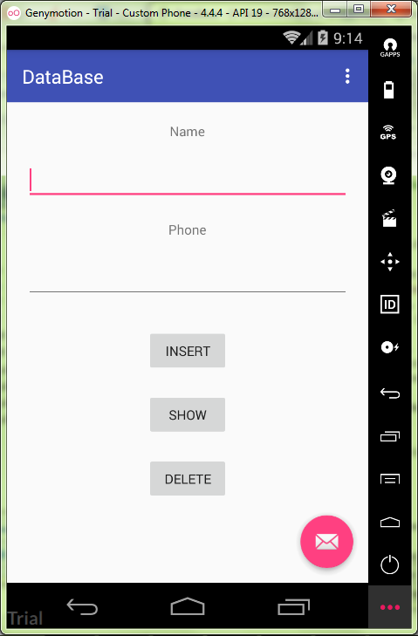

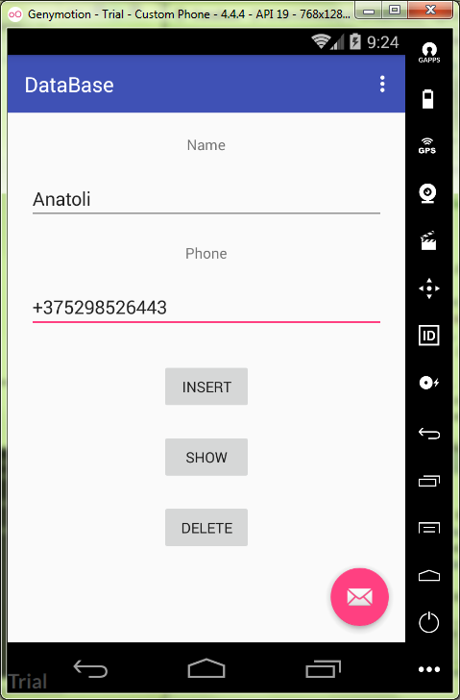

DataBase.java:

**package** ru.kuzmiankou.database;  
  
**import** android.content.Context;  
**import** android.database.sqlite.SQLiteDatabase;  
**import** android.database.sqlite.SQLiteOpenHelper;  
  
*/**  
 * Created by Anatoliy on 12.11.2017.  
 */***public class** DataBase **extends** SQLiteOpenHelper {  
  
  
 **public** DataBase(Context context) {  
 **super**(context, **"db"**, **null**, 1);  
 }  
  
 @Override  
 **public void** onCreate(SQLiteDatabase sqLiteDatabase) {  
 sqLiteDatabase.execSQL(  
 **"create table Contact(id integer primary key autoincrement, name text, phone integer);"**);  
 }  
  
 @Override  
 **public void** onUpgrade(SQLiteDatabase sqLiteDatabase, **int** i, **int** i1) {  
  
 }  
}

MainActivity.java  
**package** ru.kuzmiankou.database;  
  
**import** android.content.ContentValues;  
**import** android.database.Cursor;  
**import** android.database.sqlite.SQLiteDatabase;  
**import** android.os.Bundle;  
**import** android.support.design.widget.FloatingActionButton;  
**import** android.support.design.widget.Snackbar;  
**import** android.support.v7.app.AppCompatActivity;  
**import** android.support.v7.widget.Toolbar;  
**import** android.util.Log;  
**import** android.view.View;  
**import** android.view.Menu;  
**import** android.view.MenuItem;  
**import** android.widget.Button;  
**import** android.widget.EditText;  
  
**public class** MainActivity **extends** AppCompatActivity {  
  
 EditText **name**, **phone**;  
 Button **insert**, **show**, **delete**;  
 DataBase **dataBase**;  
  
 @Override  
 **protected void** onCreate(Bundle savedInstanceState) {  
 **super**.onCreate(savedInstanceState);  
 setContentView(R.layout.***activity_main***);  
 Toolbar toolbar = (Toolbar) findViewById(R.id.***toolbar***);  
 setSupportActionBar(toolbar);  
  
 **dataBase** = **new** DataBase(**this**);  
 **name** = (EditText) findViewById(R.id.***name***);  
 **phone** = (EditText) findViewById(R.id.***phone***);  
 **insert** = (Button) findViewById(R.id.***insertBtn***);  
 **show** = (Button) findViewById(R.id.***showBtn***);  
 **delete** = (Button) findViewById(R.id.***deleteBtn***);  
  
 **final** SQLiteDatabase sqLiteDatabase = **dataBase**.getWritableDatabase();  
  
 **insert**.setOnClickListener(**new** View.OnClickListener(){  
 @Override  
 **public void** onClick(View view) {  
 ContentValues contentValues = **new** ContentValues();  
 contentValues.put(**"name"**, **name**.getText().toString());  
 contentValues.put(**"phone"**, **phone**.getText().toString());  
 sqLiteDatabase.insert(**"Contact"**, **null**, contentValues);  
  
 Log.*d*(**"log"**, **"Data inserted"**);  
 }  
 });  
  
 **show**.setOnClickListener(**new** View.OnClickListener(){  
 @Override  
 **public void** onClick(View view) {  
 Cursor cursor = sqLiteDatabase.query(**"Contact"**, **null**, **null**,  
 **null**, **null**, **null**, **null**, **null**);  
 **if**(cursor.moveToFirst()) {  
 **do** {  
 Log.*d*(**"log"**, **"id"** + cursor.getInt(cursor.getColumnIndex(**"id"**)) + **"name"** +  
 cursor.getString(cursor.getColumnIndex(**"name"**)) + **"phone"** +  
 cursor.getInt(cursor.getColumnIndex(**"phone"**)));  
 }  
 **while** (cursor.moveToNext());  
 }  
 **else** {  
 Log.*d*(**"log"**, **"Table not found"**);  
 }  
 }  
 });  
  
 **delete**.setOnClickListener(**new** View.OnClickListener(){  
 @Override  
 **public void** onClick(View view) {  
 sqLiteDatabase.delete(**"Contact"**, **null**, **null**);  
 Log.*d*(**"log"**, **"Table deleted"**);  
 }  
 });  
  
 FloatingActionButton fab = (FloatingActionButton) findViewById(R.id.***fab***);  
 fab.setOnClickListener(**new** View.OnClickListener() {  
 @Override  
 **public void** onClick(View view) {  
 Snackbar.*make*(view, **"Replace with your own action"**, Snackbar.***LENGTH_LONG***)  
 .setAction(**"Action"**, **null**).show();  
 }  
 });  
 }  
  
 @Override  
 **public boolean** onCreateOptionsMenu(Menu menu) {  
 *// Inflate the menu; this adds items to the action bar if it is present.* getMenuInflater().inflate(R.menu.***menu_main***, menu);  
 **return true**;  
 }  
  
 @Override  
 **public boolean** onOptionsItemSelected(MenuItem item) {  
 *// Handle action bar item clicks here. The action bar will  
 // automatically handle clicks on the Home/Up button, so long  
 // as you specify a parent activity in AndroidManifest.xml.* **int** id = item.getItemId();  
  
 *//noinspection SimplifiableIfStatement* **if** (id == R.id.***action_settings***) {  
 **return true**;  
 }  
  
 **return super**.onOptionsItemSelected(item);  
 }  
}

content_main.xml:

*<?***xml version="1.0" encoding="utf-8"***?>*<**LinearLayout  
 xmlns:android="http://schemas.android.com/apk/res/android"  
 xmlns:tools="http://schemas.android.com/tools"  
 android:layout_width="match_parent"  
 android:layout_height="match_parent"  
 android:orientation="vertical"  
 android:gravity="center"  
 tools:context="ru.kuzmiankou.database.MainActivity"**>  
  
 <**TextView  
 android:layout_width="wrap_content"  
 android:layout_height="wrap_content"  
 android:text="@string/title_name"**/>  
  
 <**EditText  
 android:layout_width="match_parent"  
 android:layout_height="wrap_content"  
 android:layout_margin="20dp"  
 android:id="@+id/name"**/>  
  
 <**TextView  
 android:layout_width="wrap_content"  
 android:layout_height="wrap_content"  
 android:text="@string/title_phone"**/>  
  
 <**EditText  
 android:layout_width="match_parent"  
 android:layout_height="wrap_content"  
 android:layout_margin="20dp"  
 android:id="@+id/phone"**/>  
  
 <**Button  
 android:layout_width="wrap_content"  
 android:layout_height="wrap_content"  
 android:layout_margin="10dp"  
 android:id="@+id/insertBtn"  
 android:text="@string/btn_insert"**/>  
  
 <**Button  
 android:layout_width="wrap_content"  
 android:layout_height="wrap_content"  
 android:layout_margin="10dp"  
 android:id="@+id/showBtn"  
 android:text="@string/btn_show"**/>  
  
 <**Button  
 android:layout_width="wrap_content"  
 android:layout_height="wrap_content"  
 android:layout_margin="10dp"  
 android:id="@+id/deleteBtn"  
 android:text="@string/btn_delete"**/>  
  
</**LinearLayout**>

Repository: https://github.com/kuzanatoliy/itmo.mobile.task13.git