Screens:  
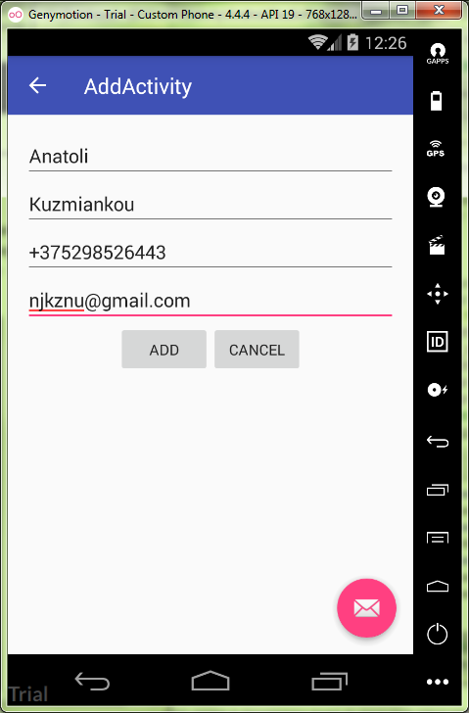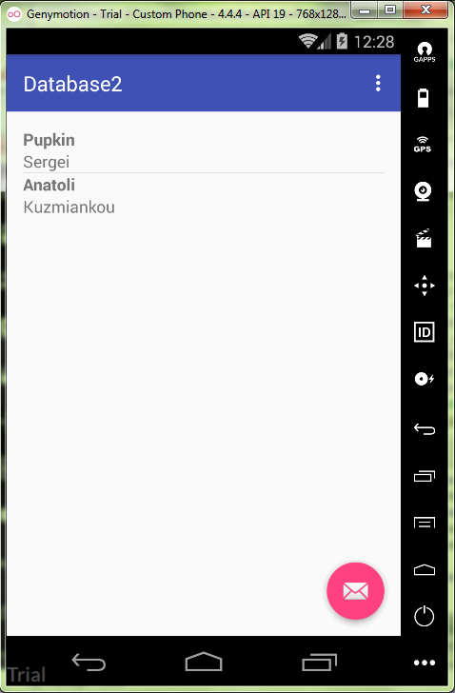

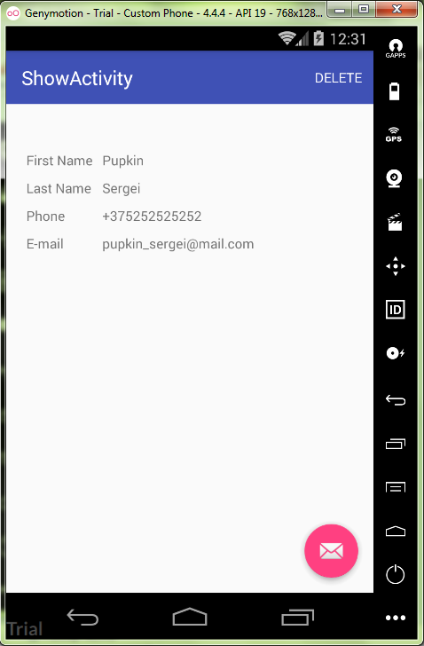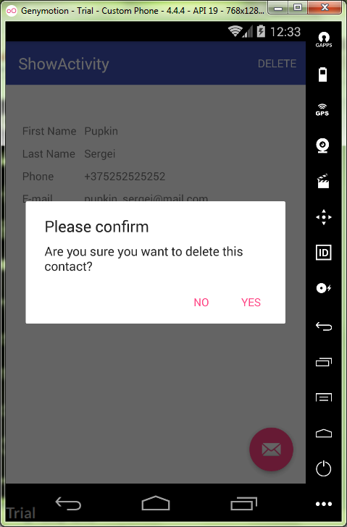

Contact.java:

**package** ru.kuzmiankou.database2;  
  
*/**  
 * Created by Anatoliy on 12.11.2017.  
 */***public class** Contact {  
 **private long id**;  
 **private** String **firstName**;  
 **private** String **lastName**;  
 **private** String **phone**;  
 **private** String **email**;  
  
 **public** Contact(String firstName, String lastName, String phone, String email) {  
 **this**.**firstName** = firstName;  
 **this**.**lastName** = lastName;  
 **this**.**phone** = phone;  
 **this**.**email** = email;  
 }  
  
 **public long** getId() {  
 **return id**;  
 }  
  
 **public void** setId(**long** id) {  
 **this**.**id** = id;  
 }  
  
 **public** String getFirstName() {  
 **return firstName**;  
 }  
  
 **public void** setFirstName(String firstName) {  
 **this**.**firstName** = firstName;  
 }  
  
 **public** String getLastName() {  
 **return lastName**;  
 }  
  
 **public void** setLastName(String lastName) {  
 **this**.**lastName** = lastName;  
 }  
  
 **public** String getPhone() {  
 **return phone**;  
 }  
  
 **public void** setPhone(String phone) {  
 **this**.**phone** = phone;  
 }  
  
 **public** String getEmail() {  
 **return email**;  
 }  
  
 **public void** setEmail(String email) {  
 **this**.**email** = email;  
 }  
}

DatabaseManager.java  
**package** ru.kuzmiankou.database2;  
  
**import** android.content.ContentValues;  
**import** android.content.Context;  
**import** android.database.Cursor;  
**import** android.database.sqlite.SQLiteDatabase;  
**import** android.database.sqlite.SQLiteOpenHelper;  
**import** android.util.Log;  
  
*/**  
 * Created by Anatoliy on 12.11.2017.  
 */***public class** DatabaseManager **extends** SQLiteOpenHelper {  
 **public static final** String ***TABLE_NAME*** = **"contacts"**;  
 **public static final** String ***ID_FIELD*** = **"_id"**;  
 **public static final** String ***FIRST_NAME_FIELD*** = **"first_name"**;  
 **public static final** String ***LAST_NAME_FIELD*** = **"last_name"**;  
 **public static final** String ***PHONE_FIELD*** = **"phone"**;  
 **public static final** String ***EMAIL_FIELD*** = **"email"**;  
  
 **public** DatabaseManager(Context context){  
 **super**(context, **"contacts_db"**, **null**, 1);  
 }  
  
 @Override  
 **public void** onCreate(SQLiteDatabase sqLiteDatabase) {  
 Log.*d*(**"db"**, **"onCreate"**);  
 String sql = **"CREATE TABLE "** + ***TABLE_NAME*** + **" ("** + ***ID_FIELD*** + **" INTEGER, "** + ***FIRST_NAME_FIELD*** + **" TEXT,"** + ***LAST_NAME_FIELD*** + **" TEXT,"** + ***PHONE_FIELD*** + **" TEXT,"** + ***EMAIL_FIELD*** + **" TEXT,"** + **"PRIMARY KEY ("** + ***ID_FIELD*** + **"));"**;  
 sqLiteDatabase.execSQL(sql);  
  
 }  
  
 @Override  
 **public void** onUpgrade(SQLiteDatabase sqLiteDatabase, **int** i, **int** j) {  
 Log.*d*(**"db"**, **"onUpdate"**);  
 sqLiteDatabase.execSQL(**"DROP TABLE IF EXISTS "** + ***TABLE_NAME***);  
 onCreate(sqLiteDatabase);  
 }  
  
 **public** Contact addContact (Contact contact) {  
 Log.*d*(**"db"**, **"addContact"**);  
 SQLiteDatabase db = **this**.getWritableDatabase();  
 ContentValues values = **new** ContentValues();  
 values.put(***FIRST_NAME_FIELD***, contact.getFirstName());  
 values.put(***LAST_NAME_FIELD***, contact.getLastName());  
 values.put(***PHONE_FIELD***, contact.getPhone());  
 values.put(***EMAIL_FIELD***, contact.getEmail());  
 **long** id = db.insert(***TABLE_NAME***, **null**, values);  
 contact.setId(id);  
 db.close();  
 **return** contact;  
 }  
  
 **public** Contact getContact(**long** id) {  
 SQLiteDatabase db = **this**.getReadableDatabase();  
 Cursor cursor = db.query(***TABLE_NAME***, **new** String[] {  
 ***ID_FIELD***, ***FIRST_NAME_FIELD***, ***LAST_NAME_FIELD***,  
 ***PHONE_FIELD***, ***EMAIL_FIELD*** }, ***ID_FIELD*** + **"=?"**,  
 **new** String[] {String.*valueOf*(id)}, **null**,  
 **null**, **null**, **null**);  
 **if**(cursor != **null**) {  
 cursor.moveToFirst();  
 Contact contact = **new** Contact(  
 cursor.getString(1),  
 cursor.getString(2),  
 cursor.getString(3),  
 cursor.getString(4));  
 contact.setId(cursor.getLong(0));  
 **return** contact;  
 }  
 **return null**;  
 }  
  
 **public** Cursor getContactsCursor() {  
 String selectQuery = **"SELECT * FROM "** + ***TABLE_NAME***;  
 SQLiteDatabase db = **this**.getWritableDatabase();  
 **return** db.rawQuery(selectQuery, **null**);  
 }  
  
 **public void** deleteContact(**long** id) {  
 SQLiteDatabase db = **this**.getWritableDatabase();  
 db.delete(***TABLE_NAME***, ***ID_FIELD*** + **" = ?"**, **new** String[] { String.*valueOf*(id)});  
 db.close();  
 }  
}

MainActivity.java:

**package** ru.kuzmiankou.database2;  
  
**import** android.content.Intent;  
**import** android.database.Cursor;  
**import** android.os.Bundle;  
**import** android.support.design.widget.FloatingActionButton;  
**import** android.support.design.widget.Snackbar;  
**import** android.support.v7.app.AppCompatActivity;  
**import** android.support.v7.widget.Toolbar;  
**import** android.view.View;  
**import** android.view.Menu;  
**import** android.view.MenuItem;  
**import** android.widget.AdapterView;  
**import** android.widget.CursorAdapter;  
**import** android.widget.ListAdapter;  
**import** android.widget.ListView;  
**import** android.widget.SimpleCursorAdapter;  
  
**public class** MainActivity **extends** AppCompatActivity {  
  
 DatabaseManager **dbMgr**;  
  
 @Override  
 **protected void** onCreate(Bundle savedInstanceState) {  
 **super**.onCreate(savedInstanceState);  
 setContentView(R.layout.***activity_main***);  
 Toolbar toolbar = (Toolbar) findViewById(R.id.***toolbar***);  
 setSupportActionBar(toolbar);  
  
 ListView listView = (ListView) findViewById(R.id.***listView***);  
 **dbMgr** = **new** DatabaseManager(**this**);  
 Cursor cursor = **dbMgr**.getContactsCursor();  
 startManagingCursor(cursor);  
 ListAdapter adapter = **new** SimpleCursorAdapter(  
 **this**,  
 android.R.layout.***two_line_list_item***,  
 cursor,  
 **new** String[] {  
 DatabaseManager.***FIRST_NAME_FIELD***,  
 DatabaseManager.***LAST_NAME_FIELD*** },  
 **new int**[] {android.R.id.***text1***, android.R.id.***text2***},  
 CursorAdapter.***FLAG_REGISTER_CONTENT_OBSERVER***);  
 listView.setAdapter(adapter);  
 listView.setChoiceMode(ListView.***CHOICE_MODE_SINGLE***);  
 listView.setOnItemClickListener(  
 **new** AdapterView.OnItemClickListener() {  
 @Override  
 **public void** onItemClick(AdapterView<?> adapterView, View view, **int** i, **long** id) {  
 Intent intent = **new** Intent(getApplicationContext(), ShowActivity.**class**);  
 intent.putExtra(**"id"**, id);  
 startActivity(intent);  
 }  
 }  
 );  
  
 FloatingActionButton fab = (FloatingActionButton) findViewById(R.id.***fab***);  
 fab.setOnClickListener(**new** View.OnClickListener() {  
 @Override  
 **public void** onClick(View view){  
 startActivity(**new** Intent(MainActivity.**this**, AddActivity.**class**));  
 }  
 });  
 }  
  
 @Override  
 **public boolean** onCreateOptionsMenu(Menu menu) {  
 *// Inflate the menu; this adds items to the action bar if it is present.* getMenuInflater().inflate(R.menu.***menu_main***, menu);  
 **return true**;  
 }  
  
 @Override  
 **public boolean** onOptionsItemSelected(MenuItem item) {  
 *// Handle action bar item clicks here. The action bar will  
 // automatically handle clicks on the Home/Up button, so long  
 // as you specify a parent activity in AndroidManifest.xml.* **int** id = item.getItemId();  
  
 *//noinspection SimplifiableIfStatement* **if** (id == R.id.***action_settings***) {  
 **return true**;  
 }  
  
 **return super**.onOptionsItemSelected(item);  
 }  
}

content_main.xml:

*<?***xml version="1.0" encoding="utf-8"***?>*<**RelativeLayout  
 xmlns:android="http://schemas.android.com/apk/res/android"  
 xmlns:app="http://schemas.android.com/apk/res-auto"  
 xmlns:tools="http://schemas.android.com/tools"  
 android:id="@+id/content_main"  
 android:layout_width="match_parent"  
 android:layout_height="match_parent"  
 android:padding="16dp"  
 app:layout_behavior="@string/appbar_scrolling_view_behavior"  
 tools:context="ru.kuzmiankou.database2.MainActivity"  
 tools:showIn="@layout/activity_main"**>  
  
 <**ListView  
 android:id="@+id/listView"  
 android:layout_width="wrap_content"  
 android:layout_height="wrap_content"**/>  
  
</**RelativeLayout**>

AddActivity.java:

**package** ru.kuzmiankou.database2;  
  
**import** android.os.Bundle;  
**import** android.support.design.widget.FloatingActionButton;  
**import** android.support.design.widget.Snackbar;  
**import** android.support.v7.app.AppCompatActivity;  
**import** android.support.v7.widget.Toolbar;  
**import** android.view.View;  
**import** android.widget.EditText;  
**import** android.widget.TextView;  
  
**public class** AddActivity **extends** AppCompatActivity {  
  
 @Override  
 **protected void** onCreate(Bundle savedInstanceState) {  
 **super**.onCreate(savedInstanceState);  
 setContentView(R.layout.***activity_add***);  
 Toolbar toolbar = (Toolbar) findViewById(R.id.***toolbar***);  
 setSupportActionBar(toolbar);  
  
 FloatingActionButton fab = (FloatingActionButton) findViewById(R.id.***fab***);  
 fab.setOnClickListener(**new** View.OnClickListener() {  
 @Override  
 **public void** onClick(View view) {  
 Snackbar.*make*(view, **"Replace with your own action"**, Snackbar.***LENGTH_LONG***)  
 .setAction(**"Action"**, **null**).show();  
 }  
 });  
 getSupportActionBar().setDisplayHomeAsUpEnabled(**true**);  
 }  
  
 **public void** cancel(View v){  
 finish();  
 }  
  
 **public void** addContact(View v) {  
 DatabaseManager dbMgr = **new** DatabaseManager(**this**);  
 String firstName = ((EditText) findViewById(R.id.***first_name***)).getText().toString();  
 String lastName = ((EditText) findViewById(R.id.***last_name***)).getText().toString();  
 String phone = ((EditText) findViewById(R.id.***phone***)).getText().toString();  
 String email = ((EditText) findViewById(R.id.***email***)).getText().toString();  
 Contact contact = **new** Contact(firstName, lastName, phone, email);  
 dbMgr.addContact(contact);  
 finish();  
 }  
  
}

content_add.xml:

*<?***xml version="1.0" encoding="utf-8"***?>*<**LinearLayout  
 xmlns:android="http://schemas.android.com/apk/res/android"  
 xmlns:app="http://schemas.android.com/apk/res-auto"  
 xmlns:tools="http://schemas.android.com/tools"  
 android:layout_width="match_parent"  
 android:layout_height="match_parent"  
 android:padding="16dp"  
 android:orientation="vertical"  
 android:scrollbars="vertical"  
 app:layout_behavior="@string/appbar_scrolling_view_behavior"  
 tools:context="ru.kuzmiankou.database2.AddActivity"  
 tools:showIn="@layout/activity_add"**>  
  
 <**EditText  
 android:layout_width="match_parent"  
 android:layout_height="wrap_content"  
 android:id="@+id/first_name"  
 android:hint="@string/first_name"**/>  
  
 <**EditText  
 android:layout_width="match_parent"  
 android:layout_height="wrap_content"  
 android:id="@+id/last_name"  
 android:hint="@string/last_name"**/>  
  
 <**EditText  
 android:layout_width="match_parent"  
 android:layout_height="wrap_content"  
 android:id="@+id/phone"  
 android:hint="@string/phone"**/>  
  
 <**EditText  
 android:layout_width="match_parent"  
 android:layout_height="wrap_content"  
 android:id="@+id/email"  
 android:hint="@string/email"**/>  
  
 <**LinearLayout  
 android:layout_width="match_parent"  
 android:layout_height="match_parent"  
 android:orientation="horizontal"  
 android:gravity="center_horizontal"**>  
  
 <**Button  
 android:layout_width="wrap_content"  
 android:layout_height="wrap_content"  
 android:text="@string/add_button_text"  
 android:onClick="addContact"**/>  
  
 <**Button  
 android:layout_width="wrap_content"  
 android:layout_height="wrap_content"  
 android:text="@string/cancel_button_text"  
 android:onClick="cancel"**/>  
 </**LinearLayout**>  
  
</**LinearLayout**>

ShowActivity.java:

**package** ru.kuzmiankou.database2;  
  
**import** android.content.DialogInterface;  
**import** android.os.Bundle;  
**import** android.provider.ContactsContract;  
**import** android.support.design.widget.FloatingActionButton;  
**import** android.support.design.widget.Snackbar;  
**import** android.support.v7.app.AlertDialog;  
**import** android.support.v7.app.AppCompatActivity;  
**import** android.support.v7.widget.Toolbar;  
**import** android.util.Log;  
**import** android.view.Menu;  
**import** android.view.MenuItem;  
**import** android.view.View;  
**import** android.widget.TextView;  
  
**public class** ShowActivity **extends** MainActivity {  
  
 **long contactId**;  
  
 @Override  
 **protected void** onCreate(Bundle savedInstanceState) {  
 **super**.onCreate(savedInstanceState);  
 setContentView(R.layout.***activity_show***);  
 Toolbar toolbar = (Toolbar) findViewById(R.id.***toolbar***);  
 setSupportActionBar(toolbar);  
  
 Bundle extras = getIntent().getExtras();  
 **if**(extras != **null**) {  
 **contactId** = extras.getLong(**"id"**);  
 DatabaseManager dbMgr = **new** DatabaseManager(**this**);  
 Contact contact = dbMgr.getContact(**contactId**);  
 **if**(contact != **null**) {  
 ((TextView) findViewById(R.id.***first_name***)).setText(contact.getFirstName());  
 ((TextView) findViewById(R.id.***last_name***)).setText(contact.getLastName());  
 ((TextView) findViewById(R.id.***phone***)).setText(contact.getPhone());  
 ((TextView) findViewById(R.id.***email***)).setText(contact.getEmail());  
 }  
 **else** {  
 Log.*d*(**"db"**, **"contact null"**);  
 }  
 }  
 }  
  
 @Override  
 **public boolean** onCreateOptionsMenu(Menu menu) {  
 getMenuInflater().inflate(R.menu.***menu_show***, menu);  
 **return true**;  
 }  
  
 @Override  
 **public boolean** onOptionsItemSelected(MenuItem item) {  
 **switch** (item.getItemId()) {  
 **case** R.id.***action_delete***:  
 deleteContact();  
 **return true**;  
 **default**:  
 **return super**.onOptionsItemSelected(item);  
 }  
 }  
  
 **private void** deleteContact() {  
 **new** AlertDialog.Builder(**this**)  
 .setTitle(**"Please confirm"**)  
 .setMessage(**"Are you sure you want to delete this contact?"**)  
 .setPositiveButton(**"Yes"**, **new** DialogInterface.OnClickListener() {  
 @Override  
 **public void** onClick(DialogInterface dialogInterface, **int** i) {  
 DatabaseManager dbMgr = **new** DatabaseManager(getApplicationContext());  
 dbMgr.deleteContact(**contactId**);  
 dialogInterface.dismiss();  
 finish();  
 }  
 })  
 .setNegativeButton(**"No"**, **new** DialogInterface.OnClickListener() {  
 @Override  
 **public void** onClick(DialogInterface dialogInterface, **int** i) {  
 dialogInterface.dismiss();  
 }  
 }).create().show();  
 }  
  
}

content_show.xml:

*<?***xml version="1.0" encoding="utf-8"***?>*<**TableLayout xmlns:android="http://schemas.android.com/apk/res/android"  
 xmlns:app="http://schemas.android.com/apk/res-auto"  
 xmlns:tools="http://schemas.android.com/tools"  
 android:id="@+id/content_show"  
 android:layout_width="match_parent"  
 android:layout_height="match_parent"  
 android:layout_gravity="center"  
 android:padding="16dp"  
 android:scrollbars="vertical"  
 app:layout_behavior="@string/appbar_scrolling_view_behavior"  
 tools:context="ru.kuzmiankou.database2.ShowActivity"  
 tools:showIn="@layout/activity_show"**>  
  
 <**TableRow  
 android:layout_width="match_parent"  
 android:layout_height="wrap_content"  
 android:padding="5dp"**>  
  
 <**TextView  
 android:text="@string/first_name"  
 android:paddingRight="10dp"**/>  
  
 <**TextView  
 android:id="@+id/first_name"**/>  
  
 </**TableRow**>  
  
 <**TableRow  
 android:layout_width="match_parent"  
 android:layout_height="wrap_content"  
 android:padding="5dp"**>  
  
 <**TextView  
 android:text="@string/last_name"  
 android:paddingRight="10dp"**/>  
  
 <**TextView  
 android:id="@+id/last_name"**/>  
  
 </**TableRow**>  
  
 <**TableRow  
 android:layout_width="match_parent"  
 android:layout_height="wrap_content"  
 android:padding="5dp"**>  
  
 <**TextView  
 android:text="@string/phone"  
 android:paddingRight="10dp"**/>  
  
 <**TextView  
 android:id="@+id/phone"**/>  
  
 </**TableRow**>  
  
 <**TableRow  
 android:layout_width="match_parent"  
 android:layout_height="wrap_content"  
 android:padding="5dp"**>  
  
 <**TextView  
 android:text="@string/email"  
 android:paddingRight="10dp"**/>  
  
 <**TextView  
 android:id="@+id/email"**/>  
  
 </**TableRow**>  
  
</**TableLayout**>

string.xml:

<**resources**>  
 <**string name="app_name"**>Database2</**string**>  
 <**string name="action_settings"**>Settings</**string**>  
 <**string name="title_activity_add"**>AddActivity</**string**>  
  
 <**string name="action_delete"**>Delete</**string**>  
 <**string name="add_button_text"**>Add</**string**>  
 <**string name="cancel_button_text"**>Cancel</**string**>  
 <**string name="first_name"**>First Name</**string**>  
 <**string name="last_name"**>Last Name</**string**>  
 <**string name="phone"**>Phone</**string**>  
 <**string name="email"**>E-mail</**string**>  
 <**string name="title_activity_show"**>ShowActivity</**string**>  
</**resources**>

Repository: https://github.com/kuzanatoliy/itmo.mobile.task14.git