Screens:  
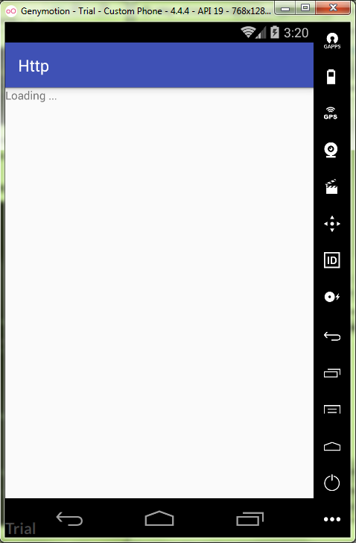

ProgressFragment.java:

**package** ru.kuzmiankou.http;  
  
  
**import** android.os.AsyncTask;  
**import** android.os.Bundle;  
**import** android.support.v4.app.Fragment;  
**import** android.view.LayoutInflater;  
**import** android.view.View;  
**import** android.view.ViewGroup;  
**import** android.widget.TextView;  
**import** android.widget.Toast;  
  
**import** java.io.BufferedReader;  
**import** java.io.IOException;  
**import** java.io.InputStreamReader;  
**import** java.net.HttpURLConnection;  
**import** java.net.URL;  
  
  
*/**  
 * A simple {****@link*** *Fragment} subclass.  
 */***public class** ProgressFragment **extends** Fragment {  
  
 TextView **contentView**;  
 String **contentText** = **null**;  
  
 @Override  
 **public void** onCreate(Bundle savedInstanceState) {  
 **super**.onCreate(savedInstanceState);  
 setRetainInstance(**true**);  
 }  
  
 @Override  
 **public** View onCreateView(LayoutInflater inflater, ViewGroup container,  
 Bundle savedInstanceState) {  
 View view = inflater.inflate(R.layout.***fragment_progress***, container, **false**);  
 **contentView** = (TextView) view.findViewById(R.id.***loading_content***);  
 **if**(**contentText** != **null**){  
 **contentView**.setText(**contentText**);  
 }  
 **return** view;  
 }  
  
 @Override  
 **public void** onActivityCreated(Bundle savedInstanceState){  
 **super**.onActivityCreated(savedInstanceState);  
 **if**(**contentText** == **null**) {  
 **new** ProgressTask().execute();  
 }  
 }  
  
 **class** ProgressTask **extends** AsyncTask<String, Void, String> {  
 @Override  
 **protected** String doInBackground(String... path) {  
 String content;  
 **try** {  
 content = getContent(**"http://vk.com"**);  
 }  
 **catch**(IOException ex) {  
 content = ex.getMessage();  
 }  
 **return** content;  
 }  
  
 @Override  
 **protected void** onProgressUpdate(Void... items) {  
  
 }  
  
 @Override  
 **protected void** onPostExecute(String content) {  
 **contentText** = content;  
 **contentView**.setText(content);  
 Toast.*makeText*(getActivity(), **"Data was downloaded"**, Toast.***LENGTH_SHORT***).show();  
 }  
  
 **private** String getContent(String path) **throws** IOException {  
 BufferedReader reader=**null**;  
 **try** {  
 URL url = **new** URL(path);  
 HttpURLConnection conn = (HttpURLConnection) url.openConnection();  
 conn.setRequestMethod(**"GET"**);  
 conn.setReadTimeout(10000);  
 conn.connect();  
 reader = **new** BufferedReader(**new** InputStreamReader(conn.getInputStream()));  
 StringBuilder buf = **new** StringBuilder();  
 String line = **null**;  
 **while** ((line = reader.readLine()) != **null**) {  
 buf.append(line + **"\n"**);  
 }  
 **return**(buf.toString());  
 }  
 **finally** {  
 **if**(reader != **null**) {  
 reader.close();  
 }  
 }  
 }  
 }  
  
}

fragment_progress.xml:

<**RelativeLayout  
 xmlns:android="http://schemas.android.com/apk/res/android"  
 xmlns:tools="http://schemas.android.com/tools"  
 android:layout_width="match_parent"  
 android:layout_height="match_parent"  
 tools:context="ru.kuzmiankou.http.ProgressFragment"**>  
  
 <**ScrollView  
 android:layout_width="match_parent"  
 android:layout_height="match_parent"**>  
  
 <**TextView  
 android:id="@+id/loading_content"  
 android:layout_width="match_parent"  
 android:layout_height="wrap_content"  
 android:text="Loading ..."** />  
  
 </**ScrollView**>  
</**RelativeLayout**>

activity_main.xml:

*<?***xml version="1.0" encoding="utf-8"***?>*<**FrameLayout  
 xmlns:android="http://schemas.android.com/apk/res/android"  
 xmlns:tools="http://schemas.android.com/tools"  
 android:layout_width="match_parent"  
 android:layout_height="match_parent"  
 tools:context="ru.kuzmiankou.http.MainActivity"**>  
  
 <**fragment  
 android:id="@+id/contentFragment"  
 android:layout_width="match_parent"  
 android:layout_height="match_parent"  
 android:name="ru.kuzmiankou.http.ProgressFragment"  
 tools:layout="@layout/fragment_progress"**/>  
  
</**FrameLayout**>

Repository: https://github.com/kuzanatoliy/itmo.mobile.task15.git