Screens:  
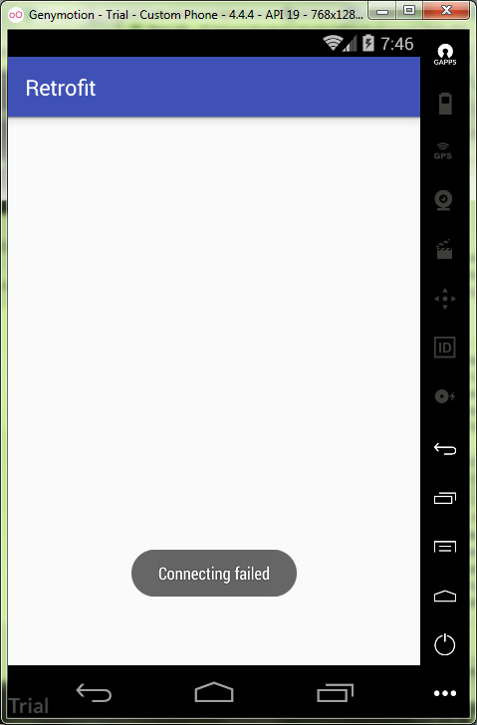

MainActivity.java:

**package** ru.kuzmiankou.retrofit;  
  
**import** android.os.Bundle;  
**import** android.support.v7.app.AppCompatActivity;  
**import** android.support.v7.widget.LinearLayoutManager;  
**import** android.support.v7.widget.RecyclerView;  
**import** android.widget.Toast;  
  
**import** java.util.ArrayList;  
**import** java.util.List;  
  
**import** retrofit2.Call;  
**import** retrofit2.Callback;  
**import** retrofit2.Response;  
  
**public class** MainActivity **extends** AppCompatActivity {  
  
 RecyclerView **recyclerView**;  
 List<PostModel> **posts**;  
  
 @Override  
 **protected void** onCreate(Bundle savedInstanceState) {  
 **super**.onCreate(savedInstanceState);  
 setContentView(R.layout.***activity_main***);  
  
 **posts** = **new** ArrayList<>();  
 **recyclerView** = (RecyclerView) findViewById(R.id.***posts_recycle_view***);  
 LinearLayoutManager layoutManager = **new** LinearLayoutManager(**this**);  
 **recyclerView**.setLayoutManager(layoutManager);  
 PostsAdapter adapter = **new** PostsAdapter(**posts**);  
 **recyclerView**.setAdapter(adapter);  
 App.*getApi*().getData(**"bash"**, 50).enqueue(**new** Callback<List<PostModel>>() {  
 @Override  
 **public void** onResponse(Call<List<PostModel>> call, Response<List<PostModel>> response) {  
 **posts**.addAll(response.body());  
 **recyclerView**.getAdapter().notifyDataSetChanged();  
 }  
  
 @Override  
 **public void** onFailure(Call<List<PostModel>> call, Throwable t) {  
 Toast.*makeText*(MainActivity.**this**, **"Connecting failed"**, Toast.***LENGTH_SHORT***).show();  
 }  
 });  
 }  
}

activity_main.xml:

*<?***xml version="1.0" encoding="utf-8"***?>*<**LinearLayout  
 xmlns:android="http://schemas.android.com/apk/res/android"  
 xmlns:tools="http://schemas.android.com/tools"  
 android:layout_width="match_parent"  
 android:layout_height="match_parent"  
 android:gravity="center"  
 android:orientation="vertical"  
 tools:context="ru.kuzmiankou.handler.MainActivity"**>  
  
 <**ImageView  
 android:layout_width="wrap_content"  
 android:layout_height="wrap_content"  
 android:id="@+id/image"  
 android:src="@drawable/newyear"**/>  
  
 <**Button  
 android:layout_width="match_parent"  
 android:layout_height="wrap_content"  
 style="?android:attr/buttonStyleSmall"  
 android:text="@string/button"  
 android:layout_marginTop="16dp"  
 android:onClick="onClick"**/>  
</**LinearLayout**>

PostAdapter.java:

**package** ru.kuzmiankou.retrofit;  
  
**import** android.os.Build;  
**import** android.support.v7.widget.RecyclerView;  
**import** android.text.Html;  
**import** android.view.LayoutInflater;  
**import** android.view.View;  
**import** android.view.ViewGroup;  
**import** android.widget.TextView;  
  
**import** java.util.List;  
  
**public class** PostsAdapter **extends** RecyclerView.Adapter<PostsAdapter.ViewHolder> {  
  
 **private** List<PostModel> **posts**;  
  
 **public** PostsAdapter(List<PostModel> posts) {  
 **this**.**posts** = posts;  
 }  
  
 @Override  
 **public** ViewHolder onCreateViewHolder(ViewGroup parent, **int** viewType) {  
 View v = LayoutInflater.*from*(parent.getContext()).inflate(R.layout.***post_item***, parent, **false**);  
 **return new** ViewHolder(v);  
 }  
  
 @Override  
 **public void** onBindViewHolder(ViewHolder holder, **int** position) {  
 PostModel post = **posts**.get(position);  
 **if** (Build.VERSION.***SDK_INT*** >= Build.VERSION_CODES.***N***) {  
 holder.**post**.setText(Html.*fromHtml*(post.getElementPureHtml(), Html.***FROM_HTML_MODE_LEGACY***));  
 } **else** {  
 holder.**post**.setText(Html.*fromHtml*(post.getElementPureHtml()));  
 }  
 holder.**site**.setText(post.getSite());  
 }  
  
 @Override  
 **public int** getItemCount() {  
 **if** (**posts** == **null**)  
 **return** 0;  
 **return posts**.size();  
 }  
  
 **class** ViewHolder **extends** RecyclerView.ViewHolder {  
 TextView **post**;  
 TextView **site**;  
  
 **public** ViewHolder(View itemView) {  
 **super**(itemView);  
 **post** = (TextView) itemView.findViewById(R.id.***postitem_post***);  
 **site** = (TextView) itemView.findViewById(R.id.***postitem_site***);  
 }  
 }  
}

App.java:

**package** ru.kuzmiankou.retrofit;  
  
**import** android.app.Application;  
  
**import** retrofit2.Retrofit;  
**import** retrofit2.converter.gson.GsonConverterFactory;  
  
*/**  
 * Created by Anatoliy on 13.11.2017.  
 */***public class** App **extends** Application {  
  
 **private static** ApiInterface *apiInterface*;  
 **private** Retrofit **retrofit**;  
  
 @Override  
 **public void** onCreate() {  
 **super**.onCreate();  
  
 **retrofit** = **new** Retrofit.Builder()  
 .baseUrl(**"http://www.umori.li/"**)  
 .addConverterFactory(GsonConverterFactory.*create*())  
 .build();  
 *apiInterface* = **retrofit**.create(ApiInterface.**class**);  
 }  
  
 **public static** ApiInterface getApi() {  
 **return** *apiInterface*;  
 }  
}

ApiInterface.java:

**package** ru.kuzmiankou.retrofit;  
  
**import** java.util.List;  
  
**import** retrofit2.Call;  
**import** retrofit2.http.GET;  
**import** retrofit2.http.Query;  
  
*/**  
 * Created by Anatoliy on 13.11.2017.  
 */***public interface** ApiInterface {  
  
 @GET(**"/api/get"**)  
 Call<List<PostModel>> getData(@Query(**"name"**) String resourceName, @Query(**"num"**) **int** count);  
}

post_item.xml:

*<?***xml version="1.0" encoding="utf-8"***?>*<**RelativeLayout  
 xmlns:android="http://schemas.android.com/apk/res/android"  
 android:layout_width="match_parent"  
 android:layout_height="match_parent"  
 android:padding="15dp"**>  
  
 <**TextView  
 android:id="@+id/postitem_post"  
 android:layout_width="match_parent"  
 android:layout_height="wrap_content"  
 android:text="Post"  
 android:textColor="?android:attr/textColorPrimary"  
 android:layout_alignParentStart="true"  
 android:layout_alignParentTop="true"** />  
  
 <**TextView  
 android:id="@+id/postitem_site"  
 android:layout_width="wrap_content"  
 android:layout_height="wrap_content"  
 android:text="Bash.im"  
 android:layout_below="@+id/postitem_post"  
 android:layout_alignParentEnd="true"  
 android:gravity="end"  
 android:textAlignment="textEnd"**/>  
  
</**RelativeLayout**>

Repository: https://github.com/kuzanatoliy/itmo.mobile.task16.git