Screens:  
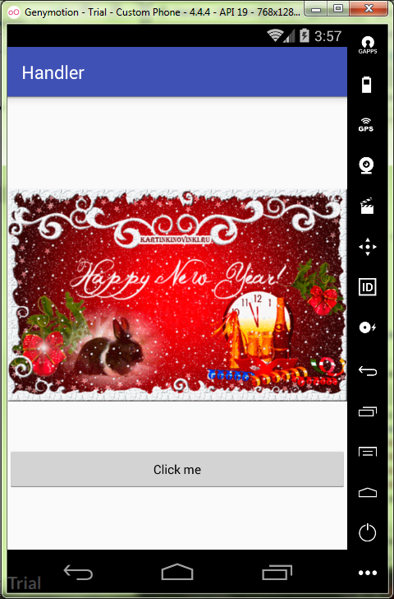

MainActivity.java:

**package** ru.kuzmiankou.handler;  
  
**import** android.os.Handler;  
**import** android.support.v7.app.AppCompatActivity;  
**import** android.os.Bundle;  
**import** android.view.View;  
**import** android.widget.ImageView;  
  
**public class** MainActivity **extends** AppCompatActivity {  
  
 **int counter** = 0;  
 Handler **handler** = **new** Handler();  
  
 @Override  
 **protected void** onCreate(Bundle savedInstanceState) {  
 **super**.onCreate(savedInstanceState);  
 setContentView(R.layout.***activity_main***);  
 getUserAttention();  
 }  
  
 **public void** onClick(View view) {  
 **counter** = 0;  
 getUserAttention();  
 }  
  
 **private void** getUserAttention() {  
 **handler**.post(**task**);  
 }  
  
 Runnable **task** = **new** Runnable() {  
 @Override  
 **public void** run() {  
 ImageView imageView = (ImageView) findViewById(R.id.***image***);  
 **if** (**counter** % 2 == 0) {  
 imageView.setVisibility(View.***INVISIBLE***);  
 }  
 **else** {  
 imageView.setVisibility(View.***VISIBLE***);  
 }  
 **counter**++;  
 **if** (**counter** < 8) {  
 **handler**.postDelayed(**this**, 400);  
 }  
 }  
 };  
}

activity_main.xml:

*<?***xml version="1.0" encoding="utf-8"***?>*<**LinearLayout  
 xmlns:android="http://schemas.android.com/apk/res/android"  
 xmlns:tools="http://schemas.android.com/tools"  
 android:layout_width="match_parent"  
 android:layout_height="match_parent"  
 android:gravity="center"  
 android:orientation="vertical"  
 tools:context="ru.kuzmiankou.handler.MainActivity"**>  
  
 <**ImageView  
 android:layout_width="wrap_content"  
 android:layout_height="wrap_content"  
 android:id="@+id/image"  
 android:src="@drawable/newyear"**/>  
  
 <**Button  
 android:layout_width="match_parent"  
 android:layout_height="wrap_content"  
 style="?android:attr/buttonStyleSmall"  
 android:text="@string/button"  
 android:layout_marginTop="16dp"  
 android:onClick="onClick"**/>  
</**LinearLayout**>

Repository: https://github.com/kuzanatoliy/itmo.mobile.task17.git