Screens:  
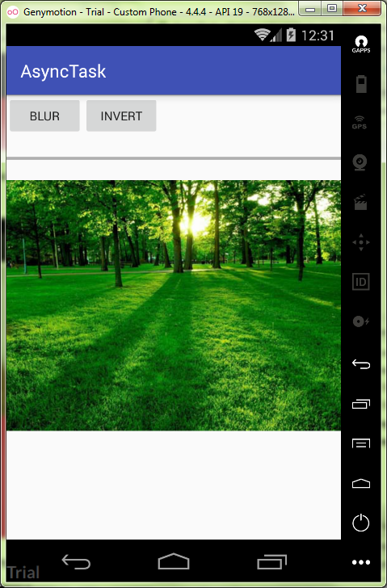

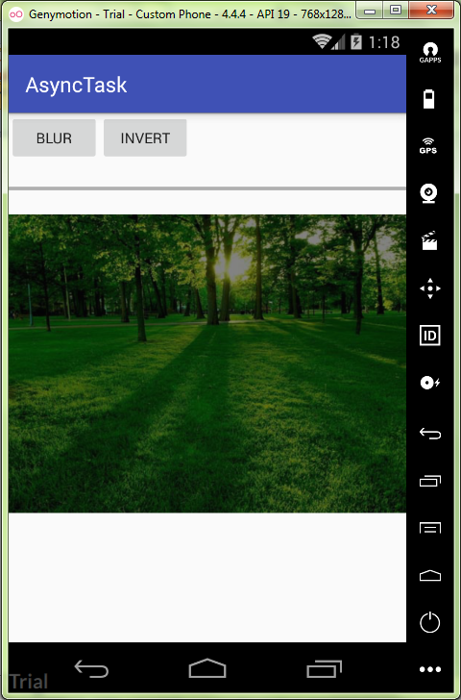

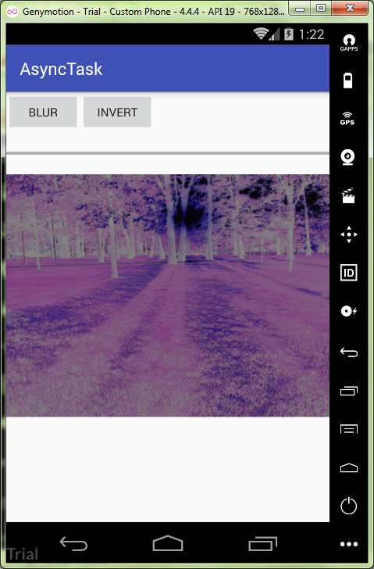

MainActivity.java:

**package** ru.kuzmiankou.asynctask;  
  
**import** android.graphics.Bitmap;  
**import** android.graphics.drawable.BitmapDrawable;  
**import** android.os.AsyncTask;  
**import** android.support.v7.app.AppCompatActivity;  
**import** android.os.Bundle;  
**import** android.view.View;  
**import** android.widget.ImageView;  
**import** android.widget.ProgressBar;  
  
**public class** MainActivity **extends** AppCompatActivity {  
  
 **private** ProgressBar **progressBar**;  
  
 @Override  
 **protected void** onCreate(Bundle savedInstanceState) {  
 **super**.onCreate(savedInstanceState);  
 setContentView(R.layout.***activity_main***);  
 **progressBar** = (ProgressBar) findViewById(R.id.***progressBar***);  
 }  
  
 **public void** doBlur(View view) {  
 BlurImageTask task = **new** BlurImageTask();  
 ImageView imageView = (ImageView) findViewById(R.id.***imageView***);  
 Bitmap bitmap = ((BitmapDrawable) imageView.getDrawable()).getBitmap();  
 task.execute(bitmap);  
 }  
  
 **public void** doInvert(View view) {  
 InvertImageTask task = **new** InvertImageTask();  
 ImageView imageView = (ImageView) findViewById(R.id.***imageView***);  
 Bitmap bitmap = ((BitmapDrawable) imageView.getDrawable()).getBitmap();  
 task.execute(bitmap);  
 }  
  
 **private class** InvertImageTask **extends** AsyncTask<Bitmap, Integer, Bitmap> {  
 **protected** Bitmap doInBackground(Bitmap... bitmap) {  
 Bitmap input = bitmap[0];  
 Bitmap result = input.copy(input.getConfig(), **true**);  
 **int** width = input.getWidth();  
 **int** height = input.getHeight();  
 **for**(**int** i = 0; i < height; i++) {  
 **for**(**int** j = 0; j < width; j++) {  
 **int** pixel = input.getPixel(j, i);  
 **int** a = pixel & 0xff000000;  
 a = a | (~pixel & 0x00ffffff);  
 result.setPixel(j, i, a);  
 }  
 **int** progress = 100 * (i + 1) / height;  
 publishProgress(progress);  
 }  
 **return** result;  
 }  
  
 **protected void** onProgressUpdate(Integer... values) {  
 **progressBar**.setProgress(values[0]);  
 }  
  
 **public void** onPostExecute(Bitmap result) {  
 ImageView imageView = (ImageView) findViewById(R.id.***imageView***);  
 imageView.setImageBitmap(result);  
 **progressBar**.setProgress(0);  
 }  
 }  
  
 **private class** BlurImageTask **extends** AsyncTask<Bitmap, Integer, Bitmap> {  
 **protected** Bitmap doInBackground(Bitmap... bitmap) {  
 Bitmap input = bitmap[0];  
 Bitmap result = input.copy(input.getConfig(), **true**);  
 **int** width = bitmap[0].getWidth();  
 **int** height = bitmap[0].getHeight();  
 **int** level = 7;  
 **for** (**int** i = 0; i < height; i++) {  
 **for**(**int** j = 0; j < width; j++) {  
 **int** pixel = bitmap[0].getPixel(j, i);  
 **int** a = pixel & 0xff000000;  
 **int** r = (pixel >> 16) & 0xff;  
 **int** g = (pixel >> 8) & 0xff;  
 **int** b = pixel & 0xff;  
 r = (r + level) / 2;  
 g = (g + level) / 2;  
 b = (b + level) / 2;  
 **int** gray = a | (r << 16) | (g << 8) | b;  
 result.setPixel(j, i, gray);  
 }  
 **int** progress = 100 * (i + 1) / height;  
 publishProgress(progress);  
 }  
 **return** result;  
 }  
  
 **protected void** onProgressUpdate(Integer... values) {  
 **progressBar**.setProgress(values[0]);  
 }  
  
 **protected void** onPostExecute(Bitmap result) {  
 ImageView imageView = (ImageView) findViewById(R.id.***imageView***);  
 imageView.setImageBitmap(result);  
 **progressBar**.setProgress(0);  
 }  
 }  
}

activity_main.xml:

<**LinearLayout  
 xmlns:android="http://schemas.android.com/apk/res/android"  
 xmlns:app="http://schemas.android.com/apk/res-auto"  
 xmlns:tools="http://schemas.android.com/tools"  
 android:layout_width="match_parent"  
 android:layout_height="match_parent"  
 android:orientation="vertical"  
 tools:context="ru.kuzmiankou.asynctask.MainActivity"**>  
  
 <**LinearLayout  
 android:layout_width="wrap_content"  
 android:layout_height="wrap_content"**>  
  
 <**Button  
 android:layout_width="wrap_content"  
 android:layout_height="wrap_content"  
 android:onClick="doBlur"  
 android:text="BLUR"**/>  
  
 <**Button  
 android:layout_width="wrap_content"  
 android:layout_height="wrap_content"  
 android:onClick="doInvert"  
 android:text="INVERT"**/>  
 </**LinearLayout**>  
  
 <**ProgressBar  
 android:id="@+id/progressBar"  
 style="?android:attr/progressBarStyleHorizontal"  
 android:layout_width="match_parent"  
 android:layout_height="50dp"** />  
  
 <**ImageView  
 android:id="@+id/imageView"  
 android:layout_width="match_parent"  
 android:layout_height="match_parent"  
 android:src="@drawable/nature"  
 android:scaleType="fitStart"**/>  
  
</**LinearLayout**>

Repository: https://github.com/kuzanatoliy/itmo.mobile.task18.git