Screens:  
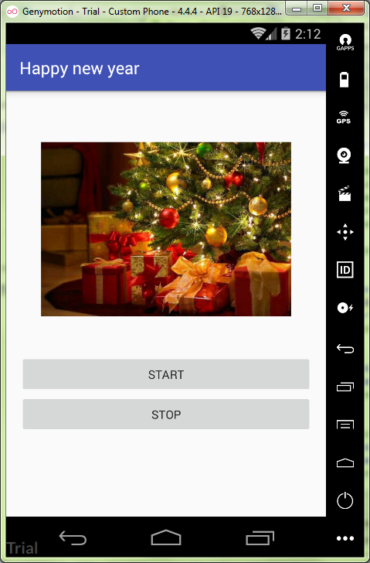

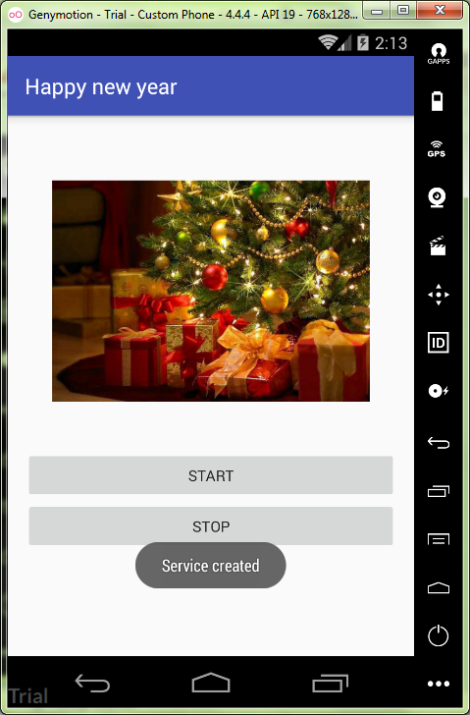

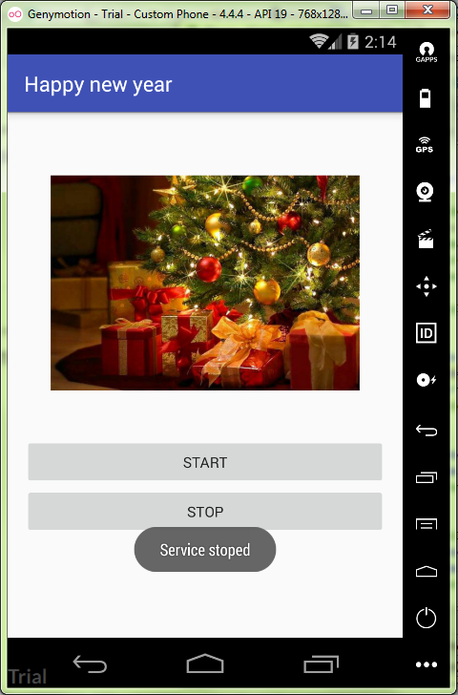

MainActivity.java:

ru.kuzmiankou.player;  
  
**import** android.content.Intent;  
**import** android.support.v7.app.AppCompatActivity;  
**import** android.os.Bundle;  
**import** android.view.View;  
**import** android.view.ViewGroup;  
**import** android.widget.Button;  
  
**public class** MainActivity **extends** AppCompatActivity {  
  
 @Override  
 **protected void** onCreate(Bundle savedInstanceState) {  
 **super**.onCreate(savedInstanceState);  
 setContentView(R.layout.***activity_main***);  
 setTitle(**"Happy new year"**);  
  
 **final** Button btnStart = (Button) findViewById(R.id.***buttonStart***);  
 **final** Button btnStop = (Button) findViewById(R.id.***buttonStop***);  
  
 btnStart.setOnClickListener(**new** View.OnClickListener(){  
 @Override  
 **public void** onClick(View view) {  
 startService(**new** Intent(MainActivity.**this**, PlayerService.**class**));  
 }  
 });  
  
 btnStop.setOnClickListener(**new** View.OnClickListener(){  
 @Override  
 **public void** onClick(View view) {  
 stopService(**new** Intent(MainActivity.**this**, PlayerService.**class**));  
 }  
 });  
 }  
}

activity_main.xml:

*<?***xml version="1.0" encoding="utf-8"***?>*<**ScrollView  
 xmlns:android="http://schemas.android.com/apk/res/android"  
 xmlns:app="http://schemas.android.com/apk/res-auto"  
 xmlns:tools="http://schemas.android.com/tools"  
 android:layout_width="match_parent"  
 android:layout_height="match_parent"  
 android:padding="16dp"  
 tools:context="ru.kuzmiankou.player.MainActivity"**>  
  
 <**LinearLayout  
 android:layout_width="match_parent"  
 android:layout_height="match_parent"  
 android:orientation="vertical"  
 android:gravity="center"**>  
  
 <**ImageView  
 android:layout_width="300dp"  
 android:layout_height="300dp"  
 android:src="@drawable/newyear"**/>  
  
 <**Button  
 android:id="@+id/buttonStart"  
 android:layout_width="match_parent"  
 android:layout_height="wrap_content"  
 android:text="@string/start"**/>  
  
 <**Button  
 android:id="@+id/buttonStop"  
 android:layout_width="match_parent"  
 android:layout_height="wrap_content"  
 android:text="@string/stop"**/>  
  
 </**LinearLayout**>  
  
</**ScrollView**>

PlayerService.java:

**package** ru.kuzmiankou.player;  
  
**import** android.app.Service;  
**import** android.content.Intent;  
**import** android.media.MediaPlayer;  
**import** android.os.IBinder;  
**import** android.support.annotation.Nullable;  
**import** android.widget.Toast;  
  
**public class** PlayerService **extends** Service {  
  
 **private** MediaPlayer **mPlayer**;  
  
 @Nullable  
 @Override  
 **public** IBinder onBind(Intent intent) {  
 **return null**;  
 }  
  
 @Override  
 **public void** onCreate() {  
 **super**.onCreate();  
 Toast.*makeText*(**this**, **"Service created"**, Toast.***LENGTH_SHORT***).show();  
 **mPlayer** = MediaPlayer.*create*(**this**, R.raw.***new_year***);  
 **mPlayer**.setLooping(**false**);  
 }  
  
 @Override  
 **public int** onStartCommand(Intent intent, **int** flags, **int** startId) {  
 Toast.*makeText*(**this**, **"Service started"**, Toast.***LENGTH_SHORT***).show();  
 **mPlayer**.start();  
 **return super**.onStartCommand(intent, flags, startId);  
 }  
  
 @Override  
 **public void** onDestroy() {  
 **super**.onDestroy();  
 Toast.*makeText*(**this**, **"Service stoped"**, Toast.***LENGTH_SHORT***).show();  
 **mPlayer**.stop();  
 }  
}

Repository: https://github.com/kuzanatoliy/itmo.mobile.task19.git