Screens:

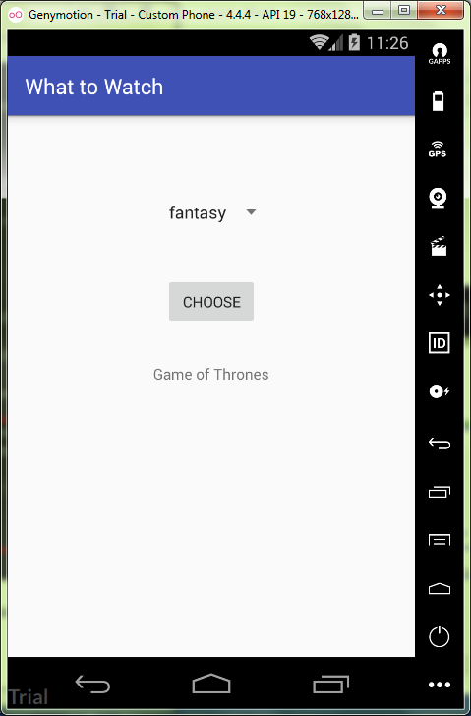

activity_main.xml:

*<?***xml version="1.0" encoding="utf-8"***?>*<**RelativeLayout  
 xmlns:android="http://schemas.android.com/apk/res/android"  
 android:layout_width="match_parent"  
 android:layout_height="match_parent"  
 android:gravity="center"  
 android:orientation="vertical"** >  
  
 <**Spinner  
 android:layout_width="wrap_content"  
 android:layout_height="wrap_content"  
 android:id="@+id/spinner"  
 android:entries="@array/choose_genre"  
 android:layout_above="@+id/choose"  
 android:layout_centerHorizontal="true"  
 android:layout_marginBottom="48dp"** />  
  
 <**Button  
 android:id="@+id/choose"  
 android:layout_width="wrap_content"  
 android:layout_height="wrap_content"  
 android:text="@string/choose"  
 android:onClick="onClickChooseSeries"  
 android:layout_centerVertical="true"  
 android:layout_centerHorizontal="true"** />  
  
 <**TextView  
 android:id="@+id/genre"  
 android:layout_width="wrap_content"  
 android:layout_height="wrap_content"  
 android:text="@string/genre"  
 android:layout_alignParentBottom="true"  
 android:layout_centerHorizontal="true"  
 android:layout_marginBottom="161dp"** />  
  
</**RelativeLayout**>

string.xml:

<**resources**>  
 <**string name="app_name"**>What to Watch</**string**>  
  
 <**string name="choose"**>Choose</**string**>  
 <**string name="genre"**>Genre</**string**>  
  
 <**string-array name="choose_genre"**>  
 <**item**>comedy</**item**>  
 <**item**>fantasy</**item**>  
 <**item**>horror</**item**>  
 <**item**>fantastic</**item**>  
 <**item**>crime</**item**>  
 </**string-array**>  
</**resources**>

MainActivity.java:

**import** android.widget.TextView;  
  
**import** java.util.List;  
  
**public class** MainActivity **extends** AppCompatActivity {  
 **private** SeriesList **work** = **new** SeriesList();  
  
 @Override  
 **protected void** onCreate(Bundle savedInstanceState) {  
 **super**.onCreate(savedInstanceState);  
 setContentView(R.layout.***activity_main***);  
 }  
  
 **public void** onClickChooseSeries(View view) {  
 TextView genre = (TextView) findViewById(R.id.***genre***);  
 Spinner spinner = (Spinner) findViewById(R.id.***spinner***);  
 String seriesPlan = String.*valueOf*(spinner.getSelectedItem());  
 List<String> genreList = **work**.getGenre(seriesPlan);  
 StringBuilder genreModified = **new** StringBuilder();  
 **for**(String genres: genreList) {  
 genreModified.append(genres).append(**'\n'**);  
 }  
 genre.setText(genreModified);  
 }  
}

SeriesList.java:

**package** ru.kuzmiankou.whattowatch;  
  
**import** java.util.List;  
**import** java.util.ArrayList;  
  
**public class** SeriesList {  
 List<String> getGenre(String spinner) {  
 List<String> genre = **new** ArrayList<String>();  
 **if**(spinner.equals(**"comedy"**)) {  
 genre.add(**"Friends"**);  
 }  
 **if**(spinner.equals(**"fantasy"**)) {  
 genre.add(**"Game of Thrones"**);  
 }  
 **if**(spinner.equals(**"horror"**)) {  
 genre.add(**"Call"**);  
 }  
 **if**(spinner.equals(**"fantastic"**)) {  
 genre.add(**"Star Trek, Discovery"**);  
 }  
 **if**(spinner.equals(**"crime"**)) {  
 genre.add(**"Breaking bad"**);  
 }  
 **return** genre;  
 }  
}

repository: https://github.com/kuzanatoliy/itmo.mobile.task2.git