Screens:  
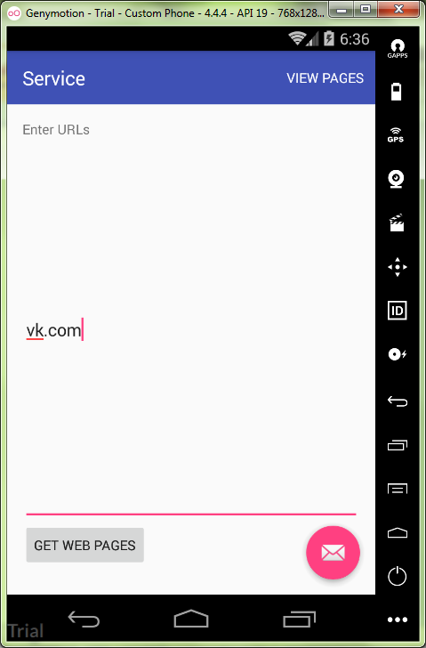

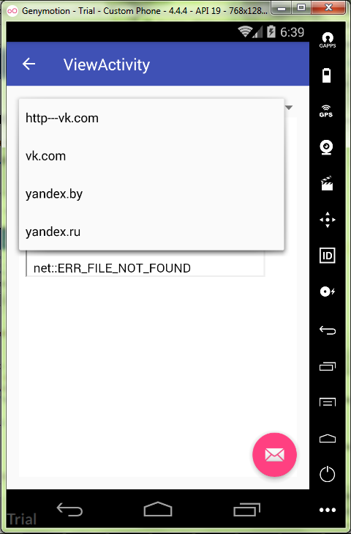

MainActivity.java:

**package** ru.kuzmiankou.service;  
  
**import** android.content.Intent;  
**import** android.os.Bundle;  
**import** android.os.StrictMode;  
**import** android.support.design.widget.FloatingActionButton;  
**import** android.support.design.widget.Snackbar;  
**import** android.support.v7.app.AppCompatActivity;  
**import** android.support.v7.widget.Toolbar;  
**import** android.util.Log;  
**import** android.view.View;  
**import** android.view.Menu;  
**import** android.view.MenuItem;  
**import** android.widget.EditText;  
  
**public class** MainActivity **extends** AppCompatActivity {  
  
 @Override  
 **protected void** onCreate(Bundle savedInstanceState) {  
 **super**.onCreate(savedInstanceState);  
 setContentView(R.layout.***activity_main***);  
 Toolbar toolbar = (Toolbar) findViewById(R.id.***toolbar***);  
 setSupportActionBar(toolbar);  
  
 StrictMode.ThreadPolicy policy = **new** StrictMode.ThreadPolicy.Builder()  
 .permitAll().build();  
 StrictMode.*setThreadPolicy*(policy);  
  
 FloatingActionButton fab = (FloatingActionButton) findViewById(R.id.***fab***);  
 fab.setOnClickListener(**new** View.OnClickListener() {  
 @Override  
 **public void** onClick(View view) {  
 Snackbar.*make*(view, **"Replace with your own action"**, Snackbar.***LENGTH_LONG***)  
 .setAction(**"Action"**, **null**).show();  
 }  
 });  
 }  
  
 @Override  
 **public boolean** onCreateOptionsMenu(Menu menu) {  
 *// Inflate the menu; this adds items to the action bar if it is present.* getMenuInflater().inflate(R.menu.***menu_main***, menu);  
 **return true**;  
 }  
  
 @Override  
 **public boolean** onOptionsItemSelected(MenuItem item) {  
 **int** id = item.getItemId();  
 **if**(id == R.id.***action_view***) {  
 Intent intent = **new** Intent(**this**, ViewActivity.**class**);  
 startActivity(intent);  
 **return true**;  
 }  
 **return super**.onOptionsItemSelected(item);  
 }  
  
  
 **public void** getWebPages(View view) {  
 EditText editText = (EditText) findViewById(R.id.***urls***);  
 Intent intent = **new** Intent(**this**, URLService.**class**);  
 intent.putExtra(**"urls"**, editText.getText().toString());  
 startService(intent);  
 }  
}

content_main.xml:

*<?***xml version="1.0" encoding="utf-8"***?>*<**LinearLayout  
 xmlns:android="http://schemas.android.com/apk/res/android"  
 xmlns:app="http://schemas.android.com/apk/res-auto"  
 xmlns:tools="http://schemas.android.com/tools"  
 android:layout_width="match_parent"  
 android:layout_height="match_parent"  
 android:orientation="vertical"  
 android:padding="16dp"  
 app:layout_behavior="@string/appbar_scrolling_view_behavior"  
 tools:context="ru.kuzmiankou.service.MainActivity"  
 tools:showIn="@layout/activity_main"**>  
  
 <**TextView  
 android:layout_width="wrap_content"  
 android:layout_height="wrap_content"  
 android:text="@string/urls"** />  
  
 <**EditText  
 android:id="@+id/urls"  
 android:layout_width="match_parent"  
 android:layout_height="400dp"  
 android:inputType="textMultiLine"**/>  
  
 <**Button  
 android:id="@+id/getBtn"  
 android:layout_width="wrap_content"  
 android:layout_height="wrap_content"  
 android:text="@string/getBtn"  
 android:onClick="getWebPages"**/>  
  
</**LinearLayout**>

menu_main.xml:

*<?***xml version="1.0" encoding="utf-8"***?>*<**LinearLayout  
 xmlns:android="http://schemas.android.com/apk/res/android"  
 xmlns:app="http://schemas.android.com/apk/res-auto"  
 xmlns:tools="http://schemas.android.com/tools"  
 android:layout_width="match_parent"  
 android:layout_height="match_parent"  
 android:orientation="vertical"  
 android:padding="16dp"  
 app:layout_behavior="@string/appbar_scrolling_view_behavior"  
 tools:context="ru.kuzmiankou.service.MainActivity"  
 tools:showIn="@layout/activity_main"**>  
  
 <**TextView  
 android:layout_width="wrap_content"  
 android:layout_height="wrap_content"  
 android:text="@string/urls"** />  
  
 <**EditText  
 android:id="@+id/urls"  
 android:layout_width="match_parent"  
 android:layout_height="400dp"  
 android:inputType="textMultiLine"**/>  
  
 <**Button  
 android:id="@+id/getBtn"  
 android:layout_width="wrap_content"  
 android:layout_height="wrap_content"  
 android:text="@string/getBtn"  
 android:onClick="getWebPages"**/>  
  
</**LinearLayout**>

content_view.xml:

*<?***xml version="1.0" encoding="utf-8"***?>*<**LinearLayout xmlns:android="http://schemas.android.com/apk/res/android"  
 xmlns:app="http://schemas.android.com/apk/res-auto"  
 xmlns:tools="http://schemas.android.com/tools"  
 android:id="@+id/content_view"  
 android:orientation="vertical"  
 android:layout_width="match_parent"  
 android:layout_height="match_parent"  
 android:padding="16dp"  
 app:layout_behavior="@string/appbar_scrolling_view_behavior"  
 tools:context="ru.kuzmiankou.service.ViewActivity"  
 tools:showIn="@layout/activity_view"**>  
  
 <**Spinner  
 android:layout_width="match_parent"  
 android:layout_height="wrap_content"  
 android:id="@+id/spinner"**/>  
  
 <**WebView  
 android:layout_width="match_parent"  
 android:layout_height="match_parent"  
 android:id="@+id/webview"** />  
  
</**LinearLayout**>

Repository: https://github.com/kuzanatoliy/itmo.mobile.task20.git