Screens:  
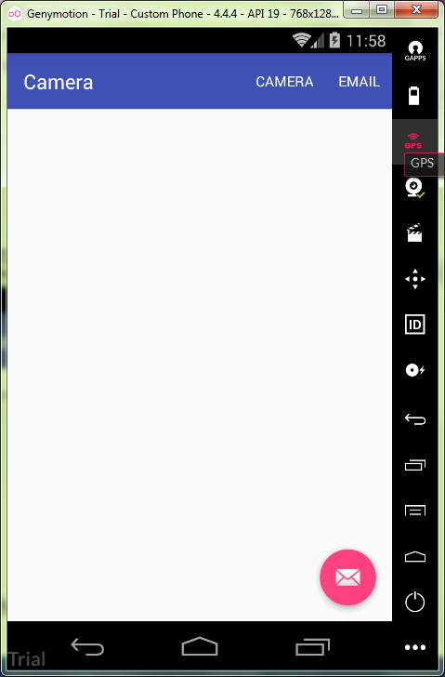

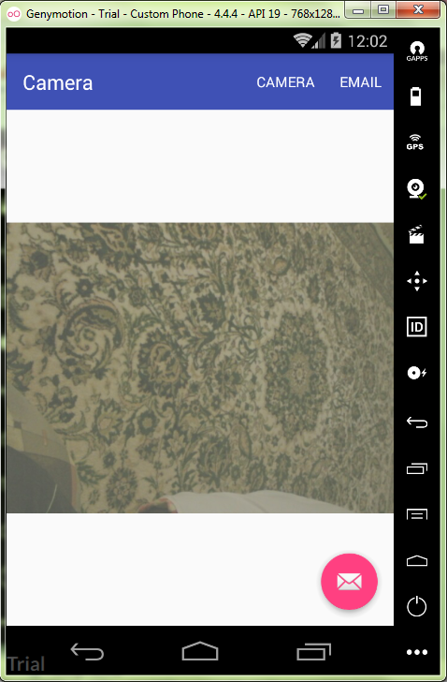

MainActivity.java:

**package** ru.kuzmiankou.camera;  
  
**import** android.content.Intent;  
**import** android.media.MediaPlayer;  
**import** android.net.Uri;  
**import** android.os.Bundle;  
**import** android.os.Environment;  
**import** android.provider.MediaStore;  
**import** android.support.design.widget.FloatingActionButton;  
**import** android.support.design.widget.Snackbar;  
**import** android.support.v7.app.AppCompatActivity;  
**import** android.support.v7.widget.Toolbar;  
**import** android.view.View;  
**import** android.view.Menu;  
**import** android.view.MenuItem;  
**import** android.widget.ImageView;  
**import** android.widget.Toast;  
  
**import** java.io.File;  
  
**public class** MainActivity **extends** AppCompatActivity {  
  
 **private static final int *CAPTURE_IMAGE_ACTIVITY_REQUWAR_CODE*** = 100;  
 File **pictureDir** = **new** File(Environment.*getExternalStoragePublicDirectory*(  
 Environment.*DIRECTORY_PICTURES*), **"CameraDemo"**);  
 **private static final** String ***FILE_NAME*** = **"image01.jpg"**;  
 **private** Uri **fileUri**;  
  
 @Override  
 **protected void** onCreate(Bundle savedInstanceState) {  
 **super**.onCreate(savedInstanceState);  
 setContentView(R.layout.***activity_main***);  
 Toolbar toolbar = (Toolbar) findViewById(R.id.***toolbar***);  
 setSupportActionBar(toolbar);  
  
 **if**(!**pictureDir**.exists()) {  
 **pictureDir**.mkdir();  
 }  
  
 FloatingActionButton fab = (FloatingActionButton) findViewById(R.id.***fab***);  
 fab.setOnClickListener(**new** View.OnClickListener() {  
 @Override  
 **public void** onClick(View view) {  
 Snackbar.*make*(view, **"Replace with your own action"**, Snackbar.***LENGTH_LONG***)  
 .setAction(**"Action"**, **null**).show();  
 }  
 });  
 }  
  
 @Override  
 **public boolean** onCreateOptionsMenu(Menu menu) {  
 *// Inflate the menu; this adds items to the action bar if it is present.* getMenuInflater().inflate(R.menu.***menu_main***, menu);  
 **return true**;  
 }  
  
 @Override  
 **public boolean** onOptionsItemSelected(MenuItem item) {  
 **switch** (item.getItemId()) {  
 **case** R.id.***action_camere***:  
 showCamera();  
 **return true**;  
 **case** R.id.***action_email***:  
 emailPicture();  
 **return true**;  
 **default**:  
 **return super**.onContextItemSelected(item);  
 }  
 }  
  
 **private void** showCamera() {  
 Intent intent = **new** Intent(MediaStore.***ACTION_IMAGE_CAPTURE***);  
 File image = **new** File(**pictureDir**, ***FILE_NAME***);  
 **fileUri** = Uri.*fromFile*(image);  
 intent.putExtra(MediaStore.***EXTRA_OUTPUT***, **fileUri**);  
 **if**(intent.resolveActivity(getPackageManager()) != **null**) {  
 startActivityForResult(intent, ***CAPTURE_IMAGE_ACTIVITY_REQUWAR_CODE***);  
 }  
 }  
  
 @Override  
 **protected void** onActivityResult(**int** requestCode, **int** resultCode, Intent data) {  
 **if**(requestCode == ***CAPTURE_IMAGE_ACTIVITY_REQUWAR_CODE***) {  
 **if**(resultCode == ***RESULT_OK***) {  
 ImageView imageView = (ImageView) findViewById(R.id.***imageView***);  
 File image = **new** File (**pictureDir**, ***FILE_NAME***);  
 **fileUri** = Uri.*fromFile*(image);  
 imageView.setImageURI(**fileUri**);  
 }  
 **else if** (resultCode == ***RESULT_CANCELED***) {  
 Toast.*makeText*(**this**, **"Action cancelled"**, Toast.***LENGTH_LONG***).show();  
  
 }  
 **else** {  
 Toast.*makeText*(**this**, **"Error"**, Toast.***LENGTH_LONG***).show();  
 }  
 }  
 }  
  
 **private void** emailPicture() {  
 Intent emailIntent = **new** Intent(Intent.***ACTION_SEND***);  
 emailIntent.setType(**"aplication/image"**);  
 emailIntent.putExtra(Intent.***EXTRA_EMAIL***, **new** String[]{**"me@example.com"**});  
 emailIntent.putExtra(Intent.***EXTRA_SUBJECT***, **"New photo"**);  
 emailIntent.putExtra(Intent.***EXTRA_STREAM***, **fileUri**);  
 startActivity(Intent.*createChooser*(emailIntent, **"Send mail..."**));  
 }  
}

content_main.xml:

*<?***xml version="1.0" encoding="utf-8"***?>*<**android.support.constraint.ConstraintLayout xmlns:android="http://schemas.android.com/apk/res/android"  
 xmlns:app="http://schemas.android.com/apk/res-auto"  
 xmlns:tools="http://schemas.android.com/tools"  
 android:layout_width="match_parent"  
 android:layout_height="match_parent"  
 app:layout_behavior="@string/appbar_scrolling_view_behavior"  
 tools:context="ru.kuzmiankou.camera.MainActivity"  
 tools:showIn="@layout/activity_main"**>  
  
 <**ImageView  
 android:id="@+id/imageView"  
 android:layout_width="match_parent"  
 android:layout_height="match_parent"  
 app:layout_constraintBottom_toBottomOf="parent"  
 app:layout_constraintLeft_toLeftOf="parent"  
 app:layout_constraintRight_toRightOf="parent"  
 app:layout_constraintTop_toTopOf="parent"** />  
  
</**android.support.constraint.ConstraintLayout**>

menu_main.xml:

<**menu xmlns:android="http://schemas.android.com/apk/res/android"  
 xmlns:app="http://schemas.android.com/apk/res-auto"  
 xmlns:tools="http://schemas.android.com/tools"  
 tools:context="ru.kuzmiankou.camera.MainActivity"**>  
 <**item  
 android:id="@+id/action_camere"  
 android:orderInCategory="100"  
 android:title="@string/action_camere"  
 app:showAsAction="ifRoom"** />  
  
 <**item  
 android:id="@+id/action_email"  
 android:orderInCategory="200"  
 android:title="@string/action_email"  
 app:showAsAction="ifRoom"** />  
</**menu**>

Repository: https://github.com/kuzanatoliy/itmo.mobile.task21.git