Screens:  
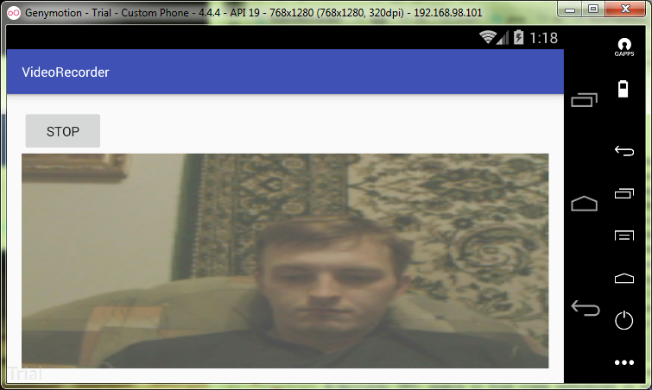

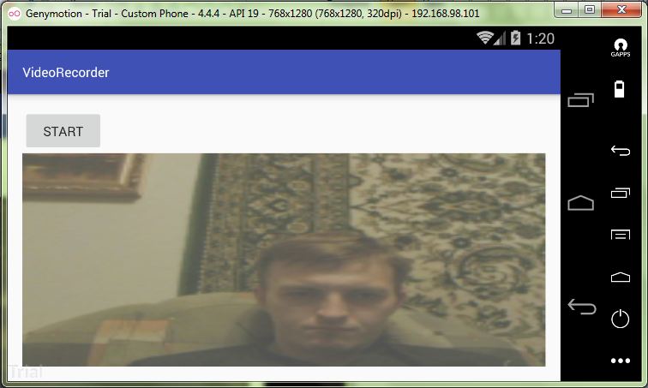

MainActivity.java:

**package** ru.kuzmiankou.videorecorder;  
  
**import** android.media.MediaPlayer;  
**import** android.media.MediaRecorder;  
**import** android.os.Environment;  
**import** android.support.v7.app.AppCompatActivity;  
**import** android.os.Bundle;  
**import** android.view.SurfaceHolder;  
**import** android.view.SurfaceView;  
**import** android.view.View;  
**import** android.widget.Button;  
  
**import** java.io.File;  
**import** java.io.IOException;  
  
**public class** MainActivity **extends** AppCompatActivity {  
  
 **private** MediaRecorder **mediaRecorder**;  
 **private** File **outputDir**;  
 **private boolean recording** = **false**;  
  
 @Override  
 **protected void** onCreate(Bundle savedInstanceState) {  
 **super**.onCreate(savedInstanceState);  
 setContentView(R.layout.***activity_main***);  
 File moviesDir = Environment.*getExternalStoragePublicDirectory*(  
 Environment.*DIRECTORY_MOVIES*);  
 **outputDir** = **new** File(moviesDir, **"VideoRecorder"**);  
 **outputDir**.mkdir();  
 }  
  
 @Override  
 **protected void** onResume(){  
 **super**.onResume();  
 **mediaRecorder** = **new** MediaRecorder();  
 initAddConfigureMediaRecorder();  
 }  
  
 @Override  
 **protected void** onPause() {  
 **super**.onPause();  
 **if**(**recording**) {  
 **try** {  
 **mediaRecorder**.stop();  
 }  
 **catch** (IllegalStateException e) {  
  
 }  
 }  
 releaseMediaRecorder();  
 Button button = (Button) findViewById(R.id.***button1***);  
 button.setText(**"Start"**);  
 **recording** = **false**;  
 };  
  
 **private void** releaseMediaRecorder() {  
 **if**(**mediaRecorder** != **null**) {  
 **mediaRecorder**.reset();  
 **mediaRecorder**.release();  
 **mediaRecorder** = **null**;  
 }  
 }  
  
 **private void** initAddConfigureMediaRecorder() {  
 **mediaRecorder**.setAudioSource(MediaRecorder.AudioSource.***CAMCORDER***);  
 **mediaRecorder**.setVideoSource(MediaRecorder.VideoSource.***CAMERA***);  
 **mediaRecorder**.setOutputFormat(MediaRecorder.OutputFormat.***MPEG_4***);  
 **mediaRecorder**.setVideoFrameRate(10);  
 **mediaRecorder**.setVideoEncoder(MediaRecorder.VideoEncoder.***MPEG_4_SP***);  
 **mediaRecorder**.setAudioEncoder(MediaRecorder.AudioEncoder.***AMR_NB***);  
 String outputFile = **new** File(**outputDir**, System.*currentTimeMillis*() + **".mp4"**).getAbsolutePath();  
 **mediaRecorder**.setOutputFile(outputFile);  
 SurfaceView surfaceView = (SurfaceView) findViewById(R.id.***videoView***);  
 SurfaceHolder surfaceHolder = surfaceView.getHolder();  
 **mediaRecorder**.setPreviewDisplay(surfaceHolder.getSurface());  
 }  
  
 **public void** startStopRecording(View view) {  
 Button button = (Button) findViewById(R.id.***button1***);  
 **if**(**recording**) {  
 button.setText(**"Start"**);  
 **try** {  
 **mediaRecorder**.stop();  
 }  
 **catch** (IllegalStateException e) {  
  
 }  
 releaseMediaRecorder();  
 }  
 **else** {  
 button.setText(**"Stop"**);  
 **if**(**mediaRecorder** == **null**) {  
 **mediaRecorder** = **new** MediaRecorder();  
 initAddConfigureMediaRecorder();  
 }  
 **try** {  
 **mediaRecorder**.prepare();  
 }  
 **catch** (IllegalStateException e) {  
 e.printStackTrace();  
 }  
 **catch** (IOException e) {  
 e.printStackTrace();  
 }  
 **mediaRecorder**.start();  
 }  
 **recording** = !**recording**;  
 }  
}

activity_main.xml:

*<?***xml version="1.0" encoding="utf-8"***?>*<**LinearLayout xmlns:android="http://schemas.android.com/apk/res/android"  
 xmlns:app="http://schemas.android.com/apk/res-auto"  
 xmlns:tools="http://schemas.android.com/tools"  
 android:id="@+id/content_main"  
 android:orientation="vertical"  
 android:layout_width="match_parent"  
 android:layout_height="match_parent"  
 android:padding="16dp"  
 tools:context="ru.kuzmiankou.videorecorder.MainActivity"**>  
  
 <**Button  
 android:id="@+id/button1"  
 android:layout_width="wrap_content"  
 android:layout_height="wrap_content"  
 android:onClick="startStopRecording"  
 android:text="START"**/>  
  
 <**VideoView  
 android:id="@+id/videoView"  
 android:layout_width="match_parent"  
 android:layout_height="match_parent"** />  
</**LinearLayout**>

AndroidManifest.xml:

*<?***xml version="1.0" encoding="utf-8"***?>*<**manifest xmlns:android="http://schemas.android.com/apk/res/android"  
 package="ru.kuzmiankou.videorecorder"**>  
  
 <**uses-feature android:name="android.hardware.camera2"**/>  
 <**uses-feature android:name="android.hardware.autofocus"**/>  
 <**uses-permission android:name="android.permission.CAMERA"**/>  
 <**uses-permission android:name="android.permission.WRITE_EXTERNAL_STORAGE"**/>  
 <**uses-permission android:name="android.permission.RECORD_AUDIO"**/>  
   
 <**application  
 android:allowBackup="true"  
 android:icon="@mipmap/ic_launcher"  
 android:label="@string/app_name"  
 android:screenOrientation="landscape"  
 android:roundIcon="@mipmap/ic_launcher_round"  
 android:supportsRtl="true"  
 android:theme="@style/AppTheme"**>  
 <**activity android:name=".MainActivity"**>  
 <**intent-filter**>  
 <**action android:name="android.intent.action.MAIN"** />  
  
 <**category android:name="android.intent.category.LAUNCHER"** />  
 </**intent-filter**>  
 </**activity**>  
 </**application**>  
  
</**manifest**>

Repository: https://github.com/kuzanatoliy/itmo.mobile.task22.git