Screens:

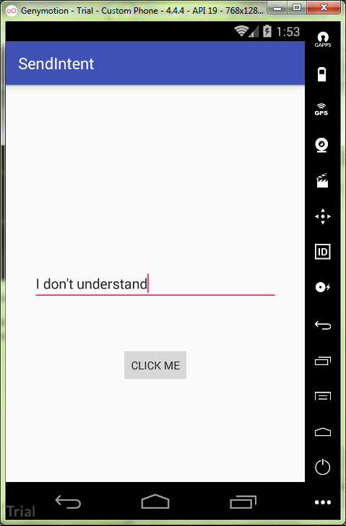

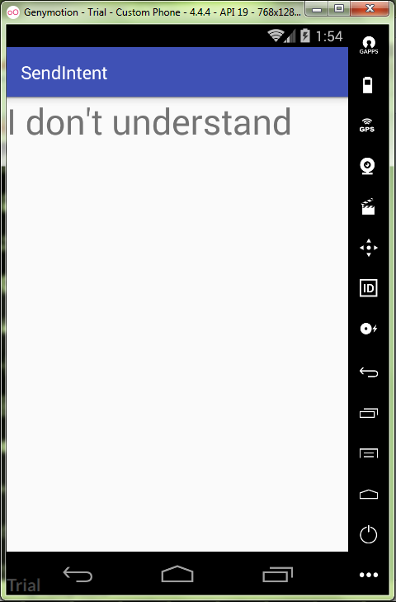

activity_main.xml:

*<?***xml version="1.0" encoding="utf-8"***?>*<**RelativeLayout  
 xmlns:android="http://schemas.android.com/apk/res/android"  
 android:layout_width="match_parent"  
 android:layout_height="match_parent"  
 android:gravity="center"  
 android:orientation="vertical"** >  
  
  
 <**Button  
 android:id="@+id/button"  
 android:layout_below="@+id/edit_message"  
 android:layout_width="wrap_content"  
 android:layout_height="wrap_content"  
 android:layout_centerHorizontal="true"  
 android:layout_marginTop="58dp"  
 android:text="@string/button_name"  
 android:onClick="sendMessage"** />  
  
 <**EditText  
 android:id="@+id/edit_message"  
 android:layout_width="wrap_content"  
 android:layout_height="wrap_content"  
 android:layout_centerHorizontal="true"  
 android:layout_marginTop="107dp"  
 android:layout_alignParentTop="true"  
 android:inputType="textPersonName"  
 android:ems="15"  
 android:hint="@string/edit_me"**/>  
</**RelativeLayout**>

string.xml:

<**resources**>  
 <**string name="app_name"**>SendIntent</**string**>  
  
 <**string name="button_name"**>Click me</**string**>  
 <**string name="edit_me"**>Pass me to new window</**string**>  
</**resources**>

MainActivity.java:

**package** ru.kuzmiankou.sendintent;  
  
**import** android.content.Intent;  
**import** android.support.v7.app.AppCompatActivity;  
**import** android.os.Bundle;  
**import** android.view.View;  
**import** android.widget.EditText;  
  
**public class** MainActivity **extends** AppCompatActivity {  
 **public static final** String ***EXTRA_MESSAGE*** = **"hello, dude!"**;  
  
 @Override  
 **protected void** onCreate(Bundle savedInstanceState) {  
 **super**.onCreate(savedInstanceState);  
 setContentView(R.layout.***activity_main***);  
 }  
  
 **public void** sendMessage(View view) {  
 Intent intent = **new** Intent(**this**, DisplayMessage.**class**);  
 EditText editText = (EditText) findViewById(R.id.***edit_message***);  
 String message = editText.getText().toString();  
 intent.putExtra(***EXTRA_MESSAGE***, message);  
 startActivity(intent);  
 }  
}

DisplayMessage.java:

**package** ru.kuzmiankou.sendintent;  
  
**import** android.content.Intent;  
**import** android.support.v7.app.AppCompatActivity;  
**import** android.os.Bundle;  
**import** android.widget.TextView;  
  
**public class** DisplayMessage **extends** AppCompatActivity {  
  
 @Override  
 **protected void** onCreate(Bundle savedInstanceState) {  
 **super**.onCreate(savedInstanceState);  
  
 Intent intent = getIntent();  
 String message = intent.getStringExtra(MainActivity.***EXTRA_MESSAGE***);  
  
 TextView textView = **new** TextView(**this**);  
 textView.setTextSize(40);  
 textView.setText(message);  
 setContentView(textView);  
 }  
}

repository: https://github.com/kuzanatoliy/itmo.mobile.task3.git