Screens:

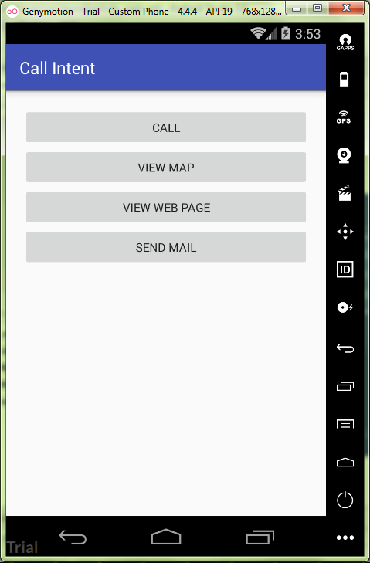

activity_main.xml:

<**LinearLayout  
 xmlns:android="http://schemas.android.com/apk/res/android"  
 xmlns:tools="http://schemas.android.com/tools"  
 android:id="@+id/activity_main"  
 android:layout_width="match_parent"  
 android:layout_height="match_parent"  
 android:paddingBottom="@dimen/activity_vertical_margin"  
 android:paddingLeft="@dimen/activity_horizontal_margin"  
 android:paddingRight="@dimen/activity_horizontal_margin"  
 android:paddingTop="@dimen/activity_vertical_margin"  
 android:orientation="vertical"  
 tools:context="ru.kuzmiankou.callintent.MainActivity"** >  
  
 <**Button  
 android:layout_width="match_parent"  
 android:layout_height="wrap_content"  
 android:id="@+id/btnCall"  
 android:text="@string/call"**/>  
  
 <**Button  
 android:layout_width="match_parent"  
 android:layout_height="wrap_content"  
 android:id="@+id/btnMap"  
 android:text="@string/map"** />  
  
 <**Button  
 android:layout_width="match_parent"  
 android:layout_height="wrap_content"  
 android:id="@+id/btnWeb"  
 android:text="@string/web"** />  
  
 <**Button  
 android:layout_width="match_parent"  
 android:layout_height="wrap_content"  
 android:id="@+id/btnSend"  
 android:text="@string/send"** />  
</**LinearLayout**>

string.xml:

<**resources**>  
 <**string name="app_name"**>Call Intent</**string**>  
  
 <**string name="call"**>Call</**string**>  
 <**string name="map"**>View Map</**string**>  
 <**string name="web"**>View Web page</**string**>  
 <**string name="send"**>Send Mail</**string**>  
</**resources**>

dimens.xml:

*<?***xml version="1.0" encoding="utf-8"***?>*<**resources**>  
 <**dimen name="activity_vertical_margin"**>20dp</**dimen**>  
 <**dimen name="activity_horizontal_margin"**>20dp</**dimen**>  
</**resources**>

MainActivity.java:

**package** ru.kuzmiankou.callintent;  
  
**import** android.content.Intent;  
**import** android.content.pm.PackageManager;  
**import** android.content.pm.ResolveInfo;  
**import** android.net.Uri;  
**import** android.support.v7.app.AppCompatActivity;  
**import** android.os.Bundle;  
**import** android.view.View;  
**import** android.widget.Button;  
**import** android.widget.Toast;  
  
**import** java.util.List;  
  
**public class** MainActivity **extends** AppCompatActivity {  
 **private boolean** isIntentSafe(Intent intent) {  
 PackageManager packageManager = getPackageManager();  
 List<ResolveInfo> activities = packageManager.queryIntentActivities(intent, 0);  
 **return** activities.size() > 0;  
 }  
  
 @Override  
 **protected void** onCreate(Bundle savedInstanceState) {  
 **super**.onCreate(savedInstanceState);  
 setContentView(R.layout.***activity_main***);  
  
 Button btnCall = (Button) findViewById(R.id.***btnCall***);  
 Button btnMap = (Button) findViewById(R.id.***btnMap***);  
 Button btnWeb = (Button) findViewById(R.id.***btnWeb***);  
 Button btnSend = (Button) findViewById(R.id.***btnSend***);  
  
 btnCall.setOnClickListener(**new** View.OnClickListener(){  
 @Override  
 **public void** onClick(View v) {  
 Uri number = Uri.*parse*(**"tel:"**);  
 Intent callIntent = **new** Intent(Intent.***ACTION_DIAL***, number);  
 **if**(isIntentSafe(callIntent)) {  
 startActivity(callIntent);  
 }  
 **else** {  
 Toast.*makeText*(getApplicationContext(),  
 **"Your phone have no app can dial!"**,  
 Toast.***LENGTH_SHORT***).show();  
 }  
 }  
 });  
  
 btnMap.setOnClickListener(**new** View.OnClickListener(){  
 @Override  
 **public void** onClick(View v) {  
 Uri location = Uri.*parse*(**"geo:37.422219,-122.08364/z=14"**);  
 Intent mapIntent = **new** Intent(Intent.***ACTION_VIEW***, location);  
 **if**(isIntentSafe(mapIntent)) {  
 startActivity(mapIntent);  
 }  
 **else** {  
 Toast.*makeText*(getApplicationContext(),  
 **"Your phone have no app can view map!"**,  
 Toast.***LENGTH_LONG***).show();  
 }  
 }  
 });  
  
 btnWeb.setOnClickListener(**new** View.OnClickListener(){  
 @Override  
 **public void** onClick(View v){  
 Uri webpage = Uri.*parse*(**"http://www.vk.com"**);  
 Intent webIntent = **new** Intent(Intent.***ACTION_VIEW***, webpage);  
 **if**(isIntentSafe(webIntent)) {  
 startActivity(webIntent);  
 }  
 **else** {  
 Toast.*makeText*(getApplicationContext(),  
 **"Your phone have no app can open webpage!"**,  
 Toast.***LENGTH_LONG***).show();  
 }  
 }  
 });  
  
 btnSend.setOnClickListener(**new** View.OnClickListener(){  
 @Override  
 **public void** onClick(View v){  
 Intent emailIntent = **new** Intent(Intent.***ACTION_SENDTO***, Uri.*fromParts*(**"mailto"**,  
 **"njkz-09@yandex.by"**, **null**));  
 emailIntent.putExtra(Intent.***EXTRA_EMAIL***,  
 **new** String[]{**"asel-romanova@mail.ru"**, **"hello_lao@mail.ru"**});  
 emailIntent.putExtra(Intent.***EXTRA_SUBJECT***, **"Hello"**);  
 emailIntent.putExtra(Intent.***EXTRA_TEXT***, **"I text mail by Android APP"**);  
 **if**(isIntentSafe(emailIntent)) {  
 startActivity(emailIntent);  
 }  
 **else** {  
 Toast.*makeText*(getApplicationContext(),  
 **"Your phone have no app can send email!"**,  
 Toast.***LENGTH_SHORT***).show();  
 }  
 }  
 });  
 }  
}

repository: https://github.com/kuzanatoliy/itmo.mobile.task4.git