Screens:

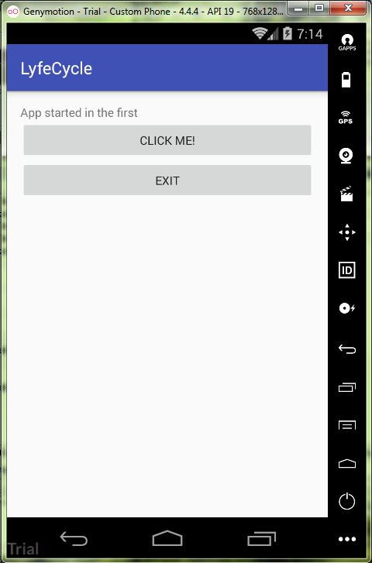

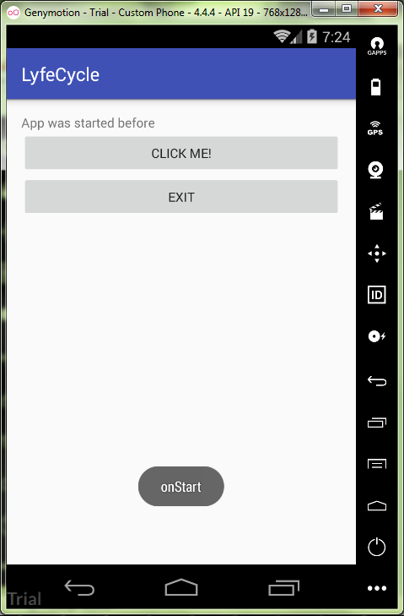

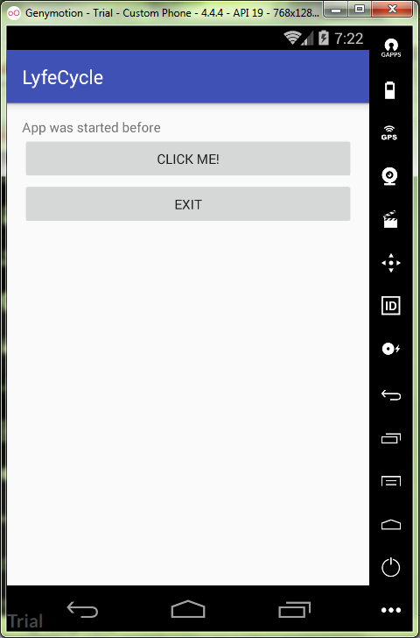

activity_mail.xml:

<**LinearLayout  
 xmlns:android="http://schemas.android.com/apk/res/android"  
 xmlns:tools="http://schemas.android.com/tools"  
 android:id="@+id/activity_main"  
 android:layout_width="match_parent"  
 android:layout_height="match_parent"  
 android:paddingBottom="16dp"  
 android:paddingLeft="16dp"  
 android:paddingRight="16dp"  
 android:paddingTop="16dp"  
 android:orientation="vertical"  
 tools:context="ru.kuzmiankou.lyfecycle.MainActivity"** >  
  
 <**TextView  
 android:layout_width="match_parent"  
 android:layout_height="wrap_content"  
 android:id="@+id/textView"  
 android:text="@string/textViewTitle"** />  
  
 <**Button  
 android:layout_width="match_parent"  
 android:layout_height="wrap_content"  
 android:id="@+id/btnAction"  
 android:text="@string/action"  
 android:onClick="onClick"** />  
  
 <**Button  
 android:layout_width="match_parent"  
 android:layout_height="wrap_content"  
 android:id="@+id/btnExit"  
 android:text="@string/exit"  
 android:onClick="onClick"** />  
</**LinearLayout**>

strings.xml:

<**resources**>  
 <**string name="app_name"**>LyfeCycle</**string**>  
 <**string name="textViewTitle"**>App started in the first</**string**>  
 <**string name="action"**>Click me!</**string**>  
 <**string name="exit"**>Exit</**string**>  
</**resources**>

MainActivity.java:

**package** ru.kuzmiankou.lyfecycle;  
  
**import** android.support.v7.app.AppCompatActivity;  
**import** android.os.Bundle;  
**import** android.util.Log;  
**import** android.view.View;  
**import** android.widget.TextView;  
**import** android.widget.Toast;  
  
**public class** MainActivity **extends** AppCompatActivity {  
 **private** String **TAG** = **"LifeCycle"**;  
 **private** TextView **mInfoLog**;  
  
 @Override  
 **protected void** onCreate(Bundle savedInstanceState) {  
 **super**.onCreate(savedInstanceState);  
 setContentView(R.layout.***activity_main***);  
  
 **mInfoLog** = (TextView) findViewById(R.id.***textView***);  
 Toast.*makeText*(getApplicationContext(), **"onCreate"**, Toast.***LENGTH_LONG***).show();  
 Log.*i*(**TAG**, **"onCreate()"**);  
 }  
  
 @Override  
 **protected void** onStart() {  
 **super**.onStart();  
 Toast.*makeText*(getApplicationContext(), **"onStart"**, Toast.***LENGTH_LONG***).show();  
 Log.*i*(**TAG**, **"onStart"**);  
 }  
  
 @Override  
 **protected void** onResume() {  
 **super**.onResume();  
 Toast.*makeText*(getApplicationContext(), **"onResume"**, Toast.***LENGTH_LONG***).show();  
 Log.*i*(**TAG**, **"onResume"**);  
 }  
  
 @Override  
 **protected void** onPause() {  
 **super**.onPause();  
 Toast.*makeText*(getApplicationContext(), **"onPause"**, Toast.***LENGTH_LONG***).show();  
 Log.*i*(**TAG**, **"onPause"**);  
 }  
  
 @Override  
 **protected void** onStop() {  
 **super**.onStop();  
 Toast.*makeText*(getApplicationContext(), **"onStop"**, Toast.***LENGTH_LONG***).show();  
 Log.*i*(**TAG**, **"onStop"**);  
 }  
  
 @Override  
 **protected void** onRestart() {  
 **super**.onRestart();  
 Toast.*makeText*(getApplicationContext(), **"onRestart"**, Toast.***LENGTH_LONG***).show();  
 Log.*i*(**TAG**, **"onRestart"**);  
 }  
  
 @Override  
 **protected void** onDestroy() {  
 **super**.onDestroy();  
 Toast.*makeText*(getApplicationContext(), **"onDestroy"**, Toast.***LENGTH_LONG***).show();  
 Log.*i*(**TAG**, **"onDestroy"**);  
 }  
  
 **public void** onClick(View v) {  
 **switch**(v.getId()){  
 **case** R.id.***btnAction***:  
 **mInfoLog**.setText(**"App was started before"**);  
 **break**;  
 **case** R.id.***btnExit***:  
 finish();  
 **break**;  
 **default**:  
 **break**;  
 }  
 }  
}

repository: https://github.com/kuzanatoliy/itmo.mobile.task5.git