Screens:

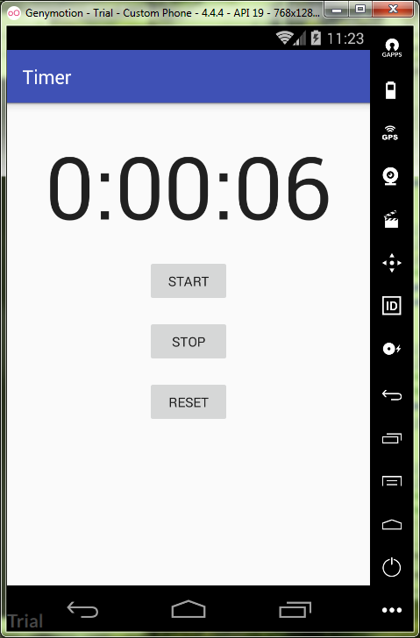

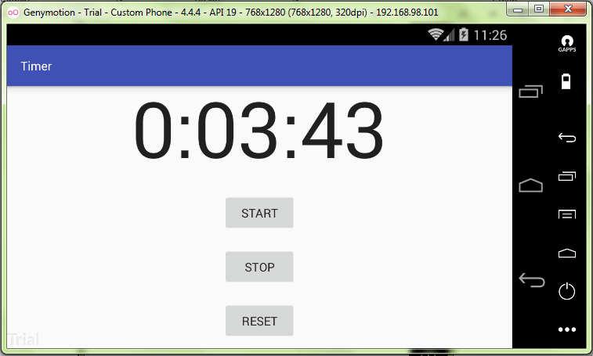

activity_mail.xml:

<**ScrollView  
 android:layout_width="match_parent"  
 android:layout_height="match_parent"  
 xmlns:android="http://schemas.android.com/apk/res/android"  
 xmlns:tools="http://schemas.android.com/tools"  
 tools:context="ru.kuzmiankou.timer.MainActivity"**>  
  
 <**LinearLayout  
 android:id="@+id/activity_main"  
 android:layout_width="match_parent"  
 android:layout_height="match_parent"  
 android:paddingBottom="16dp"  
 android:paddingLeft="16dp"  
 android:paddingRight="16dp"  
 android:paddingTop="16dp"  
 android:gravity="center"  
 android:orientation="vertical"** >  
  
 <**TextView  
 android:layout_width="wrap_content"  
 android:layout_height="wrap_content"  
 android:layout_marginTop="10dp"  
 android:id="@+id/time_view"  
 android:textAppearance="?android:attr/textAppearanceLarge"  
 android:textSize="92sp"** />  
  
 <**Button  
 android:layout_width="wrap_content"  
 android:layout_height="wrap_content"  
 android:id="@+id/start"  
 android:text="@string/start"  
 android:onClick="onClickStart"  
 android:layout_marginTop="16dp"** />  
  
 <**Button  
 android:layout_width="wrap_content"  
 android:layout_height="wrap_content"  
 android:id="@+id/stop"  
 android:text="@string/stop"  
 android:onClick="onClickStop"  
 android:layout_marginTop="16dp"** />  
  
 <**Button  
 android:layout_width="wrap_content"  
 android:layout_height="wrap_content"  
 android:id="@+id/reset"  
 android:text="@string/reset"  
 android:onClick="onClickReset"  
 android:layout_marginTop="16dp"** />  
 </**LinearLayout**>  
</**ScrollView**>

strings.xml:

<**resources**>  
 <**string name="app_name"**>Timer</**string**>  
  
 <**string name="start"**>Start</**string**>  
 <**string name="stop"**>Stop</**string**>  
 <**string name="reset"**>Reset</**string**>  
</**resources**>

MainActivity.java:

**package** ru.kuzmiankou.timer;  
  
**import** android.os.Handler;  
**import** android.support.v7.app.AppCompatActivity;  
**import** android.os.Bundle;  
**import** android.view.View;  
**import** android.widget.TextView;  
  
**public class** MainActivity **extends** AppCompatActivity {  
 **private int seconds** = 0;  
 **private boolean running**;  
  
 @Override  
 **protected void** onCreate(Bundle savedInstanceState) {  
 **super**.onCreate(savedInstanceState);  
 setContentView(R.layout.***activity_main***);  
  
 **if**(savedInstanceState != **null**) {  
 **seconds** = savedInstanceState.getInt(**"seconds"**);  
 **running** = savedInstanceState.getBoolean(**"running"**);  
 }  
 runTimer();  
 }  
  
 @Override  
 **public void** onSaveInstanceState(Bundle savedInstanceState) {  
 **super**.onSaveInstanceState(savedInstanceState);  
 savedInstanceState.putInt(**"seconds"**, **seconds**);  
 savedInstanceState.putBoolean(**"running"**, **running**);  
 }  
  
 **public void** onClickStart(View v) {  
 **running** = **true**;  
 }  
  
 **public void** onClickStop(View v) {  
 **running** = **false**;  
 }  
  
 **public void** onClickReset(View v) {  
 **running** = **false**;  
 **seconds** = 0;  
 }  
  
 **public void** runTimer() {  
 **final** TextView timeView = (TextView) findViewById(R.id.***time_view***);  
 **final** Handler handler = **new** Handler();  
 handler.post(**new** Runnable() {  
 @Override  
 **public void** run() {  
 **int** hours = **seconds**/3600;  
 **int** minutes = (**seconds**%3600)/60;  
 **int** secs = **seconds**%60;  
 String time = String.*format*(**"%d:%02d:%02d"**, hours, minutes, secs);  
 timeView.setText(time);  
 **if**(**running**) {  
 **seconds**++;  
 }  
 handler.postDelayed(**this**, 1000);  
 }  
 });  
 }  
}

repository: https://github.com/kuzanatoliy/itmo.mobile.task6.git