Screens:

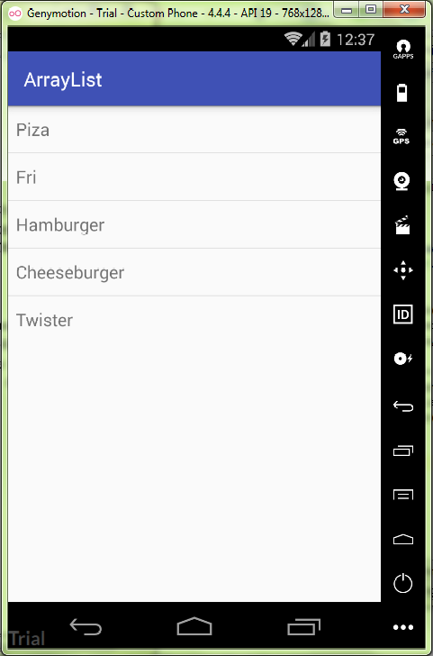

activity_mail.xml:

<**LinearLayout  
 xmlns:android="http://schemas.android.com/apk/res/android"  
 xmlns:tools="http://schemas.android.com/tools"  
 android:layout_width="match_parent"  
 android:layout_height="match_parent"  
 tools:context="ru.kuzmiankou.arraylist.MainActivity"**>  
  
 <**ListView  
 android:id="@+id/foodList"  
 android:layout_width="match_parent"  
 android:layout_height="wrap_content"**>  
  
 </**ListView**>  
  
</**LinearLayout**>

MainActivity.java:

**package** ru.kuzmiankou.arraylist;  
  
**import** android.support.v7.app.AppCompatActivity;  
**import** android.os.Bundle;  
**import** android.widget.ArrayAdapter;  
**import** android.widget.ListView;  
  
**public class** MainActivity **extends** AppCompatActivity {  
 String[] **food** = {**"Piza"**,**"Fri"**,**"Hamburger"**, **"Cheeseburger"**, **"Twister"**};  
  
 @Override  
 **protected void** onCreate(Bundle savedInstanceState) {  
 **super**.onCreate(savedInstanceState);  
 setContentView(R.layout.***activity_main***);  
  
 ListView foodList = (ListView) findViewById(R.id.***foodList***);  
 ArrayAdapter<String> adapter = **new** ArrayAdapter<String>(**this**,  
 android.R.layout.***simple_list_item_1***, **food**);  
 foodList.setAdapter(adapter);  
 }  
}

repository: https://github.com/kuzanatoliy/itmo.mobile.task7.git