Screens:

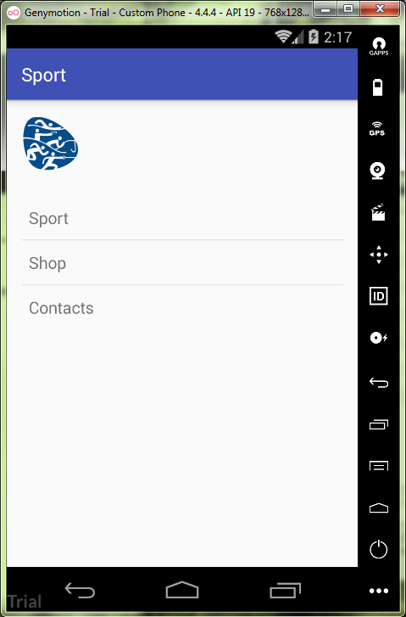

activity_mail.xml:

*<?***xml version="1.0" encoding="utf-8"***?>*<**LinearLayout  
 xmlns:android="http://schemas.android.com/apk/res/android"  
 xmlns:tools="http://schemas.android.com/tools"  
 android:orientation="vertical"  
 android:padding="16dp"  
 android:layout_width="match_parent"  
 android:layout_height="match_parent"  
 android:layout_gravity="center"  
 tools:context="ru.kuzmiankou.sport.MainActivity"**>  
  
 <**ImageView  
 android:id="@+id/logo"  
 android:layout_width="wrap_content"  
 android:layout_height="wrap_content"  
 android:adjustViewBounds="false"  
 android:contentDescription="@string/logo"  
 android:src="@mipmap/logo"** />  
  
 <**ListView  
 android:id="@+id/list"  
 android:layout_marginTop="25dp"  
 android:layout_width="match_parent"  
 android:layout_height="wrap_content"  
 android:entries="@array/options"**>  
  
 </**ListView**>  
</**LinearLayout**>

Strings.xml:

<**resources**>  
 <**string name="app_name"**>Sport</**string**>  
  
 <**string name="logo"**>Logo</**string**>  
 <**string-array name="options"**>  
 <**item**>Sport</**item**>  
 <**item**>Shop</**item**>  
 <**item**>Contacts</**item**>  
 </**string-array**>  
</**resources**>

MainActivity.java:

**package** ru.kuzmiankou.sport;  
  
**import** android.content.Intent;  
**import** android.support.v7.app.AppCompatActivity;  
**import** android.os.Bundle;  
**import** android.view.View;  
**import** android.widget.AdapterView;  
**import** android.widget.ListView;  
  
**public class** MainActivity **extends** AppCompatActivity {  
  
 @Override  
 **protected void** onCreate(Bundle savedInstanceState) {  
 **super**.onCreate(savedInstanceState);  
 setContentView(R.layout.***activity_main***);  
  
 AdapterView.OnItemClickListener itemClickListener = **new** AdapterView.OnItemClickListener() {  
 @Override  
 **public void** onItemClick(AdapterView<?> parent, View v, **int** position, **long** id) {  
 **if**(position == 0) {  
 Intent intent = **new** Intent(MainActivity.**this**, CategoryActivity.**class**);  
 startActivity(intent);  
 }  
 }  
 };  
  
 ListView listView = (ListView) findViewById(R.id.***list***);  
 listView.setOnItemClickListener(itemClickListener);  
 }  
}

CategoryActivity.java:

**package** ru.kuzmiankou.sport;  
  
**import** android.app.ListActivity;  
**import** android.content.Intent;  
**import** android.os.Bundle;  
**import** android.view.View;  
**import** android.widget.ArrayAdapter;  
**import** android.widget.ListView;  
  
**public class** CategoryActivity **extends** ListActivity {  
  
 @Override  
 **protected void** onCreate(Bundle savedInstanceState) {  
 **super**.onCreate(savedInstanceState);  
  
 ListView listSport = getListView();  
 ArrayAdapter<Sport> listAdapter = **new** ArrayAdapter<Sport>(**this**,  
 android.R.layout.***simple_list_item_1***,  
 Sport.***sports***);  
 listSport.setAdapter(listAdapter);  
 }  
  
 @Override  
 **public void** onListItemClick(ListView listView, View view, **int** position, **long** id) {  
 Intent intent = **new** Intent(CategoryActivity.**this**, SportActivity.**class**);  
 intent.putExtra(SportActivity.***EXTRA_SPORTID***, (**int**) id);  
 startActivity(intent);  
 }  
}

activity_sport.xml:

<**LinearLayout  
 xmlns:android="http://schemas.android.com/apk/res/android"  
 xmlns:tools="http://schemas.android.com/tools"  
 android:layout_width="match_parent"  
 android:layout_height="match_parent"  
 android:orientation="vertical"  
 android:gravity="center"  
 android:padding="16dp"  
 tools:context="ru.kuzmiankou.sport.SportActivity"**>  
  
 <**ImageView  
 android:layout_width="wrap_content"  
 android:layout_height="wrap_content"  
 android:id="@+id/photo"  
 android:layout_margin="15dp"** />  
  
 <**TextView  
 android:id="@+id/name"  
 android:layout_width="wrap_content"  
 android:layout_height="wrap_content"  
 android:layout_margin="15dp"**/>  
  
 <**TextView  
 android:id="@+id/description"  
 android:layout_width="wrap_content"  
 android:layout_height="wrap_content"  
 android:layout_margin="15dp"**/>  
</**LinearLayout**>

SportActivity.java:

**package** ru.kuzmiankou.sport;  
  
**import** android.support.v7.app.AppCompatActivity;  
**import** android.os.Bundle;  
**import** android.widget.ImageView;  
**import** android.widget.TextView;  
  
**public class** SportActivity **extends** AppCompatActivity {  
 **public static final** String ***EXTRA_SPORTID*** = **"sportId"**;  
  
 @Override  
 **protected void** onCreate(Bundle savedInstanceState) {  
 **super**.onCreate(savedInstanceState);  
 setContentView(R.layout.***activity_sport***);  
  
 **int** sportId = (Integer)getIntent().getExtras().get(***EXTRA_SPORTID***);  
 Sport sport = Sport.***sports***[sportId];  
  
 ImageView imageView = (ImageView) findViewById(R.id.***photo***);  
 imageView.setImageResource(sport.getImageResourceId());  
 imageView.setContentDescription(sport.getDescription());  
  
 TextView name = (TextView) findViewById(R.id.***name***);  
 name.setText(sport.toString());  
  
 TextView description = (TextView) findViewById(R.id.***description***);  
 description.setText(sport.getDescription());  
 }  
}

Sport.java:

**package** ru.kuzmiankou.sport;  
  
*/**  
 * Created by Anatoliy on 10.11.2017.  
 */***public class** Sport {  
 **private** String **name**;  
 **private** String **description**;  
 **private int imageResourceId**;  
  
 **public** String getDescription() {  
 **return description**;  
 }  
  
 **public** String toString() {  
 **return name**;  
 }  
  
 **public int** getImageResourceId() {  
 **return imageResourceId**;  
 }  
  
 **public static final** Sport[] ***sports*** = {  
 **new** Sport(**"basketball"**, **"basketball"**, R.mipmap.***basketball***),  
 **new** Sport(**"boxing"**, **"boxing"**, R.mipmap.***boxing***),  
 **new** Sport(**"dancing"**, **"dancing"**, R.mipmap.***dancing***),  
 **new** Sport(**"football"**, **"football"**, R.mipmap.***football***),  
 **new** Sport(**"hockey"**, **"hockey"**, R.mipmap.***hockey***),  
 **new** Sport(**"karate"**, **"karate"**, R.mipmap.***karate***),  
 **new** Sport(**"logo"**, **"logo"**, R.mipmap.***logo***),  
 **new** Sport(**"rugby"**, **"rugby"**, R.mipmap.***rugby***),  
 **new** Sport(**"swimming"**, **"swimming"**, R.mipmap.***swimming***),  
 **new** Sport(**"tennis"**, **"tennis"**, R.mipmap.***tennis***),  
 **new** Sport(**"volleyball"**,**"volleyball"**, R.mipmap.***volleyball***)  
 };  
  
 **private** Sport(String name, String description, **int** imageResourceId) {  
 **this**.**name** = name;  
 **this**.**description** = description;  
 **this**.**imageResourceId** = imageResourceId;  
 }  
}

repository: https://github.com/kuzanatoliy/itmo.mobile.task8.git