Screens:

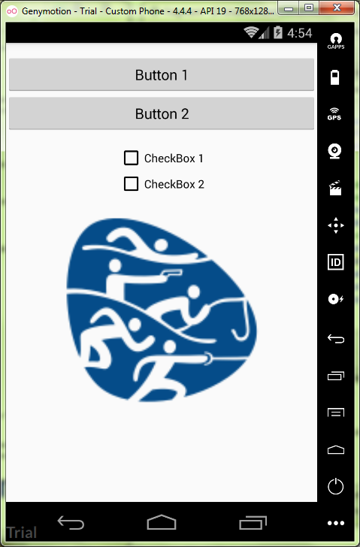

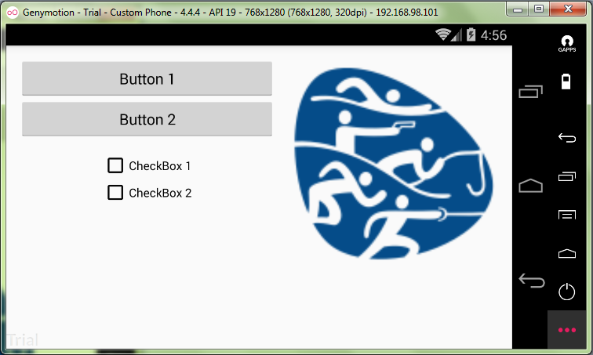

MainActivity.java:

**package** ru.kuzmiankou.fragment;  
  
**import** android.support.v4.app.FragmentActivity;  
**import** android.os.Bundle;  
  
**public class** MainActivity **extends** FragmentActivity {  
  
 @Override  
 **protected void** onCreate(Bundle savedInstanceState) {  
 **super**.onCreate(savedInstanceState);  
 setContentView(R.layout.***activity_main***);  
 }  
}

activity_main.xml:

*<?***xml version="1.0" encoding="utf-8"***?>*<**LinearLayout  
 xmlns:android="http://schemas.android.com/apk/res/android"  
 xmlns:tools="http://schemas.android.com/tools"  
 android:layout_width="match_parent"  
 android:layout_height="match_parent"  
 android:orientation="vertical"**>  
  
 <**fragment  
 android:name="ru.kuzmiankou.fragment.ButtonFragment"  
 android:id="@+id/button_fragment"  
 android:layout_width="match_parent"  
 android:layout_height="wrap_content"  
 tools:layout="@layout/button_fragment"** />  
  
 <**fragment  
 android:name="ru.kuzmiankou.fragment.CheckBoxFragment"  
 android:id="@+id/checkbox_fragment"  
 android:layout_width="match_parent"  
 android:layout_height="wrap_content"  
 tools:layout="@layout/checkbox_fragment"** />  
  
 <**fragment  
 android:name="ru.kuzmiankou.fragment.ImageFragment"  
 android:id="@+id/image_fragment"  
 android:layout_width="match_parent"  
 android:layout_height="match_parent"  
 tools:layout="@layout/image_fragment"** />  
  
</**LinearLayout**>

activity_main.xml(land):

*<?***xml version="1.0" encoding="utf-8"***?>*<**RelativeLayout  
 xmlns:android="http://schemas.android.com/apk/res/android"  
 xmlns:tools="http://schemas.android.com/tools"  
 android:layout_width="match_parent"  
 android:layout_height="match_parent"  
 android:orientation="horizontal"**>  
  
 <**fragment  
 android:name="ru.kuzmiankou.fragment.ButtonFragment"  
 android:id="@+id/button_fragment"  
 android:layout_width="wrap_content"  
 android:layout_height="wrap_content"  
 tools:layout="@layout/button_fragment"  
 android:layout_alignParentLeft="true"  
 android:layout_marginLeft="15dp"  
 android:layout_alignParentTop="true"  
 android:layout_toLeftOf="@+id/image_fragment"** />  
  
 <**fragment  
 android:name="ru.kuzmiankou.fragment.CheckBoxFragment"  
 android:id="@+id/checkbox_fragment"  
 android:layout_width="wrap_content"  
 android:layout_height="wrap_content"  
 tools:layout="@layout/checkbox_fragment"  
 android:layout_below="@+id/button_fragment"  
 android:layout_alignParentLeft="true"  
 android:layout_alignParentStart="true"  
 android:layout_toLeftOf="@+id/image_fragment"  
 android:layout_marginLeft="15dp"**/>  
  
 <**fragment  
 android:name="ru.kuzmiankou.fragment.ImageFragment"  
 android:id="@+id/image_fragment"  
 android:layout_width="wrap_content"  
 android:layout_height="match_parent"  
 tools:layout="@layout/image_fragment"  
 android:layout_alignParentTop="true"  
 android:layout_alignParentRight="true"  
 android:layout_alignParentEnd="true"  
 android:layout_marginRight="15dp"  
 android:layout_marginLeft="15dp"**/>  
  
</**RelativeLayout**>

ButtonFragment,java:

**package** ru.kuzmiankou.fragment;  
  
  
**import** android.os.Bundle;  
**import** android.support.v4.app.Fragment;  
**import** android.view.LayoutInflater;  
**import** android.view.View;  
**import** android.view.ViewGroup;  
  
*/**  
 * A simple {****@link*** *Fragment} subclass.  
 */***public class** ButtonFragment **extends** Fragment {  
  
 @Override  
 **public** View onCreateView(LayoutInflater inflater, ViewGroup container,  
 Bundle savedInstanceState) {  
  
 View viewHierarchy = inflater.inflate(R.layout.***button_fragment***, container, **false**);  
 **return** viewHierarchy;  
 }  
  
}

button_fragment.xml:

*<?***xml version="1.0" encoding="utf-8"***?>*<**LinearLayout  
 xmlns:android="http://schemas.android.com/apk/res/android"  
 android:orientation="vertical"  
 android:paddingTop="15dp"  
 android:layout_width="match_parent"  
 android:layout_height="match_parent"  
 android:layout_gravity="center"**>  
  
 <**Button  
 android:layout_width="match_parent"  
 android:layout_height="wrap_content"  
 android:id="@+id/buttonOne"  
 android:text="@string/buttonOne"**/>  
  
 <**Button  
 android:layout_width="match_parent"  
 android:layout_height="wrap_content"  
 android:id="@+id/buttonTwo"  
 android:text="@string/buttonTwo"**/>  
  
</**LinearLayout**>

checkbox_fragment.xml:

*<?***xml version="1.0" encoding="utf-8"***?>*<**LinearLayout  
 xmlns:android="http://schemas.android.com/apk/res/android"  
 android:orientation="vertical"  
 android:gravity="center_horizontal"  
 android:paddingTop="15dp"  
 android:layout_width="match_parent"  
 android:layout_height="match_parent"** >  
  
 <**CheckBox  
 android:layout_width="wrap_content"  
 android:layout_height="wrap_content"  
 android:id="@+id/checkBoxOne"  
 android:text="@string/checkBoxOne"** />  
  
 <**CheckBox  
 android:layout_width="wrap_content"  
 android:layout_height="wrap_content"  
 android:id="@+id/checkBoxTwo"  
 android:text="@string/checkBoxTwo"** />  
  
</**LinearLayout**>

image_fragment.xml:

*<?***xml version="1.0" encoding="utf-8"***?>*<**LinearLayout  
 xmlns:android="http://schemas.android.com/apk/res/android"  
 android:orientation="vertical"  
 android:gravity="center_horizontal"  
 android:paddingTop="15dp"  
 android:layout_width="match_parent"  
 android:layout_height="match_parent"**>  
  
 <**ImageView  
 android:layout_width="250dp"  
 android:layout_height="250dp"  
 android:adjustViewBounds="false"  
 android:contentDescription="@string/logo"  
 android:src="@mipmap/logo"** />  
  
</**LinearLayout**>

Repository: https://github.com/kuzanatoliy/itmo.mobile.task9.git