**ISQA 3900 - Web Application Development/ Assignment 2 - Building an Integrated Multi-Table Web Application**

**Attached my screen shots for mfscrm – for customer, services and product - add,update,edit,delete,summary**

Admin view:

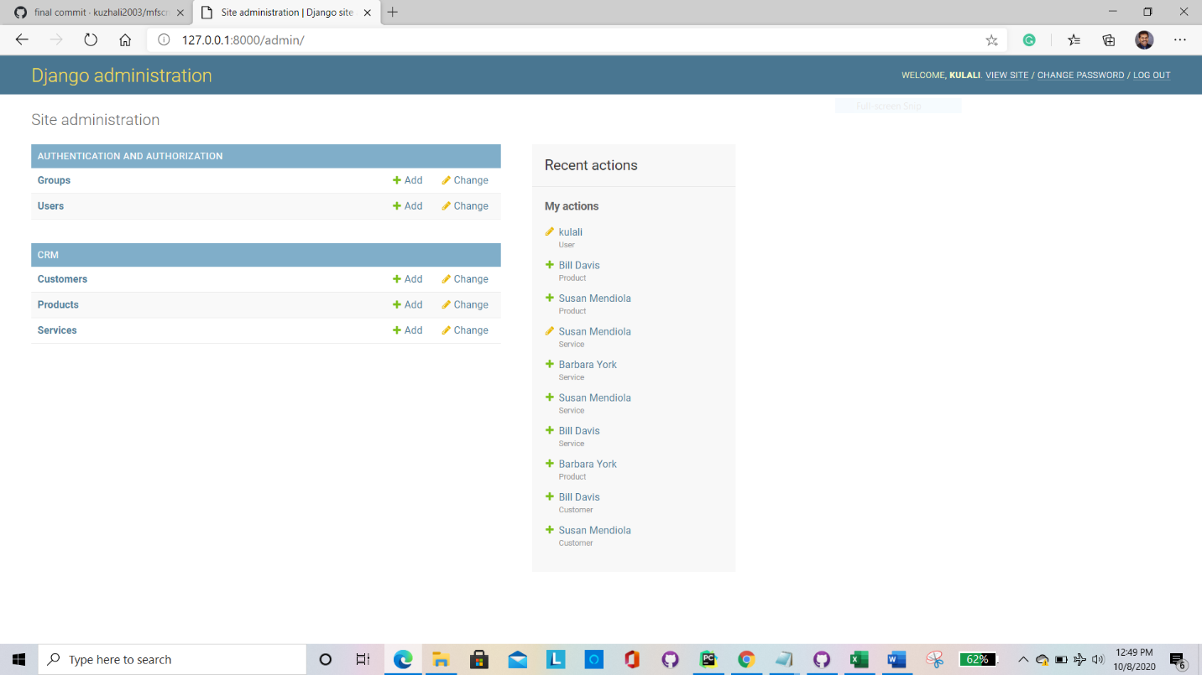

2. customer – view, update, edit,summary

a.

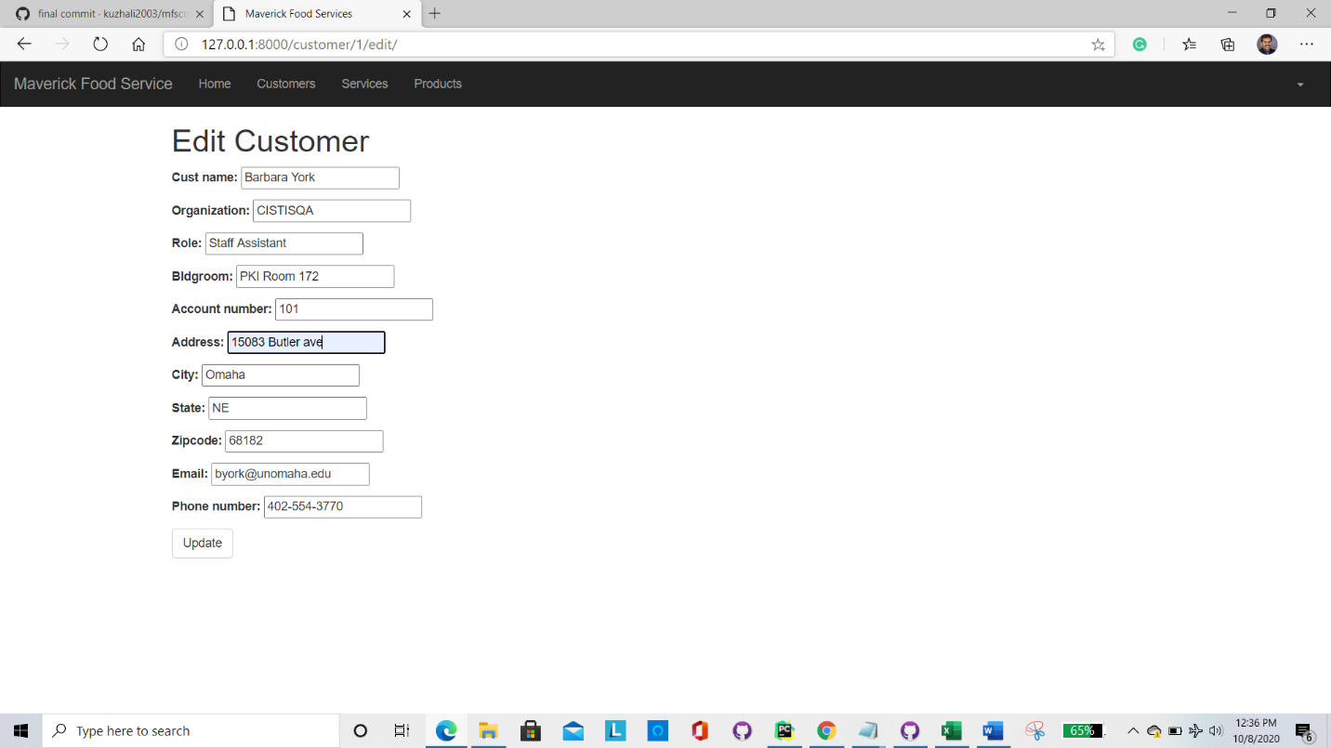

2. service – summary,add,delete

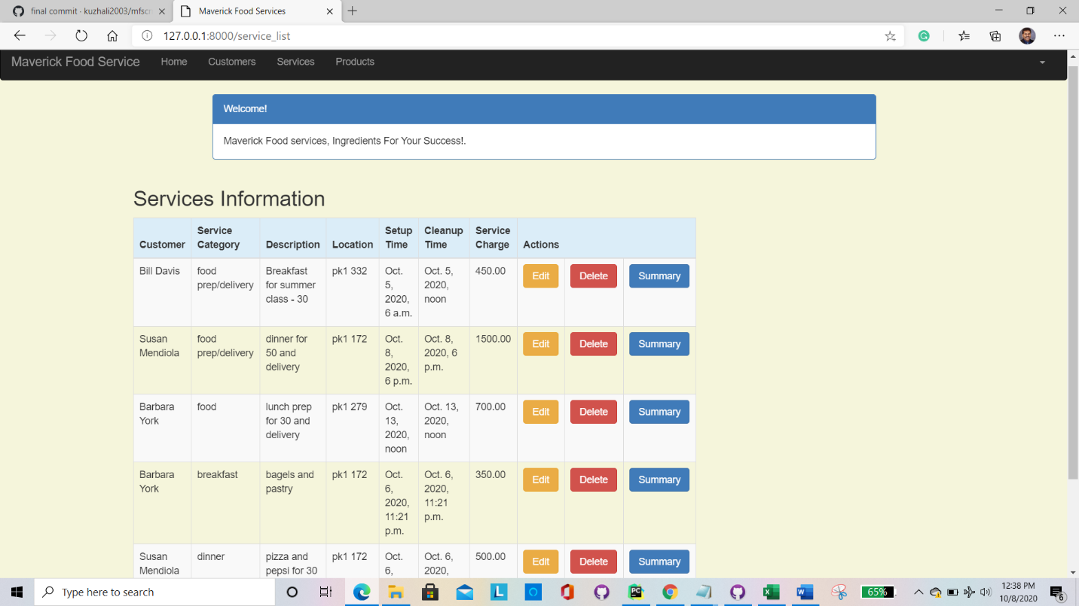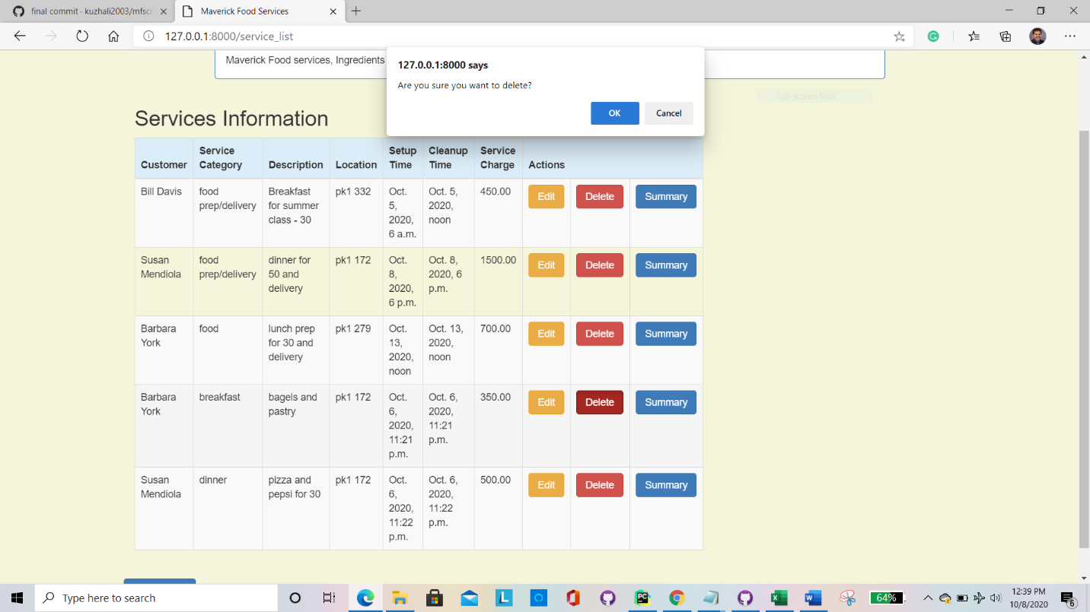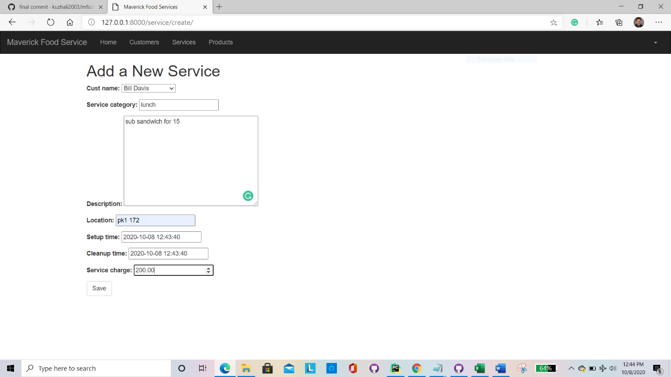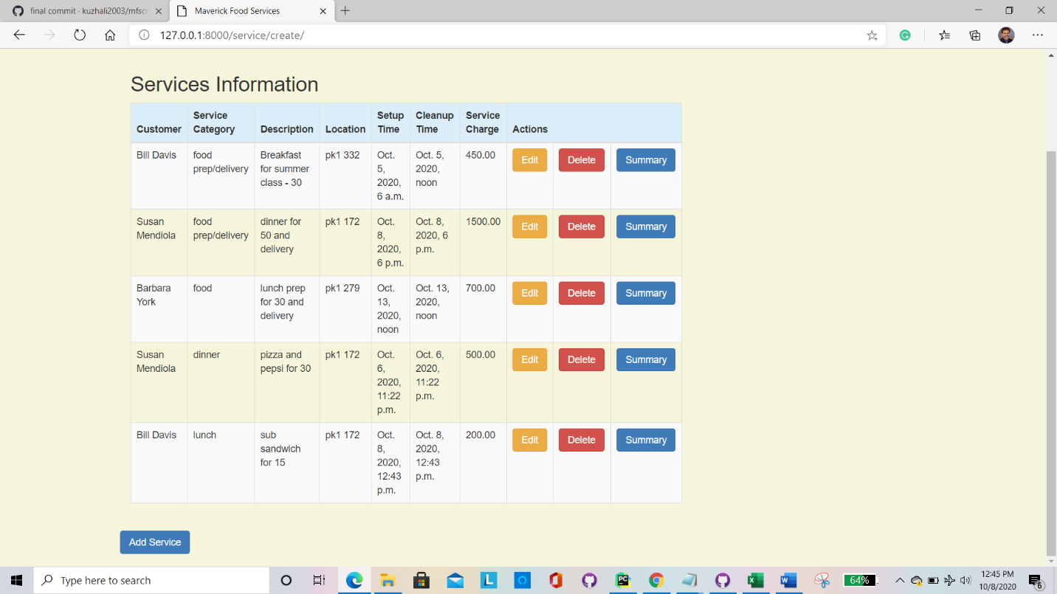

3.Product – summary,add, delete, edit

