* SELECT title FROM movies;
* SELECT director FROM movies;
* SELECT title , director FROM movies;
* SELECT title , year FROM movies;
* SELECT * FROM movies;

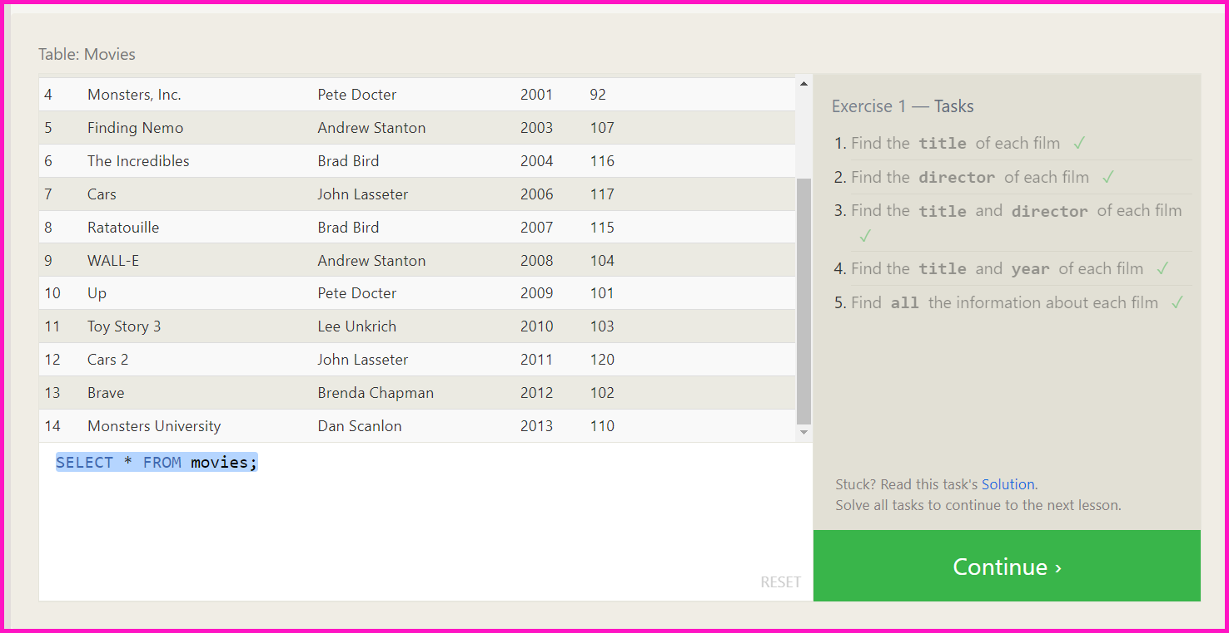

* SELECT * FROM movies where id = 6;
* SELECT * FROM movies where year between 2000 and 2010
* SELECT * FROM movies where year not between 2000 and 2010
* SELECT * FROM movies where id < 6

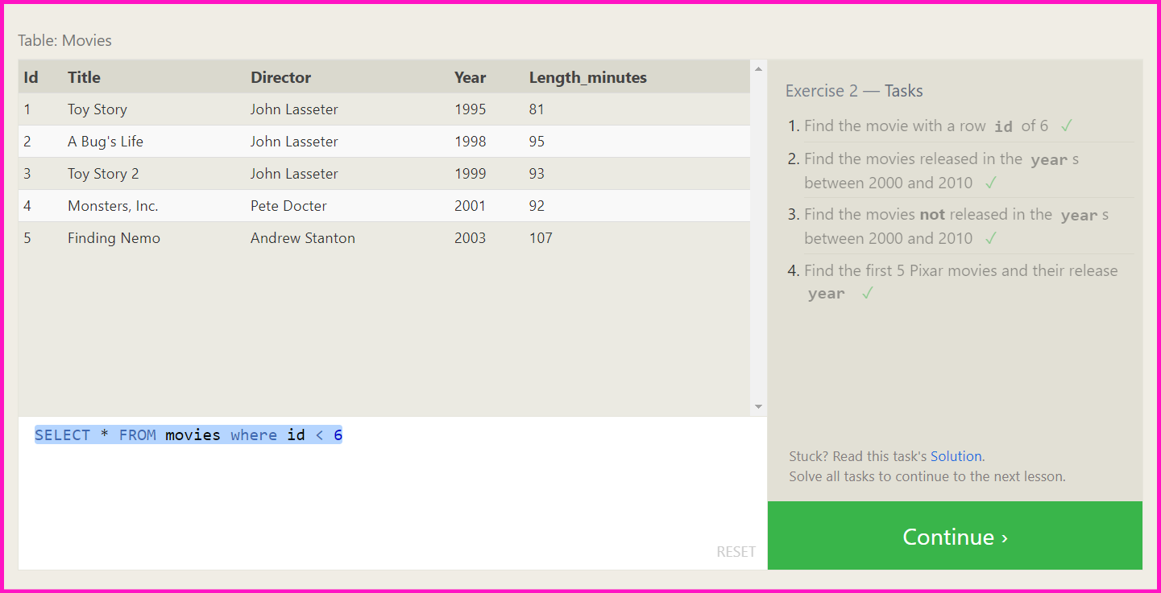

* SELECT title FROM movies where title LIKE 'Toy story%';
* SELECT * FROM movies where director like 'john lasseter'
* SELECT title, director FROM movies where director not like 'john lasseter'
* SELECT title FROM movies where title like 'wall-_'

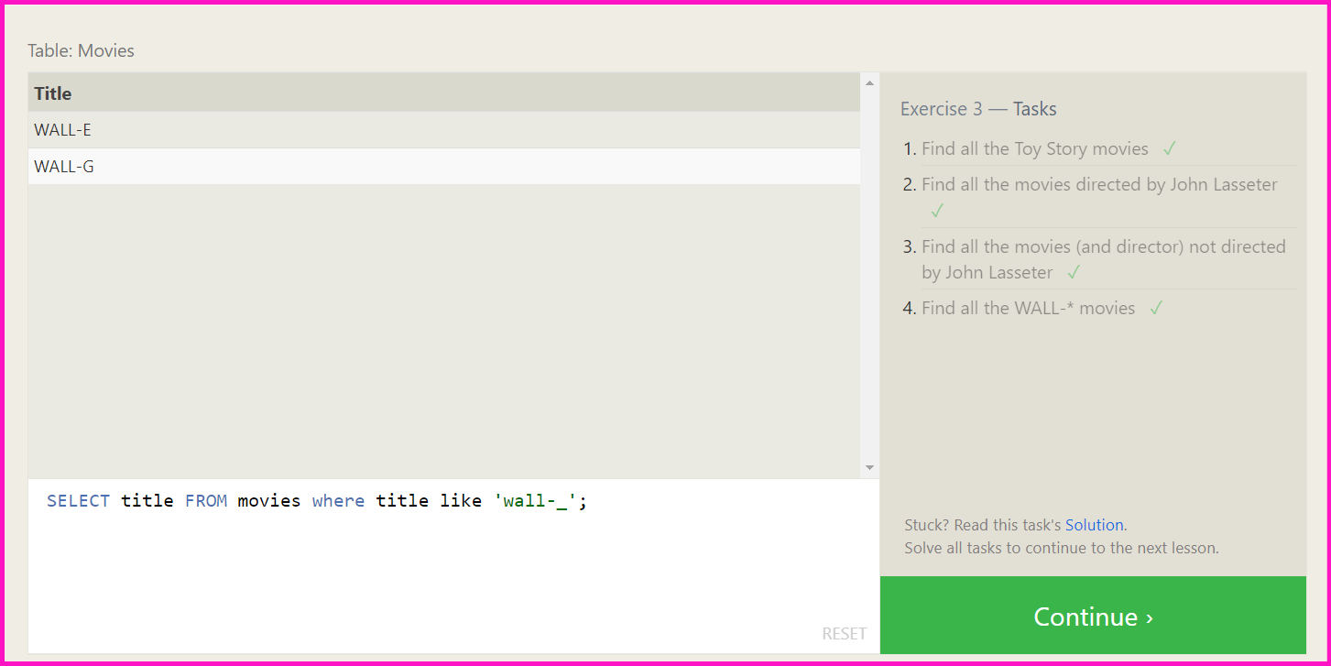

* SELECT distinct director FROM movies order by director;
* SELECT * FROM movies order by year desc limit 4;
* SELECT * FROM movies order by title limit 5;
* SELECT * FROM movies order by title limit 5 offset 5;

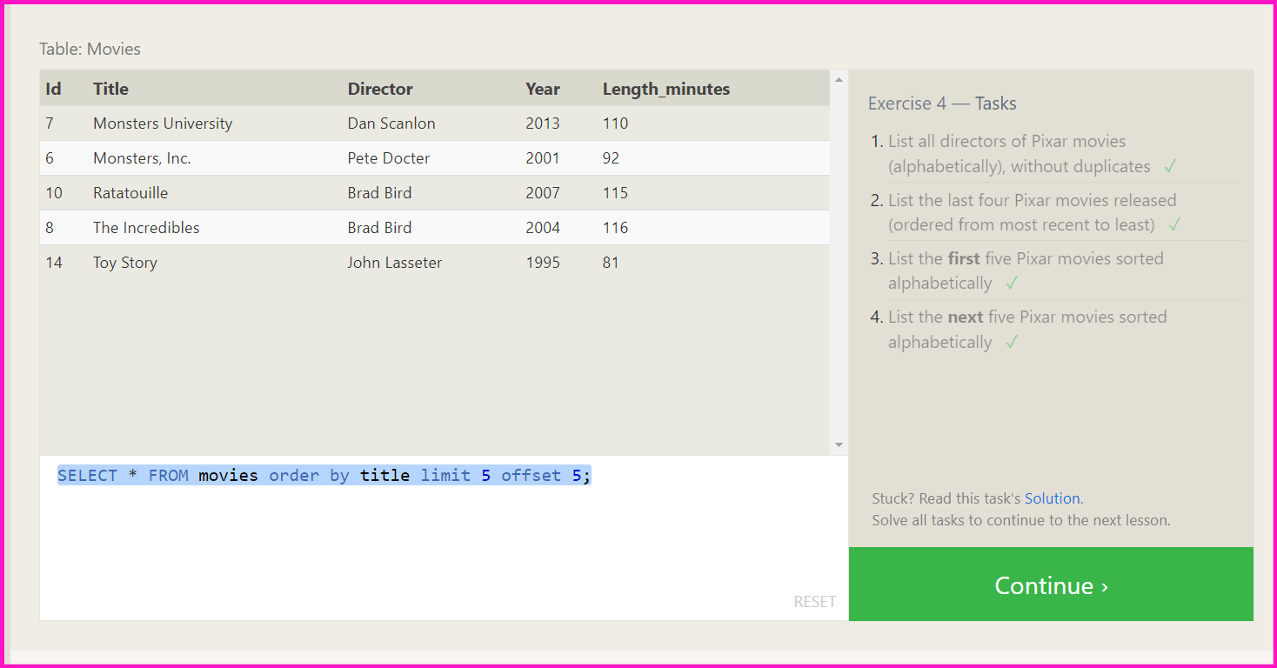

* SELECT city, population FROM north_american_cities where country like 'canada';
* select * from North_american_cities where country like 'united states' order by longitude desc
* select * from north_american_cities where longitude < -87.629798 order by longitude ASC;
* select * from north_american_cities where country like 'mexico' order by population desc limit 2
* select * from north_american_cities where country like 'united states' order by population desc limit 2 offset 2

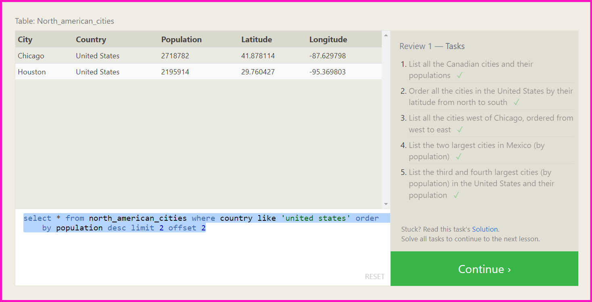

* SELECT * FROM movies join Boxoffice where movies.id = Boxoffice.Movie_id;
* SELECT Domestic_sales, International_sales FROM movies join Boxoffice on id = movie_id where International_sales > Domestic_sales
* SELECT * FROM movies join Boxoffice on id = movie_id order by rating desc

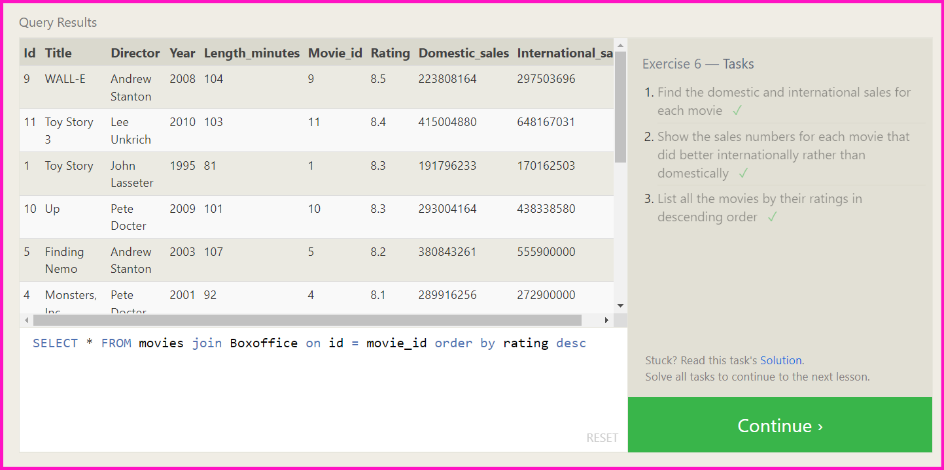

* SELECT distinct building FROM employees;
* SELECT * FROM buildings;
* SELECT distinct building_name, role FROM buildings left join employees on building_name = building;

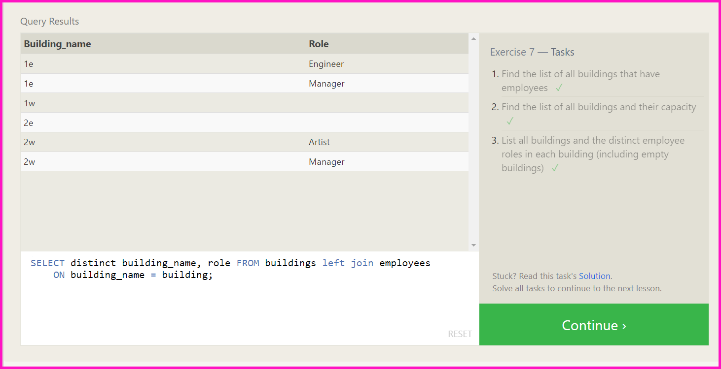

* SELECT name, role FROM where building is null;
* SELECT distinct building_name FROM buildings left join employee on building_name = building where role is null;

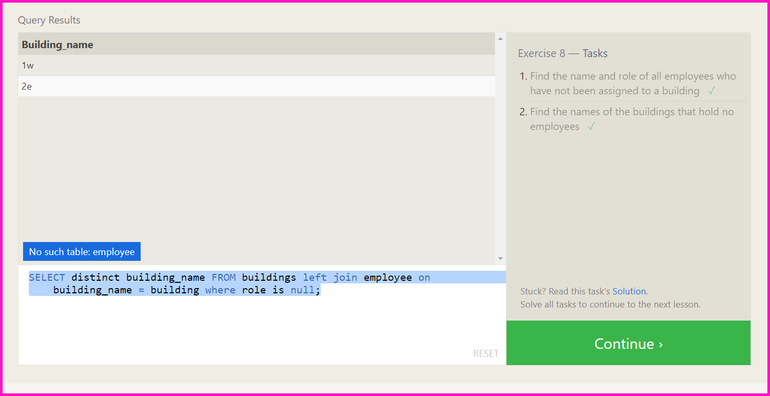

* SELECT title, (domestic_sales + international_sales) / 1000000 as gross_sales_millions from movies join boxoffice on movies.id = boxoffice.movie_id;
* SELECT title, rating * 10 as rating_percent from movies join boxoffice on id = movie_id;
* SELECT title,year from movies where year%2 = 0;

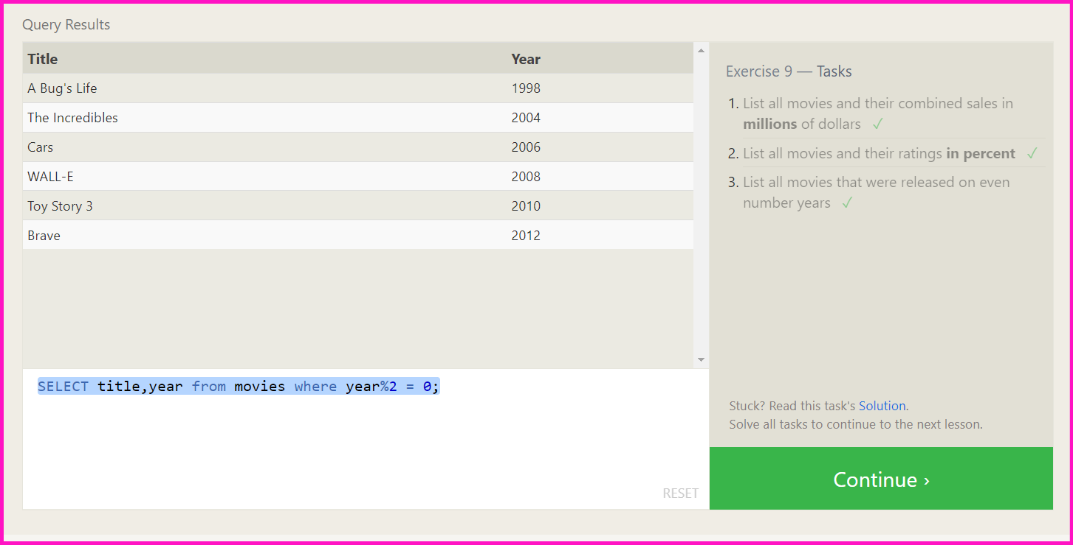

* SELECT max(years_employed) as Max_years_employed FROM employees;
* SELECT role, avg(years_employed) FROM employees group by role;
* select building, sum(years_employed) from employees group by building

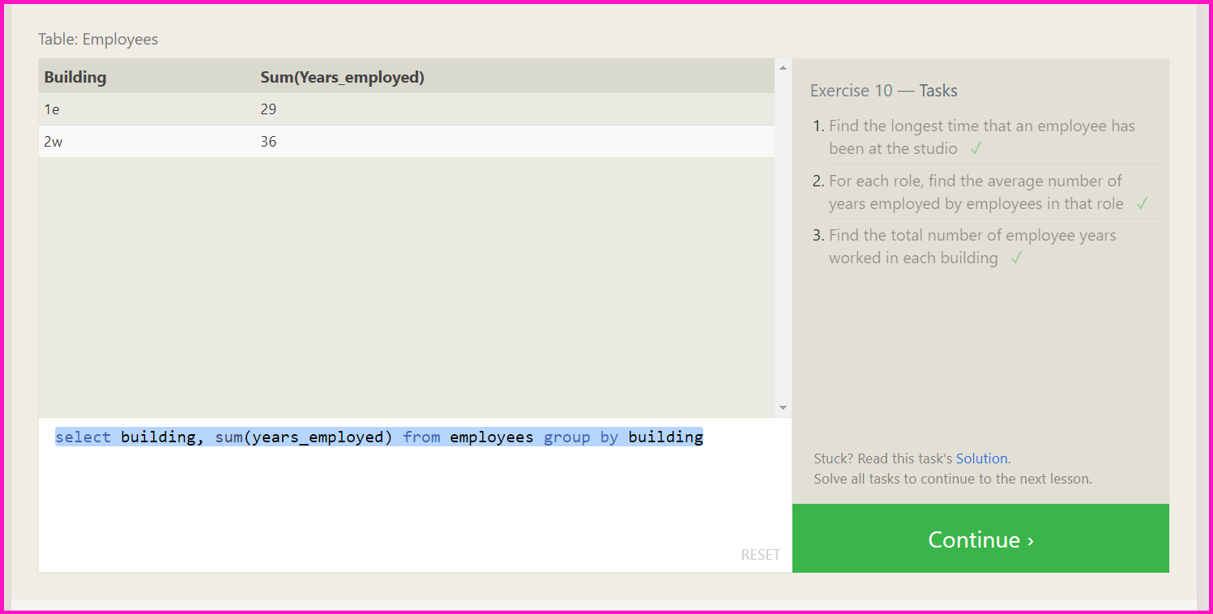

* SELECT count(), * FROM employees where role like 'artist';
* select sum(years_employed), * from employees where role like 'engineer'

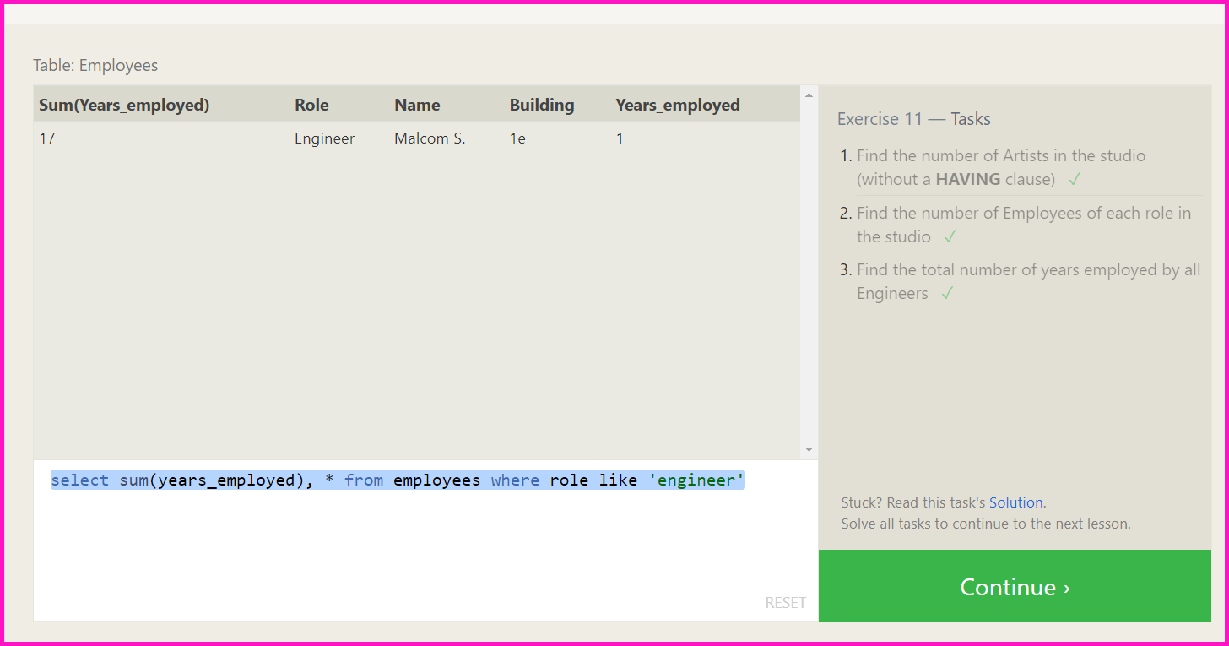

* SELECT count(), director FROM movies group by director;
* SELECT director, sum(domestic_sales + international_sales) as sales from movies join boxoffice on movies.id = boxoffice.movie_id group by director;

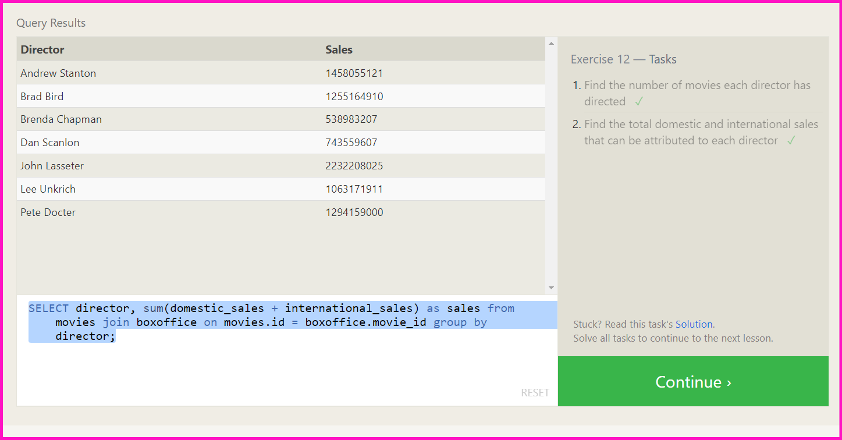

* insert into movies values(4, 'toy story 4', 'kuzhali', 1997, 90);
* insert into boxoffice values(4, 8.7, 340000000, 270000000);

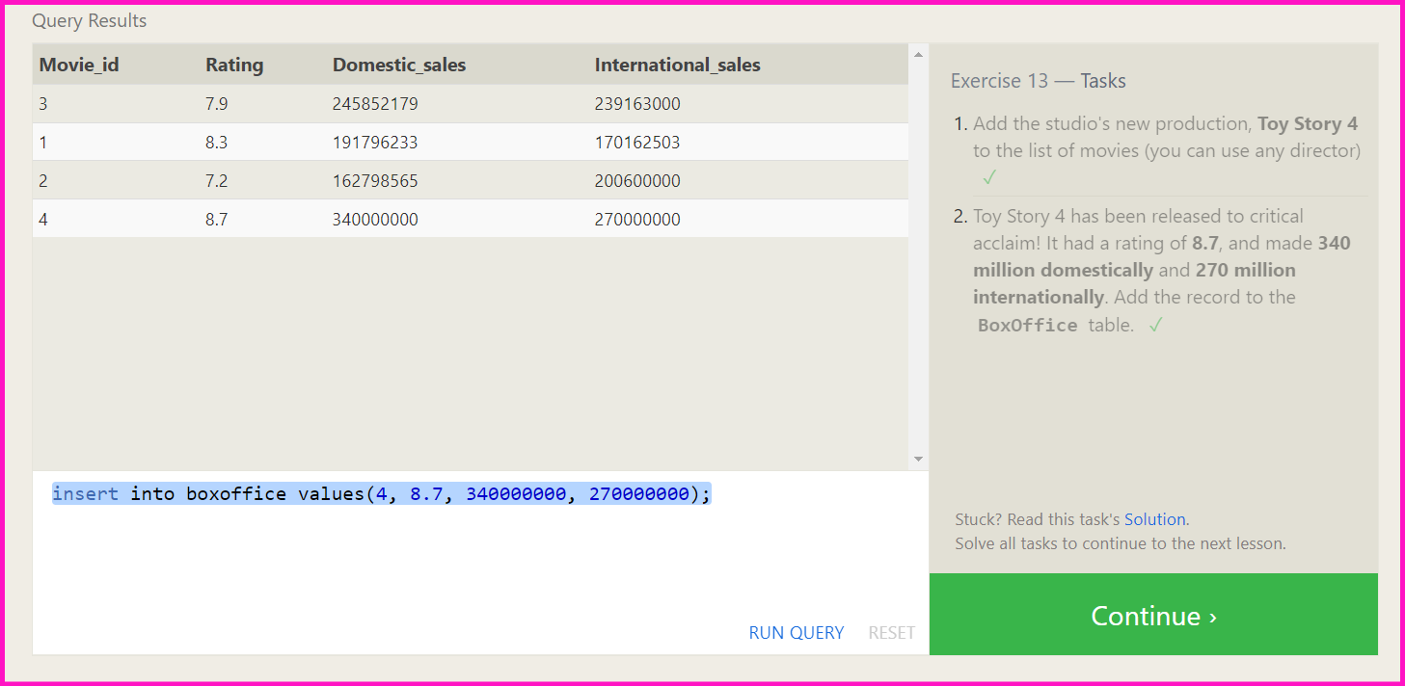

* update movies set director = "John Lasseter" where id = 2;
* update movies set year = 1999 where id = 3;
* UPDATE movies set title = "Toy Story 3", director = "Lee Unkrich" where id = 11;

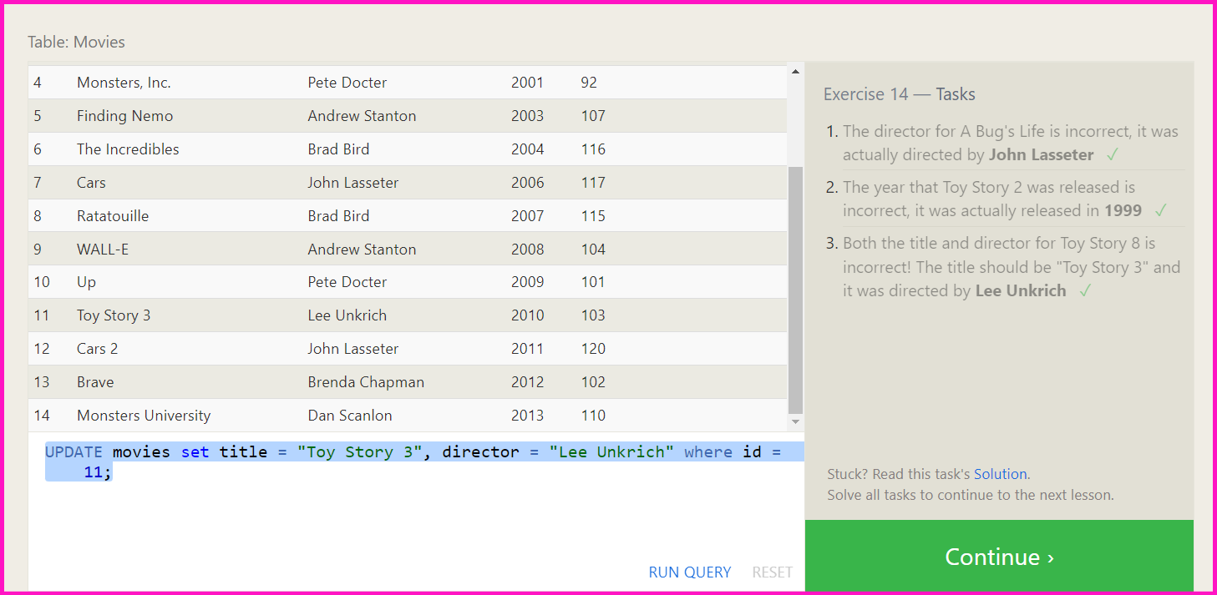

* Delete from movies where year < 2005
* delete from movies where director like 'andrew stanton';

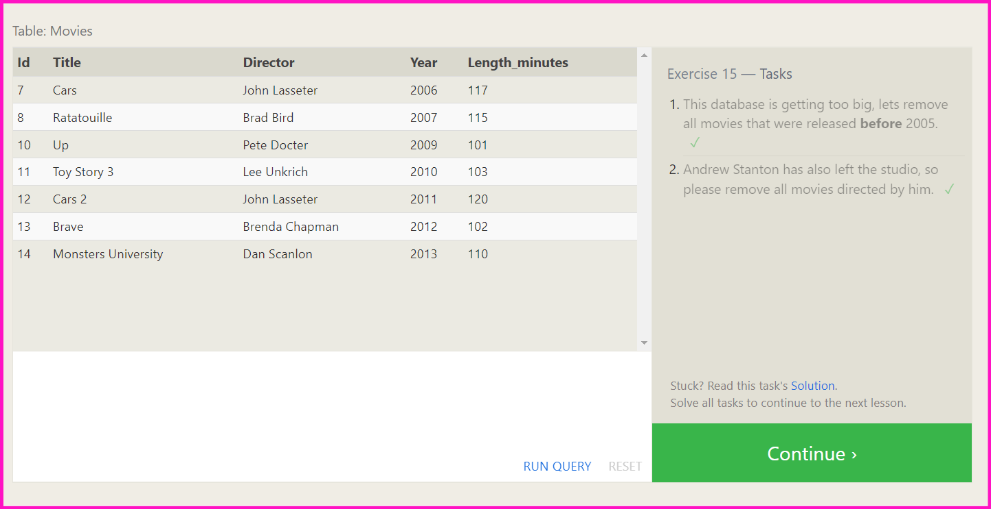

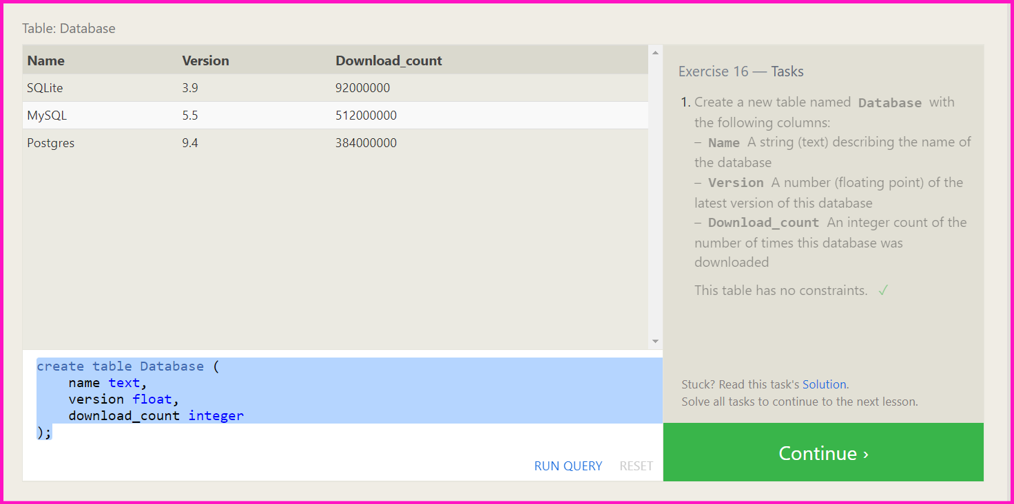

* alter table movies add column aspect_ratio float;
* alter table movies add column language text default English;
* 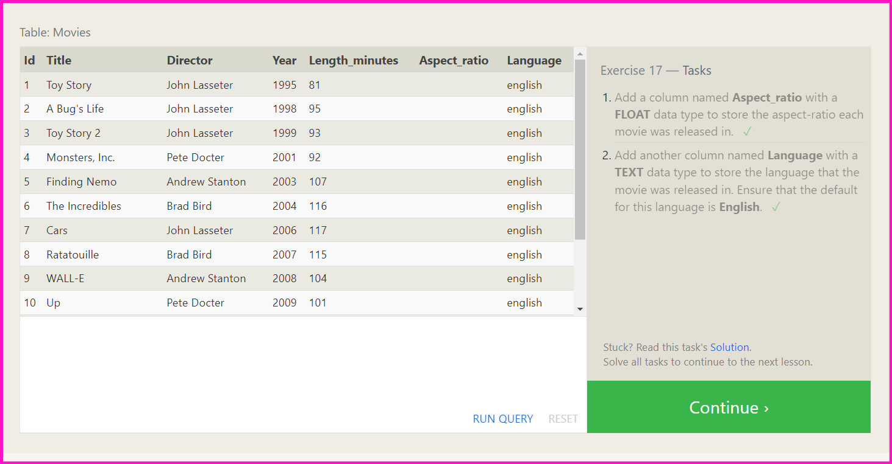
* Drop table movies;
* Drop table boxoffice;

