1.1 Introduction
In Zimbabwean higher education institutions, industrial attachment programmes play a vital role in preparing students for the professional world. These internships bridge the gap between theoretical learning and practical industry exposure. Through industrial attachment, students gain practical skills, workplace experience, and professional competencies that enhance their employability and readiness for the labour market.
However, the management of internship programmes in many universities remains fragmented and partially manual. Institutions often rely on paper-based documentation, emails, and disconnected digital tools to handle student placements, supervisor allocation, progress monitoring, and final evaluations. This lack of an integrated system results in inefficiencies, delayed communication, inconsistent record keeping, and limited transparency in tracking student performance.
Furthermore, while supervisors provide both numerical scores and written feedback during evaluations, most systems only capture and store quantitative marks. The qualitative comments submitted by industry supervisors—often containing valuable insights about student strengths, weaknesses, professionalism, and skill gaps—are rarely analyzed beyond simple record storage. As a result, institutions miss an opportunity to extract meaningful performance trends and strategic insights from this unstructured feedback.
In response to these challenges, this study proposes the development of IntraHub, an intelligent and integrated digital platform designed to manage the entire internship lifecycle, from student registration and CV pooling to placement management, evaluation, and academic project archiving. In addition to automating administrative processes, the proposed system incorporates a sentiment analysis component that evaluates textual feedback provided by industry supervisors. By applying Natural Language Processing (NLP) techniques, the system converts qualitative comments into measurable sentiment indicators, enabling the generation of performance trends and institutional analytics.
The integration of automation, analytics, and sentiment analysis transforms the internship management process from a purely administrative function into a data-driven decision-support system. This approach aligns with Zimbabwe’s Education 5.0 agenda, which emphasizes innovation, industrialization, and digital transformation in higher education.

1.2 Background of the Study
Industrial attachment is a compulsory and essential component of higher education in Zimbabwean universities. It serves as a bridge between academic learning and industry practice, allowing students to apply theoretical knowledge in real-world environments. Through internships, students develop technical competencies, professional ethics, communication skills, and workplace adaptability.
Despite its importance, the management of industrial attachment programmes in many institutions remains largely manual or semi-digital. Processes such as student registration, placement allocation, supervisor coordination, evaluation submission, and record keeping are often handled using paper-based forms, spreadsheets, and email communication. These fragmented systems lead to delays, poor coordination, duplication of records, and difficulties in tracking student progress in real time. In some cases, student reports and supervisor evaluations are misplaced or inconsistently archived, making long-term performance analysis challenging.
Another major limitation of the existing system is its focus on administrative record-keeping rather than analytical insight. While supervisors provide both numerical grades and written comments describing student performance, most institutions only record the quantitative marks for grading purposes. The qualitative feedback, which contains valuable information about student strengths, weaknesses, workplace behavior, and skill gaps, is rarely analyzed systematically. As a result, universities lack a structured mechanism to measure overall industry satisfaction, detect recurring performance trends, or identify areas requiring curriculum improvement.
Furthermore, internship coordinators often struggle to obtain a consolidated view of student performance across departments and organizations. Without automated analytics and performance dashboards, decision-making relies heavily on manual interpretation of reports. This limits the institution’s ability to respond proactively to performance issues or strategically strengthen industry partnerships.
These challenges motivate the need for an integrated and intelligent Internship Management System. The proposed IntraHub platform seeks not only to automate internship workflows and centralize academic project archiving, but also to incorporate a sentiment analysis component capable of evaluating supervisor feedback using Natural Language Processing techniques. By transforming qualitative comments into measurable sentiment scores and performance indicators, the system will provide data-driven insights that enhance transparency, accountability, and strategic planning.
Therefore, the background of this study is grounded in addressing inefficiencies in internship administration while advancing the system toward intelligent analytics that support institutional decision-making and continuous academic improvement.
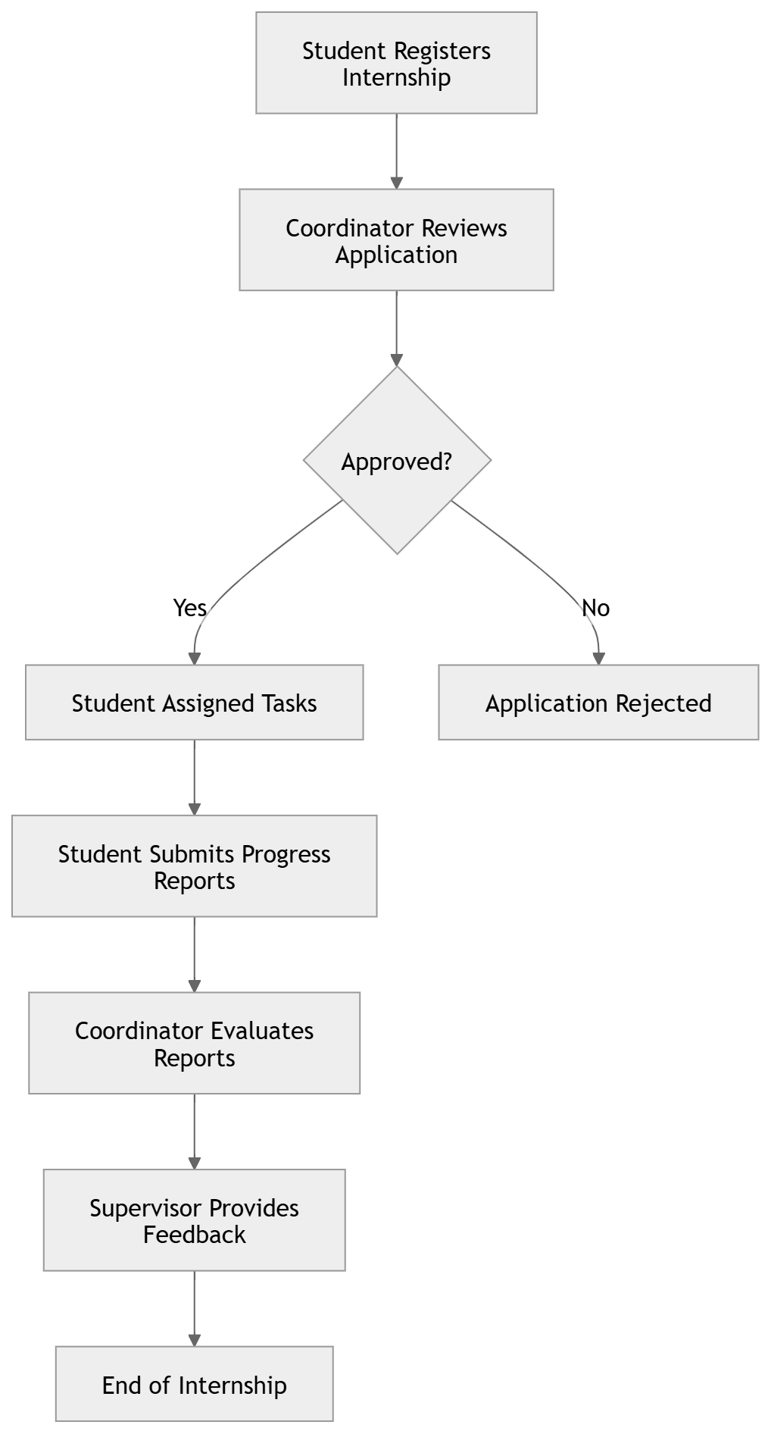

1.3 Statement of the Problem
The management of industrial attachment programmes in many Zimbabwean universities is characterized by fragmented systems, manual processes, and limited integration between stakeholders. Internship coordination often relies on paper-based documentation, spreadsheets, and email communication, resulting in delays, data inconsistencies, poor visibility of student progress, and difficulty in maintaining accurate long-term records.
Supervisors are required to assess students using structured evaluation forms and written comments. While numerical grades are recorded for academic purposes, qualitative feedback provided by industry supervisors is typically stored without systematic analysis. This unstructured feedback contains critical insights regarding student performance, professional behavior, technical competence, and workplace readiness. However, the absence of automated analytical tools prevents institutions from extracting measurable trends or identifying recurring performance patterns.
Additionally, internship coordinators lack real-time dashboards that consolidate performance data across departments and organizations. Decision-making is therefore based on manual interpretation of scattered reports rather than structured analytics. This limits the institution’s ability to monitor overall industry satisfaction, detect underperforming areas, and implement evidence-based academic improvements.
Without an integrated and intelligent system, universities face challenges in ensuring transparency, accountability, and data-driven decision-making within internship management. Therefore, there is a need to develop an enhanced Internship Management System that not only automates administrative processes but also incorporates sentiment analysis to transform qualitative supervisor feedback into actionable performance insights.

1.4 Aim of the Study
The aim of this study is to design and develop an intelligent and integrated Internship Management System that streamlines and automates internship administration processes while incorporating sentiment analysis of industry supervisor feedback to enhance performance monitoring and data-driven decision-making in Zimbabwean universities.

1.5 Research Objectives
The objectives of this study are:
- To design and develop a centralized Internship Management System that automates student registration, placement management, supervision, and evaluation processes.
- To establish a secure digital repository for storing internship records and academic project documentation.
- To implement automated notifications and workflow tracking to improve communication among students, supervisors, and administrators.
- To develop a performance evaluation module that records and manages both quantitative grades and qualitative supervisor feedback.
- To integrate a sentiment analysis module that analyzes textual feedback from industry supervisors and converts it into measurable sentiment scores.
- To generate analytical reports and dashboards that provide performance trends, departmental comparisons, and decision-support insights for institutional planning.

1.6 Research Questions
This study seeks to answer the following research questions:
- How can an integrated digital platform improve efficiency, transparency, and coordination in internship management?
- How can automation of internship workflows reduce delays and data fragmentation in existing systems?
- In what ways can qualitative feedback from industry supervisors be systematically analyzed to provide measurable performance insights?
- How can sentiment analysis of supervisor feedback enhance monitoring of student performance and overall institutional evaluation?
- How can analytics dashboards support data-driven decision-making in internship administration?

1.7 Research Hypothesis
Where applicable, the study is guided by the following hypotheses:
H₀ (Null Hypothesis):
The integration of sentiment analysis into an Internship Management System does not significantly improve performance monitoring or institutional decision-making.
H₁ (Alternative Hypothesis):
The integration of sentiment analysis into an Internship Management System significantly improves performance monitoring and supports data-driven institutional decision-making.

1.8 Relevance of the Research
The proposed Intelligent Internship Management System (IntraHub) is significant as it addresses operational inefficiencies in internship coordination while introducing analytical intelligence into performance evaluation. The research contributes both practical and strategic value to higher education institutions, particularly within the context of Zimbabwe’s digital transformation agenda.
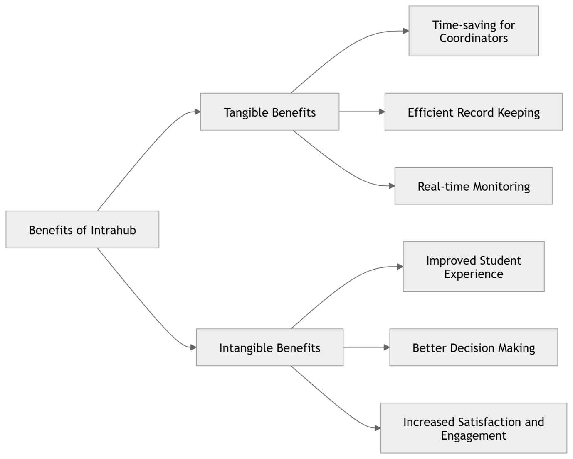

1.8.1 Business Value
From an institutional perspective, the system delivers strategic business value by improving administrative efficiency, data accuracy, and decision-making processes. By centralizing internship records, evaluations, and project archives within one platform, the university reduces operational redundancies and enhances coordination among students, supervisors, and administrators.
The integration of sentiment analysis further strengthens business value by transforming qualitative supervisor feedback into measurable performance indicators. This allows management to assess overall industry satisfaction, monitor departmental performance trends, and identify skill gaps that may require curriculum adjustments. As a result, the institution can make evidence-based strategic decisions and strengthen its partnerships with industry stakeholders.

1.8.2 Tangible Benefits
The system provides measurable and observable benefits, including:
- Reduced paperwork and administrative costs.
- Faster processing of internship applications and evaluations.
- Secure digital storage of student records and academic projects.
- Real-time tracking of student placement and assessment status.
- Automated calculation of performance scores.
- Generation of analytics dashboards and sentiment-based performance reports.
These tangible outputs improve efficiency, reduce data loss, and provide structured performance metrics that can be used for accreditation, reporting, and institutional review.

1.8.3 Intangible Benefits
In addition to measurable outcomes, the research offers important intangible benefits:
- Improved transparency and accountability in internship management.
- Enhanced institutional reputation through data-driven oversight.
- Increased industry confidence due to structured performance monitoring.
- Better student support through early detection of performance risks.
- Stronger alignment between academic training and industry expectations.
By incorporating sentiment analysis, the system enables the university to capture nuanced insights from supervisor feedback, promoting continuous improvement and a culture of evidence-based decision-making.

1.8 Assumptions of the Study
This study is based on the following assumptions:
- The university possesses the basic ICT infrastructure, including internet connectivity and server capacity, required to support the implementation of the proposed system.
- Students, academic supervisors, industry supervisors, and administrators have basic digital literacy skills necessary to interact with a web-based platform.
- Industry supervisors are willing to submit internship evaluations and provide qualitative feedback through the system.
- The textual feedback provided by supervisors is sufficiently detailed and meaningful to allow sentiment analysis techniques to generate reliable performance indicators.
- Users will adopt the system if it demonstrates perceived usefulness and ease of use in improving internship management processes.
- Adequate historical or pilot data will be available for testing and validating the analytics and sentiment analysis components of the system.
These assumptions provide the foundation upon which the system design, implementation, and evaluation are based.

1.9 Limitations of the Study
While the development of the Intelligent Internship Management System (Intrahub) aims to streamline the management of internship processes and enhance efficiency, certain limitations were observed during the study:
- Scope Limitation
The system primarily focuses on internship management for students within selected universities or organizations. Its functionality may not be fully adaptable to other institutions with different workflows or policies, limiting the generalizability of the solution.
- Resource Constraints
The project was constrained by limited time and budget for development and testing. As a result, some advanced features, such as AI-based performance analytics or predictive internship placements, were not fully implemented.
- Dependence on Internet Connectivity
The system relies heavily on stable internet access for data synchronization and communication. In regions with poor connectivity, users may experience delays or limited access to real-time information.
- User Adoption and Training
The effectiveness of the system depends on users’ familiarity with digital tools. Some users, particularly those less comfortable with technology, may face challenges in adapting to the system without proper training.
- Data Privacy and Security
Although basic security measures were implemented, the study did not fully explore advanced cybersecurity risks. The storage and handling of sensitive student and organizational data remain a potential limitation that requires further attention.
- Integration with Existing Systems
The system may face compatibility issues when integrated with existing organizational platforms such as HR systems or academic databases, limiting seamless interoperability.
- Limited Testing with Real-World Users
Testing was primarily conducted with a limited number of participants in a controlled environment. The system’s performance under a full-scale deployment in real-world scenarios may vary and would require further evaluation.

1.10 Delimitations of the Study
The study on the development and implementation of the Intelligent Internship Management System (Intrahub) is intentionally bounded by certain delimitations to ensure focus, feasibility, and alignment with the project objectives:
- Target Users
The system is designed specifically for students, internship coordinators, and organizational supervisors within selected institutions. Other groups, such as prospective employers outside the established network, are not included in this study.
- Functional Scope
While Intrahub provides features for internship registration, task monitoring, feedback collection, and performance tracking, it deliberately excludes unrelated academic management functions such as course grading or attendance tracking.
- Geographical Limitation
The system is tested and optimized for use within specific universities or partnering organizations in the study area. Deployment in institutions outside this geographical scope may require further customization.
- Data and Sentiment Analysis
The feedback module incorporates basic sentiment analysis to evaluate students’ experiences and supervisors’ evaluations. However, the analysis focuses only on textual feedback within the system and does not extend to social media or external communications.
- Technology Stack
The system utilizes web and mobile platforms supported by selected databases and frameworks. Alternative technologies, cloud platforms, or enterprise systems beyond the scope of this project are excluded.
- Timeframe
The study and system testing are conducted within a defined project period. Long-term performance, scalability, and post-deployment impacts beyond this timeframe are not addressed in this study.
- User Training and Support
While basic training materials are provided, in-depth user training, troubleshooting, or continuous support post-deployment are outside the study’s scope.

1.11 Conclusion
The development of the Intelligent Internship Management System (Intrahub) demonstrates a focused effort to enhance the management and coordination of internships through automation, real-time monitoring, and data-driven insights. The system effectively streamlines processes such as internship registration, task tracking, feedback collection, and performance evaluation, thereby reducing administrative burdens for both students and coordinators.
The integration of sentiment analysis into the feedback module further allows the system to capture qualitative insights on student experiences, providing a deeper understanding of internship outcomes. While the study faced certain limitations—including reliance on internet connectivity, limited user testing, and scope constraints—the delimitations ensured that the system remained practical, focused, and feasible within the project timeframe.
Overall, Intrahub presents a promising solution for institutions seeking to modernize internship management. It lays a foundation for future enhancements, such as advanced predictive analytics, broader institutional adoption, and full-scale deployment, which could further improve internship experiences and outcomes.

