Inga Kuznetsova, inga@relevad.com

Resource Utilization Anomaly Detection
Project Description

Developed CPU utilization data (CUD) algorithm and program that detect potential anomalies in real-time.

Methodology, Research, Data Analysis, Simulation and Training
I used Pandas environment for data processing (https://www.dataquest.io/blog/pandas-python-tutorial
I used ARIMA model package– the one of most general models for forecasting a time series package for model fitting (simulation and training). I chose ARIMA first, because literature review suggested that it may provide best fit in case of data with periodic components. With ARIMA I got some information about data distribution.
Because of smallest quadratic square error (~0.0898) I chose ARIMA(0,1,0) , it corresponds to random walk model.
Model uses rolling mean. Because the data do not have too big outliers it is possible to use
rolling mean instead of median.
See https://people.duke.edu/~rnau/411arim.htm#arima010 for more details on ARIMA equations.
In simple terminology ARIMA uses moving average (m(N)) and moving variance (s(N)) for a window size N (series of N points).
In this model there are two time scales, size of rolling window and size of chunk of data, over which data are fitted.
I obtained smallest fitting error for smallest rolling window size. I think that for given case it is reasonable to take moving window over 5-30 seconds. Average error is 0.08981511 when window size is 5 seconds, minimum is 0.0893862065634, maximum is 0.0904445940237. The result does not change much with change of size of fitting points population, if it is more than 100.
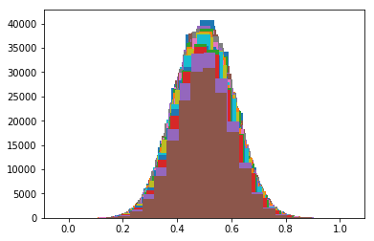
Data distribution shape is close to normal distribution. On the figure below there is the histogram of one data chunk of size 200,000.
I find root mean square error, RMSE. The anomaly is points with variance larger than 3*RSME.
On the second figure the sample with anomaly point is shown.
The other simpler and faster method for anomaly the detection is to find CPU usage variance in rolling window and impose some conditions on it.
The Anomaly is defined as a CPU time that does not belongs to a 3s (3 sigma) interval.
In this model we consider rolling mean and standard deviation.
I spend significant research time to define a relevant window N. I used a concept of robust model:
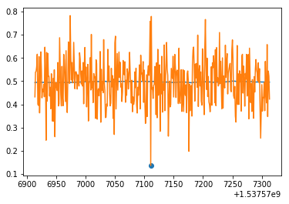
I started with window size 1000 points. Computed average number of outlier at intervals size of 10K points. I subdivided window size by half and repeated the process. If the difference between average number of outliers was less than 1% then I assumed that two window sizes produced equal results.
After several experiments, I chose window size 400 as the relevant robust window size.
In this model rolling windows size acts on result similar to chunk size.
This must be result of that the data distribution becomes less smooth if we use window less size than 400. This approach gives very close result for outliers number as the first one, ARIMA model for time window larger than 400 units. For smaller window number of detected ouliers drops.
ARIMA model is more stable to windows size.
My program in general works as follows:
It waits first 400 time intervals before it produces first results. After that program returns the list of last M outliers ordered by time stamp.

Sincerely,
Inga Kuznetsova

