Inga Kuznetsova, inga@relevad.com

Resource Utilization Anomaly Detection
Project Description
Developed CPU utilization data (CUD) algorithm and program that detect potential anomalies in real-time.
Methodology, Research, Data Analysis, Simulation and Training
I use Pandas environment for data processing (https://www.dataquest.io/blog/pandas-python-tutorial
I decided to look at different kind of possible anomalies see examples (https://msdn.microsoft.com/en-us/library/mt775197.aspx). One considered anomaly is for separate time point (1 second)
as before (1st type) and other anomaly is behavior during some time interval (2nd type) much larger than 1 second but much smaller than time, when normal distribution is well established (which is about 400 s). I chose default 20 seconds interval.
For the first type of outliers, similar as I considered before, I tried linear regression (https://en.wikipedia.org/wiki/Linear_regression) to predict deviation from rolling mean. I trained data on half chunk and predict on other half and switched train and test sets.
Model uses rolling average mean. Because the data do not have too big outliers it is possible to use
rolling mean instead of median. The condition of anomaly is deviation > 3sqrt(mse).
This model behaved and gave results very similar as I got before with ARIMA model, and it does not have algorithm convergence problems.
In this model there are two time scales, size of rolling window and size of chunk of data, over which data are fitted.
I obtained smallest fitting error for smallest rolling window size. I think that for given case it is reasonable to take moving window over 3-30 seconds. Average error is 0.082 in the case when
window size is 3 seconds. The result does not change much with change of size of fitting points population, if it is more than 100.
We know that data distribution shape is close to normal distribution for a distributions starting with few hundreds points. On the figure there is the histogram of one data chunk of size 200000.
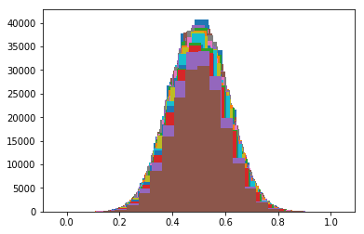
I find root mean square error, rmse. The anomaly is points with variance larger than 3*rmse.

For the other type of anomaly the purpose is to find intervals where signal is high or low during some time interval, see figure with fist and second types anomalies below. I decided to consider the distribution of rolling average mean over some
interval of time (I chose default 20 seconds). This interval much larger than 1s and much smaller then interval, where normal distribution is well established. I assumed that for larger scale of time the distribution of these rolling average mean is also normal and find standard deviation and anomaly condition is that deviation is larger than 3 std. I took minimum chunk size 400 points where average of all data is well established as 0.5, from my previous research. Result is not change if chunk size increases.
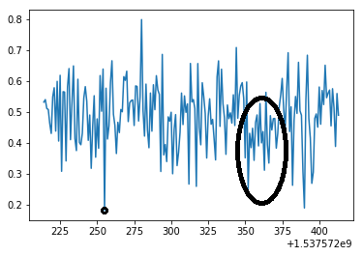
Code Description
My code is attached (please see file “anomaly_detection_part2.py”)
It contains one main class “AnomalyDetection” which provides two methods:
- Real-time data stream processing method “get_linear_regression_outliers_from_stream()”
  - Input: accepts any iterable sequence
  - Output: an iterator that returns (yields) a sequence of outliers in real-time
  - Parameters of the model are auto-tuned from the input stream
- CSV file processing method “get_linear_regression_outliers_from_file” and “get_average_outliers_from_file”
  - Input: CSV file name
  - Output: array of outliers, for 2nd type anomaly, the last time in n seconds interval and moving average over this interval are shown
  - Works faster than the streaming method (less stream processing overhead)

Usage:
class AnomalyDetector(object):
"""Resource Utilization Anomaly Detection

Implements resource utilization anomaly detection using just regular linear regression function from from scikit learn library
How to test this code:
Usage:

python anomaly_detection.py stream-test
Prints outliers determined by linear regression
fitting from a "real-time" input stream of (timestamp, cpu_usage) pairs
The model auto-tunes up its parameters from the data stream
The input stream comes from the CSV 'tests/data.csv'
Sample printout:
Outlier = (1476400708.0, 0.18241668092452884)
Outlier = (1476400931.0, 0.8239113982345683)
Outlier = (1476401114.0, 0.21467013167017163)
...
Outliers are printed in as soon as they are detected

python anomaly_detection.py file-test
Prints two types outliers from the CSV file'tests/data.csv'
The file is processed in bulk (faster than processing from a real-time)
IMPORTANT: Outliers are printed at the very end.
Please be patient and wait until the whole file is processed

"""

The code is properly formatted and documented
Sincerely,

Inga Kuzentsova

