JRGG

Jeff Ronald G. Gamasan 09452869822

Freelance Web Designer <http://caittechsorf.com/> <https://www.facebook.com/team3nity>

Requirements that need the client must be followed:

1. Details of the Corporate,

facebook page link - https://www.facebook.com/sacredheartparishshrine

contact numbers - 0906 271 2197

email - sacredheart_kamuning@yahoo.com

address - 28 Scout Ybardolaza Street, Barangay Sacred Heart, Kamuning, Philippines

1. Corporate Identity – Contents like text, logo, images, information of the item if available, etc
2. location of the office or name of the office if available this will be used for website map
3. Describe your business this will be in the about page or introduction page
4. themes or scope of the project (e.g: business, blog, school, hospitals, brochure) - Church
5. Optional this is depending on the hosting company. Domain Name and Hosting
6. Project Time

Email: [jeffgamasan@gmail.com](mailto:jeffgamasan@gmail.com)



Queenie Lyn B. Regir

Client’s Signature Over Printed Name

Describe your business this will be in the about page or introduction page

The Sacred Heart Shrine of Jesus Parish is an religious organization that serves as a vital part of the communal and spiritual lives of its members. The parish lays plans for many events carried out such as Masses, religious ceremonies, fundraisers, community outreach initiatives, and various social gatherings.

file for more information and references

<https://l.facebook.com/l.php?u=http%3A%2F%2Fwww.osacredheart.info%2F%3Ffbclid%3DIwAR3DVpsng4Q1xPgBioydIsfswQ2ftTFh2UyKaCUHxFSI2tQwZgH15eYlUYU&h=AT3as3kSWT1tzDRDIuO9ylgDlZTAQcDxbg8rr-pWGxy7wlVVW5k35TF5uglxp8vT7QOX71x2ZLCHsO9xm3ocagRousLuFpvc89UK1qtv4iURLcBh8qCoIioeq6KVHSGU9KUmHXSJa9fstaQ8o7_fCA>

House blessing



Wedding bg



baptism bg



Sacred heart of Jesus (LOGO)



Bg picture : prayer for the dead



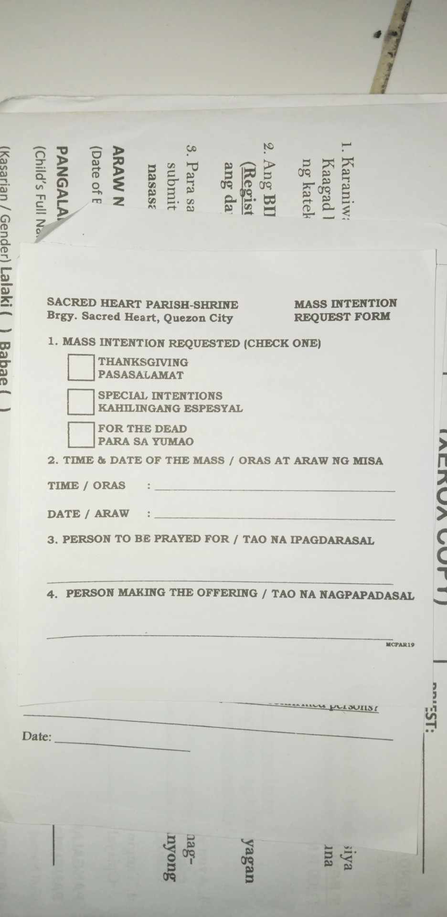 Mass intention

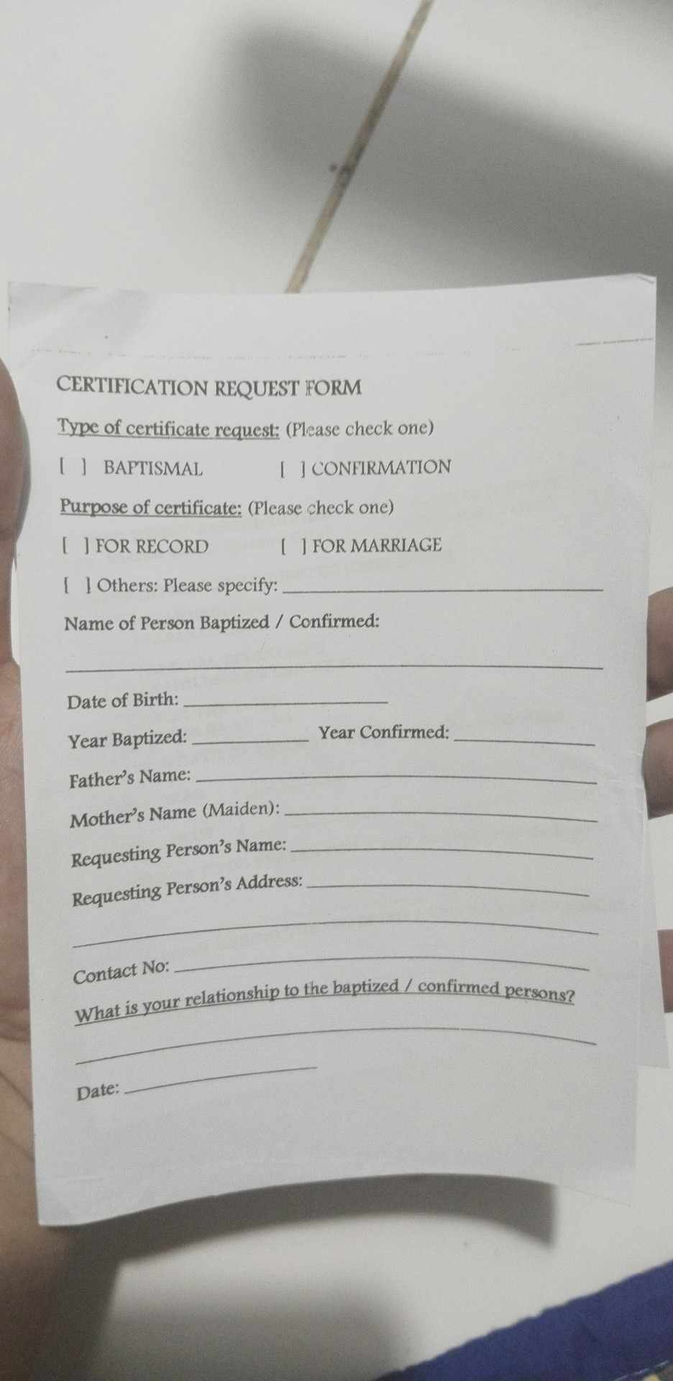 certification request form

Location of church

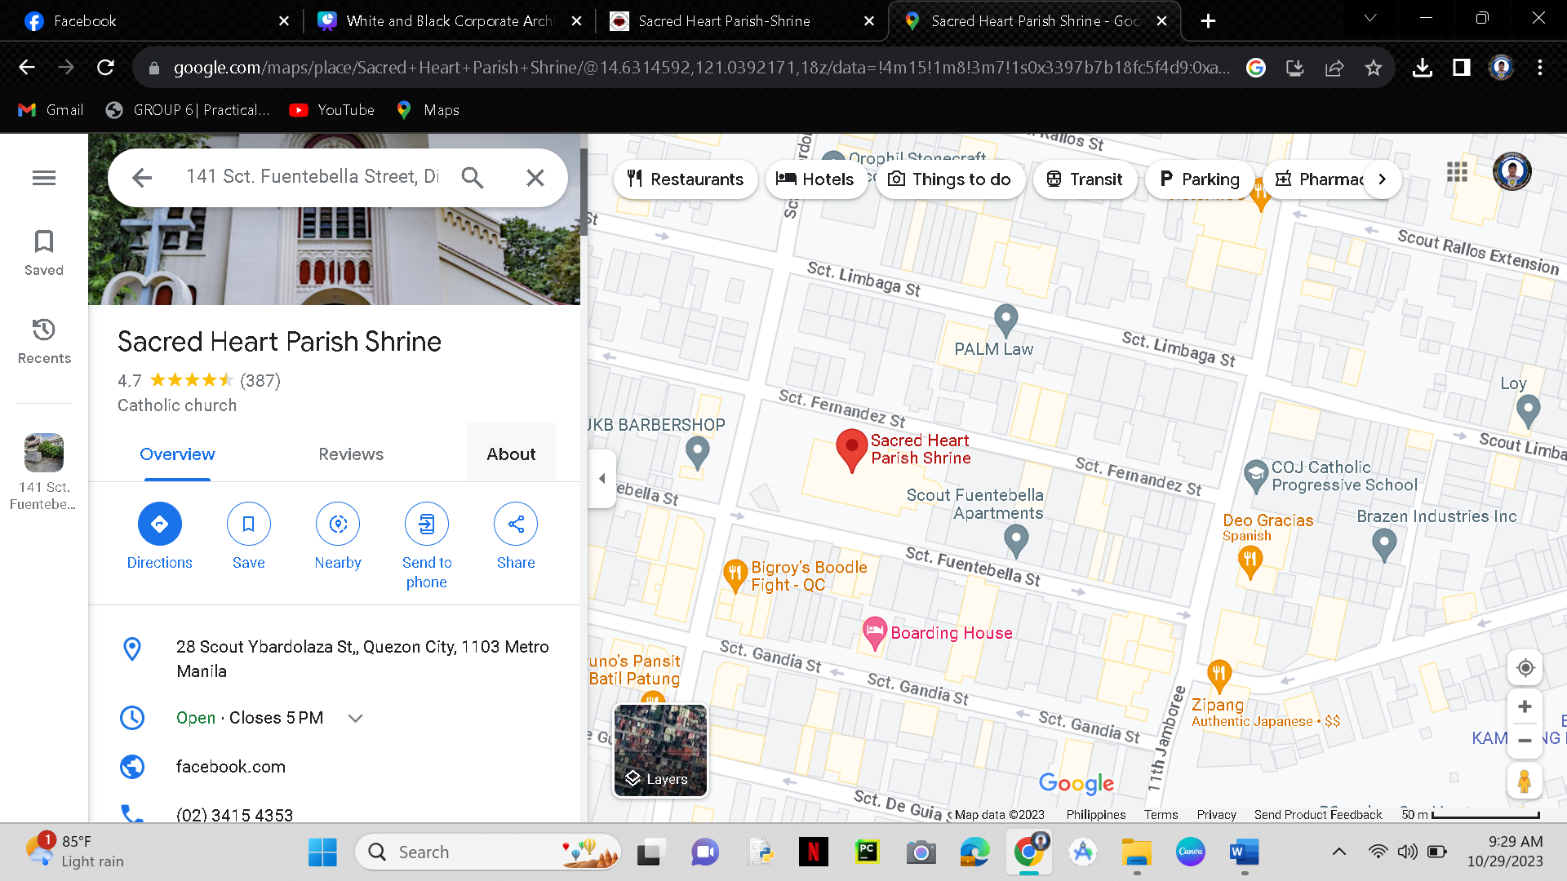

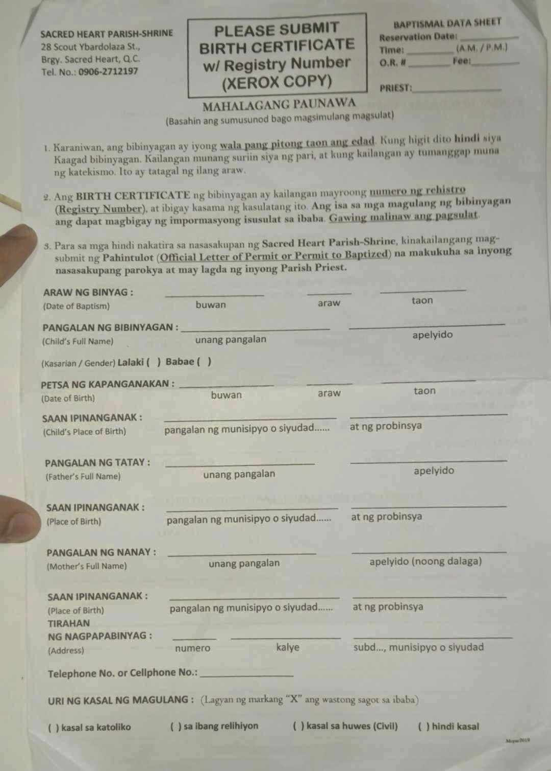

Baptism form

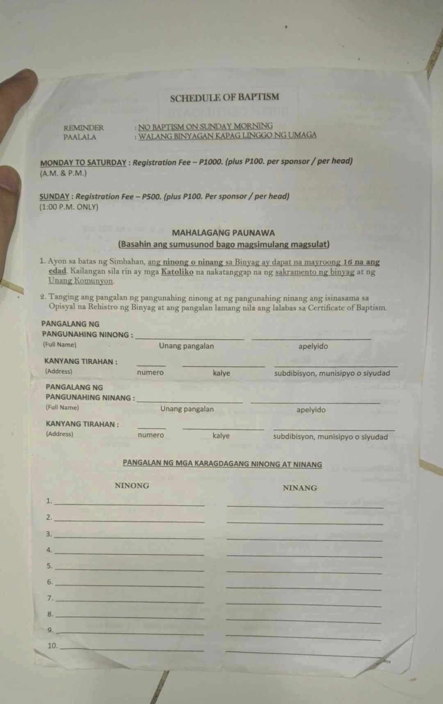

schedule of baptism form

video filming / photo taking

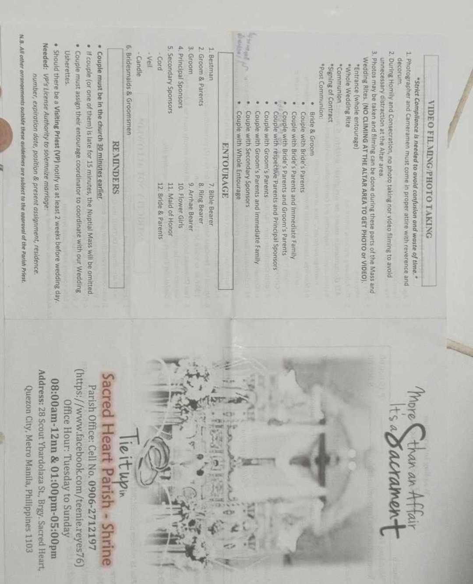

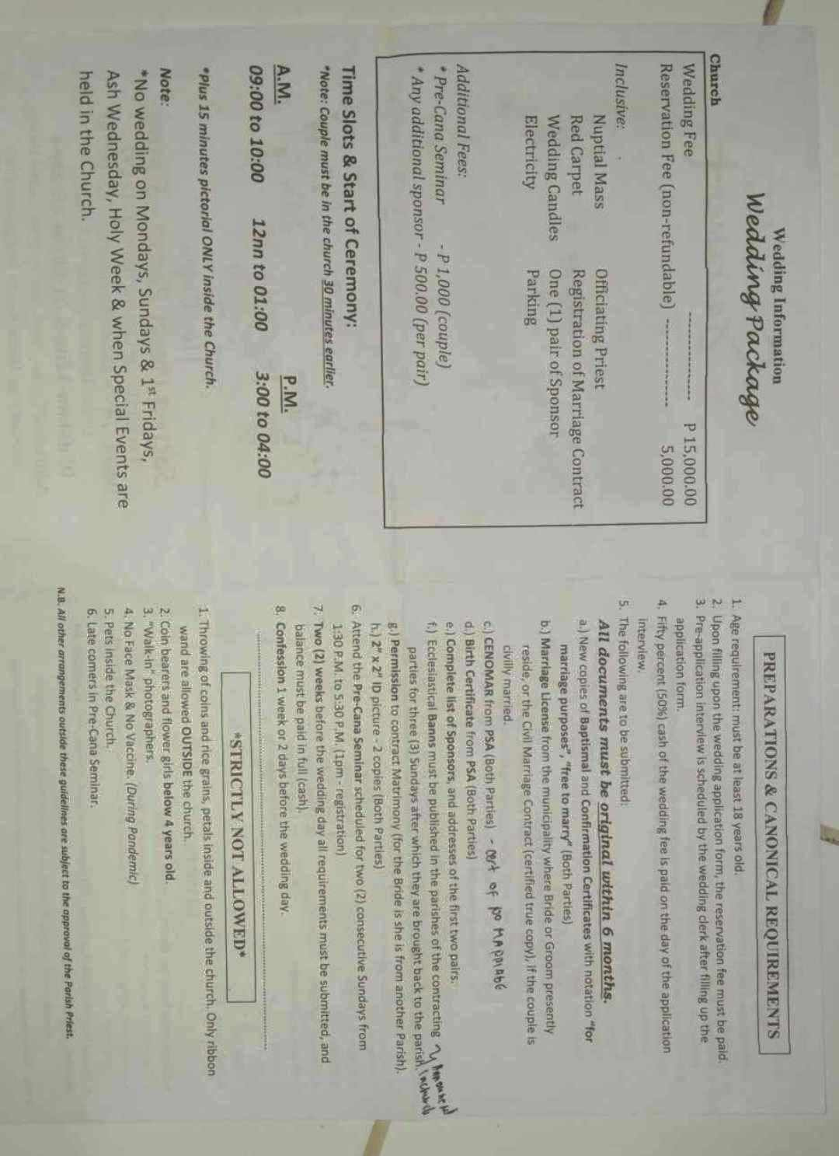

Wedding package