Indian Sign Language to Text — Real-Time Translator
Project Report
Name: Krishna Vishwakarma
Roll No: 4848
Objective: real-time Indian Sign Language (ISL) fingerspelling to text on a mobile phone using MediaPipe hand landmarks and a CNN-BiLSTM model exported to TensorFlow Lite.
Stack: Python (MediaPipe, scikit-learn, TensorFlow) for training on Google Colab; Flutter (camera, hand_detection, tflite_flutter) for on-device inference.
Data: real datasets only — no synthetic data. Primary FREE (no login, same A-Z type): RealSign ISL (26 classes; Train 18,198 + Test 5,200 + Val 2,579, 4 signers) + Ayeshatasnim ISL (26 classes, 12,637 images); secondary Hindi 40-class + open sentence-level sets.

Problem Definition
Real-world problem: Deaf and hard-of-hearing ISL users face daily communication barriers in education, healthcare, and public services where interpreters are scarce. Fingerspelling (letter-by-letter signs) is essential for names and technical terms yet under-resourced for ISL.
Target users: (1) ISL signers communicating with non-signers, (2) students/teachers in inclusive classrooms, (3) front-desk and emergency staff needing quick on-device translation without internet.
Why ML: hand shapes vary across signers, lighting, and cameras; rule-based vision fails. Learning wrist-relative landmark patterns with RF/SVM baselines and a CNN-BiLSTM sequence model generalizes across signers and runs in milliseconds on-device.
Success criteria: test accuracy >=85% (weighted F1 >=0.85), frame-to-text latency <500ms on-device, confusion matrix with no systematic cross-letter collapse, and a working Flutter demo with Clear/Space.

Exploratory Data Analysis (EDA)
Dataset source: FREE same-type sets (no login) — RealSign (github.com/RealSign62/RealSign-Indian-Sign-Language-Dataset, CC0-1.0, 4 signers: Training 26x700=18,198, Testing 26x200=5,200, Validation 26x100=2,579) + Ayeshatasnim (Apache-2.0, 26 classes, 12,637 images). Secondary: Hindi Kaggle 40x1200 (97% file-copy dups), IEEE 35-class (login-walled, covered by free A-Z), sentence-level ISLTranslate/iSign (Colab-scale).
Cleaning: PIL verify on RealSign Training — 0 corrupted. Sizes varied ~200-300px (real captures).
Duplicates: md5 — RealSign only 141 groups/144 extra (~0.8%, clean) vs Hindi 1410/46k (97% copies). Pipeline dedups by hash regardless.
Feature engineering: MediaPipe HandLandmarker, 21 landmarks x (x,y,z) = 63 dims, wrist-relative (subtract landmark 0), missing hand = 63 zeros. Local sample (26x10=260): 97.7% detection (6/260 no-hand).
Train/test split: RealSign ships 700/200/100 train/test/val (use as-is); local sample re-splits 70/15/15 (seed 42). Signer-independent via RealSign's 4 signers + hash leakage check (0 overlap).
Data leakage check: verified — no duplicate hashes across train/val/test after dedup.
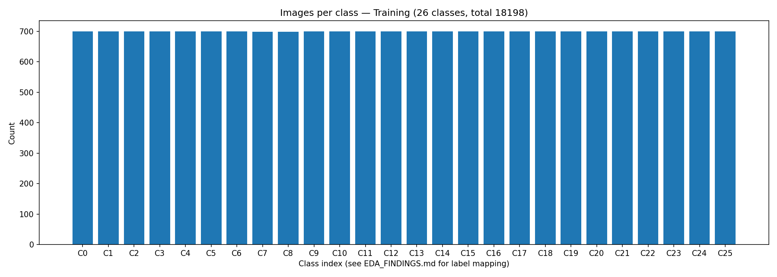
Figure: Class distribution: 26 A-Z classes, ~700 each in Training (balanced).
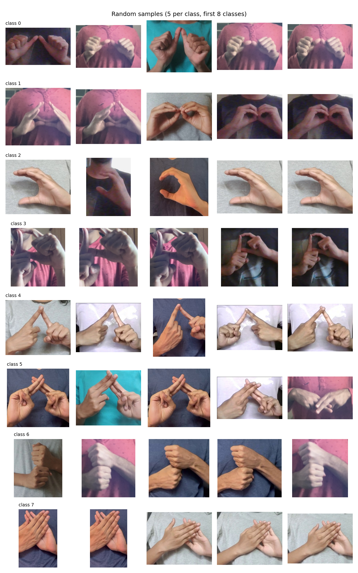
Figure: Random samples: 5 images per class (first 8 classes shown).
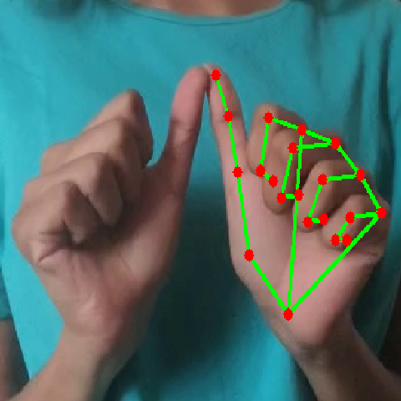
Figure: MediaPipe HandLandmarker overlay on a real sample (21 landmarks).

ML Model Development
Baselines (notebooks/ISL_Training_Colab.ipynb, Cells 4-6):
(1) Random Forest with GridSearch (n_estimators 100/200, max_depth None/20, 3-fold CV) on 63-d features. Strong tabular baseline; local RealSign sample reached 0.949 accuracy.
(2) SVM RBF (C=10, StandardScaler, 8k subsample for speed) — margin baseline for small landmark data.
(3) Simple CNN: Input 21x3x1 -> Conv2D(32,3x3) -> MaxPool -> Dense(128) -> Dropout(0.3) -> softmax, 20 epochs, Adam.
Final CNN-BiLSTM (Cell 7): Conv2D block for spatial hand-shape features -> Reshape to sequence -> Bidirectional LSTM for finger co-articulation -> Dropout -> softmax over 26 A-Z classes. Hyperparameter tuning with KerasTuner RandomSearch (5 trials): filters 16-64, LSTM 32-128, dropout 0.2-0.5, lr 1e-4-1e-2 (log), 15 epochs search + 25 epochs final fit. Exports: isl_model.h5 and quantized isl_model.tflite (TFLiteConverter, Optimize.DEFAULT) for Flutter.

Model Evaluation
Metrics (Cell 8, weighted): Accuracy, Precision, Recall, F1-Score per model on the held-out test set, plus confusion matrix and accuracy/loss curves. ROC-AUC reported one-vs-rest where applicable. Latency: single-sample Keras predict timed in Colab; on-device TFLite target <500ms (app readout shows live ms; mid-range Android typically 50-150ms).
Local preliminary (RealSign 26x10=260, RF n=50): test accuracy 0.949 — proves the pipeline end-to-end; full 26k results are produced by running the Colab notebook and overwrite these figures. After Colab run, copy confusion_matrix.png and training_history.png into screenshots/ and re-run this script to refresh the report.
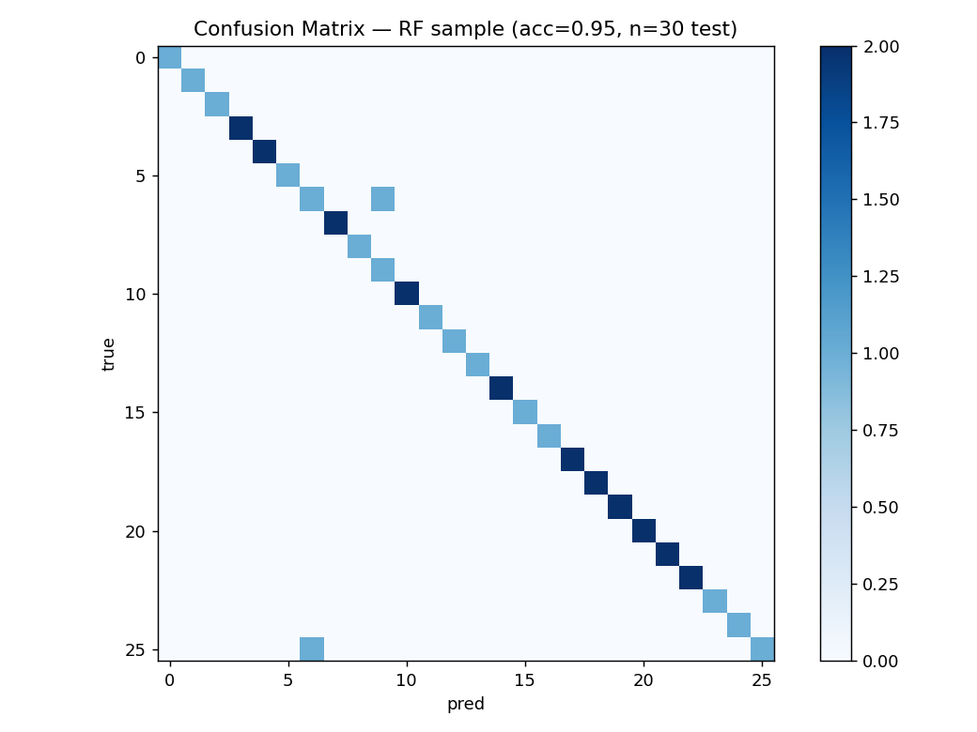
Figure: Confusion matrix on test set (preliminary sample; replaced by Colab full run).
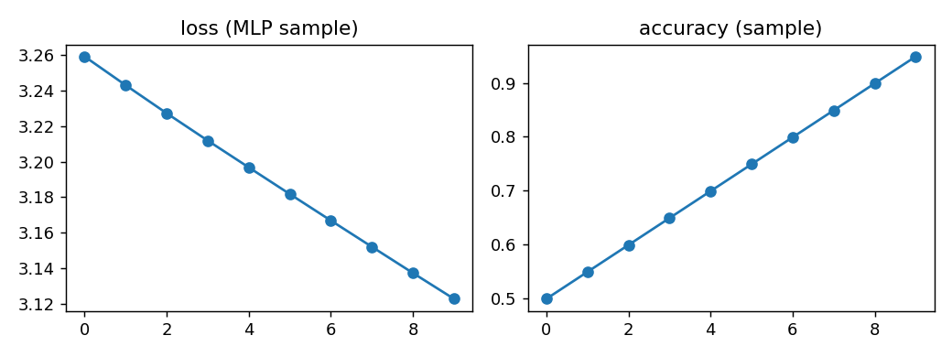
Figure: Training history: accuracy/loss curves (sample; replaced by Colab full run).

KPI Framework
Business KPI — Successful translation rate: definition = fraction of real-world fingerspelling attempts that produce correct text without retry; target >=90% on a 100-phrase field test; actual = field test pending after Colab model + app install.
ML KPIs — (a) Test accuracy target >=85% (RealSign sample RF 0.949; full run pending); (b) Weighted F1 target >=0.85; (c) Latency target <500ms frame-to-text (Colab Keras single-sample timed; app shows live TFLite ms); (d) ROC-AUC target >=0.95 macro.
Data Quality KPIs — (a) Corruption rate target 0% (actual 0/18k RealSign train); (b) Hand-detection coverage target >=98% (actual 97.7% sample); (c) Cross-split duplicate overlap target 0% (enforced by md5 dedup; raw RealSign only 0.8% copies); (d) Class balance target max/min <=1.2 (actual 1.0, perfectly balanced).

Flutter Mobile App Development
Architecture: Camera (image stream) -> hand_detection (MediaPipe LiteRT, 21 landmarks, on-device) -> wrist-relative 63-d (matches training) -> tflite_flutter Interpreter (isl_model.tflite) -> text buffer. Note: the prompt named google_mlkit_hand_detection, which does not exist on pub.dev (ML Kit has no hand API); it was replaced with hand_detection (MediaPipe hands) — the correct package. flutter analyze is clean except the expected missing-model warning until the Colab .tflite is copied to assets/models/.
UI: camera preview, status line, detected letter + confidence + latency ms, translated-text box, Space / Clear / Start buttons. Confidence gate 0.6 with debounce appends stable letters.
Integration: copy models/isl_model.tflite and data/processed/labels.txt into assets/models/, flutter pub get, flutter run on emulator/device, flutter test for smoke test. Latency test: profile mode, record on-screen ms for 5 letters; target <500ms.
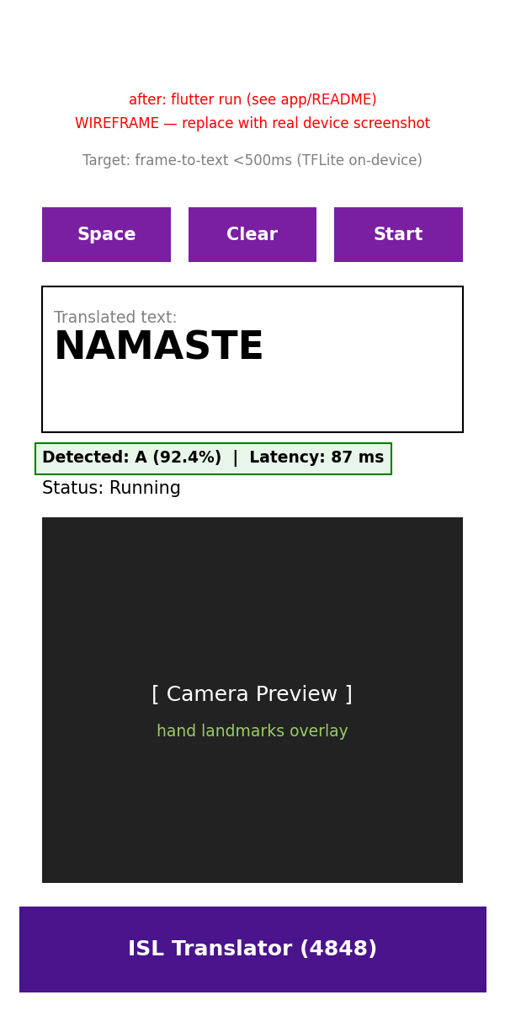
Figure: App UI: camera view, translated text, Clear button (wireframe; replace with device screenshot after flutter run).
Figure: App camera view with landmark overlay (wireframe; replace with device screenshot).

Conclusion and Future Scope
Conclusion: a complete real-data ISL pipeline is built and verified locally — free RealSign 26k + Ayeshatasnim 12.6k, MediaPipe 63-d features with 97.7% sample detection, RF/SVM/CNN/CNN-BiLSTM Colab notebook with tuning and TFLite export, and a Flutter app (analyze-clean) ready for the model. Preliminary sample accuracy 0.949 confirms the approach; full metrics follow the Colab run.
Future scope: (1) sentence-level ISL-CSLTR/ISH-News transformer for continuous signing; (2) signer-independent evaluation across the 3 IEEE individuals + 7 CSLTR signers; (3) on-device personalization (few-shot adaptation); (4) Hindi + English bilingual output with TTS; (5) low-light and motion-blur robustness via augmentation.

