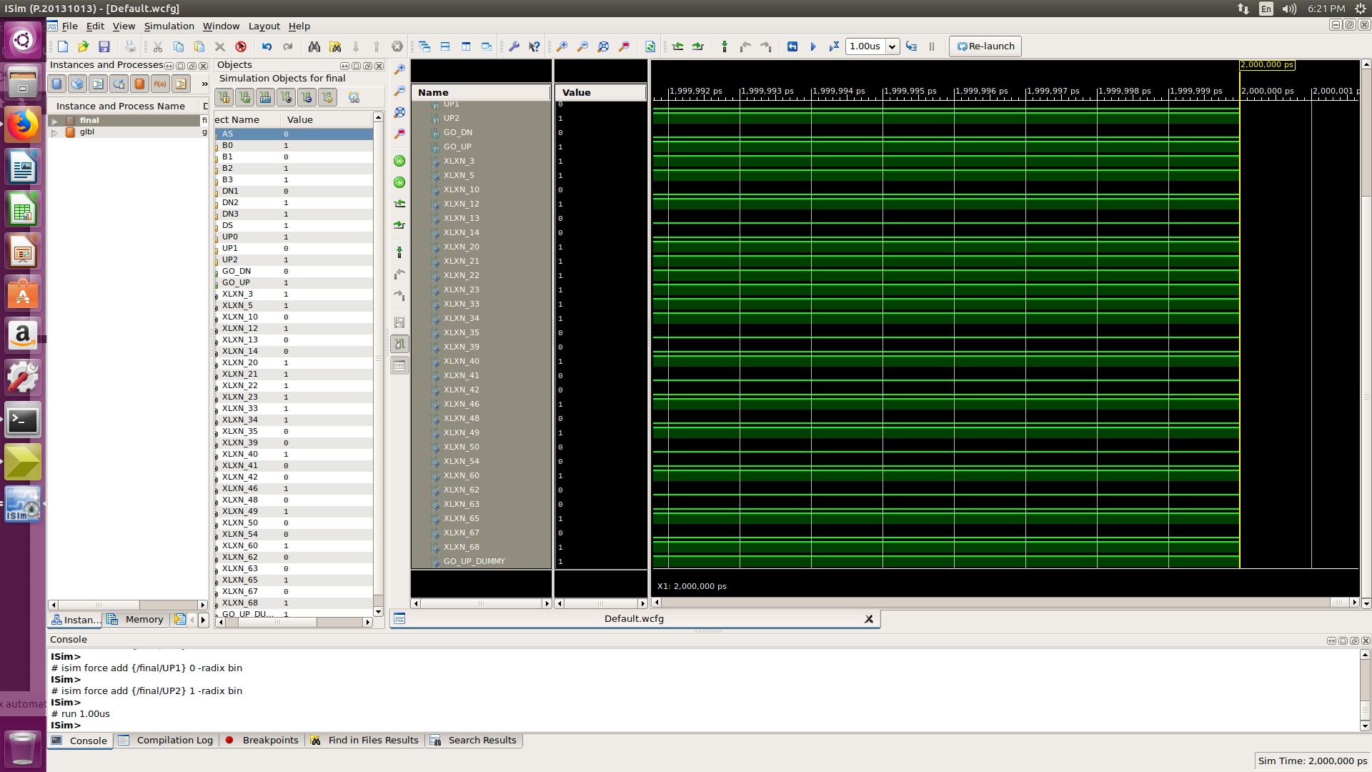

TEST CASE :1

ASSUMPTION: Lift is at Floor 1 and descending

B0 | B1 | B2 | B3 | UP0 | UP1 | UP2 | DN1 | DN2 | DN3 | ASC | DSC
1 | 0 | 1 | 1 | 1 | 0 | 1 | 0 | 1 | 1 | 0 | 1

RESULT: expected output lift should go down but our outcome was just opposite.

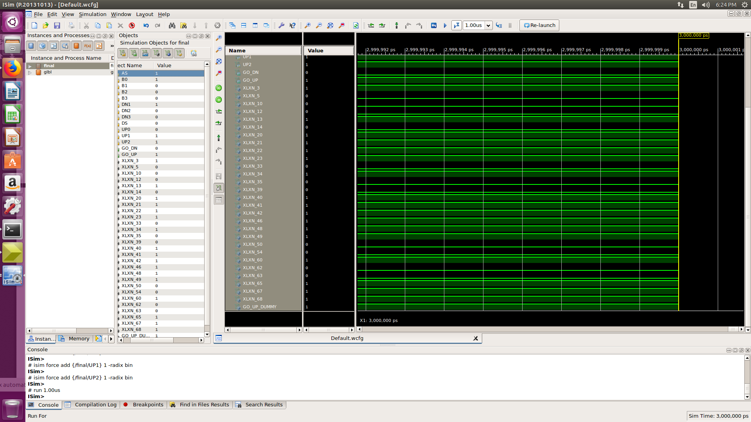

TEST CASE :2

ASSUMPTION: Lift is at Floor 2 and ascending.

B0 | B1 | B2 | B3 | UP0 | UP1 | UP2 | DN1 | DN2 | DN3 | ASC | DSC
1 | 0 | 0 | 0 | 0 | 1 | 0 | 1 | 0 | 0 | 1 | 0

RESULT: expected output lift should go up and our outcome is also same .

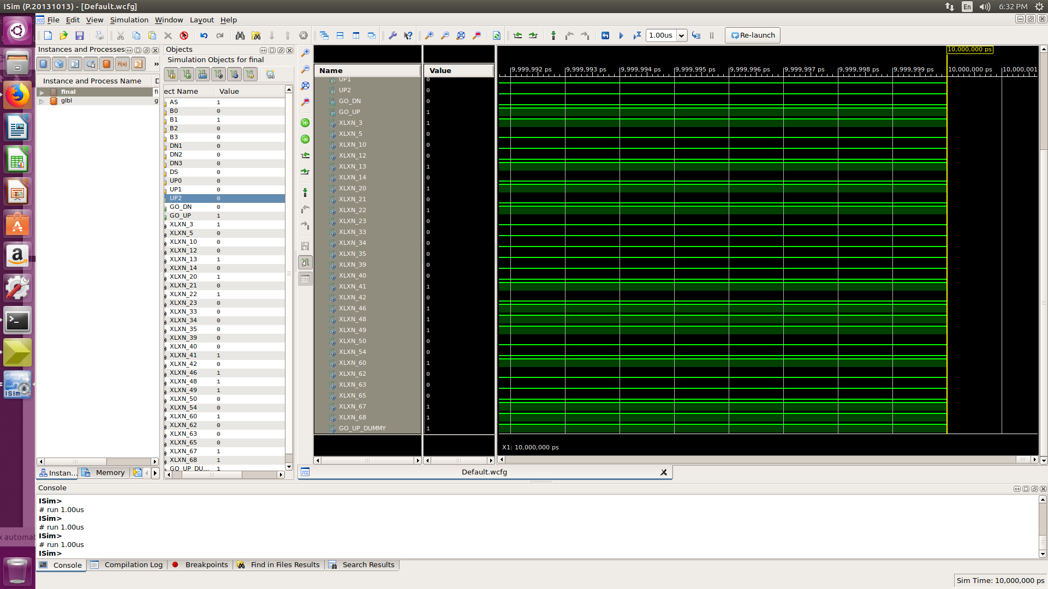

TEST CASE :3

ASSUMPTION: Lift is at Floor 1 and ascending

B0 | B1 | B2 | B3 | UP0 | UP1 | UP2 | DN1 | DN2 | DN3 | ASC | DSC
0 | 1 | 0 | 0 | 0 | 0 | 0 | 0 | 0 | 0 | 1 | 0

RESULT: expected output lift should go down but our outcome was just opposite.

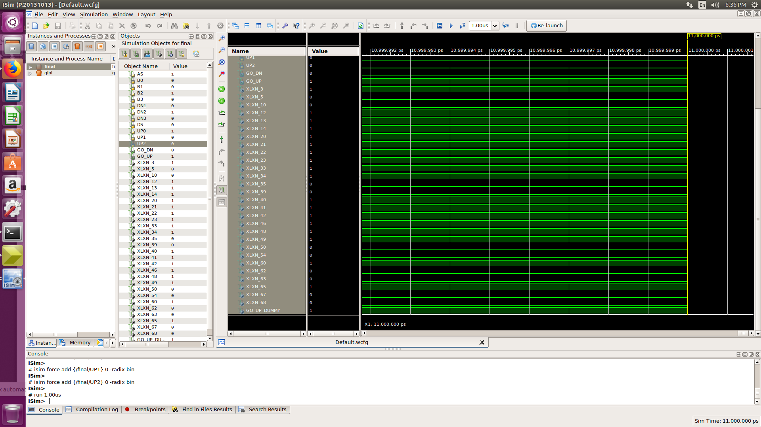

TEST CASE :4

ASSUMPTION: Lift is at Floor 1 and ascending

B0 | B1 | B2 | B3 | UP0 | UP1 | UP2 | DN1 | DN2 | DN3 | ASC | DSC
0 | 0 | 1 | 0 | 1 | 0 | 0 | 0 | 1 | 0 | 1 | 0

RESULT: expected output lift should go up and our outcome is also same.

