TEST | F0 | F1 | F2 | F3 | A | D | B0 | B1 | B2 | B3 | UP0 | UP1 | UP2 | DN1 | DN2 | DN3
1 | 0 | 1 | 0 | 0 | 0 | 1 | 1 | 0 | 1 | 1 | 1 | 0 | 1 | 0 | 1 | 1
2 | 1 | 0 | 0 | 0 | 0 | 0 | 0 | 0 | 0 | 0 | 0 | 0 | 0 | 0 | 1 | 0
3 | 0 | 0 | 1 | 0 | 1 | 0 | 1 | 0 | 0 | 1 | 0 | 1 | 0 | 1 | 0 | 0
4 | 0 | 1 | 0 | 0 | 0 | 0 | 0 | 0 | 0 | 0 | 1 | 0 | 0 | 0 | 0 | 1
5 | 0 | 0 | 1 | 0 | 1 | 0 | 0 | 0 | 0 | 0 | 0 | 0 | 0 | 1 | 0 | 0
6 | 0 | 0 | 1 | 0 | 0 | 0 | 0 | 0 | 1 | 0 | 0 | 0 | 0 | 0 | 0 | 0
7 | 0 | 1 | 0 | 0 | 1 | 0 | 0 | 1 | 0 | 0 | 0 | 0 | 0 | 0 | 1 | 0

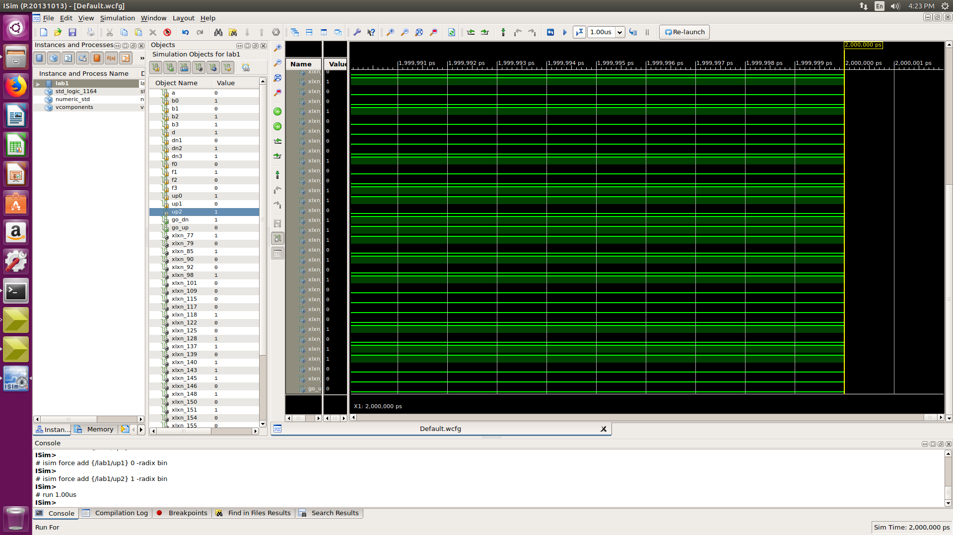
TEST-1 :

Result : OUTPUT GO UP =0 ; GO DOWN=1

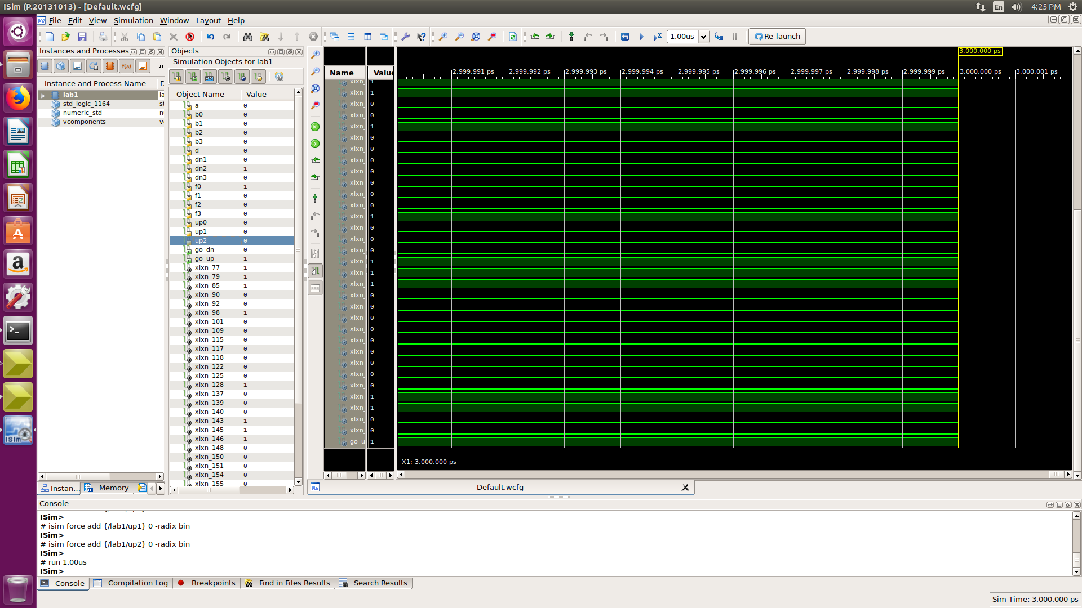
TEST-2:

Result : OUTPUT GO UP =1 ; GO DOWN=0

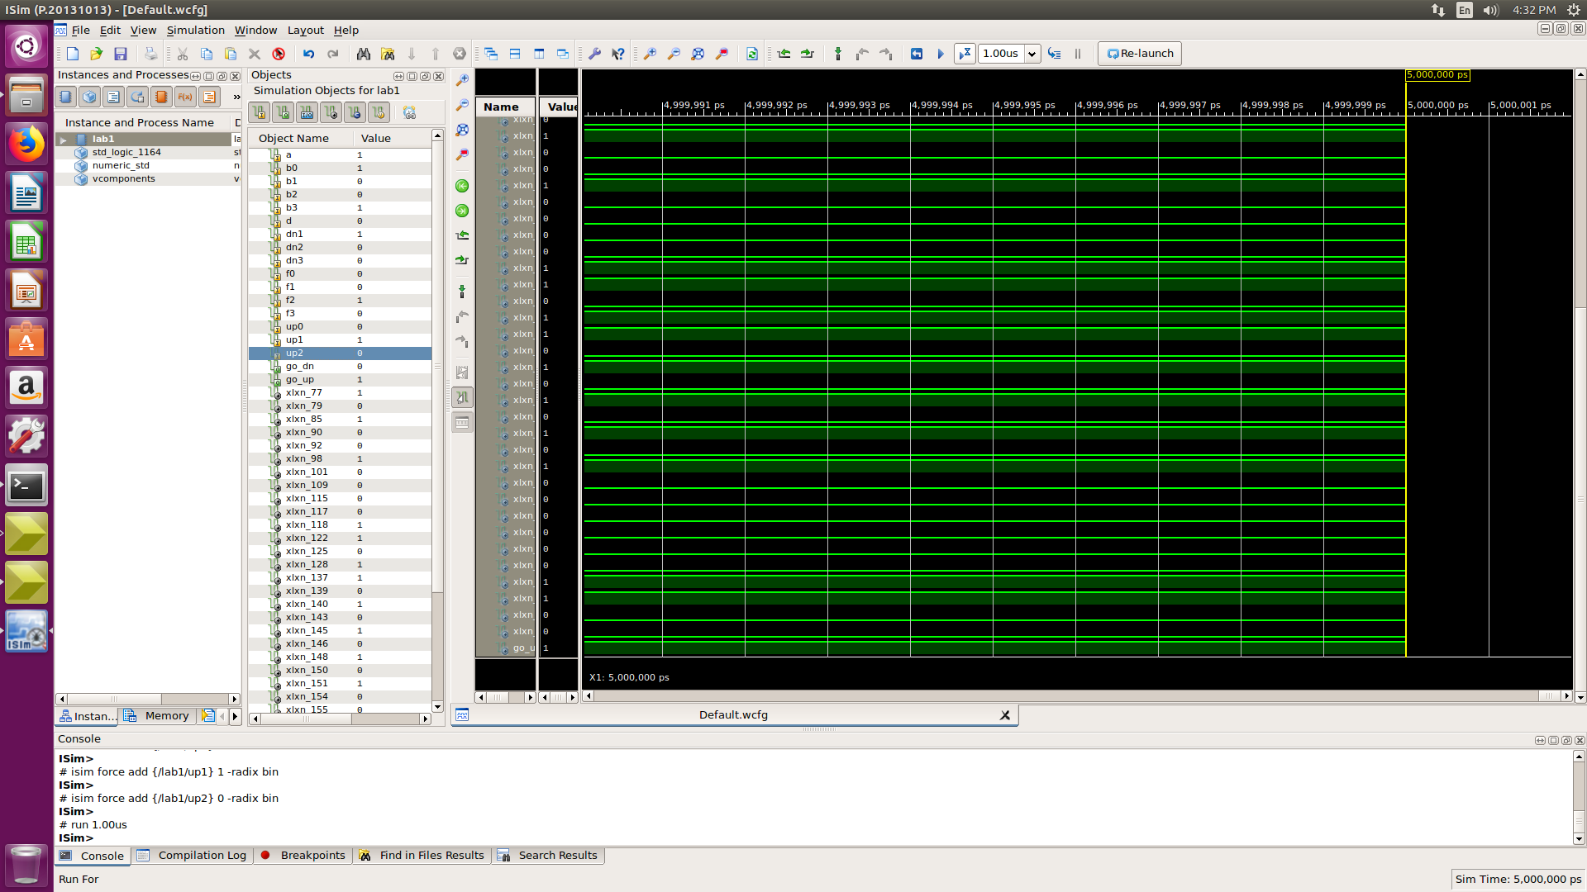
TEST-3:

Result : OUTPUT GO UP =1 ; GO DOWN=0

TEST-4:

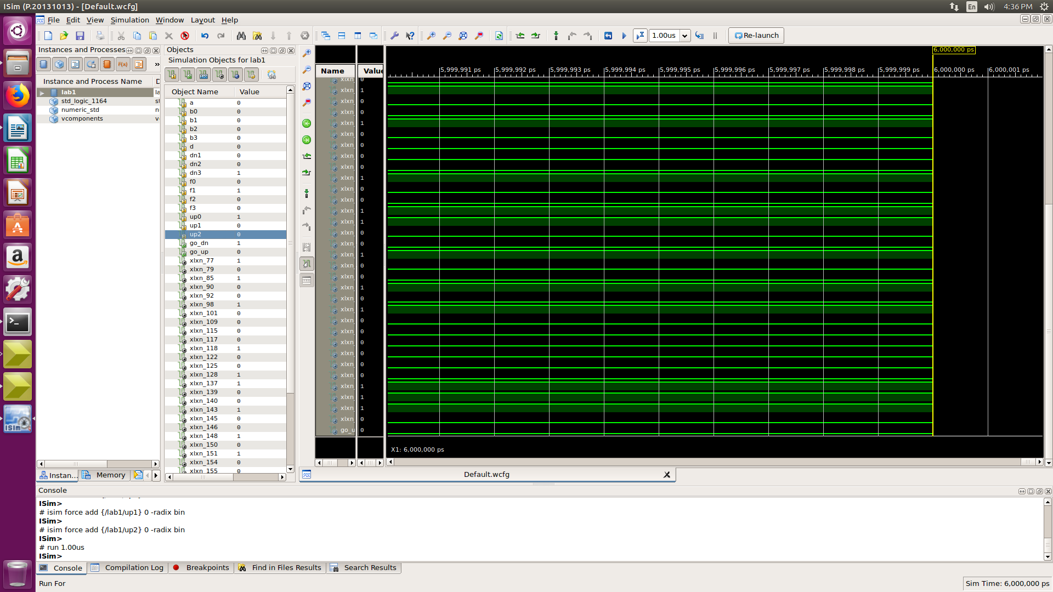

Result : OUTPUT GO UP =0; GO DOWN=1

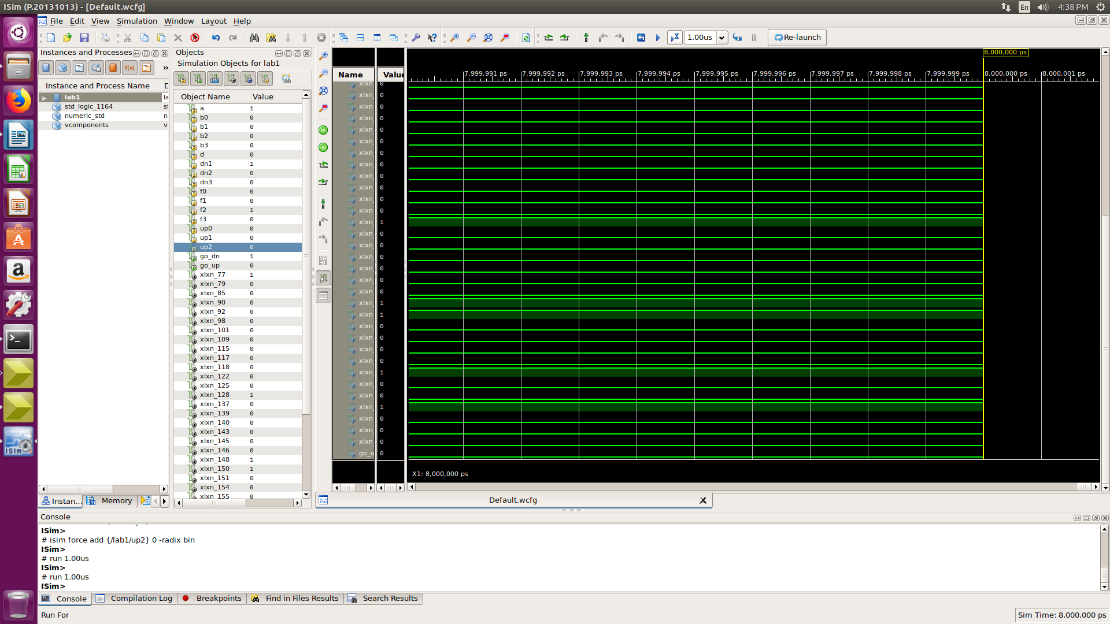
TEST-5:

Result : OUTPUT GO UP =0 ; GO DOWN=1

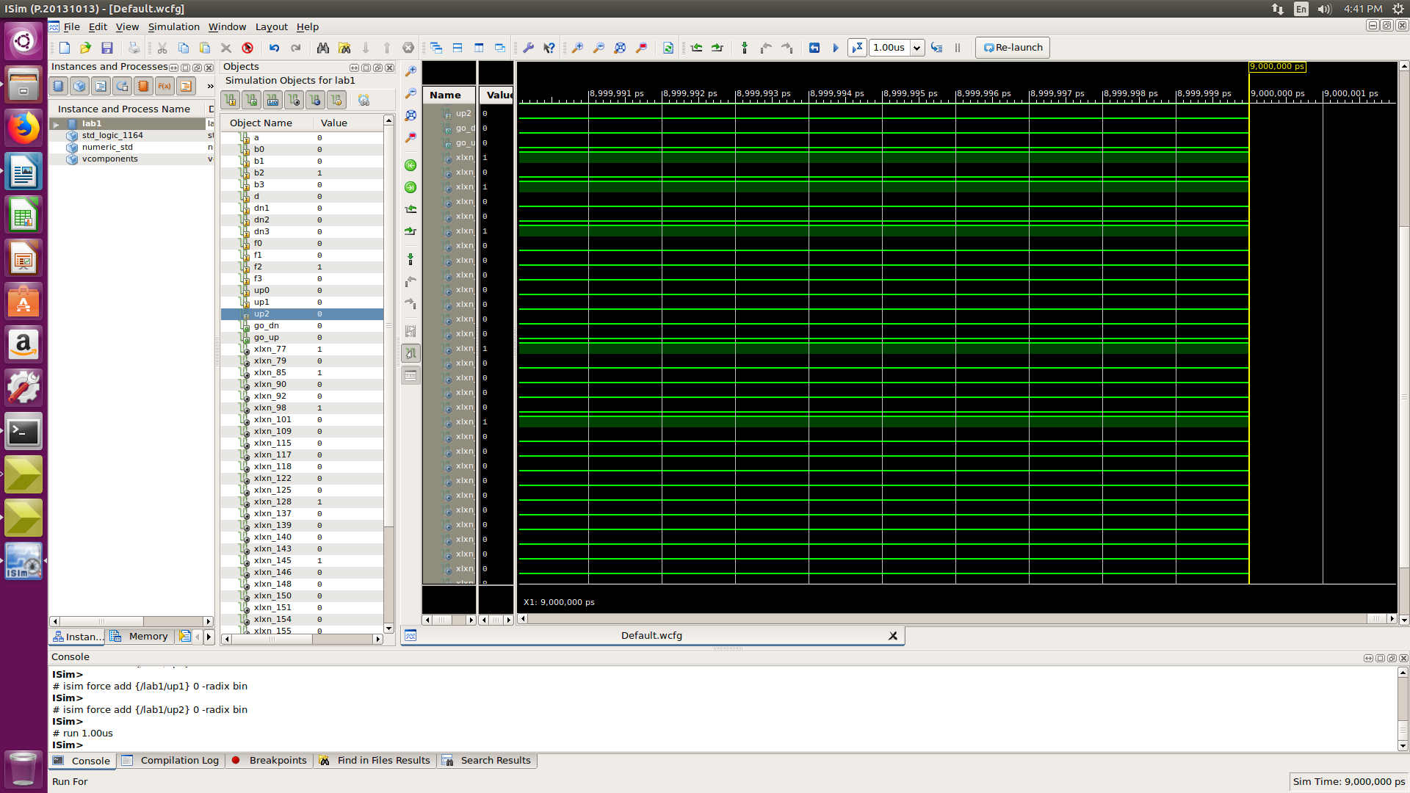
TEST-6:

Result : OUTPUT GO UP =0 ; GO DOWN=0

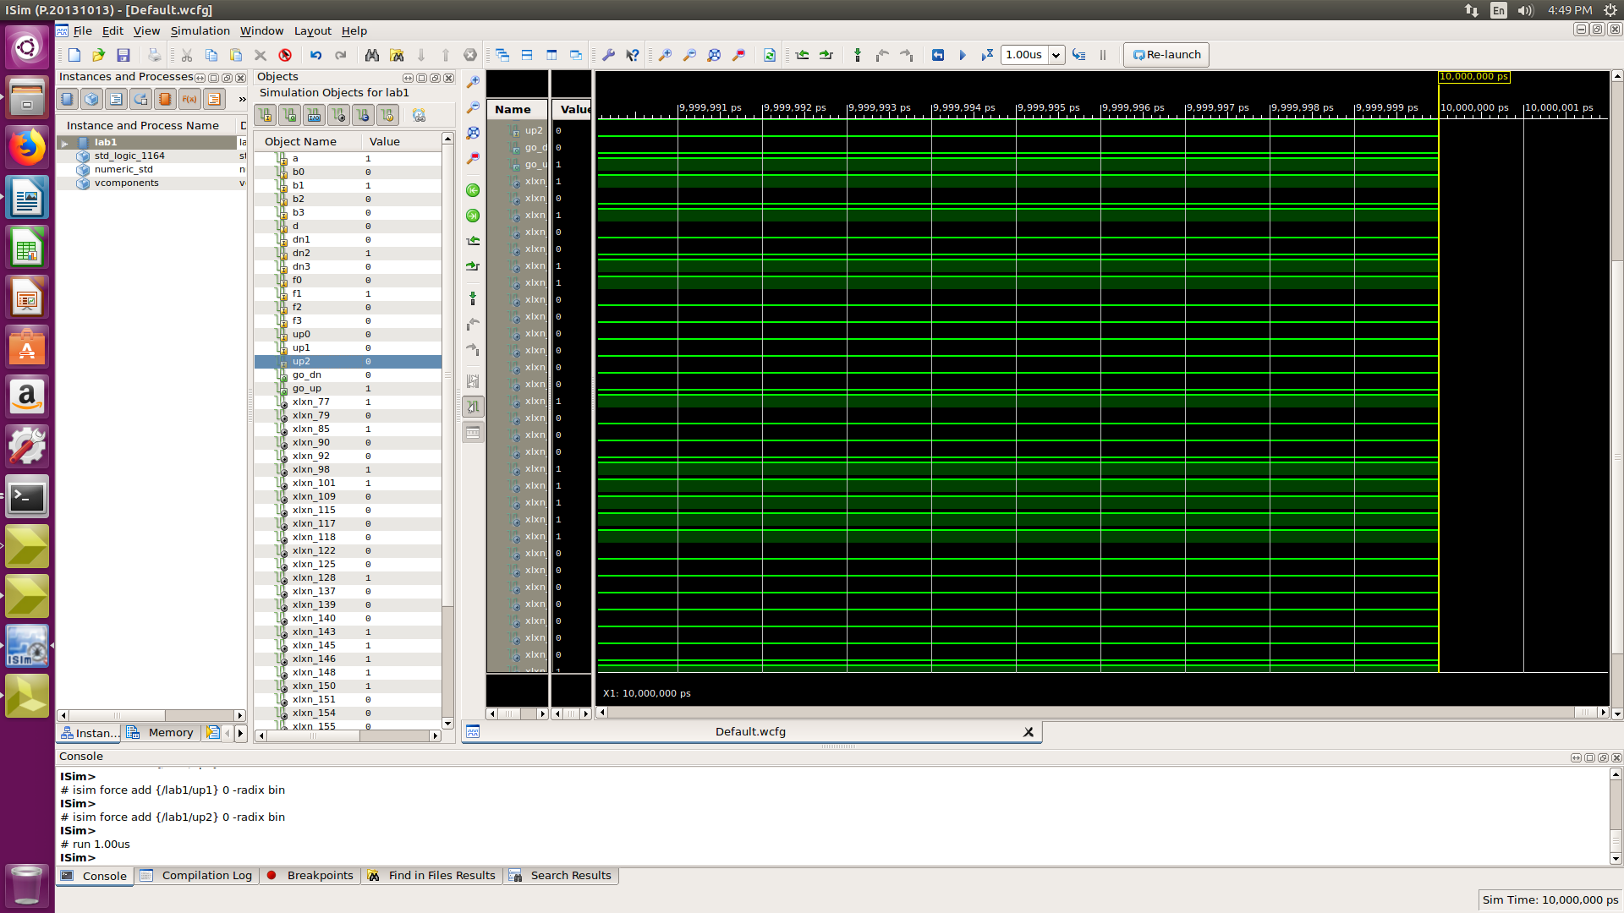
TEST-7:

Result : OUTPUT GO UP =1 ; GO DOWN=0

