ISV Sub-Account Provisioning — Process & Notification Flow
Technical documentation of the ISV sub-account provisioning workflow on the Partner Portal, spanning the LWC form, async platform events, Account/Contact creation, and email notifications.

Overview
This document traces the complete ISV sub-account provisioning flow on the Partner Portal, from form rendering and access control through asynchronous record creation and email notification.
The architecture spans five layers:
- An LWC form (prmIsvAccountRequestForm)
- An Aura-enabled Gateway (PRM_IsvAccountProvisionGateway)
- A Service layer implementing an async platform-event handler interface (PRM_IsvAccountProvisionService)
- A DTO (PRM_IsvAccountProvisionDTO)
- A dedicated email notification service (PRM_IsvAccountProvisionEmailService)

1. LWC Form — prmIsvAccountRequestForm
The form is exposed to lightning__AppPage, lightning__HomePage, and lightningCommunity__Page, making it available on the Partner Community.

Access-control gating
On connectedCallback(), the component calls fetchAccount(), which performs authorization before rendering any form fields:
- Calls validateRunningUser({ userId }) (via the Gateway). If this returns false, the component state is set to NOT_AUTHORIZED and the template renders "You do not have access to view this page." instead of the form.
- If authorized, calls getAssociatedCustomerAccounts({ userId }) to populate the Parent Account Site ID combobox with the user's eligible customer account(s).

Form fields
Field | Input type / notes
Parent Account Site ID | Combobox, populated from associated customer accounts
End Customer Company Name | Text
End Customer Address | Street, city, state/province, postal code, country
DocuSign Admin's First Name / Last Name | Text
Email | Email
Phone | Phone
Server Location | Combobox: AU, CA, EU1, NA1, NA2, NA3, NA4
Notes | Free text, max 1000 chars

Submission
On submit, handleSubmitClick():
- Validates required inputs client-side.
- Re-validates the Site ID via validateSiteId({ userId, siteId }) — if invalid, shows a toast and aborts.
- Calls submitIsvAccountProvisionRequest({ formData }) with a JSON payload containing runningUserId, accountSiteId, companyName, firstName, lastName, email, phone, server, notes, and address.

2. Gateway / Service / DTO Architecture

PRM_IsvAccountProvisionGateway
Aura-enabled Apex controller, the only Apex surface the LWC talks to directly. Each method delegates to PRM_ServiceManager.systemMode.isvAccountProvision and wraps exceptions as AuraHandledException:
- getAssociatedCustomerAccounts(userId)
- submitIsvAccountProvisionRequest(formData)
- validateRunningUser(userId)
- validateSiteId(userId, siteId)

PRM_IsvAccountProvisionService
Implements PlatformEventAsyncHandlerInterface. Holds both the synchronous validation/lookup logic called by the Gateway and the asynchronous provisioning logic triggered by the platform event.
Method | Purpose
submitRequest(formData) | Gated by Switches.PRM_PORTAL_ISV_ACCOUNT_REQUEST; publishes an Async_Microservice_Transaction_Bus__e event
getAssociatedCustomerAccounts(userId) | Resolves the user's parent Account, then the related Customer account(s)
validateRunningUser(userId) | Authorization check used to gate form rendering
validateSiteId(userId, siteId) | Confirms a submitted Site ID belongs to the user
process(lstEvents) | Async handler entry point invoked by dynamic dispatch (see Section 3)
provisionRecords() | Orchestrates DTO/account validation and record creation

PRM_IsvAccountProvisionDTO
Data wrapper shuttled as serialized JSON through the platform event payload.
Field | Purpose
accountSiteId | Parent account lookup key
subAccountId | Populated after sub-Account creation (for email WhatId)
companyName | New sub-Account name
server | Server Location selection from the form
notes | Free-text notes
address (nested Address) | street, city, province, state, country, postalCode
firstName, lastName, phone, email | DocuSign Admin contact fields
emailType | SUCCESS or FAILURE enum, set by the Service before invoking the email service
runningUserId, runningUserEmail | Submitting user context
validate() requires runningUserId, accountSiteId, companyName, email, firstName, lastName, phone, and a valid Address (street, city, postalCode, country, and either province or state).

3. Async Dispatch Chain
Form submission does not create records synchronously. It publishes a platform event, which is routed to the Service through a generic dynamic-dispatch mechanism shared by many PRM/CRM async handlers in the org.
- PRM_IsvAccountProvisionService.submitRequest — builds an Async_Microservice_Transaction_Bus__e record:
  - Transaction_Data_Payload__c = JSON-serialized form data
  - Apex_Microservice_Processor__c = 'PRM_IsvAccountProvisionService'
  - Publishes via EventBus.publish.
- AsyncMicroserviceListenerTrigger (after insert trigger on Async_Microservice_Transaction_Bus__e) — calls PlatformEventObjectService.doAfterInsert(Trigger.new).
- PlatformEventObjectService.doAfterInsert — groups incoming events by Apex_Microservice_Processor__c, then for each processor key dynamically resolves the class via Type.forName(processor).newInstance(), casts it to PlatformEventAsyncHandlerInterface, and calls .process(events).
- PRM_IsvAccountProvisionService.process(lstEvents) — the resolved handler:
  - Sets a Database.Savepoint.
  - Parses the DTO from Transaction_Data_Payload__c.
  - Calls provisionRecords() to create the sub-Account and Contact.
  - On success: sets dto.subAccountId, dto.emailType = SUCCESS, calls PRM_ServiceManager.email.isvAccountProvision.sendSuccessEmail(dto).
  - On exception: rolls back to the savepoint, logs via ExceptionLogger, creates a RevOps Case, sets dto.emailType = FAILURE, and still calls sendSuccessEmail(dto) (the single entry point that branches internally by emailType).

End-to-end flow
The flow is split into three diagrams so each stays readable: the synchronous form path, the async provisioning path, and the email service.

Diagram 1 — Form access and submission
Three gates stand before any record work: the user check, the Site ID check, and the PRM_PORTAL_ISV_ACCOUNT_REQUEST feature flag.
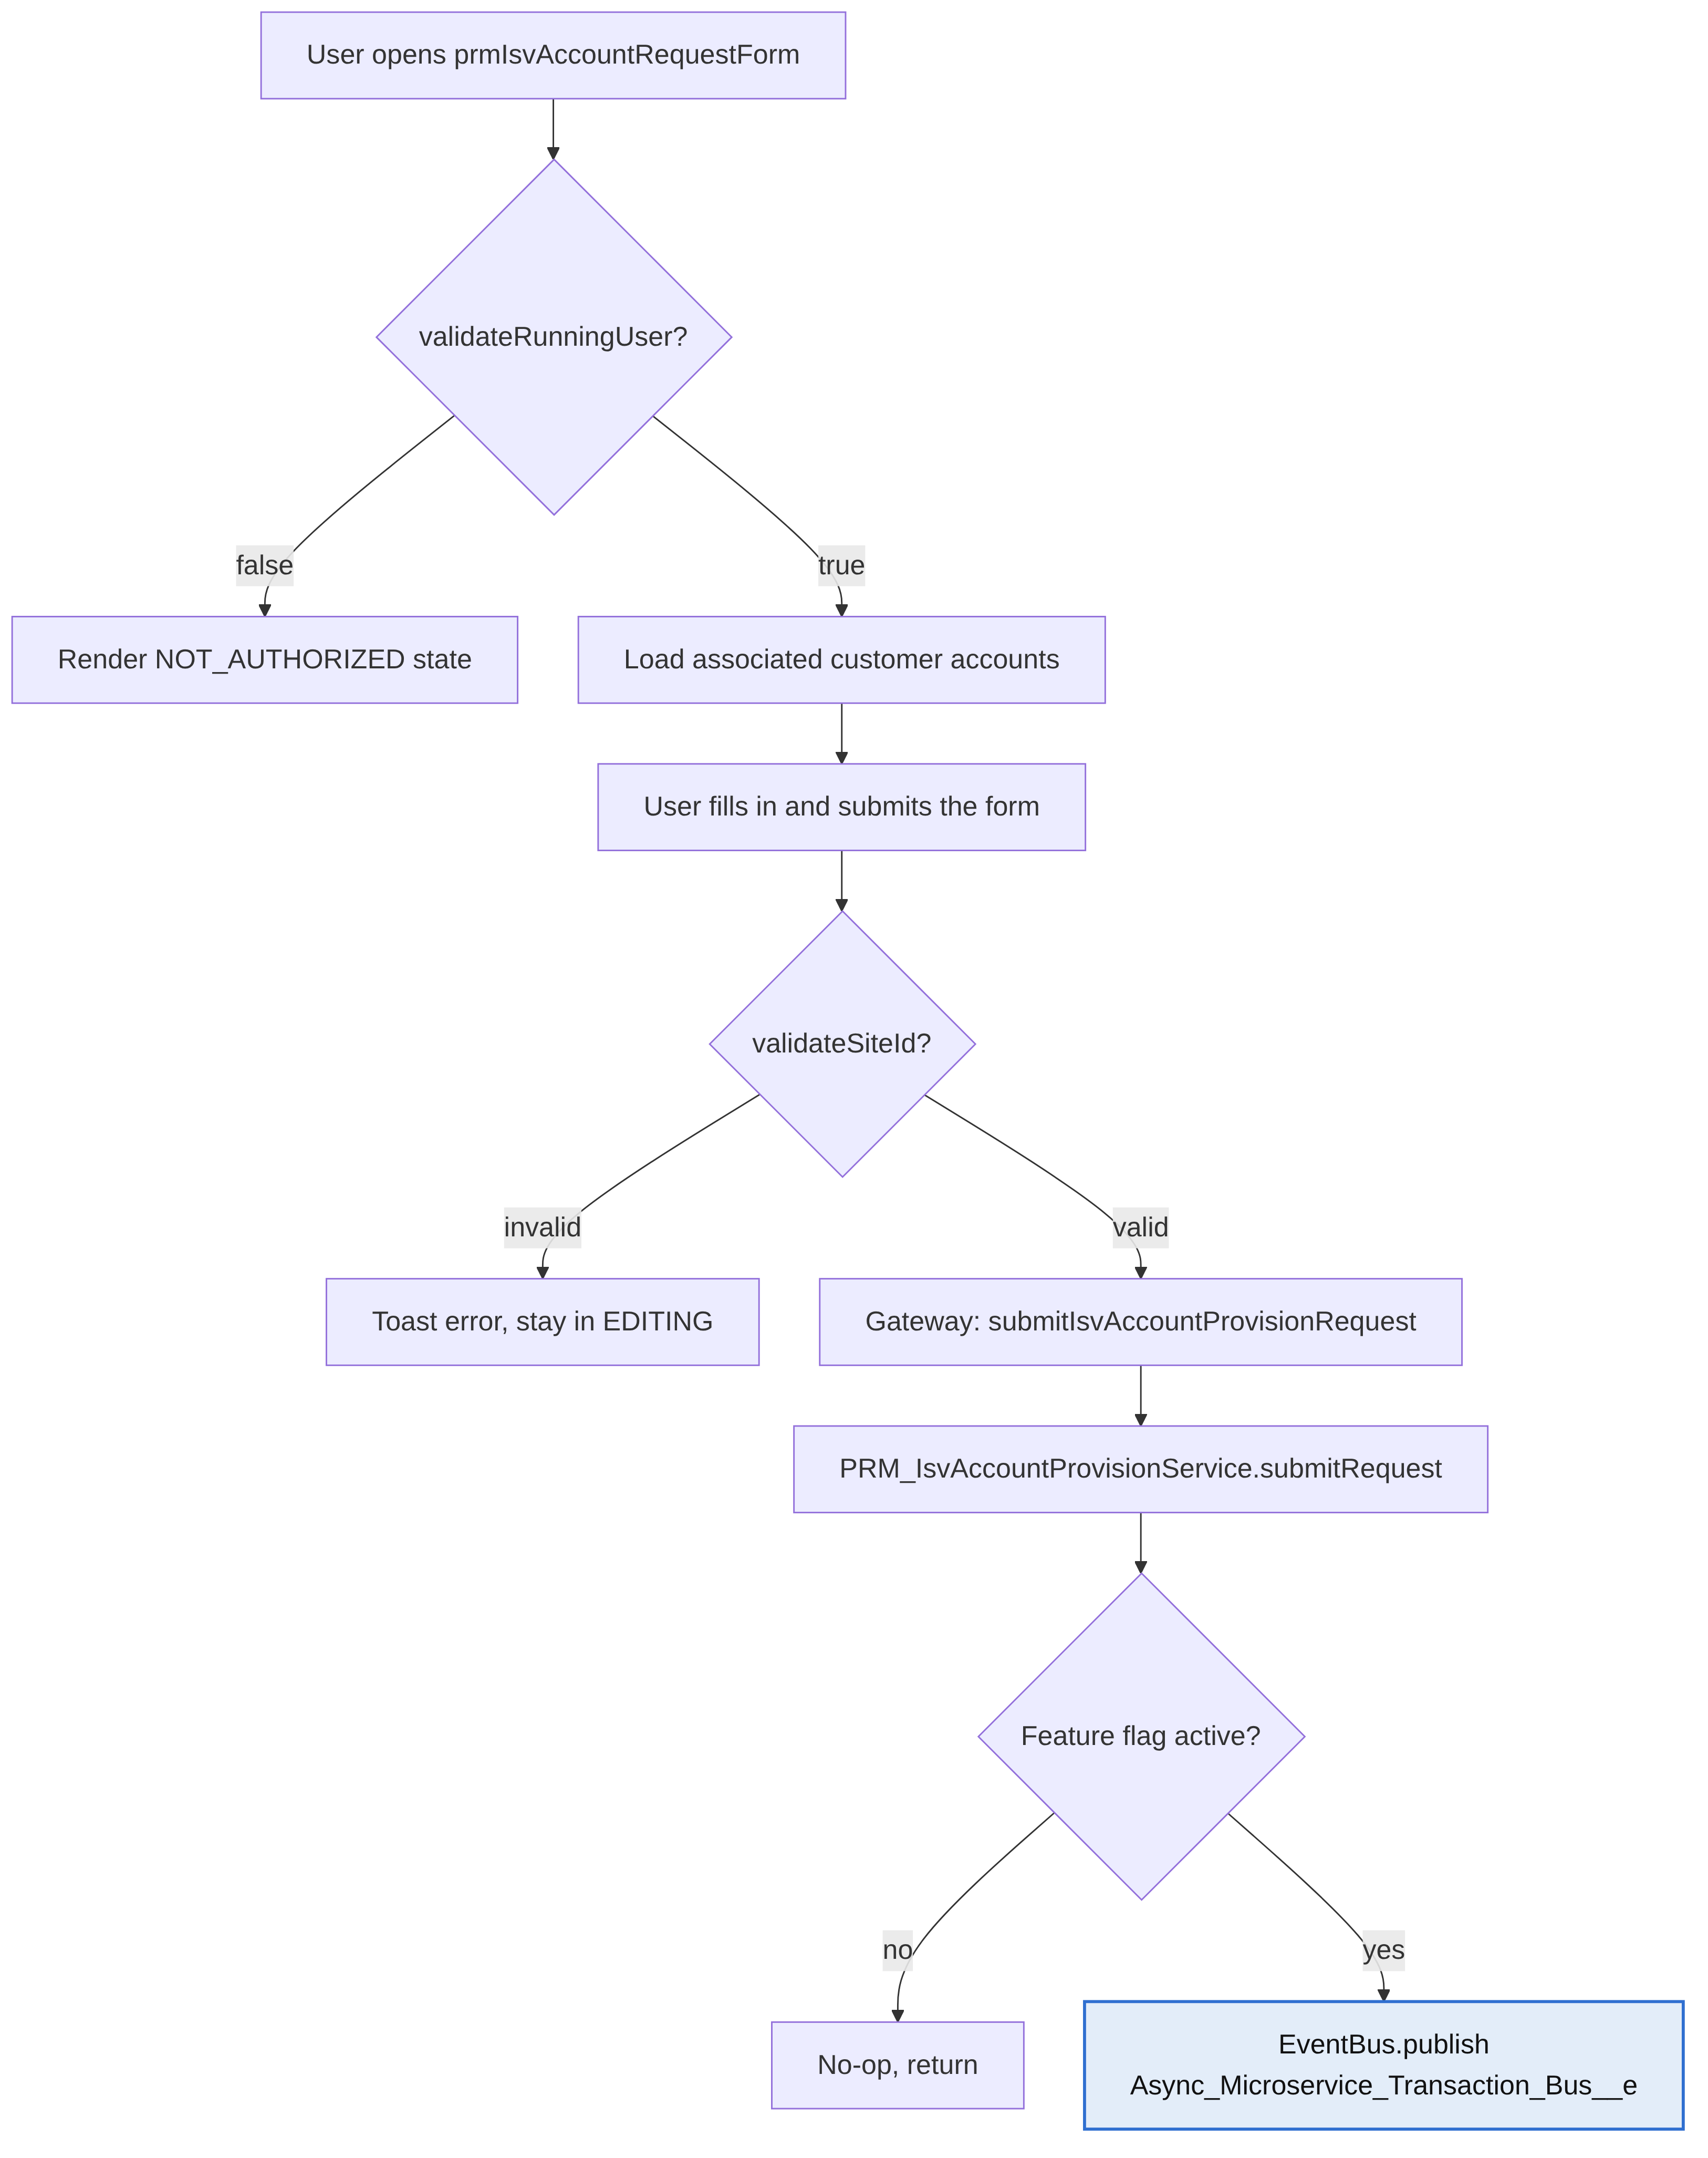

Diagram 2 — Async dispatch and record provisioning
Both branches converge on sendSuccessEmail(dto); only dto.emailType tells the email service which message to send.
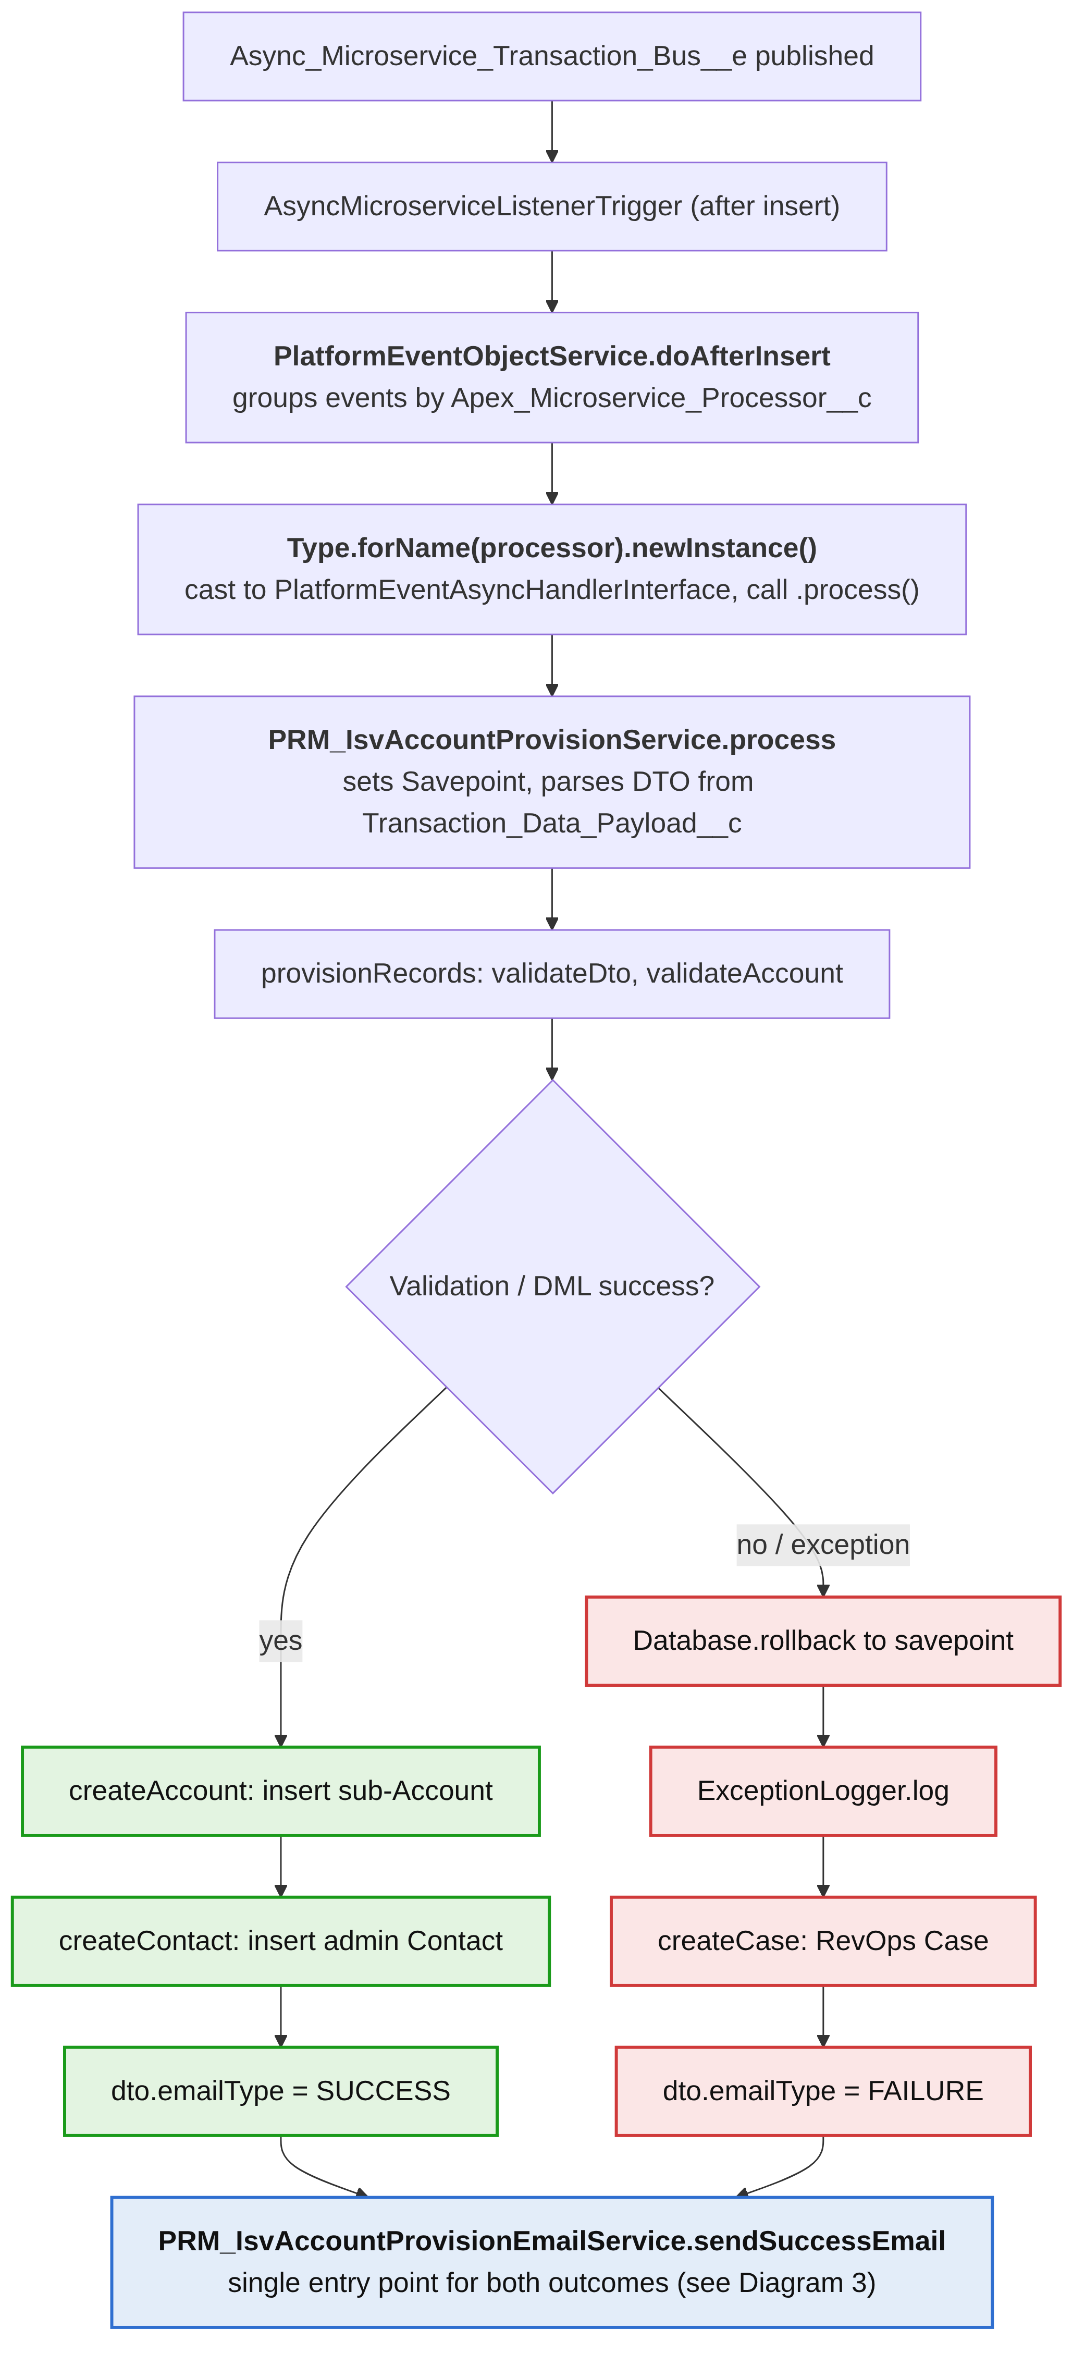

Diagram 3 — Email service branching and escalation
The running user only hears back on success; on failure they get no email, and RevOps is alerted through the distro and a Case.
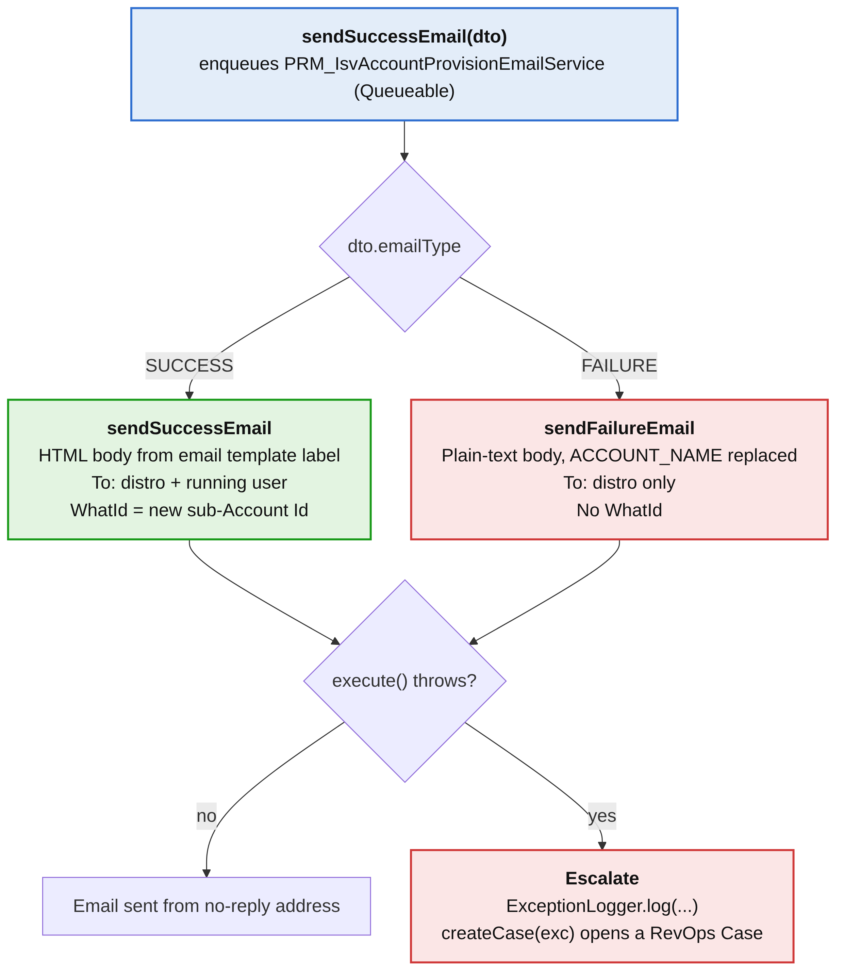

4. Record Creation
provisionRecords() sequence (all within the Service's process() savepoint):
- validateDto() — re-validates the parsed DTO.
- getParentAccountBySiteId(dto.accountSiteId) — resolves the parent Account.
- validateAccount(parentAccount) — see Section 5.
- getAccountConfigId(parentAccount.DocuSignEnvironmentAccountSuffix__c) — resolves DOSS_AccountConfiguration__c by suffix.
- getNamedAccount(parentAccount.Named_Account__c) — normalizes Parent/Child naming.
- createAccount(...) — inserts the sub-Account.
- createContact(accountId) — inserts the admin Contact, if the Account insert succeeded.

Sub-Account field mapping (createAccount)
Field | Source
Name | dto.companyName
ParentId, Subscription_Owner__c | parentAccount.Id
DocuSignEnvironment__c | resolved accountConfigId
BillingStreet/City/State/PostalCode/Country | dto.address.*
Phone, Billing_Phone__c, Fax, OwnerId, SAM_Tier__c, TCSM__c, TCSM_Program__c, Industry, Industry_Override__c, Client_Services_Executive__c, Website, EBR__c, ESR__c, Account_Score__c | copied from parentAccount
Type | TYPE_CUSTOMER_SUB
DUNS_Number__c | DUNS_CUST_SUB
DocuSign_Enrollment_Stage__c | ENROLLMENT_STAGE_PENDING
Named_Account__c | computed namedAccount
Territory_Type__c | parentAccount.Territory_Type__c
DocuSign_Account_Type__c | DS_TYPE_CUSTOMER_MANAGED_PARTNER
Partner_Referring_Account2__c | parentAccount.Partner_Referring_Account2__c
Sales_Channel__c | SALES_CHANNEL_ISV_EMBED
Sales_Channel_Sub_Category__c | SALES_CHANNEL_SUB_ISV_LICENSE_CUSTOMER
RecordTypeId | customerManagedByPartnerRecordTypeId (RecordType DS_TYPE_CUSTOMER_MANAGED_PARTNER_API)
Provisioned_By__c | PROVISIONED_BY_ISV_FORM
Inserted with Database.DMLOptions.DuplicateRuleHeader.AllowSave = true.
Note: dto.server (Server Location) is not mapped to any field on this record.

Admin Contact field mapping (createContact)
Field | Source
FirstName, LastName, Phone, Email | dto.firstName/lastName/phone/email
AccountId | newly created sub-Account Id
DS_Admin__c | true
Origin_Source__c | TYPE_CUSTOMER_SUB
MailingStreet/City/State/PostalCode/Country | dto.address.*
Also inserted with DuplicateRuleHeader.AllowSave = true.

5. Validation Rules

validateAccount(acct) — throws DataException if:
- Account is null ("missing account" message)
- DS_Status__c = Closed ("record closed" message)
- Type ≠ Customer ("not a customer" message)
- DocuSignEnvironmentAccountSuffix__c is blank ("missing env suffix" message)
- Billing_Subscriptions__r is null or empty ("missing billing sub" message)

isValidIsvCustomer(acct) — filters accounts returned to the client:
- Type equals Customer (case-insensitive)
- Sales_Channel__c equals ISV Embed
- Sales_Channel_Sub_Category__c equals ISV License
- Site_Id__c is not blank
- Partner_Referring_Account2__c is not null

validateRunningUser(userId) — gate for form access:
- Resolved parent account is not null
- Account_Status_Detail__c equals Active
- Sales_Channel__c equals ISV Embed
- Sales_Channel_Sub_Category__c equals ISV License

validateSiteId(userId, siteId):
- The Account matching the submitted Site ID must equal one of the user's associated customer accounts, OR match the user's parent Partner account directly.

6. Email Notifications — PRM_IsvAccountProvisionEmailService
Implements Queueable. Invoked via sendSuccessEmail(dto), which enqueues the job; execute() branches internally on dto.emailType to send either the success or failure email.

Summary
 | Success Email | Failure Email
Trigger condition | dto.emailType == EMAIL_TYPE.SUCCESS (provisioning succeeded) | dto.emailType == EMAIL_TYPE.FAILURE (exception in process() or missing DTO)
Subject | 'ISV Embed Sub Account Provisioning Request Confirmation – {firstName} {lastName}' | 'ISV Sub-Account Provision Error'
Recipients | System.Label.PRM_IsvAccountProvisionEmailUserId (fixed distro) + running user's email (via Selectors.user.selectByIdForContext(dto.runningUserId)) | System.Label.PRM_IsvAccountProvisionEmailUserId only — running user is not included
Body source | System.Label.PRM_IsvAccountProvisionEmailTemplate, merge-formatted | System.Label.PRM_IsvAccountProvisionFailureEmailTemplate, with {{ACCOUNT_NAME}} token replaced
Format | HTML (setHtmlBody) | Plain text (setPlainTextBody)
WhatId | New sub-Account Id (dto.subAccountId) | Not set
From | No-reply Org-Wide Email Address (PRM_ServiceManager.messaging.getNoReplyOrgWideEmailAddressId()) | Same no-reply Org-Wide Email Address

Success email body construction
generateSuccessBodyTemplate() merge-formats the label template with, in order:
- dto.companyName
- Concatenated address (street, city, state/province, postalCode, country)
- dto.firstName
- dto.lastName
- dto.email
- dto.notes (or 'No additional notes' if blank)
- dto.accountSiteId
- dto.server (Server Location)
An image is appended (System.Label.PRM_IsvAccountProvisionEmailTemplateImageURL), and a SupportTextAnnotation placeholder in the merged message is replaced with System.Label.SupportTextProvisioningEmail.
Confirmed gap: the Server Location value entered on the form (dto.server) is used only here — in the success email body. It is read into the DTO and passed through the entire pipeline, but is never written to any field on the sub-Account or Contact record. There is no persisted record of which server location was selected.

Failure email body construction
generateFailureBodyTemplate() takes the failure label template and replaces the {{ACCOUNT_NAME}} token with dto.companyName (or '[NO ACCOUNT NAME PROVIDED]' if unavailable).

Escalation on email failure
If execute() itself throws (e.g., missing subAccountId, missing running user record, or any other exception while sending), the Email Service:
- Logs via ExceptionLogger.log(...).
- Calls createCase(exc) → PRM_Utilities.cases.createRevopsCase(...) to open a RevOps Case describing the failure and serialized DTO.
This mirrors the fallback in the Service's process() method: any exception during record provisioning also creates a RevOps Case (via the same utility) in addition to triggering the failure email path — giving two independent escalation points (provisioning failure and email-send failure).

