**Pre-requisites**

1. Run the below command to create a new React App

npx create-react-app basic-auth-react-app

This creates the following folder

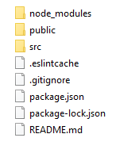

The folder node_modules contains all the dependencies required to build the React application.

The folder public contains the index.html.

All the components that you build should go into the folder src.

1. Run the below command to add Bootstrap and its dependencies jQuery and Popper JS into the app.

npm install --save bootstrap

npm install --save jquery

npm install --save popper.js

**Build the application**

1. Build the following components & Services
   1. HeaderComponent
   2. FooterComponent
   3. LoginComponent
   4. HomeComponent
   5. LoginService
   6. NavigationService
2. Orchestrate the components together to make it as an application