Git klientas yra lokali repozitorija saugoti failams ir sekti ju versijoms.

Githubas yra Claudine repozitorija.

Suinstaliavus lokalius git klientus keliuose kompiuteriuose ir sujungus lokalias repozitorijas su githubu turesime galimybe pasiekti failus is ivairiu vietu/kompiuteriu tiek budami online, tiek offline. Visi projekto failai yra sinchronizuojami tarp serverio ir visu klientu bei turi pilnas kopijas.

# <https://github.com/kvadrantas/RopTest>

# GIT GUI DOWNLOAD

<https://git-scm.com/download/gui/windows>

# INSTLL GIT CLIENT ON MAC

<https://git-scm.com/download/mac>

terminal get git version:

GIT --version

# CONFIGURE YOUR USERNAME SO GIT KNOWS WHO COMMITS CHANGES

Git config --global user.name “Rolandas Seputis”

Git config --global user.email “[vi.kvadrantas@gmail.com](mailto:vi.kvadrantas@gmail.com)”

# LIST ALL GIT SETTINGS

Git config --list

# CHECK SETTINGS

Git config user.name

Git config user.email

# VIEW ALL GIT COMMANDS and help

Man git

Git help config

Git help

# NAUJO LOKALAUS GIT REPOSITORY KURIMAS

Initialized empty Git repository

Git init

Bus sukurtas pasleptas .git katalogs

Cd .git

Ls

# GITHUBO AKAUNTO KURIMAS IR LOKALIOS REPOZITORIJOS KELIMAS I GITHUBA

<https://Github.com>

## FAILO SUKURIMAS LOKALIOJE REPOZITORIJOJE IR JO SUKOMITINIMAS

1. NAUJO FAILO SUKURIMAS

echo "# RopTest" >> README.md

1. ADD ALL PROJECT FILES (/Users/Rolandas/GitTestProject/) TO STAGING AREA

Git add .

1. COMMIT FILES

Git commint –m “First Commit”

## LOKALIOS REPOZITORIJOS IR GITHUBO SUJUNGIMAS

LINK GITHUB TO LOCAL REPOSITORY

Git remote add origin <https://github.com/kvadrantas/RopTest.git>

PUSH REPOSITORY PROJECT TO GITHUB

Git push –u origin master

# ANT ANTRO GIT CLIENTO WINDOWS 10 PARSISIUNCIAM PROJEKTO KOPIJA

Git remote add origin <https://github.com/kvadrantas/RopTest.git>

git pull origin master

Add your current files in the local folder to the staging area

git add –-all

git commit -m "first commint on win”

Push your changes to the master branch

git push origin master

https://git-scm.com/download/win

Git init

Git add .

Git commint –m “First Commit”

Git remote add origin <https://github.com/kvadrantas/RopTest.git>

Git push origin master

|  |
| --- |
| ANT PIRMO CLIENO, KURIAME PADARYTI PAKEITIMAI  Git remote add origin <https://github.com/kvadrantas/RopTest.git>  Git add .  Git commit –m “mac v2”  Git push origin master  Git commit –a –m “mano komitas” (viska sukomitina) |
| ANT ANTRO NODO ATSISIUNCIAM PAKEITIMUS  Git remote add origin <https://github.com/kvadrantas/RopTest.git>  Git pull origin master |

HELP

Man git

Git help

MAIN GIT COMMANDS

Get status of your project if it is synched with github or not

Git status

SUKURTI NAUJA FAILA

Touch vendors.txt

ADD NEW FILE TO GIT TRACKED FILES LIST

Git add vendors.txt

Git add – is not only for new files but also for modified files to be staged. You can think of this command as a way to add new and modified files to the next commit snapshot.

SHORT STATUS

Git status –s

M – modified

A – new file added to staging area

?? – new file untracked by git

MM – files was modified and added (staged) and once again modified after staged. That means that snapshot will have only first modification data but not second

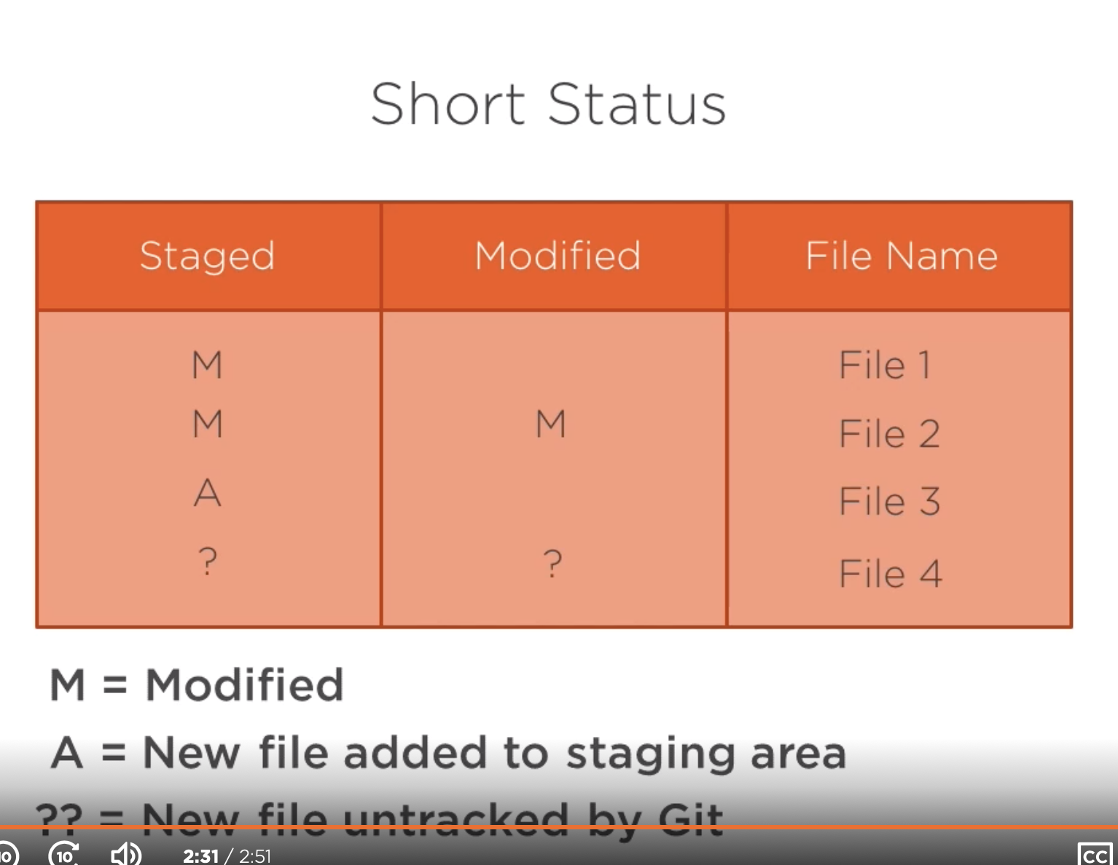

SKIRTUMAI TARP FAILU SNAPSHOTU

Skirtumai tarp nestagintu failu

Git diff

Skirtumai tarp staged failu

Git diff --staged

CHECK COMMIT HISTORY

Git log

Jaigu yra daug comitu galima riboti isvedamu comit history kieki

Git log -3

Git log --oneline

Git log --stat

Git log --patch

REMOVE A FILE IN A PROJECT and STOP TRACKING ON GIT

Git rm vend2.txt

STOP TRACKING FILE IN A GIT BUT NOT REMOVE FROM PROJECT

Git rm --cached vendors.txt

RENAME FILE

Git mv git.docx git2.docx