CS595 : Termination Project Spring 2018

Food-Forecast-Fitness

Kunal Vaghela
kvaghel1@binghamton.edu
B00672356

Introduction

Food-Forecast-Fitness is a web application which gives users a single platform to check the nutritional values of food items, check out the weather forecast and plan their fitness regime accordingly. The goal of the project was to integrate web apis of different domain together.

Tools &Framework

Front-End: HTML, Javascript, CSS
Back-End: Python 2.7 and Flask

Sample:

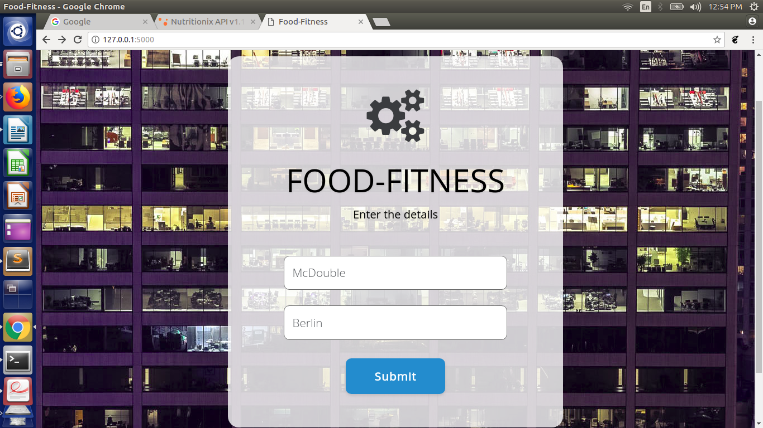
- In the provided text box the user needs to enter the details of Food item and location for which the query is to be made.

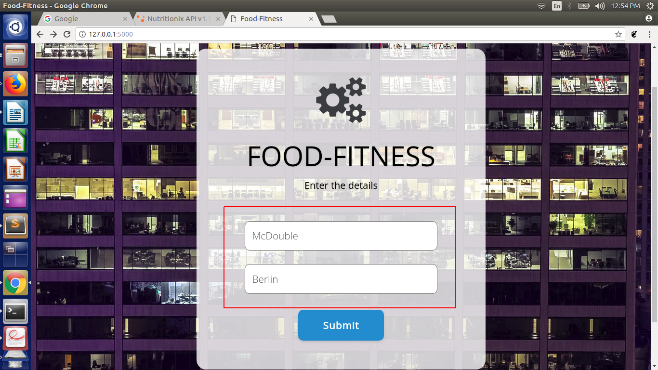

- On button click of submit, the given data will be sent to python script and the computation for food nutrition, weather of the given location and the amount of workout required to burn the gained calories will be computed.

- The left most section displays the location details of the given address. Along with the current temperature and weather condition, a brief of the weather for the next 4 days is displayed in order to help the user to plan his upcoming workouts.

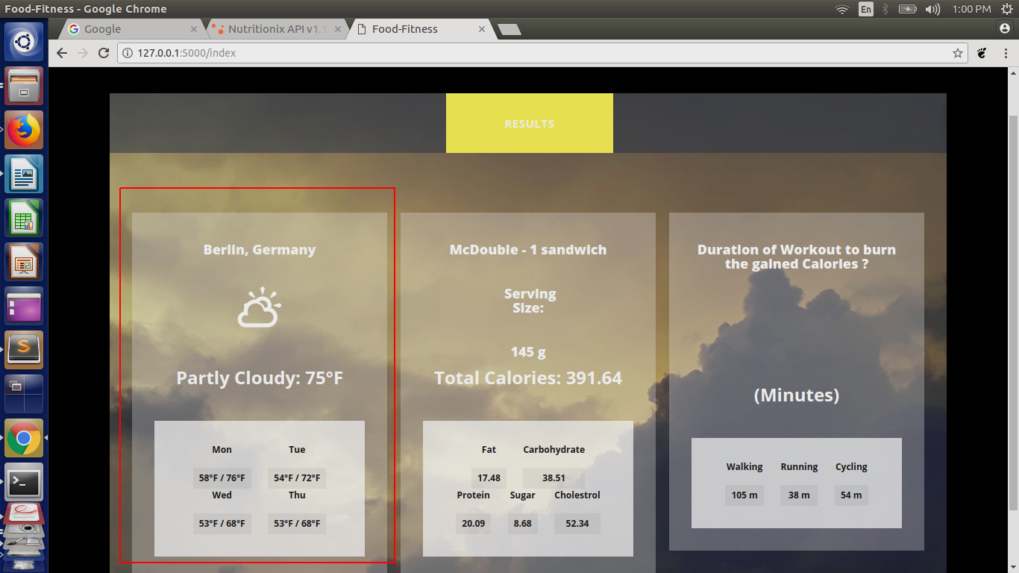
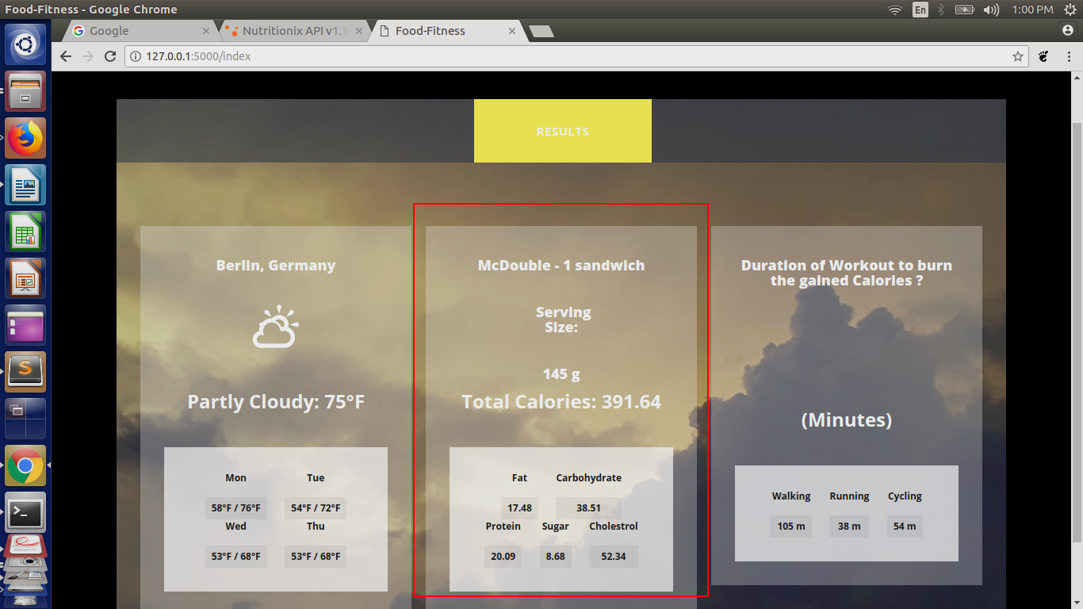
- The middle section displays the details of entered food item along with its regular serving size. A detailed summary of the nutritional value of the food item is updated in this section.
- The last section displays the time required in order to burn the calories using the specific workout. All given figures are in minutes.

