A PROJECT REPORT
ON

PRAVA – College Academic Management System
Submitted in partial fulfilment of the requirements for the degree of
Bachelor of Computer Applications
Savitribai Phule Pune University
Submitted by
Vaishnavi Vijay Kale | Roll No. 28
Rutuja Ashok Khobare | Roll No. 30
TY BCA – Third Year
Group Project
Under the guidance of
Surekha Kale
Academic Year 2026–2027
Women's College of Home Science and BCA, Loni
PKVM Campus, Babhaleshwar Road, Loni-413713
Dist-Ahmednagar, Maharashtra, India

Technology Profile
PRAVA is a browser-based academic portal. A Python and Flask application manages accounts, validates academic operations and stores structured records in a relational database. The local presentation version uses SQLite and serves the website on the same computer.
Layer | Technology | Purpose
Presentation | HTML, CSS, JavaScript | Responsive public pages and role-specific workspaces
Templates | Jinja | Server-rendered pages with shared navigation
UI library | Bootstrap 5.3.3 and Icons 1.11.3 | Locally bundled layout and interface assets
Application | Python 3.11–3.13; Flask 3.0.3 | Routes, services and application configuration
Persistence | Flask-SQLAlchemy 3.1.1; SQLite | Models, relationships and local records
Authentication | Flask-Login 0.6.3; Werkzeug 3.0.3 | Sessions and password-hash verification
Forms | Flask-WTF 1.2.1 and WTForms 3.1.2 | Input validation and CSRF protection
Testing | Python unittest | Isolated automated functional and security checks
Delivery | GitHub and Windows launcher | Versioned source and repeatable local setup

The repository also contains PostgreSQL and optional external authentication configuration for future hosting. This report evaluates the working local-authentication installation. Package versions above describe the project requirements and bundled assets.

Project Submission and Declaration
We, Vaishnavi Vijay Kale and Rutuja Ashok Khobare, students of TY BCA at Women's College of Home Science and BCA, Loni, submit the project entitled “PRAVA – College Academic Management System” for the academic year 2026–2027.
This group project presents the design and implementation of an academic management portal for students, teaching staff and college administration. The report describes the application modules, database structure, access controls, user interfaces and verification of the implemented system.
College information, curriculum references and technical documentation used in the project are acknowledged in the report. The software demonstration uses clearly identified demonstration accounts. Academic data shown as pending represents records that have not yet been entered.
We submit this report under the guidance of Surekha Kale as part of our Bachelor of Computer Applications project work.
Place: Loni
Date: ____________________
Signature: ____________________
Vaishnavi Vijay Kale
Roll No. 28
Signature: ____________________
Rutuja Ashok Khobare
Roll No. 30

Certificate
This is to certify that Vaishnavi Vijay Kale (Roll No. 28) and Rutuja Ashok Khobare (Roll No. 30), students of TY BCA at Women's College of Home Science and BCA, Loni, have submitted the group project entitled
PRAVA – College Academic Management System
under the guidance of Surekha Kale for the academic year 2026–2027, in partial fulfilment of the requirements of the Bachelor of Computer Applications programme of Savitribai Phule Pune University.
The project report is presented for academic evaluation and the project demonstration.
Place: Loni
Date: ____________________
Project Guide | Head of Department
________________________  Surekha Kale | ________________________  Dr. Sanjay Vani

Principal | External Examiner
________________________  Dr. Anushree Rajendra Khaire | ________________________  Name and signature

College seal

Acknowledgement
We thank our project guide, Surekha Kale, for guidance in the preparation of our TY BCA group project, PRAVA – College Academic Management System.
We express our gratitude to Dr. Sanjay Vani, Head of Department, and Dr. Anushree Rajendra Khaire, Principal, for the academic environment in which this project is presented. We also thank the teaching staff of Women's College of Home Science and BCA, Loni for supporting our learning.
The project gave us an opportunity to connect web development with a practical college workflow. Preparing separate student, staff and office workspaces helped us understand how interface design, validation, database relationships and access permissions work together.
We acknowledge the college website, university syllabus documents, open-source software and official technical documentation used during the development and documentation of the project. These resources helped us describe the academic context and implement the application.
We thank our families, friends and everyone who assisted us with project review and demonstration preparation.
Vaishnavi Vijay Kale
Rutuja Ashok Khobare
TY BCA – Academic Year 2026–2027

Abstract
PRAVA is a College Academic Management System for Women's College of Home Science and BCA, Loni. It connects public college information with student, staff and administrative workspaces. The project supports BCA and the Home Science specialisations in Food Science and Nutrition, and Textile Science and Designing, using a versioned 2024 NEP curriculum catalogue.
The website opens on Home. Its header contains Home, Academics, Contact and a Login dropdown. Student login continues through BCA or Home Science selection, while Staff and Office / Administration open their own forms. The authenticated account determines the displayed name, permissions and dashboard. Night mode is the default, with a Day mode option.
Students can submit a website sign-up request for Office approval. Separate Google Forms collect student and staff profile information into private response spreadsheets. Those responses require verification and conversion to the portal CSV templates; submitting a Google Form does not automatically create a PRAVA account.
Python, Flask, Jinja and SQLAlchemy implement the application, while a local SQLite database preserves users and academic records. The 22 model tables support profiles, teaching allocations, attendance, marks, materials, assignments, notices, curriculum sources, activities and review workflows. Password hashing, CSRF protection, role checks and record ownership restrict access.
The source baseline is 3ee1a7a. All 63 automated tests passed on 4 October 2026. The report presents the implementation, database design, current interface screenshots and local setup procedure. Detailed final-year syllabus verification, official NEP grade calculations and automated account notifications remain future enhancements.
Keywords: academic management, Flask, SQLite, BCA, Home Science, NEP curriculum, role-based access.

Index
Technology Profile 2
Project Submission and Declaration 3
Certificate 4
Acknowledgement 5
Abstract 6
Index 7
1 Introduction Objectives and Scope 8
2 Requirements Analysis and Feasibility 9
3 System Architecture and Modules 10
4 Login Registration and Permissions 11
5 Database Design and ER Diagrams 12
6 Data Flow Diagrams 15
7 Data Dictionary 18
8 Academic Processing and Reports 28
9 Student and Staff Information Collection 29
10 Input and Output Screens 30
11 Testing and Verification 38
12 Security and Data Maintenance 39
13 Advantages Limitations and Future Work 40
14 Project Cost and Conclusion 41
15 Bibliography 42
Appendix Local Installation and Demonstration 44

1 Introduction Objectives and Scope
College academic records connect identities, programme enrolment, teaching allocations, attendance, assessments and learning resources. Students need access to their own progress; teachers need the records of assigned classes; and the Office needs consistent institutional data. PRAVA brings these responsibilities into one browser-based application.

Problem and proposed system
Keeping the same academic information in separate registers, files and messages can make retrieval slow and introduce duplicate entries. PRAVA addresses this design problem through shared relational records and server-side access rules. Public college content, pending registrations and verified academic profiles are maintained separately.

Objectives
- Provide clear public navigation and role-specific login with the correct account identity.
- Verify student registration and roster imports before activating academic accounts.
- Link student and staff work to the correct programme, curriculum, semester and subject.
- Manage attendance, marks, materials, assignments, notices, activities and reports.
- Provide source-linked syllabus information and a repeatable local demonstration setup.

Project scope
The catalogue covers BCA, B.Sc. Food Science and Nutrition, and B.Sc. Textile Science and Designing. FY, SY and TY navigation represents the three-year journey; detail is displayed according to the available source review. Office and Principal access use distinct administrative permissions. The local project demonstrates academic operations; fees, payroll, library circulation and university result certification are outside its current modules.

2 Requirements Analysis and Feasibility
The requirements come from the requested college workflows, the supplied report format, the college and curriculum references stored in the application, and inspection of source code and tests. The Google Forms are prepared for data collection; no completed survey findings or measured adoption benefits are claimed.
Requirement | Local demonstration setup
Hardware | 64-bit laptop or desktop; 4 GB RAM and 1 GB free space are planning recommendations, not measured minima.
Software | Python 3.11–3.13, a modern browser and the pinned requirements.txt dependencies.
Database and files | SQLite in instance/prava.sqlite3; learning files and profile uploads stored separately.
Connectivity | Internet for first setup and external sources. Bundled local pages render after setup without internet.
Quality | Readable Day/Night themes, validation feedback, persistent records, controlled access and auditable review.

Feasibility
Technical feasibility follows from the conventional browser, Flask and relational database architecture. SQLite supports local presentation without a separate database server. Operational feasibility depends on the Office verifying identities and allocating subjects before Staff enters records. Separate dashboards make these responsibilities visible.
An existing laptop and open-source dependencies support an economical local demonstration. Printing, binding and any later hosting remain separate costs. Data feasibility depends on official student identifiers, staff assignments and applicable batch documents. Missing academic results remain pending, while unresolved curriculum items retain review status.

3 System Architecture and Modules
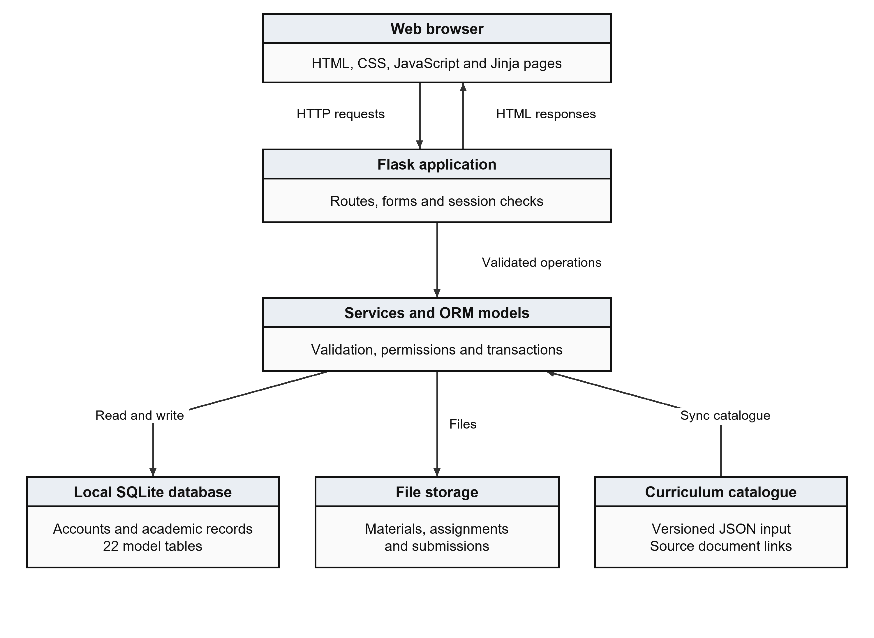
Figure 1 Browser application services and local storage
Flask routes receive requests, validate forms and check sessions and roles. Services perform academic operations through SQLAlchemy. Jinja renders HTML responses; uploaded files remain separate from their metadata. The curriculum JSON synchronises reference information into the database.
Module | Principal responsibility
Public and access | Home, college information, academics, contact, role login and student sign-up.
Student and Staff | Programme-based progress views; assigned-subject attendance, marks and learning resources.
Administration | Profiles, approvals, curriculum review, imports, notices, access scopes and exports.
Shared services | Database transactions, validation, activity records, upload checks and persistent setup.

4 Login Registration and Permissions
Entry point | Destination and rule
Home → Login dropdown | Student, Staff and Office / Administration appear immediately below Login.
Student → BCA / Home Science | Dedicated form validates credentials, active status, role and programme.
Staff | Staff credentials open the faculty workspace and assigned-subject tools.
Office / Administration | Administrative workspace follows Office, Principal or administrator scope.
Back Switch and Logout | Back uses defined internal pages. Switching requires new credentials. Logout uses protected POST.

Student sign-up and approval
Website sign-up captures identity, programme, semester, admission year and a password that is stored only as a hash. A valid request becomes Pending in student_registrations. Office approval rechecks duplicate identities and creates the user and student profile in one transaction. Rejection preserves the review decision without activating an account.

Permission boundaries
A student reads her own academic records. Staff works with explicitly assigned subjects and eligible students. Office manages authorised records and approvals. Principal scope is read-only for permitted oversight. Privileged account creation requires administrator scope. A failed account switch preserves the earlier authenticated identity; choosing a portal alone does not change the account.
Public student sign-up currently uses local password authentication. Optional external authentication requires additional provisioning work. Registration approval emails are not automated.

5 Database Design and ER Diagrams
The implementation contains 22 model tables and 227 columns. PK denotes a primary key, FK a foreign key and UQ a uniqueness constraint. A 1-to-many relationship is implemented by a child foreign key; 1-to-0..1 describes an optional unique profile for a user.
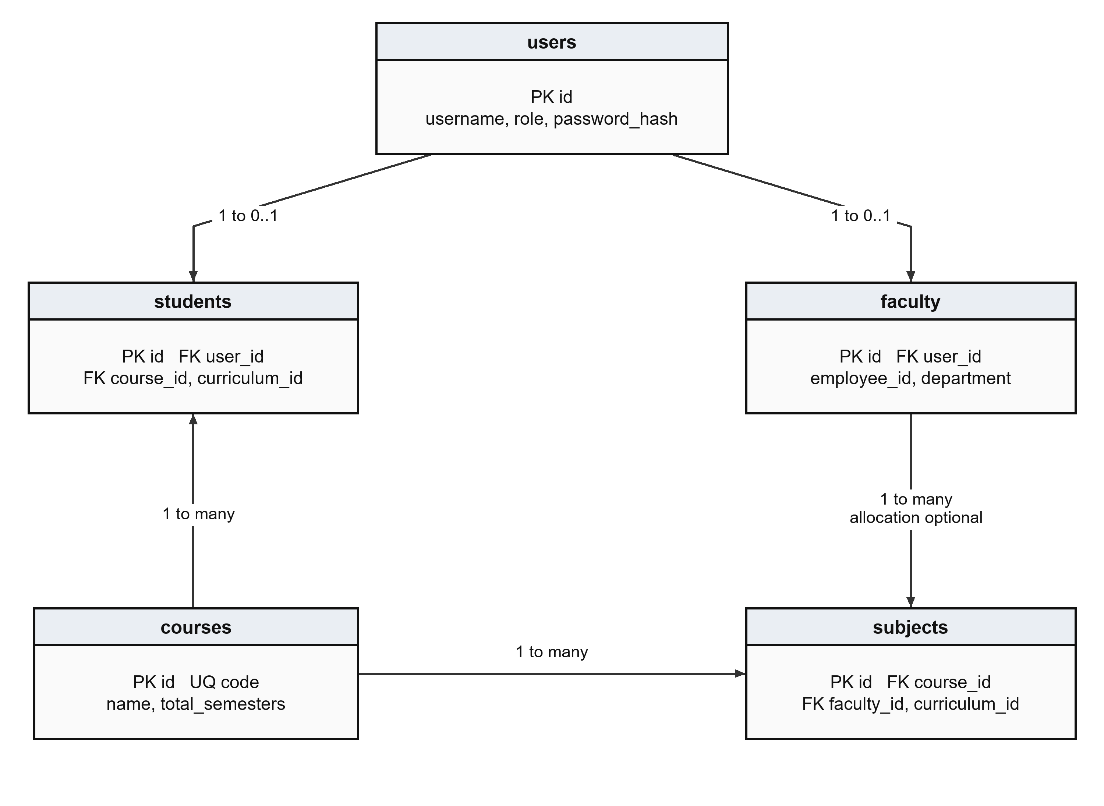
Figure 2 Accounts profiles courses and teaching subjects
users holds authentication identity; students and faculty hold role-specific profiles. Students belong to courses and curricula. subjects describes actual teaching allocations, including programme, semester and faculty. The separate curriculum catalogue provides source-reviewed reference entries.
The data dictionary follows SQLAlchemy declarations. Application validation and SQLite enforcement can differ. Password fields contain hashes; JSON text fields hold structured data. Foreign-key relationships are shown only where declared.

Academic and Learning Relationships
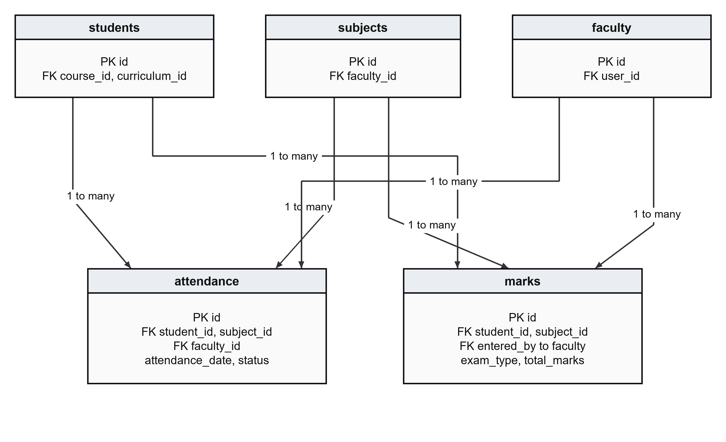
Figure 3 Student subject and faculty references in assessment
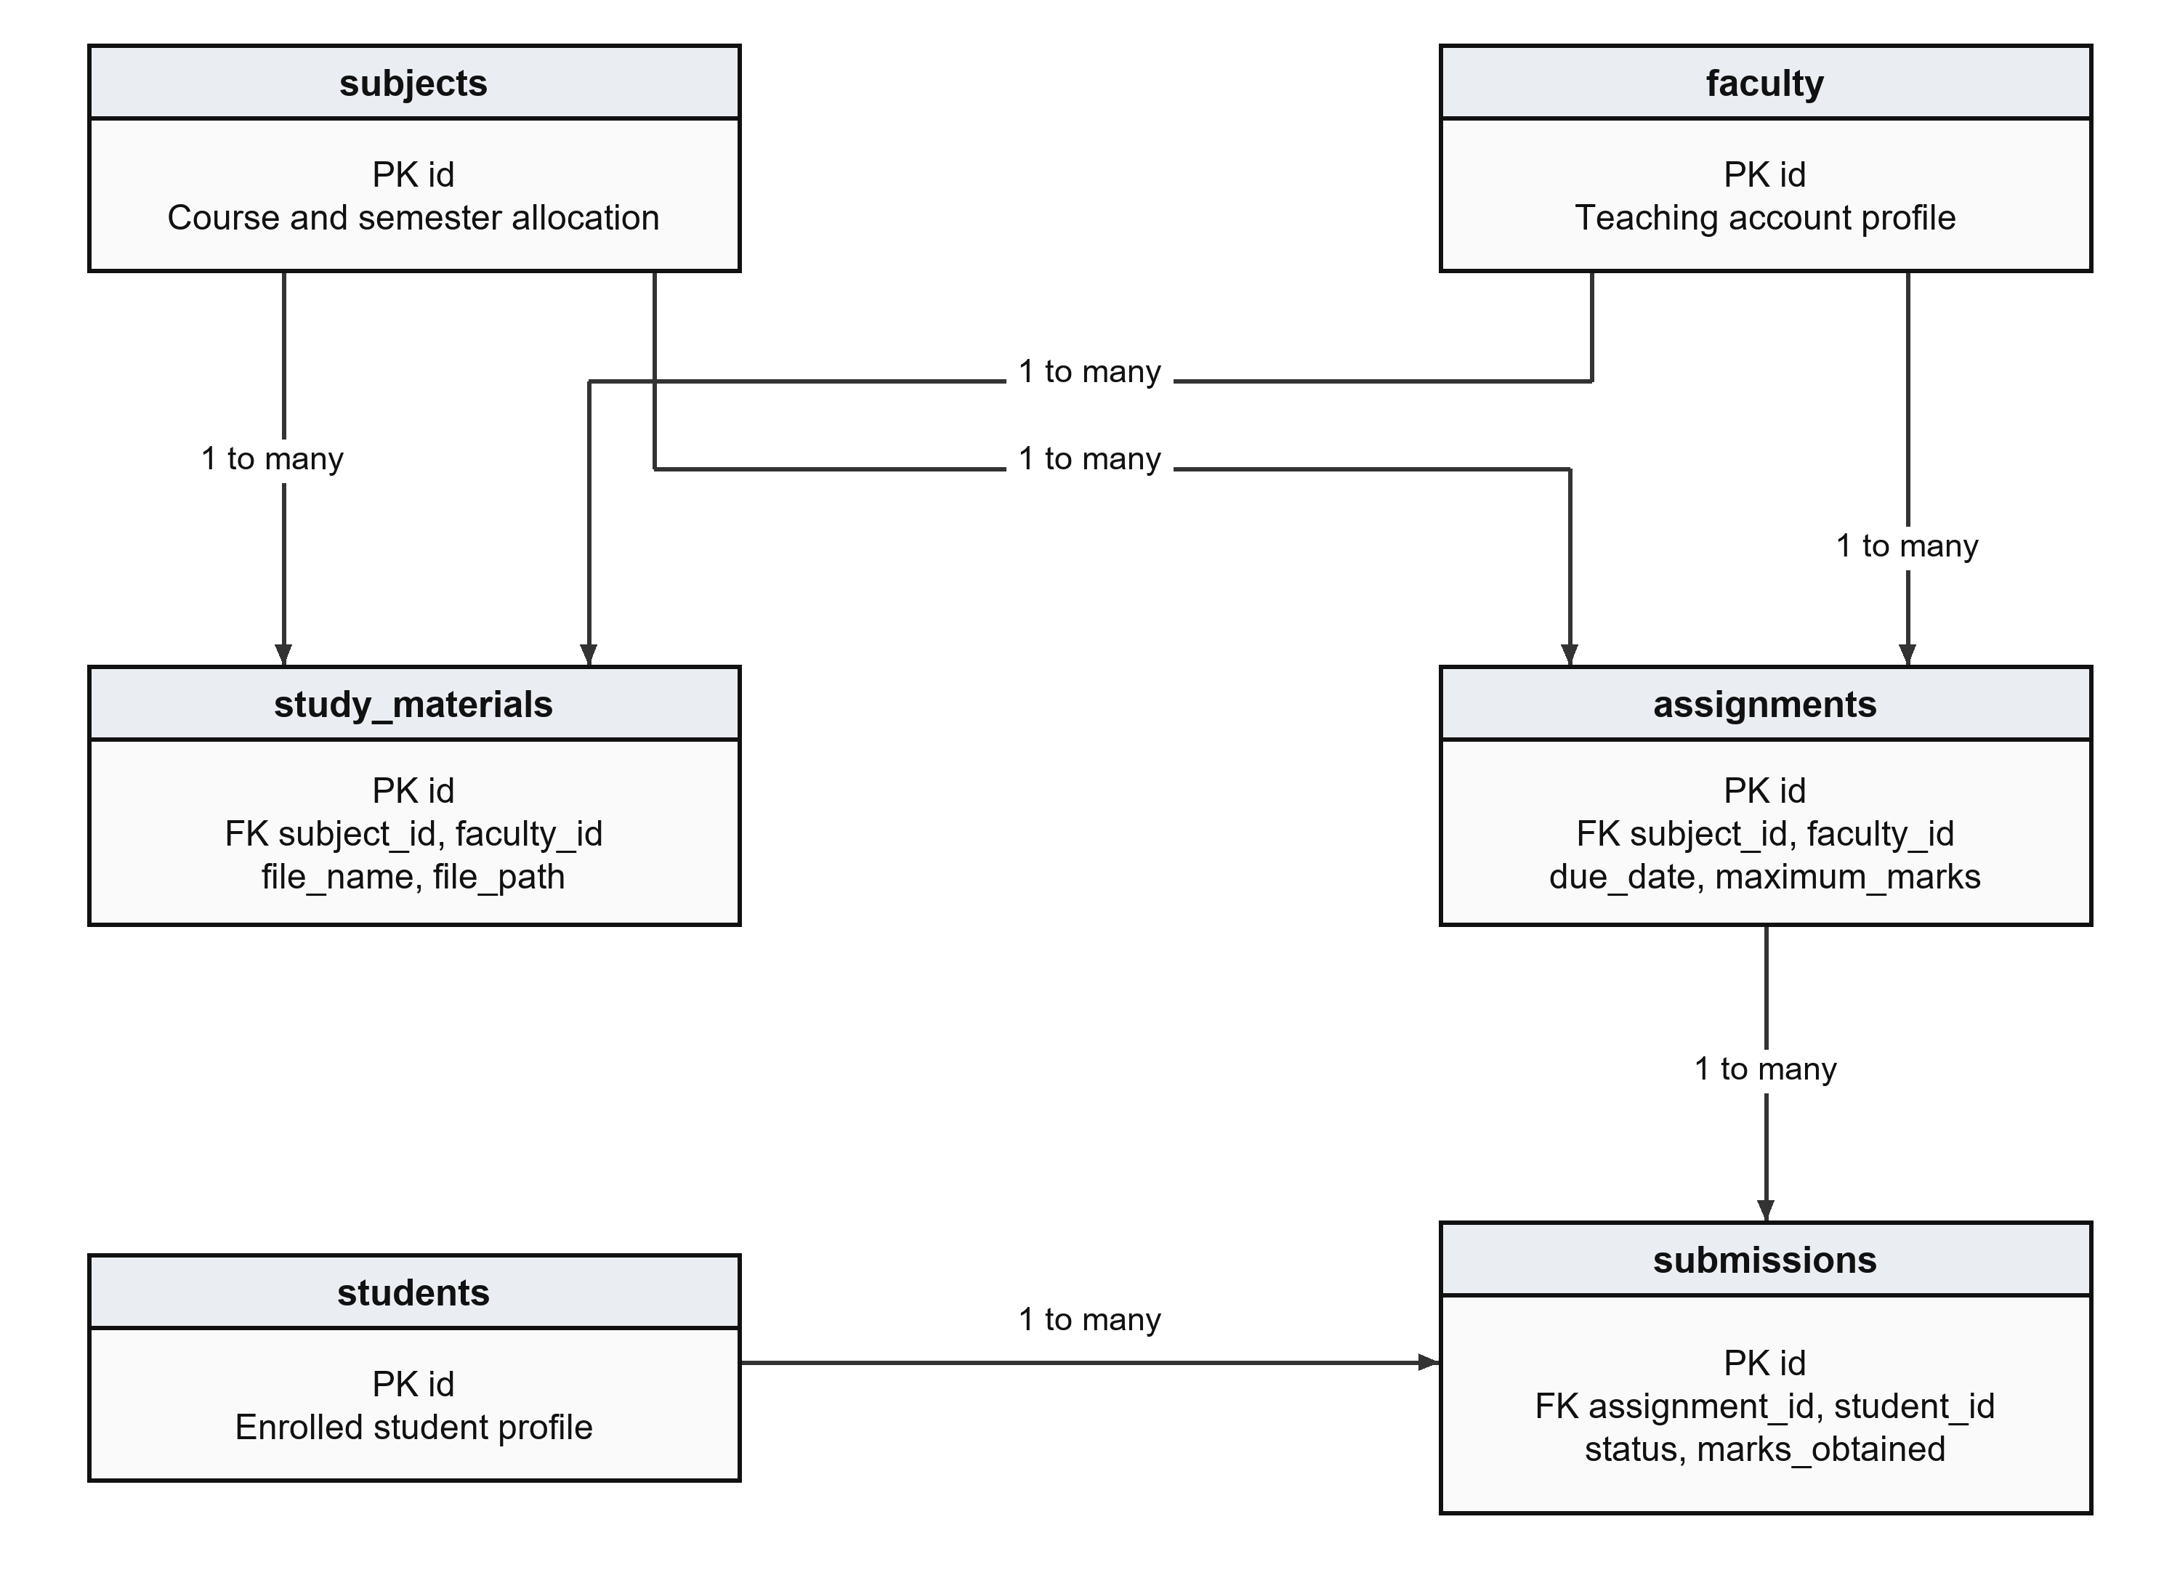
Figure 4 Learning materials assignments and submissions
Attendance is unique per student, subject and date; marks per student, subject and exam type. An assignment has at most one tracked submission per student. All academic operations also check the authorised subject relationship.

Curriculum and Participation Relationships
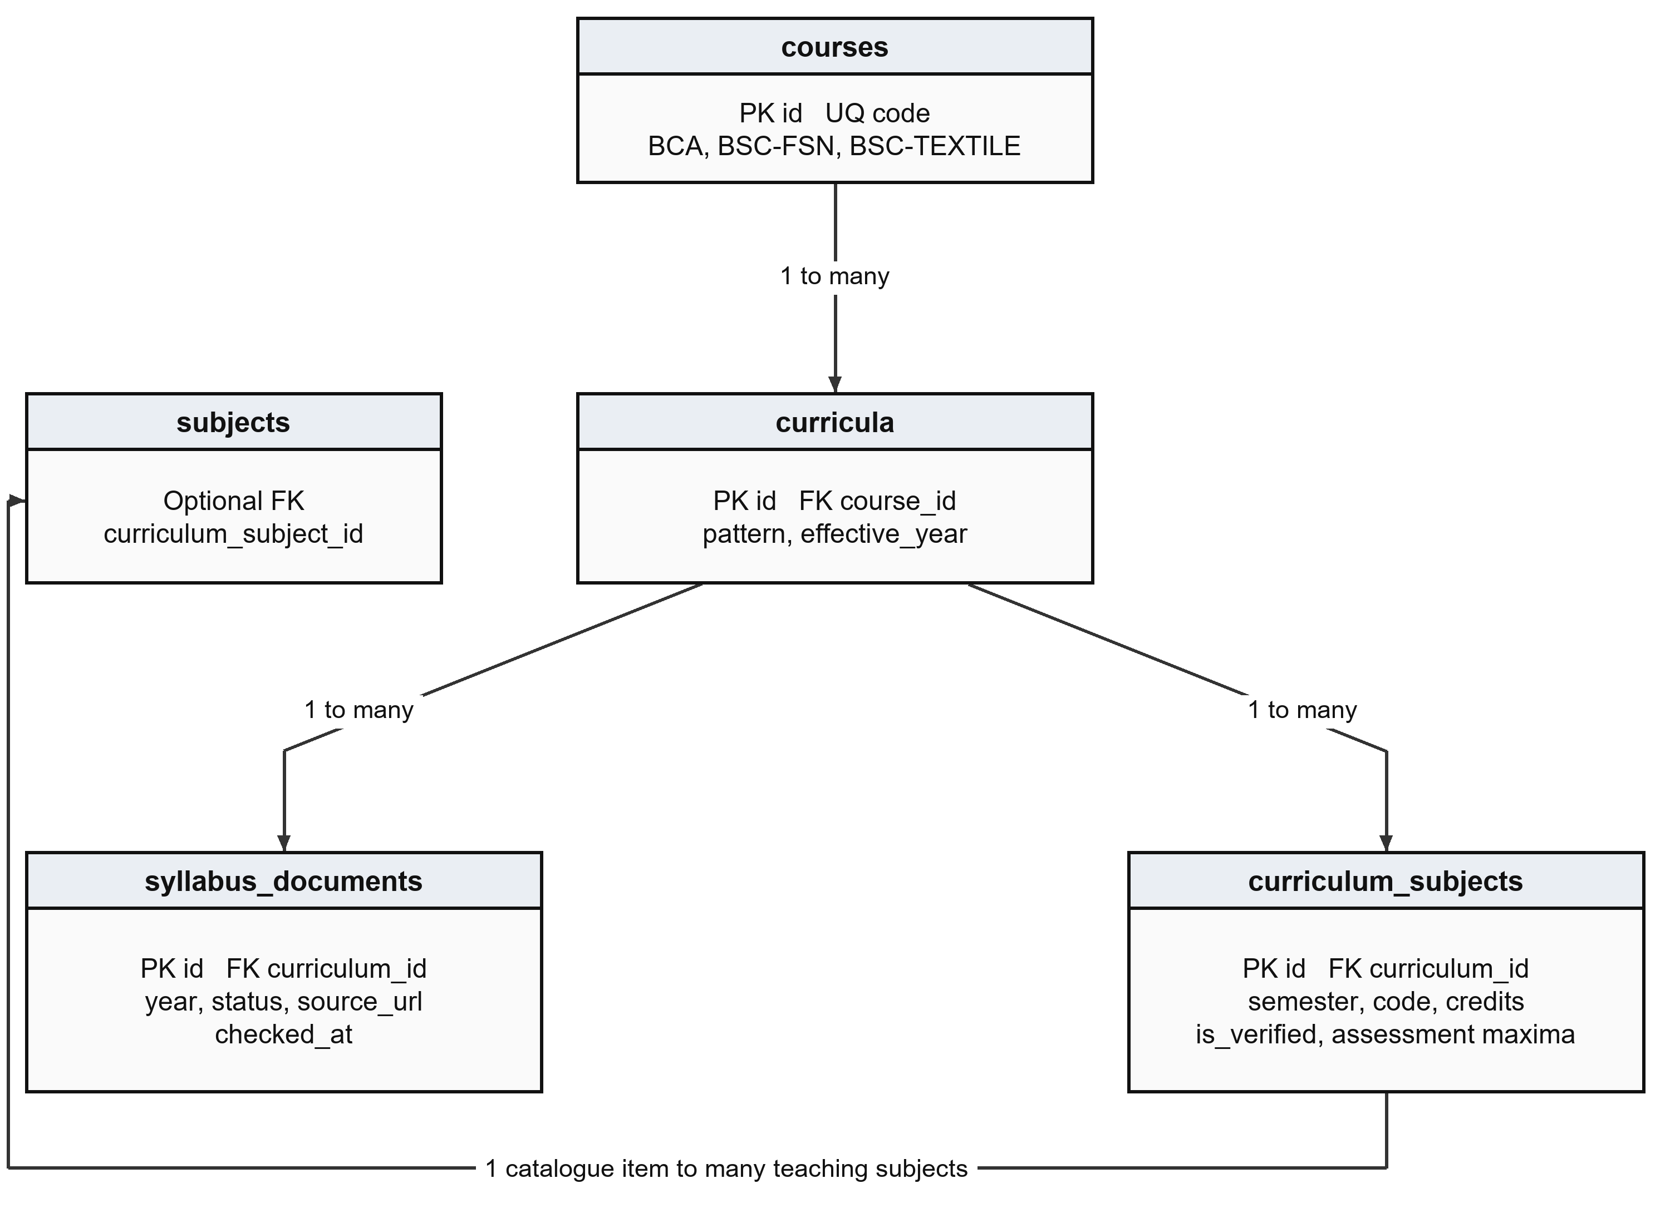
Figure 5 Versioned curriculum documents and catalogue subjects
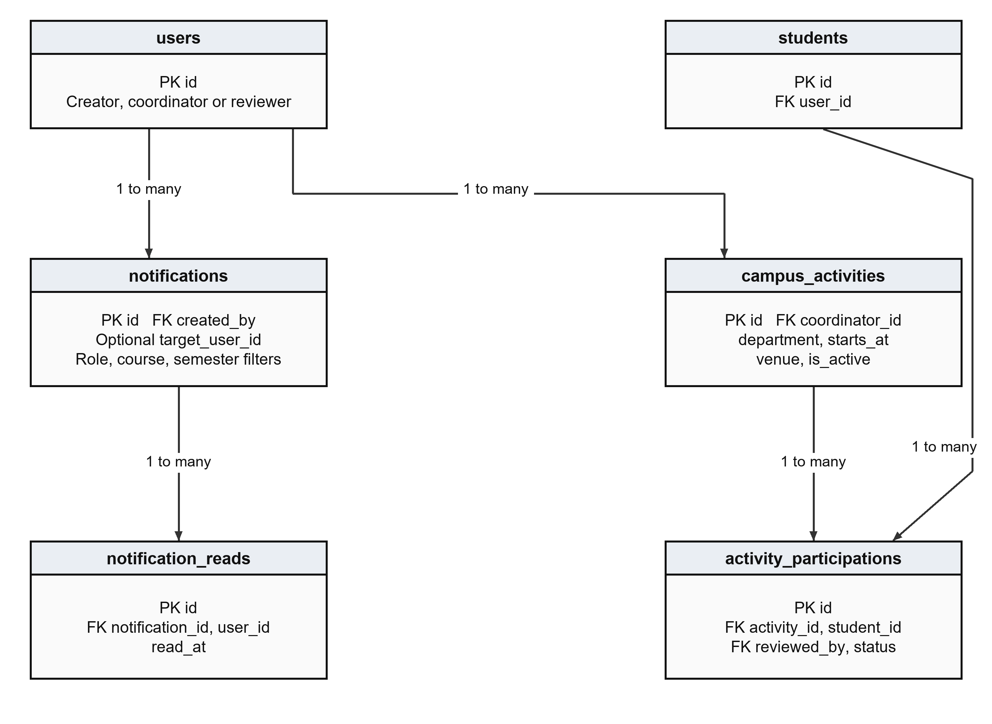
Figure 6 Notifications read receipts and activity participation
Source documents and catalogue subjects belong to a curriculum pattern. Activity participation links a student to an activity and its review. Contact inquiries and student-test snapshots are independent records; their models do not declare a student-account foreign key.

6 Data Flow Diagrams
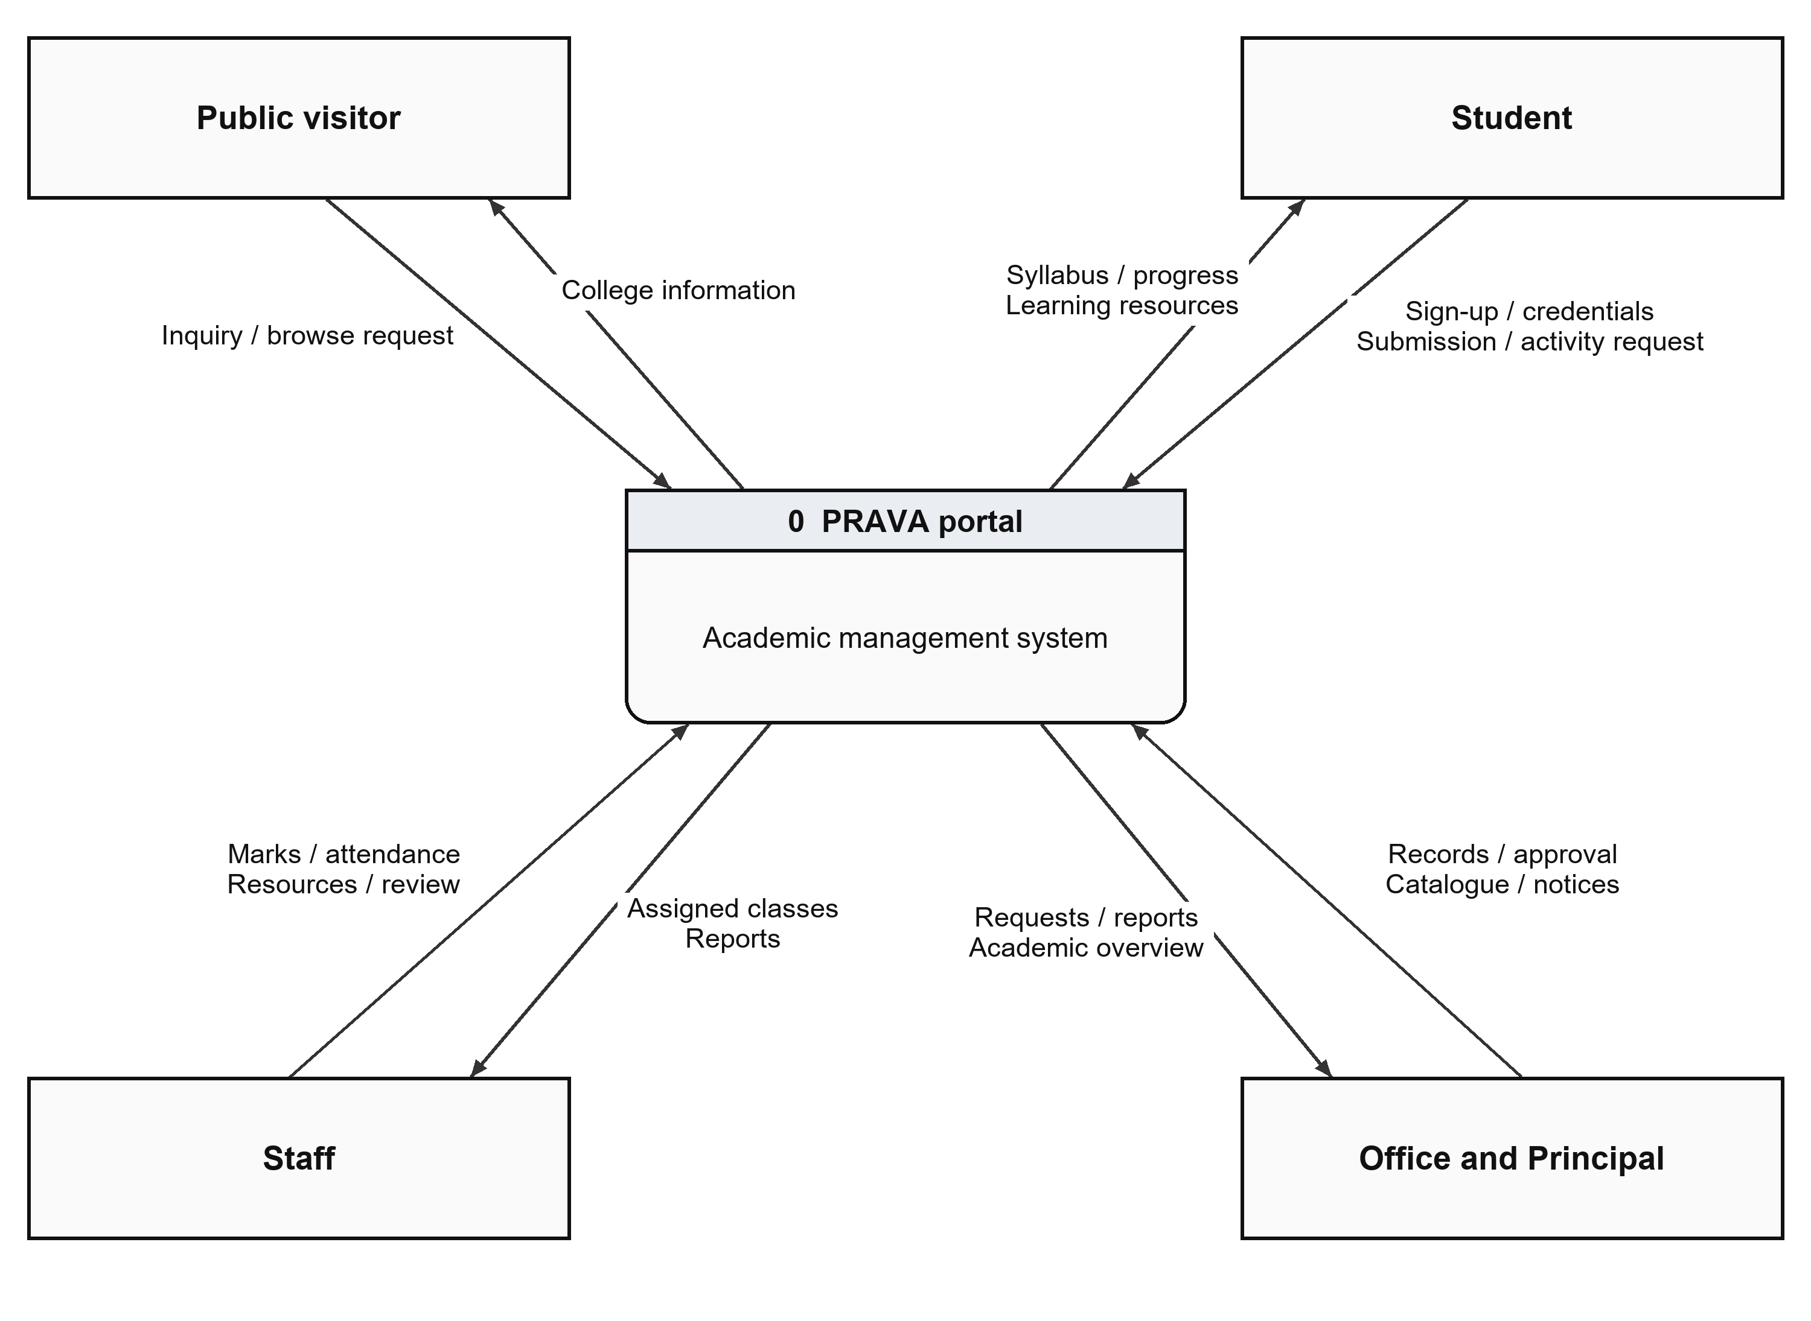
Figure 7 Context DFD for the PRAVA academic portal
The context diagram shows the system boundary. Visitors request public information and submit inquiries. Students supply registration and learning inputs and receive their academic views. Staff maintain assigned academic records. Office manages approvals and institutional records; Principal access provides permitted oversight.
Arrows identify information exchanged with the system. The database is internal to PRAVA and is expanded into logical stores at the next level. Google Forms collection is a separate preparatory intake process, followed by verified CSV import.

Level One Data Flow
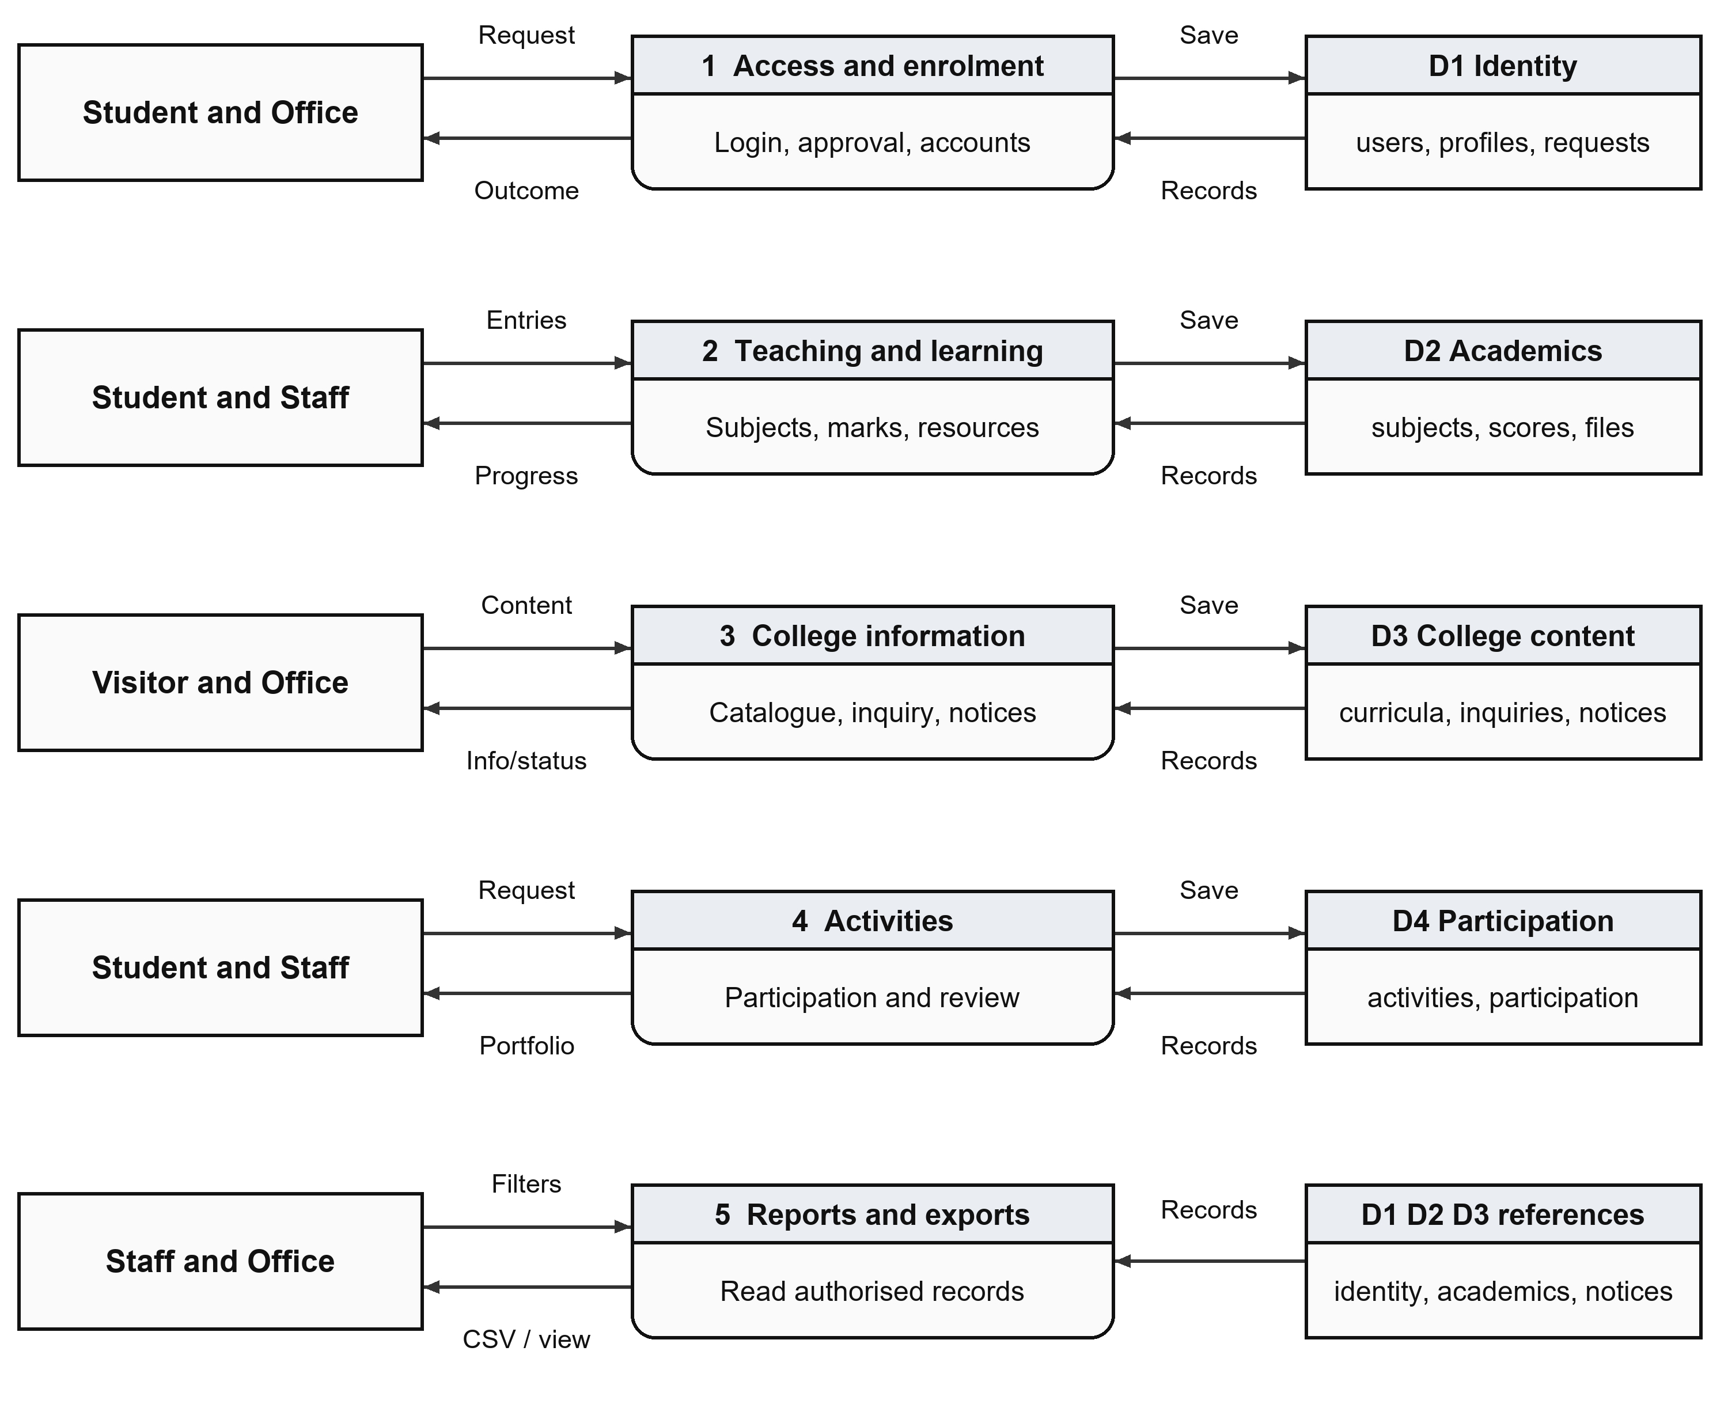
Figure 8 Level one decomposition and logical data stores
The five processes cover access and enrolment, teaching and learning, college information, activities, and reporting. D1–D4 group related tables in the same relational database. Reporting reads existing records within the current account scope and produces views or CSV files.
A report does not create a second independent academic total. The data stores are logical groups; the application maintains a shared schema with database keys and service-level validation.

Level Two Registration Review
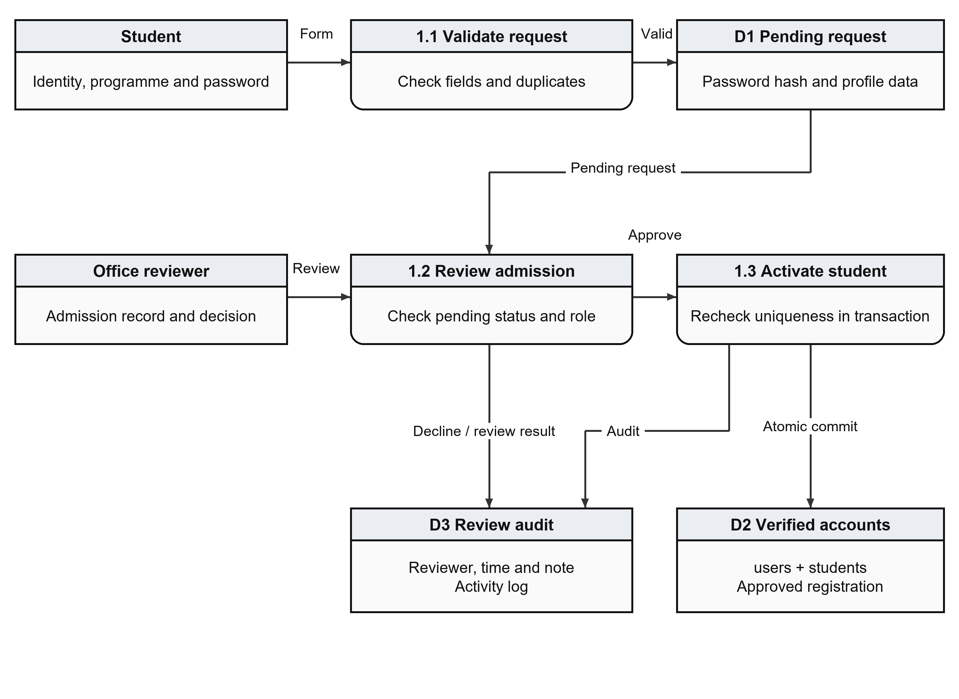
Figure 9 Student sign-up validation Office review and activation
A valid website sign-up creates a pending request after format and duplicate checks. An authorised Office user reviews the request. Approval repeats the uniqueness checks and creates a login identity and student profile atomically. A conflict rolls the operation back and returns review feedback.
The review records its decision, reviewer and time. Rejected requests remain reviewed. Approval permits the student to sign in with the chosen credentials; it does not automatically send an email or create subject allocations.

7 Data Dictionary
All 227 declared fields are included. N means nullable; R means required by the model. PK is primary key, UQ unique, and FK identifies its referenced table and column. Application forms may impose additional requirements.

users
Field | Type | Null | Keys and defaults
id | INTEGER | R | PK
username | VARCHAR(80) | R | UQ
full_name | VARCHAR(120) | R | —
email | VARCHAR(120) | R | UQ
password_hash | VARCHAR(255) | R | —
role | VARCHAR(20) | R | —
admin_scope | VARCHAR(30) | R | Default office
is_active | BOOLEAN | R | Default True
is_demo | BOOLEAN | R | Default False
last_login | DATETIME | N | —
created_at | DATETIME | R | —
updated_at | DATETIME | R | —

students
Field | Type | Null | Keys and defaults
id | INTEGER | R | PK
user_id | INTEGER | R | UQ; FK users.id
enrollment_number | VARCHAR(50) | R | UQ
mobile_number | VARCHAR(20) | N | —
date_of_birth | DATE | N | —
gender | VARCHAR(20) | N | —
address | TEXT | N | —
course_id | INTEGER | R | FK courses.id
semester | INTEGER | R | —
admission_year | INTEGER | R | —
profile_image | VARCHAR(255) | N | —
curriculum_id | INTEGER | N | FK curricula.id
created_at | DATETIME | R | —
updated_at | DATETIME | R | —

Data Dictionary 2

faculty
Field | Type | Null | Keys and defaults
id | INTEGER | R | PK
user_id | INTEGER | R | UQ; FK users.id
employee_id | VARCHAR(50) | R | UQ
mobile_number | VARCHAR(20) | N | —
qualification | VARCHAR(120) | N | —
department | VARCHAR(120) | R | —
joining_date | DATE | N | —
profile_image | VARCHAR(255) | N | —
created_at | DATETIME | R | —
updated_at | DATETIME | R | —

courses
Field | Type | Null | Keys and defaults
id | INTEGER | R | PK
name | VARCHAR(120) | R | —
code | VARCHAR(30) | R | UQ
description | TEXT | N | —
duration | VARCHAR(50) | R | —
total_semesters | INTEGER | R | —
is_active | BOOLEAN | R | Default True
created_at | DATETIME | R | —
updated_at | DATETIME | R | —

activity logs
Field | Type | Null | Keys and defaults
id | INTEGER | R | PK
user_id | INTEGER | N | FK users.id
action | VARCHAR(80) | R | —
module | VARCHAR(80) | R | —
description | TEXT | N | —
ip_address | VARCHAR(45) | N | —
created_at | DATETIME | R | —

Data Dictionary 3

subjects
Field | Type | Null | Keys and defaults
id | INTEGER | R | PK
name | VARCHAR(120) | R | —
code | VARCHAR(30) | R | —
course_id | INTEGER | R | FK courses.id
semester | INTEGER | R | —
faculty_id | INTEGER | N | FK faculty.id
maximum_marks | INTEGER | R | Default 100
passing_marks | INTEGER | R | Default 40
is_active | BOOLEAN | R | Default True
curriculum_id | INTEGER | N | FK curricula.id
curriculum_subject_id | INTEGER | N | FK curriculum_subjects.id
created_at | DATETIME | R | —
updated_at | DATETIME | R | —

Composite UQ: code, course_id, semester.

curricula
Field | Type | Null | Keys and defaults
id | INTEGER | R | PK
course_id | INTEGER | R | FK courses.id
pattern | VARCHAR(80) | R | —
university | VARCHAR(160) | R | Default Savitribai Phule Pune University
faculty | VARCHAR(100) | R | Default Science and Technology
effective_year | INTEGER | R | —
created_at | DATETIME | R | —
updated_at | DATETIME | R | —

Composite UQ: course_id, pattern.

Data Dictionary 4

syllabus documents
Field | Type | Null | Keys and defaults
id | INTEGER | R | PK
curriculum_id | INTEGER | R | FK curricula.id
year | INTEGER | R | —
title | VARCHAR(180) | R | —
source_url | VARCHAR(1000) | N | —
status | VARCHAR(30) | R | Default pending
notes | TEXT | N | —
checked_at | DATE | N | —
created_at | DATETIME | R | —
updated_at | DATETIME | R | —

Composite UQ: curriculum_id, year.

record imports
Field | Type | Null | Keys and defaults
id | VARCHAR(36) | R | PK
user_id | INTEGER | R | FK users.id
kind | VARCHAR(20) | R | —
payload | JSON | R | —
created_at | DATETIME | R | —

notification reads
Field | Type | Null | Keys and defaults
id | INTEGER | R | PK
notification_id | INTEGER | R | FK notifications.id
user_id | INTEGER | R | FK users.id
read_at | DATETIME | R | —

Composite UQ: notification_id, user_id.

Data Dictionary 5

attendance
Field | Type | Null | Keys and defaults
id | INTEGER | R | PK
student_id | INTEGER | R | FK students.id
subject_id | INTEGER | R | FK subjects.id
faculty_id | INTEGER | R | FK faculty.id
attendance_date | DATE | R | —
status | VARCHAR(20) | R | —
remarks | VARCHAR(255) | N | —
created_at | DATETIME | R | —

Composite UQ: student_id, subject_id, attendance_date.

marks
Field | Type | Null | Keys and defaults
id | INTEGER | R | PK
student_id | INTEGER | R | FK students.id
subject_id | INTEGER | R | FK subjects.id
exam_type | VARCHAR(50) | R | —
internal_marks | INTEGER | R | Default 0
external_marks | INTEGER | R | Default 0
total_marks | INTEGER | R | Default 0
grade | VARCHAR(5) | N | —
remarks | VARCHAR(255) | N | —
entered_by | INTEGER | R | FK faculty.id
created_at | DATETIME | R | —
updated_at | DATETIME | R | —

Composite UQ: student_id, subject_id, exam_type.

Data Dictionary 6

student test responses
Field | Type | Null | Keys and defaults
id | INTEGER | R | PK
public_token | VARCHAR(36) | R | UQ
full_name | VARCHAR(120) | R | —
email | VARCHAR(120) | R | —
college_name | VARCHAR(160) | N | —
course_year | VARCHAR(80) | R | —
answers_json | TEXT | R | —
score | INTEGER | R | —
total_questions | INTEGER | R | —
website_rating | INTEGER | R | —
feedback | TEXT | N | —
created_at | DATETIME | R | —
updated_at | DATETIME | R | —

study materials
Field | Type | Null | Keys and defaults
id | INTEGER | R | PK
title | VARCHAR(150) | R | —
description | TEXT | N | —
subject_id | INTEGER | R | FK subjects.id
faculty_id | INTEGER | R | FK faculty.id
file_name | VARCHAR(255) | R | —
file_path | VARCHAR(255) | R | —
file_type | VARCHAR(30) | R | —
uploaded_at | DATETIME | R | —
is_active | BOOLEAN | R | Default True

Data Dictionary 7

assignments
Field | Type | Null | Keys and defaults
id | INTEGER | R | PK
title | VARCHAR(150) | R | —
description | TEXT | N | —
subject_id | INTEGER | R | FK subjects.id
faculty_id | INTEGER | R | FK faculty.id
due_date | DATETIME | R | —
maximum_marks | INTEGER | R | Default 100
attachment_path | VARCHAR(255) | N | —
created_at | DATETIME | R | —
is_active | BOOLEAN | R | Default True

submissions
Field | Type | Null | Keys and defaults
id | INTEGER | R | PK
assignment_id | INTEGER | R | FK assignments.id
student_id | INTEGER | R | FK students.id
submitted_file | VARCHAR(255) | N | —
submitted_at | DATETIME | N | —
status | VARCHAR(30) | R | Default Pending
marks_obtained | INTEGER | N | —
faculty_feedback | TEXT | N | —
graded_at | DATETIME | N | —

Composite UQ: assignment_id, student_id.

Data Dictionary 8

notifications
Field | Type | Null | Keys and defaults
id | INTEGER | R | PK
title | VARCHAR(150) | R | —
message | TEXT | R | —
notification_type | VARCHAR(40) | R | Default General
created_by | INTEGER | R | FK users.id
target_role | VARCHAR(30) | R | Default all
target_user_id | INTEGER | N | FK users.id
target_course_id | INTEGER | N | FK courses.id
target_semester | INTEGER | N | —
created_at | DATETIME | R | —
expires_at | DATETIME | N | —
is_active | BOOLEAN | R | Default True

contact inquiries
Field | Type | Null | Keys and defaults
id | INTEGER | R | PK
full_name | VARCHAR(120) | R | —
email | VARCHAR(120) | R | —
phone | VARCHAR(20) | N | —
subject | VARCHAR(150) | R | —
message | TEXT | R | —
status | VARCHAR(30) | R | Default New
created_at | DATETIME | R | —
updated_at | DATETIME | R | —

Data Dictionary 9

curriculum subjects
Field | Type | Null | Keys and defaults
id | INTEGER | R | PK
curriculum_id | INTEGER | R | FK curricula.id
semester | INTEGER | R | —
code | VARCHAR(60) | R | —
name | VARCHAR(180) | R | —
category | VARCHAR(80) | R | —
credits | NUMERIC(4, 1) | R | —
internal_max | INTEGER | N | —
external_max | INTEGER | N | —
practical_max | INTEGER | N | —
units | TEXT | N | —
source_url | VARCHAR(1000) | R | —
is_verified | BOOLEAN | R | Default False
created_at | DATETIME | R | —
updated_at | DATETIME | R | —

Composite UQ: curriculum_id, semester, code.

campus activities
Field | Type | Null | Keys and defaults
id | INTEGER | R | PK
title | VARCHAR(180) | R | —
description | TEXT | R | —
category | VARCHAR(80) | R | —
department | VARCHAR(30) | R | Default all
starts_at | DATETIME | R | —
venue | VARCHAR(180) | R | —
coordinator_id | INTEGER | R | FK users.id
is_active | BOOLEAN | R | Default True
created_at | DATETIME | R | —
updated_at | DATETIME | R | —

Data Dictionary 10

student registrations
Field | Type | Null | Keys and defaults
id | INTEGER | R | PK
username | VARCHAR(80) | R | UQ
email | VARCHAR(120) | R | UQ
enrollment_number | VARCHAR(50) | R | UQ
full_name | VARCHAR(120) | R | —
password_hash | VARCHAR(255) | N | —
curriculum_id | INTEGER | R | FK curricula.id
semester | INTEGER | R | —
admission_year | INTEGER | R | —
status | VARCHAR(20) | R | Default Pending
reviewed_by | INTEGER | N | FK users.id
reviewed_at | DATETIME | N | —
review_note | VARCHAR(500) | N | —
user_id | INTEGER | N | UQ; FK users.id
created_at | DATETIME | R | —
updated_at | DATETIME | R | —

activity participations
Field | Type | Null | Keys and defaults
id | INTEGER | R | PK
activity_id | INTEGER | R | FK campus_activities.id
student_id | INTEGER | R | FK students.id
status | VARCHAR(30) | R | Default Registered
evidence | TEXT | N | —
hours | NUMERIC(5, 1) | N | —
reviewed_by | INTEGER | N | FK users.id
reviewed_at | DATETIME | N | —
created_at | DATETIME | R | —
updated_at | DATETIME | R | —

Composite UQ: activity_id, student_id.

8 Academic Processing and Reports

Subject allocation and attendance
Office creates teaching subjects for a course, curriculum and semester, then assigns the responsible faculty member. Staff receives the eligible cohort for that allocation. Attendance stores Present, Absent or Late per student and class date. The current report counts Present and Late as attended sessions.
Attendance percentage = attended records ÷ recorded sessions × 100. With no sessions, progress remains pending. The implemented 75 percent warning is an application threshold that requires college confirmation before formal use.

Marks and assignments
Internal and external marks must be non-negative and within configured maxima. NEP entry also requires a verified assessment link and matching component limits. The total is internal plus external marks; official NEP grade, SGPA and CGPA conversion is pending. Assignments store deadlines and maximum marks; submissions hold work, status and faculty feedback.
Report | Information produced
Students and Faculty | Identity, programme or department, contact and active status.
Attendance | Student, subject, date, status and recording faculty.
Marks | Configured scores, totals and existing generic threshold-based result.
Assignments | Assignment, subject, due date, maximum marks and submission count.
Notifications | Title, audience, creator, active status and timing.

CSV and print-friendly views support review of stored records. The generic pass/fail export uses the subject passing threshold; it is not an official university result calculation.

9 Student and Staff Information Collection
Two separate English Google Forms are published for the project: PRAVA Student Registration and PRAVA Staff Registration. Each has an independent respondent link and a private response spreadsheet in the project owner account. The planned initial collection is ten BCA students, ten Home Science students and selected staff; this is a collection target, not a claim that those records have already been received.
Form | Required information | Optional information
Student | Full name, email, college Enrollment/PRN, programme, class, semester, admission year and confirmation. | Mobile, date of birth, gender and address.
Staff | Full name, email, Employee ID, department, teaching subjects with programme/semester, and confirmation. | Qualification, mobile and joining date.

Verified entry into PRAVA
- Collect responses using the relevant link. Passwords are not collected in Google Forms.
- Office checks identifiers, email uniqueness, programme, semester and admission year against official records.
- Prepare the exact Student or Staff UTF-8 CSV template, assigning a unique username to each verified person.
- Validate the import preview, then save the records. Imported accounts remain inactive until individual passwords and activation are completed by Office.
- Enter optional profile fields and teaching allocations separately. Student website sign-up remains a separate approval workflow.
Programme codes: BCA, BSC-FSN and BSC-TEXTILE. Curriculum pattern: 2024 NEP. The configured CSV importer permits up to 200 data rows. Responses are not automatically synchronised into the website database.

10 Input and Output Screens
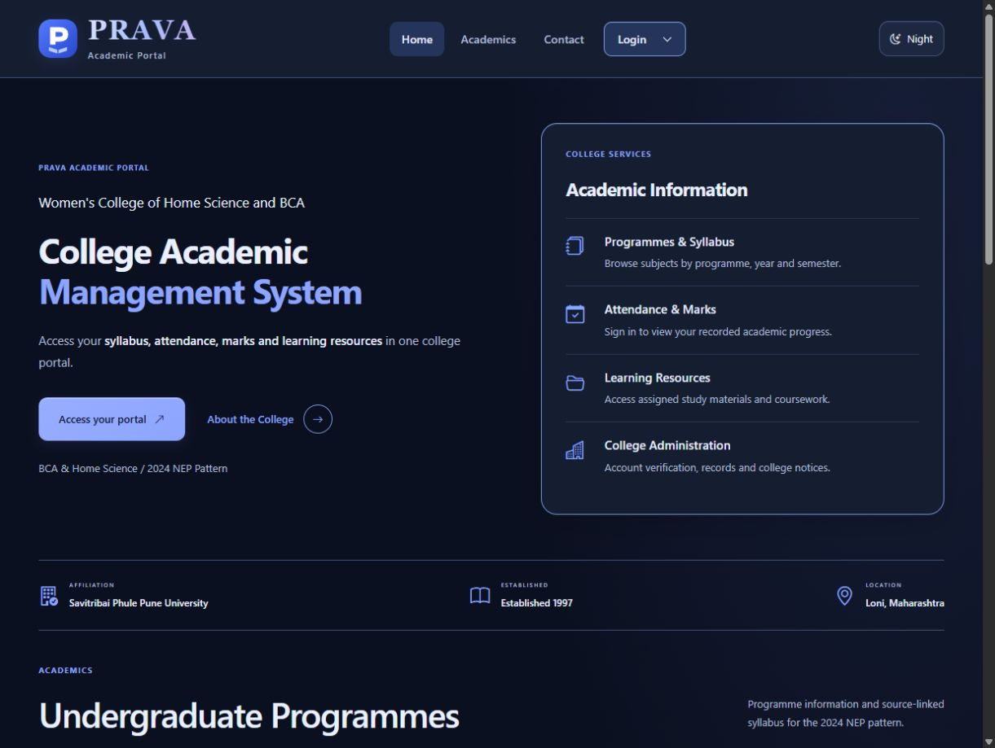
Figure 10 Current Home page in default Night mode
The header presents Home, Academics, Contact and Login. The revised heading identifies the College Academic Management System. Day mode is available from the theme control. The homepage presents academic services, programme information and college notices with functional headings.
Figures in this chapter show the interface update verified locally on 4 October 2026, based on revision 3ee1a7a. Account names use programme or role labels until verified personal details are entered. Pending results and empty lists represent academic data that has not yet been entered.

Login Dropdown and Programme Selection
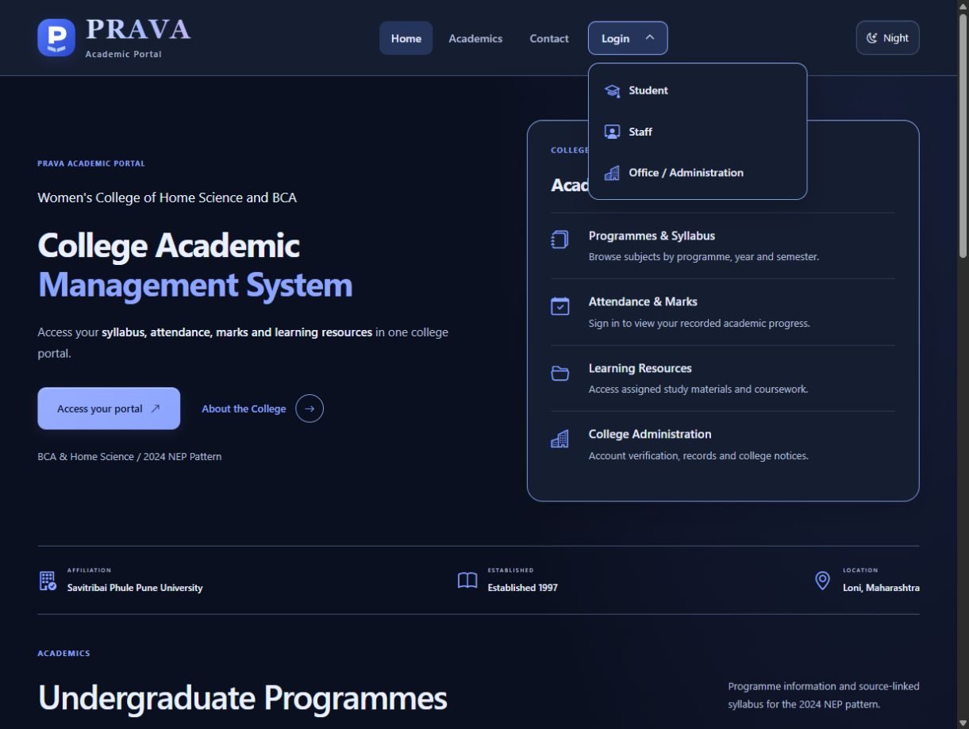
Figure 11 Login dropdown with Student Staff and Office options
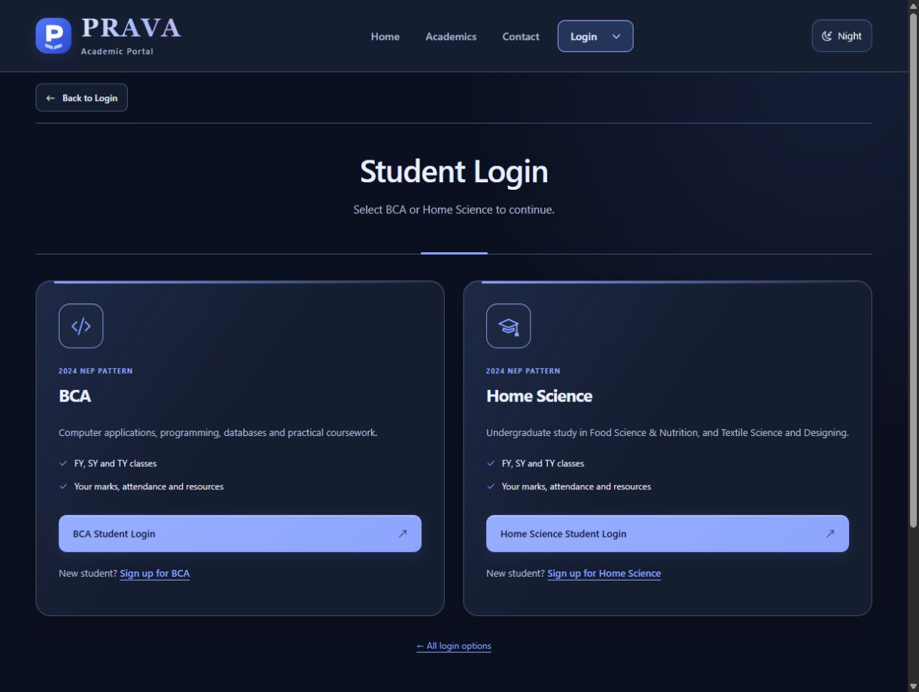
Figure 12 BCA and Home Science programme selection
Login opens a dropdown directly below the header control. Student continues to programme selection; the programme pages retain student sign-up links.

Student Login and Website Sign Up
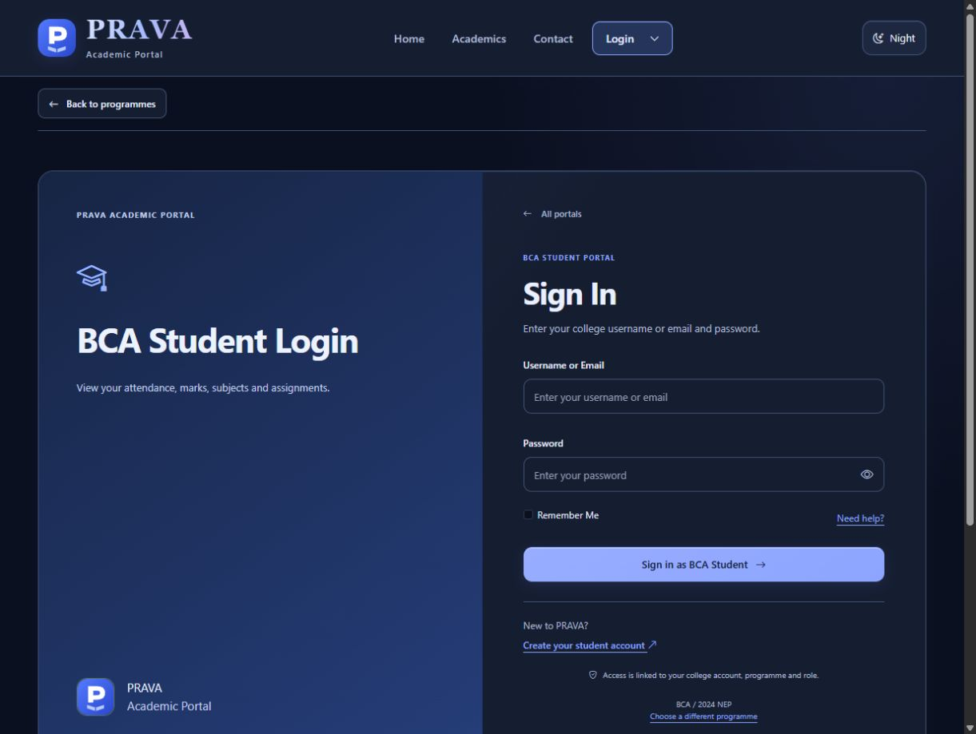
Figure 13 BCA student login form
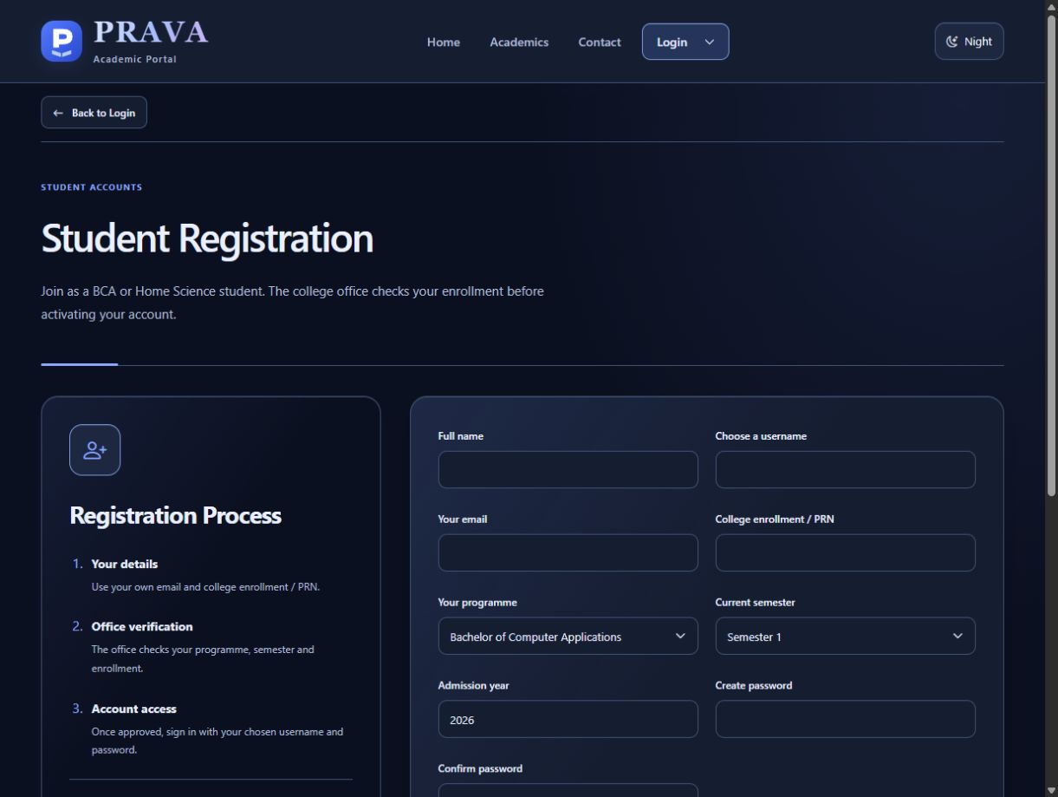
Figure 14 Student sign-up form awaiting Office verification
The role and programme are explicit on login. Website sign-up stores a pending request; successful submission alone does not grant active account access.

BCA Student Dashboard and Syllabus
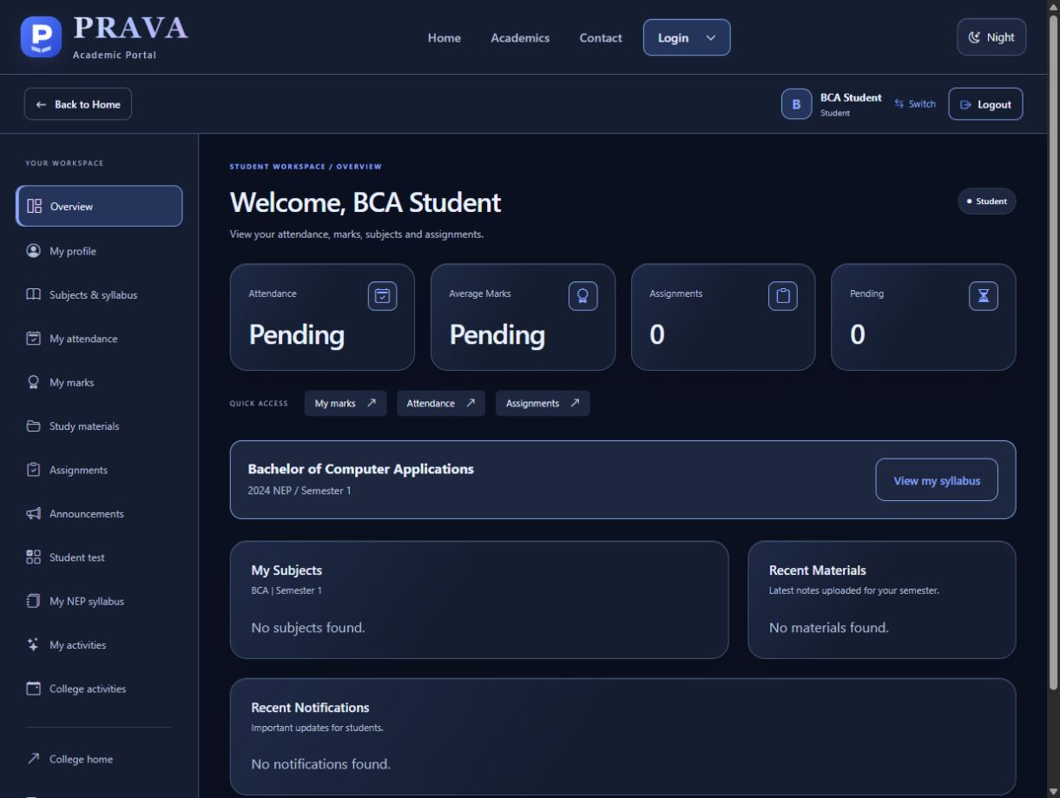
Figure 15 BCA student dashboard
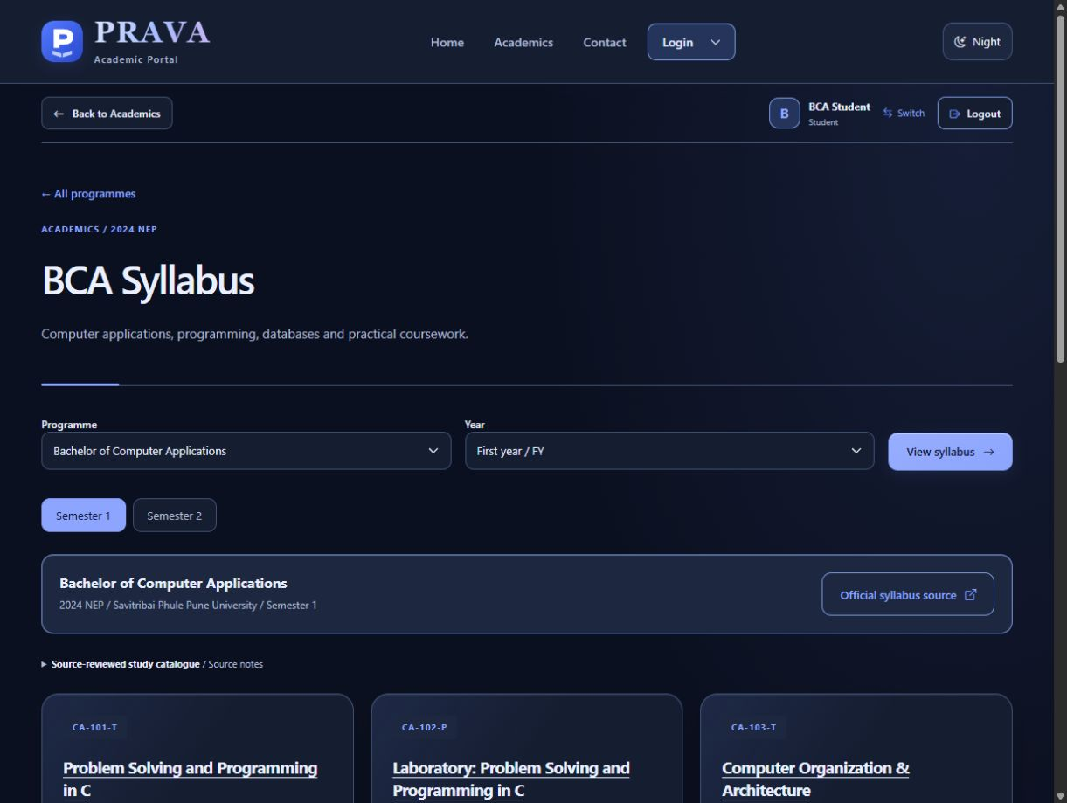
Figure 16 BCA NEP catalogue and official source link
The dashboard shows the BCA account identity and programme. Syllabus cards are reference catalogue entries; Office must separately configure actual teaching allocations.

Home Science Dashboard and Syllabus
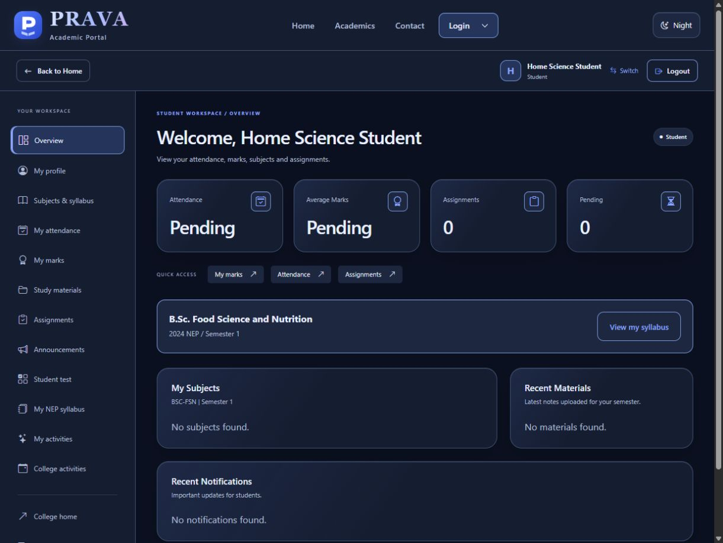
Figure 17 Home Science student dashboard
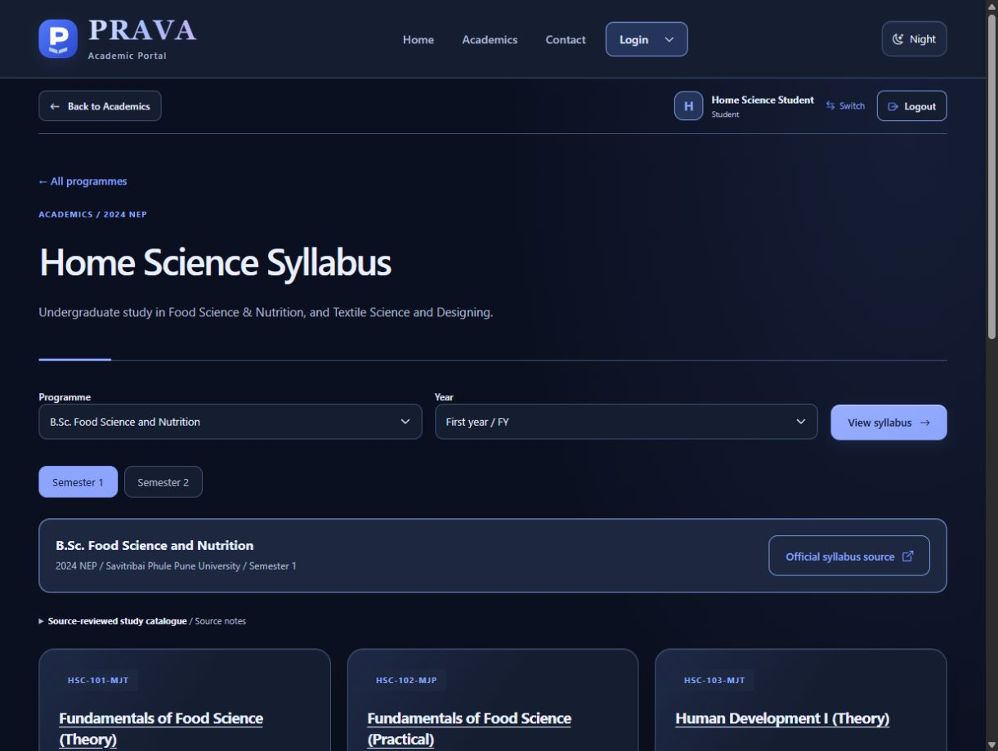
Figure 18 Home Science programme and semester catalogue
The Home Science account is configured for Food Science and Nutrition. The catalogue also supports Textile Science and Designing; each student profile identifies its actual programme and curriculum.

Staff Dashboard and Attendance
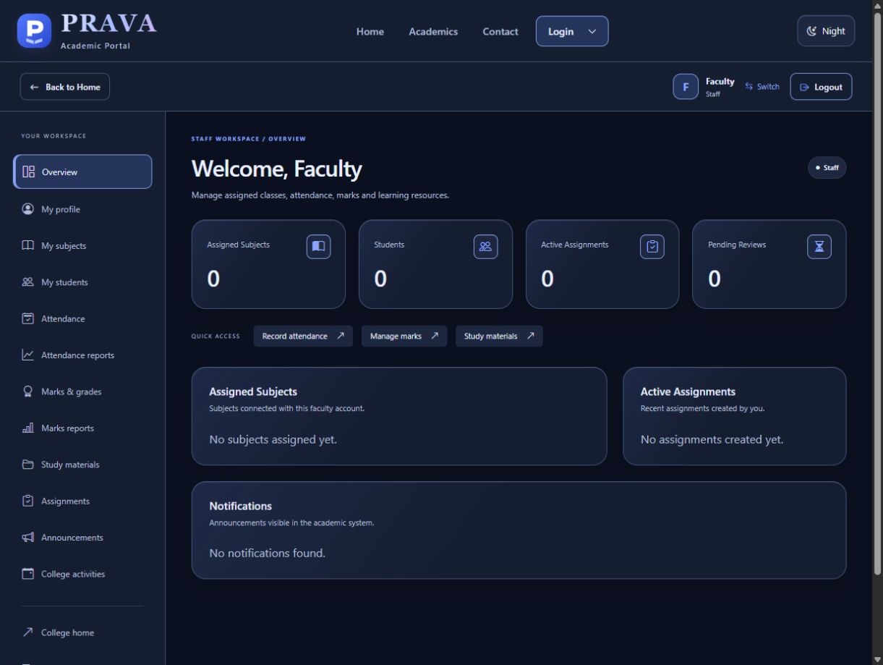
Figure 19 Staff dashboard with teaching summary
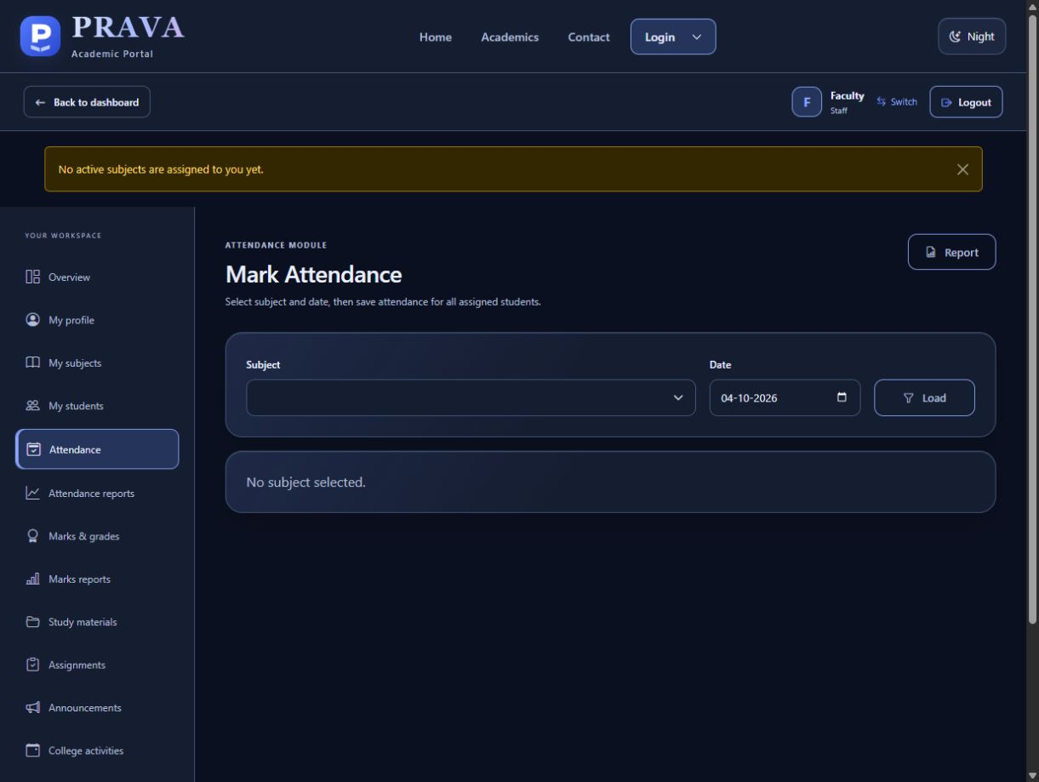
Figure 20 Attendance entry requires an assigned teaching subject
The Staff account currently has no assigned subjects. Office allocation is required before eligible student records can be loaded for attendance or marks.

Office Dashboard and Registration Review
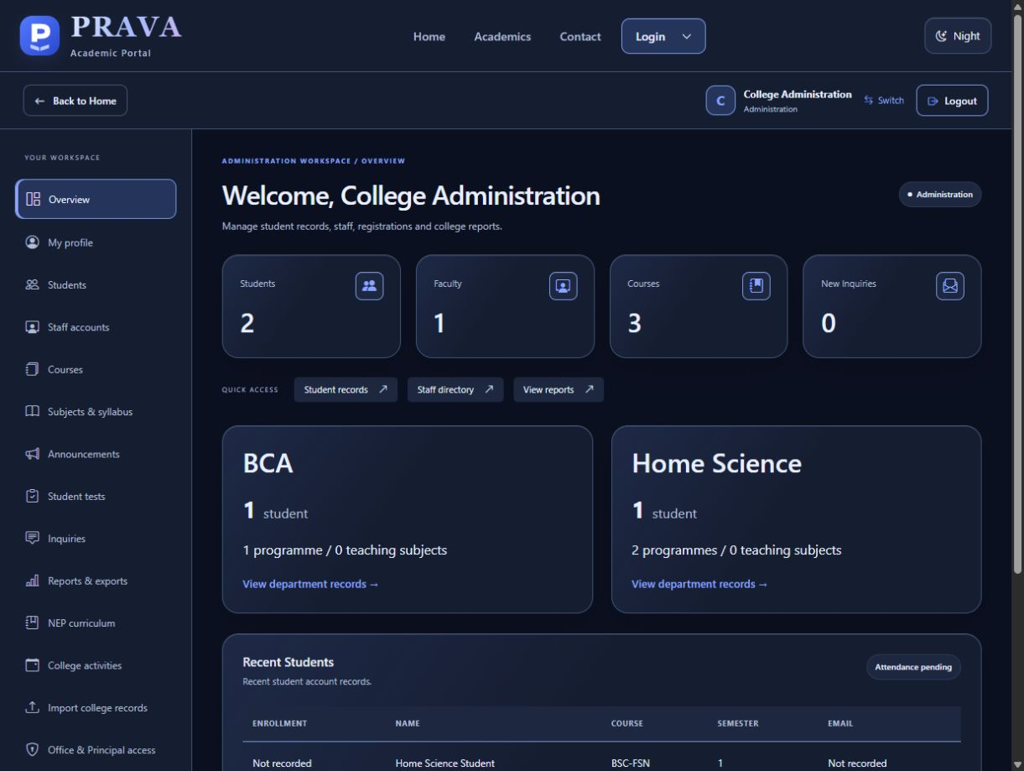
Figure 21 Office overview with BCA and Home Science departments
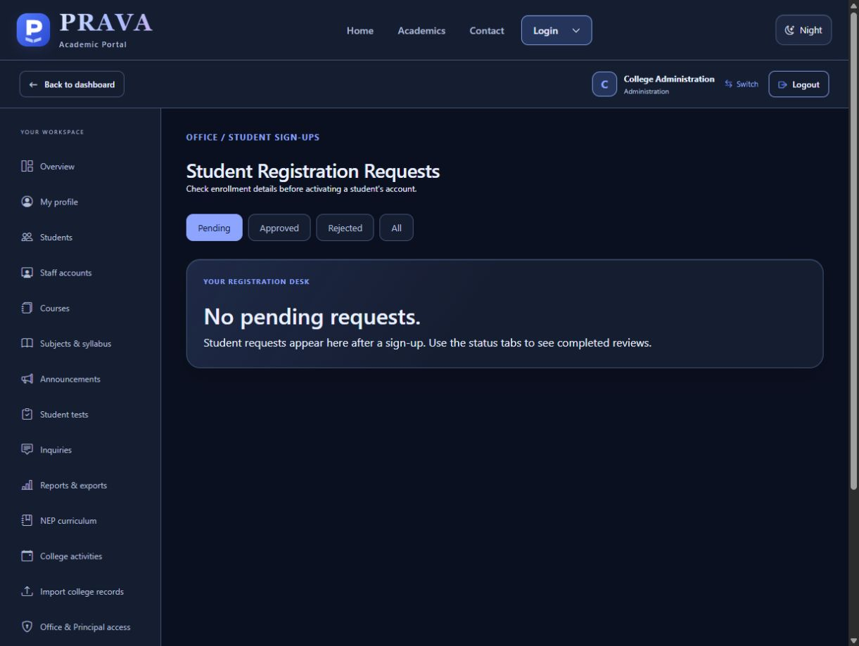
Figure 22 Office review queue for student sign-ups
Office sees institutional records and pending website requests. The two displayed students are local presentation profiles; the initial real-student collection is a separate process.

Roster Import and Report Outputs
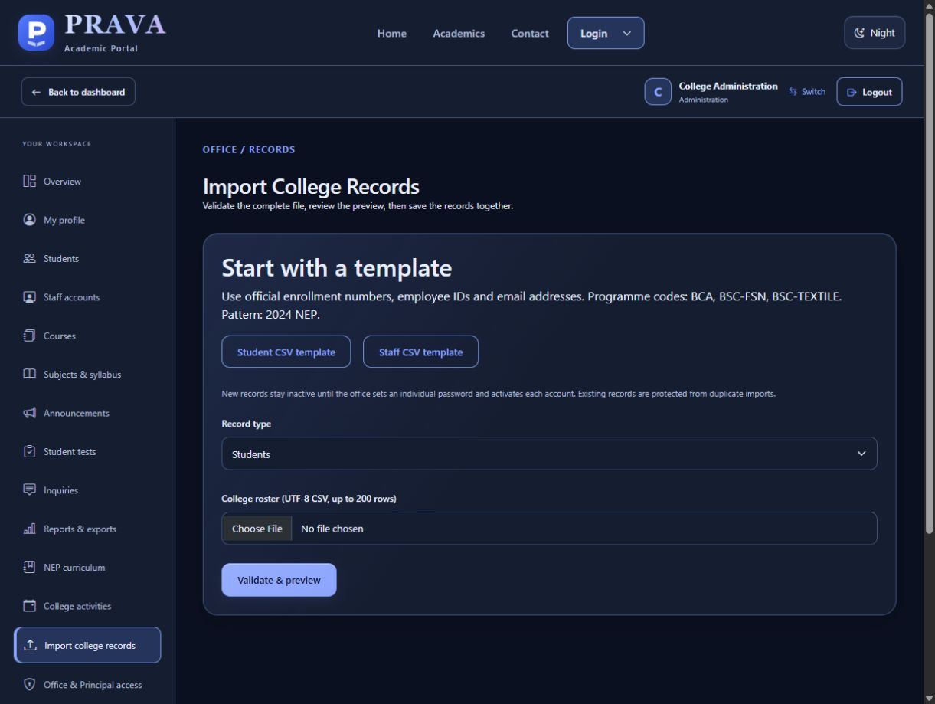
Figure 23 Separate Student and Staff CSV import templates
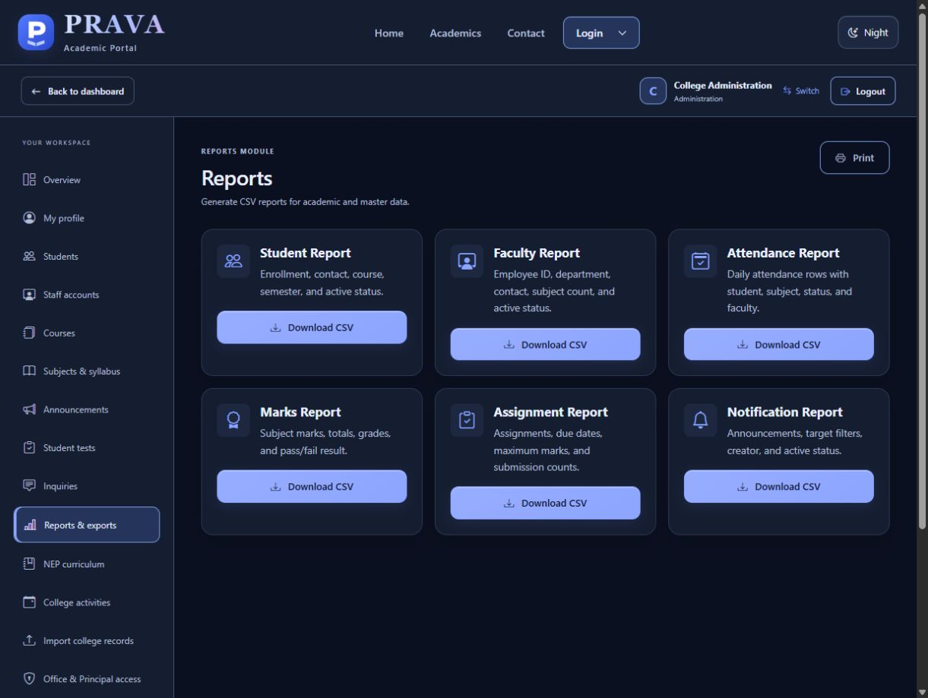
Figure 24 Administrative report and CSV export options
The import workflow validates a complete file before commit. Reports and exports use the stored records and applicable access scope.

11 Testing and Verification
The current project suite passed all 63 tests on 4 October 2026 in 23.070 seconds using isolated test fixtures. The source baseline is 3ee1a7a with the current local interface changes. The controlled error-route test intentionally logs an exception while confirming the expected friendly error response.
Test module | Tests | Result
college_upgrade | 15 | Passed
onboarding | 11 | Passed
phase14 | 12 | Passed
public_homepage | 20 | Passed
student_test | 5 | Passed
Total | 63 | Passed

Representative case | Expected and verified result
Login and switching | Role/programme checks; matching dashboard; failed switch preserves prior identity.
Registration and imports | Pending review; duplicate conflicts rejected; transaction rollback prevents partial accounts.
Permissions and security | Principal write restrictions; Staff subject ownership; CSRF and inactive account checks.
Academics and communication | NEP score bounds; curriculum publication status; notice audiences; activity ownership.
Public pages and student tests | Separate pages, valid contact storage, protected student tests and correct score handling.

Browser verification opened BCA, Home Science, Staff and Office dashboards, checked the current dropdown and captured the report screens. Both Google Forms were updated to English; question IDs, existing responses, respondent links and linked Sheets were preserved. This is functional evidence, not a load-test or a complete production security audit.

12 Security and Data Maintenance

Access and consistency
Passwords are stored as hashes. Protected routes check authentication, active status, roles and academic ownership. State-changing requests require CSRF tokens, including Logout. Imports and registration approval revalidate duplicates before commit. Unique keys and foreign keys complement service-level checks; selected actions are recorded in activity_logs.

Persistent storage and recovery
Location | Stored information
instance/prava.sqlite3 | Users, profiles, academic records, inquiries, review and activity data.
instance/.local-secret | Persistent local session secret.
instance/backups/ | Backups created by the launcher before detected schema upgrades.
app/static/uploads/ | Profile images, materials, assignments and submitted work.
Google response Sheets | Student and Staff intake responses; separate from the PRAVA database.

A complete backup preserves the database and required uploaded files. Stop the local server for a file-copy backup or use a consistent database backup procedure. Reopening the same installation retains its records. A newly extracted ZIP creates a separate installation, so populated folders should be preserved during updates.

Public deployment
The launcher binds to 127.0.0.1. Public hosting requires production settings, HTTPS, persistent database and file storage, private secrets, restricted administration and tested recovery. Local presentation credentials must be disabled for real operation. Repository publication delivers source code; it does not publish the local database or deploy a public service.

13 Advantages Limitations and Future Work

Advantages
- Public information and academic work are available through one consistent portal.
- Programme-aware student access and explicit Staff allocations keep records in the correct academic context.
- Office review, duplicate checks and transactional imports support controlled account creation.
- Source links, review labels, persistent local storage and CSV exports support demonstration and record review.

Current limitations
The versioned catalogue snapshot has 131 entries: 123 source-reviewed public entries and eight drafts. Shared Home Science content is repeated under its specialisations, so this is not a unique-subject count. The college BCA source is titled B.Sc. Computer Applications; the SY BCA source is marked draft. Final detailed TY content and some Home Science assessment/code details remain subject to confirmation.
Official NEP grade, SGPA/CGPA and individual elective enrolment are not implemented. The project does not automate email after Office approval. The Google Forms require review and manual conversion to import templates. The small local presentation dataset does not establish institutional capacity or full-semester operation.

Future enhancements
Priorities are approved batch-specific syllabus updates, elective registration, institution-validated grade calculations, controlled account recovery and registration notifications. Hosted operation should add verified backup restore, accessibility review and performance testing with representative data.

14 Project Cost and Conclusion

Illustrative cost estimate
The following is an academic planning example in INR, not recorded expenditure or logged effort. It assumes an existing laptop and connectivity. Team-hours are the combined effort of both members and are not multiplied by two again.
Planning item | Calculation | Value INR
Requirements and design | 40 hours × 100 | 4,000
Implementation | 70 hours × 100 | 7,000
Verification | 26 hours × 100 | 2,600
Documentation | 24 hours × 100 | 2,400
Total effort value | 160 hours × 100 | 16,000
Printing budget | Up to 45 pages × 3 × 2 copies | 270
Binding budget | 150 × 2 copies | 300
Local hosting fee | No paid hosting for local presentation | 0
Illustrative combined value | 16,000 + 270 + 300 | 16,570

Conclusion
PRAVA demonstrates a working college portal with clear role entry, programme-aware student access, Office-reviewed onboarding and academic tools. The relational design separates identity, teaching allocation, curriculum references and academic records. The current interface, 22-table schema, portable launcher and 63 passing tests support the implementation described in this report.
The project provides practical experience in web development, relational modelling, validation and software verification. Further work should complete approved academic rules and source review, then evaluate real operational data and hosting requirements.

15 Bibliography
Project implementation and technical references. The software versions are the repository requirements; curriculum references are preserved from the application source review.
1. PRAVA source repository
kvaishu0703/Prava_Edu. Revision 3ee1a7a; interface changes verified locally on 4 October 2026. README, models, services, templates and tests.
https://github.com/kvaishu0703/Prava_Edu
2. Python documentation
Python Software Foundation. Python 3.12 documentation.
https://docs.python.org/3.12/
3. Flask documentation
Pallets Projects. Application factories, configuration, blueprints and testing. Project dependency Flask 3.0.3.
https://flask.palletsprojects.com/en/stable/
4. SQLAlchemy ORM documentation
SQLAlchemy. Object relational mapping and model relationships.
https://docs.sqlalchemy.org/en/20/orm/
5. College information
Women's College of Home Science and BCA, Loni. Institutional information and academic references recorded by the project.
https://www.pravarahomesciencebca.in/
6. Google Forms setup
Google Apps Script Form service. Separate student/staff forms, validation, publishing and spreadsheet destinations; created 30 September 2026 and updated to English on 4 October 2026.
https://developers.google.com/apps-script/reference/forms/form

Curriculum Source References
7. SPPU FY B.Sc. Computer Applications syllabus linked by the college BCA department.
http://www.pravarahomesciencebca.in/documents/STUDENT%20CORNER/Syllabus/BCA/B.%20Sc.%20%28Computer%20Applications%29_14062024.pdf
8. SPPU SY B.Sc. Computer Applications draft hosted by Pratibha College.
https://pcccs.org.in/wp-content/uploads/2026/03/SY-B.Sc_.CA_.pdf
9. SPPU FY B.Sc. Home Science syllabus linked by the college.
http://www.pravarahomesciencebca.in/documents/STUDENT%20CORNER/Syllabus/Home%20Science/syllabus/B.Sc.%20%28Home%20Science%29_07062024.pdf
10. SPPU SY B.Sc. Home Science syllabus on the university circulars site.
http://collegecirculars.unipune.ac.in/sites/documents/Syllabus2025/S.Y.B.Sc.%20(Home%20Science)_25082025.pdf
The catalogue records its source-check date as 20 September 2026. Source title, pattern, effective year and review notes must be interpreted together. A college department label may differ from a university document title. Formal academic use requires confirmation that each document applies to the student batch.
The report preserves known source qualifications and current implementation status. It does not convert draft or incomplete syllabus content into a confirmed university scheme.

Appendix Local Installation and Demonstration
- Open https://github.com/kvaishu0703/Prava_Edu and choose Code → Download ZIP, then Extract All.
- Preserve any existing populated project folder. A new folder has its own local database.
- Install supported 64-bit Python; the README recommends 3.12 with Add Python to PATH.
- Open the inner folder containing START-PRAVA.cmd and double-click it. Internet is needed for first dependency setup.
- Keep the server window open. The browser opens http://127.0.0.1:5000/. Stop the server with Ctrl+C.
PowerShell: right-click the project folder → Open in Terminal. Run .\START-PRAVA.cmd. If port 5000 is busy, run .\START-PRAVA.cmd -Port 5001 and open http://127.0.0.1:5001/. The .\ prefix selects the file in the current folder.
Role | Login ID | Password
BCA student | bca | bca123
Home Science student | home | home123
Staff | staff | staff123
Office / Administration | office | office123

These credentials are for local presentation only. Verified college accounts use individual credentials. The local accounts are blocked when PRAVA_DEMO_MODE is disabled or production configuration is active.
Presentation order: Home and theme → Login dropdown → BCA and Home Science dashboards → Staff academic tools → Office review, import and reports. Use Logout or Switch account between roles. README.md contains the setup and maintenance instructions.

